Chapter 6: Aging and the Life-course
Introduction:
- For the first time in the Canadian census history, seniors will outnumber the younger generations.
  - Baby boomers are reaching the age of 65
  - Leaving the job market
- A higher life expectancy and a low fertility level will have an impact on the composition of the Canadian population
  - Immigration helped demographic growth but is not the solution to curb an aging population.
- 1 out of 4 canadian will be over the age of 65.
- Over the past century, the population of elderly (age 65 or older) has doubled (Statistics Canada, 2011).
- Northern and Central European populations have much higher proportions of elderly people than North America.
- Canada’s age pyramid today is a diamond shape.
  - This reflects a population undergoing change as the birth rate slows (Statistics Canada, 2011).
Canada’s Population Pyramid:
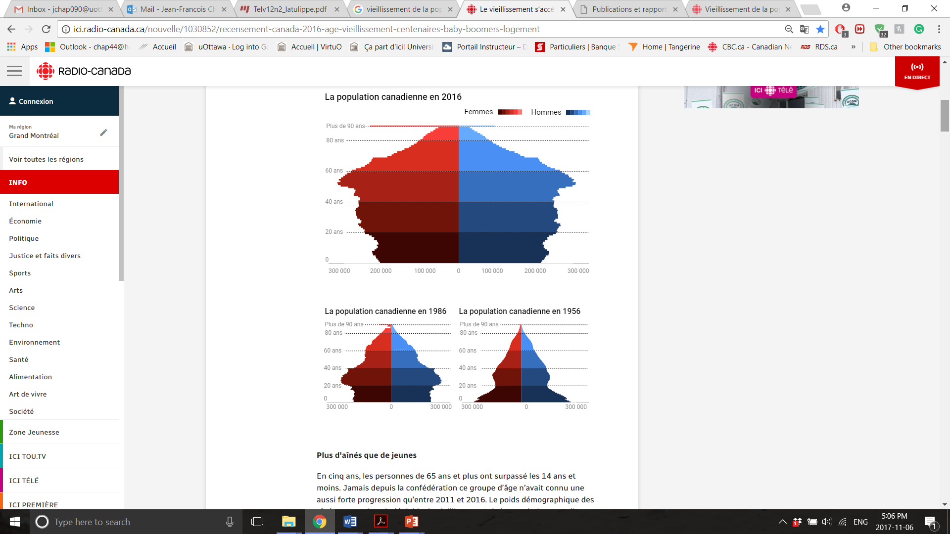
The idea of a life-course:
- Life course approach has five main assumptions (Elder, 1999):
  - Human development and aging are lifelong processes;
  - The developmental antecedents (history) and consequences of life transitions, events, and behaviour patterns vary according to their timing in a person’s life;
  - Lives are lived interdependently and socio-historical influences are expressed through this network of shared relationships;
  - The life course of individuals is embedded in and shaped by the historical times and places they experience over their lifetime; and
  - Individuals construct their own life courses through the choices and actions they take within the opportunities of history and social circumstances.
- Not everyone passes through the life course in the same way; therefore, not everyone socially “ages” in the same way.

Consideration of elders:
- Many cultures consider their elderly members as vessels of wisdom and authority.
- However, Western cultures tends to revere youth and fear aging due to physical decline…
  - Most seniors are believed to be frail and ailing.
    - 2.6% of men and 3.3% of women aged 64 to 74 live in special-care institutions, and 82.1% of these live alone or with family members (Statistics Canada, 2011).
  - Most elderly people are believed to be senile
    - Alzheimer’s affects only 9% people aged 65 to 74 (Alzheimer’s Association, 2014).
Ageism:
- Ageism: Prejudice or discrimination against any member of society based on their age.
- Many Canadians openly practise ageism—direct or indirect discrimination against people based on their age (Dobbs et al., 2008; Jonson and Larsson, 2009).
- This includes refusing jobs to qualified and willing candidates because of stereotypic attitudes towards people—young or old—who violate the age norms and expectations of our society.

Cross-cultural attitudes to aging:
- We learn our negative attitudes towards aging, and older people, from the mass media, jokes, and cartoons.
- By shaping the popular views of older people, the media create a self-fulfilling prophecy.
  - The elderly people begin to think and behave as people expect.
  - This tends to reinforce and lend legitimacy to the stereotype (Angus and Reeve, 2006).

Aspects of the sociology of aging:
- From birth onwards, an individual’s physical and mental abilities gradually improve and then begin to decline, a biological process known as senescence.
    - Senescence: the biological aging of an organism as it lives beyond its maturity, usually accompanied by chemical and organic changes
- However, exactly at what age and in what form the decline takes place varies widely from one person to another.

Age stratification:
- Age stratification theory focuses on the way social structures affect individuals.
- It is concerned with the segregation and mistreatment of certain age groups.
  - Much in the same way class stratification is concerned with the segregation and mistreatment of certain social classes (Uhlenberg and Gierveld, 2004).
- It is a sign that we do not believe in rewards based on achievement, not ascriptions.
- Aging populations with low-fertility rates (i.e., a high proportion of very old or very young people) poses challenges for a society.
  - Dependent populations consume a high proportion of their national economy.
  - The increased proportion of elderly people means increasing:
    - Population who need costly care and support, and
    - Proportion of people who are considered useless and held in low regard.

Theoretical perspectives on aging:
- Structural Functionalism
- All elements in society are interrelated and only a strong as its weakest members.
- Society benefits least from the least active and most infirm members.
- Disengagement theory (Cumming & Henry,1961):
  - Accounts for the relegation of older people to the sidelines of society.
  - As people age they gradually decline, physically and mentally, elderly people are also more prone to illness and disability.
  - They voluntarily remove themselves from activities and social contacts, to ease their passage into less active lifestyles.
  - Retirement serves several functions, especially the reinvigoration of social institutions.
    - It empties job positions allowing younger people to move up the occupational and social hierarchy.
    - It gives the retiree a celebratory to honour his/her contribution.
    - It ensures outdated skills and ideas are replaced with more useful ones.
- Conflict Theory
- Many disagree with functionalist assumptions that excluding older people from financially rewarding and socially important roles is good for society.
- Age-related discrimination against the young or old is not useful to society.
  - It is merely a form of inequality exercised by one group over another, to further its own interests.
- Elderly people do not disengage; they are pushed out of the workforce.
- The very young and very old lack the organization and power needed to influence public policy.
- As a result, interests and needs of elderly people and children are often ignored.
- While society may need older people to disappear from the workforce, many seniors remain active, refuse to retire, and fight their obsolescence.
- Symbolic Interactionism
- Theorists focus their attention on how socially constructed definitions of age and aging affect people’s experience of growing old.
- Age is a state of mind shaped by the labels society applies.
- Satisfaction with aging means rejecting the definition of old age as inadequate or outdated.
- Socially constructed definitions of age and aging affect one’s experience of growing old.
- Media portrayals reflect and reinforce society’s stereotypes about older people.
- Contrary to disengagement theory, which argues the idea that people give up roles as they age, activity theory argues people take on new roles and identities as they age (Havighurst & Albrecht, 1953)
  - Continued activity preserves a sense of continuity and self-worth gaining greater life satisfaction.
- People who keep up a high level of activity age more “successfully” than people who do not (Hardwicke and Sproule, 2010; Bezerra et al. 2012).
- Feminist Theory
- Aging affects men and women differently and brings different resources to old age, and they are subject to different expectations.
  - For women, aging is associated with a culturally defined loss of youth and glamour—a less critical concern for men.
  - Women in our Western culture fear growing old in a way that men do not, a notion some feminist scholars refer to as “double jeopardy” (Ross-Sheriff, 2008).
- Social Constructionism
- Retirement income
  - Canada’s elderly support themselves through government and private pensions, savings, and contributions by other family members.
  - There have been increases in age-related government spending on public pensions and health care.
  - More working age people are needed to help pay through taxes.

Health consequences of ageing:
- Physical illness
  - Senescence, the natural declining physical and mental abilities with the aging process, changes the quality of life for seniors.
  - Health problems often arise alongside and because of changes in the life course.
  - Loss of independence as one ages (e.g., loss driver’s licence) creates the daily need to rely on others.
  - Loss of physical control—can also cause emotional and physical distress (Harkins et al., 2006).
- Home care issues
  - 20% of Canadian seniors receive informal help because of long-term health problems.
  - Elderly are more likely to live independently.
  - Sandwich generation—middle-aged adults caring for both elderly parents and their own young children.
  - Shift from institutional to community-based care.
  - Funding cuts by federal government for elderly care services.
- Elder abuse
  - Elder care is viewed as a private matter rather than a public responsibility.
  - Older person is mistreated in his or her own home by a spouse, sibling, child, friend, or trusted caregiver.
  - Physical, sexual, emotional or psychological abuse, neglect, abandonment, and financial or material exploitation.
  - Improper use of an elderly person’s savings, property, or assets without authorization or beyond the terms set out in a caregiver–patient contract.
  - Relatives are most likely to report abuse and to perpetrate abuse and neglect.

Solutions for problems of ageing:
- Government legislation
  - Need creative management of private and public pension funds.
  - Ethical issues
    - The right to die
    - The creation of living wills
    - Guardianship for the dependent elderly
    - Empowerment of the elderly population
    - Equity across genders, races, ethnic groups, and religions

Chapter 7: Crime and Violence
Introduction:
- Crime is a social problem with real effects on people’s health, safety, and sense of well-being.
- Due to differential socialization and a cultural norm of aggressiveness among men, young males are more likely to experience crime. How can society’s values regarding gender be altered to decrease the likelihood of young men experiencing crime? If you were an elementary school teacher, how would you teach these new gender scripts to your students?
- Strain theory suggests that societal inequalities may encourage individuals to turn to crime. Do you believe that there would be fewer incidents of crime if society no longer valued material wealth? What goals could replace the achievement of wealth and material gains, and how would these new goals impact
- Researchers tend to differ about the causes of criminal behaviour. Some posit that:
  - Property crimes are the result of rational calculation of risk versus profitability.
  - Crime occurs whenever there is unequal power and influence between competing groups.
  - Crime will increase whenever there is social inequality.
  - Strict law enforcement and harsh sentencing will resolve the crime problem.
  - Prisons harden and teach criminals—causing as many problems as they solve.

Defining crime, laws and social order:
- All societies have formal rules about what is good and bad behaviour, and punish bad behaviour.
- Laws: Rules of conduct that may provide for the punishment of violators (i.e., formal rules) about what a society’s members can and cannot do.
- Police and courts enforce these rules
- Crime: Any behaviour that, in a given time and place, is prohibited by applicable statutory law. When a law is violated, a crime is said to have been committed.
- Social order: The prevalence of harmonious relationships that exists only when people obey rules and social institutions are controlled and predictable.
  - Social order is manufactured and protected by a society.
- Social disorder: The uncertain and unpredictable condition in which rules are not obeyed.
  - The environment is unsafe, and the boundaries of acceptable behaviour have broken down.

Crime in Canada and elsewhere:
- Canada crime statistics, which are based on conviction records, offer only a glimpse of the actual amount of crime in society.
- Of the many criminal incidents, only a few are reported, and even fewer result in arrests, convictions, and imprisonment.
- Measuring the total rate of crime is difficult because of incomplete self-reporting and police records.
- Victimization surveys offer the most precise data.

Crimes of violence:
- Violent crimes account for only about 20% of the crime, contrary to the impression presented on the nightly news (Brennan and Dauvergne, 2011).
- Conventional crimes: The traditionally illegal behaviours that most people think of as “crime” (e.g., homicide and sexual assault) are given the most media coverage but account for only 12% of crime.
  - Crimes most people agree are serious and deserve harsh punishment.
- Homicide: The killing of a human being by another, directly or indirectly, by any means, includes:
  - Murder (i.e., the unlawful killing of another human being with malicious intent)
  - Manslaughter (i.e., the unlawful killing of another person without sufficient intent to constitute murder)
- Men are more likely to be involved in homicide than women:
  - 88% of offenders and 67% are victims male.
  - We tend to kill and are killed by people we know.
- Assaults are common, accounting for 60% of all reported violent crimes (Statistics Canada, 2011a).
- Sexual assault: (i.e., defined as rape) is another form of violent crime.
  - Most sexual assault victims do not report their experience to the police because they are ashamed or embarrassed, and may believe they are partially responsible for the occurrence (Jones et al., 2009).
- Stalking: associated with gendered harassment, abuse, and violence.
  - Most stalkers are former, rather than current, intimates, and are more likely to be men.
- Non-violent crimes:
Most crimes in Canada are non-violent.
  - Theft, break and enter, mischief and wilful damage, drug production and trafficking
- Vice crimes: Deviant behaviour often defined as immoral (e.g., gambling, prostitution, drug trafficking); provide the greatest opportunity for organized crime.
- White-collar crimes: Committed by management and usually performed in the normal course of work usually by reputable organizations.
  - Governments give lower priority to this type of crime

Organized crime:
- Organized crime: A group or system of professional criminals who practise illegal activities as a way of life and whose criminal activities are co-ordinated and controlled through a hierarchical system of bosses.
- It prospers under four conditions in North America:
  - Where scarcity and inequality are common,
  - Where poverty and prejudice keep people from moving easily to find work elsewhere,
  - In communities that lack good access to welfare, health care, good-quality and police protection, and
  - Among people who lack human capital and cultural capital.

The demography of crime:
- Most perpetrators and the victims of crime tend to be the less-educated young men.
- Women commit far fewer crimes than men, and this gender gap in crime—whether organized, professional, or amateur crime—is universal (Davies, 2008).
- Some researchers argue that biology and higher levels of testosterone causes aggression males.
- Others argue it is differential socialization (i.e., a more violent male subculture encouraging aggressive and violent behaviours to resolve problems).
- Gender of victims
  - Just as criminal offenders are mainly male, so too are the victims of crime.
  - However, men are disproportionately the perpetrators of domestic and sex-based crimes, and women are disproportionately their victims.
- Age
  - Young people are more likely to commit crimes than old people, particularly property crimes.
  - People aged 20–60 are more likely to be unemployed or to work in low-wage jobs.
  - Aggression is a cultural norm for many young men.

Victimization:
- Some people are at higher risk of victimization than others, include demographic variables (e.g., male, young, unmarried, or unemployed) (Arnold et al., 2005).
- Factors influencing community safety:
  - Socio-economic vitality
  - Social cohesion and trust
  - Community resources and infrastructure
  - Mechanisms of informal social control.
- Crime rates rise as neighborhoods decline.
  - Community cohesion is down and crime goes up.
- Secondary victimization occurs not as a direct result of the crime, but through the response of institutions and individuals to the victim.
  - Refusal by law enforcement officers to recognize an individual’s experience as a victim of crime
  - Intrusive or inappropriate conduct by police or judicial officers
  - Psychological stress associated with the criminal investigation and trial process
  - Criminal justice processes and procedures that ignore, marginalize, or discount the role and input of the victim

Theoretical perspectives on crime:
- Structural Functionalism
    - Social Disorganization Theory
- Crime results from a breakdown in social norms and social integration following rapid social change.
- Leads to a loss of social cohesion, which in turn increases the likelihood of criminal behaviours such as robbery and assault.
- Exposure to chronic random violence produces individuals who are more likely to act violently.
- Increased cohesion reduces crime.

    - Social Bond Theory
- Travis Hirschi (1969) argued that developing strong social bond in childhood can prevent people from giving in to the temptation to commit criminal acts, but requires four elements:
- An attachment to other people
- A commitment to conventional goals
- An involvement in conventional activities
- A belief in the legitimacy of conventional values, norms, and moral standards encouraged by society
- Criminal activities increase where bonds are weak and individuals are exposed to anti-social values and activities.

    - Strain Theory
- Strain is produced when social structure prevents people from achieving culturally defined goals through legitimate means.
- Anomie is a condition characterized by a breakdown of norms and personal disorganization, which may lead to crime.

    - Subculture Theory
- Investigates the norms that set a group apart from mainstream society.
- Violent subcultures, such as gangs, provide minority youth with an alternative community for achieving social status, friendship, and economic mobility.
- Using violence to right a wrong or defend one’s honor may be considered justifiable under the value and belief systems of delinquents and criminals.

- Conflict Theory
- Conflict theories of crime and violence point to inequalities in society as the cause of such deviant behaviour.
- Criminal activity increases as inequality increases.
- Dominant ideology and formal laws protect the privileged status of the ruling class and mask white-collar crimes that benefit the social elite.

- Social Constructionist Theory
- Theorists examine how deviant behaviours come to be defined as “deviant.”
- Behaviours are not innately right or wrong. They only become wrong, deviant, or criminal when someone in power ascribes a moral value to them.

      - Labelling Theory
- Deviance is not a quality of the act a person commits, rather a consequence of the application by others of rules and sanctions to an “offender.”
- Being labelled as deviant or criminal may promote further deviancy, and the person may be unable to escape stigmatization and internalizes the “deviant” identity.

- Differential Association Theory
- Argues that people are social beings who tend to imitate each other to gain acceptance and approval.
- Through frequent and close association individuals eventually adopt the reasoning and rationale of their peers.
- Seeing criminals act illegally without consequence can teach others not only the techniques of crime, but motives, rationales, and attitudes of such a lifestyle.
- Thus by close and frequent association, individuals are socialized into a criminal environment and reproduce the prevailing order.

Social consequences of crime and violence:
- Poverty and inequality
  - Media present violent street crimes.
  - Most people arrested are under-educated, poor, unemployed, or working in low-wage, low-status jobs.
  - Police, courts, and politicians target lower-income criminals and overlook upper-income criminals.
    - There are equally high rates of crime among the wealthy.
- The racial dimension
  - First Nations people make up 3% of the Canadian population but are over-representation in the criminal justice system accounting for 22% of crime.
  - Explanations include:
    - Racially prejudiced law enforcement and correctional system;
    - A conflict between the values of Aboriginal culture and mainstream Canadian culture; and,
    - The social and economic effects of colonization and oppression.

Economic consequences of crime:
- Losses of property: Due to theft, identity theft, robbery, break and enter, embezzlement and copyright violations
- Criminal violence losses: the loss of productivity and the medical costs of treating crime victims
- Unrecorded or illegal spending on drugs, prostitution, gambling, and other underground activities diverts from legitimate businesses and goes untaxed.
- Government spending on law enforcement, the criminal court system, and correctional services.
- Criminal activity is shifting to cyberspace where concerns with identity theft is growing.

Health consequences of crime and violence:
- Victims of crime report lowered levels of well-being after their victimization (Green &Pomeroy, 2007).
  - Physical pain and suffering due to injuries,
  - Post-traumatic stress disorder (PTSD)
  - Lowered self-esteem
  - Depressive episodes
  - Various phobias
- Life of Criminals also stressful with health issues:
  - Increase risk of drug abuse
  - HIV/AIDS
  - Severe mental illnesses (e.g., schizophrenia)
  - Rape and violent assaults

Solutions to the crime and violence problem:
- Reducing crime through prevention
  - Improve education, create jobs, supply daycare, upgrade low-income housing, increase access to health care, and support poor families
  - More use of probation, better gun control, and expanded treatment for drug addicts
  - The victims’ rights movement
  - Give injured party an equal voice in the criminal justice process
  - Has so far resulted in harsher and more punitive verdicts

Chapter 8: Addictions
Discussion:
- In labelling certain drugs as legal or illegal, the argument can be made that the government does not believe that individuals are able to make informed decisions regarding what they consume. Do you believe it is possible to create a society in which individuals can make their own informed decisions about drugs and alcohol without these drugs and alcohol being criminalized? What would need to change in order to make such a society possible? If you were the prime minister of such a society, how would you trust that individuals were making informed decisions?
- You have identical twin girls, one abuses multiple substances (alcohol, GHB, cough syrup mixed with 7up), the other never experienced drugs or alcohol.
  - What would explain this situation?
  - What would explain the choice of drugs made by one of the twins?

Addiction:
- Addiction: Socially disapproved behaviour that is uncontrollable, repetitious, and possibly harmful
  - Alcohol, drug, gambling
- Other recent socially disapproved behaviours (i.e., excessive sex, shopping, Internet use, or overeating) have emerged and labelled addictions without research to justify them.
- The American Psychiatric Association (DSM-V) and the World Health Organization (ICD-10) medical definitions of addiction have seven criteria, and require interviews to determine if an individual has an addition issue.
- When is it considered an addiction?

Are drugs and alcohol social problems?
- Drug: Any substance that causes a biochemical reaction in the body.
  - What people define as legal drugs or an illegal drug depends on economy, society, and politics.
- The use of legal drugs (i.e., alcohol, tobacco, medicine) is more common in Canada than illegal drugs.
  - The use of illegal drugs is considered a major problem while the harm done by legal drugs is often ignored.
  - Attitudes towards specific drugs vary over time and from one society to another (e.g., Opium commonly used as painkiller until early 1900s).
- Drug abuse: This concept begins with the notion of excessive or inappropriate drug use resulting in social, psychological, and/or physiological impairments stemming from drug dependency to avoid unpleasant withdrawal.
- There are two aspects to this concept of abuse: objective and subjective.
  - The objective aspect relies on physical, mental, or social evidence that the use of a drug harms the individual and society.
- Drug abuse may lead to drug dependency, the routine need for a drug for:
  - Physiological reason (i.e., to avoid withdrawal symptoms), and/or
  - Psychological reasons (i.e., to keep a sense of well-being) (Hathaway et al., 2009).
- Tolerance: A symptom of repeated and frequent drug use referring to the decreased effectiveness of any given drug.
  - Regular drinkers are often to be able to “hold their liquor,” which is nothing more than tolerance, but does not render them immune from its effects.

Social and physical characteristics of alcohol addictions:
- Social factors influence how individuals learn to use alcohol to cope with stress, and provides opportunities for the use alcohol for any reason.
- Men are more likely than women to drink heavily (Carey & DeMartini, 2010).
- Women are more likely to use other chemical substances to cope with stress (Statistics Canada, 2012).
- Higher education has a moderating influence on drinking.
- Age is also an important determinant of alcohol use.

Social and physical characteristics of illicit drug use:
- Factors reducing the likelihood of drug use and abuse, include:
- Strong family bonds reduce the use of all illegal drugs—except marijuana,
- A strong religious commitment,
- Normative boundaries separating adolescents, who occasionally use drugs socially, from individuals who use drugs often or in isolation,
- Marriage and parenthood.
- Factors increasing the likelihood of drug use and abuse, include:
  - Parents who use tobacco or alcohol,
  - Early initiation into drug use,
  - Friends who are users.
- Workers with complex jobs and low cognitive ability tend to use more cigarettes, alcohol, and marijuana,
- Workers with complex jobs and high cognitive ability tend to use less use less of these same substances.
- Gender: Males have more opportunities to use marijuana, crack cocaine, and other forms of cocaine, and at a younger age:
  - Males are more likely to receive offers of drugs from other males in public settings,
  - Male peers enforce these norms as drug dealers and distributors,
  - Males are no more likely than females to begin using drugs once an opportunity has arisen.
- Traditional gender roles limit girls’ access to certain types of leisure activities and sociability.
  - Drug offers to females are more likely to come from other females or dating partners in private settings.

Theoretical perspectives on addiction:
- Structural Functionalism
- Alcohol and drug abuse result from the social structure’s influence on the individual.
- Drug and alcohol use is common because it serves social functions.
- It is argued that it seems compulsory on certain occasions (i.e., Mardi Gras or Carnival or New Year’s Eve), where it breaks down personal inhibitions and fosters conviviality.

        - Social Disorganization Theory
- Institutions that traditionally discouraged deviant behaviour have become less effective due to rapid social change.
- Breakdown in community norms and traditions deprives individuals of a sense of meaning and moral guidance.
- Relearning or re-establishing traditional institutions can reduce substance abuse (e.g., in First Nations communities).

        - Merton’s Strain Theory
- Drug and alcohol abuse is the result of the paradox between culturally defined goals and the socially approved means for attaining these goals.
- Various adaptations include:
  - Ritualism, retreatism, rebellion, and innovation.
  - One adaptation to this gap is to retreat (abandon efforts to achieve goals, escape reality, via substance abuse)

- Conflict Theory
- Alcohol and drug use affect different socio-economic groups differently.
- Powerful capitalist members of society are in a position to define whether a substance is legal or illegal.
- The poor tend to suffer harmful outcomes of substance abuse more than the rich, due to labelling and the criminalization process.
- Symbolic Interactionism
- Considers the social meanings and values associated with drug and alcohol use.
- The labels people attach to these activities (i.e., when appropriate to use these substances) are the focus for understanding addiction.
- The term “alcoholic” is laden with negative characterizations, judgments, and stereotypes in a way that “social drinker” is not.

Social consequences of addiction:
- Crime and violence
  - Drug use is strongly linked to other forms of deviant and even criminal activity.
  - Alcohol use and abuse are strongly associated with non-violent and violent behaviours (e.g., assault and domestic violence).
  - Alcohol use causes biochemical changes that influence behaviours that would not have otherwise occurred.
- Poverty and income
  - Alcohol use rates are higher among well-educated, high-income people than among the poorly-educated, low-income people.
  - However, alcohol abuse and problem drinking is more common among the poor.
  - Poverty may lead to substance abuse and substance abuse, in turn, reinforces joblessness and poverty.

Solutions to addiction:
- Legalizing drugs seeks to address health concerns rather than punishment of offenders.
- Decriminalization of possession of marijuana decreased costs within the criminal justice system.
- Oversight of availability and quality of to consumer and regulations for their use.
- Promoting protocols for healthy use of recreational drugs
- Would eliminate the underground drug culture and organized crime.
Canada’s drug strategy:
- Canada’s current drug strategy is built on the following pillars: prevention, treatment, and harm reduction.
  - This strategy recognizes that drug abuse is a public, medical, and social health concern that should be averted and discouraged where possible and treated where necessary.
  - The plan also recognizes that the supply of illicit drugs must be controlled and limited.

Chapter 10: War and Terrorism
Introduction:
- At no point in recorded history has there been a complete absence of conflict between human groups.
- When societies form, conflict inevitably arises.
- Warfare and violent conflict appear to be universal, though outbreaks of violence vary over time and place.
- Just as some groups are more prone to violence than others, some periods of history have been more prone to war than others.
- Canadians seem to lack the desire for war. They go to war only when they are pushed into it through loyalty to allies like Britain/US.

The role of the state:
- The military has rarely played an important role in state decision making.
- Power in Canada is shared among competing political, bureaucratic, and economic elites—unlikely to mobilize the will and the assets to wage war.
- Decentralized leadership is less likely to engage in warfare that centralized or, especially, dictatorial leadership.

Ideology and religion:
- Ideology: A system of beliefs that explains how society is, or should be; any system of ideas underlying and informing political action.
- In a Marxist sense, ideological ideas justify and legitimize subordination of one group to another.
- Rebirth of religion as a political force—“the opiate of the masses” (Karl Marx).
- Canada’s formal commitment to multiculturalism makes strong, unified religious or ideological beliefs impossible.

The nature of war and terrorism:
- War: A state of armed conflict between different nations or states or different groups within a nation or state.
  - Undeclared battles, guerrilla wars, covert operations, and even terrorism
  - Most countries have a war system in which units of their social institutions and their cultural practices promote warfare as normal aspects of life.
- Collective violence: Organized by a groups or a social movement, this type of violence is used to promote an agenda or to resist an oppressive other.
  - Interpersonal violence: Violent interactions occurring between individuals.

Terrorism:
- To be considered a terrorist act, the crime must be intentional, have social, political or religious claims.
- Extremists acts are defined as serious threats to security or crime based on ideologies.
- Between1960 and 2014:
  - 1400 terrorists acts
- Roots can be found in any of the differences that prevent people from living together in peace.
- Participants feel that, all things considered, violence is the best course of action.
- State-sponsored terrorism is the state-sanctioned use of terrorist groups to achieve foreign policy objectives.
- US might be viewed as a state that sponsors terrorism, with the aim of destabilizing foreign governments and undermining particular political movements.

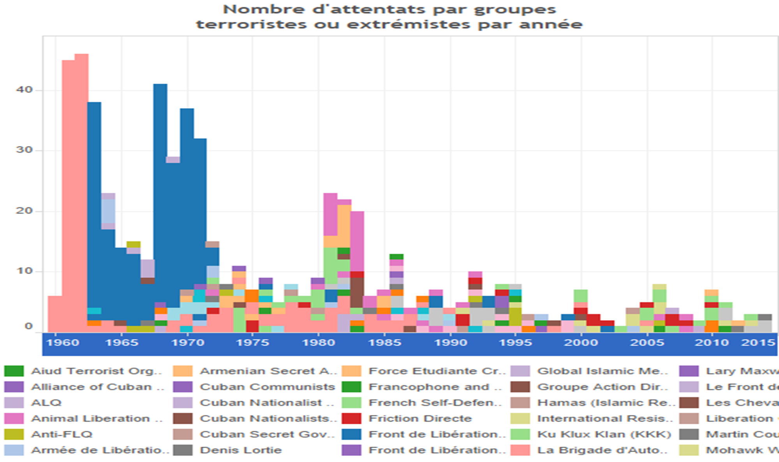

- In Canada:
- Neo Nazis: Skinheads International, The Aryan Guards, KKK, Edmund Burke Society
- Environmentalists: Voluntary Extiinction Movement, The Earth Liberation Front, Animal Liberation Brigade
- Political radicalism: Sons of Freedom, Cuban Secret Government, FLQ, The Black Hand
- Religious radicalism: Chruch of Creator, Daesh, Al Quaida, Baby Liberation Army
- Discussion:
- Infantry in Canada:
  - Hundreds every year, 4-5% women, varies in time of war or not
- Daesh
  - End of 2015 - 180
  - End of 2014 – 130
  - 20% women
  - Last two years 60 returned
- Street gangs in Canada
  - 434 gangs
  - 7000 members
  - 6% women (but increasing)
- Why?
- Social stigma (humiliation, injustice) – psychological event or trauma
- Intolerance in regards to ambiguity (closed minded, no degree of interpretation, one way or the other, right or wrong – ideologies will appeal to them because gives an answer without critical analysis.
- Stereotypes
- Dehumanisation
- Social groups that incites to violence
- Criminal background
- Mental illness
  - When an individual commits an act that goes against the majority = deviance = labels
  - Seen as crazy
  - Over simplification of the phenomena, not supported by scientific evidence
- Motivation
  - Quest for meaning
  - Need to make a difference… to be part of something… to belong… to have a goal
- Manifests itself in 2 ways:
  - Reaction to a loss of meaning (real or potential)
    - Substantial psychological pain
  - Considerable occasion to gain meaning (be a hero, mark history)

Revolution and rebellion:
- Revolution
- The successful overthrow of the prevailing elite by a new elite who, after having taken over power, fundamentally change the social structure and structure of authority.
- Rebellion
- Armed opposition by a portion of the citizenry to an established government or other authority.
- The difference between a Rebellion and a Revolution lies in the outcome.
  - If a rebellion succeeds in overthrowing the government and making significant social and political changes, it is classified as a revolution.
  - If the rebellion succeeds and the rebels form a new government, the rebels are no longer criminals: they are considered heroes and rulers (Coates, 1997).
- Revolutions and rebellions are crimes, and whether history views the rebels as heroes or villains depends on whether they succeed.

War crimes:
- Genocide: The deliberate, systematic, and planned killing of an entire national, ethnic, racial, or political group
  - E.g., the extermination of the Jews and Roma (gypsies) by Nazi Germany during World War II, Rwanda, etc.
- Many governments believe that slaughtering soldiers is an acceptable cost of war, while the intentional slaughter of civilians is indefensible.
  - These distinctions are socially and politically meaningful, though some would question whether they are morally meaningful.
- Prosecution of war crimes fall into four categories:
  - Assigning responsibility for criminal acts
  - Trying and punishing criminals
  - Bringing about national reconciliation
  - Ensuring that a nation remembers its criminal past and learns from it
- The International Criminal Court (ICC)
  - A permanent, international court to prosecute war crimes and crimes against humanity
  - However, the US (and others) have refused to participate.

Theoretical perspectives on war and terrorism:
- Structural Functionalism
- Believe all elements in society are interrelated, and most elements in society exist to serve some purpose.
  - Conflict and violence are the results of a system malfunctioning.
  - Wars occur because groups or societies do not know how to resolve their conflicts peacefully.
  - War and terrorism reinforce group identity and increase social cohesion as well as conformity.
  - Increased employment and production of weapons lead to economic benefit.
  - War may arise when military institutions and activities are given importance within a society and culture.
- Conflict Theory
- Wars are struggles between opposing groups over power, limited assets, or ideological domination taken to their logical, violent conclusions.
  - Conflict and change are features of social life everywhere.
  - War and terrorism reflect struggles between opposite groups over power, limited resources, or ideological domination.
  - War benefits some groups—most notably, corporations, politicians, and the military—but not others.
- Symbolic Interactionism
- Examine how culture socializes people to adopt certain attitudes towards war and conflict.
  - Socialization and labelling shape attitudes and roles people adopt towards war efforts and conflicts.
  - In times of war, leaders use propaganda and euphemistic language to legitimize combat and to reduce the rational and emotional impacts of death.
  - “War on terror,” “justified war” against “evil” terrorism
  - Soldiers on both sides are not “murder victims,” but “casualties.”
  - A missile “services the target,” and causes “collateral damage.”
- Feminist Theory
- Masculinity and militarism have had a close relationship over time and across cultures.
  - Where boys wage make-believe wars with GI-Joe action figurines, girls tend to act out domestic routines with dolls.
  - In Western culture, mainly men have fought in wars as a misguided protective chivalry or paternalistic sexism towards the “lesser” sex.
  - Consequences of war: Women are raped, forced into prostitution.
  - The “meanings attached to masculinity are so firmly linked to compliance with military roles that it is often impossible to disentangle the two” (Enloe, 1987).
- Social Constructionism
- Stresses the role of moral entrepreneurs in mobilizing support for social causes.
  - Propaganda legitimizes war and reduces the rational and emotional impact of death.
  - Political parties deflect criticism by focusing national attention on real or imagined enemies, on the valour of the nation’s fighting forces, and on the “good” they are doing the country that has been invaded.
  - People mobilize to form social movements and to influence public policy.

Consequences of war:
- Social consequences
- Two most socially consequential facts about war:
  - It kills many people—not only soldiers.
  - It is a massive cost to society.
    - The rise in both casualty rates and military expenditures in modern warfare is partly due to the larger scale of conflict and partly due to the advanced technology used in waging war.
    - Warfare shatters morale and the fabric of civic society and has lasting negative impacts on the health of populations.
- Effects on the economy
- Increased employment and production
- Scientific and technological innovations
- Effects on children
- Increasingly, wars are being waged with the help of child soldiers.
- UN Convention on the Rights of the Child states that children under the age of 15 are not to be used as soldiers
- According to the Child Soldiers Global Report, roughly 300,000 child soldiers are currently fighting in more than 40 countries around the world (Coalition to Stop the Use of Child Soldiers, 2009).

- Health consequences
- Death toll
  - According to some estimates, military conflicts in the twentieth century have led to the deaths of over 100 million soldiers and civilians—more than the total number of casualties in all previous wars in human history combined (Porter, 1994).
  - These numbers pale in comparison to the “possible” death tolls humanity would achieve were a full-scale nuclear war to break out.
- Physical injury
  - Maim rather than kill the enemy as this takes more of your enemies resources to care for the wounded than it does to discard their bodies.
  - Post-traumatic stress disorder (PTSD):
    - A form of psychological distress produced by a traumatic experience such as crime victimization, sexual assault, or military combat.
    - Symptoms include nervousness, sleep disturbances, disruption of concentration, anxiety, depression, irrational fear, and flashbacks triggered by loud noises such as thunder or a car’s backfiring.

Solutions to war and global conflict:
- Reduce the number and types of weapons used.
  - Landmines Convention—Ottawa Convention (1999)
- Limit production and sale of small arms.
  - In 2008 the top 10 arms exporters were US, Russia, Germany, France, UK, Spain, the Netherlands, Italy, China, and Israel
- Redistribution of economic assets more equally among nations.
  - Does not guarantee that poorer nations will have a better standard of living.
- International peacekeeping and prevention of global conflicts.

