COMM 223 Chapter summaries

Chapter 1:

Demands: human wants backed by buying power

Wants: the form human needs take as they are shaped by culture and individual personality.

Market myopia: The mistake of paying more attention to specific products a company offers than to the benefits and experiences produced by the products.

Major Marketing mix tools:
Product: create a need satisfying market offering.
Price: how much a firm decides to charge for the offering.
Place: How it will make the offering available to target consumers.
Promotion: Communicate with target consumers about the offering and persuade them to its merits.

Building customer relationships:
-Customer relationship management is the overall process of building and maintaining profitable customer relationships by delivering superior customer value and satisfaction.

Customer-perceived value: The customer’s evaluation of the difference between all the benefits and all the costs of a marketing offer relative to those of competing offers.

Customer satisfaction: The extent to which a product’s perceived performance matches a buyer’s expectations.
-if expectations are too low, they will satisfy those who buy but do not attract others.
-If expectations are too high, they will disappoint buyers.

Value proposition is the set of benefits or values it promises to deliver to consumers to satisfy their needs. Differentiate one brand from another.

Marketing management orientations
The production concept: idea that consumers will favour products that are available and highly affordable. Therefore, the organization should focus on improving production and distribution efficiency.
The product concept: idea that consumers will favour products that offer the most quality, performance and features. Focus on continual product improvement.
Selling concept: idea that consumers will not buy a firm’s products unless there is promotion.
Marketing concept: achieving organizational goals depends on knowing the needs and wants of target markets and being better than competitors.
Societal marketing concept: doing what’s good for the consumers, society and company requirements. (wants, welfare, profits)

Club marketing programs: Offers members special benefits and create member communities.

Frequency marketing programs: Rewards customers who buy frequently or in large amounts.

Customer Engagement:

-Old Marketing involved marketing brands to consumers.

Customer-engagement marketing (New Marketing): Making the brand a meaningful part of consumers’ conversations and lives by fostering direct and continual customer involvement in shaping brand conversations, experiences, and community.

Consumer-Generated Marketing: Brand exchanges created by consumers themselves both invited and uninvited by which consumers are playing an increasing role in shaping their own brand experiences and those of other consumers.

Partner relationship management: working closely with partners in other company departments and outside the company to jointly bring greater value to customers.

Customer lifetime value: The value of the entire stream of purchases a customer makes over a lifetime of patronage.

Share of customer: The portion of the customer’s purchasing that a company gets in its product categories.

Customer equity: The total combined lifetime values of all the company’s customers. Future value of company’s customer base.

“Butterflies”: High profitability, short-term customers.
“Strangers”: Low Profitability, short-term customers.
“True Friends”: High profitability, long-term customers.
“Barnacles”: Low profitability, Long-term customers.

Chapter 2:

Marketing Strategy: The marketing logic by which the company hopes to create customer value and achieve profitable customer relationships.

Market Segmentation: Dividing a market into distinct groups of buyers who have different needs, characteristics, or behaviours and who might require separate products or marketing programs.

Market segment: A group of customers who respond in a similar way to a given set of marketing efforts.

Market Targeting: The process of evaluating each market segment’s attractiveness and selecting one or more segments to enter.

Positioning: Arranging for a product to occupy a clear distinctive and desirable place relative to competing products in the minds of consumers.

Differentiating: Actually differentiating the market offering to create superior customer value.

Marketing mix (PAGE. 62 in textbook) : The four P’s. The set of controllable, tactical marketing tools – product, place, promotion and price – that the firm blends to produce the response it wants in the target market.

Product Costumer solution
Price Customer cost
Place Convenience
Promotion Communication

SWOT analysis: Strengths, Weaknesses, Opportunities, Threats.

Chapter 4:

Microenvironment (internal): Aspects of the company that affects its ability to serve its customers. The company, the suppliers, marketing intermediaries, customer, markets, competitors, and publics.
-the major actors in the marketers microenvironment:
The company: responsibility for understanding customer needs and creating customer value
Suppliers: Provide the resources needed by the company to produce its goods and services.
Marketing intermediaries: help promote, sell, and distribute products and services.
Competitors: company must provide greater customer value and satisfaction than it’s competitors do.
Publics: any group that has an interest or impact on an organization’s ability to achieve its objectives.
Customers: most important. Consumer markets, business markets, reseller markets, government markets, international markets.

Macroenvironment (external): The larger societal forces that affect the microenvironment. Demographic, economic, natural, technological, political, and cultural forces.

Economic environment: Economic factors that affect consumer purchasing power and spending patterns.
-Industrial economies (rich), Subsistence economies (few market opportunities), developing economies (an in-between).

Natural environment: The physical environment and the natural resources that are needed as inputs by marketers or that are affected by marketing activities. (EX: hot weather = more people buy running shoes). Growing shortage of raw materials.

Environmental sustainability: Developing strategies and practices that create a world economy that the planet can support indefinitely. (Ex: Solar powered distribution centers)

Technological environment: Forces that create new technologies, creating new product and market opportunities. (most dramatic force now). If companies do not keep up their products will be outdated.

Political Environment: Laws, government agencies, and pressure groups that influence and limit various organizations and individuals in a given society. Helps protect consumers from unfair business practices. Also to protect companies from each other.

Cause-related marketing: companies link themselves to worthwhile causes.

Cultural environment: Institutions and other forces that affect society’s basic values, perception, preferences and behaviours. Core beliefs and secondary beliefs.

Chapter 5:

Customer Insights: Fresh understandings of customers and the market place derived from marketing information that become the basis for creating customer value and relationships.

Marketing Information system (MIS): People and procedures dedicated to assessing information needs, developing the needed information, and helping decision makers use the information to generate and validate actionable customer insights.
-MIS must monitor the marketing environment to provide decision makers with information they should have to better understand customers and make key marketing decisions.

Internal databases: Electronic collections of consumer and market information obtained from data sources within the company network.

Competitive marketing intelligence: The systematic collection and analysis of publicly available information about consumers, competitors, and developments in the marketing environment.

Marketing research: The systematic design, collection analysis and reporting of data relevant to a specific marketing situation facing an organization.

Exploratory research (usually first): Marketing research to gather preliminary information that will help define problems and suggest hypotheses. Open ended questions.

Descriptive research: Marketing research to better describe marketing problems, situations, or markets, such as the market potential for a product or the demographics and attitudes of consumers. Surveys.

Causal research: Marketing research to test hypotheses about cause-and-effect relationships.

Secondary data: Information that already exists somewhere, having been collected for another purpose. Quicker and cheaper than primary data. Has to be Relevant, accurate, current and impartial.

Primary data: Information collected for the specific purpose at hand. Done by observation, surveys and experiments.

Observational research: Gathering primary data by observing relevant people, actions, and situations.

Ethnographic research: A form of observational research that involves sending trained observers to watch and interact with consumers in their “natural environments”.

Experimental research: Gathering primary data by selecting matched groups of subjects, giving them different treatments, controlling related factors, and checking for differences in group responses. Best for exploratory and descriptive research.

-telephone interviewing is the quickest way to gather info, pricey. Bias
-online and email surveys are more flexible and lower cost.
-personal interviews are more expensive than focus group interviews.
-internet-based surveys are quick and low cost. More honest

Behavioural targeting: Using online consumer tracking data to target advertisements and marketing offers to specific consumers. From behavioural targeting to social targeting.

Sample: a segment of the population selected for marketing research to represent the population as a whole.
Probability sample:
-simple random sample, stratified random sample, cluster sample
nonprobability sample:
-convenience sample, judgment sample, quota sample

The Marketing Research Process:
1.Defining the problem and research objectives (hardest step)
2.Developping the research plan for collecting information
3.Implementing the research plan, collecting and analyzing the data
4.Interpreting and reporting the findings

Customer Relationship Management (CRM): Managing detailed information about individual customers and carefully managing customer touch points to maximize customer loyalty. It is a software. The most important part is the relationship.

-small organizations with low budgets can use secondary data, observations, surveys, and experiments effectively.

-International marketing has high costs and problems associated with them.

Intrusion on consumer privacy
-most companies have hired a chief privacy officer to safeguard the privacy of consumers who do business with the company.

Chapter 6:

Consumer Buyer Behaviour: The buying behaviour of final consumers, individuals and households that buy goods and services for personal consumption.

Consumer Market: All the individuals and households that buy or acquire goods and services for personal consumption. EX: the North American consumer market consists of more than 345 million people.

What is consumer behaviour?
What consumers buy, where they buy, how and how much do they buy, when they buy, and why they buy. Consumer purchases are influenced strongly by cultural, social, personal, and psychological characteristics.

-Cultural Factors: Cultural factors exert a broad influence on consumer behaviour. Marketers need to understand the role played by the buyer’s culture, subculture, and social class.

Culture: The set of basic values, perceptions, wants, and behaviours learned by a member of society from family and other important institutions.

Subculture: A group of people with shared value systems based on common life experiences and situations.

Cross-cultural marketing: Including ethnic themes and cross-cultural perspectives within a brand’s mainstream marketing, appealing to consumer similarities across subcultures rather than differences.

Social class: Relatively permanent and ordered divisions in a society whose members share similar values, interests and behaviours.

-Influence from Social Factors: A consumer’s behaviour is also influenced by social factors, such as the consumer’s small groups, social networks, family, and social roles and status.

-Influence from personal factors: buyer’s decision influenced by personal characteristics such as the buyers: age and life cycle stage, occupation, economic situation, lifestyle, and personality and self-concept.

-influence from psychological factors: motivation, perception, learning, beliefs and attitudes.

Word-of-mouth influence: The impact of the personal words and recommendations of trusted friends, associates, and other consumers on buying behaviour.

Opinion leader: A person within a reference group who, because of special skills, knowledge, personality, or other characteristics, exerts social influence on others.

Buyer Decision Process:
1.Need recognition
2.Information Search
3.Evaluation of alternatives
4.Purchase decision
5.Postpurchase behaviour

Cognitive Dissonance: Buyer discomfort caused by post purchase conflict.

Stages in the adoption process: Consumers go through five stages in the process of adopting a new product
-Awareness: the consumer becomes aware of the new product but lacks information about it.
-Interest: the consumer seeks information about the new product.
-Evaluation: the consumer considers whether trying the new product makes sense.
-Trial: The consumer tries the new product on a small scale to improve his estimate of its value.
-Adoption: the consumer decides to make full and regular use of the new product.

Business Buyer Behaviour: The buying behaviour of organizations that buy goods and services for use in the production of other products and services that are sold, rented, or supplied to others.

Business buying process: The decision process by which business buyers determine which product and services their organizations need to purchase and then find, evaluate, and choose among alternative suppliers and brands.

Derived demand: Business demand that ultimately comes from the demand of consumer goods.

Supplier development: Systematic development of networks of supplier-partners to ensure an appropriate and dependable supply of products and materials for use in making products or reselling them to others.

Buying centre: all the individuals and units that play a role in the purchase decision-making process.
-this group includes the actual users of the product or service, the influencers, the buyers and those who control the buying info (gatekeepers).
-complex purchases require a lot of people

Major types of buying situations
-Straight rebuy: A business buying situation in which the buyer routinely reorders something without any modifications.
-Modified rebuy: A business buying situation in which the buyer wants to modify product specifications, prices, terms, or suppliers.
-New task: A business buying situation in which the buyer purchases a product or service for the first time.

Systems selling: Buying a packaged solution to a problem from a single seller, thus avoiding all the separate decisions involved in a complex buying situation.

Stages of the business buying process:
1.Problem recognition
2.General need description
3.Product specification
4.Supplier search
5.Proposal solicitation
6.Supplier selection
7.Order-routine specification
8.Performance review

Product value analysis: Carefully analyzing a products or service components to determine whether they can be redesigned and made more effectively and efficiently to provide greater value.

E-procurement: Purchasing through electronic connections between buyers and seller, usually online.
-reverse auctions, trading exchanges, company buying sites, extranet links.

Chapter 7:

Four major steps to designing a customer-driven marketing strategy:
-Select customers to serve
1. Segmentationdivide the total market into smaller segments
2.Targetingselect the segment or segments to enter
-Decide on a value proposition
3.DifferentiationDifferentiate the market offering to create superior customer value
4.PositioningPosition the market offering in the minds of target customers

Segmentation: Dividing a market into distinct groups with distinct needs, characteristics, or behaviours that might require separate marketing strategies or mixes.

Targeting: The process of evaluating each market segment’s attractiveness and selecting one or more segments to enter.

Differentiating: Actually differentiating the market offering to create superior customer value.

Positioning: Arranging for a market offering to occupy a clear, distinctive, and desirable place relative to competing products in the minds of target consumers.

Geographic segmentation: Dividing a market into different geographical units, such as global regions, countries, regions within a country, province, city, or even neighbourhoods.

Demographic segmentation: Dividing the market into segments based on variables such as age, gender, family size, life cycles, household income, occupation, education, ethnic or cultural group and generation. Most popular factors of customer segmentation.

Age and life-cycle segmentation: Dividing a market into different age and life-cycle groups.

Gender Segmentation: Dividing a market into different segments based on gender.

Household income segmentation: Dividing a market into different income segments. Services such as automobiles, clothing, cosmetics and travel. Affluent consumers (families with an HHI over 100K).

Psychographic segmentation: Dividing a market into different segments based on social class, lifestyle, or personality characteristics.

Behavioural segmentation: Dividing a market into segments based on consumer knowledge, attitudes, uses, or responses to a product.

Occasion segmentation: Dividing the market into segments according to occasions when buyers get the idea to buy, actually make their purchase, or use the purchased item. Ex: holiday decorations, food products associated with certain occasions.

Benefit segmentation: Dividing the market into segments according to the different benefits that consumers seek from the product. Ex: Trek bikes.

Intermarket (cross-market) segmentation: Forming segments of consumers who have similar needs and buying behaviours even though they are located in different countries. Ex: H&M, Coca-Cola.

Using multiple segmentation bases: Using multiple segmentation bases to identify smaller, better-defined target groups.
-PRIZM is the leading segmentation system.

Market segments must use the following to be useful:
-Measurable
-Accessible
-Substantial
-Differentiable
-Actionable

Evaluating market segments
-marketers must look at three factors: segment size and growth, segment structural attractiveness, and company objectives and resources.

Target market: A set of buyers sharing common needs or characteristics that the company decides to serve.

Undifferentiated (mass) marketing: A Market-coverage strategy in which a firm decides to ignore market segment differences and go after the whole market with one offer. Focusses on what is common not different.

Differentiated (segmented) marketing: a market-coverage strategy in which a firm decides to target several market segments and designs separate offers for each. Ex: Toyota produces different car brands, each targeting a different group of target buyers.

Concentrated (niche) marketing: A market-coverage strategy in which a firm goes after a large share of one or a few segments or niches.

Micromarketing: The practice of tailoring products and marketing programs to the needs and wants of specific individuals and local customer segments, includes local and individual marketing. Very small market segment.

Local marketing: A small group of people who live in the same city or neighbourhood or who shop at the same store.

Individual marketing (mass customization): tailoring products and marketing programs to the needs and preferences of individual customers

Product position: The way the product is defined by consumers on important attributes, the place the product occupies in consumers’ minds relative to competing products.

Competitive advantage: An advantage over competitors gained by offering greater customer value, either through lower prices or by providing benefits that justify higher prices.
Value proposition: The full positioning of a brand, the full mix of benefits upon which it is positioned.

Chapter 8:

Product: Anything that can be offered to a market for attention, acquisition, use, or consumption that might satisfy a want or need.

Consumer products: products purchased by consumers for their personal use.

Convenience product: A consumer product that consumers usually buy frequently, immediately, and with a minimum of comparison and buying effort.

Shopping product: Less frequently purchased consumer product and services that shoppers compare carefully on suitability, quality, price, and style.

Specialty Product: A consumer product with unique characteristics or brand identification for which a significant group of buyers is willing to make a special purchase effort.

Unsought product: A consumer product that the consumer does not know about or does not think of buying.

Major Stages in New-Product Development:
1.Idea generation
2.Idea screening
3.Concept development and testing
4.Marketing strategy development
5.Business analysis
6.Product development
7.Test marketing
8.Commercialization

Product line: A group of closely related products because of function, target market, types of outlets, and price.

Product mix/portfolio: all the product lines and items that a company market.

Crowdsourcing: Inviting broad communities of people such as customers, employees, independent scientists and researchers, and even the public at large into the new-product innovation process.

Product life cycle: The course of a product’s sales and profits over its lifetime. It involves 5 stages; product development, introduction, growth, maturity, and decline.

-Introduction phase: The product life-cycle stage in which the new product is first distributed and made available for purchase.
Marketing Objective
Competition | Few
Product | One
Price | Skimming or penetration
Promotion | Inform, educate
Place (Distribution)
Sales | Low
Cost per customer | High
Customer | Innovators

-Growth Stage: The product life-cycle stage in which a product’s sales start climbing quickly. Strategy is to stay here and find new segments, adding new distribution channels.
Marketing Objective
Competition | Few
Product | One
Price | Skimming or penetration
Promotion | Inform, educate
Place (Distribution)
Sales | Low
Cost per customer | High
Customer | Innovators

-Maturity Stage: The product life-cycle stage in which sales growth slows or levels off. Longest stage of all.
Marketing Objective
Competition | Few
Product | One
Price | Skimming or penetration
Promotion | Inform, educate
Place (Distribution)
Sales | Low
Cost per customer | High
Customer | Innovators

How to prevent the decline in the maturity stage?
-Modify the target market
-modify the product
-modifying the marketing mix

-Decline stage: The product life-cycle stage in which a product’s sales decline.
Marketing Objective
Competition | Few
Product | One
Price | Skimming or penetration
Promotion | Inform, educate
Place (Distribution)
Sales | Low
Cost per customer | High
Customer | Innovators

Product life cycle’s order of the consumers: 1. innovators,2. Early adopters, 3. Early majority, 4. Late majority, 5. Laggards.

Alternative product-life cycles”
-Style: A basic and distinctive mode of expression
-Fashion: A currently accepted or popular style of design, colour, or theme.
-Fad: A temporary period of unusually high sales driven by consumer enthusiasm and immediate product or brand popularity.
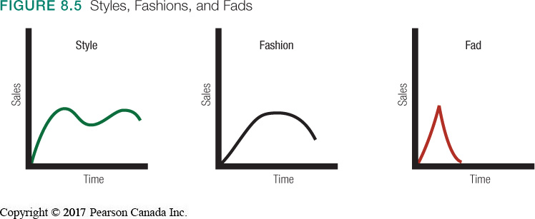

SERVICES MARKETING

Product and service decisions:
The important decisions in the development and marketing of individual products are product and service attributes, packaging and labelling, product line decisions, and product support decisions.
-Product and service attributes: quality, features, and style and design.
-Packaging and labelling: protection, communicated important information, sustainable packaging,
-Product line decisions: product line length, product line stretching.
-Product mix: product mix depth and consistency.

-The service sector is the single most important industry in Canada’s economy.

Service intangibility: A major characteristic of services, they cannot be seen, tasted, felt, heard, or smelled before they are bought.

Service inseparability: A major characteristic of services, they are produced and consumed at the same time and cannot be separated from their providers.

Service variability: major characteristic of services, their quality may vary greatly, depending on who provides them and when, where, and how.

Service perishability: major characteristic of services, they cannot be stored for later sale or use.

MARKETING STRATEGIES FOR SERVICE FIRMS

Service-profit chain: The chain that links service firm profits with employee and customer satisfaction.
Internal marketing: Orienting and motivating customer contact employees and supporting service people to work as a team to provide customer satisfaction.

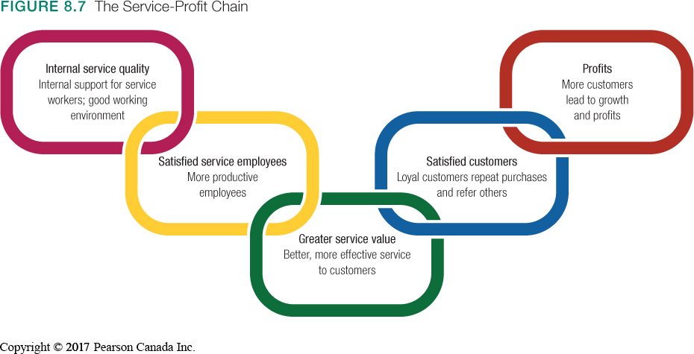

Chapter 9

What is a brand?
A name, symbol, icon, design, or a combination of these, that identifies the maker or marketer of a product.

BRAND CHARACTERISTICS

Logos: designed to represent the brand, and that may or may not incorporate the brand name.

Brand personality: The sum total of all the attributes of a brand and the emotions it inspires in the minds of consumers.

Brand equity: The dollar amount attributed to the value of the brand, based on all the intangible qualities that create that value.

Brand positioning: importance of segmenting the market and positioning a product in the marketplace. Brands can be positioned based on product attributes. Associate brand with a particular benefit. The strongest brands are positioned on strong beliefs and values.

National brand: A brand created and owned by the manufacturer of the product.

Private brand (store brands and private labels): Brand names applied by the marketer to products manufactured for them under contract.

Licensing: The buying and selling of the rights to use a brand name or logo, character, icon, or image.

Co-branding: The practice of using the established brand names of two different companies on the same product.

Line extensions: Extending an existing brand name to new forms, colours, sizes, ingredients, or flavours of an existing product category.

Brand extensions: Extending an existing brand name to new product categories.

Multibranding: A brand development strategy in which the same manufacturer produces many different brands in the same product category.

Touchpoints: Advertising, marketing communications, personal experience with the brand, word of mouth, social media, company and brand websites, store displays and anything else that brings a consumer into contact with a brand.

Brand characters: Lifelike icons, or mascots, that can move speak, and interact, and that have personality traits.

Brand engagement: The interaction between consumers and brands, based on the emotional connection consumers feel toward the brand.

Brand ambassador: A real person who, under contract with the brand’s marketing organization, acts as a spokesperson for the brand.

Brand advocates: Customers, employees, and others who willingly and voluntarily promote their favourite brands.

CHAPTER 10:

What is a price?
The amount of money charged for a product or a service, or the sum of the values that customers exchange for the benefits of having or using the product or service.
-Price is the major factor affecting buyer choice.
-Only element in the marketing mix that produces revenue

Major pricing strategies

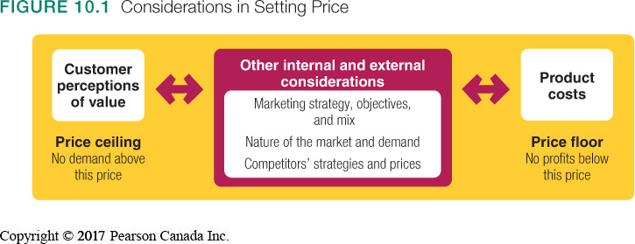

Three major pricing strategies: Customer value-based pricing, Cost-based pricing and Competition-based pricing.

Customer value-based pricing: Setting price based on buyers’ perceptions of value rather than on the seller’s cost.
-Value-based pricing means that the marketer cannot design a product and marketing program and then set the price. Price is considered along with the other marketing mix variables before the marketing program is set.

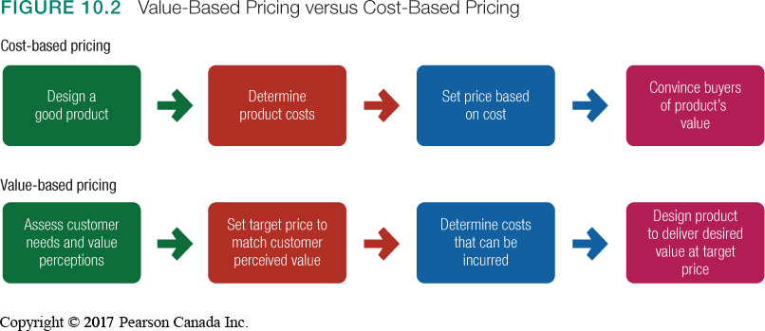

Cost-based pricing: Usually product driven. The company designs what it considers to be a good product, adds up the costs of making the product and sets a price that covers costs plus a target profit.
-Marketing must convince buyers that the products value at that price justifies the purchase.

Value-based pricing: Company first assesses customer needs and value perceptions. It then sets its target price based on costumer’s perceptions of value. Pricing begins with analyzing consumer needs and value perceptions, and price is set to match consumers perceived value.

Good-value pricing: Offering just the right combination of quality and good service at a fair price.
-EX: Ryanair flights.
-Everyday low pricing (EDLP) => Charging a constant everyday low price with few or no temporary price discounts.
-High-low pricing => Running frequent promotions to lower prices temporarily on selected items

Value-added pricing: Attaching value-added features and services to differentiate a company’s offers and charging higher prices.
-EX: movie theatres with gourmet food and drink services.

Types of costs
-A company’s costs take two forms: fixed and variable.

Fixed costs: Costs that do not vary with production or sales level. EX: Rent

Variable costs: Costs that vary directly with the level of production. Ex: Apple tablets, this is varied because it varies with the number of units produced.

Total costs: The sum of the fixed and variable costs for any given level of production.

Cost-plus pricing (or mark-up pricing): Adding a standard mark-up to the cost of the product. Ex: An electronic retailer might pay a manufacturer $20 for a cable and mark it up to sell for $30.

Break-even pricing (or target return pricing): Setting price to break even on the costs of making and marketing a product, or setting price to make a target return.
-When total revenue=total costs

Competition-based pricing: Setting prices based on competitors’ strategies, prices, costs, and market offerings. Consumers will base their judgments of a product’s value on the prices that competitors charge for similar products.

What factors should be considered when setting prices?
Internal factors:
-Marketing strategy
-Marketing mix
-Costs
-Organizational consideration

External factors:
-The market and demand
-Competition
-Other environmental elements

Target costing: Pricing that starts with an ideal selling price, and then targets costs that will ensure that the price is met.
-The best strategy is not to charge the lowest price but rather to differentiate the marketing offer to make it wort a higher price.

Who should set prices?
-In large companies: Pricing departments
-In small companies: Top management

How do prices vary in different types of market?

-Pure competition: Many buyers and sellers trading in a uniform commodity. Marketing strategy plays no role

-Monopolistic competition: Many buyers and sellers trading over a range of prices. KEY: Differentiated offers. Marketing matters

-Oligopolistic competition: few sellers highly sensitive to each other’s pricing and marketing strategies.

Price elasticity: A measure of the sensitivity of demand to changes in price.

Market-skimming pricing (or price skimming): Setting a high price for a new product to skim maximum revenues layer by layer from the segments willing to pay the high price; the company makes fewer but more profitable sales. Ex: when Apple introduces a new iphone.

Market-penetration pricing: Setting a low price for a new product in order to attract a large number of buyers and a large market share. Ex: IKEA

Product mix pricing

Product line pricing: Setting the price steps between various products in a product line based on cost differences between the products, customer evaluations of different features, and competitors’ prices.

Optional-product pricing: The pricing of optional or accessory products along with a main product.

Captive-product pricing: Setting a price for products that must be used along with a main product, such as blades for a razor and games for a video-game console.

By-product pricing: Setting a price for by-products to make the main product’s price more competitive.

Product bundle pricing: Combining several products and offering the bundle at a reduced price.

