Thermochemistry Lab

By Raeann Stambulic
300002183
and
Kaitlyn Prophet
300001949

CHM1311 Section E5

TA:
Mosammat Khan

September 30th, 2017

Department of Chemistry
University of Ottawa

Introduction:
Calorimetry is the science behind determining the changes in energy in a system by measuring its surroundings. By using a basic calorimeter, a researcher can determine key variables in solving the formula:
Q_{surr}= mCΔT
The researchers of the team chose to use the salt NH₄Cl. This was to keep the drink as cheap as possible for both the company to produce this product, and the consumer to purchase the drink.
The design chosen was, an aluminum can inside a calorimeter with 100mL of water in it, as well as another 100mL on the outside of the can within the calorimeter. This design was chosen in order to keep the 100mL of water within the can safe to drink, as you could not put the NH₄Cl in the can because it is not safe for human consumption, however, it is still a necessary component of the drink, as it helps cool the drinkable water.
References: Experiment 2: Background Theory in Thermochemistry

Purpose:
The purpose of this experiment was to determine the exact amount of salt required to lower the initial temperature of 100cm³ of H₂O by 5 degrees Celsius using calorimetry.

Materials:
- Calorimeter
- Thermometer
- Soda can
- Water
- Either NH₄Cl or NH₄NO₃
- Graduated Cylinder
- Grams Weigh Scale

Safety Precautions:
- Chemicals are being used so know each background, check the msds
- Safety glasses and lab coat must be worn always while in laboratory
- Chemicals must be disposed of properly within their respective waste containers

Procedure:
- Place 100g of water within the can, and 100g of water in the calorimeter. At this point, place the can inside the calorimeter and proceed to measure the initial temperature of the system.
  - Be careful to not touch the can, calorimeter, or the thermometer to much as it can affect your initial measurement of the temperature, biasing your final results.
- Next, measure out your first amount of your chosen salt and stir it into the 100g of water on the outside of the can. This is to keep the water inside the can safe to consume.
  - Once again take care not to over stir the salt into the water as it adds energy to the system and will slightly bias you results.
- After the salt has been completely dissolved in the solvent, the lid should be placed on the calorimeter and a timer should be set for 5 minutes.
- Once the time is over, take the reading of the final temperature, and calculate the change in temperature.
  - If the temperature change was above 5 degrees then the amount of salt used should be decreased, if the change in temperature is below 5 degrees then the salt should be increased for the next trial.
- Repeat steps one through four until desired amount of trials is accumulated or desired temperature change has been found.

Collected Data:
Mass NH₄Cl (grams) | Initial Temperature (°C) | Final Temperature (°C) | Temperature Change (°C)
11.1 | 22.9 | 19.8 | 3.1
12.0 | 22.9 | 19.2 | 3.7
13.0 | 22.9 | 18.4 | 4.5
14.0 | 22.9 | 18.2 | 4.8
15.0 | 22.9 | 17.8 | 5.1
16.0 | 22.9 | 17.6 | 5.3
Note: For trial 3, measuring the change in temperature of 100g of H₂O using 13.0 grams of NH₄Cl in a separate 100g of H₂O, the percent error of the measurement of the H₂O is slightly higher than the rest of the trials due to the precision at which it was measured. This trials water was measured using a scale, while the others were measured with a graduated cylinder.

Calculations:

ΔT = T₂ – T₁
ΔT = 22.9°C – 19.8°C
ΔT = 3.1°C

Q = mCΔT
Q = 200g (4.18)(-5)
Q = -4.800kJ

n = 9/ΔH ΔH = 17kJ/mol *calculated in prelab*
n = -4.800kJ/17kJ/mol
n = 0.282
n = 0.282 x M
n = 0.282mol x 53.5g
n = 15.106g
Observations:
During this experiment the things that were observed were that the more salt that was added to the outside amount of water, the more the inner water was cooled before the temperature plateaued. The speed at which the inner water cooled was also observed, to initially be fast but slows down over time, as well as, when a higher mass of salt was added, the temperature change was more drastic in the beginning compared to when there was a smaller mass of salt added.

Graph:
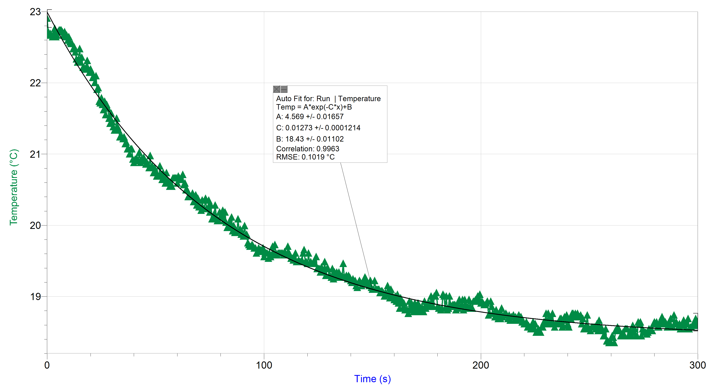

Discussion:
From this experiment, the researcher could conclude that the optimal mass of salt added to 100mL of H₂O is approximately 15g of NH₄Cl in order to cool 100mL of water by 5°C in 5 minutes. From the collected data it was also seen that more than 15g of the salt resulted in over-cooling of the drink, while less than 15g of the salt caused the drink to not be cooled enough. The design of the calorimeter paired with an aluminum can worked well, as it successfully kept the water with NH₄Cl separate from the drinking water, while sufficiently providing an accurate reading of temperature since it allowed little to no outside factors to effect it.
The impact of this design is that it was able to successfully cool 100mL of water with approximately 15g of NH₄Cl by 5°C, which is the ideal temperature change, as it won’t freeze the consumers mouth but it is still able to cool them down easily. As well as not contaminant the drinking water with a salt that could potentially harm the consumer.
This experiment could have been improved by cutting the height of the can shorter, so that the lid of the calorimeter could sit perfectly flush on the calorimeter. This would help to reduce any escape of energy from the system. The experiment could have also been improved by stirring the salt into the water less vigorously, as it would have added energy to the water, causing a small increase in temperature.
The calculated mass of the salt needed to lower the system by 5°C was 15.106g. Although in trial the mass of the salt was found to be slightly lower than this value, landing somewhere between 14.5g to 15g.

Conclusion:
It was found that the ideal mass of NH₄Cl in 100mL of H₂O was approximately 15g used in the system to cool the water by 5°C. This mass was found in both the initial calculations as well as the experimental data collected in the experiment. By using a calorimeter, it was easy to get accurate results with minimal room for error.



