ECO1102 – Chapter 8 Notes
The Cost of Living
- In the real world, prices change at different speeds across time and place
  - This means, that at any given time wages might be rising more slowly than the price of consumer goods

Measuring Price Changes over Time
- Market basket method used to compare prices over time and locations
- Used to track changes in the cost of living
- Market basket – a list of specific goods and services in fixed quantities that roughly correspond to a typical consumers spending. The goal is to see how the cost of buying the goods and services on the list changes over time.
- By keeping the goods and the quantities constant, we can be sure that any change in the total cost of the basket is caused by changes in price, rather than the type or amount being consumed.
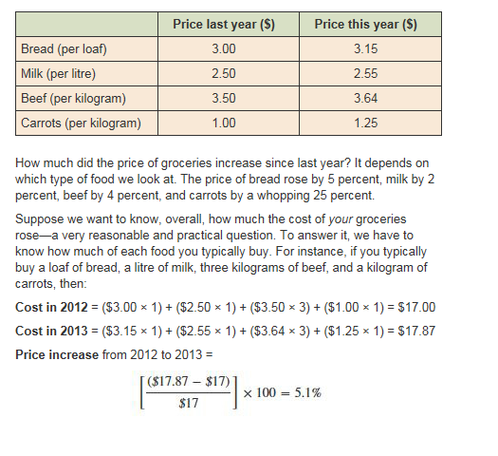

Consumer Price Index
- Price index is used to summarize the changes in the cost of living
- Price index – a measure showing how much of the cost of a market has risen or fallen relative to the cost in a base period or location
- Consumer price index – a measure that tracks changes in the cost of a basket of goods and services purchased by a typical Canadian household as calculated by Statistics Canada.
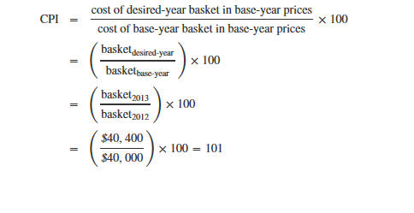

The Challenges in Measuring Price Changes
- CPI is based on an average of the goods and services purchased by urban consumers – anyone living in a city of 100,000 or more.
- Two main reasons for changes in consumption patterns over time:
  - Substitution
    - The idea that people switch between similar goods and services when relative prices shift
  - Innovation
    - As new goods and services become available, people change what they consume

Using Price Indexes
- Many economic variables give an incomplete picture when expressed in nominal terms—that is, without accounting for price differences. To solve this problem, we can use price indexes to turn nominal variables into real ones. With price indexes, we can isolate changes in prices from changes in fundamentals like income and output and express those changes in constant dollars relative to a base year.
- Inflation rate – the size of the change in the overall price le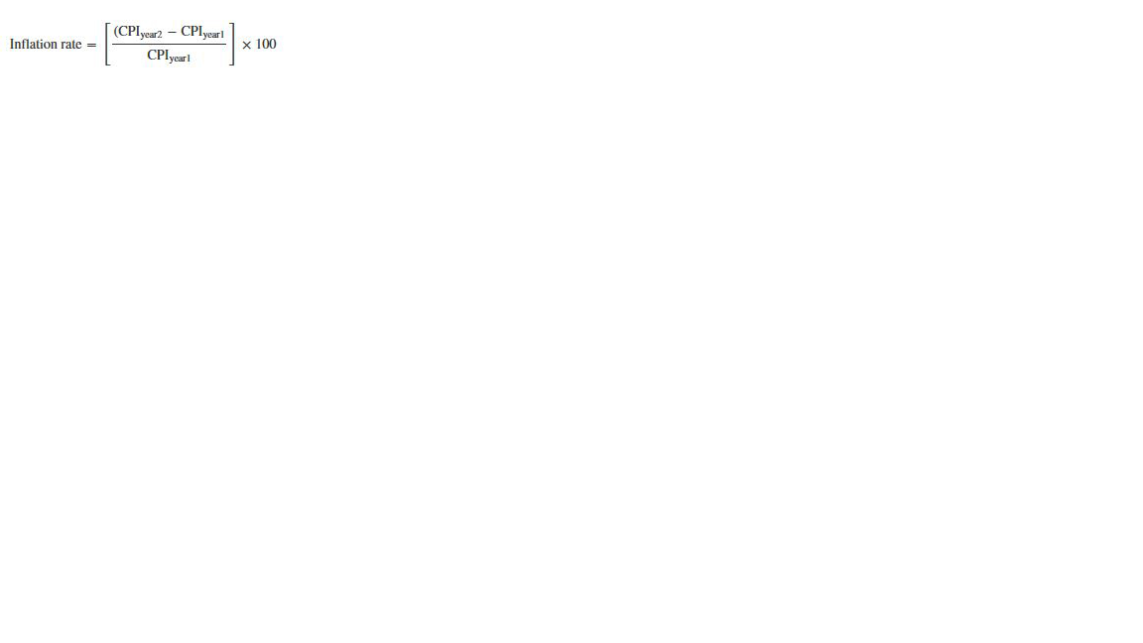
- All-items inflation – measure the changes in the prices for the entire market basket of the average urban consumer, another term for inflation measured using the CPI
- Core inflation – measures price changes using eight of the most volatile components (mostly related to energy and food) taken out of the basket
- Compared to many goods, energy and food prices go up and down a lot. Because they might be very high or very low at the time the CPI is calculated, including them might over- or understate the real change in overall prices. On the other hand, most Canadians spend a large part of their income on food and gas. Any basket that does not include these goods is missing a large part of the cost-of-living picture. Looking at both all-items and core inflation can give us a more accurate sense of what’s really happening in the economy.
- The difference between the all-items and core measurements suggests a more general idea: we can measure inflation using any basket of goods or price index we want. The resulting measures of inflation will reflect changes in the prices of different sets of goods. The CPI focuses on prices paid by consumers.
- Producer Price Index (PPI) - measures the prices of goods and services purchased by firms. The PPI includes things that are not part of the typical person’s consumption basket, such as industrial machinery. Because increases in input prices eventually make it to consumers when they buy the final product, the PPI is considered a good predictor of future consumer prices. Regardless of the index we use, inflation is measured as a percent increase in the index from one year to the next.
- GDP deflator - measures price changes for everything produced in the country. It doesn’t, however, include goods produced abroad that might have a real effect on the typical household’s cost of living, such as imported food items. Another key difference is that the GDP deflator is computed using the actual quantities that are produced in the economy each year, rather than using a fixed basket of goods.

Deflating Nominal Variables
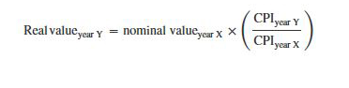

Adjusting for Inflation: Indexing
- One fundamental theory in macroeconomics says that, with enough time, wages should naturally rise to offset the effects of inflation, so in the end inflation should not matter to people’s well-being and their choices

Accounting for Price Differences across Places
Purchasing Power Parity (PPP)
- PPP – the theory that price levels in difference countries should be the same when stated in a common currency
  - Transaction costs
    - One reason that PPP doesn’t hold is transportation costs. It costs money to move goods from place to place. However, the difference in PPP is usually larger than what would be explained by transport costs alone. There are other transaction costs; for example, it costs time and money to find sellers in another country. If the price difference is small and the costs of making transactions in another country are high, the trade-off involved may not be worth it, and those entrepreneurs will decide not to bring cheap jeans in from Mexico
  - Non-tradables
    - Some goods and services just can’t be taken from place to place very easily, or at all. For instance, you can’t buy an apartment in Iowa City and transport it to Manhattan. You can’t buy a pizza in Italy and transport it to North Dakota. (Well, you could, but it wouldn’t be worth eating when you got it there.)
  - Trade restrictions
    - Finally, international trade isn’t free. There are often tariffs and trade restrictions that increase the cost or difficulty of making exchanges across national borders. Such restrictions discourage people from fully taking advantage of lower prices in other countries.

Purchasing Power Indexes (PPI)
- Describes differences in prices across locations
- First, we need to find a market basket of goods and services that we can compare across countries.
- Next, we measure the price of the goods in the basket in each country, and calculate the overall cost of purchasing it in each country.
- Then, we build an index showing how much the basket costs in each country relative to some base

PPP-Adjustment
- PPP-Adjustment involves recalculating economic statistics to account for differences in price levels across countries. We are calculating PPP-adjusted variables.


