Organizational Behaviour and Theory – COMM 222
Chapter 1
What Is Organizational Behaviour (OB)?
- The attitudes and behaviours of individuals and groups in organizations.
- How organizations can be structured more effectively.
- How events in the external environment affect organizations (What events? What external?)
What are organizations?
- Organizations are social inventions for accomplishing common goals through group effort.
- Key characteristics of organizations:
  - Social inventions
  - Goal accomplishment
  - Group effort
Why Study Organizational Behaviour?
  - Is Interesting. It is about people and human nature, and explains the success and failure of organizations (we all members of organization).
  - Is Important. It has a profound impact on managers, employees, clients and consumers.
  - Makes a difference. It affects individuals’ attitudes and behaviour as well as the competitiveness and effectiveness of organizations.
Goals of Organizational Behaviour
- The field of organizational behaviour has three commonly agreed-upon goals:
  - Predicting organizational behaviour and events.
  - Explaining organizational behaviour and events in organizations.
  - Managing organizational behaviour.
What is management?
- The art of getting things accomplished in organizations through others.
- Managers acquire, allocate, and utilize physical and human resources to accomplish goals.
- If behaviour can be predicted and explained, it can often be managed.
- Prediction and explanation involves analysis while management is about action.
- Effective management involves evidence-based management.
What is evidence-based management?
- Involves translating principles based on the best scientific evidence into organizational practices.
- Making decisions based on the best available scientific evidence from social science and organizational research rather than personal preference and unsystematic experience.
- The use of evidence-based management is more likely to result in the attainment of organizational goals.
Historical Milestones I
Early 1900s
- Classical viewpoint: high specialization of labor , intensive coordination, centralized decision making.
- Scientific management: introduction of research to determine the optimal degree of specialization and standardization.
- Bureaucracy (Weber): strict chain of command, detailed rules, high specialization, centralized power; ‘ideal type of organization’
- Key words: Control and Coordination
Historical Milestones II
- Hawthorn studies: psychological and social processes on productivity
- Human relations movement (after WWII); people oriented style of management; addressing social and psychological needs of employees.
- Key words: flexibility and adaptability
Contingency
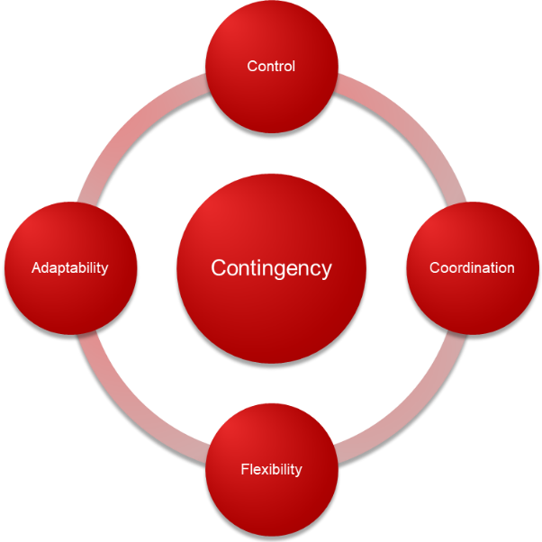
Contemporary: Contingency
Four issues with which organizations and managers are currently concerned:
  - Diversity – Local and Global
  - A Positive Work Environment and Employee Well-Being
  - Talent Management and Employee Engagement
  - Corporate Social Responsibility (CSR)

Chapter 2
Part I. Personality
What Is Personality?
- The relatively stable set of psychological characteristics that influences the way an individual interacts with his or her environment and how he or she feels, thinks, and behaves.
- Dimensions and traits that are determined by genetic predisposition and one’s long-term learning history.
- People have a variety of personality characteristics.
Personality and Organizational Behaviour
- Personality has a long history in organizational behaviour.
- The role of personality in organizational behaviour has often been debated in what is known as the “person-situation debate”
- This has led to three approaches:
  - The dispositional approach
  - The situational approach
  - The interactionist approach
I. The Dispositional Approach
- Focuses on individual dispositions and personality.
- Individuals possess stable traits or characteristics that influence their attitudes and behaviours.
- Individuals are predisposed to behave in certain ways.
II. The Situational Approach
- Characteristics of the organizational setting such as rewards and punishment influence people’s feelings, attitudes and behaviour.
- Many studies have shown that job satisfaction and other work-related attitudes are largely determined by situational factors such as the characteristics of work tasks (Examples please).
III. The Interactionist Approach
- Organizational behaviour (individuals’ attitudes and behaviour) is a function of both dispositions and the situation.
- To predict and understand organizational behaviour, we need to know something about an individual’s personality and the work setting.
- The interactionist approach is the most widely accepted perspective within organizational behaviour.
Personality and the Situation
- Situations can be described as being either “weak” or “strong”.
- In strong situations, roles are defined, personality tends to have less impact.
- In weak situations, roles are loosely defined, there are few rules and weak reinforcement and punishment contingencies.
- Personality has the strongest effect in weak situations.
Trait Activation Theory
- Traits lead to certain behaviours only when the situation makes the need for the trait salient.
- Personality influences people’s behaviour when the situation calls for a personality characteristic.
Implications of the Interactionist Approach
- Some personality characteristics are useful in certain organizational situations.
- There is no one best personality.
- Managers need to appreciate the advantages of employee diversity.
- The importance of fit - putting the right person in the right job, group, or organization.

The Five-Factor Model of Personality
Five basic but general dimensions that describe personality:
  - Extraversion
  - Emotional stability/neuroticism
  - Agreeableness
  - Conscientiousness
  - Openness to experience
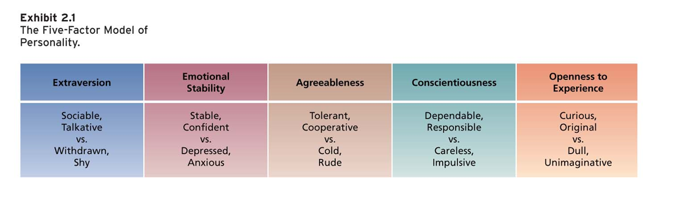
I. Extraversion and OB
- Important for jobs that require interpersonal interaction and where being sociable, assertive, energetic, and ambitious is important for success (examples please).
II. Emotional stability/neuroticism and OB
- Persons high on emotional stability will have more effective interactions with co-workers and customers as they tend to be more clam and secure (examples please).
III. Agreeableness and OB
- Contributes to job performance in jobs that require interaction and involve helping, cooperating, and nurturing others as well as in jobs that involve teamwork and cooperation (examples please).
IV. Conscientiousness and OB
- Important for job performance on most jobs given the tendency towards hard work, achievement, self-discipline (examples please).
V. Openness to Experience and OB
- Important for jobs that involve learning, creativity and innovation given the tendency to be intellectual, curious, and imaginative and have broad interests (examples please).

The Five-Factor Model of Personality: Research
- Each of the “Big Five” dimensions are related to job performance and organizational citizenship behaviours.
- Best predictors of job performance depends on the occupation.
- Conscientiousness is the strongest predictor of overall job performance across all occupations.
- The “Big Five” are related to work motivation, job satisfaction, and life satisfaction.
- The “Big Five” are also related to job search and career success.
- The effects of personality on career success are relatively enduring.

- Locus of Control
- A set of beliefs about whether one’s behaviour is controlled mainly by internal or external factors.
- Internals believe that the opportunity to control their own behaviour resides within themselves.
- Externals believe that external forces determine their behaviour.
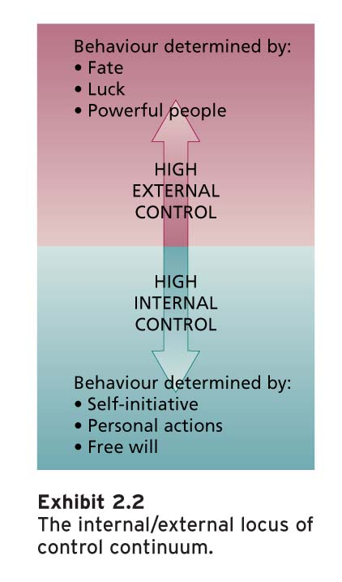
Locus of Control: Research
- Internals are more satisfied with their jobs, more committed to their organization, earn more money, and achieve higher organizational positions.
- Internals perceive less stress, cope with stress better and experience less burnout, and engage in more careful career planning.
- Internals are less likely to be absent from work and are more satisfied with their lives.

- Self-Monitoring
- The extent to which people observe and regulate how they appear and behave in social settings and relationships.
- High self-monitors take great care to observe and control the images that they project.
- High self-monitors show concern for socially appropriate emotions and behaviours, and tune into social and interpersonal cues; they regulate their behaviour and self-presentation according to these cues.
Self-Monitoring: Research
- High self-monitors gravitate to jobs that require role-playing and the use of their self-presentation skills.
- High self-monitors are more involved in their jobs, perform better, and are more likely to emerge as leaders.
- High self-monitors experience more role stress and show less commitment to their organization.
- High self-monitors are more likely to change employers and locations and to receive more promotions.
- High self-monitors are not comfortable in ambiguous social settings in which it is hard to determine what behaviours are socially appropriate.
- Dealing with Unfamiliar Cultures Might Provoke Stress.

(Additional Concepts Related to Personality…)
- Self-Esteem
- The degree to which a person has a positive self-evaluation.
- People with high and low self-esteem have favourable and unfavourable self-images respectively.
Self-Esteem and Behavioural Plasticity Theory
- Plasticity; Bendability;
- People with low self-esteem tend to be more susceptible to external and social influences than those who have high self-esteem.
- Events and people in organizations have more impact on the beliefs and actions of employees with low self-esteem.

- Positive and Negative Affectivity; Emotional Dispositions
Positive:
Experience positive emotions and moods; joy, excitement and view the worlds , including themselves sand other people, in a positive light.
Negative:
Experience negative emotions and moods like fear and anxiety, view the world in a negative light. Negative view of themselves.
Job satisfaction; Performance; Citizenship behavior; Creativity; Success

- Proactive Personality
- Taking initiative
- Challenging the status quo
- Tendency to take personal initiative across a range of activities and situations and to affect positive change in one’s environment
Job satisfaction; Performance; Citizenship behavior; Creativity; Success; Tolerance for Stress; Leadership Effectiveness… (and more)

- General self-efficacy
- A general trait the refers to an individual’s belief in his or her ability to perform successfully in a variety of challenging situations.
- Not affective but motivational trait.
1) I can always manage to solve difficult problems if I try hard enough.
2) It is easy for me to stick to my aims and accomplish my goals.
3) I am confident that I could deal efficiently with unexpected events.
Adaptation to new situations, job satisfaction, job performance.

- Core self-evaluations
Broad personality concept that consists four traits that make up a person’s core self evaluation:
- Self-esteem
- General self-efficacy
- Locus of control
- Neuroticism (emotional stability)
Job satisfaction, organizational commitment, job performance, life satisfaction, less stress.

Part II .Learning
What is Learning?
- Learning occurs when practice or experience leads to a relatively permanent change in behaviour potential (Examples)
- The practice or experience that prompts learning stems from an environment that provides feedback concerning the consequences of behaviour.

4 Things That Employees Learn; The Bottom Line
I. Practical skills:
  - Job-specific skills, knowledge, technical competence.
II. Intrapersonal skills:
  - Problem solving, critical thinking, alternative work processes, risk taking.
III. Interpersonal skills:
  - Interactive skills such as communicating, teamwork, conflict resolution.
IV. Cultural awareness:
  - The social norms of organizations, company goals, business operations, expectations, and priorities.

How Do People Learn?
Two theories that describe how people in organizations learn:
  - Operant learning theory
  - Social cognitive theory
I. Operant Learning Theory
- Learning in which the subject learns to operate in the environment to achieve certain consequences.
- Operantly learned behaviour is controlled by the consequences that follow it.
- It is the connection between the behaviour and the consequence that is learned.
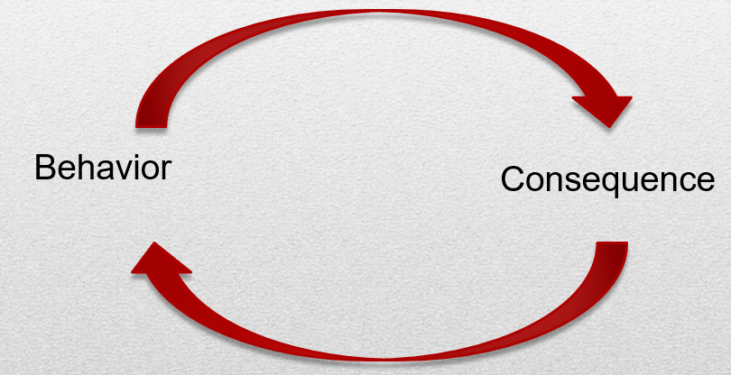
Operant learning can be used to increase the probability of desired behaviours and to reduce or eliminate the probability of undesirable behaviours.

Increasing the Probability of Behavior; +Ve and –Ve Reinforcement
I want Peter to sell more..
Positive reinforcement:
Commission
Negative reinforcement:
Criticism
Remember: both increase desired behavior

Increasing the Probability of Behaviour
- One of the most important consequences that influences behaviour is reinforcement.
- Reinforcement is the process by which stimuli strengthen behaviours.
- A reinforcer is a stimulus that follows some behaviour and increases or maintains the probability of that behaviour.
- Positive reinforcers work by their application to a situation.
- Negative reinforcers work by their removal from a situation.
- Remember that both increase behaviour
Positive
- The application or addition of a stimulus that increases or maintains the probability of some behaviour.
- The stimulus is the positive reinforcer.
- The reinforcer is dependent or contingent on the occurrence of some desired behaviour.
- Whether or not something is a positive reinforcer depends on whether it increases or maintains the occurrence of some behaviour by its application.
Negative
- The removal of a stimulus from a situation that increases or maintains the probability of some behaviour.
- Negative reinforcement occurs when a response prevents some event or stimulus from occurring.
- The removed or prevented stimulus is a negative reinforcer.
- Negative reinforcers are defined by what they do and how they work, not by their unpleasantness.

Organizational Errors Involving Reinforcement
- Rewards fail to serve as reinforcers when they are not made contingent on some specific desired behaviours (e.g. overtime).
- Organizations often fail to appreciate individual differences in preferences for reinforcers.
- Managers should consider the stimuli under their control for their applicability as reinforcers for particular employees.
- Managers often neglect important sources of reinforcement such as those administered by co-workers or intrinsic to the job.
- Two important sources of reinforcement that managers often ignore are:
  - Performance feedback
  - Social recognition
Note:
Confusing Rewards with Reinforcers. Rewards can fail to serve as reinforcers when they are not made contingent on specific behaviours that are of interest to the organization. Rewards that are not contingent on specific behaviours which an organization wishes to encourage may fail to serve as reinforcers.
Rewards fail to serve as reinforcers when they are not made contingent on some specific desired behaviour.
Neglecting Diversity in Preferences for Reinforcers. Organizations tend to neglect diversity and individual differences in preferences for reinforcers. Thus, even rewards that are made contingent on behaviour may fail to have a reinforcing effect. Managers need to consider the possible range of stimuli under their control for their applicability as reinforcers for particular individuals.
Managers often neglect important sources of reinforcement such as those administered by co-workers or intrinsic to the job.
Neglecting Important Sources of Reinforcement. While concentrating on potential reinforcers of a formal nature, such as pay or promotions, managers often neglect those which are administered by co-workers or intrinsic to the jobs being performed. One important source of reinforcement that managers often ignore is information that accompanies the successful performance of tasks: feedback and recognition.

Reinforcement Strategies (what is the best way?)
- Continuous: every time the behavior of interest occurs
- Short: immediately

- Partial: not all the behavior is reinforced
- Long: long delay
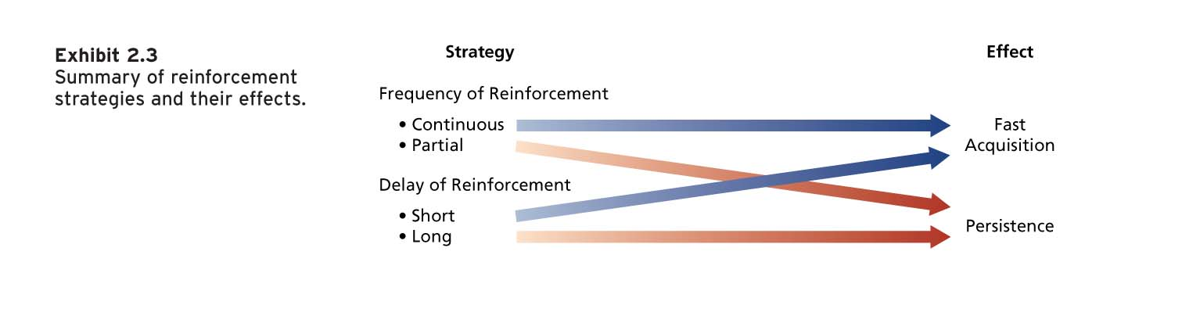
Reducing the Probability of Behaviour
Extinction
- The gradual dissipation of behaviour following the termination of reinforcement.
- If the behaviour is not reinforced, it will gradually dissipate or be extinguished.
- Extinction works best when coupled with the reinforcement of some desired substitute behaviour.
Punishment
- The application of an aversive stimulus following unwanted behaviour to decrease the probability of that behaviour.
- A nasty stimulus is applied after some undesirable behaviour in order to decrease the probability of that behaviour.
Summary of Learning Effects
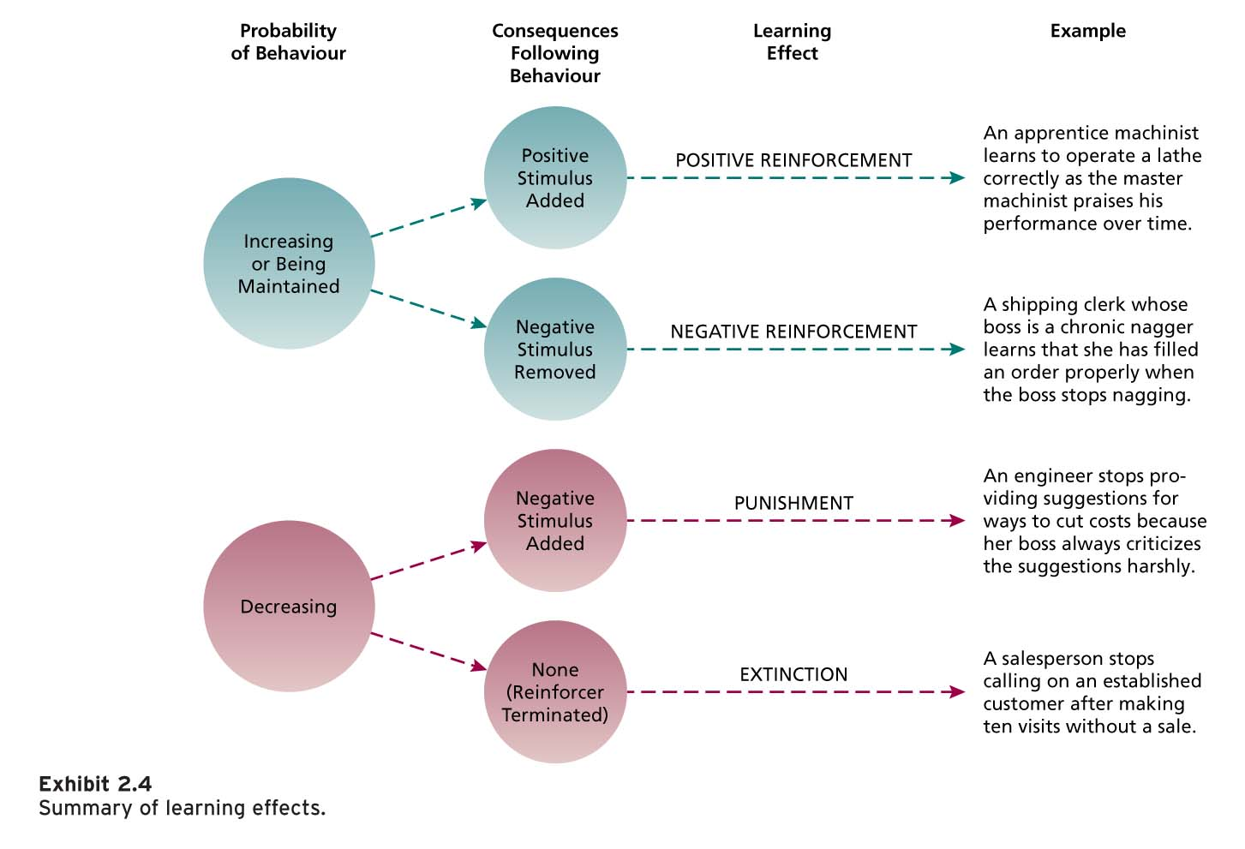
II. Social Cognitive Theory
- Social cognitive theory (SCT) emphasizes the role of cognitive processes in regulating people’s behaviour.
- People learn by observing the behaviour of others and can regulate their own behaviour by thinking about the consequences of their actions, setting performance goals, monitoring performance, and rewarding themselves for goal accomplishment.
Social Cognitive Theory
- Human behaviour can best be explained through a system of triadic reciprocal causation:
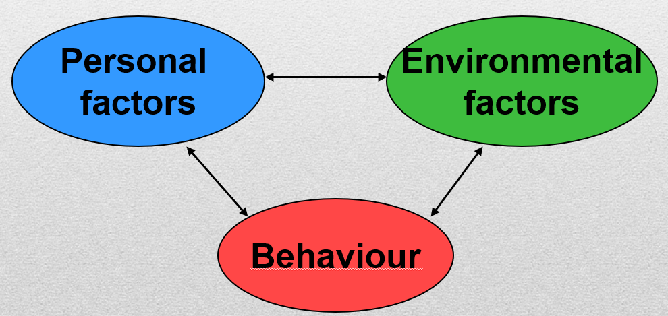
Human behaviour can best be explained through a system of triadic reciprocal causation in which personal factors and environmental factors work together and interact to influence people’s behaviour. In addition, people’s behaviour also influences personal factors and the environment.
1. Observational Learning
- The process of imitating the behaviour of others
- Involves self-reinforcement.
- Attractive, credible, competent, high-status people are most likely to be imitated.
- It is important that the model’s behaviour result in positive consequences and that it is vivid and memorable.
The process of imitating the behaviour of others:
- Examining the behaviour of others
- Seeing the consequences they experience
- Thinking about what might happen if we act the same way
- Imitating the behaviour if we expect favourable consequences

2. Self-Efficacy
Beliefs people have about their ability to successfully perform a specific task.
It is a cognitive belief that can be changed and modified in response to different sources of information.

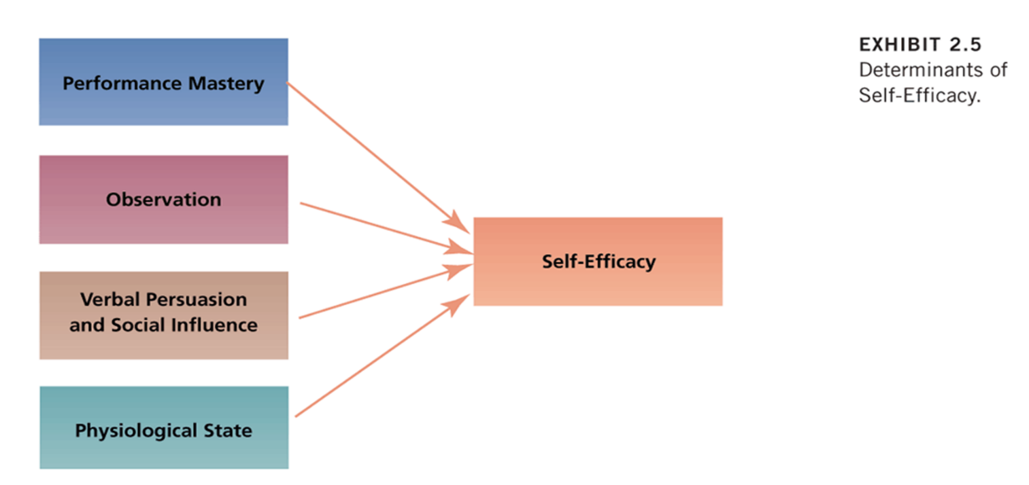
Self-efficacy influences the activities people choose to perform, the amount of effort and persistence devoted to a task, affective and stress reactions, and job performance.

3. Self-Regulation
- People’s pursuit of self-set goals that guide their behaviour.
- Discrepancy reduction & discrepancy production
- Self-regulation involves the following activities:
  - Collect self-observation data, Observe models, Set goals, Rehearse, Reinforce oneself
- When there exists a discrepancy between one’s goals and performance, individuals are motivated to modify their behaviour in the pursuit of goal attainment (a process known as discrepancy reduction).
- When individuals attain their goals, they are likely to set even higher and more challenging goals, a process known as discrepancy production.
- In this way, people continually engage in a process of setting goals in the pursuit of ever higher levels of performance. Thus, discrepancy reduction and discrepancy production lie at the heart of the self-regulatory process.
Research has found that self-regulation:
- Improves learning and result in a change in behaviour.
- Reduces absenteeism
- Improves sales performance insurance salespeople.
- Self-regulation programs have been successful in positively changing a variety of work behaviours and are an effective method of training and learning.

Chapter 3
What is perception?
- The process of interpreting the messages of our senses to provide order and meaning to the environment.
- People base their actions on the interpretation of reality that their perceptual system provides, rather than on reality itself.

Components of Perception
Perception has three components:
  - A perceiver
  - A target that is being perceived
  - Some situational context in which the perception is occurring
Each component influences the perceiver’s impression or interpretation of the target.
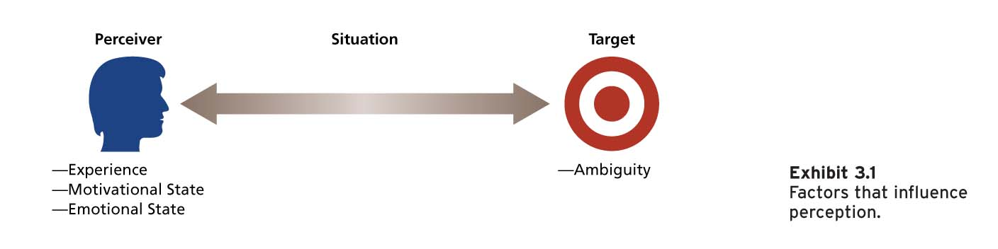
I. The Perceiver
- Past experiences lead the perceiver to develop expectations that affect current perceptions.
- Needs unconsciously influence perceptions by causing us to perceive what we wish to perceive.
- Emotions, such as anger, happiness, or fear, can influence our perceptions.

Perceptual Defence
- The tendency for the perceptual system to defend the perceiver against unpleasant emotions.
- People often “see what they want to see” and “hear what they want to hear.”
- Our perceptual system works to ensure we do not see or hear things that are threatening.
II. The Target
- Ambiguous targets are especially susceptible to interpretation and the addition of meaning.
- Perceivers have a need to resolve ambiguities.
- The perceiver does not or cannot use all the information provided by the target.
- A reduction in ambiguity might not be accompanied by greater accuracy.
III. The Situation
- Perception occurs in some situational context, and this context can affect what is perceived.
- The most important effect that the situation can have is to add information about the target.
- The perception of a target can change with the situation even when the perceiver and target remain the same.

Social Identity Theory
- People form perceptions of themselves based on their personal characteristics and memberships in social categories.
- Our sense of self is composed of a personal identity and a social identity.
- Personal identity is based on our unique personal characteristics (e.g., interests).
- Social identity is based on our perception that we belong to various social groups (e.g., gender).
- Personal and social identities help us answer the question: “Who am I?”
- We perceive ourselves and others as embodying the most typical attributes of a category or what are called “prototypes.”
- We also form perceptions of others based on their membership in social categories.
- Social identities are relational and comparative.
- People tend to perceive members of their own social categories in more positive and favourable ways.

Bruner’s Model of the Perceptual Process
How does the perceiver go about putting together the information contained in the target ?
- When the perceiver encounters an unfamiliar target, the perceiver is very open to the informational cues in the target and the situation.
- The perceiver will actively seek out cues to resolve ambiguity.
- As the perceiver encounters some familiar cues, a crude categorization of the target is made.
- The search for cues then becomes less open and more selective.
- The perceiver will search for cues that confirm the categorization of the target.
- As the categorization becomes stronger, the perceiver will ignore or even distort cues that violate initial perceptions.



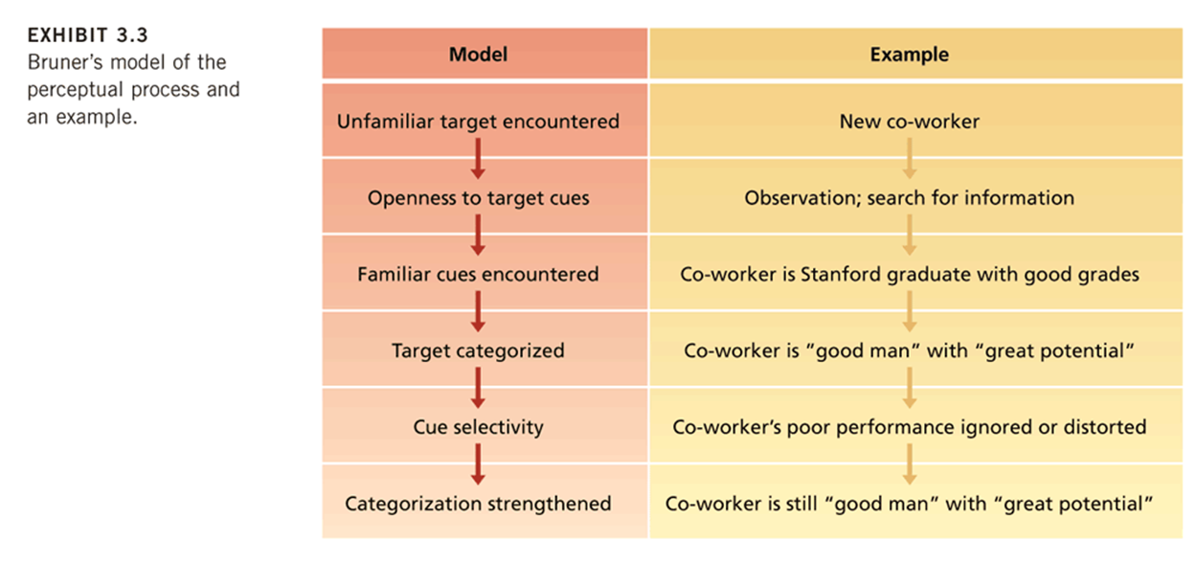

Characteristics of the Perceptual Process
Bruner’s model demonstrates three important characteristics of the perceptual process:
I. Perception is selective:
- Perceivers do not use all of the available cues, and those they do use are given special emphasis.
- Perception is efficient but this can aid and hinder perceptual accuracy.
II. Perceptual constancy:
- The tendency for the target to be perceived in the same way over time and across situations.
- The experience of “getting off on the wrong foot.”
III. Perceptual consistency:
- The tendency to select, ignore, and distort cues so that they fit together to form a homogenous picture of the target.
- We strive for consistency in our perception of people.

Basic Biases in Person Perception
The impressions we form of others are susceptible to a number of perceptual biases...
I. Primacy Effect
- The reliance on early cues or first impressions is known as the primacy effect.
- Primacy can have a lasting impact.
- Primacy is a form of selectivity and its lasting effects illustrate the operation of constancy.
- (Example please)
II. Recency Effect
- The tendency for a perceiver to rely on recent cues or last impressions is known as the recency effect.
- Last impressions count most.
III. Reliance on Central Traits
- People tend to organize their perceptions around central traits.
- Central traits are personal characteristics of a target person that are of particular interest to a perceiver.
- Central traits often have a very powerful influence on our perceptions of others.
- Physical appearance is a common central trait in work settings (attractiveness, height etc..)
IV. Implicit Personality Theories
- Personal theories that people have about which personality characteristics go together.
- Perhaps you expect hardworking people to also be honest, or people of average intelligence to be most friendly.
- If such implicit theories are inaccurate, they provide a basis for misunderstanding.
V. Projection
- The tendency for perceivers to attribute their own thoughts and feelings to others.
- In some cases, projection is an efficient and sensible perceptual strategy.
- Projection can lead to perceptual difficulties and can serve as a form of perceptual defence.
VI. Stereotyping
- The tendency to generalize about people in a social category and ignore variations among them.
- Categories on which people might base a stereotype include race, religion, age, gender, ethnic background, social class, and occupation.
- There are three specific aspects to stereotyping:
  - We distinguish some category of people.
  - We assume that the individuals in this category have certain traits.
  - We perceive that everyone in this category possesses these traits.
- People can evoke stereotypes with incredibly little information.
- Stereotypes help us develop impressions of ambiguous targets.
- Most stereotypes are inaccurate, especially when we use them to develop perceptions of specific individuals.
Why Do Stereotypes Persist?
- Several factors work to reinforce inaccurate stereotypes.
- Even incorrect stereotypes help us process information about others quickly and efficiently.
- Inaccurate stereotypes are often reinforced by selective perception.
Attribution: Perceiving Causes and Motives
- Attribution is the process by which we assign causes or motives to explain people’s behaviour.
- Rewards and punishments in organizations are based on judgments about what really caused a target person to behave in a certain way.
- An important goal is to determine whether some behaviour is caused by dispositional or situational factors.
Dispositional vs. Situational
Dispositional
- Dispositional attributions suggest that some personality or intellectual characteristic unique to the person is responsible for the behaviour.
- Intelligence, greed, friendliness, or laziness.
Situational
- Situational attributions suggest that the external situation or environment in which the target person exists was responsible for the behaviour.
- Bad weather, good luck, proper tools, or poor advice.

Attribution Cues
- We rely on external cues and make inferences from these cues when making attributions.
- Three implicit questions guide our decisions as to whether we should attribute some behaviour to dispositional or situational causes.
Three Attribution Questions
- Does the person engage in the behaviour regularly and consistently? (Consistency cues).
- Do most people engage in the behaviour, or is it unique to this person? (Consensus cues).
- Does the person engage in the behaviour in many situations, or is it distinctive to one situation? (Distinctiveness cues).
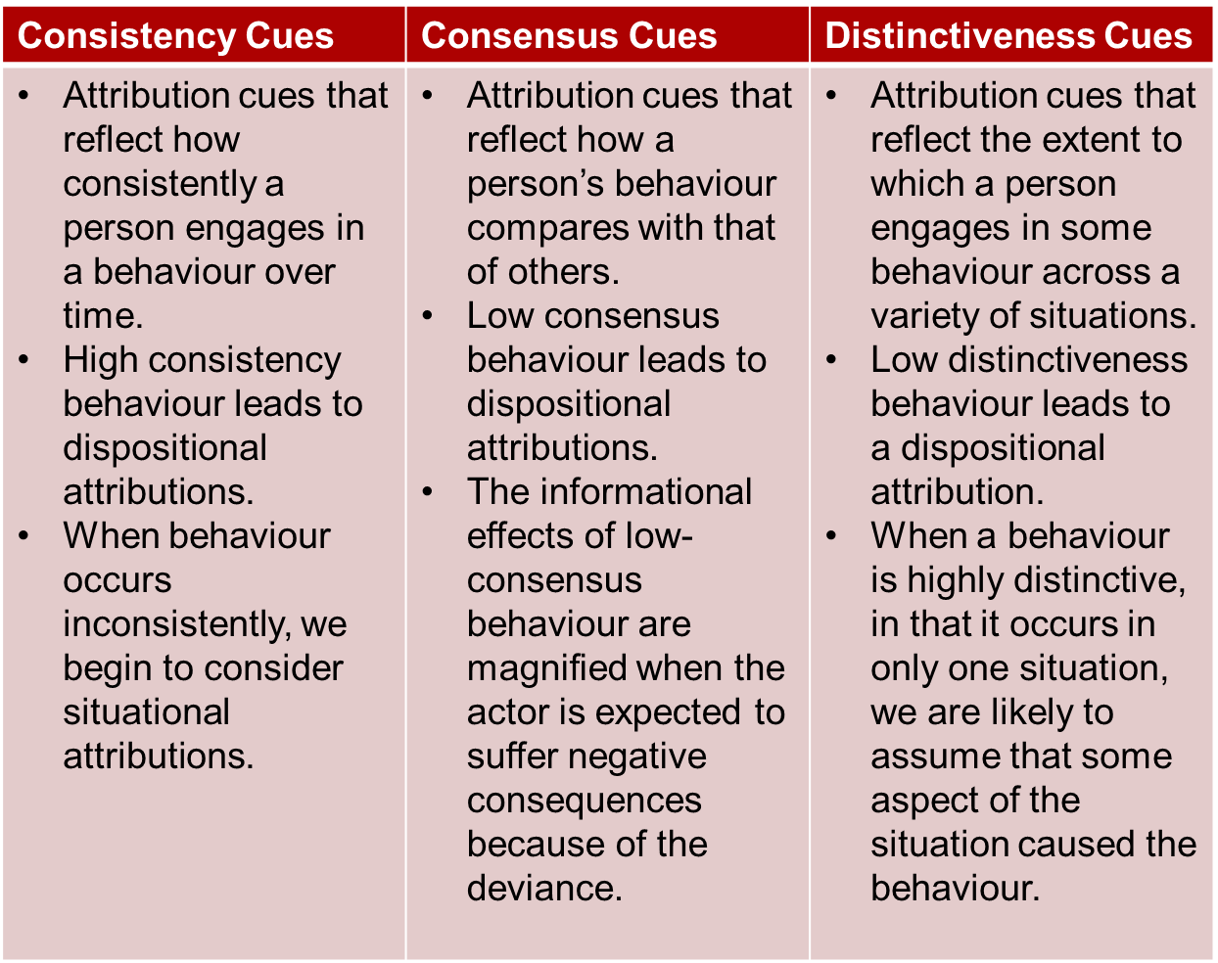
Attribution in Action
- Observers put information about consistency, consensus, and distinctiveness together to form attributions.
- Consider three employees who are absent from work.
- A manager must develop an attribution about the cause to decide which action is warranted.
- Roshani is absent a lot, her co-workers are seldom absent, and she was absent a lot in her previous job.
- Mika is absent a lot, her co-workers are also absent a lot, but she was almost never absent in her previous job.
- Sam is seldom absent, her co-workers are seldom absent, and she was seldom absent in her previous job.
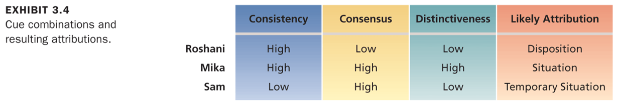
Biases in Attribution
Although observers often operate in a rational, logical manner in forming attributions about behaviour, this does not mean that such attributions are always correct.
Three biases in attribution:
  - Fundamental attribution error
  - Actor-observer effect
  - Self-serving bias
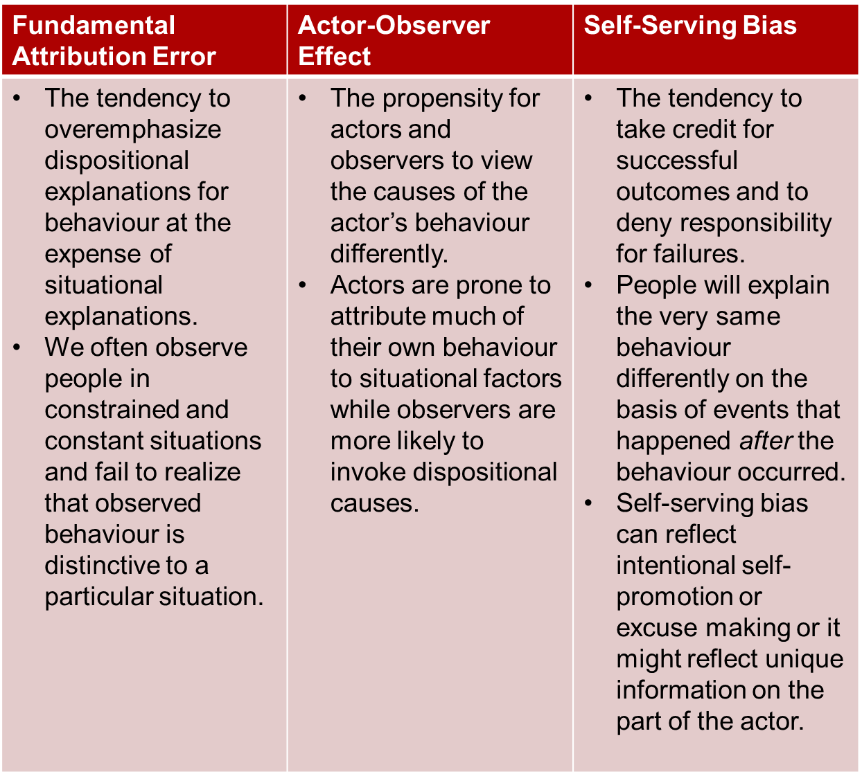

Person Perception and Workforce Diversity
- Workforce diversity refers to differences among recruits and employees in characteristics, such as gender, race, age, religion, cultural background, physical ability, or sexual orientation.
- The workforce is becoming more diverse.
- Many organizations have not successfully managed workforce diversity.
Valuing Diversity
  - Improved recruiting
  - Improved marketing
  - Improved competitiveness in global markets
  - Resource-Acquisition
  - Improved Creativity
  - Improved Problem-Solving
  - System Flexibility

Stereotypes and Workforce Diversity
- A major barrier to valuing diversity is the stereotype.
- The tendency to generalize about people in a certain social category and ignore variations among them.
- Common workplace stereotypes are based on gender, age, race, and ethnicity.
- Stereotypes can have negative effects on how individuals are treated in organizations.
Stereotype Threat
- When members of a social group
  - feel they might be judged or treated according to a stereotype and
  - that their behaviour or performance will confirm the stereotype.
- The activation of a salient negative stereotype threat in a testing situation has been found to result in lower cognitive ability and math test performance scores of minorities and women.
Gender Stereotypes
- Women are underrepresented in managerial and administrative jobs.
  - 14.4 percent of corporate officer positions.
- Stereotypes of women do not correspond well with stereotypes of businesspeople or managers.
- Successful managers are perceived as having traits and attitudes that are generally ascribed to men (leadership ability, competitiveness, self-confidence, ambitiousness, and objectivity)
Age Stereotypes
- Older workers are seen as having less capacity for performance:
- They are perceived as more rigid and dogmatic, and less adaptable to new corporate cultures.
- They are perceived as more honest, dependable, and trustworthy.
- These stereotypes are inaccurate:
  - Age seldom limits the capacity for development until post-employment years.
  - Research has found that age and job performance are unrelated.

Managing Workforce Diversity
- Select enough minority members to get them beyond token status.
- Encourage teamwork that brings minority and majority members together.
- Ensure that those making career decisions about employees have accurate information about them.
- Train people to be aware of stereotypes.
Example: Managing Workforce Diversity at Boeing Canada Technology
- Diversity days.
- Diversity training.
- Language and ASL training.
- Monthly awareness campaigns.
- Aboriginal recruitment.
- Job shadowing.
- Volunteer employment equity and diversity team.

Diversity Training Programs
- Awareness training should be accompanied by skills training relevant to the needs of the organization.
- Build senior management commitment and accountability.
- Conduct a thorough needs assessment.
- Develop a well-defined strategy tied to business results.
- Emphasize team-building and group process training.
- Establish metrics and evaluate the effectiveness of diversity initiatives.

Perceptions of Trust
- Do you trust your boss, co-workers, and organization?
- Employee trust toward management is on the decline.
- Trust perceptions influence organizational processes and outcomes.
- What is trust?
What is Trust?
- A psychological state in which one has a willingness to be vulnerable and to take risks with respect to the actions of another party.
- Trust perceptions toward management are based on three distinct perceptions:
  - Ability
  - Benevolence
  - Integrity
- The combination of these three factors influences perceptions of trust.

Perceptions of Trust (continued)
- Higher perceptions of management ability, benevolence, and integrity are related to greater perceptions of trust.
- Perceptions of fairness are related to trust perceptions.
- Perceptions of trust in management are positively related to job attitudes and job performance, and negatively related to turnover intentions.
- Trust among co-workers is also important and has been found to be related to fewer physical symptoms and less withdrawal from work.
- Trust is considered to be the most critical factor when judging the best workplaces in Canada.

Perceived Organizational Support (POS)
- Employees’ general belief that their organization values their contribution and cares about their well-being.
- When employees have positive POS, they believe their organization will provide assistance when they need it.

Organizational Support Theory
- Employees who have strong POS feel an obligation to care about the organization’s welfare and to help the organization achieve its objectives.
- Employees feel a greater sense of purpose and meaning and a strong sense of belonging to the organization.
- Employees feel obligated to reciprocate the organization’s care and support.

Perceived Organizational Support (continued)
- POS has many positive consequences for employees and organizations such as higher job satisfaction, organizational commitment, and job performance and lower absenteeism and turnover.
- Employees with higher POS have a more positive mood at work and are more involved in their job and less likely to experience strain symptoms.
Factors that contribute to POS include:
  - Favourable treatment, support, and concern for one’s well-being from supervisors or what is known as perceived supervisor support (PSS).
  - Fair organizational procedures.
  - Favourable rewards and job conditions.
- Supervisors who experience greater POS are more supportive of others.

Predictors and Consequences of POS
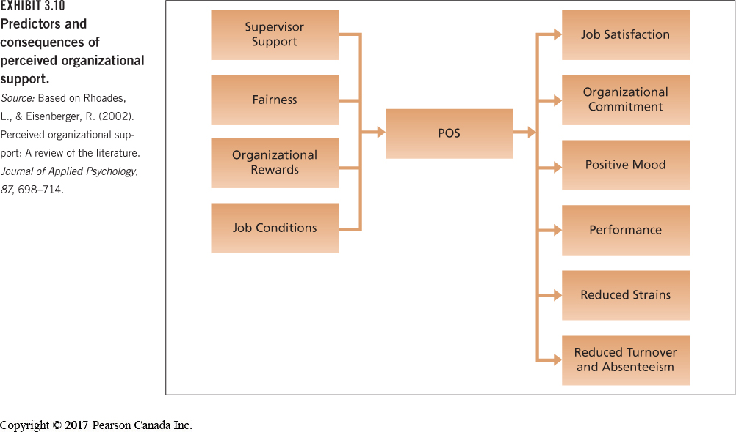
- What can organizations do to improve employee POS?
- Supportive human resource practices that demonstrate an investment in employees and recognition of employee contributions are most likely to lead to the development of greater POS.
- Supportive human resources practices include:
  - Participation in decision making.
  - Opportunities for growth and development.
  - Fair reward and recognition system.
  - Equality and diversity programs.

Chapter 4
1. Values
What Are Values?
- A broad tendency to prefer certain states of affairs over others.
- Values have to do with what we consider good and bad.
- Values are motivational; they signal how we believe we should and should not behave.
- Values are very general; they do not predict behaviour in specific situations very well.
- People tend to hold values structured around such factors as achievement, power, autonomy, conformity, tradition, and social welfare.

Four Generations in Today’s Workplace
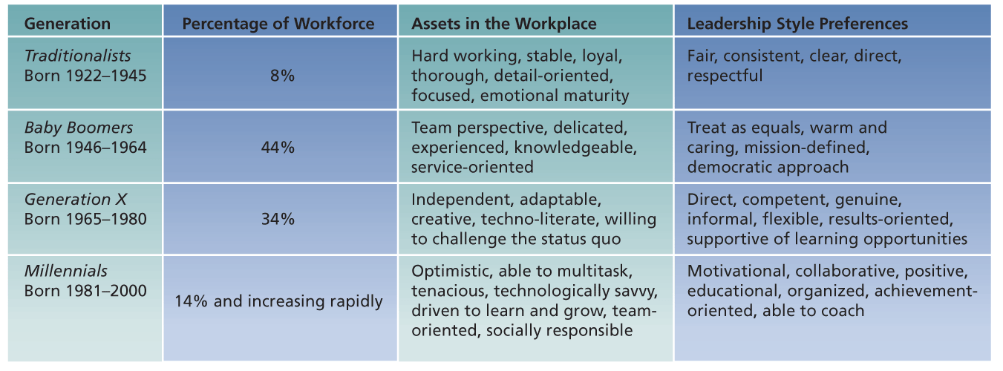
- These generations grew up under rather different socialization experiences.
- These differences have led to notable value differences between the generations.
- Such value differences might underlie the differential workplace assets and preferences for leadership style.
- Are these stereotypes accurate?

Cultural Differences in Values
- There are basic differences in work-related values across cultures.
- A lack of understanding of cross-cultural differences can cause foreign assignments to terminate early and business negotiations to fail.
Work Centrality
- Work is valued differently across cultures.
- There are cross-national differences in the extent to which people perceive work as a central life interest.
- People for whom work was a central life interest work more hours.
- Cross-cultural differences in work centrality can lead to adjustment problems for foreign employees and managers.

Work Centrality Questionnaire (Kanungo, 1982)
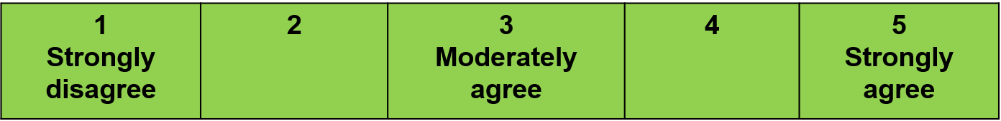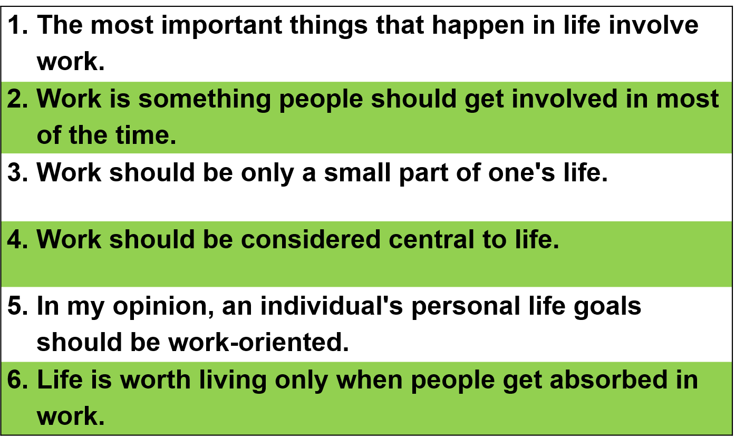

Hofstede’s Study
Geert Hofstede questioned over 116,000 IBM employees in 40 countries about their work-related values.
He discovered four basic dimensions along which work-related values differed across cultures:
  - Power distance
  - Uncertainty avoidance
  - Masculinity/femininity
  - Individualism/collectivism
  - Long-term/short-term orientation*
  - Indulgent/Restraint
https://geert-hofstede.com
*Subsequent work with Canadian Michael Bond 1987
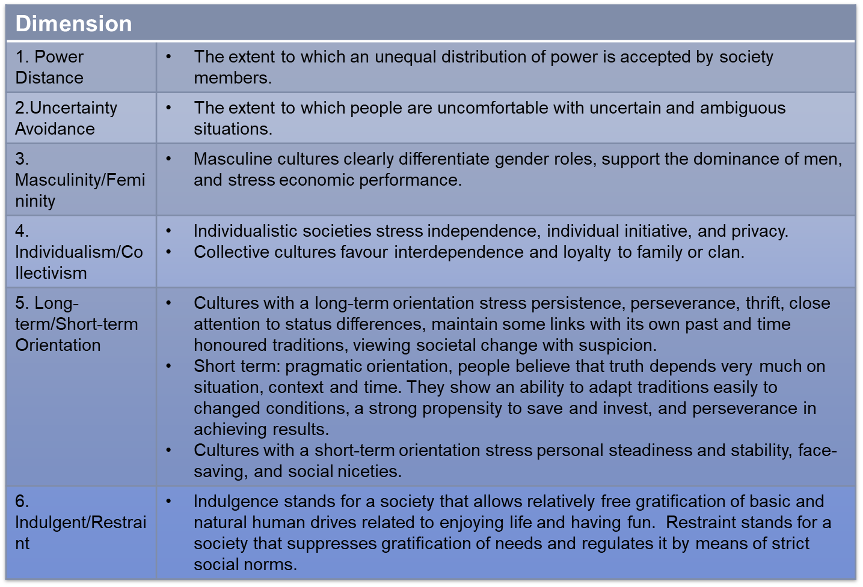

Cross-Culture Value Comparisons
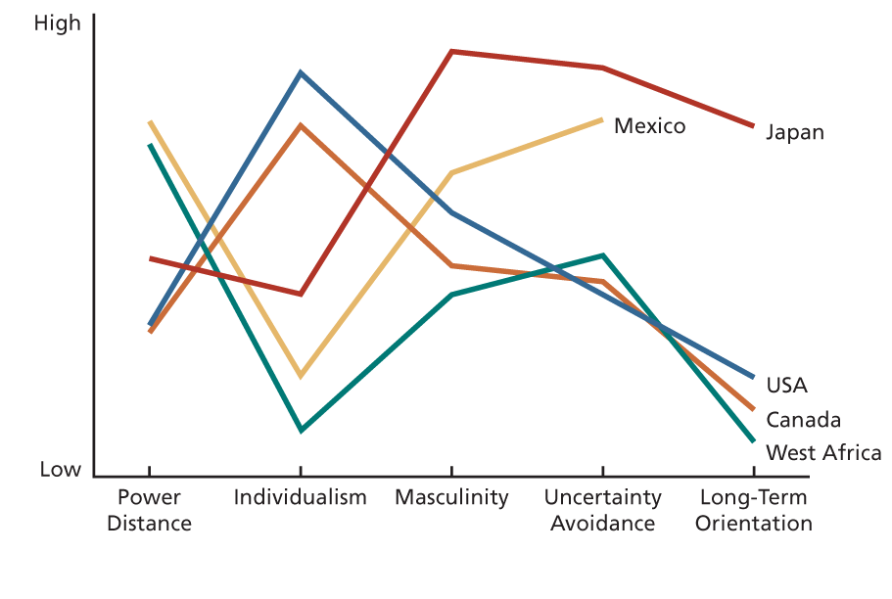
Power Distance and Individualism Values for Various Countries and Regions

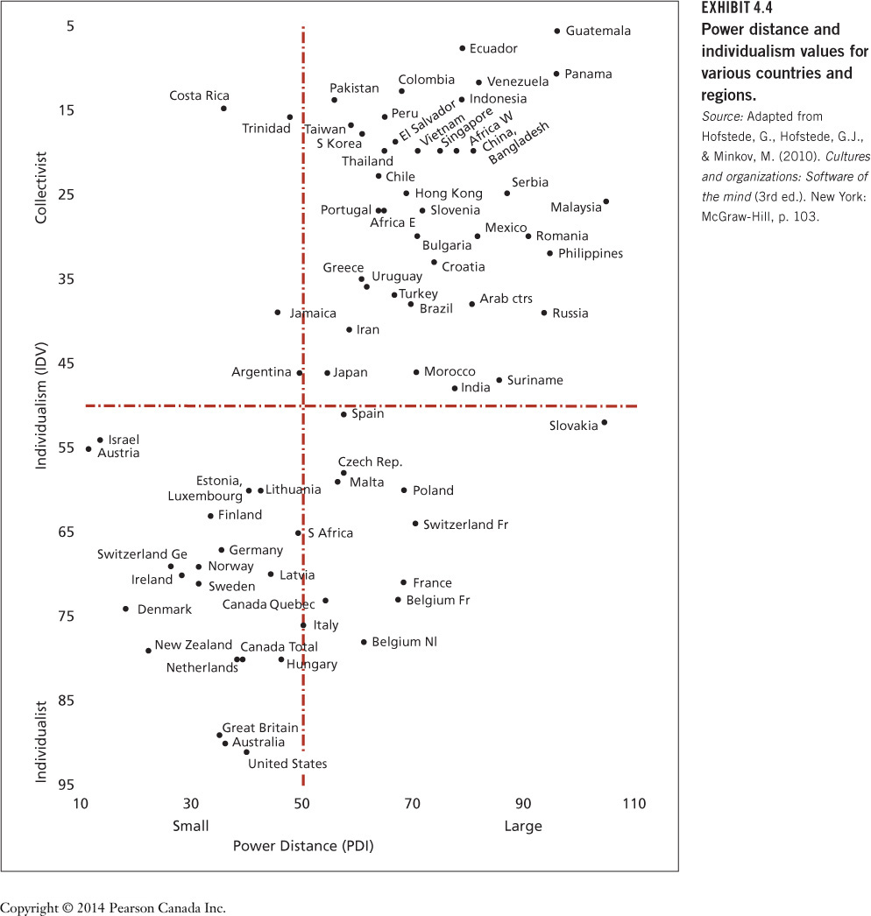

What are the implications of cultural variation for organizational behaviour?
- Organizations need to tailor management practices to the home culture’s concerns.
- An appreciation of cross-cultural differences in values is essential to understanding the needs and tastes of customers or clients around the world
- Companies need to select, train, and develop employees to have an appreciation of differences in cultural values and the implications

- Attitudes
What Are Attitudes?
- An attitude is a fairly stable evaluative tendency to respond consistency to some specific object, situation, person, or category of people.
- Attitudes involve evaluations directed toward specific targets.
- They are more specific than values.
- Attitudes are tendencies to respond to the target of the attitude.
- Attitudes often influence our behaviour toward some object, situation, person, or group.
Attitude Behaviour
- However, attitudes are not always consistent with behaviour.
- Behaviour is most likely to correspond to attitudes when people have direct experience with the target of the attitude and when the attitude is held confidently.
- Where do attitudes come from?
- Attitudes are a function of what we think and what we feel.
- Attitudes are the product of a related belief and value.
Belief + Value Attitude Behaviour
Where do attitudes come from?
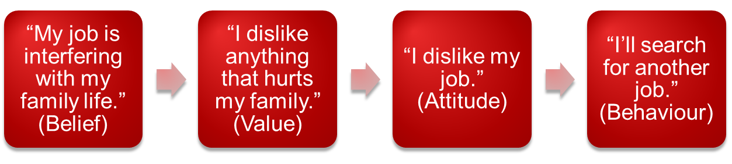
- Job Satisfaction
What Is Job Satisfaction?
A collection of attitudes that workers have about their jobs.

Two aspects of satisfaction:
I. Facet satisfaction refers to the tendency for an employee to be more or less satisfied with various facets of the job.
The most relevant attitudes toward jobs are contained in a rather small group of facets.
Examples: The work itself, Compensation, Recognition, Benefits, Conditions, Supervision, Co-workers, Policies
II. Overall satisfaction is a summary indicator of a persons’ attitude toward his or her job that cuts across the various facets.
It is an average or total of the attitudes individuals hold toward various facets of the job.
Two employees might express the same level of overall satisfaction for different reasons.

JDI vs. MSQ
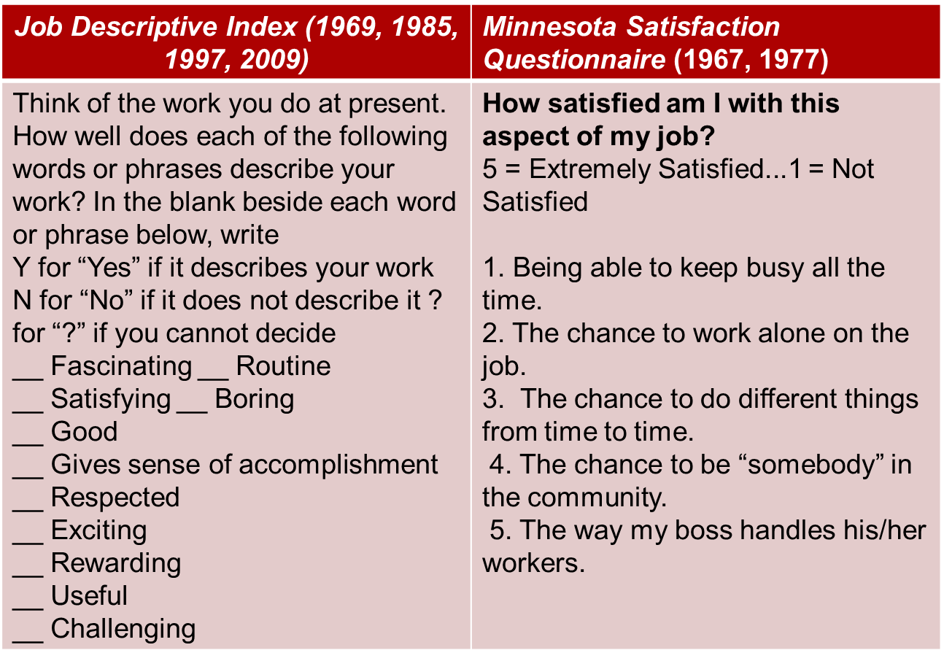
What Determines Job Satisfaction?
- We frequently find differences in job satisfaction expressed by individuals performing the same job in a given organization such as two nurses who work side by side.
How does this happen?
- Discrepancy
- Fairness
  - Distributive
  - Procedural
  - Interactional
- Disposition
Mood & emotions
- Other factors

1. Discrepancy
- According to discrepancy theory, job satisfaction is a function of the discrepancy between the job outcomes people want and the outcomes that they perceive they obtain.
- There is strong evidence that satisfaction with one’s pay is high when there is a small gap between the pay received and the perception of how much pay should be received.
- The discrepancy between the job outcomes wanted and the outcomes that are perceived to be obtained will determine job satisfaction.
- There is strong evidence that satisfaction with one’s pay is high when there is a small gap between the pay received and the perception of how much pay should be received.
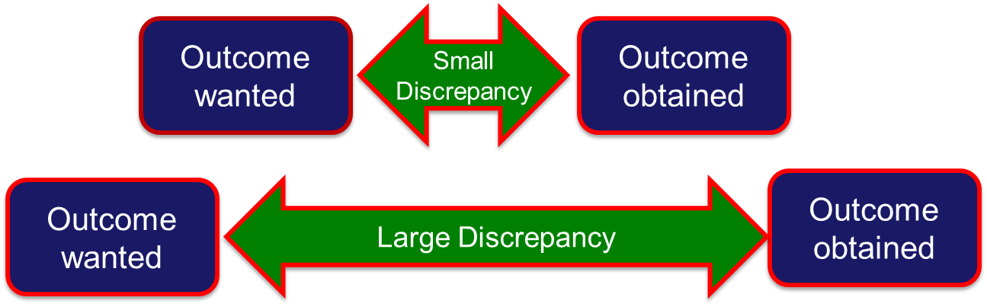
2. Fairness
Issues of fairness affect both what people want from their jobs and how they react to the inevitable discrepancies of organizational life.
There are three basic kinds of fairness:
  - Distributive fairness
  - Procedural fairness
  - Interactional fairness
i. Distributive Fairness
- Fairness that occurs when people receive the outcomes they think they deserve from their jobs.
- It involves the ultimate distribution of work rewards and resources.
- Individuals want “what’s fair.”
- Equity theory provides a way of understanding how people determine what is fair.
- A theory that job satisfaction stems from a comparison of the inputs one invests in a job and the outcomes one receives in comparison with the inputs and outcomes of another person or group.

Equity Theory
Equity will be perceived when the following distribution ratios exist:
My outcomes = Other’s outcomes
My inputs Other’s inputs
Inputs refer to anything that people give up, offer, or trade to their organization in exchange for outcomes (e.g., education).
Outcomes are factors that an organization distributes to employees in exchange for their inputs (e.g., pay).
The other in the ratio might be a co-worker performing the same job, a number of co-workers, or even one’s conception of all the individuals in one’s occupation.
Consider yourself in terms of the hours you spent studying as your input to this class and the final grade as the outcome and compare yourself to a friend in the class...

ii. Procedural Fairness
- Fairness that occurs when the process used to determine work outcomes is seen as reasonable.
- It is concerned with how outcomes are decided and allocated.
- It is particularly relevant to outcomes such as performance evaluations, pay raises, promotions, layoffs, and work assignments.
- In allocating outcomes, the following factors contribute to perceptions of procedural fairness. The allocator:
  - Follows consistent procedures over time and across people.
  - Uses accurate information and appears unbiased.
  - Allows two-way communication during the allocation process.
  - Welcomes appeals of the procedure or allocation.

iii. Interactional Fairness
- Fairness that occurs when people feel that they have received respectful and informative communication about an outcome.
- Interactional fairness is important because it is possible for absolutely fair outcomes or procedures to be perceived as unfair when they are inadequately or uncaringly explained.
- People who experience interactional unfairness are most likely to be dissatisfied with the boss.

3. Disposition
- Could your personality contribute to your feelings of job satisfaction?
- The dispositional view of job satisfaction is based on the idea that some people are predisposed by virtue of their personalities to be more or less satisfied despite changes in discrepancy or fairness.
- In general, people who are optimistic and proactive report higher job satisfaction (and live longer).
- Mood and emotion may contribute to this connection.

Mood and Emotion
- Affect is a broad label for feelings that includes emotions and moods.
- Emotions are intense, often short-lived feelings caused by a particular event (e.g. bad performance appraisal)
- Moods are less intense, longer-lived, and more diffuse feelings.
Affective Events Theory
- Jobs consist of a series of events and happenings that have the potential to provoke emotions or to influence moods, depending on how we appraise these events and happenings.
- Emotions and moods can then influence job satisfaction.
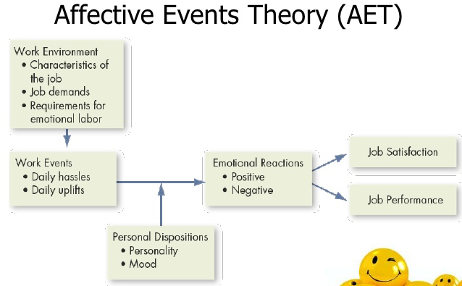
Emotional Contagion
- Mood and emotion can also influence job satisfaction through emotional contagion.
- Emotional contagion is the tendency for moods and emotions to spread between people or throughout a group.
- People’s moods and emotions tend to converge with interaction.
Emotional Regulation
- Mood and emotion can also influence job satisfaction through the need for emotional regulation.
- Emotional regulation is the requirement for people to conform to certain “display rules” in their job behaviour in spite of their true mood or emotions.
- This is often referred to as “emotional labour.” In some jobs, employees must exaggerate positive emotions while in others they must suppress negative emotions.
- All jobs have implicit display rules, however, service roles (e.g., waiter, flight attendants, bank tellers ) are especially laden with them.
- What are the consequences of the requirement for emotional regulation?
Consequences of Emotional Regulation
- The frequent need to suppress negative emotions and fake emotions can lower job satisfaction and increase stress.
- Some research suggests that the need to express positive emotions improves job satisfaction.
Do organizations pay a premium for emotional labour?
- Those in occupations with high cognitive demands tend to be paid more when the jobs are also high in emotional labour.
- Occupations with low cognitive demands entail a wage penalty when emotional labour is higher.
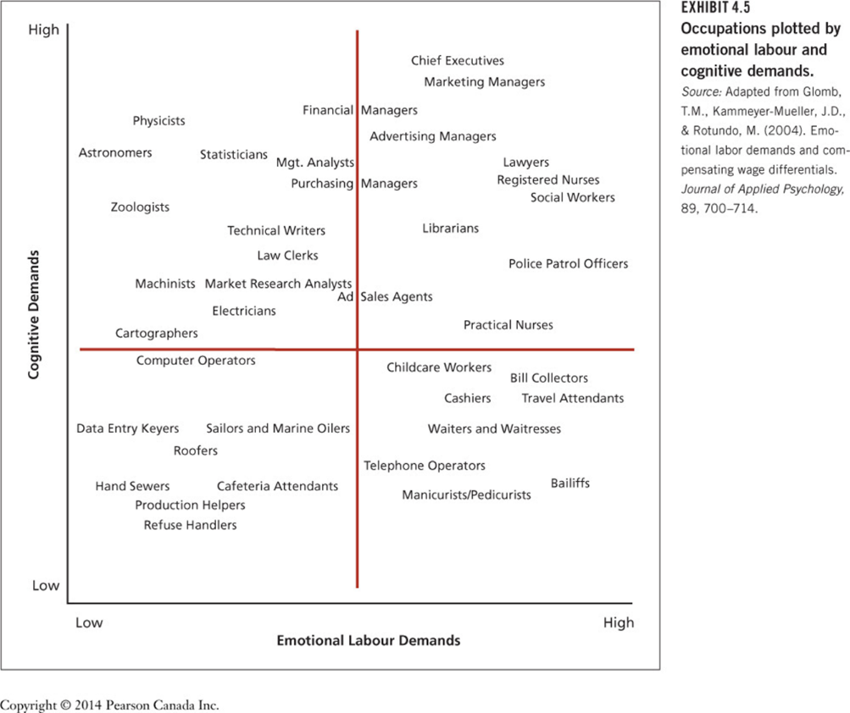

How Discrepancy, Fairness, Disposition, Mood, and Emotion Affect Job Satisfaction
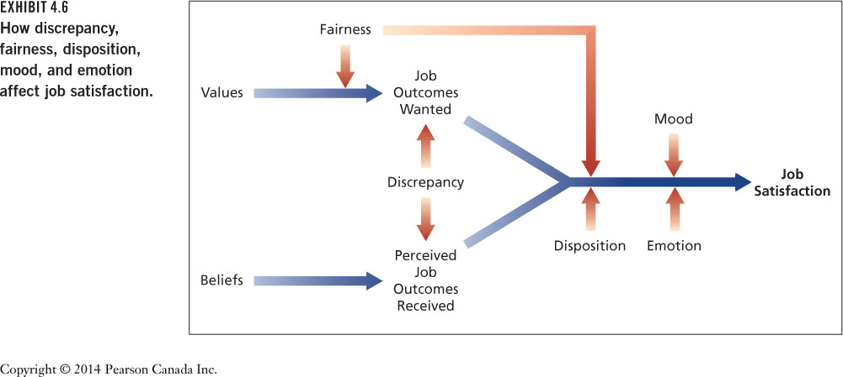

Some Key Contributors to Job Satisfaction
The facets that seem to contribute the most to feelings of job satisfaction for most North American workers include:
  - Mentally challenging work: work that tests employees’ skills, abilities, setting own pace, involving and important
  - Adequate compensation: adequacy,
  - Career opportunities: promotions + signals about self-worth
  - People (friendly or helpful colleagues)

Consequences of Job (dis)Satisfaction
Job satisfaction has a number of consequences:
  - Absence from work
  - Turnover
  - Performance
  - Organizational citizenship behaviour
  - Customer satisfaction and profit
1. Absence from Work
- Absenteeism is an expensive behaviour (“sick pay” lost productivity).
- Less satisfied employees are more likely to be absent.
- Some absences are unavoidable
- Satisfaction with the content of the work is the best predictor of absenteeism.
- Still the absence-satisfaction connection is not very strong.
2. Turnover
- Turnover refers to resignation from an organization and it can be very expensive.
- High turnover rates damage organizational financial performance
- Research indicates a moderately strong connection between job satisfaction and turnover.
- Less-satisfied workers are more likely to quit.
A Model of Employee Turnover
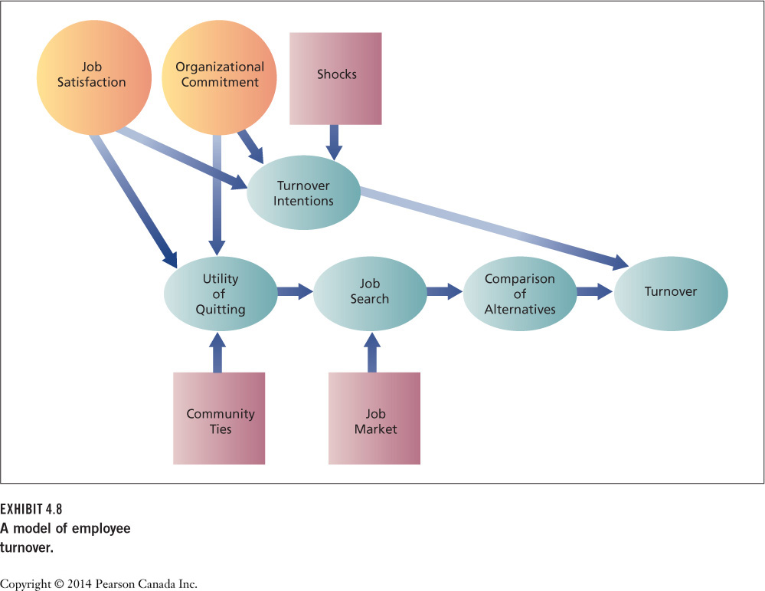
- The model shows that job satisfaction as well as commitment to the organization and various “shocks” can contribute to intentions to leave.
- Research shows that such intentions are very good predictors of turnover.
Why do satisfied people sometimes quit their jobs and dissatisfied people stay?
The Honeymoon-Hangover Effect (continued)
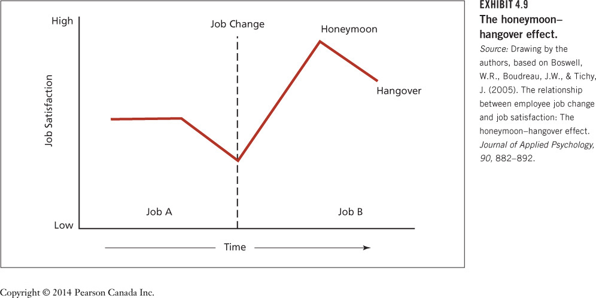
3. Performance
- Research has found that job satisfaction is associated with higher job performance.
- “a happy worker is a productive worker”
- However, the connection is complicated; many factors influence motivation and performance besides job satisfaction.
- The most important satisfaction facet for stimulating performance is the content of the work itself.
4. Organizational Citizenship Behaviour (OCB)
- OCB is voluntary, informal behaviour that contributes to organizational effectiveness.
- In many cases, the formal performance evaluation system does not detect and reward it.
- Job satisfaction contributes greatly to the occurrence of OCB, more than it does to regular task performance.
The various forms that OCB might take:
  - Helping behaviour and offering assistance to others.
  - Conscientiousness to the details of work.
  - Being a good sport.
  - Courtesy and cooperation.
Progression of Withdrawal
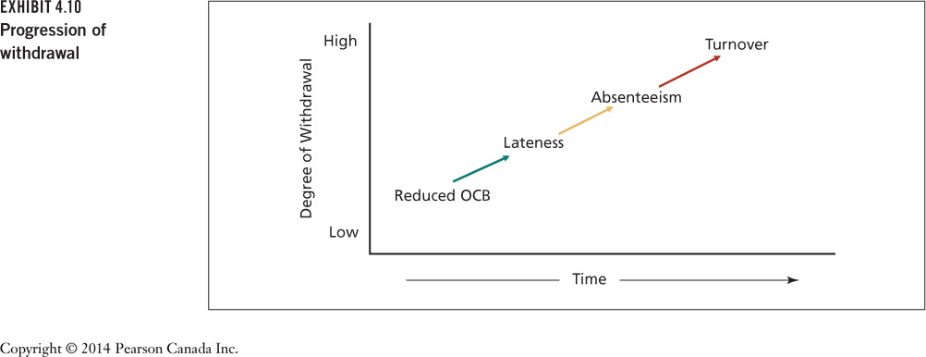

- There is sometimes a progression of withdrawal in response to job dissatisfaction and reduced commitment.
- People withdraw their attention or work effort to compensate for dissatisfaction.
- This begins with more subtle behaviours and progresses to more extreme behaviours until some equilibrium is struck.
- A reduction in OCB is often the first withdrawal response.
5. Customer Satisfaction and Profit
- A growing body of evidence has established that employee job satisfaction is translated into customer or client satisfaction and organizational profitability.
- Organizations with higher average levels of employee satisfaction are more effective.
- The same applies to units within larger organizations.

What Is Organizational Commitment?
Organizational commitment is an attitude that reflects the strength of the linkage between an employee and an organization.
- This linkage has implications for whether someone tends to remain in an organization.
- There are three very different types of organizational commitment:
  - Affective commitment
  - Continuance commitment
  - Normative commitment

1. Affective Commitment
- Commitment based on a person’s identification and involvement with an organization.
- People with high affective commitment stay with an organization because they want to.
2. Continuance Commitment
- Commitment based on the costs that would be incurred in leaving an organization.
- People with high continuance commitment stay with an organization because they have to.
3. Normative Commitment
- Commitment based on ideology or a feeling of obligation to an organization.
- People with high normative commitment stay with an organization because they think that they should do so.

What Is Organizational Commitment?
- Employees can also be committed to various constituencies within and outside the organization.
- Each type of commitment could also apply to one’s work team, union, or profession.
- The causes of the three forms of commitment tend to differ.

Chapter 5
Why Study Motivation?
- It is one of the most traditional topics in organizational behaviour.
- Motivation is especially important in contemporary organizations:
  - Need for increased productivity
  - Global competitiveness
  - Rapid change
  - Need for flexibility
  - Attention to customers

Characteristics of Motivation (EPDG)? (Johns & Saks 2017)
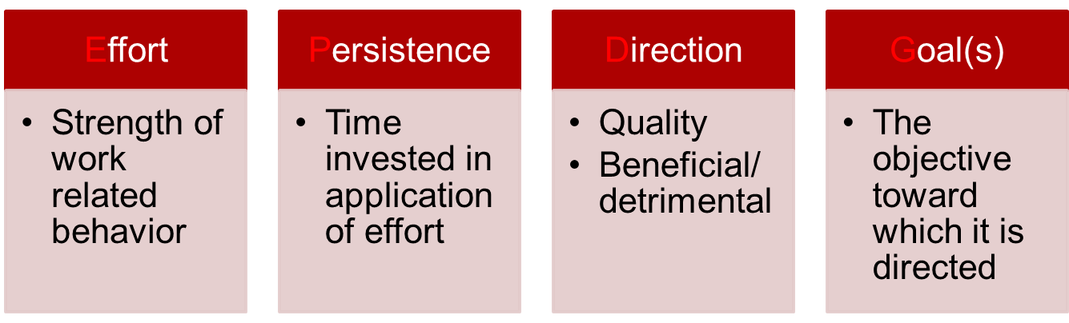

Motivation and Performance
- Performance refers to the extent to which an organizational member contributes to achieving the objectives of the organization.
- While motivation contributes to performance, the relationship is not one-to-one because many other factors also influence performance (e.g., personality, intelligence).

Factors Contributing to Individual Job Performance
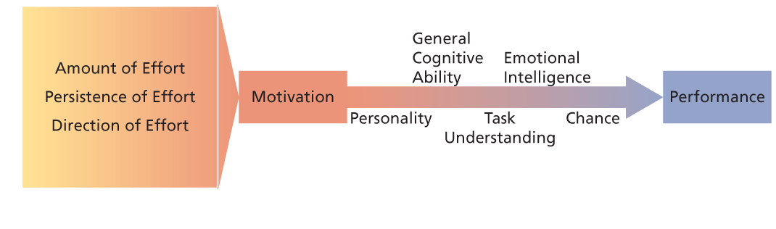
- General Cognitive Ability
- Emotional Intelligence (EI)
- Poor understanding of the task
- Luck and chance factors

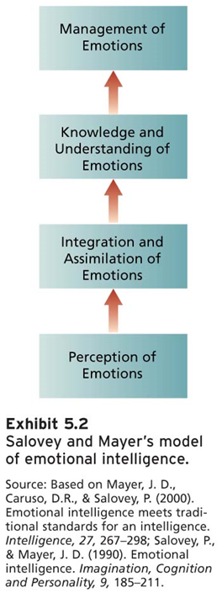
Salovey and Mayer’s Four-Branch Model of EI
- The ability to perceive emotions and to accurately identify one’s own emotions and the emotions of others.
- The ability to accurately identify emotions in people’s faces and in non-verbal behaviour.
- The ability to use and assimilate emotions and emotional experiences to guide and facilitate one’s thinking and reasoning.
- Using emotions in functional ways such as making decisions.
- EI predicts performance in many areas including job performance and academic performance.
- EI predicts job performance above and beyond cognitive ability and the Big Five personality variables.

Intrinsic: self-applied
Feelings of achievement, accomplishment, challenge and competence derived from performing one’s job.
Extrinsic: stems from the environment external to the task and is usually applied by someone other than the person being motivated.

Theories of Motivation
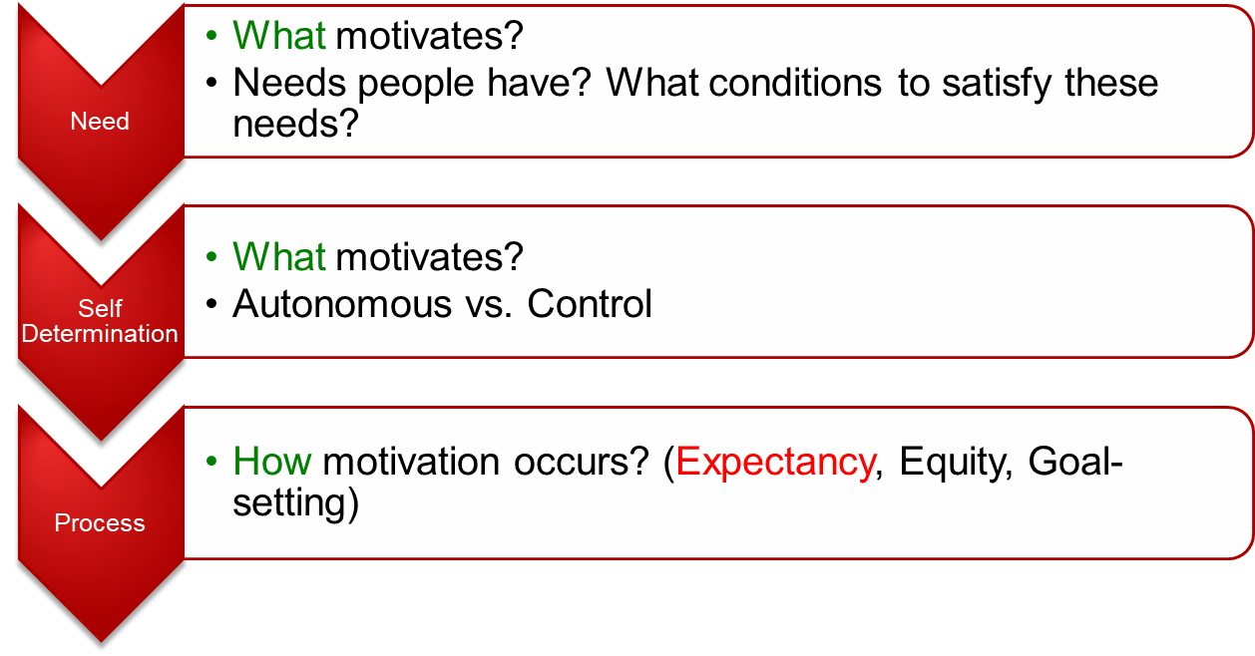
I. Need Theories of Work Motivation
Theories that specify the kinds of needs people have and the conditions under which they will be motivated to satisfy these needs.
Needs Behavior Incentives and Goals

Alderfer’s ERG Theory
- (Streamlines Maslow’s need classifications and makes some different assumptions about the relationship between needs and motivation.)
- A three-level hierarchical need theory of motivation (existence, relatedness, growth) that allows for movement up and down the hierarchy.
Existence Needs
- Needs that are satisfied by some material substance or condition.
- They correspond closely to Maslow’s physiological needs and to those safety needs that are satisfied by material conditions rather than interpersonal relations:
  - Need for food, shelter, and pay
  - Safe working conditions
Relatedness Needs
- Needs that are satisfied by open communication and the exchange of thoughts and feelings with other organizational members.
- They correspond closely to Maslow’s belongingness needs and to those esteem needs that involve feedback from others:
  - Open, accurate, honest interaction rather than uncritical pleasantness
  - Safe working conditions
Growth Needs
- Needs that are fulfilled by strong personal involvement in the work setting.
- They correspond to Maslow’s need for self-actualization and the aspects of esteem needs that concern achievement and responsibility:
  - The full utilization of one’s skills and abilities
  - The creative development of new skills and abilities

McClelland’s Theory of Needs
- A non-hierarchical need theory of motivation that outlines the conditions under which certain needs result in particular patterns of motivation.
- Needs reflect relatively stable personality characteristics.
- Concerned with the specific behavioural consequences of three needs: achievement, affiliation, and power.
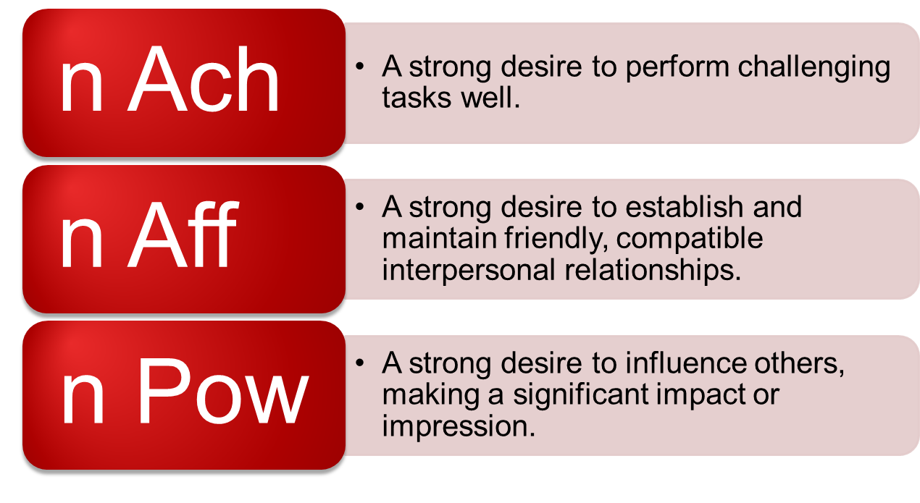
McClelland predicts that people will be motivated to seek out and perform well in jobs that match their needs.
- People with high need for achievement:
  - Sales jobs or entrepreneurial positions
- People with high need for affiliation:
  - Social work or customer relations
- People with high need for power:
  - Journalism and management

II. Self-Determination Theories
Theories of Motivation that explains what motivate people and whether motivation is autonomous or controlled
Self-Determination Theory (Deci & Ryan)
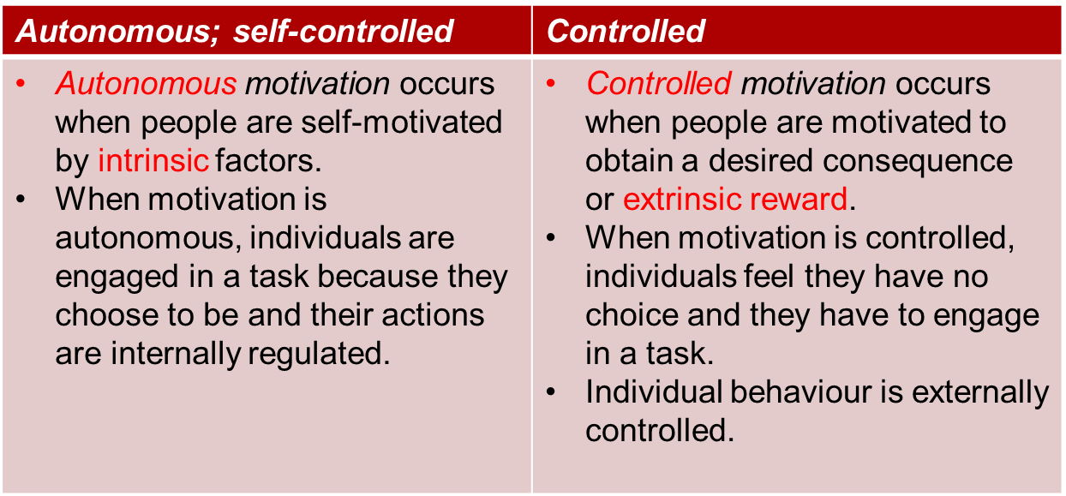

Self-Determination Theory (SDT)
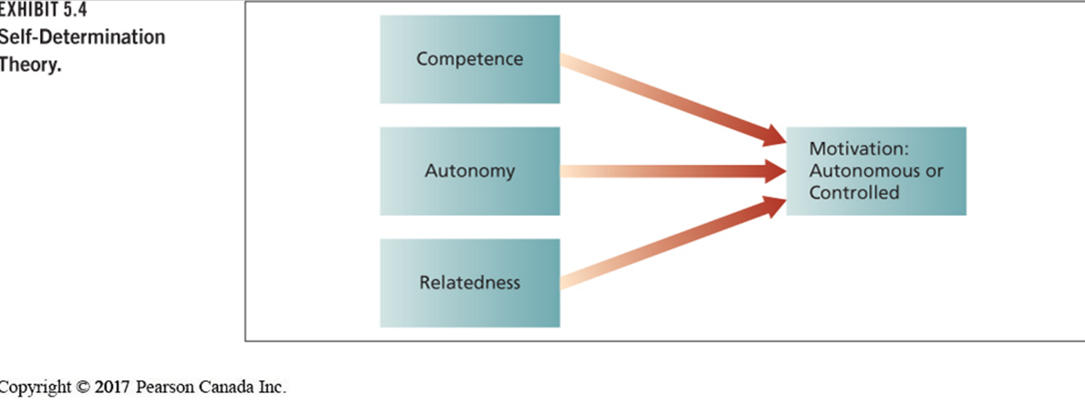
III. Process Theory of Work Motivation
How motivation occurs?
- Equity
- Goal-setting
- Expectancy
1. Equity
- Equity theory explains people’s job satisfaction through a comparison process of inputs and outcomes.
- When workers’ perceive equity they experience job satisfaction; when they perceive inequity, they experience job dissatisfaction.
In what sense is equity theory a theory of motivation?
- Motivation stems from a comparison of the inputs one invests in a job and the outcomes one receives in comparison with the inputs and outcomes of another person or group.
- Individuals are motivated to maintain an equitable exchange relationship.
From Terry’s perspective..
- Perceptually distort one’s own inputs or outcomes.
- Perceptually distort the inputs or outcomes of the comparison person or group.
- Choose another comparison person or group.
- Alter one’s inputs or alter one’s outcomes.
- Leave the exchange relationship
From Maxine’s perspective..
Gender and Equity
- Both men and women tend to choose same-sex comparison persons.
- This might provide a partial explanation for why women are paid less than men, even for the same job.
Research Support for Equity Theory
- When workers are underpaid on an hourly basis, they tend to lower their inputs by producing less work.
- When workers are underpaid on a piece-rate basis, they tend to produce a high volume of low-quality work.
- Goal Setting
- A goal is the object or aim of an action.
- Research has demonstrated when and how goal setting can be effective.
Goal and Motivation..
- A process theory that states that goals are motivational when they are specific, challenging, and when organizational members are committed to them and feedback about progress toward goal attainment is provided.
What is the difference?
  - I will run a marathon
  - I will take brisk walks around the block every day for a month. Then I will jog every day for a month. I will continue this routine and run in a 5k race by next spring.
  - I will complete my university degree at night
  - I will take classes at night towards a degree in accounting and will graduate in four years time. I will commit myself to studying to get a minimum 3.5 grade-point average in accounting and 3.0 in all other subjects
  - I will do my best

The Mechanisms of Goal Setting
- Goal Specify: exact level of achievement for people to accomplish in a particular time frame.
- Challenge: Goals that are easy or impossible to achieve will not be motivational.
- Commitment: Individuals must be committed to specific, challenging goals if the goals are to have effective motivational properties.
- Goal Feedback: accurate, specific, credible, and timely.
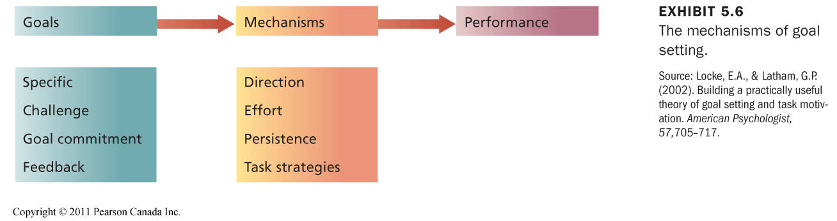
Enhancing Goal Commitment
Factors that might affect commitment to challenging, specific goals:
Participation
Participation can improve goal commitment and facilitate performance in some situations:
  - When a climate of distrust exists between management and employees.
  - When participation provides information that assists in the establishment of fair, realistic goals.
Rewards
Goal setting should be compatible with any system to tie pay to performance that already exists for the job in question.
Management Support
- When supervisors behave in a threatening manner to encourage goal accomplishment, they can badly damage employee goal commitment.
- Supervisors must demonstrate a desire to assist employees in goal accomplishment and behave supportively if failure occurs.
- Threat and punishment in response to failure will be extremely counterproductive.

Research Support for Goal Setting Theory
Research has demonstrated that specific, difficult goals lead to improved performance and productivity on a wide variety of tasks and occupations.
- The effect of group goal setting on group performance is similar to the effect of individual goal setting.
- The positive effects of goals persist over a long enough time to have practical value.
The effects of goal setting on performance depend on a number of factors.
- When individuals lack the knowledge or skill to perform a novel or complex task, a specific and challenging performance goal can decrease performance.
- When a task is straightforward, a specific, high performance goal results in higher performance.
- A specific, high learning goal is more effective when individuals are learning to perform a novel or complex task.
- Proximal goals are especially important for novel and complex tasks.
- When distal goals are accompanied with proximal goals they have a significant positive effect on the discovery and use of task-relevant strategies, self-efficacy, and performance.
- Managers should set specific and challenging goals and provide ongoing feedback to employees so they can compare their performance with the goal.
- The performance impact of specific, challenging goals is stronger for simpler jobs than for more complex jobs.
Theories of Motivation
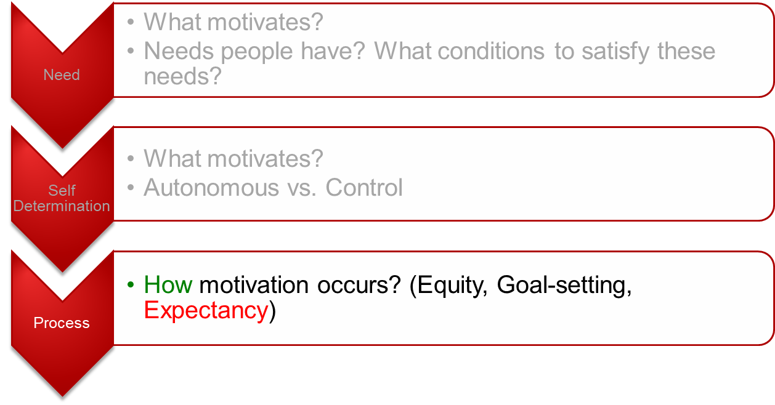
Expectancy Theory; features
- Expectancy theory is based on the perceptions of the individual worker that we are analyzing.
- It can handle any form of (second-level) outcome that has relevance for the person in question (extrinsic and intrinsic outcomes).
Expectancy Theory; Basic Premises
- People will be motivated to engage in those work activities that they find attractive and feel they can accomplish
- The attractiveness of various work activities depends upon the extent to which they lead to favourable personal consequence
- Meet Benoit and Brenda..

Perceptions of The Individual Worker
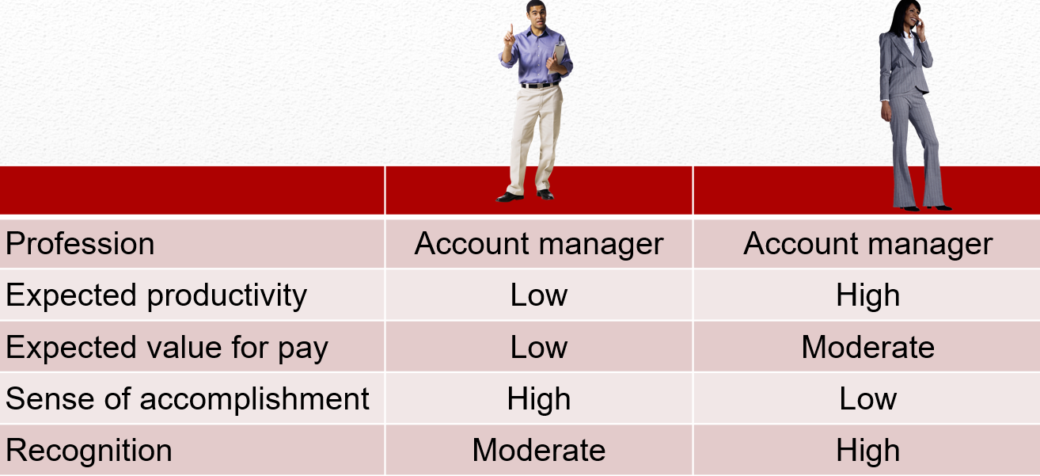
Perceptions of The Individual Worker About His Outcomes
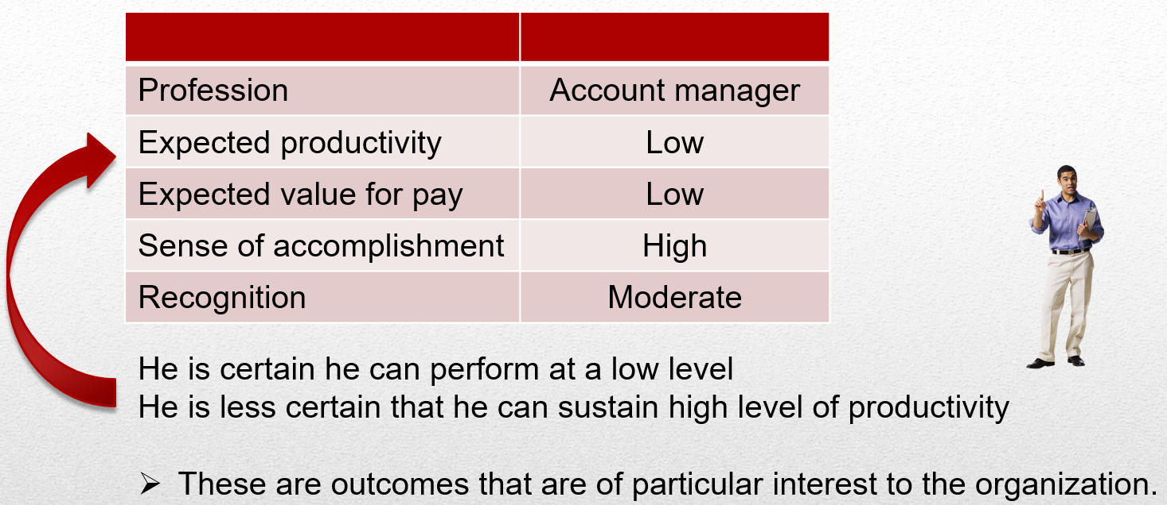
Expected values of work outcomes; Valence
Valence; the expected values of work outcomes
- The extent to which the work outcome are attractive or not
- High sense of accomplishment, and recognition are more attractive
- Expected value of money less attractive
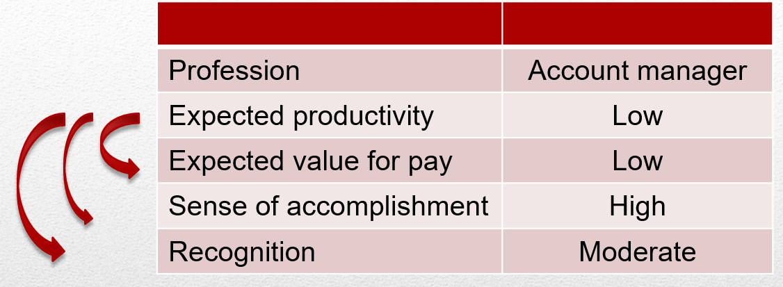

A Hypothetical Expectancy Model; First level outcomes
The consequences that may follow certain work behaviours.
Expectancy theory is concerned with specifying how an employee might attempt to choose one first-level outcome (e.g., high productivity) over another (e.g., average productivity).
A Hypothetical Expectancy Model; Second Level Outcomes
- Second-level outcomes are consequences that follow the attainment of a particular first-level outcome.
- They are of particular interest to the individual worker and involve things such as the amount of pay, sense of accomplishment, acceptance by peers, and so on.
A Hypothetical Expectancy Model; Instrumentality (I)
The probability that a particular first-level outcome (e.g., high productivity) will be followed by a particular second-level outcome (e.g., pay).
High productivity 80% chance of a pay increase
Average productivity 30% chance of a pay increase
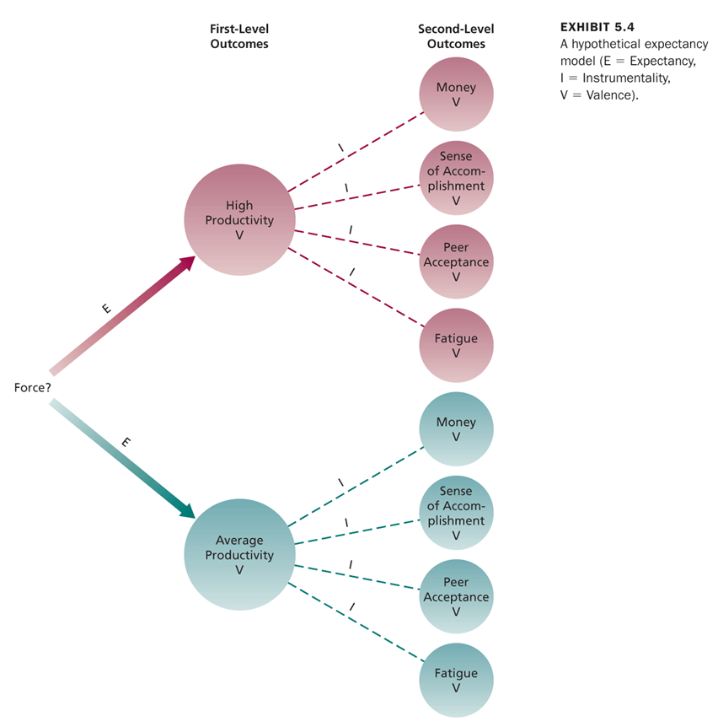

Expectancy Theory (Vroom)
Motivation is determined by the outcomes that people expect to occur as a result of their actions on the job.
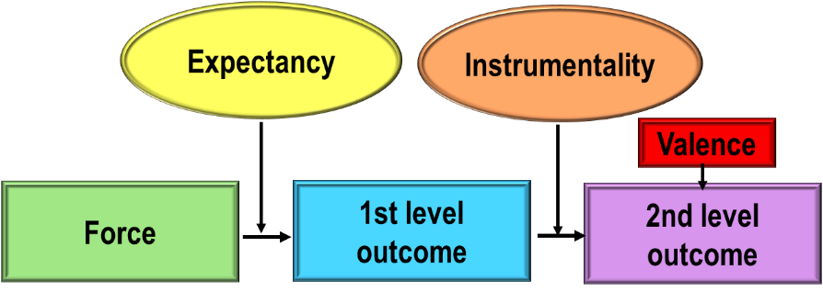
- Force is the end product of the other components of the theory.
- It represents the relative degree of effort that will be directed toward various first-level outcomes.

Expectancy (Mathematical) Model
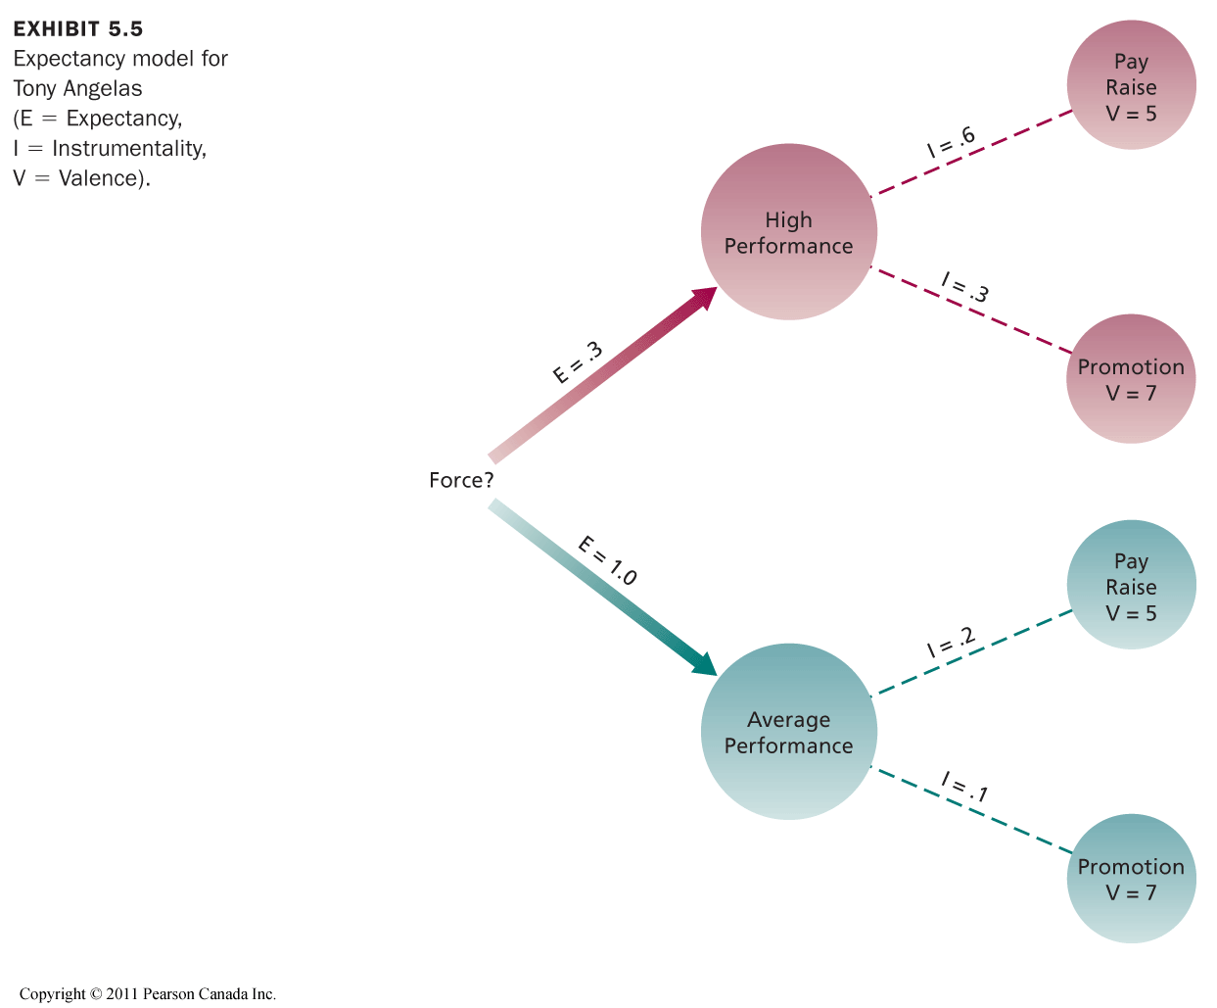
The valence of high performance:
(5 x .6) + (7 x .3) = 5.1.
The valence of average performance:
(5 x .2) + (7 x .1) = 1.7.
High performance is more valent for Benoit than average performance.
Does this mean that Benoit will try to perform at a high level?

Expectancy Model for Benoit (continued)
- We need to take into account his expectancy for high and average performance.
- He is certain he can perform at an average level (expectancy = 1.0).
- He is less certain that he can sustain high performance (expectancy = .3).
- Force is the product of these expectancies and the valence of their respective first-level outcomes.
- The force associated with high performance:
.3 x 5.1 = 1.53
- The force associated with average performance:
1 x 1.7 = 1.70
- Although high performance is attractive to Benoit, he will probably perform at an average level.
Expected Success x Perceived Value = Motivation

Research Support for Expectancy Theory
- Moderately favourable support for expectancy theory.
- There is especially good evidence that the valence of first-level outcomes depends on the extent to which they lead to favourable second-level consequences.
- Experts in motivation generally accept expectancy theory.

Managerial Implications of Expectancy Theory
- The motivational implications of expectancy theory involve “juggling the numbers” that individuals attach to expectancies, instrumentalities, and valences.
- Three implications:
  - Boost expectancies
  - Clarify reward contingencies
  - Appreciate diverse needs
1. Boost Expectancies
- One of the most basic things managers can do is ensure that their employees expect to be able to achieve first-level outcomes that are of interest to the organization.
- Manager should clarify the path to beneficial first-levels outcomes so that employees expect to be able to achieve first-level outcomes that are important to the organization.
- Workers will not pursue goals if expectancy is low.
Low expectancies can take many forms...

Reasons for Low Expectancies
- Poor equipment, poor tools, lazy co-workers
- Lack of understanding of what the organization considers good performance and how to achieve it (also mixed messages).
- Perception that performance evaluation ratings are arbitrary, and not understanding how to obtain a good rating.

Boost Expectancies (continued)
- Expectancies can usually be enhanced by:
  - Providing proper equipment
  - Training
  - Demonstrating correct work procedures
  - Explaining how performance is evaluated
  - Listen to employee problems
- The point is to clarify the path to beneficial first-level outcomes.
2. Clarify Reward Contingencies
- Managers should try to ensure that the paths between first- and second-level outcomes are clear.
- Employees should be convinced that first-level outcomes are clearly instrumental in obtaining positive second-level outcomes and avoiding negative outcomes.
- To ensure that instrumentalities are strongly established, they should be clearly stated and then acted on by the manager.
- Managers should provide stimulating, challenging tasks for workers who are interested in such work.
3. Appreciate Diverse Needs
- Managers should analyze the diverse preferences of employees and attempt to design individualized “motivational packages” to meet their needs.
Do Motivation Theories Translate Across Cultures?
Are motivation theories culture-bound?
- Most theories that revolve around human needs will come up against cultural limitations to their generality.
- Equity theory will be constrained by what is considered “fair” in a particular culture in terms of how to allocate rewards (e.g., equity versus equality).
- Because of its flexibility, expectancy theory is very effective when applied cross-culturally.
- Setting specific and challenging goals should be motivational when applied cross-culturally.
- Goal setting has been found to predict, influence, and explain behaviour in many countries around the world.

- For goal setting to be effective, the goal setting process must be adjusted to the culture (e.g., individual goals in individualistic cultures, group goals in collective cultures).
- Cultural blinders often lead to motivational errors.
- Appreciating cultural diversity is critical for maximizing motivation.

Chapter 6
Motivation in Practice
I. Money as a Motivator
How important is pay for you?
- I. Money as a Motivator
- Employees and managers seriously underestimate the importance of pay as a motivator.
How effective is pay as a motivator?
- The motivation theories suggest that pay is a very important motivator.
- If pay can satisfy a variety of needs, it should be highly valent, and it should be a good motivator to the extent that it is clearly tied to performance.
- Financial incentives and pay-for-performance plans have been found to increase performance and lower turnover.
- Pay may well be the most important and effective motivator of performance.
- The ability to earn money for outstanding performance is a competitive advantage for attracting, motivating, and retaining employees.
II. Job Design as a Motivator
- Job design refers to the structure, content, and configuration of a person’s work tasks and roles.
- It is an attempt to capitalize on intrinsic motivation.
- The goal of job design is to identify the characteristics that make some tasks more motivating than others and to capture these characteristics in the design of jobs.

Traditional Views of Job Design
- From the beginning of the Industrial Revolution until the 1960s, the prevailing philosophy regarding the design of most non-managerial jobs was job simplification.
- Organizations recognized that specialization was the key to efficient productivity.
- The zenith of job simplification occurred in the early 1990s with Taylor’s principles of scientific management that advocated:
  - Extreme division of labour and specialization.
  - Careful standardization and regulation of work activities and rest pauses.
- Jobs designed according to the principles of scientific management are not intrinsically motivating.
- The motivational strategies consisted of close supervision and piece-rate pay.
- Simplification helped workers achieve a reasonable standard of living.
Job Scope and Motivation
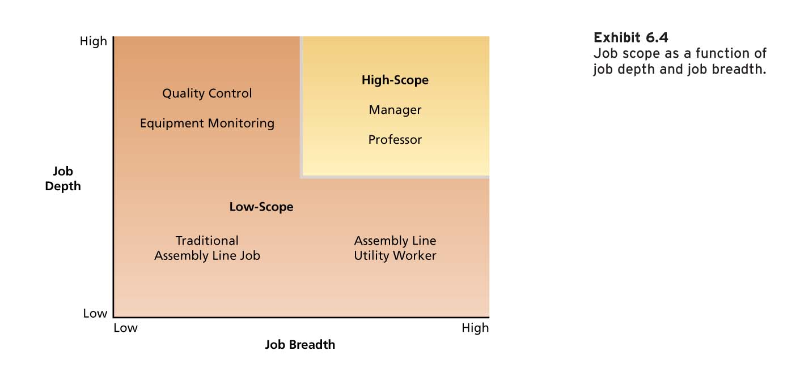
- Job scope refers to the breadth and depth of a job.
- Breadth refers to the number of different activities performed on the job.
- Depth refers to the degree of discretion or control the worker has over how these tasks are performed.
- Jobs that have great breadth and depth are called high-scope jobs.
- Job Scope as a Function of Job Depth and Job Breadth
- Job Scope and Motivation
- Traditional views of job design were attempts to construct low-scope jobs in which workers specialized in a single task.
- The motivation theories suggest that high-scope jobs provide more intrinsic motivation than low-scope jobs.
To increase the scope of the job..
To increase the scope..
- One way to increase the scope of a job is to assign employees stretch assignments.

They provide employees challenging opportunities to broaden their skills by working on a variety of tasks with new responsibilities. Another approach for increasing the scope of an individual’s job is job rotation.
- Employees are rotated to different tasks and jobs in an organization.
It can involve working in different functional areas and departments.
It can provide a variety of challenging assignments, develop new skills and expertise, and prepare employees for future roles.
The Job Characteristics Model
- The Job Characteristics Model proposes that there are several “core” job characteristics that have a certain psychological impact on workers.
- The psychological states induced by the nature of the job lead to certain outcomes.
- Several factors called moderators influence the extent to which these relationships hold true.

Core Job Characteristics
There are five core job characteristics that have particularly strong potential to affect worker motivation:
- Skill variety: The opportunity to do a variety of job activities using various skills and talents. It corresponds to job breadth.
  - Task identity: The extent to which a job involves doing a complete piece of work, from beginning to end.
  - Task significance: The impact that a job has on other people.
- Autonomy: The freedom to schedule one’s own work activities and decide work procedures. It corresponds to job depth.
- Job Feedback: Information about the effectiveness of one’s work performance. People are not motivated for long if they do not know how well they are doing.
The Job Characteristics Model; Core Job Characteristics
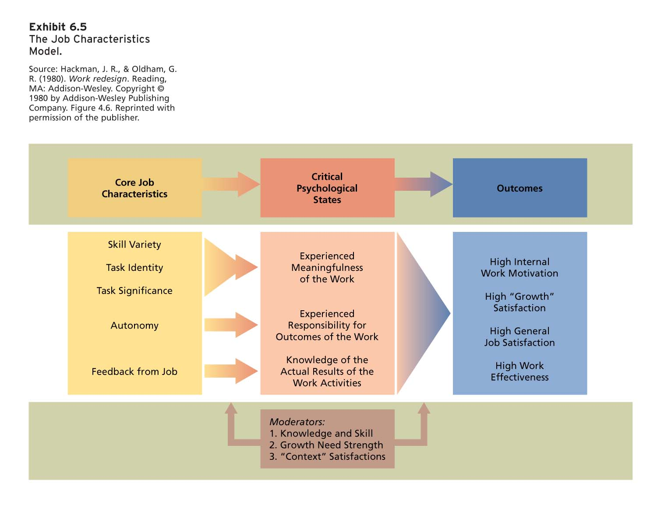
Job Diagnostic Survey (JDS)
- The Job Diagnostic Survey (JDS) is a questionnaire to measure the core job characteristics.
- Individuals report the amount of the various core job characteristics contained in their jobs.
- An overall measure of the motivating potential of a job can be calculated from scores on the core job characteristics.
- Motivating Potential Score
The motivating potential score (MPS) of a job is calculated using the following formula:
Skill Task Task
MPS = variety + identity + significance x Autonomy x Feedback
3
The Job Characteristics Model; Critical Psych State
Critical Psychological States
Jobs that are higher on the core job characteristics are more intrinsically motivating because of their effect on three psychological states:
  - Experienced meaningfulness of the work; Jobs that are high on skill variety, task significance, and task identity are perceived as more meaningful.
  - Experienced responsibility for outcomes of the work; Jobs that are high on autonomy provide for greater personal responsibility for work outcomes.
  - Knowledge of the actual results of the work activities;
Jobs that are high on performance feedback provide workers with knowledge of the results of their work activities.
The Job Characteristics Model; Outcomes
Outcomes
The presence of the critical psychological states leads to a number of outcomes that are relevant to both the individual and the organization:
  - High intrinsic motivation
  - High-quality productivity
  - Satisfaction with higher-order needs
  - General satisfaction with the job
  - Reduced absenteeism and turnover
The Job Characteristics Model; Moderators
Moderators
- Jobs that are high in motivating potential do not always lead to favourable outcomes.
Three moderator or contingency variables intervene between job characteristics and outcomes.
- Job-relevant knowledge and skill of the worker.
- Growth need strength which refers to the extent to which people desire to achieve higher-order need satisfaction by performing their jobs.
- Workers who are dissatisfied with the context factors that surround their job (e.g., pay) will be less responsive to challenging work than those who are reasonably satisfied with context factors.
Research Evidence
- Workers respond more favourably to jobs that are higher in motivating potential.
- All five job characteristics are related to work outcomes.
- Among the psychological states, strongest support for experienced meaningfulness of the work, less support for experienced responsibility, and no support for the role of knowledge of results.
- Evidence for the role of growth needs and context satisfaction is weak or contradictory.
Job Enrichment
- The design of jobs to enhance intrinsic motivation, quality of working life, and job involvement.
- Job enrichment involves increasing the motivating potential of jobs via the arrangement of their core job characteristics.
Job Involvement
- A cognitive state of psychological identification with one’s job and the importance of work to one’s total self-image.
- All of the core job characteristics are positively related to job involvement.
- Employees who are more involved in their job have higher job satisfaction and organizational commitment, and are less likely to consider leaving their organization.
Job Enrichment Procedures
Many job enrichment schemes include the following:
- Combining tasks: This involves assigning tasks that might be performed by different workers to a single individual. Should increase the variety of skills employed and might contribute to task identity.
- Establishing external client relationships: This involves putting employees in touch with people outside the organization who depend on their products or services. Might involve the use of new interpersonal skills, increase the identity and significance of the job, and increase feedback about one’s performance.
- Establishing internal client relationships: This involves putting employees in touch with people who depend on their products and services within the organization. Advantages are similar to those that result from establishing external client relationships.
- Reducing supervision or reliance on others: This increases the autonomy and control one has over their own work.
- Forming work teams: Teams can be formed when a product or service is too large or complex for one person to complete alone or to complete an entire product. This can result in the development of a variety of skills and increase the identity of the job.
- Making feedback more direct: Permit workers to be identified with their “own” product or service so that if a customer encounters problems, he or she can contact the worker directly. It is usually used in conjunction with other job design aspects that permit workers to be identified with their “own” product or service.

Potential Problems with Job Enrichment
Job enrichment can encounter a number of challenging problems:
1. Poor diagnosis: when job is instituted without a careful diagnosis of the needs of the organization and the particular jobs in question. An especially likely error involves increasing job breadth or what is known as job enlargement
Enlargement
Increasing job breadth by giving employees more tasks to perform at the same level while leaving the other crucial core characteristics unchanged.
Workers are given more boring, fragmented, routine tasks to do.
Job enrichment can encounter a number of challenging problems:
2. Lack of desire or skill
- Some workers do not desire enriched jobs.
- Some workers might lack the skills and competence necessary to perform enriched jobs effectively.
- Enrichment might entail substantial training costs for poorly educated or trained workers.
- It might be difficult to train some workers in certain skills required by enriched jobs (e.g., social skills).
- Potential Problems with Job Enrichment
Job enrichment can encounter a number of challenging problems:
3. Demand for rewards:
- Workers who experience job enrichment often expect greater extrinsic rewards, such as pay, to accompany their redesigned jobs.
- This is because enriched jobs often require the development of new skills and entail greater responsibility.
Job enrichment can encounter a number of challenging problems:
4. Union Resistance
- North American unions have traditionally not been enthusiastic about job enrichment.
- Companies and unions have begun to dismantle restrictive contract provisions regarding job design.
- Fewer job classifications mean more opportunities for flexibility by combining tasks and using team approaches.
Job enrichment can encounter a number of challenging problems:
5. Supervisory resistance
- Job enrichment can fail due to unanticipated effects on other jobs or parts of the organizational system.
- Enrichment increases the autonomy of employees and it might “disenrich” the supervisor’s job.
- This will not help facilitate a smooth implementation of the job redesign.
- Some organizations have eliminated direct supervision of workers performing enriched jobs.
- In other cases, the supervisor becomes a trainer and developer of individuals on enriched jobs.

Management by Objectives (MBO)
An elaborate, systematic, ongoing program designed to facilitate goal establishment, goal accomplishment, and employee development.
- Objectives for the organization as a whole are developed by top management and diffused down through the organization.
- Organizational objectives are translated into specific behavioural objectives for individual members.
- The nature of the interaction between managers and individual workers in an MBO program is important.
The Management by Objectives Process (continued)
MBO manager-employee interactions:
  - The manager meets with individual workers to develop and agree on employee objectives which can include job performance and personal development objectives.
  - There are periodic meetings to monitor employee progress in achieving objectives.
  - An appraisal meeting is held to evaluate the extent to which the agreed upon objectives have been achieved.
  - The MBO cycle is repeated.
Research Evidence
- Research evidence shows that MBO programs result in productivity gains.
- A number of factors are associated with the failure of MBO programs:
  - Lack of commitment from top management.
  - An overemphasis on measurable objectives at the expense of more qualitative objectives.
  - Excessive short-term orientation.
  - Performance review becomes an exercise in browbeating or punishing employees for failure to achieve objectives.

Alternative Working Schedules as Motivators for a Diverse Workforce
Many organizations have modified traditional working schedules.
- The purpose is to meet diverse workforce needs and promote job satisfaction.
- Alternative working schedules can also facilitate recruitment and reduce absenteeism and turnover.
- Alternative Working Schedules
Some of the most common alternative working schedules:
- Flex-time:
- An alternative work schedule in which arrival and quitting times are flexible.
- Flex-time is well suited to meeting the needs of a diverse work-force and is most frequently implemented in office environments.
- Employees prefer it compared to fixed hours.
- Work attitudes are more positive.
- A positive effect on productivity, job satisfaction, and satisfaction with work schedule and lower employee absenteeism.
- Alternative Working Schedules
Some of the most common alternative working schedules:
- Compressed work week:
- An alternative work schedule in which employees work fewer than the normal five days a week but still put in a normal number of hours per week.
- The most common compressed workweek is the 4-40 system.
- Potential roadblocks to implementation:
  - Reduced customer service
  - Negative effects of fatigue
People who have experienced it tend to like it.
- Workers often report an increase in fatigue following its introduction.
- Research shows a positive effect on job satisfaction and satisfaction with work schedule but no effect on absenteeism or productivity.
- Alternative Working Schedules
Some of the most common alternative working schedules:
- Job and work sharing:
- Job sharing is an alternative work schedule in which two part-time employees divide the work of a full-time job.
- Work sharing involves reducing the number of hours employees work to avoid layoffs when there is a reduction in normal business activity.
- Many companies implemented work sharing programs to save jobs and avoid layoffs during the recession.
- Work sharing cuts costs, saves jobs, avoids layoffs and allows organizations to retain skilled workers.
- Job sharing can result in coordination problems if communication is not adequate.
- Job sharers must make a concerted effort to communicate well with each other as well as with superiors, co-workers, and clients.
Alternative Working Schedules
Some of the most common alternative working schedules:
- Telecommuting:
- A system by which employees are able to work at home but stay in touch with their offices through the use of communications technology, such as a computer network, voice mail, and electronic messages.
- Distant staffing enables employees to work for a company without ever having to come into the office or even be in the same country.
- Telework centres provide workers all of the amenities of a home office in a location close to their home.
- Distributed work programs involve a combination of remote work arrangements that allow employees to work at their business office, a satellite office, and a home office.
- Telecommuting: Research Evidence
- Telecommuting has a small but positive effect on perceived autonomy and lower work-family conflict.
- It has a positive effect on job satisfaction and job performance and results in lower stress and turnover intentions.
- It does not have detrimental effects on the quality of workplace relationships or one’s career prospects.
- A greater frequency of telecommuting is associated with a greater reduction in work-family-conflict and stress.
- The positive effects of telecommuting are mostly due to an increase in perceived autonomy.
- Telecommuting: Potential Problems
- Negative consequences can result due to a lack of informal communication.
- Can have a negative effect on relationships with co-workers.
- Distractions in the home environment.
- Feelings of isolation and overwork.
- Concerns about trust and control.

Implementing Telecommuting
- A strong perception of trust between employees and management must exist before implementing telecommuting.
- A telecommuting program must be preceded by careful planning and accompanied by clear guidelines.
- It may not be appropriate for all organizations, jobs, and employees.

