Marketing 201 / fall 2016
Chapter 1.
Marketing / marketing relationships
Definitions:
  - Managing profitable customer relationships
  - Creating value for customers and building strong relationships to capture value from customers in return
Discovering and satisfying needs
Goals:
  - Attracting new customers
  - Keeping and growing current customer base
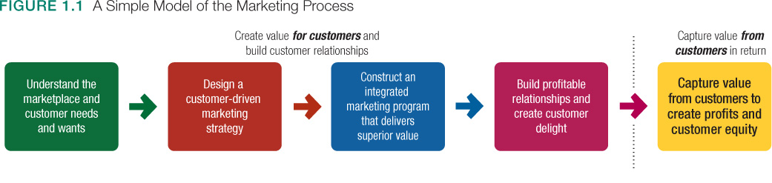
Understanding the Marketplace and customer needs :
  - Needs, wants, and demands
  - Market offerings
  - Value and satisfaction
  - Exchanges and relationships
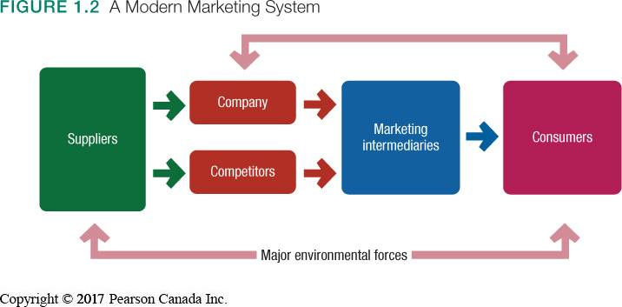
  - Markets

Chapter 2
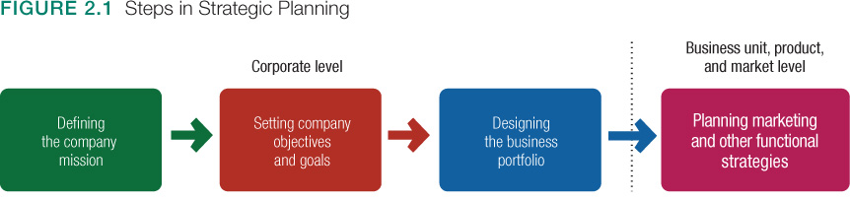
- Mission statement: Statement of the organizations purpose – the value it offers and for whom
- Turn mission into supporting objectives : e Business objective is to increase profits and marketing is the increase market share of domestic and international markets
- Business portfolio: to evaluate the current business and products and decide who gets more or less investment.

Stars: High-share of high-growth market
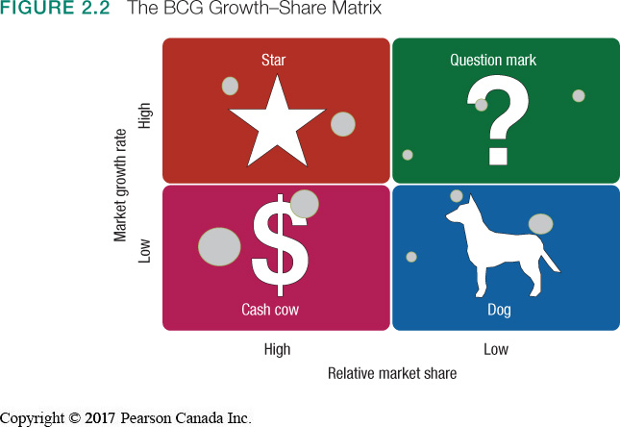
- Strategy: Build into cash cow via investment
Cash cows: High-share of low-growth market
- Strategies: Maintain or harvest for cash to build Stars
Question marks: Low-share of high-growth market
- Strategies: Build into Stars via investment OR reallocate funding and let slip into Dog status
Dogs: Low-share of low-growth market
- Strategies: Maintain or divest

Role of Marketing in Planning
- Value delivery network includes:
  - Company’s value chain
  - Suppliers
  - Distributors
  - Customers
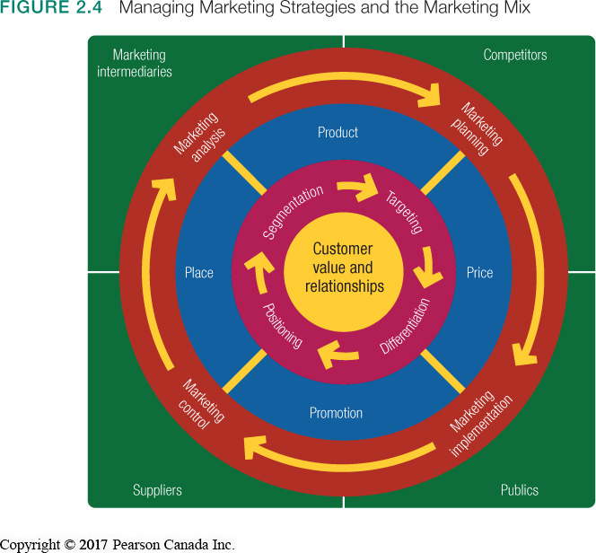
- The goal is improved performance in delivering value to customers

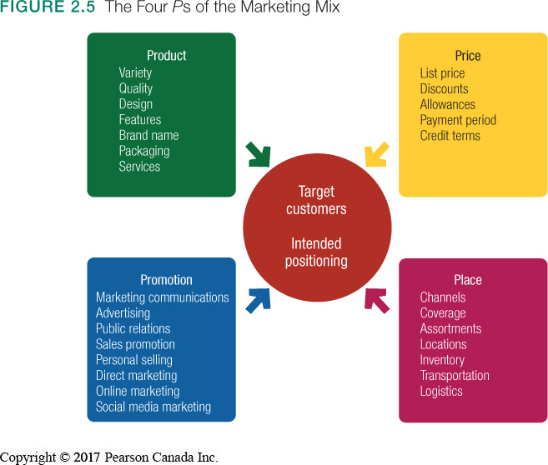

- Marketing Mix:
    - Product
    - Price
    - Place
    - Promotion

er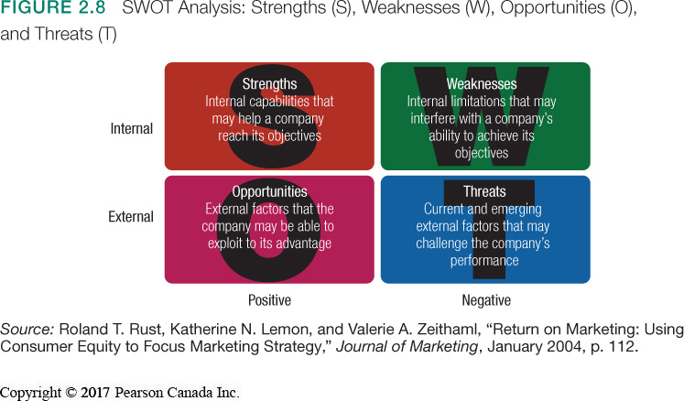

Chapter 4
Analyzing the Marketing Environment
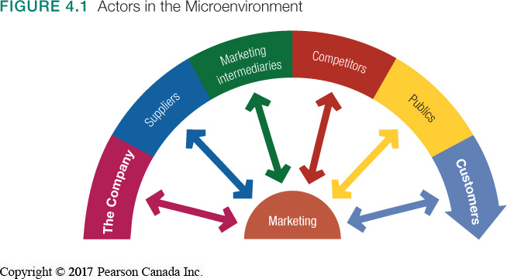
- Includes internal forces (e.g., company, suppliers, intermediaries) which the firm can control
- Includes external forces (markets, competitors, publics) for which the behaviour is outside the firm’s control
- Company forces include: corporate culture, leadership, ownership, finance, R&D, purchasing, operations, accounting
- These in turn can have great impact on marketing decisions and planning strategies
- All departments must work together to provide superior customer value
- Suppliers:
- Important link in the overall customer value delivery system
- Provide resources needed to produce goods and services
- Most marketers treat suppliers like partners in creating and delivering customer value
- Intermediaries:
- Help the company to promote, sell, and distribute its goods to final buyers
- Resellers
- Physical distribution firms
- Marketing services agencies
- Financial intermediaries

Marketing Intermediaries
  - Resellers
  - Physical distribution firms
  - Marketing service agencies
Chapter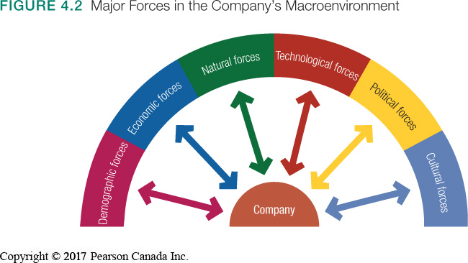

Chapter 5
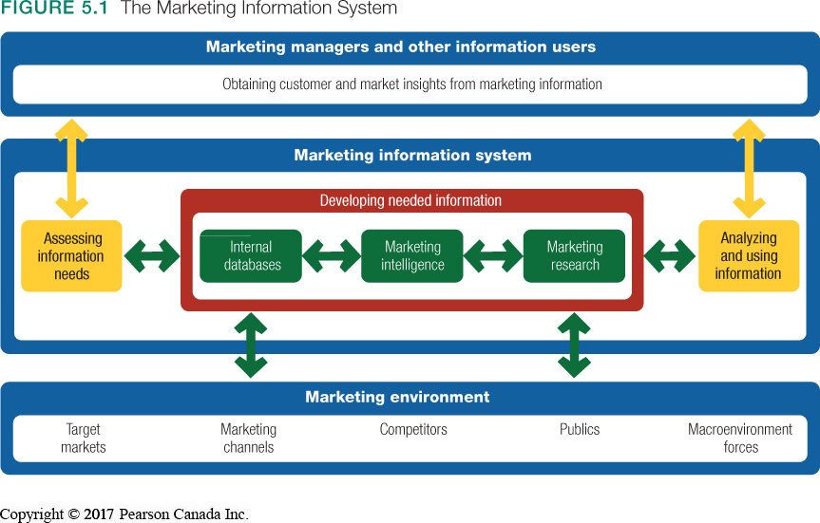
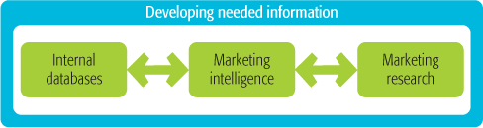
Developing Market information:

- Internal:
- Electronic collections of consumer and market information obtained from data sources within the company network (e.g., customer databases)
- Can be accessed more quickly and cheaply than other information sources
- However, may be incomplete or in the wrong form for marketing decisions
- Competitive marketing intelligence:
- Collection and analysis of publicly available information about consumers, competitors, and developments in the marketing environment (e.g., annual reports; brand discussions on blogs)
- Can raise ethical issues as some techniques are considered shrewd

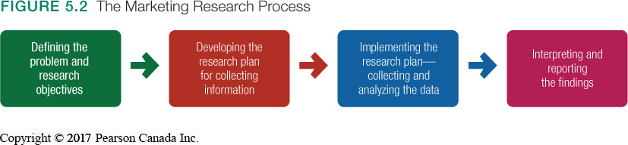
Marketing Research Process:

- Various Objectives:
  - Exploratory: Gathers information to help define the problem
  - Descriptive: Describes marketing situations or markets
  - Causal: Test hypotheses of cause-and-effect relationships
- Research plan outlines:
  - Sources of existing data
  - Specific research approaches
  - Contact methods and sampling plans
  - Instruments for data collection
Research plans may outline need for secondary and primary data
Secondary Data:
- Advantages of secondary data:
- Available more quickly and cheaply than primary data
- Can provide data individual firm cannot collect on its own
- Disadvantages of secondary data:
- Needed information may not exist
- Information may not be usable; must evaluate relevancy, accuracy, currency, and impartiality
- Secondary data rarely provides all necessary information, requiring firms to collect primary data
- Primary data:
- Consists of information collected for the specific purpose at hand
- Must be relevant, accurate, current, and unbiased

Implementation:
Collecting the data:
- Most expensive phase
- Subject to error
-Processing the data:
- Check for accuracy
- Code for analysis
- Analyzing the data:
- Tabulate results
- Compute statistical measures
Chapter 6

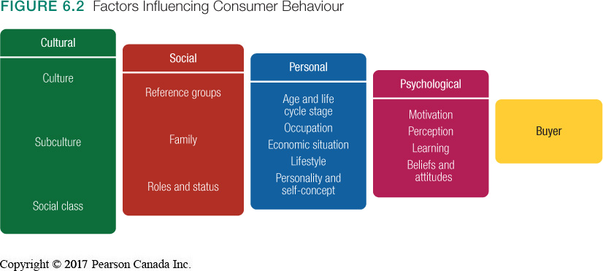

- Basic trigger of wants & behaviour
  - Deeply entrenched but when changed – creates opportunity
- Shared value systems within groups
  - Regional, Demographic, Ethnographic
  - Cultural Marketing
- Divisions based primarily on socio-economic status
  - Combination of occupation, income, education, wealth, and other variables

Membership, reference, and aspirational groups vary in how they influence
- Word-of-mouth influence/opinion leaders

Household “power-broker(s)” influence buying behaviour (parents, children)

Role = Expected activities
Status = Esteem given to role by society

- Needs for different products change

- Job affects the products bought
- Personal finances affects buying choices
- People buy the lifestyles products represent

- Self-concept theory suggests possessions contribute to and reflect personal identities

- Motive: a need requiring satisfaction
- Process of interpreting information
- Behavioural change based on experience

- Personal thoughts on subjects and evaluations thereof

Buyer Decision Process:
  - Need recognition: triggered internally or externally.
  - Information search: proceeds through a variety of sources:
    - Personal sources
    - Commercial sources
    - Public sources
    - Experiential sources
  - Evaluation of alternatives: depends on the buying situation and the consumer
  - Purchase decision: further influenced by:
- Attitudes of others
- Unexpected situational factors
  - Post-purchase behavior: hinges on buyer’s expectations vs. actual
performance of product.
- Most major purchases result in cognitive dissonance. ( Discomfort caused by post-purchase conflict)
Chapter 7

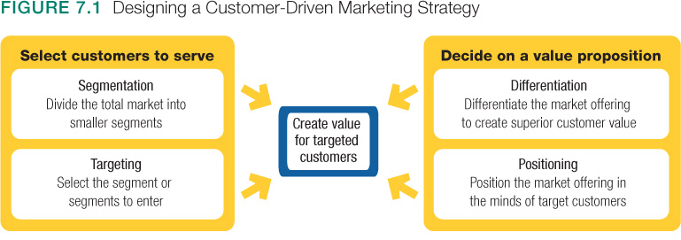
Market segmentation:
- Grouping buyers based on needs, traits, or behaviours that might require separate marketing strategies or mixes

Geographic segmentation
calls for dividing a market into different geographical units, such as global regions, countries, regions within a country, provinces, cities, or even neighbourhoods. A company may decide to operate in one or a few geographical areas or to operate in all areas but pay attention to geographical differences in needs and wants.
Demographic Segmentation
Age and life-cycle stage:
- addresses the fact that consumer needs and wants change with age
- Different products and marketing approaches are used for different life-cycle stages
Gender:
- Neglected gender segments can offer new opportunities
Household income:
- refers to total family income, whether one or both parents work
- Useful for targeting the affluent for luxury goods
- People with low annual incomes can be a lucrative market
- Troubled economy makes targeting all income groups a challenge
Ethnic or cultural segmentation:
-based on race, ethnicity and language

Psychographic Segmentation
- Social class
- Lifestyle
- Personality characteristics
Behavioural Segmentation
Occasions: Helps firms build up product usage
Benefits sought: Different segments desire different benefits from products
User status: Non-users, ex-users, potential users, first-time users, regular users
Usage rate: Light, medium, heavy
Loyalty status: Brands, stores, companies ,Divide into groups by degree of loyalty
Segmenting International Markets
  - Geographic location
  - Economic factors
  - Political and legal factors
  - Cultural factors
Segmenting consumers who have similar needs and buying behaviour even though they are located in different countries
Evaluating Market Segments
  - Competitors
  - New Entrants
  - Substitute products
  - Relative power of buyers
  - Power of suppliers

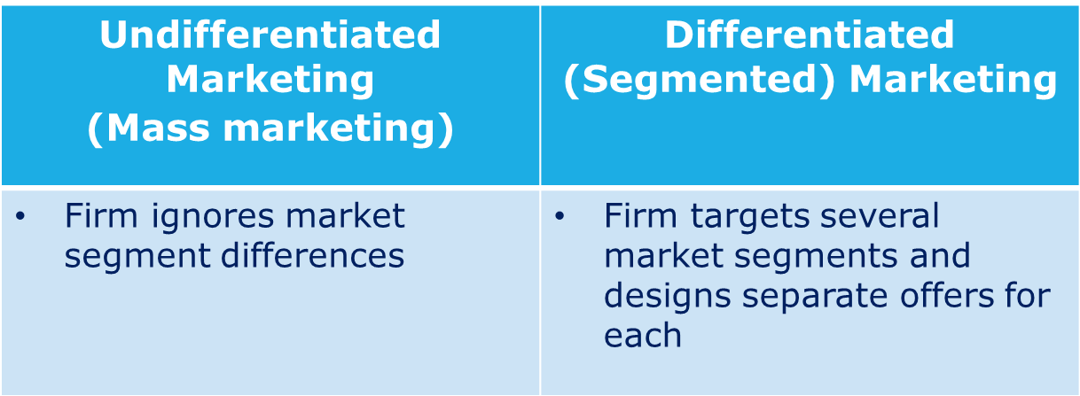
By using an undifferentiated marketing or mass marketing strategy, a firm might decide to ignore market segment differences and target the whole market with one offer. This mass-marketing strategy focuses on what is common in the needs of consumers rather than on what is different. The company designs a product and a marketing program that will appeal to the largest number of buyers.
Differentiated Marketing - By using a differentiated marketing or segmented marketing) strategy, a firm decides to target several market segments and designs separate offers for each. Toyota, for example, produces many different brands of cars, from Yaris to Lexus, each targeting a different group of car buyers—a different market segment. Procter & Gamble markets six different laundry detergent brands, which compete with each other on supermarket shelves. But perhaps no brand practises differentiated marketing quite like Hallmark Cards!

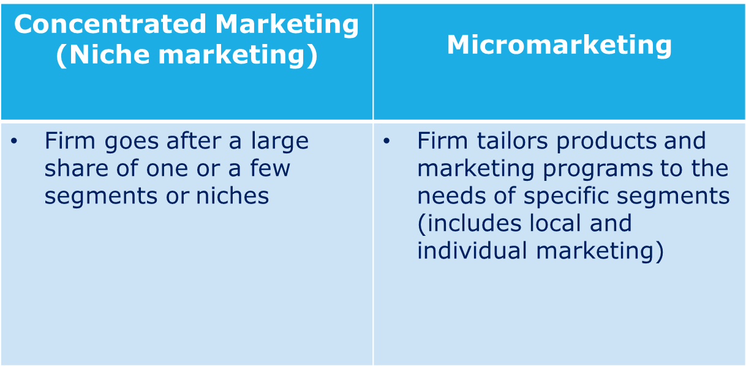
By using a concentrated marketing (or niche marketing) strategy, instead of going after a small share of a large market, the firm goes after a large share of one or a few smaller segments or niches.
Micromarketing is the practice of tailoring products and marketing programs to suit the tastes of specific individuals and locations. Micromarketing is an extreme form of market segmentation, where the market segment is so small that it’s contained within a small geographic area—local marketing—or so small that it consists of only one person—individual marketing.

Target Strategy
Companies need to consider many factors when choosing a market-targeting strategy. Which strategy is best depends on company resources. When the firm’s resources are limited, concentrated marketing makes the most sense.
The best strategy also depends on the degree of product variability. Undifferentiated marketing is more suited for uniform products such as grapefruit or steel. Products that can vary in design, such as cameras and cars, are more suited to differentiation or concentration. The product’s life-cycle stage must also be considered.
When a firm introduces a new product, it may be practical to launch only one version, and undifferentiated marketing or concentrated marketing may make the most sense. In the mature stage of the product life cycle, however, differentiated marketing often makes more sense.
Another factor is market variability. If most buyers have the same tastes, buy the same amounts, and react the same way to marketing efforts, undifferentiated marketing is appropriate.
Finally, competitors’ marketing strategies are important. When competitors use differentiated or concentrated marketing, undifferentiated marketing can be suicidal. Conversely, when competitors use undifferentiated marketing, a firm can gain an advantage by using differentiated or concentrated marketing, focusing on the needs of buyers in specific segments.

Differentiation and Position
- Product Position:
  - Consumer perception of products
  - Place product occupies in minds of consumers relative to competitors
A product position is the way the product is defined by consumers on important attributes—the place the product occupies in consumers’ minds relative to competing products. More often, positioning is based not just on the product, but on the product’s brand name. Branding experts say that products are created in the factory, but brands are created in the mind.
- A differentiation and positioning strategy involves:
  - Identifying competitive advantages
  - Selecting competitive advantage(s) on which to create position
  - Developing a positioning strategy
- Identifying competitive advantages:
  - Understand customer needs better than competitors, then deliver more value
  - Points of differentiation can occur anywhere in the entire customer experience
Ways to differentiate:
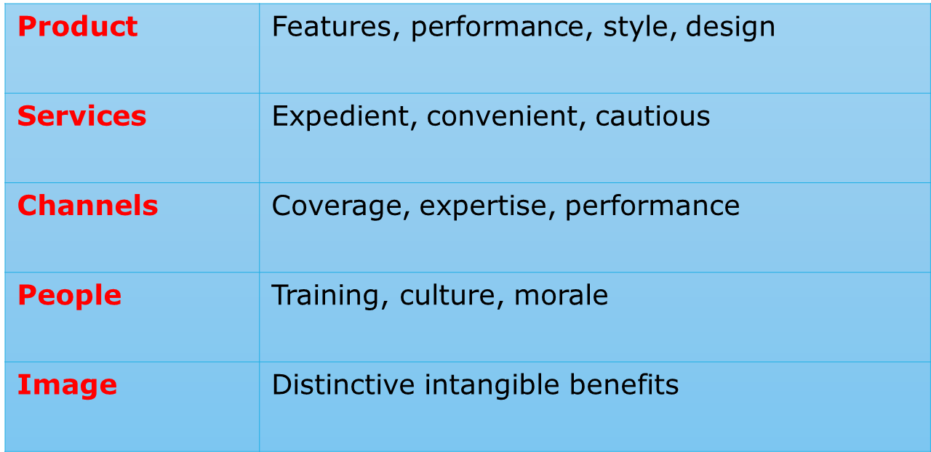

Differences to Promote:
- Important: The difference delivers a highly valued benefit to target buyers.
- Distinctive: Competitors do not offer the difference, or the company can offer it in a more distinctive way.
- Superior: The difference is superior to other ways that customers might obtain the same benefit.
- Communicable: The difference is communicable and visible to buyers.
- Preemptive: Competitors cannot easily copy the difference.
- Affordable: Buyers can afford to pay for the difference.
- Profitable: The company can introduce the difference profitably.
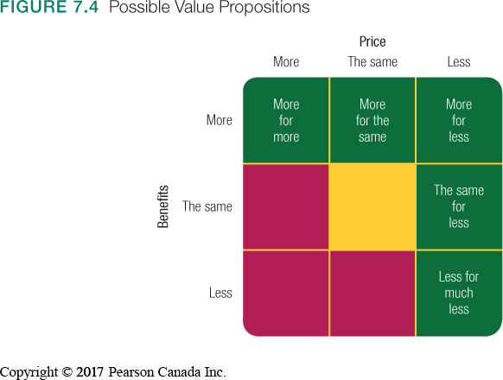
Positioning statement:
  - Format:
“To (target segment and need)
(our brand) is (a concept) that (point of difference).”
  - Example:
“To busy, mobile professionals who need to always be in the loop,
BlackBerry is a wireless connectivity solution that gives you an easier, more reliable way to stay connected to data, people, and resources while on the go.”

