COMM 210 FINAL

Chandler
- Economics of
  - Scale: large plants produce at lower costs than small plants because cost per unit DECREASES as volume of output INCREASES
    - E.g.: High fixed cost of a national network (tap water) large investment in huge network of water many households needs water, meaning that the cost per unit decreases, while output increases!
  - Scope: large plants use existing resources to make array of products and benefit from low average costs (like scale)
    - E.g.: A firm produces soft drinks uses marketing and distribution to make alcoholic beverages
- Major claims:
  - For firms to benefit from economies of scale and scope
    - Flows of materials must remain CONSTANT
    - National / International marketing and distribution functions must be created
    - Teams of lower and middle management are needed
- Secondary claims:
  - Once a firm loses the opportunity to be a FIRST MOVER, it is hard to regain competitive advantage
    - FIRST MOVER: Competitive advantage earned when company is the first to enter a particular market or industry
    - CHALLENGERS: Create distribution + sales to try and capture markets where first movers are already established
  - Entrepreneurial companies that don’t make investments to grow organizational capabilities cannot achieve long-term success
  - Growth through unrelated diversification is a poor corporate strategy (DQ hot food vs. ice cream)
  - Business ownership patterns decrease potential for long-term success (DQ-Partnership)
- Concept list:
  - Scale vs scope
  - Functional division, management hierarchy, geographical expansions
  - First movers vs. challengers
  - Research and development (R&D – Innovation)
  - Related and unrelated diversification
  - Entrepreneurial enterprise (staying small)
  - Separation of top and middle management (in the case of unrelated diversification)
- OWNERSHIP PATTERN: Many different owners = AGAINST chandler because then decision are difficult to make and people disagree
- UNRELATED DIVERSIFICATION: AGAINST idea of owning array of different products (coffee vs shoes)
- RELATED DIVERSIFICATION: FOR making products that are related (shoes and shoe laces)

Greiner
- Major claims:
  - Organizations grow through a series of evolution and revolution phases that are a function of the age and size of the organization
  - Management practices that go well in one phase bring about a crisis in another
- Secondary claims:
  - Organizations should not skip phases
  - Growth is NOT inevitable (or unavoidable)
  - Top management whose style is no longer appropriate should remove themselves (Second Cup, for example, were eliminating top people who were no longer applicable)
- Concept list:
  - Age of the organization: the life span of an organization
  - Size of the organization: company’s problems/solutions tend to change as the number of its employees and sales volume increase
  - Stages of evolution: periods of prolonged growth
  - Stages of revolution: time of crisis and turmoil between periods of evolution
  - Growth rate of industry: speed rate at which industry goes through stages is related to the market environment of the industry
  - Management style
  - Organizational structure
- Five Phases of Organizational Growth:
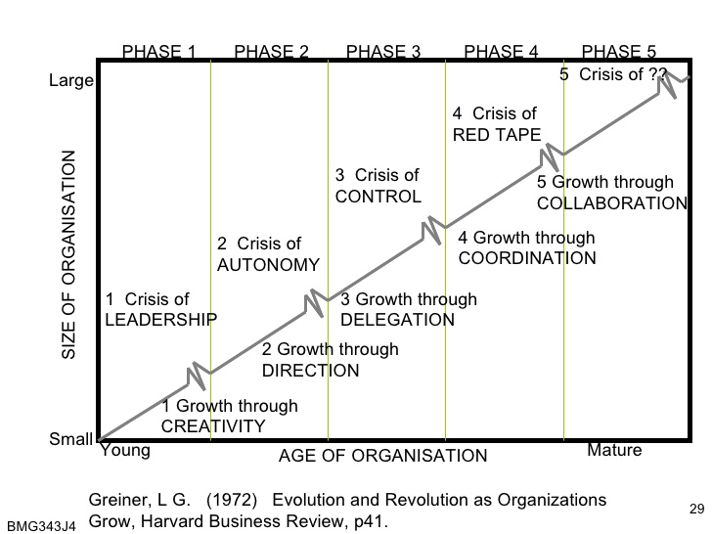

  - PHASE 1: CREATIVITY
    - Entrepreneurial
    - Informal communication
    - Low profits
    - Reactive to customers
    - ISSUES: Larger productions requires knowledge about efficiencies of manufacturing, standardization, employee & management motivation, more capital, and unwanted management responsibilities
    - CRISIS OF LEADERSHIP: Who will lead the company out of confusion and solve the managerial problems confronting it?
    - SOLUTION: Strong manager needed
  - PHASE 2: DIRECTION
    - Functional organizational structure introduced to separate manufacturing from marketing activities
    - Incentives, budgets, work standards are adopted
    - New management assumes most of responsibility; lower-level supervisors are treated like functional specialists
    - ISSUES: too much control, employees feel torn between following procedure and taking initiative, employees have more direct knowledge than management
    - CRISIS OF AUTONOMY: employees want more responsibility and ability to take initiative
    - SOLUTION: delegating responsibility to lower-level managers
  - PHASE 3: DELEGATION
    - Need to decentralize, give employees more responsibility, top management steps back
    - Bonuses for motivation = achieving growth through motivation
    - ISSUES: loss of control, information isn’t received
    - CRISIS OF CONTROL: management is trying to regain control, need new techniques
    - SOLUTION: Special coordination techniques
  - PHASE 4: COORDINATION
    - Use of formal systems to achieve better coordination
    - Decentralized units become product groups
    - Formal planning
    - Control & review
    - Centralize certain function
    - Use profit-sharing = achieve growth through resource allocation
    - ISSUES: lack of confidence grows between staff, all controls become a burden & very time consuming
    - RED TAPE CRISIS: producers take over problem solving, becomes too bureaucratic (overly concerned with procedure at expense of efficiency or common sense), no innovation
      - E.g.: Each dept has its own agenda, departments don’t cooperate to help each other to get the job done
    - Top management = misinformed and insulated from what is happening on front-line
    - Quantity over quality
    - Employees/customers = treated like numbers
    - SOLUTION: Collaboration to over-come red tape crisis
  - PHASE 5: COLLABORATION
    - Strong interpersonal collaboration
    - Spontaneous action through teams
    - Self-discipline
    - Flexible, behaviour approach to management
    - Matrix structure (for senior management)
    - ISSUES: organizations begin to look outside for partners/opportunities, to sell itself to larger company
- Advantages of large, bureaucratic organizations
  - Hierarchical authority: promises control and responsibility
  - Specialization of sub-units: promises accountability, control, and expertise
  - Management by rules: promises control and consistency
  - Being impersonal: promises objectivity, consistency, and equality

Tannenbaum and Schmidt
- How to lead:
  - Forces in the manager:
    - Value system
    - Confidence in subordinates
    - Own leadership inclinations
    - Feelings of security
  - Forces in the subordinate:
    - High need for independence
    - Readiness to assume responsibility
    - High tolerance for ambiguity
    - Identify with organizations problems and goals
    - Have knowledge and experience
    - Learned to be a part of decision making
  - Forces in the situation:
    - Type of organization
    - Group effectiveness
    - Nature of the problem
    - Time pressures
    - Long-run strategy
    - Objectives to be obtained

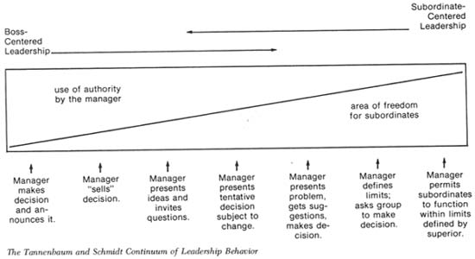

Collins and Porras
- Vision: provides guidance about what CORE to preserve + what FUTURE to stimulate progress toward
- Core ideology
  - Enduring character of the organization; consistent identity that transcends product/market life cycles, technological breakthroughs, management fads, and individual leaders
  - Glue that holds the business together
  - CORE VALUES
    - 3-5 values
    - essential/enduring tenets of belief
    - require no external justification
    - small set of timeless guiding principles
    - beliefs about what is important
  - CORE PURPOSE
    - 100 year test
    - organization’s reason for being or “raison d’etre”
    - the idealistic motivations for doing a company’s work
    - can never be fulfilled
    - captures the soul of the organization – “WHY do we exist?”
  - ENVISIONED FUTURE
    - What we aspire to become
    - Audacious/vivid goals that stimulate progress

- BHAGs: Big, Hairy, Audacious, Goal
  - 10-30 years
  - Powerful way to stimulate progress
  - Clear/compelling; a unifying focal point of efforts
  - Promotes team spirit
  - Takes little or no explanation
  - Not a sure bet…!
- Goal achievement
  - Vivid description
  - Beware of the “we’ve arrived” syndrome
  - What it would feel like to achieve BHAG
  - Picture people can carry around
  - Passion, emotion, conviction: essential
- Discovering core ideology:
  - You do not create/set core ideology
  - Description of what actually is, not what we wish existed
  - Meaningful/inspirational only to people within organization
  - Find people who are inclined to share organization’s core values/purpose
  - More than creating a “perfect statement”

Mintzberg
- Manager’s roles:
  - MYTH: Managers plan, organize, coordinate, and control
  - REALITIES:
    - Interpersonal roles:
      - Figurehead (a nominal leader without real power): performs ceremonial duties
      - Leader: responsible for work of people in their unit
      - Liaison (cooperation/relationship): contacts people outside the verticle chain of command
    - Informational roles:
      - Monitor: scanning environment for information
      - Disseminator: passes privileged information to subordinates
      - Spokesperson: passes information to people outside of the unit
    - Decisional roles:
      - Entrepreneur: seeks to improve unit
      - Disturbance-handler: responds to conflicts
      - Resource-allocator: decides who will get what resource
      - Negotiator: deal-making

French & Raven
- The concept of “POWER”: power is a relationship, not an attribute
- Types of power
  - Reward: based on one’s perception that the other has the ability to mediate (bring about) rewards for him
  - Coercive: based on one’s perception that the other has the ability to mediate punishments on him
  - Legitimate: based on one’s perception that the other has a legitimate right to prescribe behaviour to him
  - Referent: based on one’s identification with the other
  - Expert: based on one’s perception that the other has some special knowledge/expertise

Barney
- SWOT analysis (NOT BARNEY’S FRAMEWORK)
  - Traditional tool for strategic environment analysis
  - Two components: internal and external environment analysis
    - Internal: internal resources and capabilities of the firm (strengths and weaknesses)
    - External: business and societal trends, industry conditions and competitive environment (opportunities and threats)
- Barney provides a tool to assess company’s INTERNAL resources/capabilities
- Major claims
  - Firm will have a sustained, competitive advantage if its resources/capabilities are valuable, rare, Inimitable and organized in a way that allows it to achieve potential opportunities (VRIO framework)
  - A firm will be successful if it has resources with the right attributes/characteristics
  - The most careful/complete analysis of firm’s competitive environments cannot (by itself) define their success
  - Strategists also need to analyze the competitive implications of firms’ internal strengths/weaknesses
- Firm’s Resources/Capabilities: FINANCIAL, PHYSICAL, HUMAN, ORGANIZATIONAL assets used to develop, and deliver products/services to consumers
  - Financial: debt, equity, retained earnings, etc.
  - Physical: machines, manufacturing facilities, buildings
  - Human: experience, knowledge, judgment, wisdom, etc.
  - Organizational: history, relationships, trust, culture, formal reporting structure, patents, etc.
- FOUR important questions about resources/capabilities:
  - Question of VALUE: do they enable firm to achieve an opportunity, and/or neutralize a threat?
  - Question of RARENESS: how many competing firms already possess them?
  - Question of IMITABILITY: do firms without a resource/capability face a cost disadvantage in obtaining it to firms that already possess it?
    - Importance of history: valuable/rare resources acquired through unique historical circumstances can be considered sustainable, competitive advantages
    - Importance of numerous small decisions: firm’s competitive advantage depends on several small decisions through which resources/capabilities are developed/achieved
    - Importance of socially complex resources: reputation, trust, friendship, teamwork and culture, while not patentable are difficult to imitate
  - Question of ORGANIZATION: is a firm organized to achieve the full competitive potential of its resources/capabilities?
- Value, Rarity, Imitability, Organization – VRIO Framework

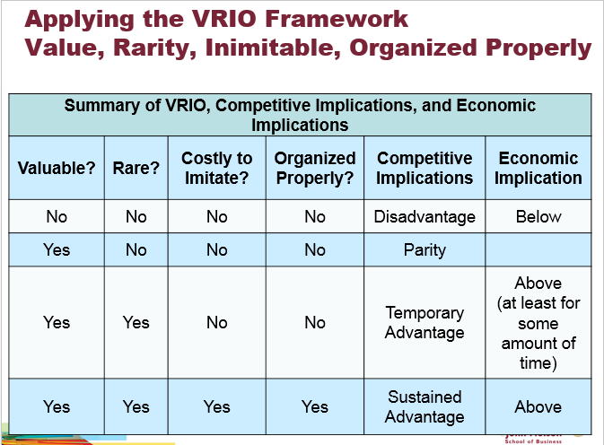

Kaplan & Norton
- The balanced scorecard
  - A performance measurement system/tool
  - What you measure is what you get
  - The traditional financial performance measures worked well for the industrial era, but the “bottom line” isn’t enough
- FOUR perspectives for balanced scorecard:
  - Customer perspective: what matters most to customers
  - Internal business perspective: how we can meet customer expectations
  - Innovation and learning perspective: how can we make continual improvements
  - Financial perspective: how can we ensure profitability for shareholders

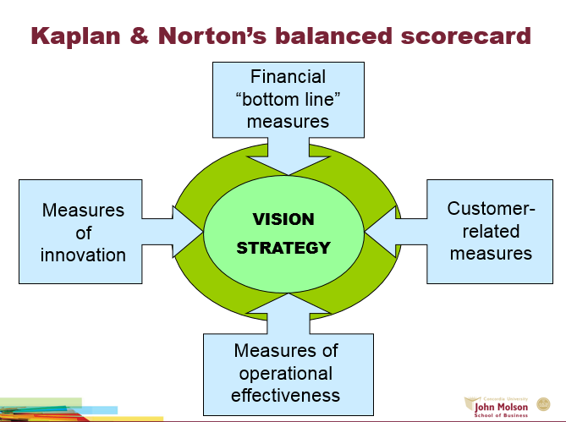

Handy
- Sigmoid Curve

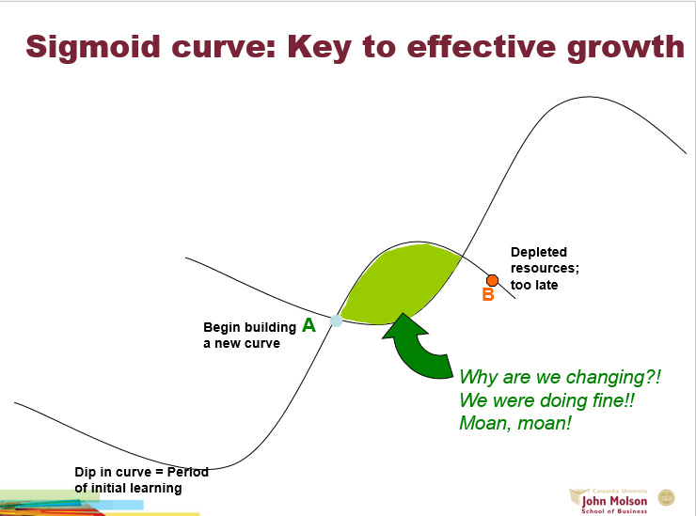

- The S-shaped curve:
  - Empires, corporations, product life cycles, love and relationships, personal career, etc.
  - The 2 curves: when should the 2nd curve begin?
  - Who should lead the 2nd curve?
  - Turmoil: time of great confusion!
- The “discipline” of the 2nd curve
  - Always assume you’re near peak of 1st curve (POINT A) and start preparing for 2nd curve. Even if you’ll be on 1st curve much longer, preparing for the downturn offers alternatives to spur on the start of the 2nd curve.
  - Keeping the 2 curves going should be habit
  - Benefits of the discipline of devising the 2nd curve: always prepared for downturn
  - Tradition four-stage of discovery:
    - Questions: what if X Y Z happens?
    - Ideas: come up with alternatives
    - Test + Review: Possible scenarios
    - Essential: let go of past
- “Curvilinear logic”
  - Conviction: the world (and everything in it) is a Sigmoid curve nothing lasts forever, it means starting life over again
  - Paradox of success: “What got you where you are won’t keep you where you are”
  - Starting life again harder as you get older
  - Entrust curvilinear logic to next generation
  - Be careful not to abandon 1st curve too soon
- Fertilizing the 2nd curve
  - Seniors: permission & encouragement
  - New ideas can co-exist with old
- The paradox of time
  - By the time you know where you have to go, it’s too late to go there
  - If you keep on going the way you are, you’ll miss the road to the future
  - Easy to explain things looking backward we think we can predict them going forward

Herzberg
- How to motivate employees:
  - Hygiene factors
  - Motivators
  - Dissatisfaction/satisfaction
  - Job enrichment / Vertical job loading
  - Job enlargement / Horizontal job loading
  - Negative KTA
  - Positive KTA
- Principles of Vertical Job Loading
  - Remove some controls while retaining accountability
  - Increase accountability of individuals for own work
  - Giver person a complete natural unit of work
  - Grant additional authority; job freedom
  - Make periodic reports directly available to workers themselves rather than supervisors
  - Introduce new, more difficult tasks
  - Assign workers to specialized tasks, enabling them to become experts
- Some steps of job enrichment
  - Select jobs + approach them with conviction they can be changed
  - Brainstorm changes
  - Screen to remove hygiene suggestions + horizontal job loading
  - Avoid direct participation by the employees whose jobs are to be enriched
  - Be prepared for an initial drop in performance
  - Expect first-line supervisors to suffer some anxiety

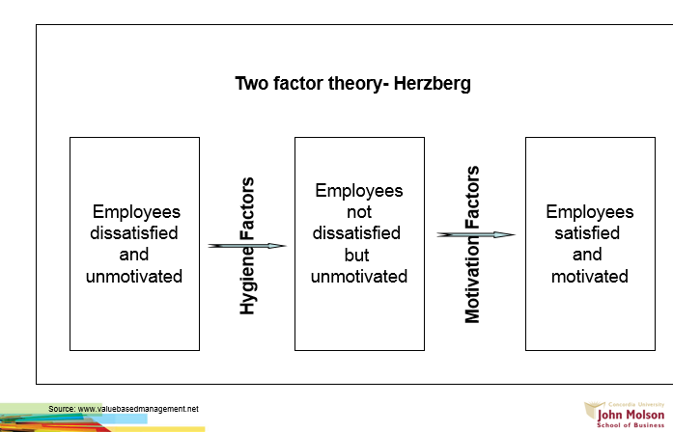

Terminology
- Claim: major conclusion author is trying to persuade you to accept
  - Implicitly stated: not directly expressed
  - Explicitly stated: clear and in detail
  - Cue words: “therefore, “thus”, “in summary”, “I believe that”, “clearly”, “in short”…
- Presenting claims: concept list/maps
- Concept maps: simple boxes-and-arrows figures that highlight main-issues and show relationships
- Unproblematic Claim
  - Consistent with our own experiences/observations
  - Facts independent of interpretation
  - Strongly supported general claims (common sense)
  - Technical/mathematical claims
- Contestable claims
  - Not commonly accepted knowledge
  - Often introduce ne ideal awakens curiosity
  - Sometimes presented as if it were a fact
  - Cannot stand on their own
  - Note: a once uncontestable claim can be re-examined in later years
- Critical thinking: analyzing validity of arguments presented in text
  - Identify author’s claim
  - Describe and evaluate supporting evidence
- Evidence: any statement that is a response to the question “why is this true?”
  - Criteria
    - Accuracy: difficult to judge without an independent source of information
      - 2 ways to proceed:
        - do our own research to verify accuracy
        - use proxies to evaluate accuracy: trivial errors, grammar, spelling, mistakes, inaccurate quotes, or lack of precision
    - Precision:
      - Creates the impression of accuracy
      - Come from numbers and quotes
      - 18.4% is better than “quite well” or “almost 20%”
      - Ambiguous words shouldn’t be overused
      - Numbers and direct quotes should be provided
      - Beware of over-precision
    - Sufficiency:
      - How much evidence
      - Importance of claim
      - Potential damage
      - Fallacy of hasty generalization
    - Representativeness (fallacy of hasty generalization)
      - Variety in the sources of evidence should match the variety in the population
      - Fallacy of hasty generalization
    - Authority
      - Training, credentials, experience of others
      - Classics or current writing
      - Context-dependent
      - Fallacy of false appeal to authority
      - Fallacy of argumentation ad populum (bandwagon)
    - Clarity of expression (quotations, etc.)
      - Quantitative data should be interpreted
      - Direct quotations should also be interpreted
      - Other objections: issues of relevance related to underlying assumptions

Underlying Assumptions: logical link that fills the gap between the evidence and the claim
- Implicit/explicit principles that form the basis of our beliefs and reasoning
- Tell us whether evidence provided for claim is relevant or not
- E.g.:
  - Claim: Canada should be boycotted
  - Evidence: Canada Goose kills Coyotes to make fur-lined hoods
  - Underlying assumption (gap): wearing fur is wrong
- Reality assumption: our beliefs about reality; about the way things are
- Value assumption: our ideals; standards of right/wrong; way things “ought to be”.

Causal Claims: author’s interpretation of cause and effect relationships
- Rival causes: the same evidence can be consistent with different interpretations
  - E.g.: due to high quality of our product, sales have increased. (or back order of competitor products? Or pricing?)
- Three types of rival causes:
  - Differences between groups:
    - E.g.: Team A is more organized than Team B so will they get a higher bonus (smarter? More experienced? Older? Better equipment?)
  - Association of characteristics:
    - Reverse causation: E.g.: using iPads makes students more creative creative students tend to use iPads.
    - Effect of 3rd variable: E.g.: Absenteeism is high and so is sales of tea in cafeteria (3rd variable – flu season)
  - The post hoc, ergo, propter hoc fallacy (after this, therefore, because of this)
    - E.g.: after a change in management, our sales dropped therefore the decrease in sales was because of new management (or recession, or low demand)

Persuasion
- Techniques of persuasion
  - Anticipate objections based on:
    - Negative evidence
    - Alternative causes
    - Conflicting assumptions
  - Counter-argue objections
  - Limit claims you cannot rebut
    - Acknowledging limitations makes your writing more persuasive
    - Limit generalizations
    - Level of probability less than 100%
    - Re-defining terms
  - Rhetoric use of language to convince
    - Detail (evidence and assumptions)
    - Tone (clarity vs. narrative)
    - Vividness (being concrete draws attention)

Writing a Persuasive Essay
- Outline your (contestable) claim and sub-claims
  - Ask yourself: “Why do I think this claim is true?” List reasons
  - Logic of your argument must be clear
- Arrange evidence
  - 2-3 pieces of evidence for each sub-claim (sufficient, accurate)
  - Views of experts, quotes from interviews (authoritative; precise)
  - Examples from your own experience, diverse, variety of others (representative)
  - Detailed descriptions/background information (precise)
- Give each section of your essay a meaningful subtitle (clarity)
- Ask yourself: any negative evidence? Anticipate reader objections? Need more evidence?
- Write your 1st draft
  - Don’t perfect 1st time
  - Don’t plagiarize
- Revise
  - Team contributions have to be integrated similarly
  - Introductory sentences engage reader’s interest/attention
  - Concluding sentences strong, summarizes
  - Visual aids charts, photos, clipart, concept maps
- Full list of references

