Stereochemistry Assignment

TITLE PAGE

Stereochemistry Assignment: Construction Assignment for Tuesday AM, Even Week

- $H_{2}NCH{(CH}_{3}){CH}_{2}{CH}_{3}$
There is only one chiral centre in the compound. Hence two stereoisomers are possible.
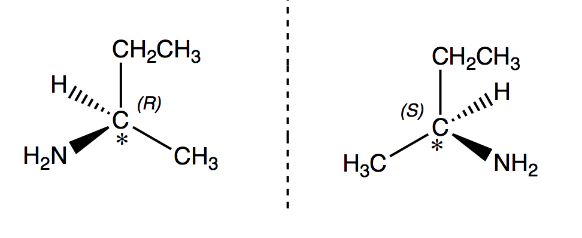

- ${CH}_{3}CH\left(OH\right)CH{(NH}_{2}){CH}_{3}$
There are two chiral centres present in the compound. Hence, four stereoisomers are possible.
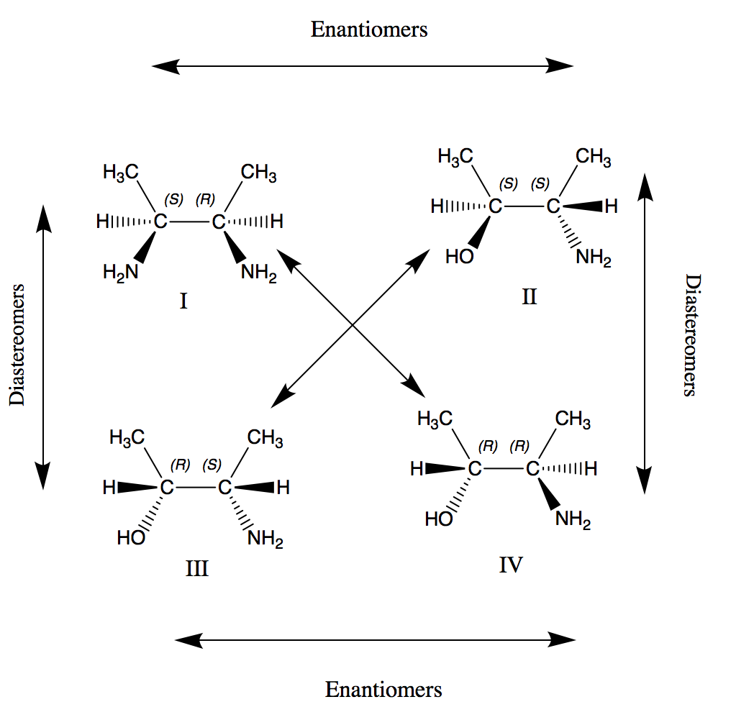
Diastereomers

- ${CH}_{3}{CH}_{2}CH{(CH}_{3}){CH}_{2}{CH}_{3}$
There is no chiral centre in the compound. No stereoisomers are possible.
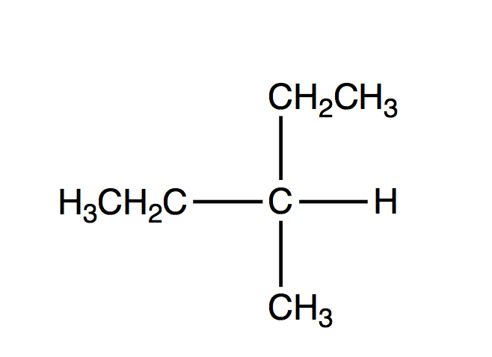

- ${CH}_{3}CH{(CH}_{3})CH{(CH}_{3})Cl$
- The asterisk (*) represents the stereoisomer.
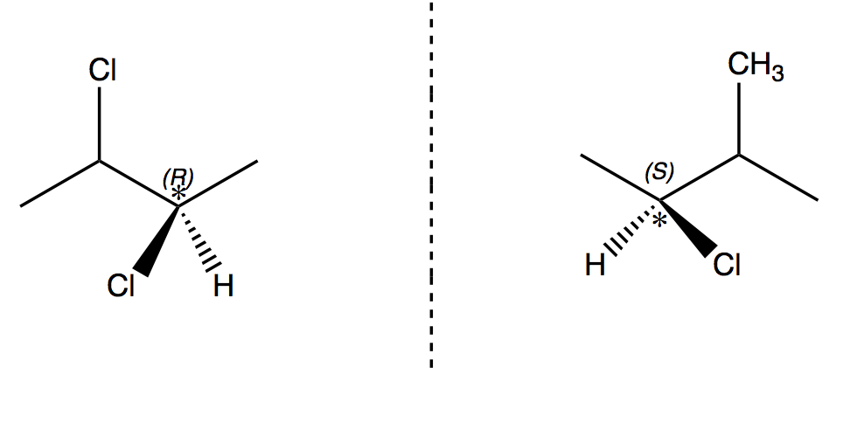

- The molecules images cannot be superimposed; therefore, both are enantiomers.
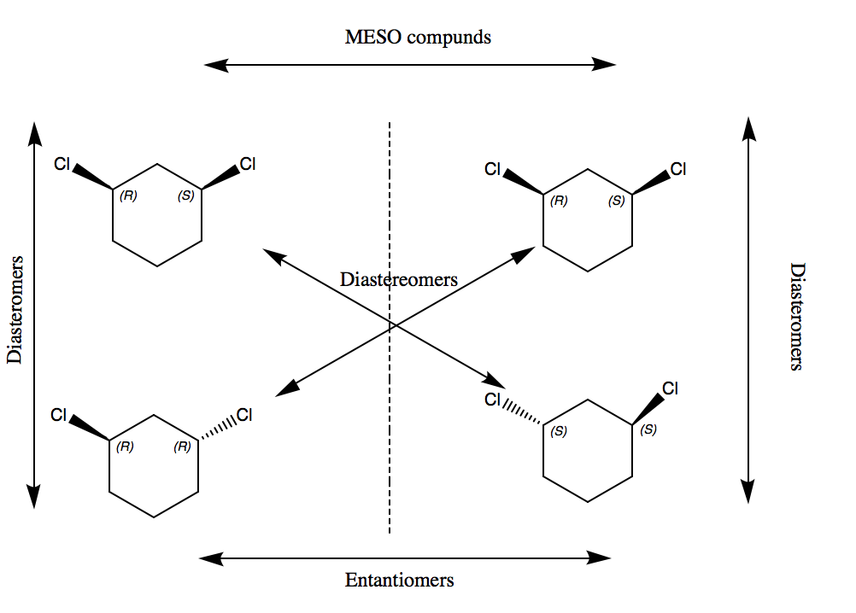
Diasteromers
MESO compounds

Newman Projections
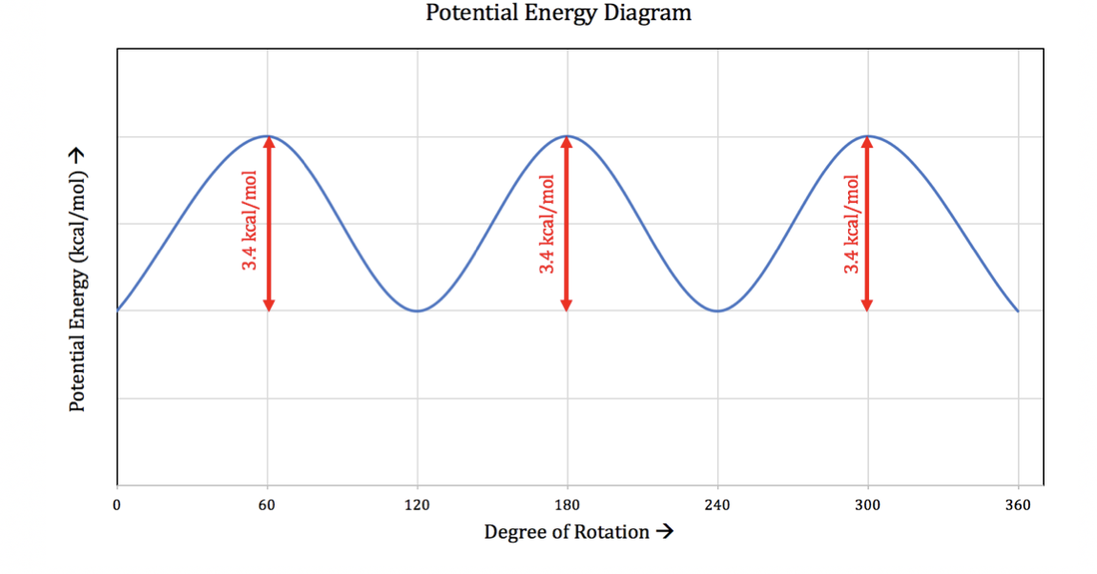
2. Energy Diagram of the free energy of $n-butane$:

3.

4. What is the energy difference between the two most stable conformations?

The difference between the two most stable conformations is 0 since they both have the same amount of energy due to the functional groups being in equatorial position.

Cyclohexanol

Questions 1-5
- & 2)

Questions 6
Boat conformer #1

Questions 8
Yes, the model can be converted to other boat conformers. This boat conformer #2 is more unstable since the OH group is in the axial position.

Boat Conformers 3 & 4:

Questions 10
The Newman projection of chair conformer number 1.

Questions 11
The Newman projection of chair conformer number 2.

The Newman projection of chair conformer (1) is the more stable chair conformer since the largest functional group $OH$ is in the equilatorial position versus the axial position of the functional group $OH$ in conformer (2).

Questions

- Draw the zig-zag structure of the R isomer of CH(OH)ClBr.
Asterisks represents the central atom.

- Draw the zig-zag structures of all the isomers of 2,3-diaminopentane. Draw the Newman projection along the C2-C3 bond of the major conformers of each isomer.

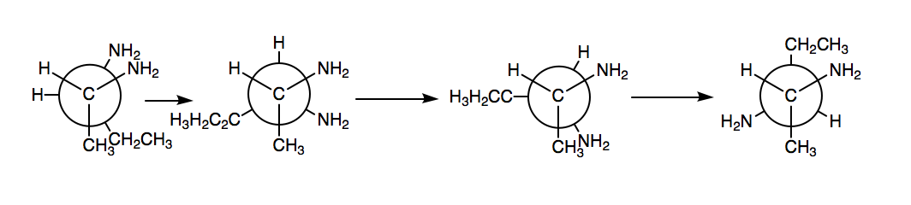

- How many stereoisomers are possible for the following compound? Draw them.

