Topic #1: Anatomical Terms
  - Become familiar with anatomical nomenclature (pp. 11-20)

  - Describe the anatomical position, the regional and the directional terms as well as planes and sections

The Anatomical Position of the Human Body (see Table 1.1)
To describe body parts/positions precisely & with as few words as possible:
- An initial reference point = body in standard anatomical position
- An indication of direction – remember that “right” and “left” refer to the patient or the cadaver, not the observer

The anatomical position is very simple: body erect, feet slightly apart, and palms face forward with thumbs pointing away from body

Regional Terms
Two fundamental divisions of body
- axial part: head & trunk
- Appendicular part: = appendages or limbs attached to axis

Then regional terms (see fig. 1.7) used to designate specific areas within the axial or appendicular part of the body

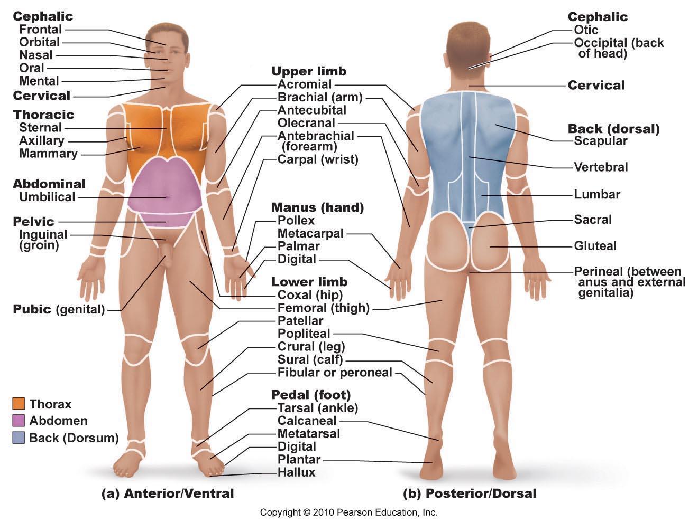

Body Planes & Sections

3 common body planes – 2 are vertical & 1 is horizontal
- Sagittal plane: vertical plane that divides body into right & left parts
Why not right and left halves? There are not perfect halves and will have differences.
What is a midsagittal or median plane? Goes down the mid line
What is a parasagittal plane? Does not go down the midline and is slightly shifted
- Frontal plane: vertical plane that divides the body into anterior and posterior parts; also called a coronal plane
- Transverse or horizontal plane: from right to left dividing the body into superior and inferior parts.
Transverse section = cross-section
What is an oblique section? It is an angle that is not straight. Harder to interpret

  - Describe the body cavities

1. Dorsal body cavity

Cranial cavity: enclosed by the skull and houses the brain
Vertebral (spinal) cavity: enclosed by the vertebral column houses and the spinal cord

Both cavities are continuous and well protected

2. Ventral body cavity
larger; houses the viscera
thoracic cavity: 2 lateral pleural cavities + central pericardial cavity abdominopelvic cavity: superior abdominal cavity (stomach, intestines, spleen, liver,) & inferior pelvic cavity (bladder, some preprod organs, rectum

What structure separates the thoracic and abdominopelvic cavities?? The Diaphragm. Abdominal and pelvic cavities? None.
In which body cavity do the organs receive the least protection from physical trauma.
Abdominal.

Abdominopelvic Quadrants

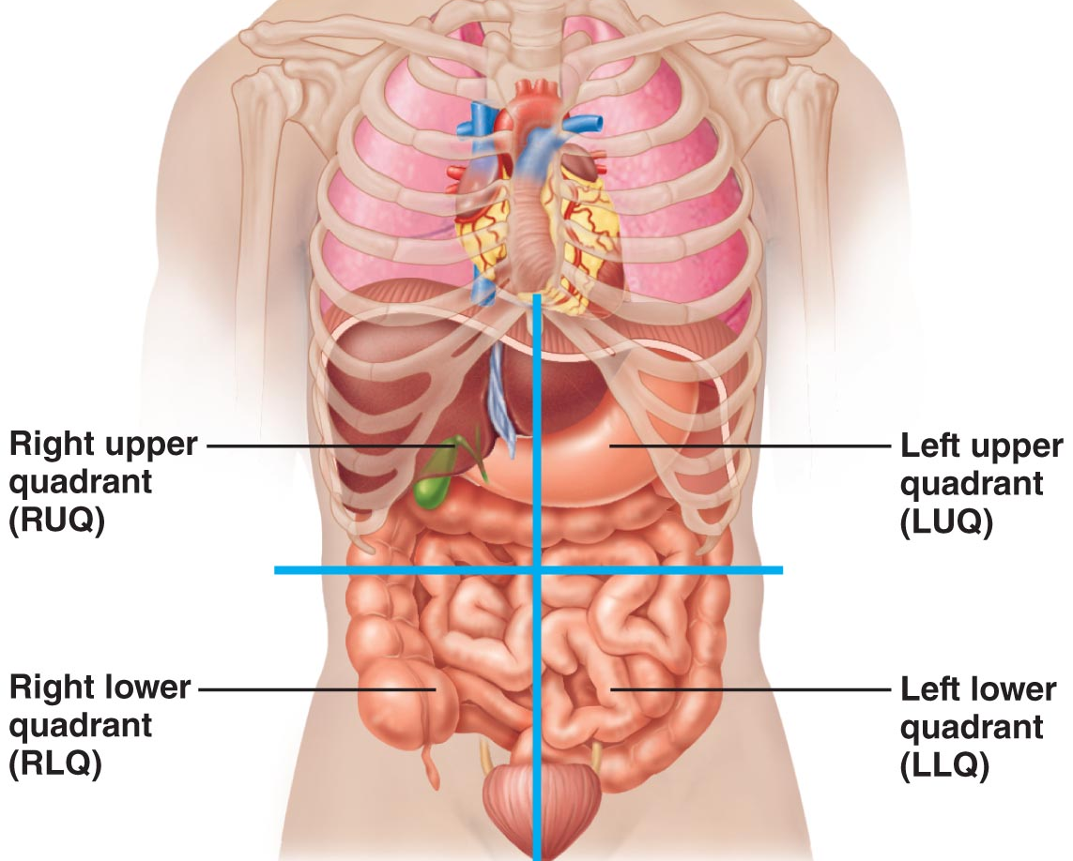

Nine abdominopelvic regions

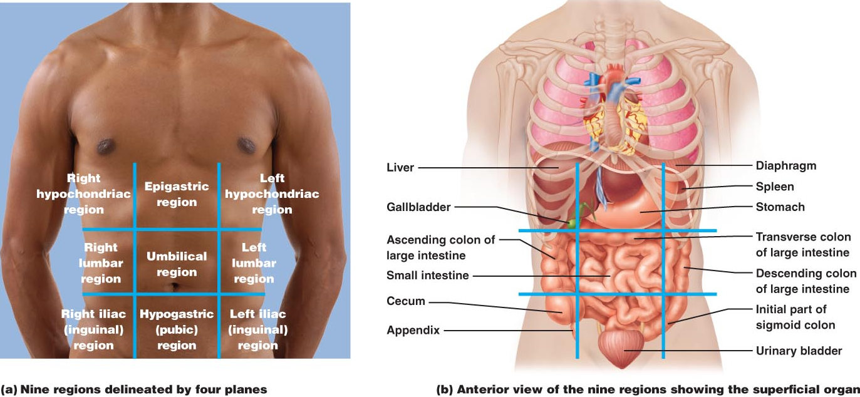

Fig 1.12: This division method is primarily used by anatomists.

