Biochemistry: covers the quantitative measurement of xenobiotics (drugs and their metabolites, and biological molecules in unnatural locations or concentrations) and biotics (marcomolecules, proteins, DNA, large molecule drugs, metabolites) in biological systems.

“SMS CIA CREST”: size, mass, shape, charge, isoelectric point, affinity interactions, chemical reactivity, electron structure

Selenocysteine: amino acid that is present in several enzymes
Hypusine: a non-standard amino acid found in all eukaryotes and in some archaea, but not in bacteria.

Kjeldahl method:
- a food is digested with a strong acid so that it releases nitrogen, which can be determined by a suitable titration technique.
- The amount of protein present is then calculated from the nitrogen concentration of the food.
- It is usually considered to be the standard method of determining protein concentration.
- Method doesn’t measure the protein content directly a conversion factor is needed to convert the measured nitrogen concentration to a protein concentration
- Conversion factor of 6.25 (0.16 g nitrogen per gram of protein) is used for many applications
  - Only a average value, each protein has a different conversion factor depending on its amino acid
- Divided into four steps:
  - Degradation
  - liberation of ammonia
  - capture of ammonia
  - back-titration
- Advantages:
  - widely used
  - standard method
  - precision and good reproducibility therefore major method for estimation of protein in food
- Disadvantages:
  - Doesn’t give a measure of true protein since all nitrogen in food is not in the form of protein
  - Different protein need different correction factors
  - Using sulphuric acid at high temps is hazardous
  - Time consuming
Dumas method:
- Capable of rapidly measuring the protein concentration of food samples.
- A sample of known mass is combusted in a high temperature chamber in the presence of oxygen.
- This leads to the release of CO₂, H₂O, and N₂.
- The CO₂ and H₂O are removed by passing the gasses over special columns that absorb them
- The nitrogen content is measure by passing the remaining gasses through a column that has a thermal conductive detector at the end
- The column helps separate the nitrogen from any residual CO₂ and H₂O that may have remained in the gas stream
- The instrument is calibrated by analyzing a material that is pure and has a known nitrogen concentration, such as EDTA
- The signal from the thermal conductivity detector can be converted into nitrogen content
- Advantages:
  - Faster than kjeldahl method
  - Doesn’t need toxic chemicals
  - Many samples can be measured automatically
  - Easy to use
- Disadvantages:
- High initial cost
- Doesn’t give measure of true protein
- Diff proteins need diff conversion factors
- Small sample size makes it difficult to obtain a representative sample

Measurement of Adsorption of Radiation
- UV Visible: The concentration of proteins can be determined by measuring the absorbance of ultraviolet radiation
- Infrared: infrared techniques can be used to fetermin the concentration of proteins in food samples.
  - Protein absorbs IR naturally due to characteristic vibrations (stretching and bending) of certain chemical groups along the polypeptide backbone.
  - Measurements of the absorbance of radiation at certain wavelengths can be used to quantify the concentration of protein in the sample.
  - IR is useful for rapid on-line analysis of protein content
  - Also requires a little sample prep and is non-destructive.
  - Major disadvantage is the need for extensive calibration.
- Nuclear Magnetic Resonance: NMR spectroscopy can be used to determine the total protein concentration of foods. Protein content is determined by measuring the area under the peak in an NMR chemical shift spectra that corresponds to the protein fraction. High initial cost
Measurement of Scattering Radiation
- Light scattering: the concentration of protein aggregates in aqueous solution can be determined using light scattering techniques because the turbidity of a solution is directly proportional to the concentration of aggregates present.
- Ultrasonic scattering: the concentration of protein aggregate can also be determined using ultrasonic scattering technique because the ultrasonic velocity and absorption of ultrasound are related to the concentration of protein aggregates present

Scopes Method
- Direct measurement at 205 nm
- If the protein of interest contains few or no Trp or Tyr residues, the concentration may be determined by measuring the absorbance at 205 nm.
- Most of the absorbance at 205 nm is due to peptide bonds, but scopes described a method to estimate molar extinction coefficient at 205 nm for proteins that also contain some Trp and Tyr residues.
- Method of choice for proteins that don’t contain Trp or Tyr residues.
- Works best for dilute protein solutions that are in non-absorbent buffers or solvents

Pace Method
- Direct measurement at 280 nm
- Proteins in solution absorb UV light with absorbance maxima at 280 and 205 nm.
- Amino acids with aromatic rings are the primary reason for the absorbance peak at 280 nm
- Peptide bonds are responsible for the peak at 205 nm
- Secondary, tertiary and quaternary structure all affect absorbance, therefore factors such as pH, ionic strength, etc. can alter the absorbance spectrum.
- ε280= (5500x ntrp)+(149+xntyr)+(125xns-s)

Measuring Total Concentration of Proteins
- Biuret
- BCA
- Lowry
- All depend on the “biuret reaction”

Biuret Reaction
- By reducing the copper ion from cupric to cuprous form, the reaction produces a faint blue-violet color
- 2 reactions involved: chelation and redox reaction
- A violet-purplish color is produced when cupric ions (Cu²⁺) interact with peptide bonds under alkaline conditions. The biuret reagent, which contains all the chemicals required to carry out the analysis, can be purchased commercially. It is mixed with a protein solution and then allowed to stand for 15-30 minutes before the absorbance is read at 540 nm.
- The major advantage of this technique is that there is no interference from materials that adsorb at lower wavelengths, and the technique is less sensitive to protein type because it utilizes absorption involving peptide bonds that are common to all proteins, rather than specific side groups.
- However, it has a relatively low sensitivity compared to other UV-visible methods.
Bicinchoninic Acid (BCA) Protein Assay
- The BCA Protein Assay combines the protein-induced biuret reaction with the highly sensitive and selective colorimetric detection of the resulting cuprous cation (Cu⁺¹) by bicinchoninic acid (BCA).
- Thus, two steps are involved.
  - First is the biuret reac;on, whose faint blue color results from the reduction of cupric ion to cuprous ion.
  - Second is the chelation of BCA with the cuprous ion, resulting in an intense purple color.
- The purple colored reaction product is formed by the chelation of two molecules of BCA with one cuprous ion.
- The BCA/copper complex is water-soluble and exhibits a strong linear absorbance at 562 nm with increasing protein concentrations.
- The purple color can be measured at any wavelength between 550 nm and 570 nm with minimal (less than 10%) loss of signal.
- The BCA reagent is approximately 100 times more sensitive (lower limit of detection) than the biuret reagent.
Lowry Method
- The method combines the reactions of copper ions with the peptide bonds under alkaline conditions (the Biuret test) with the oxidation of aromatic protein residues.
- The Lowry method is best used with protein concentrations of 0.01-1.0 mg/mL and is based on the reaction of Cu⁺¹, produced by the oxidation of peptide bonds, with Folin-Ciocalteu reagent (a mixture of phosphotungstic acid and phosphomolybdic acid in the Folin-Ciocalteu reaction).
- The reaction mechanism is not well understood, but involves reduction of the Folin reagent and oxida;on of aroma;c residues (mainly tryptophan, also tyrosine). The concentration of the reduced Folin reagent is measured by absorbance at 750 nm.
- As a result, the total concentration of protein in the sample can be deduced from the concentration of Trp and Tyr residues that reduce the Folin reagent

Dye Binding Methods:
- Bradford
- Pierce 660 nm
- 1,8-ANS
- A known excess of a negatively charged (anionic) dye is added to a protein solution whose pH is adjusted so that the proteins are positively charged (i.e. < the isoelectric point). The proteins form a complex with the dye because of the electrostatic attraction between the molecules. The anionic dye binds to cationic groups of the basic amino acid residues (histidine, arganine and lysine) and to free amino terminal groups.

Coomassie Dye (Bradform) Protein Assay
- In the acidic environment of the reagent, protein binds to the Coomassie dye.
- This results in a spectral shift from the reddish/brown form of the dye (absorbance maximum at 465 nm) to the blue form of the dye (absorbance maximum at 610 nm).
- The difference between the two forms of the dye is greatest at 595 nm, so that is the optimal wavelength to measure the blue color from the Coomassie dye-protein complex. If desired, the blue color can be measured at any wavelength between 575 nm and 615 nm. At the two extremes (575 nm and 615 nm) there is a loss of about 10% in the measured amount of color (absorbance) compared to that obtained at 595 nm.
- Development of color in coomassie dye-based (Bradford) protein assays has been associated with the presence of certain basic amino acids (primarily arginine, lysine and histidine) in the protein.
- Van der Waals forces and hydrophobic interactions also participate in the binding of the dye by protein. The number of Coomassie dye ligands bound to each protein molecule is approximately proportional to the number of positive charges found on the protein.
- Free amino acids, peptides and low molecular weight proteins do not produce color with coomassie dye reagents.
- In general, the mass of a peptide or protein must be at least 3,000 daltons to be assayed with this reagent. The assay is performed at room temperature and no special equipment is required. Simply add the sample to the tube containing reagent and the resultant blue color is measured at 595 nm following a short room-temperature incubation.
- The coomassie dye containing protein assay is compatible with most salts, solvents, buffers, thiols, reducing substances and metal chelating agents encountered in protein samples.
Pierce 660 nm Protein Assay
- Thermo Scientific Pierce 660 nm Protein Assay is a dye-based reagent that offers the same convenience as Coomassie-based assays while overcoming several of their disadvantages.
- Pierce 660 nm Assay is compatible with most detergents and produces a more linear response curve.
- The reagent contains a proprietary dye-metal complex in an acidic buffer. The dye-metal complex binds to protein in the acidic condition, causing a shift in the dye's absorption maximum, which is measured at 660 nm. The reagent is reddish-brown and changes to green upon protein binding. The color produced in the assay is stable and increases in proportion to a broad range of increasing protein concentrations. The color change is produced by the deprotonation of the dye at low pH facilitated by protein-binding interactions through positively charged amino acid groups and the negatively charged deprotonnated dye-metal complex.

Non-Covalent Binding Fluorescent Dyes
- Binding of 1,8-ANS (1-anilinonaphthalene-8-sulfonic acid) to proteins is noncovalent and involves a combination of electrostatic and hydrophobic modes.
- 1,8-ANS is a fluorescent dye that binds with high affinity to hydrophobic surfaces of proteins.
- The emission maximum of 1,8-ANS undergoes a blue shift and fluorescence intensity increases significantly upon binding to low polarity regions of a protein surface.
- Fluorescence enhancement of 1,8-ANS upon binding to protein. The image shows aqueous solutions of 1,8-ANS excited by ultraviolet light. Addition of protein (bovine serum albumin) to the solution in the cuvette on the left results in intense blue fluorescence. In comparison, the fluorescence of uncomplexed free dye in the cuvette on the right is negligible.

Amine Reacting Methods
- OPA
- Fluorescamine
- FQ
- CBQ
OPA
- o-Phthalaldehyde [OPA] Fluorescent Protein Assay
- OPA will react only with primary amines.
- When reacted with primary amines in the presence of mercaptoethanol, OPA yields an intense blue colored fluorescent product that has a maximum wavelength of excitation of 340 nm and emission at 455 nm.
- Wavelengths from 330-375 nm have been used for excitation and 436-490 nm for measuring emission.
- Protein concentrations as low as 50 ng/ml can be measured with an OPA assay.
- The inherent sensitivity and speed of OPA, along with its broad linear range, makes it a useful protein and peptide assay reagent.
- OPA is ideal for assaying peptides that do not contain tyrosine residues, or for other applications in which absorbance at 280 nm cannot be used.
Fluorescamine
- Fluorescamine is intrinsically nonfluorescent but reacts in milliseconds with primary aliphatic amines, including peptides and proteins, to yield a fluorescent derivative.
- This amine-reactive reagent has been shown to be useful for determining protein concentrations of aqueous solutions and for measuring the number of accessible lysine residues in proteins.
- Protein quantitation with fluorescamine is particularly well suited to a minifluorometer or fluorescence microplate reader.
- Fluorescamine can also be used to detect proteins in gels and to analyze low molecular weight amines by TLC, HPLC and capillary electrophoresis.
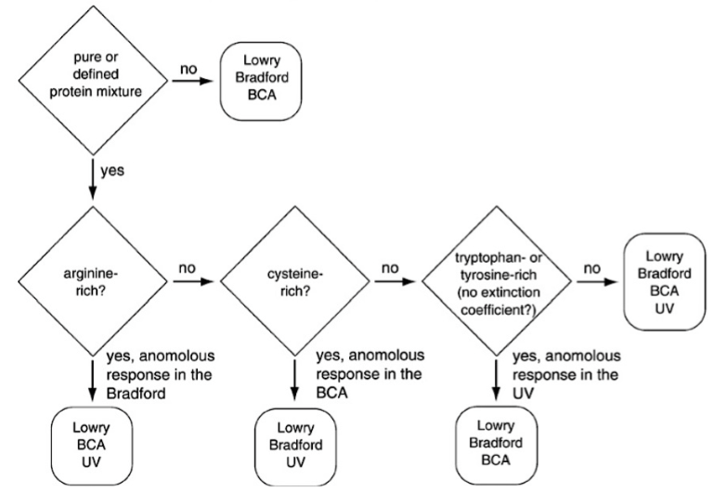

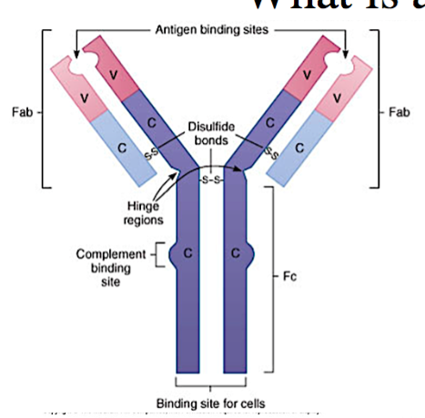
Antibodies
- a blood protein produced in response to and counteracting a specific antigen.
- Structure:
  - IgG antibodies consist of four chains, two heavy chains (blue) and two light chains (red), linked by disulfide bonds. The heavy and light chains come together to form Fab domains, which have the antigen-binding sites at the ends. The two heavy chains form the Fc domain. The Fab domains are linked to the Fc domain by flexible linkers.
- Classes:
  - There are 5 classes of antibodies:
    - IgG, IgA, IgM, IgD, IgE
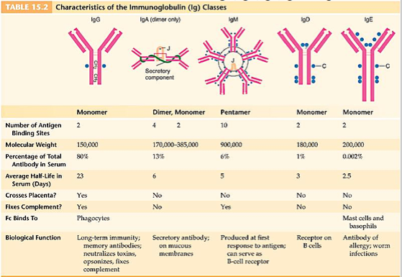
- Functions:
  - 4 functions:
    - 1. Neutralize (trap) the antigen
    - 2. Agglutinate (round up) the antigen and immobilize them until macrophages can ingest them
    - 3. Opsonize (coat) the antigen to stimulate macrophage-mediate phagocytosis
    - 4. “Mark” the antigen for destruction by complement protein binding (complement fixation)
Polyclonal and Monoclonal Antibodies
- Most antigens have several epitopes.
- Polyclonal antibodies are heterogeneous mixtures of antibodies, each specific for one of the various epitopes on an antigen.
- Monoclonal antibodies are all identical, produced by clones of a single antibody-producing cell. They recognize one specific epitope.
Producing polyclonal antibodies
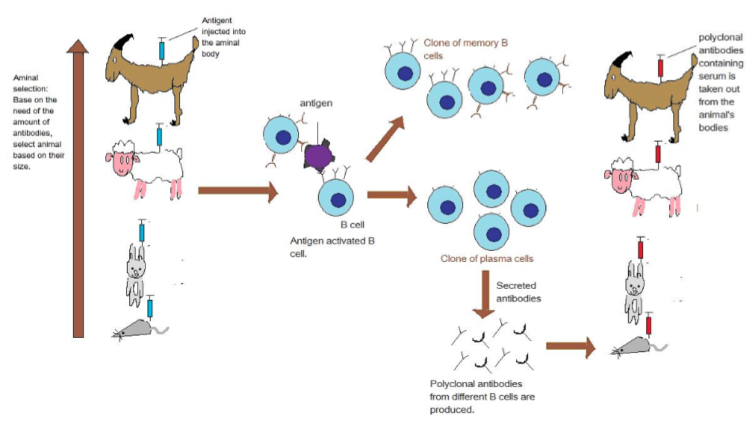
- Based on the need of the amount of antibodies, select animal based on their size
- Inject antigen into the animals body
- Antigen activated B cell
- Clone of memory B cells and of plasma cells
- Addition of secreted antibodies
- Polyclonal antibodies from different B cells are produced
- Polyclonal antibodies containing serum is taken out of animals body
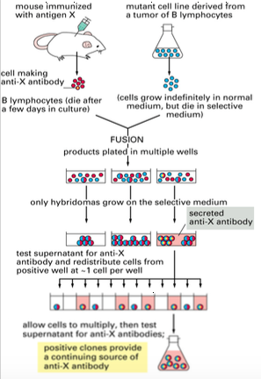
Preparation of Monoclonal Antibodies
- Hybridoma cells are formed by fusion of antibody-producing cells and myeloma cells. The hybrid cells are allowed to proliferate by growing them in selective medium. They are then screened to determine which ones produce antibody of the desired specificity.
ELISA
- Enzyme-Linked ImmunoSorbent Assay
- Used to screen donated blood for evidence of viral contamination, measure hormone levels, detecting infections, detecting illicit drugs, detecting allergens in food and house dust
- Types of ELISA
  - Indirect ELISA
Non-competitive ELISA
  - Direct ELISA
  - Sandwich ELISA
  - Competitive ELISA
Indirect ELISA
- Indirect ELISA is used to detect infecPon by tesPng paPents’ blood for the presence or absence of ANTIBODIES against a parPcular pathogen.
- The presence of such anPbodies indicates that the individual has been infected and that their body has launched an immune response against the disease-causing agent.
- Enzyme activity measure is proportional to amount of specific antibody in
original serum
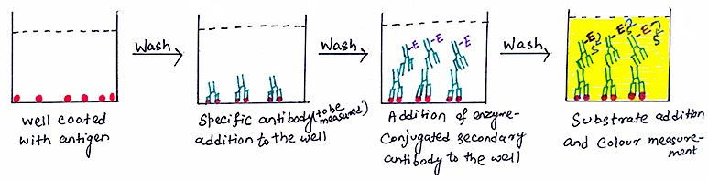

Direct ELISA
- Assays for the presence or absence of certain antigens in patients’ blood
- Steps:
  - Apply a sample of known antigen to a surface
  - Enzyme linked primary antibody is applied to the plate
  - Washed, after this wash, only the antibody-antigen complexes remain attached
  - Apply a substrate which is converted by the enzyme to elicit a chromogenic signal
- Enzyme activity measured is proportional to amount of specific antibody in the original serum
Sandwich ELISA
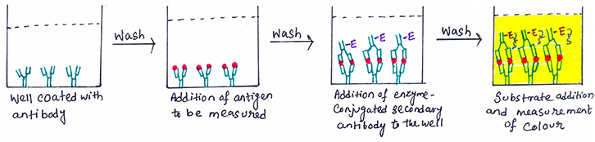
- Plate is coated with suitable antibody
- Blocking buffer is added
- Sample is added to plate so antigen is bounded by capture antibody
- A suitable biotin labeled detection antibody is added to plate
- Enzyme HRPO is added and binds the biotin labeled detection antibody
- TMB substrate is added and converted by HRPO to colored product
- The enzyme activity measurement is proportional to the amount of specific antigen in the original serum

Competitive ELISA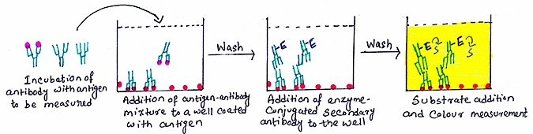
- Unlabeled primary antibody is first incubated in solution with a sample containing antigen
- The antigen-antibody mixture is then added to an antigen coated microtiter well
- The more antigen present in the sample, the less free antibody will be available to the antigen coated-well. Therefore competition arises.
- The plate is washed to remove any unbound antibody
- The enzyme-conjugated secondary antibody, specific for the isotype of the primary antibody is added to determine the amount of primary antibody bound to the well
- A substrate is added, and colour change is measured
- The concentration of antigen in the original sample in inversely proportional to the colour produced

Different forms of ELISA
- Direct ELISA
- Indirect ELISA
- Direct sandwich ELISA
- Indirect sandwich ELISA
- Direct competition ELISA
- Indirect competition ELISA

ELISPOT Assay
- 1. The wells of the microtiter plate are coated with the antigen (capture antigen) recognized by the antibody of interest or with the antibody (capture antibody) specific for the antigen whose production is being assayed.
- 2. This assay is commonly used to detect cytokine secreted from different cells.
- 3. A suspension of cell population thought to contain some members secreting cytokine are added to the wells coated with relevant antibodies (capture antibodies). It is allowed to be incubated.
- 4. After the incubation period, the wells are washed and enzyme-labeled anti-cytokine antibodies (detection antibodies) are added.
- 5. Then again the wells are washed to remove any unbound antibody. After washing the wells, a chromogenic substrate that forms an insoluble colored product is added.
- 6. The colored product precipitates and forms a spot only on the areas of the wells, where cytokine-secreting cells had been deposited.
- 7. The number of cytokine-secreting cells present in the added cell suspension were identified by counting the number of colored spots.
Immunoflorescence: an antigen-antibody reaction where the antibodies are tagged with a fluorescent dye and the antigen-antibody complex is visualized using UV microscope.
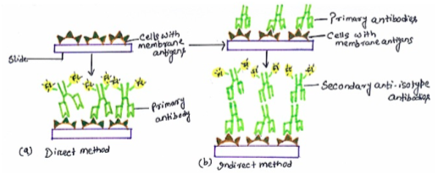
Flow Cytometry
- the technological process that allows for the individual measurements of cell fluorescence and light scattering. This process is performed at rates of thousands of cells per second.
- Flow cytometry integrates electronics, fluidics, computer, optics, software, and laser technologies in a single platform.
- Each cell generate a quanta of fluorescence
- Negative cells are also detected
FSC and SSC
FSC: forward scatted- diffracted light
- Related to cell surface area
- Detected along axis of incident light in the forward direction
SSC- side scatter- reflected and refracted light
- Related to cell granularity and complexity
- Detected at 90° to the laser beam
Clusters of Differentiation (CD)
- Profile different cells
- Can profile immune cells, cancer cells
FACS
- Fluorescence activated cell sorting
- a specialized type of flow cytometry. It provides a method for sorting a heterogeneous mixture of biological cells into two or more containers, one cell at a time, based upon the specific light scattering and fluorescent characteristics of each cell.
Electrostatic Flow Sorting
- After the cells are interrogated by the laser, vibrations separate the sample stream into droplets containing either one or zero cells, called the “break-off point”
- At the point at which the stream breaks into droplets, it passes through an electrically charged ring which charge cells based on the results detected by the cytometer’s laser and detector system
- The cells then pass by charged plates which sort he cells based on the charge that they have been given

Mass cytometry: allows single-cell atomic mass spectrometry of heavy elemental
(>100 Da) reporters. An affinity product (e.g. antibody) tagged with a specific element binds to the cellular epitope. The cell is introduced into the ICP by droplet nebulization. Each cell is atomized, ionized, overly abundant ions removed, and the elemental composition of remaining heavy elements (reporters) is determined. Signals corresponding to each elemental tag are then correlated with the presence of the respective marker and analyzed using conventional cytometry platforms.

Types of Luminescence
- Fluorescence
  - Happens quickly after the absorption of the initial photon (us to ps lifetime)
- Phosphorescence
  - Happens slowly after the absorption of the initial photon (min to ms lifetime)
- Chemiluminescence
  - Excitation arises from a chemical reaction instead of photoabsorption
Internal Conversion: radiationless transition to lower state when vibrational energies math
External Conversion: radiationless transition to lower state by collisional deactivation
Intersystem Crossing: transition with spin change
Fluorescence: emission not involving spin change
Dissociation: excitation to vibrational state with enough energy to break bond
Predissociation: relaxation to state with enough energy to break bond
Fluorescence Quantum Yield: ratio of number of molecules fluorescing to number excited.
GFP and EGFP
- Green Fluorescent Protein is a protein produced by a jellyfish Aequorea victoria; which produces glowing points of light around the margin of it's umbrella. The light arises from yellow tissue masses that each consists of about 6000-7000 photogenic cells.
- Enhanced green fluorescent protein

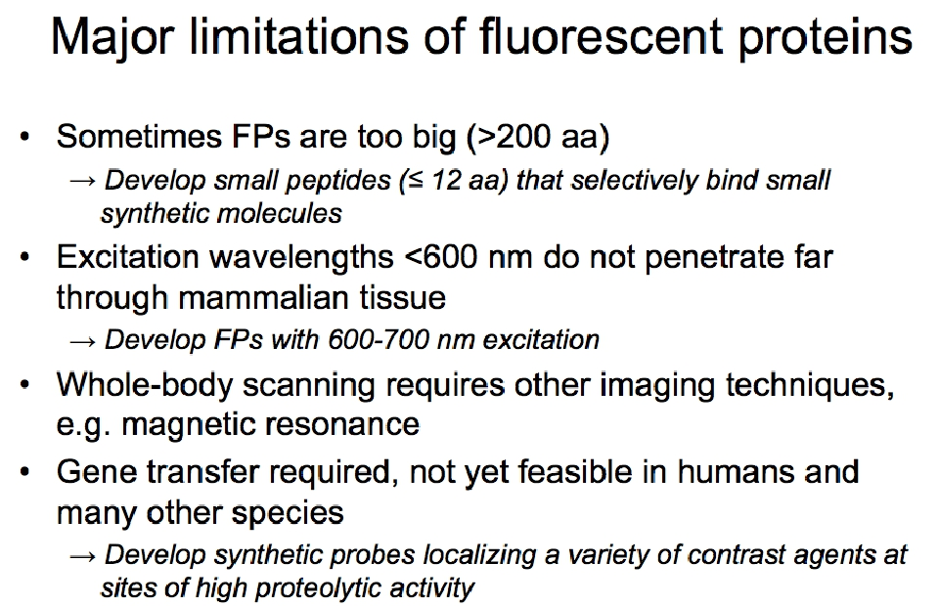
Fluorescence Energy Transfer (FRET)
- Reaction involed in ET between donor (D) and acceptor (A)
- Two types of processes:
  - Non-resonance energy transfer requires collision of D and A
  - Fluorescence resonance energy (FRET) by the forster mechanism is widely used to study dynamics of molecular interactions
Using FRET between CFP and YFP to measure protein interactions
- When Z-CFP and Y-YFP fusion proteins do not interact, illumination with cyan light results in stronger CFP fluorescence (IeW). As a result of phosphorylation-induced interactions between Z and Y, CFP and YFP are brought into close proximity and excitation energy is transferred, resulting in stronger YFP fluorescence
Chemiluminescence
- Activated by chemical reactions
- Some chemical reactions can deposit exothermic reaction energy into electronic excitation of the product molecules. The usual cascade of non-radiative and radiative decay processes can lead to the emission of photons. Bioluminescence (fireflies) is simply chemiluminescence in biological context.
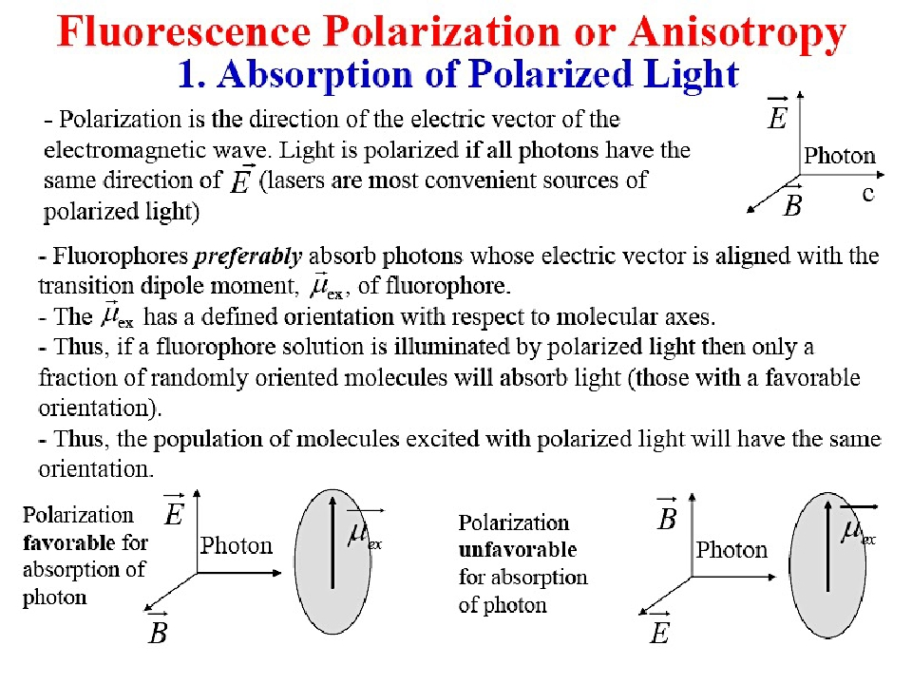
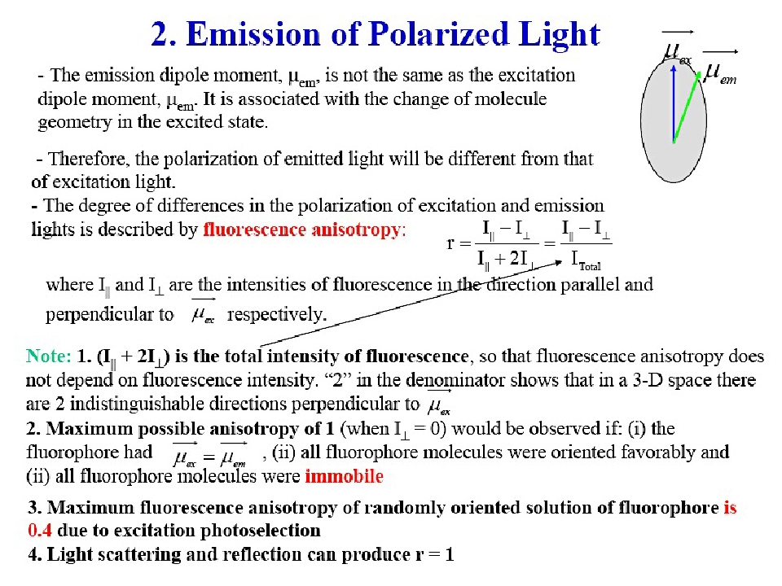
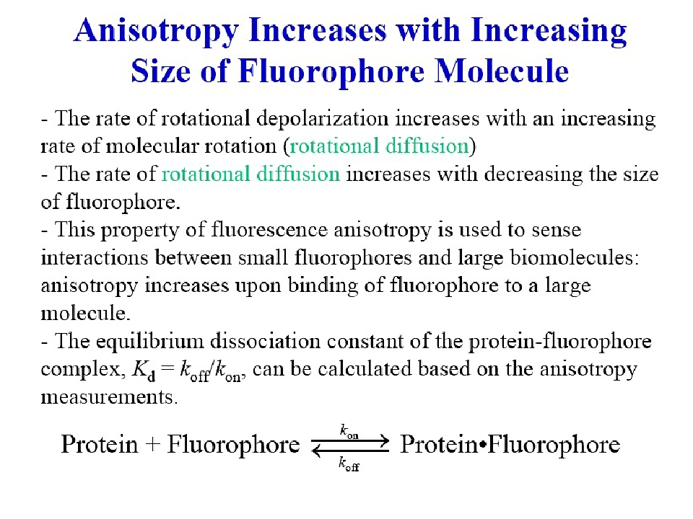

Circular Dichroism (CD)
- Measures the difference between the absorption of left and right handed circularly polarized light, polarized light
- UV CD is used to investigate the secondary structure of proteins. UV/Vis CD is used to investigate charge-transfer transitions. Near-infrared CD is used to investigate geometric and electronic structure by probing metal d→d transitions.
- IR CD is used for structural studies of small organic molecules, and most recently proteins and DNA.
SPR
- Surface plasmon resonance
- A powerful technique to measure bimolecular interaction in real time in a label free environment.
- While one of the interactions is immobilized to the sensor surface, the other is free in solution and passed over the surface.
- Association and dissociation is measure in arbitrary units and displaced in a graph called the sensogram.
- Info it provides:
  - How specific is an interaction
  - How strong is an interaction and what is the affinity
  - How fast is the interaction
  - What are the kinetic binding parameters
  - Why is the interaction that strong or that fast
  - What are the thermodynamic parameters for an interaction
  - What is the biologically active concentration of a specific molecule in a sample
- Phenomenon
  - SPR is an optical phenomenon that occurs when a thin conducting film is placed between two media of different refractive indices
  - When binding occurs to surface, local refractive index will change which leads to a change in SPR angle
  - Rates of chane of SPR angle yield apparent rate constants
  - Size of signal change is directly proportional to mass bound to the surface
BIAcore Sensorgram
- baseline: gold with the ligand on the surface. Surface doesn’t change b/c flushing with buffer. Light just shines through
- Start to deliver analyte. They bind. Signal increases and you have an association of the analyte with the ligand. The surface changes b/c different moleule binds signal increases
- Equilibrium part: signal doesn’t change. Have binding and association at equilibrium. Both rates are equal signal doesn’t change, plateau
- Dissocation: Change the vial and start to rinse with the buffer and no analyte. You don’t have eq. anymore b/c the analyte dissociated on the surface is being flushed away with the buffer signal
- Regeneration: destroy complex completely by changing pH or something. Regenerate the god with the ligand on the surface you can start the process again if you want
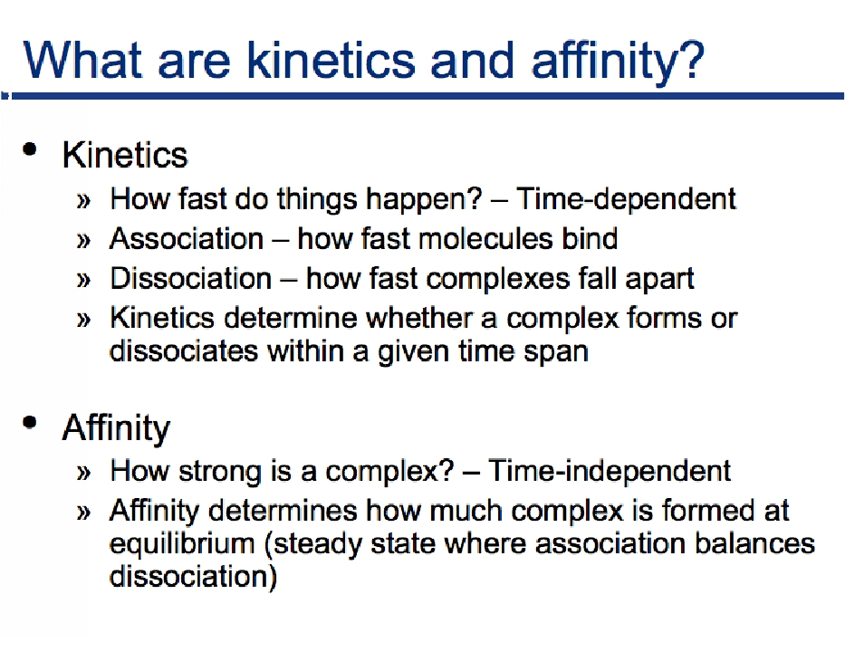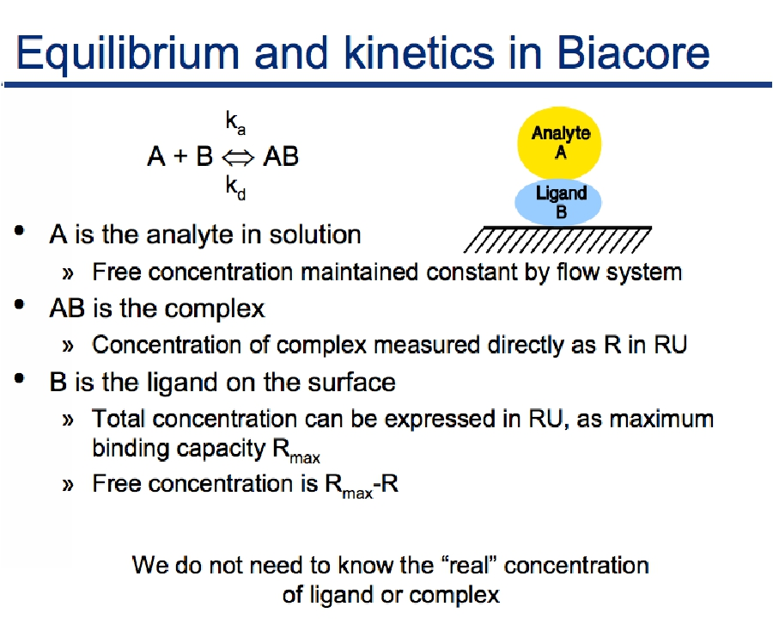
Sesor Chip CM5
- Dextran matrix covered with carboxyl groups
- Captures ligands such as proteins, lipids, carbs and nutrients (irreversible)
Sensor chip SA
- CM dextran pre-immobilized with streptavidin
- Captures biotinylated ligands such as carbs, peptides, proteins and DNA (irreversible)
Sensor Chip NTA
- CM dextran matrix pre-immobilized with nitrilotriacetic acid (NTA)
- Capture of HIS-tagged ligands via metal chelation
- Controlled steric orientation of ligand for optimal site exposure
- Regeneration by injection of EDTA to remove metal ions
Sensor Chip L1
- CM dextran matrix modified with lipophilic anchor molecules
- For rapid and reproducible capture of lipid membrane vesicles such as liposomes, with retention of lipid bilayer structure
- Allows studies of transmembrane receptors in a membrane-like environment
Possible studies for binding kinetics assays
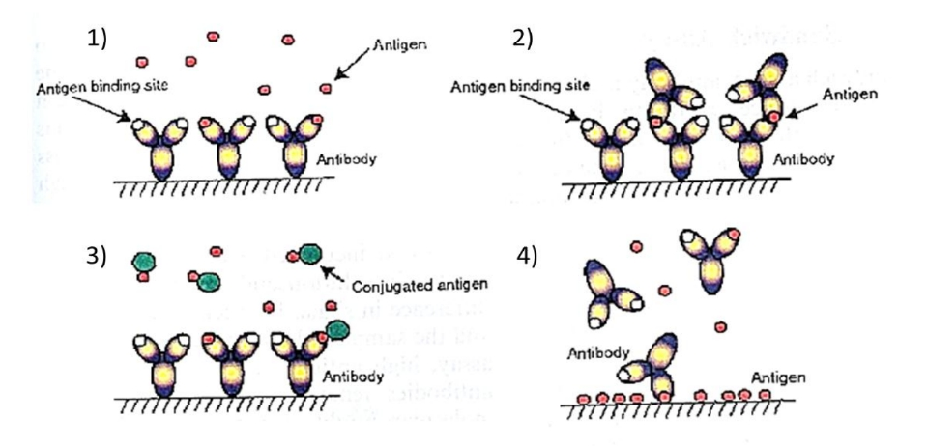
1) Direct assay: Suitable for high molecular weight molecules
2) Sandwich assay: To be selected for relatively high molecular weight antigens and when hig aaffinity antibodies are available.
3) Competition assay: Designed for low molecular weight antigens that do not generate sufficient signal when they accumulate on the surface (Direct assay) and are too small for a sandwich assay.
4) Inhibition assay
Salting Out (Salt Precipitation)
- Proteins are precipitated from aqueous solutions when the salt concentration exceeds a critical level, which is known as salting out, because all the water is bound to the salts, and is therefore not available to hydrate the proteins. Ammonium sulfate is commonly used because it has high water solubility although other neutral salts may also be used.
- Generally a two-step procedure is used to maximize separation efficiency.
  - 1. The salt is added at a concentration just below that necessary to precipitate out the protein of interest. The solution is then centrifuged to remove any proteins that are less soluble than the protein of interest. The salt concentration is then increased to a point just above that required to cause precipitation of the protein. This precipitates out the protein of interest (which can be separated by centrifugation), but leaves more soluble proteins in solution. The main problem with this method is that large concentrations of salt contaminate the solution, which must be removed before the protein can be resolubilized by dialysis.
Isoelectric Precipitation
- The isoelectric point (pI) of a protein is the pH where the net charge on the protein is zero.
- Proteins tend to aggregate and precipitate at their pI because there is no electrostatic repulsion keeping them apart. Proteins have different isoelectric points because of their different amino acid sequences and thus they can be separated by adjusting the pH of a solution with trichloroacetic acid. When the pH is adjusted to the pI of a particular protein it precipitates leaving the other proteins in solution.
- When pH=PI, it’s the best pH for precipitation of a protein b/c the protein molecules are neutral and start to interact with each other and precipitate
Solvent Fractionation
- The solubility of a protein depends on the dielectric constant of the solution that surrounds it because this alters the magnitude of the electrostatic interactions between charged groups. As the dielectric constant of a solution decreases the magnitude of the electrostatic interactions between charged species increases. This tends to decrease the solubility of proteins in solution because they are less ionized and therefore the electrostatic repulsion between them is not sufficient to prevent them from aggregating.
- The dielectric constant of aqueous solutions can be lowered by adding water-soluble organic solvents, such as ethanol or acetone. The amount of organic solvent required to precipitate a protein varies from about 5 to 60%. Solvent fractionation is usually performed at 0 degrees or below to prevent protein denaturation caused by temperature increases that occur when organic solvents are mixed with water
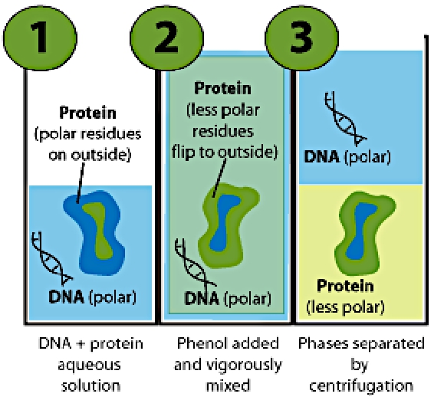
Phenol extraction
Phenol extraction is a commonly used method for removing proteins from a DNA
sample, e.g. to remove proteins from cell lysate during genomic DNA preparation

Add phenol and shake it so the protein reverses the residues/opens up so the hydriphibic residues will be on the outside
DNA doesn’t have this option to flip, remains polar
All proteins will be in chloroform/phenol phase, the DNA will be in the top
Only disvantage: protein is denature b/c opened to protein. This is not a good method if you need the protein to be active

Denaturation of Contaminating Proteins
- Many proteins are denatured and precipitate from solution when heated above a certain temperature or by adjusting a solution to highly acid or basic pHs. Proteins that are stable at high temperature or at extremes of pH are most easily separated by this technique because contaminating proteins can be precipitated while the protein of interest remains in solution
Separating due to different, adsorption characteristics
- Adsorption chromatography involves the separation of compunds by selective adsorption-desorption at a solid matrix that is contained within a column through which the mixture passes. Separation is based on the different affinities of different proteins for the solid matrix. Affinity and ion exchange chromatography are the two major types of adsorption chromatography commonly used for the separation of proteins. Separation can be carried out using either an open column or high pressure liquid chromatography
Different Types of Chromatography
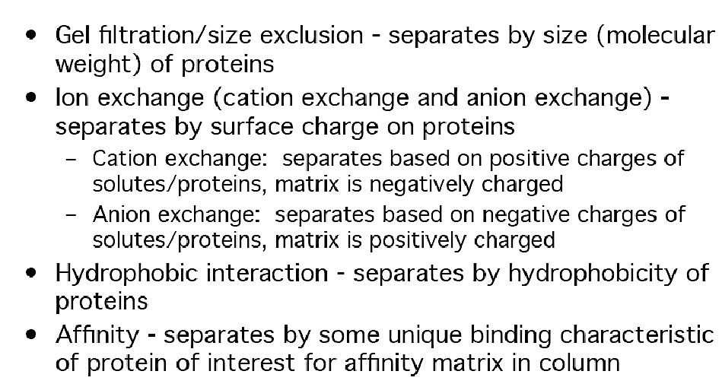
Ion exchange Chromatography
- Ion exchange chromatography relies on the reversible absorption, desorption of ions in solution to a charged solid matrix or polymer network. This technique is the most commonly used chromatographic technique for protein separation. A positively charged matrix is called an anion exchanger because it binds negatively charged ions (anions). A negatively charged matrix is called a cation exchanger because it binds positively charged ions (cations). The buffer conditions are adjusted to favour maximum binding of the protein of interest to the ion exchange column. Contaminating proteins bind less strongly and therefore pass more rapidly through the column. The protein of interest is then eluted using another buffer solution which favours its desorption form the column.
Commonly used affinity columns:
- Ni²⁺ -> binds to poly histidines (ex. 6xHis)
- Specific antibodies (anti-Flag tag)
- Glutathione -> binds to GST
- Protein A or G -> binds antibodies
Dialysis
- Dialysis is used to separate molecules in solution by use of semi permeable membranes that permit the passage of molecules smaller than a certain size through, but prevent the passing of larger molecules. A protein solution is placed in dialysis tubing, which is sealed and placed into a large volume of water or buffer, which is slowly stirred. Low molecular weight solutes flow through the bag, but the large molecular weight protein molecules remain in the bad. Dialysis is a relatively slow method, taking up to 12 hours to be completed. It is therefore most frequently used in the lab. Dialysis is often used to remove salt from protein solutions after they have been separated by salting out and to change buffers
Physical principles of dialysis
- Diffusion, ultrafiltration and osmosis are the basic physical principles of dialysis
- Diffusion is the net directional movement of molecules occurring from a solution of higher concentration to a solution of low concentration
- Ultrafiltration is the movement of solvent across a semipermeable membrane in response to a pressure difference applied across the membrane. If the solutes dissolved in the solvent is small enough to permeate the membrane, they are dragged along with the solvent and cross over to the other side, and this called convection
- Osmosis the movement of the solvent from the side of low concentration to the side of higher concentration.
Ultrafiltration
- A solution of protein is placed in a cell containing a semipermeable membrane, and pressure is applied. Smaller molecules pass through the membrane, whereas the larger the molecules remain in the solution. The separation principle of this technique is therefore similar to dialysis, but because pressure is applied separation is much quicker.
Hemodialysis
Hemodialysis removes wastes and water by circulating blood outside the body through an external filter, called a dialyzer, that contains a semipermeable membrane. The blood flows in one direction and the dialysate flows in the opposite. The counter-current flow of the blood and dialysate maximizes the concentration gradient of solutes between the blood and dialysate, which helps to remove more urea and creatinine from the blood. The dialysis solution has levels of minerals like potassium and calcium that are similar to their natural concentration in healthy blood. For another solute, bicarbonate, dialysis solution level is set at a slightly higher level than in normal blood, to encourage diffusion of bicarbonate into the blood, to act as a pH buffer to neutralize the metabolic acidosis that is often present in these patients
Size Exclusion Chromatography
This technique, sometimes known as gel filtration, also separates proteins according to their size. A protein solution is poured into a column which is packed with porous beads made of a cross-linked polymeric material (such as dextran or agarose). Molecules larger than the pores in the beads are excluded, and move quickly through the column, whereas the movement of molecules which enter the pores is retarded. Thus molecules are eluted off the column in order of decreasing size. Beads of different average pore size are available for separating proteins of different molecular weights. Manufacturers of these beads provide information about the molecular weight range that they are most suitable for separating. Molecular weights of unknown proteins can be determined by comparing their elution volumes V_{o}, with those determined using proteins of known molecular weight: a plot of elution volume versus log(molecular weight) should give a straight line. One problem with this method is that the molecular weight is not directly related to the Stokes radius for different shaped proteins.
Electrophoresis
Electrophoresis relies on differences in the migration of charged molecules in a solution when an electrical field is applied across it. It can be used to separate proteins on the basis of their size, shape or charge.
Non-denaturing Electrophoresis
- In non-denaturing electrophoresis, a buffered solution of native proteins is poured onto a porous gel (usually polyacrylamide, starch or agarose) and a voltage is applied across the gel. The proteins move through the gel in a direction that depends on the sign of their charge, and at a rate that depends on the magnitude of the charge, and the friction to their movement.
- • Proteins may be posi?vely or nega?vely charged in solu?on depending on their isoelec?c points (pI) and the pH of the solu?on. A protein is nega?vely charged if the pH is above the pI, and posi?vely charged if the pH is below the pI. The magnitude of the charge and applied voltage will determine how far proteins migrate in a certain time. The higher the voltage or the greater the charge on the protein the further it will move. The fric?on of a molecule is a measure of its resistance to movement through the gel and is largely determined by the rela?onship between the effec?ve size of the molecule, and the size of the pores in the gel. The smaller the size of the molecule, or the larger the size of the pores in the gel, the lower the resistance and therefore the faster a molecule moves through the gel. Gels with different porosity's can be purchased from chemical suppliers, or made up in the laboratory. Smaller pores sizes are obtained by using a higher concentra?on of cross-linking reagent to form the gel. Gels may be contained between two parallel plates, or in cylindrical tubes. In non-denaturing electrophoresis the na?ve proteins are separated based on a combina?on of their charge, size and shape.
- PolyAcrylamide Gel Electrophoresis (PAGE)
- • gels are cast between a pair of glass plates by polymerizing a solu?on of acrylamide monomers into polyacrylamide chains and simultaneously cross-linking the chains into a semisolid matrix • gel pore size can be varied by adjus?ng the concentra?ons of polyacrylamide and the cross-linking reagent
- • highly cross-linked polyacrylamide gel = pores are quite small • such a gel could resolve small proteins and pep?des, but large proteins would not be able to move through it
- • smaller proteins migrate faster than larger proteins through the gel • gel's pore size and strength of the electric field influence the rate of movement
- Denaturing Electrophoresis
In denaturing electrophoresis proteins are separated primarily on their molecular weight. Proteins are denatured prior to analysis by mixing them with mercaptoethanol, which breaks down disulfide bonds, and sodium dodecyl sulfate (SDS), which is an anionic surfactant that hydrophobically binds to protein molecules and causes them to unfold because of the repulsion between nega?vely charged surfactant head-groups. Each protein molecule binds approximately the same amount of SDS per unit length. Hence, the charge per unit length and the molecular conforma?on is approximately similar for all proteins. As proteins travel through a gel network they are primarily separated on the basis of their molecular weight because their movement depends on the size of the protein molecule rela?ve to the size of the pores in the gel: smaller proteins moving more rapidly through the matrix than larger molecules. This type of electrophoresis is commonly called sodium dodecyl sulfate -polyacrylamide gel electrophoresis, or SDS-PAGE
Isoelectric Focusing Electrophoresis
This technique is a modifica1on of electrophoresis, in which proteins are separated by charge on a gel matrix which has a pH gradient across it. Proteins migrate to the loca1on where the pH equals their isoelectric point and then stop moving because they are no longer charged. This methods has one of the highest resolu1ons of all techniques used to separate proteins. Gels are available that cover a narrow pH range (2-3 units) or a broad pH range (3-10 units) and one should therefore select a gel which is most suitable for the proteins being separated.
Two-Dimensional Difference Gel Electrophoresis (2D DIGE)
Coomassie Dye Stains
The most common method for in-gel protein detec1on is staining with coomassie dye. In acidic buffer condi1ons, coomassie dye binds to basic and hydrophobic residues of proteins, changing from dull reddish-brown to intense blue. As with all staining methods, coomassie dye reagents detect some proteins beKer than others based on their chemistry of ac1on and differences in protein composi1on. Thus, coomassie dye reagents can detect as few as 8-10 nanograms per band for some proteins and 25 nanograms per band for most proteins.
Coomassie dye staining is especially convenient because it involves a single, ready-to-use reagent and does not permanently chemically modify the target proteins. An ini1al water wash step is necessary to remove residual SDS, which interferes with dye-binding. Then stain reagent is added, usually for about 1 hour; finally, a water or simple methanol:acetic acid destaining step is used to wash away excess non-bound dye from the gel matrix. Because no chemical modifica1on occurs, excised protein bands can be completely destained and the proteins recovered for analysis by mass spectrometry or sequencing.
Silver Staining
Silver staining is the most sensi1ve colorimetric method for detec1ng total protein. The technique involves the deposi1on of metallic silver onto the surface of a gel at the loca1on of protein bands. Silver ions (from silver nitrate in the stain reagent) interact and bind with certain protein func1onal groups. Strongest interac1ons occur with carboxylic acid groups ( Asp and Glu), imidazole (His), sulfhydryls (Cys), and amines (Lys). Various sensi1zer and enhancer reagents are essen1al for controlling the specificity and efficiency of silver-ion binding to proteins and effec1ve conversion (development) of the bound silver to metallic silver. The development process is essen1ally the same as for photographic film; silver ions are reduced to metallic silver, resul1ng in brown- black color.
Western Blotting
Proteins on an SDS-polyacrylamide gel are transferred to a polymer sheet and stained with radioactive antibody. A band corresponding to the protein to which the antibody binds appears in the autoradiogram.
Stains only one protein
Immunoprecipitation (IP)
Co-immunoprecipitation (co-IP)
Co-immunoprecipitation is based on the same principles as IP. However, in co-IP, the antibody not only precipitates the antigen, it precipitates any other molecule that’s bound to its target. These extra molecules are assumed to have some form of relationship with the target protein on the cellular level.
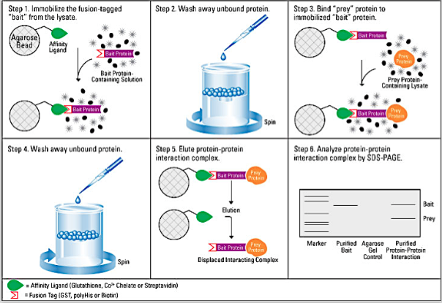

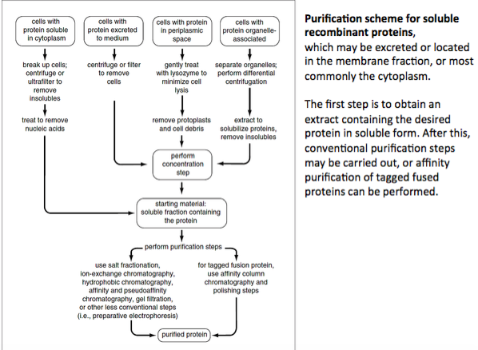

Proteomic analysis
• measurement of protein response, which is not always indicated by mRNA response • post-transla;onal modifica;ons • macromolecular interac;ons • sub-cellular loca;on • high-resolu;on structural and molecular characteriza;on
Mass resolution: represents the ability to separate two adjacent masses. It measures the “sharpness” of the MS peak
Mass accuracy: indicated the accuracy of the mass information provided by the mass spectrometer. The difference which is observed between the theoretical mass and the measured mass
Mass spectrometer System

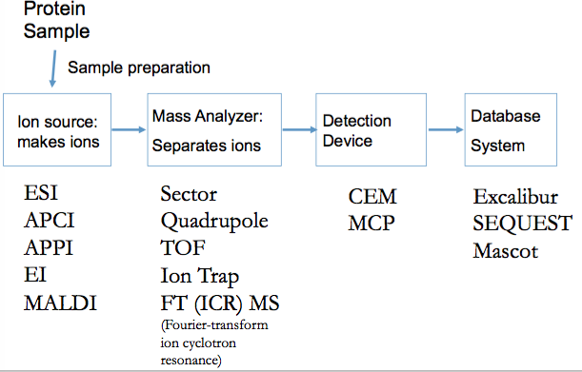
Electrospray ionization (ESI)
- Protein and peptide analysis, multiply charged ions
- Solution phase ionization- enables online coupling with liquid chromatography
- ESI is carried out at atmospheric pressure. Ions are transported into the mass spectrometer via a differentially pumped interface.
- ESI is carried our from bulk solution. No need for mixing with matrix and drying’ steps. This makes ESI ideal for coupling with LC separation
- ESI is very good at producing multiply charged ions. Thus, even very big, heavy things can be analyzed
- ESI is gentler than a baby’s handshake. It’s so gentle that even non-covalent protein complexes can be transferred intact into the gas phase.
- ESI is not tolerant to non-volatile salts... such as those used by biochemists (e.g. Na3PO4)
ESI and Charge State Distributions
- For a single protein, ESI will almost always generate several charge states.
- The intensities of these charge states are arranged in a roughly Gaussian distribution (although there is no physical justification for this). This is called the charge state distribution.
MALDI (Matrix Assisted Laser Desorption Ionization)
- In MALDI, a laser is used to irradiate a sample that is embedded in a matrix
- The Matrix is usually a small organic molecule that is good at forming crystals and absorbs light at the irradiation wavelength.
- So the predominant mechanism for analyte ion formation is just a proton transfer, which would be quite gentle.
- We just have to make sure our laser won’t destroy our analyte, which is unlikely in any case, but it helps to pick a wavelength at which the analyte doesn’t absorb (for proteins and peptides, usually around 300 nm).
- Other important considerations: Gas phase transfer is not great at making multiply charged ions. Thus m/z will be quite high. We will need a TOF mass analyzer... MALDI is actually more efficient at ionizing the matrix than the analyte. Consequently the ‘low mass’ region of MALDI spectra will be washed out by matrix and matrix fragmentation products
Surface Enhanced Laser Desorption Ionization (SELDI)
MALDI= SELDI
- Sample applied to protein chip
- Nonspecifically bound proteins washed away
- EAM (sinapinnic acid) applied to each sample. A laser is fired that desorbs and ionizes the proteins in the EAM
- Ions are detected and mass of each protein calculated by time-of-flight mass spectroscopy
Detectors
- CEM- chanel electron multiplier
- MCP- microchannel plate
Quadrupole Mass Analyzer
Resolution: Depends on residence time in quadrupole. Quadrupoles can get up to a resolution of about 5000 – but remember, in a quadrupole, higher resolution = lower sensitivity.
Sensitivity: Inversely proportional to resolution Mass Accuracy: Around 0.1 Da on new instruments
m/z limit: Depends on the maximum RF potential that can be applied to the quadrupole rods. Normally goes to about 7000 V. The practical limit is about 10,000 – 15,000 V for electronic and arcing reasons. 7000 V translates into a limit of about 8000 m/z.

Tandem Quadrupole MS
- Many mass spectrometers have quadrupoles set up in tandem for the purpose of carrying out MS/MS
- The most common setup is a ‘tripple quadrupole’ arrangement
Time of flight (TOF) Mass Analyzer
- In TOF mass analyzers, ions are accelerated down a long flight tube via a brief ‘pulse’ electric field
- Ions enter the flight tube close to a square electric pulse generator called the pusher.
- This imparts a potential energy zU to a charged particle which we assume is all converted to kinetic energy
SILAC- stable isotope labelling of amino acids in cell culture
- Grow cells in media containing isotopically labelled amino acids
- Labelling arginine and lysine to ensure all tryptic peptides are labelled
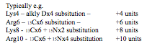
ICAT- Isotope Coded Affinity Tags
- is an isotopic labeling method used for quantitative proteomics by mass spectrometry that uses chemical labeling reagents
- Two protein mixtures representing two different cell states are treated with the isotopically light (pink) or heavy (red) ICAT reagents, respectively. The labeled protein mixtures are then combined and proteolyzed; tagged peptides are selectively isolated and analyzed by MS. The relative abundance is determined by the ratio of signal intensities of the tagged peptide pairs. The CID spectra are recorded and searched against large protein sequence databases to identify the protein. Therefore, in a single operation, the relative abundance and sequence of a peptide are determined.
Proteolytic ¹⁸O labellling
For enzymatic labeling, proteins from two distinct proteomes are proteolytically digested in aqueous buffer containing either normal water (H2 ¹⁶O; white squares) or isotopically labeled water (H2 ¹⁸O; red squares). This encoding strategy effectively labels every C terminus produced during digestion. The samples are combined at the peptide level and then analyzed by microcapillary LC-MS.
iTRAQ (isobaric tag for relative and absolute quantitation)
The method is based on the covalent labeling of the N-terminus and side chain amines of peptides from protein digestions with tags of varying mass. There are currently two mainly used reagents: 4- plex and 8-plex, which can be used to label all peptides (in theory) from different samples/ treatments. These samples are then pooled and usually fractionated by liquid chromatography and analyzed by tandem mass spectrometry (MS/MS). A database search is then performed using the fragmentation data to identify the labeled peptides and hence the corresponding proteins. The fragmentation of the attached tag generates a low molecular mass reporter ion that can be used to relatively quantify the peptides and the proteins from which they originated.
cICAT (cleavable ICAT)
- 1. Affinity enrich modified peptides.
- 2. Cleave tag using TFA, removing the biotin.
- The smaller isotopically labeled tag fragments less than the whole protein, making peptide identification simpler.
- Light and heavy reagents co-elute, making quantitation easier. Issue
- Most proteins are identified by a single peptide, requiring high accuracy and reproducibility in measurements to be able to draw conclusions.
AQUA (absolute quantification with reference peptides)
- Create an isotopically labeled peptide similar to one found in the sample and spike into the sample
XIC- extracted ion chromatogram
Mass spectra are acquired, resulting in isotope clusters for each peptide (doubly charged peptide, black in top graph). As the peptide elutes from the column, the signal is sampled several times, forming the black curve in the right panel. The area under the black curve is the XIC, a measure that is proportional to the peptide's abundance. The red isotope cluster is a heavy isotope–labeled analog of the black peptide, 4 Da higher in mass and present at 85% of the unlabeled peptide. The 85% ratio can also be determined by comparing the areas under the red and black curves. Several thousand such peptide XICs can be extracted from a data file obtained in typical complex mixture analysis.
Spectral Counting
- Count the number of peptides identified from a protein in each sample.
- Not accurate at quantifying magnitude of change, but can be used to determine if there is a difference.
- In general, need a spectral count difference of about 4 peptides in order to be confident of a difference being real.
- Most proteins in complex mixtures are identified by less than 4 peptides.
H/D Exchange (HDX)
- we can also study protein folding and dynamics by MS exchanging deuterium ontot he amide groups of the peptide backbone
- The exchange of amide proteons for deuterium happens on the millisec timescale, which is the same timescale as large motions in protein folding. Thus we can have two limiting scenerios:
  - Exchange is much faster than the rate of closing (EX1)
    - When the protein opend all amide groups exposed as a consequence of that motion are exposed.
  - The closing rate is much faster than exchange (EX2)
    - Everytime protein opens there is a probability that a deuteron will exchange on. Deuterons appear little by little
Biomarkers
Molecular Biomarkers are molecular signatures associated with the quantity, state, or localization of biomolecules in the cells. They are measurable indicators of cellular states, which are used to screen for diseases and guide medical treatments. Biomarkers can also serve as surrogate end points in pharmaceutical drug trials.
Biomarkers can take many different forms including particular proteins or peptides (e.g., prostate-specific antigen as an indicator of increased risk for prostate cancer), antibodies (e.g., anti-citrullinated protein antibodies for rheumatoid arthritis), cell types (e.g., white blood cell counts in infection or cancer), metabolites (e.g., phenylalanine in urine of newborns with phenylketonuria), lipids (e.g., cholesterol and other lipid levels in cardiovascular disease), hormones (e.g., thyroid stimulating hormone in Hashimoto's Disease), enzyme levels (e.g., various hepatic enzymes for liver cancer), physiological states such as blood pressure or fever, or imaging studies of particular organs or organ systems (e.g., neural degeneration in Parkinson's Disease). A biomarker can also be an exogenous substance introduced into a patient to assess how internal organ systems are functioning, such as radioactive iodine used to measure thyroid function.

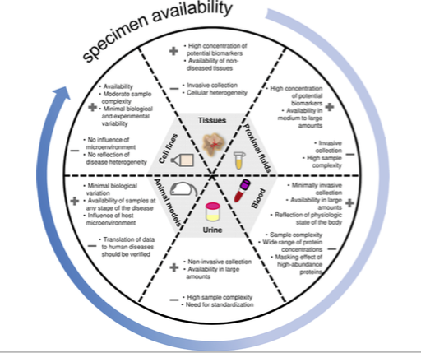
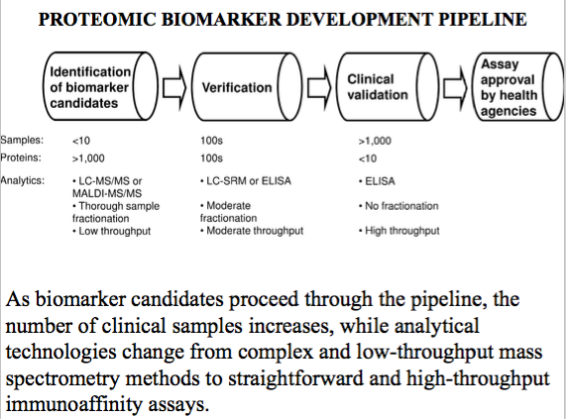

Limitations of mass spectrometry for protein biomarkers
- Lack of the general quantitative relationship between ion intensity and the amount of analyte, which makes all MS- based measurements relative
- Significant effect of matrix resulting in the ion suppression and deviation from linear correlation between protein amount and spectral intensity of the same analyte.
- Multiple steps of protein fractionation, derivatization, and trypsin digestion in bottom-up proteomic approaches that lead to high day-to-day variability and low reproducibility of protein assays.
Structure of DNA
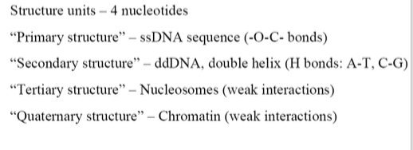
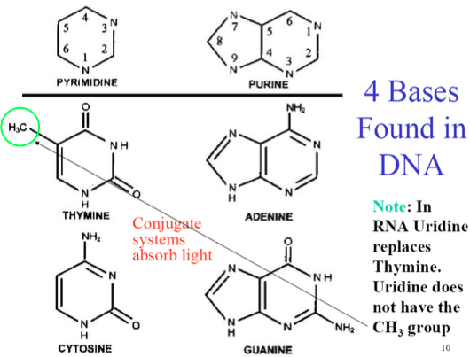
Sugars found in DNA and RNA
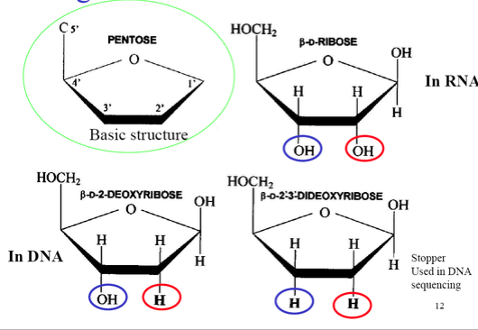
Single stranded DNA
- Sugars are involved in forming covalent bonds in ssDNA
- The charge of DNA molecule is negative due to phosphate groups, The charge to mass ratio is constant
DNA functions
- Storage of genetic info
- Self duplication and inheritance
- Expression of the genetic message
- DNAs major function is to code for proteins
- Info is encoded in the order of nitrogenous bases
Prokaryotic and eukaryotic
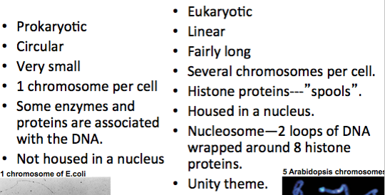
Splicing- a modification of an RNA after transcription in which introns are removed and exons are joined
Alternative Splicing
A single gene can contain numerous exons and introns, and the exons can be spliced together in different ways. For example, if a gene contains 10 exons, one version of the mRNA transcribed from that gene might contain exons 1-9. Another version of the mRNA might contain exons 1-8, and exon 10. This is called alternative splicing, and can produce different forms of a protein from the same gene. The different forms of the mRNA are called transcript variants, splice variants, or isoforms.
DNA Gel Electrophoresis
Why do you use ethidium bromide?
Ehtidium bromide is a fluorogenic molecule
- Doesn’t fluoresce when its in free solution, it rotates
- Binds to the major groove and intercolates between the bases
- Space is quite tight
- The 2 rings become aligned and flat, the small ring doesn’t rotate anymore b/c theres no space
- Big molecular orbital containing these 4 benzine rings and the molecule becomes fluorescent once it binds
- Ehtidium bromide only binds to double strand. Single strands don’t have the aligned bases
- Binds every major groove

SYBR green is another dye
- Ethidium bromide is cytotoxic and causes cancer
- Can cause skin cancer if in contact with the skin (melanoma)

2 critical things to remember
- Inensity of the bands→ more DNA molecules in that band and more ethidium bromide
- Gives info about the # of molecules
- Position gives you information about the size
- Ladder has known size molecuels
Blue loading dye to see the sample (bromophenol blue)
Ethidium bromide is colourless

Pulsed-field gel electrophoresis (PFGE)
a method for separation of large DNA molecules. Whereas standard DNA gel electrophoresis commonly resolves fragments up to 50 kb in size, PFGE fractionates DNA molecules up to 10 Mb. The mechanism driving these separations exploits the fact that very large DNA molecules unravel and "snake" through a gel matrix, and such electrophoretic trajectories are perturbed in a size- dependent manner by carefully oriented electrical pulses.
Nucleic Acid Extraction Requirements
- Disruption of cell wall and membranes to liberate cellular components
- Inactivation of DNA and RNA degrading enzymes (DNAases, RNAses)
- Separation of nucleic acids from other cellular compnents
  - Extraction/precipitation method
  - Adsorption chromatography method
Extraction/Precipitation Method
- Disruption of cell walls by grinding
  - Grind sample into a fine powder to shear cell walls and membranes
- Lysis of cells in extraction buffer
  - Mix thoroughly with extraction buffer to dissolve cell membranes and
inhibit nuclease activity
- Organic extraction
  - Mix thoroughly with an equal volume of organic solvent (ex. Phenol, chlorofoam)
  - Centrifuge
  - Collect aqueous phase (contains watersoluble molecules including nucleic acids. Proteins and lipids get trapped in organic phase)
  - Preform additional extractions for increased purity
- Nucleic acid precipitation
  - Add alcohol and salt to precipitate nucleic acids from the aqueous fraction
DNA extraction
There are three basic & two optional steps in a DNA extraction :
- Cell lysis , to expose the DNA within .
- removing membrane lipids by adding a detergents or surfactants .
- removing proteins by adding a protease .
- removing RNA by adding an Rnase.
- precipitating the DNA with alcohol- usually ice cold ethanol. In these alcohols , DNA strand will aggregate together, giving a pellet upon centrifugation . This step also removes alcohol- soluble salt.
Hybridization is the process whereby a single-stranded nucleotide sequence (the target) binds through H-bonds to another complementary nucleotide sequence (the probe). Ex. DNA-RNA complex
Southern hybridization or blotting combines transfer of electrophoresis-separated DNA fragments to a filter membrane and subsequent fragment detection by probe hybridization. The method is named after its inventor, the British biologist Edwin Southern.
Northern blot is a technique used in molecular biology research to study gene expression by detection of RNA (or isolated mRNA) in a sample
Restriction enzyme (or restriction endonuclease) is an enzyme that cuts double-stranded or single stranded DNA at specific recognition nucleotide sequences known as restriction sites
Multiplex-PCR
Mul1plex-PCR uses several pairs of primers annealing to different target sequences. This permits the simultaneous analysis of mul1ple targets in a single sample. For example, in tes1ng for bacterial strains, four or more amplifica1ons might be combined. In the standard protocol for DNA Fingerprin1ng, the targets assayed are often amplified in groups of 3 or 4.
A Variable Number Tandem Repeat (or VNTR) is a location in a genome where a short nucleotide sequence is organized as a tandem repeat. These can be found on many chromosomes, and often show variations in length between individuals. Each variant acts as an inherited allele, allowing them to be used for personal or parental identification
Asymmetric PCR - is used to preferen1ally amplify one strand of the original DNA more than the other. It finds use in some types of sequencing and hybridiza1on probing where having only one of the two complementary stands is ideal. PCR is carried out as usual, but with a great excess of the primers for the chosen strand. Due to the slow (arithme1c) amplifica1on later in the reac1on aJer the limi1ng primer has been used up, extra cycles of PCR are required.
Nested PCR
It is intended to reduce the contamina1ons in products due to the amplifica1on of unexpected primer binding sites. Two sets of primers are used in two successive PCR runs, the second set intended to amplify a secondary target within the first run product. This is very successful, but requires more detailed knowledge of the sequences involved.
RT-PCR (Reverse Transcription PCR) is the method used to amplify, isolate or iden1fy a known sequence from a cell or 1ssues RNA (a green strand). Essen1ally normal PCR preceded by transcrip1on by Reverse transcriptase (to convert the RNA to cDNA) this is widely used in expression mapping, determining when and where certain genes are expressed.
Q-PCR (Quantitative PCR) is used to rapidly measure the quan1ty of PCR product (preferably real-1me), thus is an indirect method for quan1ta1vely measuring star1ng amounts of DNA, cDNA or RNA. This is commonly used for the purpose of determining whether a sequence is present or not, and if it is present the number of copies in the sample. Aka real time PCR
Aptamers are RNA or DNA oligonucleotides that bind to different targets (proteins, peptides, small molecules, living cells, solid particles). Similar to antibodies, aptamers recognize targets with high affinity and specificity
1. Aptamers are cell specific probes – cell imaging reagents.
2. The targets are at their native state, a true molecular profile of the disease cells.
3. Aptamers are valuable tools for isolating and identifying new biomarkers.
4. Aptamers are promising drug delivery and cell depleted agents.
Aptamer Structure
- Unique tertiary structures allow aptamers to fold into stable scaffolds for carrying out molecular recognition
- van der Waals, hydrogen bonding, and electrostatic interactions drive high affinity target binding
- Designed to block protein-protein interactions
- Share properties of both small molecules and biologics
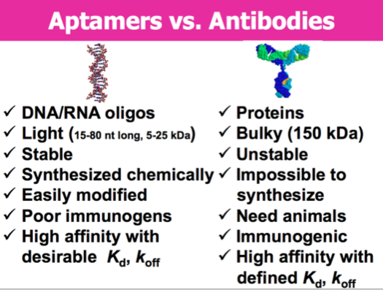

Macugen is an antivascular endothelial growth factor (anti-VEGF) RNA aptamer for the treatment of age- related macular degeneration. VEGF participates in promoting the growth of abnormal new blood vessels in the eyes, which eventually leak blood and cause vision loss.
SELEX (systematic evolution ligands by exponential enrichment
- A general concept of aptamer selection
- A multi-step process in which strongly binding ligands re preferably selected by round of affinity assays and PCR amplification
- 1. The ssDNA library is synthesized with a random sequence in the middle and constant regions at the ends
- Selection of RNA aptamers also requires T7 promoter at 5’ constan region of DNA. RNA polymerase uses it to transcribe DNA library to RNA library
- 2. Target T is mixed with the DNA (or RNA) library and allowed to reach equilibrium in the complex formation reaction. The number of equilibria is equal to the number of unique sequences in the library
- 3. Bound and unbound ligands are separated by a partitioning process, which is typically a heterogeneous binding assay. Target ligand complexes are adsorbed on the surface that binds target (protein) but does not bind ligands (DNA)
- 4. Bound ligands are amplified in PCR
- 5. Error prone PCR: introduces random mutations during amplification used for diversification of sequence space in the selected pool or individual sequence.
- 6. Cloning and Sequencing: dsDNA pool>modified plasmids>delivery into bacteria>growing bacteria>plasmids from each clony are sequenced>random site of aptamer sequence is unraveled
Personalized Digital drugs output
1. Obtaining tumour specific aptamers leads to identification new protein biomarkers of the tumour cells.
2. Selected aptamers visualize a primary tumour and metastases for evaluation of cancer treatments (Whole body imaging by Ultrasound, Spectroscopic Imaging or Positron Emission Tomography).
3. Modified aptamers can activate an immune system to eliminate tumours.
4. Personalized medicine
Electrophoresis: Capillary
- With capillary, all analytes travel the same distance, but the migration time (tm) for that distance is measured.
- Relate time to identity
- Relate peak area or height to amount

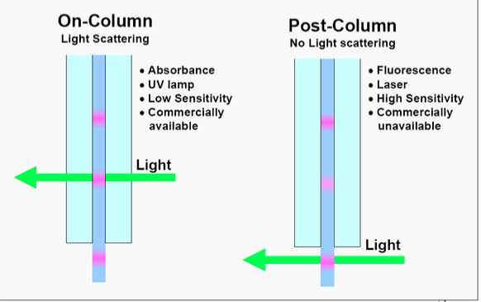
Control of EOF (Electroosmotic flow)
- Flow of positively charged buffer from anode to cathode
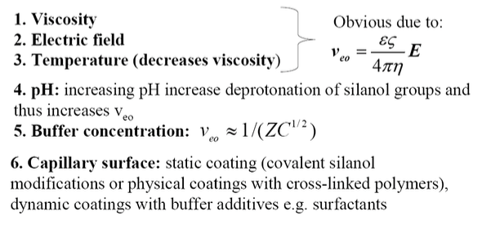
Capillary Zone Electrophoresis (CZE)
The separation mechanism is based on differences in the charge-to-mass ratio of the analytes. Fundamental to CZE are homogeneity of the buffer solution and constant field strength throughout the length of the capillary. The separation relies principally on the pH controlled dissociation of acidic groups on the solute or the protonation of basic functions on the solute.
Capillary Micellar Electrokinetic Chromatogaphy (MEKC)
- Separates molecules with similar electrophoretic mobilities (ex neutral molecules)
Separation Mechanism for Chiral CE
The cyclodextrins form inclusion complexes with the different enantiomers which results in a chiral separation being obtained. A range of different sized and chemically modified cyclodextrins are used to obtain the required chiral separation.
EXAM
Head of the lab, working in a hospital and your received the patient with the viral infection
Suggest a work flow of the methods to analyse the viral infection
Need to know how to amplify DNA or RNA b/c for viruses DNA or RNA (don’t use ELISA, its not sensitive) viruses are small amounts so if you do Elisa or SPR you wont see anything, need very sensitive methods

Take a sample, incubate with, simplify with, detect with

Colleage isolated a protein and need to detect the protein in the blood. What method will you use
Not UV-vis b/c not specific
Something with amplification that will have enough sensitivity, e.g. Elise, flow cytometry

