BIO 1140 REVIEW QUESTIONS (by topic/midterm)

The Cell
TOPIC ONE
How did life evolve into organisms and cells? (Review from BIO1130)
Life is thought to have evolved from the early processes of earth and its changing atmosphere/ temperature. Due to this, lipids and monomers were created. From then on, lipids made an appearance and, due to their hydrophilic heads and hydrophobic tails, when placed in water naturally formed a membrane type structure called micelles (bubble hypothesis) and even lipid bilayers (if there are a sufficient number of lipids available). This is what is thought to have been the first membrane enclosed item which later became a cell.

What are the different types or classes of organisms?
EUKARYOTE: Multicellular organisms, excluding protists,
ARCHEA: Unicellular prokaryotic organisms, and known as extremophiles due to the fact that they tend to live in extreme environments (i.e. Halophiles, etc.).
BACTERIA/EUBACTERIA: Known as the “true bacteria”, and are lipids strictly unicellular prokaryotic organisms. Their cell wall is composed of peptidoglycan.

What is a cell?
Known as the fundamental unit of life as no living organism is without cells, whether they are composed of many or one singular cell.
What is a cell made of? Define the different features, organelles and explain the roles/functions for each.
Organelle | Function | Relative size
Mitochondrion | Main site of aerobic energy production. (has two membranes) | 3-10 µm long
Nucleus | Area in which stores the genome and where TRANCRIPTION occurs. (inner membrane, outer membrane (turns into E.R)) | 7.5-10 µm
Nucleolus | Production of rRNA, which travels through the E.R to reach the ribosomes which line the R.E.R | 2.5 µm
Golgi body | Re-packaging center for proteins and macromolecules to group them together to make travel across the cell simpler. (Uses vesicles) | 1 by 1 µm
Vesicles | Small vacuole type bubbles in which package items using the cell membrane. | N/A
Lysosomes | Responsible for degrading certain components (eg. Dead organelles, proteins, etc) using enzymes to return the polymers to their monomeric form. | 0.2-0.5 µm
Ribosomes | String amino acids together using rRNA, to produce proteins. | 0.025 µm
SMOOTH endoplasmic reticulum (SER) | Synthesises fatty acids and phospholipids. (lacks ribosomes) | 0.2 µm (each layer)
ROUGH endoplasmic reticulum (RER) | Synthesises membrane and organelle proteins. (lined with ribosomes) | 0.2 µm (each layer)
Cytosol | Major part in the metabolic processes of the cell, proteins and other macromolecules float freely. | N/A
Cell membrane | Regulates the material in which enters and exits as well as houses many recognition proteins. (in multicellular organisms) | 0.009 µm thick
SPECIAL ORGANELLES (plant vs animal)

Plasmodesmata (plant) | Used to allow intercellular communication in plants (small ions, ect), passage can be regulated. (Gap junctions) | 0.02-0.04 µm
Gap junctions (animal) | Used to allow intercellular communication in animals (small ions, ect), passage can be regulated. (Plasmodesmata) | 0.002-0.004 µm
Chloroplast (plant) | Create free energy using photosynthesis. (has two membranes) | 10 µm long
Vacuole (plant) | Known as storage compartment for water, nutrients and waste and create turgor pressure. Can also practice degradation of some substances. | 50-80% of cell
Peroxisomes (animal) | Oxidizes organic substances (using oxidase) and catalyses the degradation of peroxide. | 3 µm
Cell wall (plant) | Used to protect and to aid in structure in plant cells. | 1-2 µm thick

(What are the different scales/sizes for cells and organelles?)
Explain the theory of the cell and the theory of endosymbiosis – can you provide some examples?
Cell theory: Theory in which all life stems from one, or multiple, cells. In other words, the cell is the fundamental unit of life.
Endosymbiotic theory: The theory in which chloroplasts and mitochondria stemmed from the engulfment of ancient unicellular bacteria similar to that of cyanobacteria and a bacteria that practice aerobic respiration. It’s thought that initially the aerobic bacteria was engulfed and was never used and began an endosymbiotic relationship with the cell. Proof of this is;
-Its prokaryotic structure (i.e. no nucleus, own ribosomes, circular DNA and relative size),
-Both divide by prokaryotic means (splitting in two binary fission),
-Has its own unique DNA that is portrayed in one of the two membranes that surrounds them,
-Has two membranes, one being accustom to the chloroplast/mitochondria, and the other belonging to the cell in question.

What are the main groups or types of cells and how do they differ?
Prokaryotic | Eukaryotic
Genetic material in form of plasmids floating freely in cytosol (nucleic region) | Membrane bound nucleus with double helix strands of DNA
Smaller in size (1-5 µm) | Larger in size (10-100 µm, or larger)
Unicellular | Multicellular (excluding protists)
No organelles | Multiple membrane bound organelles
No cytoskeleton | Has a cytoskeleton for support and other functions
Simple and can adapt quickly | Complex and adapt slowly
ARCHEA and EUBACTERIA | EUKARYOTIC

Understand the different types of microscopy and their requirements for use in cell biology.
TEM: Using electrons, the microscope pass electron through the dead specimen using cathodes. This allows an observation by transmission and see the innards of the specimen. Fixatures are needed to prepare the specimen before it dies and cut into thin sections.
SEM: Using electrons, the microscope produces an image of the surface of the specimen with a beam of electrons. (Hence a scanning microscope)
DARK-FIELD: Using light directed from the side and the scattered type lights waves, it illuminates the specimen against a dark background. Can observe mitosis.
BRIGHT-FIELD: Using light and the lights waves, it’s able to observe specimens as small as the wavelength used will allow. Often a general tolerance of 0.2-0.7 µm and see mitochondria. The specimen is often needed to be treated with a fixature and sliced to observe innards of some things.
FLUORESCENCE: Uses dyes to excite antibodies and stain certain parts of the cell, can allow the observation of certain proteins and macromolecules. (Used to observe the plasma membrane using the bleach recovery technique)
INTERFERENCE-CONTRAST: Exploits the interference effects or waves to create an image of the cells structure. This comes from the different possible densities in a specimen.

TOPIC TWO

Understand the role, identify areas and determine the importance of a molecule’s polarity (electronegativity) of different biologically relevant macromolecules (particularly amino acids and proteins).
A molecules polarity effects its STRUCTURE, FUNCTION and also, due to the two first inferences, it’s LOCATION in the cell.
Amino acids (out of the 20 known), and their polarity effect the resulting protein that the chain intends to build. This is due to the secondary, tertiary, quaternary protein structures. The secondary structure varies in two ways; a flexible alpha helix, which is a result of polar amino acids forming peptide bonds and practicing hydrogen bonding, or a rigid beta pleated sheet, which is a result of nonpolar amino acid domains.
Proteins, depending on the amino acid created domains, can have polar and nonpolar regions, which influence their final structure, for example globular or linear. Which in turn influences (as well as the general polarity) where the protein can be found (i.e. plasma membrane, cytoplasm).

Explain the relationship between polarity, molecular structure, cellular location and function – particularly for proteins and lipids.
PROTEINS: Proteins can be found in many areas of the cell, all depending on their structure (which is ultimately determined by polarity in the way the amino acid chains can fold on one another). For example, different structures are synthesised for different areas of the cell as globular proteins are synthesised by free floating ribosomes and are incorporated into the cytoplasm.
The domains of polarity (created by the domains of polar/nonpolar amino acids) can also influence where the cell can be found. For example, a generally polar protein is soluble in water and will be placed in areas in which this will be helpful for the cell. Also, if integrated into the membrane, it would be found with the polar phospholipid heads rather than the nonpolar fatty acid tails.
LIPIDS: Lipids are found all over the cell but the most concentrated area is the phospholipids which make up the plasma membrane. As they are made of a polar head and nonpolar tails, it’s a prime example of how polarity influences location. Also the length of the tails and the saturation also influence the functionality of the phospholipid and also the fluidity of the membrane.

What are the types of chemical bonds present in cellular macromolecules and how are they relevant to cell biology.
Ionic bonds: Chemical bond between atoms in which an electron is given from one molecule to the other. Known as a strong rigid bond.
Covalent bonds: Bond in which an electron is shared between two atoms. Characterized by strong bonds which are often hard to break.
Non-covalent bonds: Same concept as covalent bonds, but much weaker and therefore used very often in cells in terms of structural building blocks.
Hydrogen bonding: Bonds in which hydrogen atoms are shared between molecules and due to this “resonance” a type of bond is created.
Van de Waals forces: The forces found in every atoms, in terms of the general attraction of protons and electrons of atoms.

What is the importance of water in biology.
Water is known to be approximately 70% of a cells weight, and also most intracellular reactions must occur in an aqueous environment. This is due to the fact that water often weakens the bonds between many molecules (i.e. ionic, hydrogen bonding, covalent and noncovalent).

Know and identify the main classes of macromolecules, recognize their general structures, and interpret these in relation to their cellular location and their roles in cells.
Carbohydrates:
Proteins:
Found, in majority, floating freely in a globular structure within the cytoplasm, or in different structures within the plasma membrane. They vary greatly in structure, depending on their amino acid domains. RIBOSOMES.
Lipids:
Found in majority, in the lipid bilayer, surrounding the cell. SMOOTH ENDOPLASMIC RETICULUM.
Nucleotides:
Found in the nucleus in form of a DNA double helix, but also found thought the cell in the form of RNA. Use phosphorous groups, pentose deoxyribose sugar and bases to create a linear chemical code.

TOPIC THREE

How is the cell’s interior organized?
The cell is organized, using the cytoskeleton and its three structural components, in such a way that information and nutrients can travel from one destination to another in the easiest way possible using molecular motors.

Compare how each component of the cytoskeleton is formed.
NO COVALENT BONDING IS USED IN ORDER TO EASE THE DEFORMATION/FORMATION OF CYTOSKELETON
- Intermediate Filaments: Composed of
Form spontaneously (no energy needed), from keratin like proteins which form long chains. These long chains are superposed on others, in a head to tail like fashion, which eliminates direction within the fibers. These now dimers, are attached to other dimers to form tetramers, and once 8 tetramers are assembled they are able to form a hollow rope like structure with a braid type appearance and structural properties (i.e. strong and flexible).
- Microfilaments: (found all around the edges of the cell) Composed of actin and uses ATP
Globular actin subunits bind to ATP binding sites, creating a “-“ to a “+” ends. However, they assemble in a staggered form, simulating as if two strands were bonded and twisted together. This, effectively, creates a pointed “-“ end and a barbed “+” end.
- Microtubules: (centralized near the nucleus) Composed of tubulin and uses GTP
Begins with the assembly of tubulin as dimers, which are then attached to one another, forming a heterodimer (with a beta and alpha end), on GTP binding sites (GTP exposed), and initially attached to an anchor protein.
The alpha ends bind to the beta, GTP exposed, end, to finally create a protofilament. These then stack to make sheets, which lastly for hollow centriole using 13 protofilaments.

Relate the structure of the cytoskeletal fibers to their roles in the cell.
Intermediate filaments: They are INTERMEDIATE in size, compared to the other cytoskeleton elements. They form a braided, flexible, and rigid rope out of keratin like proteins. The proteins form in long chains and, using a second chain, coil together to form a dimer. Then, two dimers are superposed in a staggered type fashion, of head on tail, to form tetramers. Finally 8 tetramers are able to create a sheet in which becomes a hollow cylindrical, braided, shape. They are located within the cytoplasm, in or to aid in the resistance to mechanical compression as well as the flexibility of the cell (thanks to their braid like structure). They form a cage around the nucleus in order to protect it. Therefore, they have NO NEED for molecular motors, regardless of their inability to practice molecular movement due to their lack of direction.
Microfilaments: They are the SMALLEST of the cytoskeleton elements, and are composed of acting subunits, which form to creates a twisted like rope. They are located, primarily, the whole interior of the cell and due to their smaller and more flexible structure, they are able to support and aid the plasma membrane.
Microtubules: The LARGEST element of the cytoskeleton, composed of tubulin monomers which assemble into dimers, then heterodimers, protofilaments, then finally into hollow cylindrical tubes. They are anchored near the nucleus, and cover the majority of the interior of the cell but “fall short” near the plasma membrane, and don’t quite make it there. This is due to the fact that their function is really to allow molecular motor proteins to transport cargo inside the cell.

Associate the different cytoskeletal fibers with their preferred molecular motors and contrast their characteristics with respect to their roles.
Intermediate filaments: The role of intermediate filaments is NOT transport, as their tetramers are superposed in a head to tail manner there is no direction for molecular motors to travel. Rather, intermediate filaments are used for mechanical strength, due to their rigidity of their braided structure, and resistance to stress, due to their elasticity.
Microtubules: Generally, microtubules are used for intracellular transport, as well as cell division. Uses DYENIN (“-“ end) and KINESIN (“+”) motors to transport things on their centriole “train tracks”. The ends are determined by the presence (“+”) or absence (“-“) of GTP. The dynein motor therefore travels to the end in which GTP is not present, near the anchor (as microtubules build off the GTP end) which nonetheless is near the nucleus. Kinesin do the opposite as they travel towards the GTP end.
Microfilaments: Used to shape the cell as well as whole cell locomotion as the seemingly twisted built cytoskeleton element is truly in a linear fashion. Its concentrated near the edge of the cell with one pointed (“-“) end and one barbed (“+”) end. This cytoskeleton element uses the family of MYOSIN molecular motors, which prefer the end in which ATP is located (“+”).

What are the main types of cell-to-cell interactions and their characteristics?
- Occluding Junction: (Tight Junction)
Seals neighbouring cells together to prevent the passage of molecules through. Composed of proteins and ACTIN.
- Anchoring Junction:
Known to be two types, cell to cell (adhere junctions and desmosomes), and cell to extracellular matrix (focal adhesions and hemidesmosomes). They use actin filaments and intermediate filaments, respectively.
- Communication Junction: (Gap Junction)
Channels between neighbouring cells by proteins connexions. Allow the passage of small molecules and ions for communication purposes.

Discuss how cellular motility and mobility are different and how they are accomplished.
Motility: the movements of organelles, vesicles, macromolecules and other components INSIDE the cell. This is done by molecular protein motors on train tracks of microfilaments or microtubules.
(Specifically concerned with intracellular motion)
Mobility: the physical displacement of the cell or something OUTSIDE (in front, eg. Water flow) the cell. Done by structures made of microtubules (extensions) which are known as flagella or cilia.
(Specifically concerned with extracellular motion)

TOPIC FOUR

Describe what the extracellular matrix is made of, and interpret why it is important to cells.
The extracellular matrix is composed of proteins and polysaccharides secreted by cells and a variety of macromolecules, but is truly more just a small fluid space between cells. It is important as it is able to act as connective tissues, while it anchors cells together, acts as a permeable filter, helps grow and repair cells, communicates and signals to surrounding cells (receptors), and lastly aids in cell movement.

Discuss the role of membranes, and in particular the plasma membrane, in a cell.
Boundary: A varied selective permeability, allowing the secretion and uptake of many molecules, made up of lipids and proteins which are keys to the membrane fluidity and permeability (diffusion).
Organization: Organelles and the organization provided by the cytoskeleton allow intracellular functions to occur at their highest proficiency.
Transport: Incorporated into the lipid bilayer are protein transporters and carriers, which aid in the uptake and release of larger molecules and ions. (Transporters, pumps, porins, channels)
Signalling: Found on the membrane are receptors used for signaling to other neighbouring cells, as well as cytoskeleton filaments, extending to other cells, incorporated into the membrane.
Communication: Cell junctions in which allow a transfer and share of certain molecules which are used to communicate and send messaged to other cell.

Understand and explain the fluid mosaic model. Include the membrane’s properties in the discussion.
The fluid mosaic model

What is the membrane made of? Describe and organize the different macromolecules involved and link them to the membrane’s properties.
Phospholipids: There are four main phospholipids that compose the cellular membrane, Phosphatidylcholine, Phosphatidylethanolamine, Phosphatidylserine and Sphingomyelin. They make up the phospholipid bilayer and due to the fact that their polar heads are not covalently bonded they allow the fluidity of the membrane. They are composed of a polar head and two nonpolar fatty acid tails which range in length and saturation.
Sterols: Characterized as buffers used to increase or decrease fluidity when there is a drastic temperature change. They are composed of 4-ring hydrocarbons and are named CHOLESTEROL, ERGOSTEROL and PHYTOSTEROL
Proteins: Built using amino acids as monomers (approx. 200+ to make a protein), which in turn determine the proteins polarity and resultant structure.
Glycolipids: Used in cell recognition and are made of one or two fatty acid chains. Found on the outer layer of the membrane.

Compare the different types of transport across the membrane and give examples for each.
PASSIVE
Simple diffusion:
Linear diffusion directly across the lipid bilayer. It’s only done by small molecules as they move WITH their concentration gradient. (eg. H2O, CO2, O2, glucose)
*aquaporin: pores in the membrane which specifically pass water molecules*
Facilitated diffusion:
Diffusion of larger and polar molecules which could not pass through the membrane themselves and require assistance from a channel of carrier protein. Are still traveling WITH their concentration gradient.
CHANNEL
Uses an INETRGRAL protein, which can be electrochemically or mechanically triggered, and is highly selective.
CARRIER
Can be a uniporter, co-transporters or exchanges by the passage through INTERGRAL proteins. Always exchanging something (eg. Potassium/sodium)

ACTIVE
Powered by the use of energy to pass highly large and polar molecules AGAINST their concentration gradients with INTERGRAL proteins.
Primary active transport:
Uses ATP to transport molecules.
P-pump: Ion pumps for large ions, Na/K pump.
V-pump: Pumps hydrogen ions into the cell for intracellular use.
F-pump: Pumps hydrogen ions to facilitate the stabilization of pH within the cell.
ABC-pump: Pumps many ions, sugars, amino acids, proteins and larger molecules. (Family)
Secondary active transport:
The transport is powered by another molecules transport/gradient.
SYMPORT
Both molecules/ions in question are being transported in the same direction.
ANTIPORT
Where both ions ARE NOT going in the same direction. (i.e. one into cell, other out of)

How are membrane dynamics important for transport?
The dynamic fluidness of the membrane is extremely important for transport due to the ability of simple diffusion as well as the characteristics associated with the fluidity. First, if the membrane was not dynamic, and simple diffusion was unable to occur, a large percent of the molecules needed by the cell would not be able to enter and therefore would die. Secondly, the fluidity associated with the cell is used often in functions of the cell, like for example exocytosis and keeping the cell alive when temperature changes.

How is the membrane potential formed and how is it useful in a cell?

Midterm 2
TOPIC FIVE

Explain, contrast and compare, the role of mitochondria and chloroplasts in cells with regards to energetics
SIMILARITIES:
- Believed to have arisen from endosymbiosis (have their own genetic material, ribosomes, double membrane, etc.).
- They have a highly permeable outer membrane; a much less permeable inner membrane, in which membrane transport proteins are embedded; and a narrow intermembrane space in between.
- Have similar chemiosmotic mechanism (the stroma is very similar to the matrix, and so on).
- Use/store similar enzymes/coenzymes.
- The cyclic calvin cycle, like the cyclic krebs occur in the stroma/matrix (similar processes in similar regions).
- Proton-motive force is the same in both mitochondria and chloroplasts.
- FUNCTIONAL SIMILARITIES

DIFFERENCES:
- Chloroplast use light+CO₂ to create glucose (carbonification), and mitochondria use glucose to create ATP. (use oxygen vs. produce oxygen)
- The ETC is found in the thylakoid membrane of the chloroplast, and found in the inner membrane of the mitochondria.
- Inner membrane of the chloroplast is not folded into cristae like the mitochondria’s.
- Chloroplast can temporarily store starch and lipids.
- Chloroplasts use photosynthetic pigments for their respective reactions.
- Photosynthesis uses NADP⁺, and aerobic respiration uses NAD⁺.
- Photosynthetic processes are uniquely done within the chloroplast, whereas aerobic respiration processes occur also in the cytoplasm.
- Chloroplasts are much larger.
- Chloroplasts have in addition to the inner/outer membrane, a thylakoid membrane/space.
- CARRYOUT OPPOSITE PROCESSES

Understand the importance of calcium homeostasis
Calcium homeostasis: Regulation of the calcium ion concentration of the cells cytoplasm using protein channels, binding proteins and by storing it in organelles

Availability, Storage, regulation (later with signal transduction)
Availability:
The availability of calcium ions is, in majority, rare. This is why it is stored in a multitude of organelles to insure it is available at any time and when it is needed by the cell.

Storage:
Storing calcium ions in cells are done by organelles; the mitochondria, the endoplasmic reticulum and the sarcoplasmic reticulum (in muscle cells). The calcium stores are gated by transmembrane protein channels regulated by Bcl2 (ER - IP3 gated protein channel).

Regulation:
The concentration of calcium ions present in organelles and present in the cytoplasm are all regulated by a variety of different calcium ion-channels (eg. Ca²⁺/Na⁺ channel), many of which are further regulated by Bcl2, and similar molecules, to ensure the channels are open/closed when necessary.

Provide examples of cellular functions that rely on calcium
Cellular function that rely on calcium levels are that of, firstly, the cell death pathways, both necrosis and apoptosis are a result of elevated calcium ion concentrations. Secondly, the voltage gradient (electrochemical) that calcium can take part in, in muscle cells (cardiac and skeletal) as well as in nerve cells (neurons).

What is mitophagy and how/why does it occur?
Mitophagy: To selectively remove damaged mitochondria OR to lower the number of mitochondria by autophagy (degradation by lysosomes).
Damage of a mitochondria can be a result of; low oxygen levels, production of lethal molecules or a damaged membrane.

This is done by the following steps (PINK/Parkin pathway):
- The kinase PINK is expressed, on the outside, by the mitochondria.
- As it is a kinase, PINK then phosphorylates a nearby protein, specifically MFN2.
- When MFN2 is phosphorylated, it signals the recruitment of the ubiquitin ligase (enzyme) Parkin.
- Parkin then binds ubiquitin, which signals to lysosomes that the mitochondria in question is in need of degradation (autophagy).
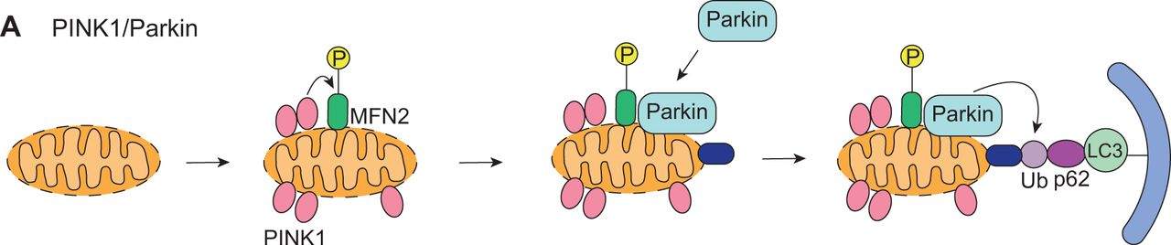

Describe and differentiate the two cell-death mechanisms and explain the role of mitochondria and calcium in both
NECROSIS: (Calpin-Cathepsin pathway)
- Sufficient damage to the cell initiates an elevation of calcium concentration in the cell.
- Calcium rises are attributed to the opening of Ca²⁺ channels in the membrane, ER and mitochondria (and sacroplasmic reticulum in muscle cells) which allow influx as well as a release of calcium stores within the cell.
- When a peak concentration is reached, Calpin is activated (calcium dependant protease).
- Calpin then begins degrading the proteins found in the lysosomal membrane, allowing release of lysosomal enzymes.
- When Cathepsin is release from the lysosome, it then is activated (due to lower pH of the cytoplasm) and begins degrading EVERYTHING.
- Results then in cell burst/death.

APOPTOSIS: (Intrinsic pathway)
- The cell is either damaged, or reaches the time in which it’s programed to die. Which then sends apoptotic signals throughout the cell.
- And apoptotic signal activated Bad by dephosphorylating it, allowing it to bind to Bcl2 molecules which regulate calcium channels in both the ER and mitochondria.
- Bad then inhibits Bcl2, dysregulating the Ca²⁺ channels, which forces the release of calcium stores from the ER and the uptake of those stores into the mitochondria.
- Bax and Bak are recruited to aid the release of calcium from the ER, by binding to the (IP3) channels and assuring they remain open.
- The mitochondria then rearranges its cristae due to the full storage of calcium, which creates a pore allowing cytochrome C to exit the mitochondria.
- Cytochrome C binds the Apaf-1 and Caspase 9, and forms a multiprotein complex (apoptosome complex) to activate caspase 9.
(APOPTOSIS IS NOW IRREVERSIBLE)
- Activated caspase 9 goes on to activate other initiator and executer caspases, creating a cascade.
- The caspase cascade inhibits and activating responses, killing the cell.

Relate cell death to the cell cycle (We will discuss this later in the cell cycle regulation learning sessions)

TOPIC SIX

Explain and give examples of cellular communication and the role it plays in cellular biology.
Cellular communication is a form of communication between cells using chemical signalling, also known as signal transduction, in which an exchange of information between cells is received, interpreted and initiates a given response.
An example of this is in the situation of a damaged cell, working in a harmful manner, and could result in death of the organism entirely. Therefore, a signal could easily be transmitted by another cell to initiate apoptosis and ultimately kill the cell for the good of the organism. Cell communication aids in the GROWTH, EVOLUTION and SURVIVAL of an organism.

Define the 3 steps of cell communication.
- Signalling: A chemical signal is sent via passive diffusion or exocytosis from a neighbouring or far away cell. The signal can piggy back on hydrophilic proteins if it is lipophilic and in need to travel using the blood stream, etc.

- Interpretation: The given signal reaches the target cell and can be either passively diffused by the cell to begin the interpretation pathway or bind to a protein on the cell membrane to being. This signal initially binds to a receptor, starting a pathway begging a specific response from the cell in question.

- Response: After the pathway have completed, a response will be initiated from it. This could be the initiation of transcription of a specific gene or even cell death. The responses vary.

Know and differentiate the 6 paths of communication between cells
- AUTOCRINE: When a cell releases a chemical message, to perform signal transduction, which effects itself. This is often done during planned cell death (apoptosis) in order for the cell to “commit suicide” for the better of the organism.

- PARACRINE: Describes the process of signal transduction in a local sense. Meaning, that a signal is released by a given cell, which only is able to diffuse a short distance, therefore only effecting nearby, neighbouring, cells.

- ENDOCRINE: Often used by hormonal transport, this is describes as signal transduction by long distances, often using the blood as its “route”. This is done by a cell, secreting a given messenger, meant for a certain organ or group of cells in another region of the organism. By traveling using the bloodstream, the message reaches its destination and effects the target cells.

- NEURONAL: Only observed in neurons (nerve tissues). This is done by a signal travelling down one neuron (using action potential) and the given message is then passed on to a second neuron across their synaptic cleft. Often this can mix with other types of signalling to accomplish a given task (i.e. endocrine or paracrine)

- CELL TO CELL: (Direct communication) Often uses gap junctions (animal cells) or plasmodesmata (plant cells) to communicate a chemical message to a neighbouring cell.

- NEUROENDOCRINE: A mix of neuronal signalling and endocrine signalling. This is done by a neuron, having passed down a message from the origin, travelling down to a neuron near a blood vessel. This then allows the passage of the message from the neuron to the blood stream and can be further passed on to its target.

Identify and differentiate the 6 messenger classes and their characteristics
- STEROIDS
Due to their small size and non-polar nature (lipophilic), they are able to diffuse through the membrane and THEREFORE use their respective intracellular receptors to bind to. These then can act as transcription factors within the cell. They are derived from CHOLESTEROL molecules.

- LIPIDS (EICOSANOIDS) (2)
Due to their small size and non-polar nature (lipophilic), like steroids, they are able to diffuse through the membrane and can therefore use their respective intracellular receptors to bind to. These then can easily act as transcription factors. They are derived from phospholipids in two different types of pathways, yielding either LEUKOTRIENE eicosanoids or PROSTAGLANDIN eicosanoids.

- GASES
Also, due to their small size, can diffuse passively through the membrane and can therefore use their respective intracellular receptors to bind to. These then can easily act as transcription factors. They also use INDERECT (messaging by long distances, e.g. Hormones traveling through the body) or DIRECT (done by neighbouring cells) pathways.

- PEPTIDES/PROTEINS
Being hydrophilic, these types of messengers are packaged by vesicles when they enter or leave the cell, which also allows them to be stored in the cell for a quick response, unlike lipophilic which need to be synthesized when needed. Messenger proteins are known as GLOBULAR proteins which are rendered inactive when being transported by an additional sequence to protect their enzymatic behaviour.

- PURINES
These messengers are characterized as hydrophilic, and can, as well as the others, be packaged in vesicles and stored within the cell due to their inability to diffuse across the cell membrane. These molecules are derived from adenine and guanine (nitrogenous bases). The majority of this class of messengers are used in paracrine and endocrine (indirect) pathways.

- AMINES
Characterized by their amine group (NH₂), these messengers are hydrophilic, allowing them to be stored in the cell. An exception however is the lipophilic THYROID HORMONE. They are derived (biosynthesized) from amino acids or can be themselves amino acids. They often act as neurotransmitters in both indirect and direct pathways.

Know and recognize the 4 different classes of receptors
- Intracellular receptors
Occurs when the ligand in question is lipophilic, and diffuses through the membrane and binding to its given receptor. Done by three classes of messengers; STERIOD, EICOSANOIDS, GASES and also THYROID HORMONES (amine). When bonded to the receptor, the two form a ligand-receptor complex which can act as a transcription factor for DNA (i.e. bind at a promotor site of a gene).
- Ligand gated ion channels
These types of receptors are transmembrane proteins, which undergo a conformation change, either OPENING or CLOSING its channel, when a ligand is binds to its extracellular domain (occasionally intracellular). Used by HYDROPHILIC messengers to regulate the flow of a specific/unspecific ion by passive or active transport.

- G-protein coupled receptors
As they are transmembrane receptors which span the membrane seven times, they are used by HYDROPHILIC messengers which bind to their extracellular domain, initiating a conformation change. This conformation change allows the binding of a g-protein composed of three subunits (alpha, gamma and beta) which an attached GDP (to the alpha subunit). This phosphorylates the GDP which then allows the detachment of the alpha subunit with the GTP to continue the pathway alone.

- Enzyme receptors (Tyrosine kinase)
Initially as monomers in their inactive form, are subject to a conformation change when a ligand binds to their extracellular domain (transmembrane receptor). This allows the dimerization of the receptor which in turn activates the receptors enzymatic intracellular domain.

Define what is cellular signalling and transduction
Cellular signalling: Occurs between two cells, often by gap junctions or plasmodesmata, by a short path in which need to transmit a chemical message using small molecules or ions to do so.

Cellular transduction: Can be accomplished in many way in either short or long paths/distances to relay a message which begs a response from the receiving cell. Is done by many messengers, which can be small or large, lipophilic or hydrophilic. Often, the messengers which are sent are unable to cross the membrane.

Identify and compare the basic signalling pathways:
Intracellular receptors
The Cortisol Pathway:
- Cortisol passively diffuses through the cell’s membrane and binds to its receptor, Glucocorticoid receptor (GR), via its ligand binding site.
- The binding of the cortisol allows the detachment of the receptor and its ligand (i.e. cortisol) from its chaperon proteins (this complex assures that GR does not bind to another GR without its needed ligand).
- The monomer GR-G complex (receptor and ligand) is then free to dimerize with another GR-G complex.
- This dimerized complex is then able to enter the nucleus and act as a transcription factor to the gene in which response to a change in cortisol levels (GRE site – glucocorticoid response element).
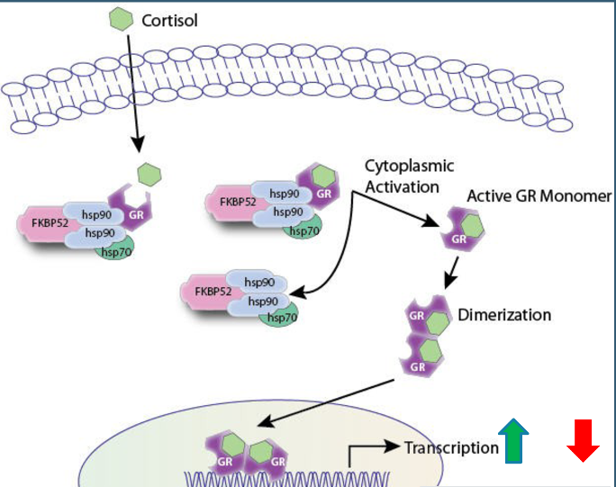

Ligand gated ion channels
The Acetylcholine Pathway:
- An action potential travels down the cell by use of Ca²⁺ channels, and opens acetylcholine channels in the mitochondria, allowing the release of acetylcholine.
- Acetylcholine is the package into a vesicle and transported to the cell membrane, directly opposing the synaptic cleft, with the help of the cytoskeleton (microtubules, microfilaments and their molecular motors).
- The acetylcholine is then released into the synaptic cleft by exocytosis.
- Two molecules of acetylcholine are then needed to bind to a channel on the opposing cells membrane which then opens the channel
- The open channel allows an influx of Na⁺ ions (with small amounts of K⁺ and Ca²⁺) allowing the membrane potential to rise till it becomes an action potential.
- The action potential travels down the new cell while acetylcholine is degraded by acetylcholinesterase, closing membrane channels.
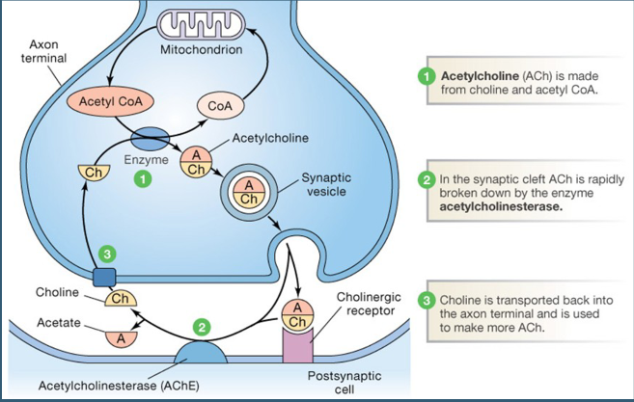
IN A MUSCLE CELL:
- The action potential travels down the cell and opens voltage gated Ca²⁺ on the sarcoplasmic reticulum to open.
- The released calcium then is able to bind to the trocanan (on actin/microfilaments) changing trocanans shape.
- This changes the shape of the cytoskeletal fiber subject to the torcanan, initiating a shortening of the muscle (contraction).
- Degradation of acetylcholine (via acetylcholinesterase) allows the unbinding of calcium from trocanan, and elongation of the muscle (relaxation)

Enzymatic receptors (We will focus particularly on tyrosine kinase receptors)
The Ras/MAPK Pathway:
- The binding of a growth hormone (ligand) allows the dimerization of the enzymatic receptor to another monomer, which unwinds the intracellular catalytic domain.
- The dimer is then activated due to its ability to autophosphorylation, creating an intracellular binding site for proteins with SH₂ domains.
- GRB2-Sos then is able to bind, and then acts as an intermediate to a (inactive) Ras protein. Ras then binds to GRB2-Sos which causing a conformation change and allows Ras to exchange GDP for GTP (binding affinity).
- The addition of GTP activates Ras, which then can release from the intermediate complex (GRB2-Sos) and act as an active kinase.
- The now active kinase, Ras, can go on to phosphorylate its protein target (Raf, which phosphorylates MEK, which phosphorylates MAPK which lastly activate a transcription factor). While doing so the bridge complex (GRB2-Sos) can bind another inactive Ras, amplifying the response.
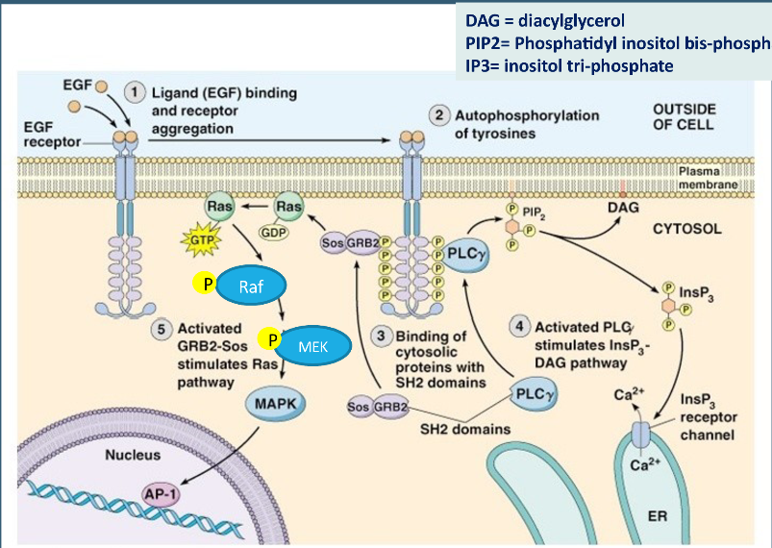
(If GTP were to not be slowly degraded from Ras, it would remain active and continue activating transcription which in turn leads to cancer, but when controlled contributes to cell growth/survival by being a transcription factor for anti-apoptotic genes (Bcl2) )

- The Ras pathway then can go on to initiate the InsP₃ – DAG pathway by the already autophosphoryated receptor binding PLC (phospholipase C) and activating it.
- PLC then goes on to cleave phospholipids producing InsP₃ to be free in the cytosol and DAG to remain in the cell membrane.
- InsP₃ goes on to activate ligand gated calcium channels on both the ER and mitochondria, while DAG can interact with other molecules in the membrane.

GPCR (The cAMP and IP3 Pathways)
The cAMP Pathway:
- A given ligand binds to GPCR receptor, which initiate a conformation change and allows the recruitment of a heterotrimeric g-protein (with three subunits; alpha (has GDP), gamma and beta).
- The binding of the g-protein to the g-protein coupled receptor decreased the binding affinity of GDP to the alpha subunit and allows it to exchange GDP for GTP, which activates the alpha subunit and allows it to detach from the two other subunits and receptor.
- The activated alpha subunit then binds to adenylate cyclase, activating it, and is not able to convert ATP to cAMP.
- The two cAMP molecule then bind to the regulatory subunits (two) on PKA (protein kinase A), allowing it to unravel and free the catalytic domains of PKA (two) and go on to act as active kinases.
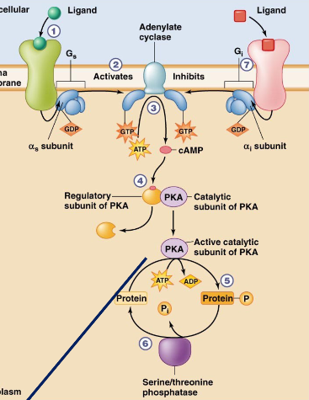

The IP3 Pathway:
- Ligand binds, initiating a conformation change, and allowing the recruitment of a heterotrimeric g-protein. This allows the alpha subunit to exchange GDP for GTP, activating it and allowing it to detach from the other subunits and receptors.
- The alpha subunit goes on the activate PLC (phospholipase C) which cleave phospholipids to create InsP₃ and DAG.
- DAG remains in the membrane to form arachidonic acid, promoting the synthesis of eicosanoids from phospholipids which can activate PKC.
- IP₃ (InsP₃) is released into the cytoplasm to becomes IP₄ OR to bind to calcium channels on the ER/mitochondria and opening them.
- The released Ca²⁺ is then able to bind to calmodulin OR stimulate PKC which can act as active kinase.
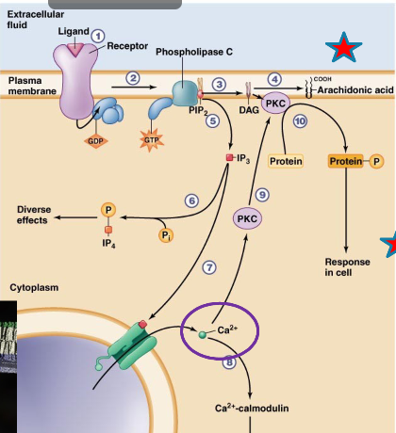

Describe in detail an example of a signal transduction cascade starting from ligand binding to cellular response
Growth factor is bound, Ras is activated, continuing its cascade and phosphorylating its given targets, which in turn activate transcription factors for anti-apoptotic genes. The genes are transcribed and translated resulting in anti-apoptotic proteins fighting against apoptosis (keeping Bad phosphorylated, repressing Bax and Bak) and the cell survives.

Recognize and describe the mechanisms (6) that terminate a cellular response
- Degradation the original ligand from its binding site on the receptor, reverting the receptor back to its inactive state.
- Removal by a neighbouring cell which takes up the ligand, reverting the receptor back to its inactive state.
- Removal by a distant tissue, often the blood stream, which reverts the receptor to its inactive state.
- Hiding of the receptor by pulling it into the lipid membrane, inhibiting a ligand to bind.
- Binding of an inhibitor protein, initiating a conformation change which inhibits a ligand from binding to its domain.
- Inactivation of the pathway by something further down the signal transduction pathway.

TOPIC SEVEN

Understand, describe and demonstrate the steps involved in transcribing DNA to mRNA.
- Binding of a transcription factor aids in the recruitment of the initiation complex (only in eukaryotes, composed of TATAbox binding protein (TBP), transcription factors and regulatory proteins) which further aids the binding and stabilizing of RNA polymerase II.
- RNA polymerase II then goes on to transcribe, and after approximately 20-50 nucleotides, a 5’ G Cap is added to the growing mRNA molecule (allows mRNA to be functional and to be translated).
- As the RNA polymerase II continues, it will eventually reach a poly A signal sequence, communicating to RNA poly II that it is finished transcribing and will stop.
- A poly A tail is then added to the 3’ end of the mRNA allowing it be shuttled out of the nucleus.

(mRNA is shuttled, after maturation in the nucleus, using chaperon proteins to guide them through a nuclear pore)

Be familiar with the elements comprised in a transcription initiation complex, and its role.
The transcription initiation complex is comprised of the TATAbox binding protein, regulatory proteins and transcription factors which all aid in the binding and stabilizing of RNA polymerase II to insure the correct reading frame is being used.

Explain and demonstrate RNA maturation and splicing
Used to rid of the non-coding sequences on the mRNA (introns) and create a continuous coding sequence for translation. To do so, it splices introns from in between exons using “chemical scissors” known as the SPLICEOSOME COMPLEX (contains snRNPs, RNA and enzymes).
- snRNPs locate the introns by their specific beginning and end sequences, and bind to both, using complementary sequences (base pairing), and create a loop (lariats).
- This loop is promoted by proteins as well.
- Enzymes then cleave at the beginning and end of the intron, and protein ligases bind the two exons together.
- Introns are then LEFT IN THE NUCLEUS to be degraded and recycled OR can act as positive/negative regulatory sequences on DNA.

Compare and contrast RNA transcription in prokaryotes vs eukaryotes
EUKARYOTES | PROKARYOTES
- Due to the existence of the nucleus, the mRNA must be “matured” to leave the nucleus  - Use splicing enzymes to mature the mRNA  - Is limited to only being able to transcribe genes during the G₁ and G₂ phases, of interphase, during the cell cycle.  - The mRNA needs a poly A tail as well as a 5’ G cap to be able to leave the nucleus and be translated (respectively).  - Translation CANNOT occur till after the mRNA leaves the nucleus.  - Use chaperon proteins to aid in shuttling the mRNA out of the nucleus by nuclear pores. | - No nucleus, produces mature mRNA.  - Do not use splicing ( mRNA is already mature)  - Can transcribe genes at any time, no limitation.  - No need for a poly A tail or G cap.  - Translation can occur during transcription.  - No chaperon proteins needed.
Elongation
- Use three different RNA polymerases (I, II, III) which are used dependant on what RNA is being made, but RNA polymerase II transcribes. | - Only have one RNA polymerase.
Gene organization
- Have exons (coding) and introns (noncoding) sequences on the mRNA. | - Only are composed of “exons” (coding sequences) and no introns.
Initiation and termination
- Initiated by the binding of the TATAbox binding protein (TBP) to the TATAbox promoter sequence.  - Terminated by a Poly A signal sequence to communicate to RNA polymerase II transcription is finished.  AND  it recruits poly A polymerase to add a poly A tail to the end of the mRNA. | - Initiated by a sigma σ factor which allows the binding of RNA polymerase to the DNA (is removed shortly after)  - Terminated by the use of a GC rich sequence (hairpin pressure of folding detaches RNA poly)  OR  the use of Rho proteins (block RNA poly from continuing, collides and detaches)

SIMILARITIES:
- Both transcribe from the 5’ to 3’ direction.
- Each contain coding sequences.
- Use ribonucleotides to create mRNA from a DNA sequence.
- Both use RNA polymerase to transcribe mRNA.
- Each use consensus sequences to initiate transcription.

Know, describe and/or compare the different elements of control for gene expression in prokaryotes vs eukaryotes

PROKARYOTES

Operons
Use operons to regulate transcription of a gene by genetic switches turning transcription “ON and OFF”. (e.g. Lac operon)
Lac is controlled by the concentration of lactose in the cell, due to the fact that it digests lactose. This is done by a constant repressor which is bonded to the operon of the lac gene. This repressor protein can only be detached when a lactose molecule binds to the lactose domain on the repressor, initiating a conformation change and decreasing its binding affinity for the lac operon. RNA polymerase is then no longer blocked by the protein and can transcribe the gene.

EUKARYOTES

Activators, Enhancers (enhancers, silencers)
Also known as POSITIVE CONTROL, activators bind to a specific sequence on DNA known as a promoter site, and promote the transcription of the gene in question. These can be transcription factors which form the transcription initiation complex.

Repressors
Also known as NEGATIVE CONTROL, repressors bind to a specific sequence on the gene and INABLE transcription of a gene. This can be by binding to promotor sites, enabling the binding of the transcription initiation complex or transcription factors.

Alternative splicing
This is done to MAXIMISE the use of DNA in terms of allowing it to be more efficiently used. This is done by having slightly different proteins created by one gene, which is transcribed into identical mRNA molecules BUT is spliced in a way that some exons are removed. This ability to remove exons and still create a functional protein is due to the presence of interchangeable exons, relating to specific protein domains.
This is accomplished by the spliceosome complex by binding to the beginning of one intron and the ending of another, having an exon present in the loop/lariat which is then removed.

TOPIC EIGHT

Know the components and roles of a ribosome
The ribosome is composed of two major units;
- The SMALL ribosomal subunit which binds to the mature mRNA molecule.
- The LARGE ribosomal subunit which contains peptidyl transferase to bind the amino acids to one another and contains three units; the aminoacyl binding site (a-site), the peptidyl binding site (p-site) and lastly, the exit site (e-site).
The ribosome aids the complementary binding of a tRNA molecules anticodon to the mRNAs codon and binds the growing amino acid chain to the amino acid, on the tRNA, in the a-site.

Understand and demonstrate the different steps involved in translation
- The mRNA molecule assembles with the small ribosomal subunit, and is followed by the first tRNA molecule which has a matching anticodon to that of the AUG start codon (had Met amino acid).
- The large ribosomal subunit is then recruited, and is placed so that the binded tRNA is in the p-site.
- Elongation factors (EF) guide a loaded tRNA molecule and match it to the next codon on the mRNA, on the a-site of the ribosome. The peptidyl transferase in the large subunit then binds the first amino acid to the second, and resulting in a two acid chain in the a-site.
- The GDP on the EF is exchanged for GTP and it is released from the tRNA.
- A new EF comes in, and aids in translocation of the tRNA, bumping each tRNA one spot, resulting in an empty a-site. The EF then exchanges its GDP and releases.
- A third amino acid is recruited, and once a second translocation occurs, the initial empty tRNA is released from the ribosome and is free to be reused.

- Once the stop codon is reached, a release factor instead of a tRNA is recruited, which promotes the last peptide bond to form and the last transloction. This allows the separation of every component and a finished peptide chain. The rest is recycled.

COTRANSLATION (constitutive or regulatory)
Constitutive: done spontaneously and used for delivery of proteins which are regularly produced by the cell.
Regulatory: done by activation by a neurotransmitter or hormone, signalling the vesicle storing the needed protein, by use of calcium ions, to move to the cell membrane.

Secretory protein pathway
- Due to a signal sequence on the growing peptide bond, it is recognized by the signal recognition particle, which it needs to be brought to the ER, then binds to the sequence and temporarily pauses transcription.
- The signal recognition particle binds to its receptor on the translocon protein complex in the rough ER membrane.
- The signal recognition particle then passes the peptide chain to signal peptidase, and translation is resumed

- Translation continues as normal and the finished protein is then released into the ER lumen.

Transmembrane protein pathway
- (steps 1-3 are followed)

- Once a SECOND signal sequence is reached, it is recognized by the translocon complex as the “transmembrane domain” of the protein.

- The translocon complex then slowly released the ribosome as the transmembrane domain is translated without being interrupted. This allows the transmembrane section to be incorporated in the ER membrane.

- The cytosolic domain is then transcribed by the now free cytosolic ribosome.

(Using the codon table, be able to obtain the mRNA and amino acid sequence corresponding to a given DNA strand – 5’ to 3’)

Define and explain, using an example, the different genetic point-mutations and possible mutagens
POINT MUTATION: a small mutation resulting in the change of one or two nucleotides.
Silent mutations: when a change in a single nucleotide does not change the amino acid that is added to the peptide chain. This can be attributed to the wobble effect (i.e. the synonyms for amino acids demonstrated in the codon table).
Missense mutations: change in a nucleotide which results in a change in the amino acid added to the peptide chain. (E.g. sickle cell anemia – amino acid which inhibits the compact structure of a normal hemoglobin)
Nonsense mutations: lead to nonsensical proteins and can result in a premature stop codon.
Frame shift mutations: due to the insertion or deletion of a nucleotide, the reading frame is completely shifted resulting in a completely different protein.

Discuss/Compare the possible scenarios for protein sorting following translation
Sorting and distribution of proteins all depend on their structure and characteristics, which inevitably lead to their given role in the cell. The two major possibilities are protein which are soluble in the cytoplasm and ones which are not.
The soluble proteins are translated by free cytosolic ribosomes and are used or secreted without any use of vesicles.
Insoluble proteins must undergo cotranslation, with the help of the rough endoplasmic reticulum (ER) as they are soluble in its lumen. Using the translocon protein complex (membrane pore, SRP receptor and signal peptidase) can be translated and packaged using a vesicle, transported to the golgi body and lastly be re-packaged and delivered.

Relate vesicular transport to the cytoskeletal elements and motor proteins previously discussed
Vesicles are used to transport certain proteins which are insoluble in the cytoplasm or membrane to where they need to be. This can vary from the cell membrane, to organelle membranes and finally to be secreted out of the cell. Molecular motors on microtubules and microfilaments are used to transport the vesicles throughout the cell. Kinesin, Dyenin and Myosin motors can be used to transport storage vesicles or vesicles containing proteins which need to be brought to an organelles, whereas ONLY Kinesin (and a few myosin) can transport secretory vesicles towards the membrane of the cell.

Analyse a cascade of events from a messenger molecule to a nuclear response, including protein secretion

Final
TOPIC NINE

