Nutrition 3210 Midterm Notes
Introduction to Nutrition
- Nutrition is the study of the processes by which organisms ingest, digest, absorb, transport, utilize and excrete food substances
- Essential nutrient is a chemical that is required for metabolism, but cannot be synthesized or cannot be synthesized rapidly enough to meet the needs of an animal or human for one or more physiological functions
- Nutrients are essential if:
- Removing the nutrient from the diet causes a deficiency and decline in health
- Putting the nutrient back into the diet corrects the problem and health will return
- Take out = have a problem, put back = problem fixed
Deficiency
- Nutritional deficiency – occurs when a person’s nutrient intake consistently falls below the recommended requirement
- Anemia = deficient in iron, folate and/or vitamin B12
- Not enough red blood cells to transport O2, important in key stages of development
- Beriberi = deficient in Thiamine (B1)
- Defective energy production, abnormalities in NS
- Scurvy = deficient in Vitamin C
- Defective collage production (important for structure), hemorrhaging & bleeding of the gums
- Rickets = vitamin D deficiency
- defective bone growth
Estimating Nutrient Requirement
- Deficiency prevention of disease
- nutritional requirement ensure optimal health
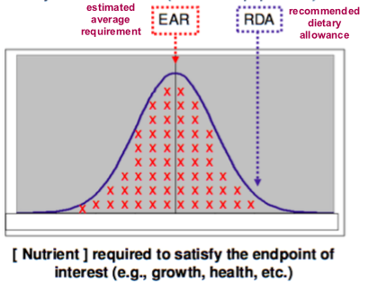
- eating enough of X so you aren’t not ‘deficient’ may prevent disease but doesn’t give you optimal health
- early recommendations for nutritional requirement didn’t take into account differences in age, gender, body size physical activity
- nutritional requirements can be estimated statistically
- the estimated average requirement (EAR) is the amount of X nutrient that satisfies 50% of the populations end point (end point being proper growth, storage and health)
- the recommended dietary allowance (RDA) is EDA + 2 standard deviations, and is the value of X which satisfies 98% of the populations end point
- there is also an tolerable upper limit to nutrient intake, when you consume more than the upper limit the nutrient is in excess which also causes health problems
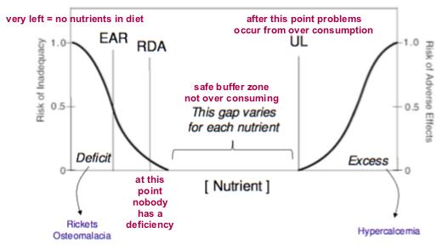
- dietary reference intake (DRI) is the set of reference values for specific nutrients (EAR, RDA and UL)
- the DRI defines the EAR, RDA and UL for every nutrient
Starvation
- Minnesota starvation experiment: 3 months high cal. diet, 6 months low cal. diet, 3 months rehab
- starvation led to weight loss, irritability, dizziness, tiredness, hair loss, reduced sex drive, depression and more
- the effects of starvation can take more than a year to be reversed
4 characteristics of a nutritious dies
- adequate: a diet that provides enough calories, essential nutrients and fibre to keep you healthy
- moderate: ensuring you don’t consume excessive calories, or eat more of one food or food group than recommended
- balanced: making sure you eat nutrient-dense foods, rather than nutrient-poor foods
- varied: eating a wide selection of food to get the necessary nutrient
Methods for studying nutrition
- cell cultured models
- animal models
- epidemiological studies
Nutrient Classes
Organic (contains carbon) | Inorganic
Carbohydrates (& fibre) *  Lipid*  Protein *  Vitamins # | Minerals #  Water
- * Macronutrients: consume in large quantities
- # micronutrients: consume in small quantities
- water is essential but is neither a macro or micro nutrient
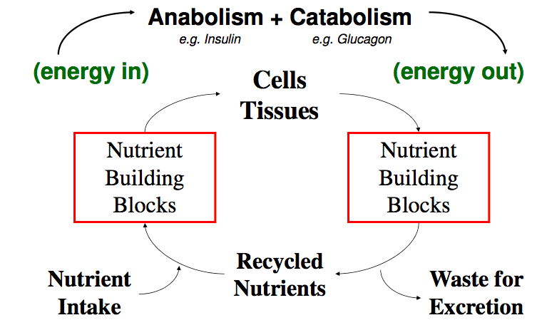
- water makes up 60% of the body, lipids make up 20-25%, protein 15%, vitamins & minerals 2%, carbs 0.5%

Metabolism
- metabolism = anabolism + catabolism
- anabolism = building (simple complex)
- catabolism = breakdown (complex simple)

Water
- Functions of water:
- Solvent in biochemical reactions
- Catabolism (hydrolysis)
- Maintains vascular volume
- Nutrient transport
- Temperature regulation
- adult require intake: 2.7L – 3.7L
- 20% of water comes from food
- average intake of carbs: 250 -350 grams per day
- fat: 60 – 80 grams per day
- protein: 50-80 grams per day
Water Toxicity
- occurs when, water intake >> kidney’s ability to process (~0.9L per hour)
- water is processed through the kidney where urine is made to be excreted)
- hyponatremia = water / sodium imbalance
- can occur from excessive fluid intake, under-replacement of sodium or both
- hyponatremia is avoided with urination
- hyponatremia causes CN edema and muscle weakness
- can occur in elite athletes who consume large amount of water without enough electrolytes
Proximate Analysis
- food analysis is the development, application and study of analytical methods for characterizing foods and their constituents
- why is knowing food composition important?
- information about foods produces foods that are safe and nutritious and allows the consume to make informed decisions
- government regulation: maintain quality food, ensure food industry makes safe foods, fair competition between companies, eliminate economic fraud
- quality control: ensures food composition doesn’t change, characterize raw materials
Nutrient Density
- all foods are not created equal
- caloric content does not predict nutrient content in foods
- nutrient dense foods: have a high, nutritional value: caloric content is very high
- empty calorie foods: have high calories and low nutrients
Steps of Proximate Analysis
- Moisture (water content)
- To determine water content air dry the feed sample (dehydrate it)
- % moisture = (weight loss / wet weigh sample) x 100%
- % dry matter = 100 - % moisture
- determining water content is important since:
- water is weight, more weight = higher cost
- moisture content plays a role in storage conditions, too much water a food spoils quickly, too little water and the food is less palatable
- moisture dilutes energy and nutrients in food
- moisture is important for optimum intake and performance of animals
- sources of errors and limitations:
- drying can remove other volatile compounds such as short chain fatty acids and some minerals
causing a slight under-estimation of dry weight
- human food labels are based on wet weight, animal feed is more interested in dry matter
- Ether extract (crude fat)
- Run an ether extraction creates a solution (liquid) phase and a residue phase
- Remove the solution phase (which contains the lipids) and dry it out
- % crude fat = (weight of crude fat/wet weight of sample) x 100%
- Potential sources of error / limitations:
- Things other than lipids are soluble in the extract (e.g chlorophyll, resins and waxes are soluble in the ether extract but provide no nutritional value – they are not dietary fats)
- This causes an over-estimation of crude fat
- New method: the ether extract is ran through gas chromatography (instead of drying out), provides you with the amounts of specific dietary fats in the ether extract
- Ash (mineral content)
- The residue phase of the ether extraction is burned, the organic material burns off and all you are left with is ASH (the minerals/inorganic material)
- Determining ASH content is important for:
- Nutritional labelling
- Quality and taste of food
- Microbiological stability
- Nutritional requirements
- Manufacturer processing
- % ASH = (weight of ASH / wet weight of sample) x 100%
- Potential sources of error/limitations:
- Volatile minerals may be lost when the residue is burned
- This causes an underestimation of mineral content
- There is not information about individual minerals (it is now mandatory for food labels to indicate Na content)
- Nitrogen (crude protein)
- Determine by Kjeldahl analysis of the dry matter
- 2 assumptions of Kjeldhal analysis:
- all nitrogen is protein
- all protein contains 16% nitrogen
- 3 main steps of Kjeldahl Analysis
- digestion – dry food sample mixed with sulfuric acids, converting Nitrogen to ammonia
- Distillation – separated ammonia
- Titration – quantifies amount of ammonia
- % crude protein = ( (Nitrogen in sample x 6.25)/ wet weight of sample) x 100%
- 6.25 comes from the idea that all protein is 16% nitrogen
- 100% (total protein) / 16% (nitrogen) = 6.25
- nitrogen x 6.25 = crude protein
- midterm: could be given a different nitrogen content (not 16%) and would have to change the conversion factor
- Potential sources of error/limitations
- Assume all protein has 16% nitrogen (in reality it ranges from 13%-19%)
- There are other sources of nitrogen that aren’t protein (nitrates, nitrites, urea, nucleic acids etc.)
this causes an over estimation of crude protein content
- Crude fibre (fibre)
- Take residue from ether extract:
- Boil in acid
- Take residue (what is not soluble in acid) and boil in alkali
- Take residue (which consists of ASH and crude fibre) and ignite
- You are left with ASH, must back calculate to get fibre
- % crude fibre = ((weight of ASH + crude fibre) – wt of ash)/wet weight of sample) x 100%
- crude fibre ≠dietary fibres
- crude fibre is insoluble, dietary fire is both insoluble and soluble fibre
- crude fibre is primarily cellulose and lignin, soluble fibres are mostly loos during the analysis process
- Potential sources or error/limitations:
- Unable to distinguish the different fibre components
- Measuring crude fibre underestimates actual dietary fibres content by up to 50%
- Dietary fibre includes cellulose, hemicellulose, pectin, mucildges, gums, lignin which are lost during analysis
6) Nitrogen Free Extract (NFE) = Digestible carbohydrates (CHO)
- Estimates starch and sugar content
- % NFE = 100 – (% moisture + % crude fat + % ASH + % crude protein, + % crude fibre)
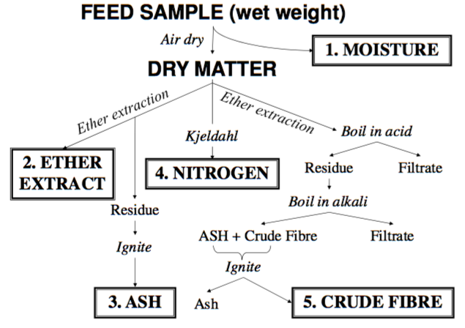
- potential sources of error/limitations:
- NFE accumulates ALL of the ERRORs that exists for the other components
General Notes of Proximate Analysis
- No information on ‘digestibility of food/feed
- Don’t know what is actually absorbed by the organism
- No information of specific AA, minerals, lipids or carbohydrates
- Still is the basis for food labelling and animal feed analysis
Dietary Fibre
- Dietary fibres are non-digestible complex carbs
- Come from structural part of plants
- INSOLUBLE FIRBES = cellulose, lignin, hemicellulose
- Do not dissolve in water
- Insoluble fibres remain intact through the intestinal tract
- Insoluble fibres help move food along the digestive tract (reducing constipation, bloating etc.), they also help maintain the pH of the digestive tract helping the bacterial community survive
- SOLUBLE FIRBES = pectin, gums, mucilage
- dissolves in water
- forms a gel
- hangs onto other nutrients and slows down absorption (slowing down glucose absorption helps w type 2 diabetes, slowing down cholesterol absorption reduces risk for cardiovascular disease)
- other fibre analyses that complements Proximate Analysis:
- Van Soest Method
- Southgate Method
Van Soest Method of Fibre Analysis in Feeds
- Detergent fibre analysis
- Differentiates between the insoluble fibres
- Cellulose & hemicellulose
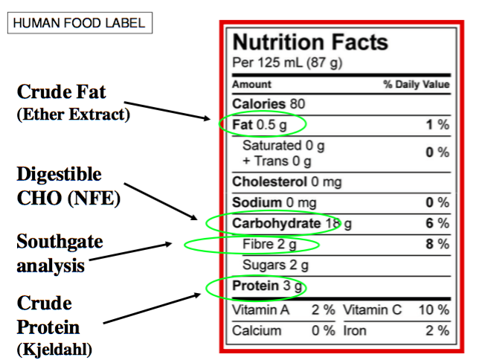
- Lignin (poorly fermented, prevents fermentation of other fibres)
- Determines fermentable and non-fermentable CHO
- Important in agriculture applications
- Poorly differentiates sugars, starches and soluble fibres
Southgate Method of Fibre Analysis for Human Food Labels
- Provides information about sugars, starches and various fibres
- Used for human nutrition and food labels
- Does not differentiate b/w various fibre components adequately, therefor NOT used is agriculture
Digestive Systems
Gastrointestinal Tract
- Composed of the:
- Mouth
- Esophagus
- Stomach (monogastric = 1 stomach, avian = 2 compartment stomach, ruminant = 4 compartment stomach)
- Small intestine
- Large intestine
- Caecum
- Rectum
- GI tract = digestive tract ≠ digestive system
- Digestive system refers to the GI tract + associated organs (salivary glands, liver, pancreas, gallbladder)
General Terms for Dietary CHO and Digestion
- Digestibility = does the host organisms have the enzymes necessary to digest CHO?
- Digestible CHO vs non-digestible CHO (fibre)
- Solubility = is CHO soluble in the aqueous environment of the digestive tract?
- Yes = soluble, no = insoluble
- Fermentability = does the gut bacteria have the enzymes necessary to break down the CHO
- Yes = fermentable, no = non-fermentable
- Simple System w/o caecum
- Monogastric stomach
- Non-functional caecum
- Suited for nutrient dense, low fibre diets
- E.g. pig, human, cat, dog
Digestion at each part of GI tract
- Oral cavity:
- food is chewed and mixed with saliva
- 2 enzymes released: α−amylase and lingual lipase
- Stomach (cardia, fundus, body and antrum)
- Gastric emptying takes 2-6 hours (full = 1-1.5L empty = 50 mL)
- pH of stomach is acidic ~2 (important in digesting proteins)
- food becomes “chyme”
- gastric glands release gastric juice, gastric juice = water, electrolytes, HCL and enzymes
- Small intestine: (duodenum, jejunum, ileum)
- Main site of nutrient digestion and absorption
- Surface area = 30m² (this large SA enables nutrients to be absorbed)
- Intestinal motility controlled by longitudinal and circular muscles
- Chyme acidity is neutralized by pancreatic juice (contains bicarbonate to counter acidity)
- Food digested by pancreatic juice and bile acids (bile acid solubilizes dietary fats)
- Large intestine (also called colon)
- Site of fermentation (break down by bacteria)
- Production of short chain fatty acids (SCFA) also called volatile fatty acids (VFA)
- SCFA doesn’t provide much energy to the host, they are mainly used by the bacteria
- Site for water absorption
How is the Surface Area of the Small Intestine Achieved?
- Kerckring folds the more folds the more sites of absorption)
- each fold contains villi (projections) and crypts (pits)
- each cell that makes up the villi is covered in microvilli
- total SA is about the size of half a badminton court
Nutrient Transport Mechanisms
- passive transport (no energy input required) diffusion and facilitated diffusion
- active transport (requires energy)
- they type of transport mechanism used depends on the nutrients
- solubility
- concentration gradient
- molecular size
Large Intestine
- 10² – 10¹² bacteria per g content (region specific)
- 500 – 1000 species identified per person in the gut
- different species but all have similar core function
- the species of bacteria may differ in the gut of each person but there is a core preserved functionality of bacteria in everyone
- 1000:1 anaerobic to aerobic bacteria
- bacteria is important for fermentation of non-digestible CHO
- CHO fermentation produces lactate and SCFA
- Gut bacteria contributes to body weight and metabolism
- Foods with probiotics are trying to change and enrich the bacterial community in your gut
- Simple System w Functional Caecum
- Horse, rabbit, hamster
- Hind gut fermentor
- ‘pseudo-ruminant’
- functional caecum
- suited for a diet with large amounts of fodder (fodder – plant material)
- Function of caecum
- Enormous hindgut (20-30L capacity in horse) filled with bacteria allowing fermentation to take place
- SCFA produced by the bacteria provide 70% of energy needs for host
- Generates vitamins
- A sign of energy/nutrient deficiency in horses is coprophagy where they begin to eat feces
Digestion in a Horse
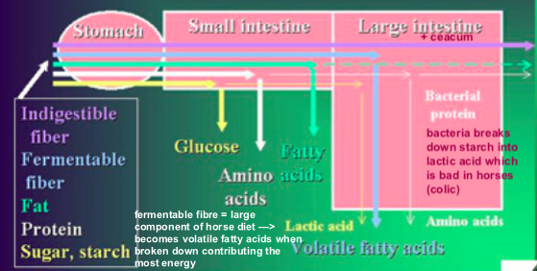
- Small intestine: sugar & starch breaks down to glucose, protein broken down to AA, fat breaks down to lipids
- Large intestine: bacteria!!
- fermentable fibre breaks down to volatile fatty acids, starch broken down to lactic acids, protein broken down the amino acids
- indigestible fibre goes through whole GI tract with no digestion
- Ruminant
- Cattle, sheep, goats
- Fermentation takes place mostly before small intestine
- Large stomach divided into 4 sections
- Rumen
- Reticulum
- Omasum
- Abomasum
- System highly suited for animals that eat a high quantity of fodder (hay)
Ruminant Digestion
- Rumen
- Largest section of the stomach
- Rich in bacteria (fermentation vat)
- Rumen papillae increases surface area for absorption (similar to microvilli)
- Food is mixed and partially broken down and stored temporarily
- 60-80% of total energy produced here through SCFA (SCFA come from bacteria fermentation)
- Reticulum
- Honeycomb appearance in order to capture nutrients and trap foreign materials
- Rich in bacteria (fermentation vat)
- Omasum
- Resorption of water and some electrolytes
- Filters large particles
- Abomasum
- Digestive enzymes secreted from gastric glands (HCL, mucin, pepsinogen, lipase, etc.)
- “true stomach” similar to that of a monogastric animal
- Fermentation takes place before entering the intestine (foregut digestion)
- Nutrients are produced by bacteria and then become available for digestion and absorption by the ruminant
- Rumination 2. Eructation (belching)
- Rumen has 10-50 billion bacteria per gram of ruminal fluid
- Advantages of ruminant system:
- Vitamin synthesis
- Non-protein nitrogen used for making protein
- Disadvantages:
- Carbs are degraded into gases and lost through eructation (belching)
- Heat production (bacterial fermentation produced energy, and energy is heat)
- Avian System
- Birds
- Beaks and claws are important for breaking up foods into smaller pieces that birds can swallow (no teeth)
- Rapid digestion
- Components:
- esophagus Crop (storage reservoir) Preventriculus + gizzard (together these = the monogastric stomach) Small intestine Cecum Large intestine Cloaca + vent
- Crop
- Enlarged area of the esophagus
- Temporary storage location for food
- Food is softened (often regurgitated from the crop to feed offspring)
- Two chamber stomach
- Glandular portion = proventriculus
- Muscular portion = gizzard
- Small intestine
- Function is similar to other systems (nutrient digestion and absorption)
- Ceca
- Minor site of bacterial fermentation
- Large intestine
- Very short, and serves predominantly to connect the small intestine and the cloaca
- Small storage of undigested material
- Water absorption
- Cloaca
- Digestive, urinary and reproductive systems meet
Digestibility
- Digestibility is a measure of the fraction of a specific nutrient that is extracted by the GI tract
- Calculated from the amount of nutrient in the diet and the amount appearing in the feces
- Combines nutrient release from food matrix, microbial fermentation and absorption
- Understanding digestibility is important in preventing deficiency and ensuring essential nutrients are available to the organism
- Factors that affect digestibility:
- Feed intake (food matrix)
- Particle size (smaller particles move faster through GI tract decreasing their chance of being absorbed)
- Chemical composition
- Climate
- Age (born sterile with no gut bacteria, as we age we shape our internal microbiome and become more efficient at digesting food)
Total Collection Method
- Animal adapts to diet (7-21day period)
- Isolate animal for quantitative analysis
- Measure nutrient intake over a 3-10 day period
- Collect and weigh all feces over the same period
- Analyze for nutrient of interest
- Apparent digestibility coefficient = (total intake –total feces) / total intake
- Limitations:
- Not accurate
- Metabolic cages (collect and analyze urine and feces) used in the experiments create anxiety which can cause animals to behave abnormally
- Labour intensive
- Animals confined in costly equipment
- Not feasible for captive wild animals
Indicator Method
- Requires a marker:
- Internal (natural component of the feed)
- External (component added to the feed)
- Characteristics of a marker:
- Non-absorbable
- Must not affect or be affected by the GI tract
- Must mix easily with food
- Easily and accurately measured in samples
- Marker examples: ferric oxide, chromic oxide, silica, lignan
- Steps:
- Adapt animal to test diet (contains a marker)
- Collect a feed and fecal sample
- Analyze each (feed and fecal sample) for marker and nutrient of interest relative to your indicator
- Apparent digestibility coefficient = (A –B) / A
- Advantages of indicator method:
- Less labour intensive
- Ideal for wild animals
Apparent vs True Digestibility
- Apparent digestibility underestimates true digestibility
- When apparent digestibility is calculated these things are not taken into account:
- Endogenous secretions: dead epithelial cells from digestive tract appear as fatty acids in the feces
- Bacterial growth in the gut: nutrient synthesis produces biotin (get bacteria produce and release vitamins)
- Digestive enzymes: protein secretion (enzymes are proteins, constantly being secreted by cells and can be found in the feces)
True digestibility
- Preform digestibility study using a TEST DIET
- Switch to diet containing none of the nutrient of interest (ZERO NUTRIENT DIET)
- Analyze feces after TEST DIET is cleared
- Subtract level of nutrient in feces of animals fed the ZERO NUTRIENT DIET from the TEST DIET
- True digestibility = (A – (B –C)) / A
- A = ratio of nutrient/marker in the test diet
- B = ratio of nutrient/marker in the feces
- C = ratio of nutrient/marker in the feces after zero nutrient diet
Energy
Energy Terms
- Cellular source of energy = ATP
- Supplied by macronutrients in the diet, sustains physical energy, anabolism and active transport
- The energy unit of food is calorie (calorie is a measure of heat)
- Kcal = 1000 calories = 1 Calorie = 1 Cal
- 1 kcal (or 1 Cal) = 4.18 kJ energy required to raise the temp of 1 kg of water by 1ºC
Energy Balance
- energy in = food and drink
- energy out = metabolic and cellular function, physical activity
- Positive energy balance: more energy in than out
- Weight gain/obesity
- Infertility
- Increased blood lipids
- Insulin resistance
- Negative energy balance: more energy out than in
- Weight loss
- Infection
- Loss of performance
- Reduced bone mass
Estimating Energy in Food
- Historical methods:
- Lavoisier: compared heat produced and CO2 produced by a guinea pig, ice calorimeter (heat produced estimated by the amount of ice that melts)
- Liebig: recognized that proteins, carbs and fats are oxidized by the body
- Rubner: measured energy values of certain foods to determine Caloric content
- Calorimetry = measurement of heat production
- Uses heat as an indicator of the amount of energy stored in the chemical bonds of food
- Bomb calorimetry:
- Dry and weigh sample and place in enclosed chamber with oxygen
- Ignite sample
- Heat released is absorbed by water and measured
- Heat of combustion (gross energy)
- Potential errors:
- Overestimate energy: we don’t digest food like a bomb calorimeter (e.g. fibre burns and releases energy but we do not digest all fibre)
- Doesn’t take into account the energy needed for digestion and absorption
Physiological Fuel Values
 | Heat of Combustion (Gross energy) | Loss in urine | Apparent Digestibility | Physiological Fuel Value (Atwater value, available energy, metabolizable energy)
 | (a) | (b) | (c) | (a-b) x c
Units | Kcal/g | Kcal/g | % | Kcal/g
CHO | 4.15 | --- | 97 | 4
Fat | 9.40 | -- | 95 | 9
Protein | 5.65 | 1.25 | 92 | 4
Why Does Fat Provide More Kcal Per Gram?
- Lipid ratio of H to O is greater than CHO
lipids have a lot of H atoms available for cleavage and oxidation for energy
- CHO ratio of H to O is 1:2
- Protein has nitrogen which contributes to gross energy in a calorimeter but our bodies dot used N for energy
Fatty Acid Structure and Gross Energy
- Not every fat gives the “Atwater value” of 9, 9 is just an average value
- Steric acid – 18:0 9.53 kcal/g
- Oleic acid – 18:1 9.48 kcal/g
- Linoleic Acid – 18:2 9.42 kcal/g
- Heat of combustion for fatty acids is affected by:
- Chain length: the longer the chain the more energy released
- Degree of unsaturation: the more double bonds the less energy released
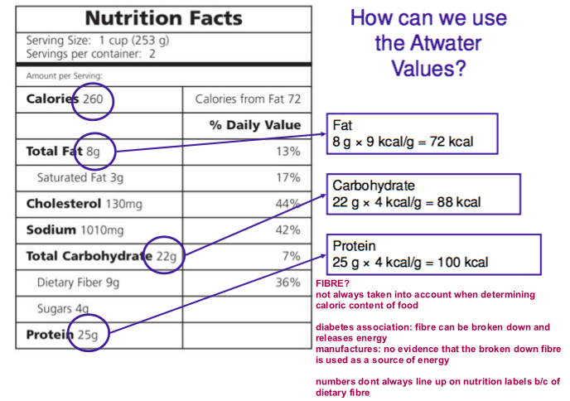

Use of Available Energy
- Heat increment of feeding (HIF)
- thermic effect of food
- energy used for digestion, absorption, distribution and storage of nutrients
- 5-30% of energy expenditure
- Net energy = Available energy – HIF
- Net energy: supports basal metabolism, physical activity, growth, pregnancy etc.
- any energy left over after HIF is used for the processes listed above
- energy goes to basal metabolic function first, then the excess after that is used for physical activity, growth etc.
Partitioning Energy from Food
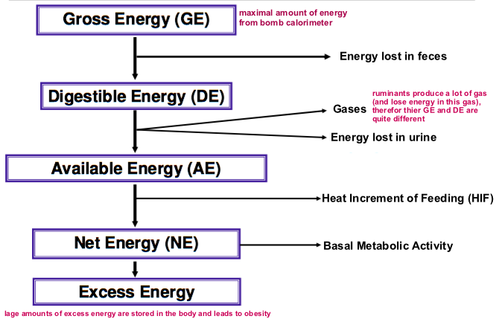
Total Energy Expenditure
- three primary components to energy expenditure:
- basal metabolic rate (BMR)
- thermic effect of food (same as HIF)
- physical activity energy expenditure (PAEE)
- thermoregulation can also contribute to energy expenditure but this one isn’t very important since we typically regulate temperature though clothing
Basal Metabolic Rate
- BMR = the minimal amount of energy you need to survive and maintain essential body processes
- measuring BMR:
- shortly after waking
- post-absorptive state (no food)
- lying down
- completely relaxed
- comfortable room temp
- BMR = kcal/24 hours (how much energy does a person require for a day)
- Muscle and bone are most reflective of BMR
- BMR (basal metabolic rate) vs RMR resting metabolic rate
- Essentially the same thing but RMR is a little more crude and is something you can do quicker
Calculating BMR
- BMR = A x [M^{0.75}] kcal/day
- A – metabolically active tissue (muscle and bone)
- Constant value, humans = 70, dogs = 30, horse =155
- M – body weight in kg
- 0.75 – Kleiber’s law – used for all vertebrates, invertebrates and unicellular organisms
Harris Benedict Equation
- takes into account level of activity, sex, age, weight and height
Factors affecting BMR
- genetics – inherits a fast or slow metabolic rate
- age – young people have higher BMR than old (more muscle mass)
- sex – men > women (more muscle mass)
- exercise – changes body tissue proportions
- putting on muscle has a significant impact on metabolic rate!
- Fat tissue = 20% of body weight and 5% of metabolic activity
- Muscle = 30-40% of body weight and 25% of metabolic activity
- Brain, liver, heart and kidney = 5% body weight and 60% metabolic activity (this doesn’t change with exercise)
- Temperature – maintaining thermoregulation can impact BMR
- As age increases BMR increases
- As weight increases BMR increases
- And fat free mass (FFM) increases BMR increases
Using % body fat to calculate BMR
- If you can measure body fat % you can get a more accurate measure of BMR
- Katch-Mcardle BMR equation takes into account % body fat and only measures activity of metabolically active tissue
Measuring Total Energy Expenditure
- All metabolic processes in the body generate heat
- Heat production can be used as a measure of energy expenditure
- Can be measures by direct or indirect calorimetry
Calorimetry
- Fuel + O2 CO2 + H20 + Heat
- Indirect calorimetry measures O2 and CO2
- Direct calorimetry measures heat
- There is a <1% difference b/w the 2 they are very comparable
Direct Calorimetry
- Measures the heat a person generates = total heat loss
- Expensive and impractical
Indirect Calorimetry
- Estimates heat production by measuring
- O2 consumption (in L)
- CO2 production (in L)
- Urinary nitrogen loss (in g)
- This method cannot account for anaerobic processes (such as production of lactate from glucose during intense exercise)
- Disadvantages:
- Hyperventilation (produces a lot of CO2 but has nothing to do with energy breakdown)
- Hard to get an airtight seal
- Masks are impractical
- Advantages:
- Can be used with animals
- Determines the type of substrate being oxidized (e.g. can determine how much carb vs fat is being used by the body)
Respiratory Quotient
- Provides information about
- Energy expenditure
- Biological substrate being oxidized
- Is a ratio of metabolic gas exchange
- RQ = (CO2 produced)/(O2 consumed)
- Also called the non-protein RQ because protein contributes little to energy metabolism
- RQ varies for macronutrients
- Differences in chemical composition means that each macronutrient requires a different amount of O2 uptake in relation to CO2 production
- Carbohydrate: RQ = 1 (for every O2 used a CO2 is produced)
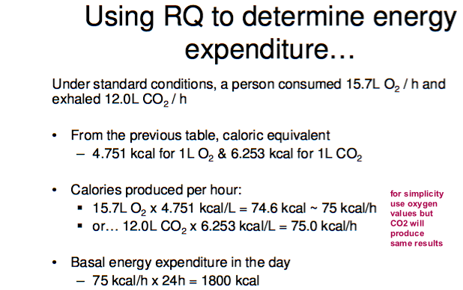
- Fats: RQ = 0.7 (for every 10 O2 used 7 CO2 are made)
- Our normal RQ lies between 0.7-1 since our body uses a combination of fats and carbohydrates for fuel
- Assumptions
- only CHO and fat are metabolized
- no synthesis is taking place at the same time as breakdown
- amount of CO2 exhaled = amount of CO2 produced by tissues
Crossover Concept
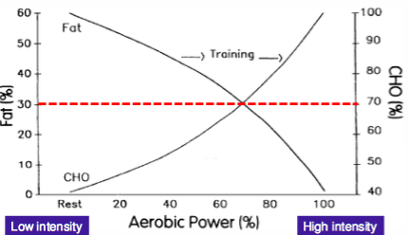
- during low intensity exercise mainly fat is used for energy (at rest we used 60% fat for fuel and 40% CHO)
- during high intensity only CHO is used for energy (at 100% aerobic power 0% fat for fuel and 100% CHO)
- the crossover point is when muscle starts to use more CHO than Fat to sustain power
- endurance = fat, high intensity = CHO
- training enables a person to move their crossover point to the R meaning they use more fat for energy than CHO

Carbohydrates
CHO Classification
Simple
- Monosaccharides
- Most common is glucose
- Occur naturally
- Cannot be hydrolyzed any smaller
- Reducing sugar = anomeric carbon free
- Disaccharides
- Most common is sucrose
- 2 monosaccharides joined by an acetyl bond (glyocosidic bond)
Complex
- oligosaccharides
- polysaccharides (condensed energy sources)
- homo-polysaccharides = made of only 1 type of monosaccharide, hetero-polysaccharide = made of 2 or more types of monosaccharides
- glycogen = storage in animals
- starch & cellulose = plants
Monosaccharides
- triose = 3 carbons = metabolites of glucose
- pentose = 5 carbons = components of DNA and RNA
- hexose = 6 carbons = nutritionally most important
- the anomeric carbon has the carbonyl group attached to it (C=O)
Stereoisomers
- have same molecular formula and sequence but different in their 3D structure due to chiral carbon atoms
- diff structures but chemically identical
- chiral carbon = carbon with 4 different atoms or groups attached to it
- enantiomers = mirror images
- diastereomers = not a mirror
- Fischer projection
- Look at farthest chiral carbon from the carbonyl group:
D = -OH on the right
L = -OH on the left
- The number of stereoisomers for a molecule = 2^{n}, n = the number of chiral carbons
- D-monosaccharides are nutritionally important digestive enzyme are stereospecific to D sugars
Haworth Model
- Linear CHO becomes cyclic anomeric C and last chiral C link
- Anomeric C becomes a new chiral center
- Rules for what’s up what’s down:
- Non-acetyl/ketal CH2OH always point up
- Hydroxyl (-OH) groups: L in fisher = above in Haworth = β
- LAB: left- above-beta
- RBA: right-below-alpha
- Our body is only capable of breaking down α−carbons
- Hemiacetal monosaccharide with an aldehyde
- Hemiketal monosaccharide + ketone
CHO Nomenclature
- Anomeric vs chiral carbon
- Anomeric C has the carbonyl group (=O)
- Chiral C has 4 different atoms/groups attached to it
- D vs L configuration
- D has –OH on the R and is more nutritionally important
- α or β configuration of hemiacetal or hemiketal group
- B is more common than a
- B has –Oh group on anomeric C pointing up
- Fischer projection vs Haworth Model
- Liner = fischer
- Cyclic = Haworth
Disaccharides
- Most common oligosaccharide
- 2 monosaccharides attached by a glyocosidic bond (formed b/w 2 –OH groups)
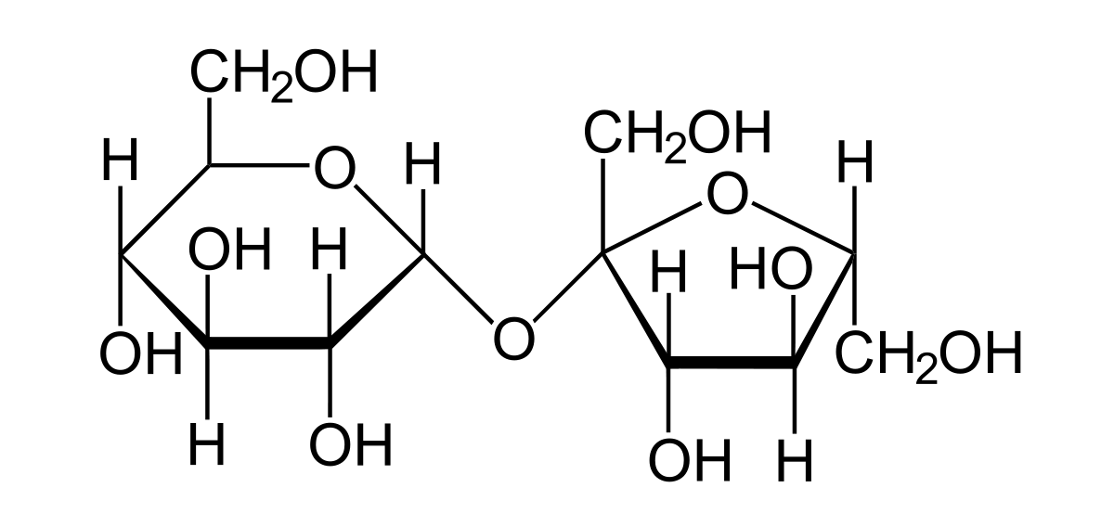
- glyocosidic bond can be α or β
Common Disaccharides
- sucrose: (glucose -α1-2-fructose)
- found in sugar cane and fruits
- glucose + fructose
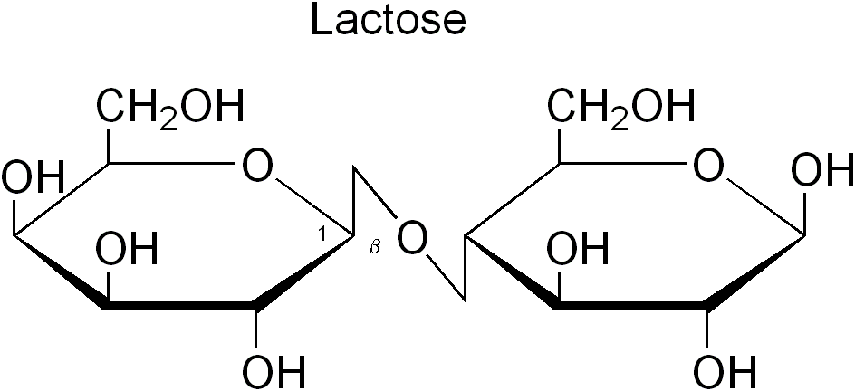
- non-reducing both anomeric C used
- lactose: (galactose -β1 – 4-glucose)
- found in milk
- galactose + glucose
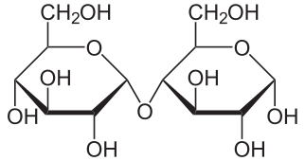
- reducing anomeric C free on glucose
- maltose: (glucose-α1 – 4-glucose)
- found in beer and liquor
- glucose + glucose
- reducing
Polysaccharides
- long strings or branches of monosaccharides attached by glyocosidic bonds
- homopolysaccharides – 1 type of monosaccharide
- heteropolysaccharides – 2+ types of monosaccharides
- homopolysaccharides are more abundant in food
- starch = plants (chains of D-glucose)
- amylopectin = branched starch
- amylose = unbranched
- glycogen = animals, highly branched
- branching provides a larger number of ends from which glucose can be cleaved when energy is required
Dietary Fibre
- non-digestible CHO, structural part of plants
- insoluble: cellulose, lignin, hemicellulose
- remains intact through intestinal tract
- reduces transit time (moves things quickly through the gut)
- increases fecal bulk (prevents fecal deposits from building up in GI tact)
- soluble: pectins, gums, mucilages, glucans
- forms gel
- delays gastric emptying, increases transit time
- slows down nutrient absorption
- characteristics of dietary fibre:
- water-holding ability: ability of a fibre to hold water and become viscous solution
- absorptive ability: ability of a fibre to bind enzymes and nutrients
Cellulose (insoluble)
- both a dietary and functional fibre
- dietary = naturally occurs in the food we eat
- functional = is added to foods
- homopolysaccharides of β-1,4 glucose units linear
- poorly fermented by gut bacteria
- humans lack cellulose-fermenting microbes (metanogens)
- rich in bran, legumes, nuts and peas
Hemicellulose (solubility depends on composition)
- heteropolysaccharide
- mixture of α & β glyocosidic linkages
- can contain both pentose and hexose sugars
- xylose is most common monosaccharide in hemicellulose
- can be branched or linear
- solubility and fermentability depends on the sugar composition of hemicellulose
- bran, whole grains, nuts and some vegetables/fruits
Pectin (soluble)
- dietary and functional fibre
- part of the primary cell wall of plants
- unbranched α-1,4-linked D galacturonic acid
- stable at low pH
- highly fermentable by b=gut bacteria (can be broken down by gut bacteria but cant be broken down by human)
- good bulking agent in animal feeds
- rich in fruits
Resistant Starch
- 4 main types, RS1, RS2, RS3, RS4
- found in plant cell walls
- resistant to amylase activity – can’t break down
- as a banana ripens resistant starches break down to become simple sugars
Health Benefits of Fibre
- maintains function and health of the gut
- insoluble fibre decreases constipation
- stimulated contraction to break down waste
- decreases risk of bacterial infection
- soluble fibre increases satiety
- delays gastric emptying (feel fuller longer)
- long term weight control
- reduced blood cholesterol decreasing risk for cardiovascular disease
- soluble fibres help slow down the absorption of glucose reducing risk of diabetes
Carbohydrate Digestion
Mouth
- saliva α-amylase breaks down α-1,4-glyscodidic bonds
- cellulose and lactose are resistant to α−amylase since they are α-1,6-glycosidic bonds
- produces only a few monosaccharides
Stomach
- α-amylase digestion continues until the pH drop in the stomach then the enzyme is deactivated
- at this point CHO have been broken down to small polysaccharides and maltose
- no further carb digestion in the stomach
Small Intestine
- pancreatic α-amylase
- works at neutral pH (bicarbonate in pancreatic juice converts pH for acidic to neutral)
- α-1,6-glycosidic bonds still cannot be broken down, leads to production of isomaltose
Nutrition news: over time our diets have shaped our genes, high CHO diets have led people to have more copies of the α-amylase gene
Brush Border Enzyme Activity
- disaccharides are too big for transport in the body so they require specific enzymes to be broken down
- these enzymes are located in the intestinal lumen
- maltase – breaks down maltose 2 glucose
- α-dextrinase (also called isomaltase) – breaks α-1,6-glycosidic bonds 2 glucose
- invertase – breaks down sucrose glucose + fructose
- lactase – breaks down lactose glucose + galactose
- transporters then transport the monosaccharides into the cells
Lactose Intolerance
- caused by a less efficient lactase enzyme
- when lactose isn’t broken down by lactase in the small intestine it travels to the large intestine which has bacteria that can break down lactose. These bacteria release lactic acid + gases which leads to bloating, gas, pain etc.
- digestive ability decreases with age
- digestive ability changes with ethnicity
- variants in the LCT gene (which codes for lactase) can cause lactose intolerance
Monosaccharide absorption
- nearly all monosaccharides are absorbed by then end of the jejunum (middle of small intestine) \
- fate of glucose
- 60% transported into circulation by GLUT2
- 25% diffuses into circulation by basolateral membrane
- 15% leaks back into small intestine
- active transport system moves glucose and galactose
- SGLT1 (sodium glucose transport 1) lies of the apical side of the intestinal cell and brings glucose into the cell along with Na+ (cotransport)
- once in the cell glucose passes out of cell basolaterally by Glut-2 transporter
- Na+/K+ ATPase pump uses energy to pump Na+ out of the cell, ensuring a favourable gradient for SGLT1
- Glut-2 and Na+/K+ pump maintain the concentration gradient allowing SGLT1 to work
- Facilitated transport for fructose
- GLUT5 on apical surface
- GLUT2 on basolateral surface
Functions of CHO in the Body
- Glucose = primary source of energy for cells
- CHOs ‘spare’ protein
- Prevents break down of protein for energy
- Allows to proteins to concentrate on building, repairing and maintaining body tissue
- Prevents ketosis
- When CHO is low fats are used for energy this leads to production of ketone bodies causes the body’s pH to be acidic
- Primary source of energy for brain
- Ensures growth of healthy bacteria in the gut
Carbohydrate Metabolism
- Glycogenesis creating glycogen
- Glycogenolysis breaking down glycogen
- Gluconeogenesis creating glucose
- Glycolysis creating energy
- Hexose monophosphate shunt fat biosynthesis, nucleotide production
- Krebs cycle
- Glucose has 3 fates in a cell:
- Enter glycogenesis for energy storage
- Enter glycolysis for energy production
- Enter hexose monophosphate shunt to generate precursors for biogenesis
Glycogenesis
- Glycogenesis is the process of turning glucose into glycogen
- Skeletal muscles and the liver are the only 2 places where glycogen can be stored
- liver is the only tissue that can release glucose back into the blood
- glucose transported into the cell
- once in the cell glucose is phosphorylated to glucose-6-phosphate ( hexokinase does this in the muscle, glucokinase does this in the liver)
- glucose 6-phosphate converted to glucose-1-phosphate
- glucose 1-phosphate is dephosphorylated and converted to glycogen by glycogen synthase
- glycogen synthase is activated by insulin
- glucokinase and hexokinase is activated by insulin
- phosphorylating glucose to become glucose-6-phosphate tricks the cell into thinking it has no glucose in it so that more glucose can be transported in
- feedback inhibition in the muscle turns off hexokinase, glucose is no longer phosphorylated, the cell recognizes there is glucose in it and glucose transport is stopped
- glycogenin is an enzyme that serves as a scaffold which glucose can attach to and build glycogen
- initially attached glucose molecules to itself then once there are ~8 glucose molecules in the chain glycogen synthesis takes over
Glycogenolysis
- breaking down glycogen reserves
- glucagon activates glycogen phosphorylase (breaks α-1,4-glycosidic bonds, thus breaking off glucose from glycogen)
- 1 by 1 each glucose is broken off glycogen to make glucose 1-phosphate which then becomes glucose 6-phosphate
- glucose 6-phosphate is used in the muscle for energy, glucose 6-phophate can be converted to glucose by glucose-6-phosphatase in the liver only****
- this glucose can then be released into the blood
- high glucagon = glycogen broken down to glucose (blood sugar low fasting state)
- high insulin = glucose stored as glycogen (blood sugar high after a meal)
- in a normal body only one of insulin or glucagon is high at a time
- type II diabetic is an imbalance b/w glucagon and insulin
Where is energy produced in the cell?
- Substrate level phosphorylation
- Transfer of high energy P bonds
- Takes place in mitochondria and cytoplasm
- Oxidative phosphorylation (ETC)
- Only takes place in the mitochondria
- In cells that don’t have a mitochondria substrate level phosphorylation is the only way to make energy
Glycolysis
- Occurs in the cytoplasm
- All life on earth performs glycolysis
- Endpoint depends on O2 aerobic = kreb cycle anaerobic = lactic acid
- Glycolysis is the only way to generate energy in RBC (no mitochondira!)
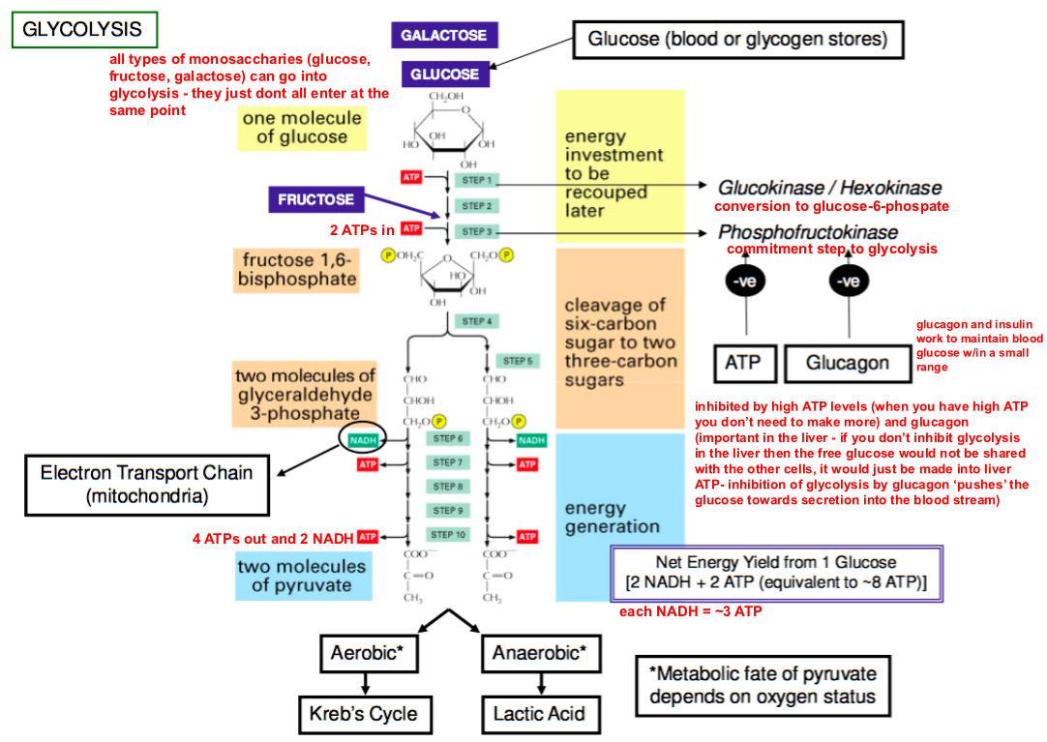
3 steps: energy investment, cleavage of 6-C sugar into 2 3-C sugars, energy generation
Important enzymes:
- Glucokinase (liver), hexokinase (muscle) = conversion of glucose glucose 6-phosphate
- Phosphofructokinase = creates fructose 1,6-biphospate ** this is the commitment step
- Inhibited by ATP and glucagon
- 6-C sugar split into 2 molecules of glyceraldehyde 3-phosphate
- end glycolysis with 2 pyruvate molecules, 2 NADH and 2 ATP
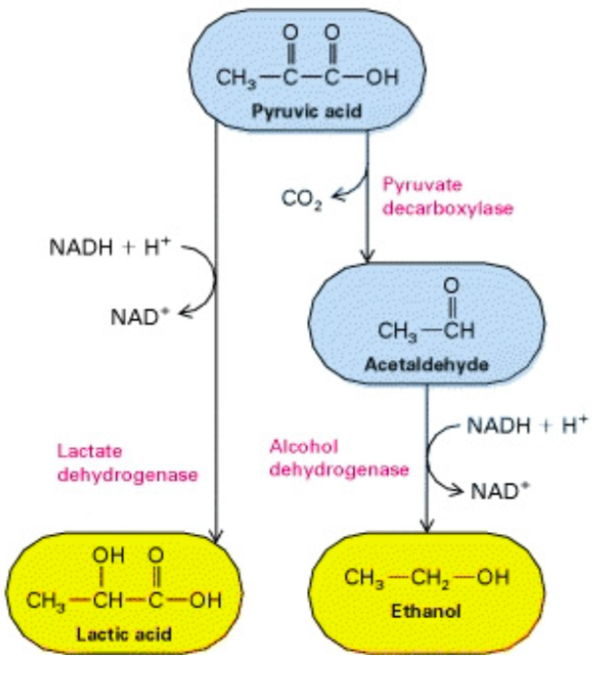
- pyruvate enters the Krebs cycle in aerobic conditions and is converted to lactic acid in anaerobic conditions **** metabolic fate of pyruvate depends on O2
Anaerobic Metabolism of Glucose
LACTIC ACID
- pyruvate is converted to lactic acid by lactate dehydrogenase which regenerates NAD+ allowing glycolysis to continue
Ethanol
- yeast breaks down pyruvate into CO2 and ethanol
- CO2 removed by pyruvate decarboxylase
- Acetaldehyde is converted to ethanol by alcohol dehydrogenase which regenerates NAD+
- this is the basis of fermentation in the making of alcohol
CORI CYCLE
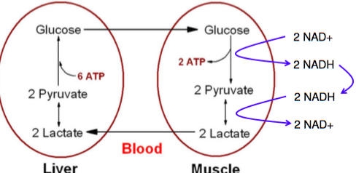
- muscle converts pyruvate to lactate
- liver carries our gluconeogenesis converting lactate to pyruvate and then back to glucose
- converting 2 molecules of lactate (produced from glycolysis) to 1 glucose molecule uses 6 ATP
- cannot be sustained since more energy is consumed than produced
Hexose Monophosphate Shunt
- important for NADPH production and ribose synthesis (precursors for nucleotides)
- all cells use non-oxidative phase to produce ribose sugars, only cells that perform biosynthesis (regeneration of antioxidants) use the oxidative phase
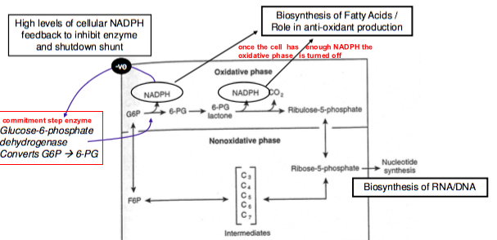
Pyruvate Dehydrogenation
- pyruvate dehydrogenase is the gatekeeper of the Krebs cycle, it converts pyruvate acetyl CoA
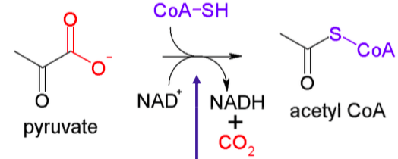
- pyruvate dehydrogenase complex = large enzyme with many cofactors including 4 vitamins 1) thiamine 2) niacin 3) riboflavin 4) pantothenic acid
- 2 steps of pyruvate dehydrogenation
- decarboxylation
- dehydrogenation
- net energy yield ~6 ATP (1 NADH x 2 pyruvate molecules per glucose)
- each NADH makes ~ 3ATP
Krebs Cycle
- over 90% of energy from food is released in this biochemical process
- common & final pathways for proteins, lipids and CHO
- takes place in the mitochondria
- pyruvate oxaloacetate by the enzyme Pyruvate Carboxylase and requires ATP
- oxaloacetate is KEY to the Krebs cycle, Krebs cycle will not run without it
- acetyl CoA is produced from the breakdown of CHO, fat and protein
PROTEIN USE
- amino acids can be converted to both pyruvate and oxaloacetate
- amino acids can be converted to Succinyl-CoA
- acetyl CoA can be made by breakdown of protein
NET ENERGY YEILD
- 1 acetyl CoA produces 3 NADH, 1 FADH2 and 1 GTP = ~12 ATP
- 1 glucose molecule = 2 Acetyl CoA = 24 ATP
Overall Energy Production
- key points: 1 NADH = 3 ATP, 1FADH2 = 2 ATP, 1 GTP = 1 ATP
- glycolysis = 2 ATP + 2 NADH = 8ATP
- pyruvate dehydrogenation = 2 x (1 NADH) = 6 ATP (multiple by 2 b/c 1 glucose = 2 pyruvates)
- Krebs cycle = 2 x (3 NADH + 1 FADH2 + 1 GTP) = 24
- Total = 38 ATP but ~2ATP are used to import the 2 NADH produced in glycolysis from the cytoplasm to the mitochondria total energy = 36 ATP
Gluconeogenesis
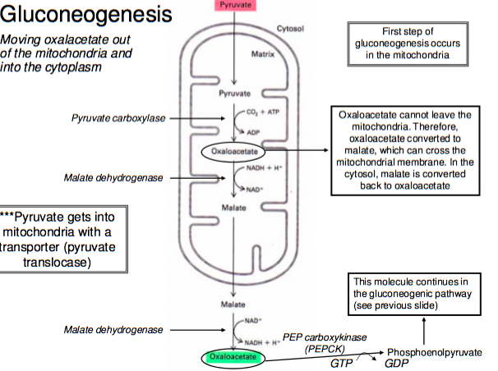
- Active in liver and also happens in the kidney during starvation
- Muscles and adipose tissue lack the enzymes for gluconeogenesis
- Enzymes must bypass the irreversible steps of glycolysis
- Glucokinase/hexokinase converting glucose glucose 6-phosphate
- Phosphofructokinase converting fructose 6-phophate fructose 1,6-biphosphate
- Pyruvate kinase converting PEP pyruvate
- Pyruvate carboxylase and PEP carboxylase bypass c
- fructose 1,6-biphospatase bypasses b
- glucpse-6-phosphatase bypasses a
Lipids
- defined by solubility in organic solvent
- wide variety of structures and functions
- source of energy
- major component in cell and organelle membranes
Lipid Functions
- concentrated source of energy: 9kcal/g
- increases palatability of food and increases satiety (feeling full)
- source of essential fatty acids (α-linolenic acid (omega -3) and linolenic acid (omega-6)
- carries fat soluble vitamins (ADEK)
- necessary for growth and development
- important precursor of hormones
- effects inflammation and blood clotting
- key role is disease development atherosclerosis, diabetes, obesity
Fatty Acids
- hydrophobic hydrocarbon tail with a hydrophilic carboxylic acid head
- saturated = single bonds, maximum number of H
- unsaturated = doubles bonds, missing H atoms, cis or trans configuration
Naming
- delta system (Δ) numbering starts from carboxyl end of fatty acid
- omega system (w) number starts from methyl end
Essential Fatty Acids
- linoleic acid = omega 6 (18:2 n-6, 18:2 Δ^{9,12})
- nuts, seeds, legumes
- α-linolenic acid = omega 3 (18:3 n-3, 18:2 Δ^{9,12,15})
- fatty fish, canola oil, almonds
- these fatty acids are essential b/w humans lack the enzymes necessary to insert double bonds beyond the Δ⁹ position
Signs of Essential Fatty Acid Deficiency
 | n-6 deficient | n-3 deficient
Skin | Dermatitis | Ok
Growth | Decrease | Ok
Reproductive maturity | Decrease | Ok
CNS development | Ok | Decrease in IQ
Retinal development | ok | Decrease in visual acuity
- EFA deficiencies are not common but infants and hospitalised patients are most susceptible
- Omega 6 = 2-3% of energy in diet, omega 3 = 1% of energy in diet don’t need a lot to avoid deficiency
- Pets are susceptible to EFA deficiency (still pretty rare unless they eat low-fat dry foods)
- Dogs can convert ALA to EPA but not to DHA (require DHA in diet)
- Cats cannot make any long chain fatty acids
Changes if FA consumption over time
- Overall fat consumption has increase
- Omega-6, trans and saturated fatty acid consumption has increased
- Omega-3 consumption has decreased
- Disproportionate balance between omega 3 and omega 6 in modern diets
EFA Desaturation and Elongation
- 3 steps: desaturation by FADS2, elongation by ELOVL5, desaturation by FADS1
- desaturation inserts a double bond, elongation extends the FA by 2 carbons
- linoleic acid arachidonic acid which is pro-inflammatory
- α-linoleic acid eicosapentaenoic acid which is anti-inflammatory
- EPA can be further converted to DHA which is also anti-inflammatory
- Conversion efficiency <8% (not much of the omega 3 or 6 is made into these)
Eicosanoids
- 20 carbon metabolites of AA (arachidonic acid) and EPA (eicosapentaenoic acid)
- produced by most cells in the body
- hormone-like but function locally (doesn’t travel in the blood to other tissues)
- role is inflammation, platelet aggregation (clotting), blood pressure etc.
- prostaglandins, thromboxanes and leukotrienes
Eicosanoid Production
- phospholipase A2 (PLA2) clips of AA or EPA from a phospholipid
- corticosteroids inhibit PLA2
- AA or EPA then has 3 pathways
- Cyclooxygenase pathway: mediated by COX and produces prostaglandins and thromboxanes
- Epoxidase pathway: mediated by Cyp450 and produces EETs
- Lipoxygenase pathway: mediated by LOX and produces lipoxins and leukotrienes
- Aspirin and ibuprofen inhibits COX, preventing the production of prostaglandins and thromboxanes which reduces inflammation
- Fish oils (rich in EPA) changes the type of FA used to make phospholipids creating a better balance between EPA and AA, balancing inflammation better
Triglycerides (TAG)
- Main dietary lipid
- Major storage lipid
- Key in several pathways
- Lipogenesis: production of new lipids
- Lipolysis: breakdown of TAG (to access energy)
- Transport in lipoproteins
- Structures:
- # of FA attached to the glycerol backbone can change
- monoacylglycerol (MG, MAG) easily absorbed
- diacylglycerol (DG, DAG) signalling pathways
- Triacylglycerol/triglycerides (TAG)
- Fatty acid composition determines the physiochemical properties
- Fatty acids linked to glycerol by ester bonds
Phospholipids (PL)
- Structural feature
- More polar that TAGS hydrophilic phosphate head group, hydrophobic FA tails
- Functions:
- Components of membranes
- Sources of physiologically active FA for eicosanoid synthesis
- Anchors membrane proteins
- Intracellular signalling
Sterols
- Steroid alcohols
- Cholesterol = animals, sitosterol = plants
- Can be free or esterified to a FA
- Sources of cholesterol:
- ~40% come from our diet (eggs, meat) and ~60% comes from endogenous production (made by our own body)
- Functions
- Essential components of membranes
- Precursor for bile acid, steroid sex hormones, vitamin D synthesis
Lipid Digestion
- Mouth: Lingual lipase (breaks down lipids) – continuously secreted
- Stomach: Gastric lipase – continuously secreted and stable at low pH
- Liver: production of bile acids
- Gallbladder: storage of bile and release of bile triggered by hormones
- Small Intestine: pancreatic enzymes including pancreatic lipase and cholesterol esterase
- Bile acid = emulsifier, solubilizes fats to mix with water
Mixed Micelles
- Digested lipids are stabilized by bile acids
- Mixed micelles = small, spherical complexes containing lipid digestion products + bile acid
- Able to access intramicrovillus spaces of the intestinal membrane
- Delivered into intestinal mucosal cells by carrier-mediated transporters
- Bile acids are then reabsorbed
Enterohepatic Circulation
- Bile acid recycling
- Bile acids made in the liver (cholesterol primary bile acids bile salts)
- Bile acids stored in the gallbladder
- Bile acids released to the small intestine
- 95% of bile acids are reabsorbed and recycled back to the liver (via portal vein)
- 5% of bile acids continue to large intestine and are lost in the feces
- soluble fibres reduce the efficiency of enterohepatic circulation by holding on to bile acids, which are then secreted in feces
Lipid absorption
- in order to cross the membrane of intestinal cells dietary fats must be broken down/simplified, once inside the intestinal cell they can be reassembled
- brush border enzymes breakdown mixed micelle into smaller components in the unstirred water layer. Bile acids are required to get the insoluble lipids into the unstirred water layer
- pancreatic lipase: breaks down triglycerides 2 FA and 2 MG
- cholesterol esterase: breaks down cholesterol ester 1 FA and 1 cholesterol
- phospholipase: breaks down phospholipids 1 Fa + 1 lysolPL
- once inside the intestinal cell the TAG, CE and PL are remade and then packaged into a lipoprotein for transport
- Short chain fatty acids do NOT require a transport system, then can freely diffuse into the intestinal cell and then out into the blood
Lipid Transport
- Lipids are transported via lipoproteins
- Lipoprotein classification is determined by:
- Ratio of lipid-to-protein
- Specific apolipoproteins (Apo)
Chylomicrons and C.Remnant “BAD” | Very low density lipoprotein VLDL “BAD” | Intermediate density lipoprotein IDL | Low density lipoprotein LDL “BAD” | High density lipoprotein HDL “GOOD”
High lipid  Low protein  ApoB-48, ApoC, ApoE | High lipid  Low protein  ApoB-100, ApoC, ApoE |  | “Bad cholesterol”  Moderate lipid and protein  ApoB-100, ApoC, ApoE | “good cholesterol”  high protein  low lipid  ApoA
- VLDL and HDL are produced by the liver
- Chylomicron concentration high after eating, VLDL concentration high during fasting state
Chylomicrons
- Increases in blood after a meal
- Enters the blood at a slow rate with peak levels 30 min – 3 hours after eating
- Chylomicrons are cleared from the blood via lipoprotein lipase (LPL)
- The ApoC recognizes and interacts with LPL, allowing for the breakdown of TAG in the chylomicron
- After LPL hydrolyzes the TAG in the chylomicron it is referred to as a chylomicron remnant CR
- CR is removed from circulation via ApoE interactions with a receptor on the liver
- LPL located on endothelial cell surface of small blood vessels and capillaries
- LPL expressed in adipose and muscle but NOT the liver (most lipids we consume are stored in adipose or used for energy in the muscle)
- ApoC on the chylomicron interacts with LPL
- LPL removes TAG from the chylomicron creating a CR
- ApoE on CR interacts with receptors on the liver, the liver removes the CR from circulation
Lipoproteins
VLDL
- You do not want storage of lipids in the liver therefor the liver creates and secretes VLDL
- VLDL is the main transported of newly synthesized TAG from the liver
- In the body VLDL interacts with LPL to release its TAG (used for energy storage or oxidation)
- VLDL eventually becomes LDL its TAG are removed by cells in around the body
LDL
- Delivers cholesterol for essential functions but can also deposit cholesterol in unwanted places
HDL
- Made by the liver
- ApoA on HDL interacts with LCAT’
- LCAT attaches cholesterol to HDL via ester bonds
- HDL brings cholesterol esters back to the liver –reverse cholesterol transport
- Cholesterol can be transferred from HDL to LDL or VLDL via CETP = cholesterol ester transfer protein
Cholesterol
- In the liver cholesterol has several fates:
- Converted into bile acids to replenish the bile acid pool
- Secreted directly with bile to be eliminated in the feces
- Repackaged into lipoproteins and sent around the body
SUMMARY
- Chylomicrons are assembled in the intestines. They then enter the blood stream where they circulate and lose their TAGs becoming CR. CR are enriched in cholesterol esters
- VLDL is created by the liver and circulates to peripheral tissues where it delivers TAG. As the TAGs are hydrolyzed by LPL the VLDL becomes IDL and eventually LDL. LDL is rich in CE
- Reverse cholesterol transport – HDL carries CE back to the liver or CETP transfers the CE to LDL
- Cholesterol is eliminated from the body by conversion to bile acids or secretion into the gut
Recommended Caloric Intake
- Men: 2500 kcal/day, women: 2000 kcal/day
- Protein: 10-35% of daily calories
- Carb: 45-65% of daily calories
- Fat: 20-35% of daily calories
- To find out the about of food in grams:
- ( % x total calories ) / energy from macronutrient
- e.g. (0.35 x 2500 kcal/day) = 875 kcal/day / 9 kcal/g of fat = 97g of fat/ day
Lipid Metabolism in the Liver
- Free FA fatty acid pool or are made into TAG
- DG and MG made into TG
- Phospholipids, cholesterol and TAG packaged into HDL or VLDL
- Cholesterol made into bile acids
Lipid Metabolism in Adipose Cell
- TG made into glycerol then released back into blood
- TG broken down into DG, or MG in order to cross meme brane made back into TG
- TG broken down into FFA stored into fatty acid pool or made back into TG
- Acetyl CoA from glucose can be made into FA for storage or enter the Krebs cycle to create energy
Integrated Metabolism
- Gluconeogenesis: glycerol backbone is glucogenic
- Kreb’s cycle: fat oxidation via Acetyl CoA
- Lipase breaks TAG down into glycerol and FA
- Glycerol can be made into glyceraldehyde 3 P which can be used in gluconeogenesis or glycolysis
- FA can be made into Acetyl CoA via B-oxidation
- Acetyl CoA can then enter the TCA cycle or be made into ketone bodies
β-Oxidation
- Converts FA into acetyl CoA
- Dehydrogenation
- Hydration
- Oxidation
- Thiolysis
- Each round of β-Oxidation cleaves off 2 carbons (creating an Acetyl CoA group)
- Each round = 1 FADH2, 1 NADH, 2 C cut off (creating an Acetyl CoA)
- Each FADH2 = 2 ATP, each NADH = 3 ATP, each Acetyl CoA = 12 ATP
Impacts on Health
Cholesterol
- Limiting dietary cholesterol doesn’t change blood cholesterol much
- Plant sterols compete with cholesterol for uptake by NPC1L1 into intestinal cells, decreases the absorption of cholesterol cholesterol then excreted in feces
- Plant sterols taken up by NPC1L1 then released back into lumen by ABCG5/8 (they aren’t absorbed)
Trans FA
- Unsaturated FA w at least one double bond in the trans configuration
- Produced during hydrogenation of vegetable oils increases stability during cooking, longer shelf life and more palatability
- Partial hydrogenation = trans fatty acid
- Complete hydrogenation = saturated fatty acid
- Increase amount of hydrogenation increase degree of saturation
- Consuming high amount of industrial trans FA: ↑LDL cholesterol, ↑ total cholesterol, ↑ inflammation and ↓ HDL cholesterol
- Trans fats are linked to CVD and increase the risk of CHD (coronary heart disease) more than any other nutrient

