Experiment 2: Purifying Chemicals by Distillation

By ------------
--------

CHM 1321 Section

Demonstrator:
------------

January 31, 2018

University of Ottawa

Procedure
- Refer to lab manual
Observations
- The 1:1 [2-propanol:1-butanol] solution is a clear colourless liquid
- The first drop of distillation occurred at 82.3°C and took 41 minutes to form
- The total time to complete the simple distillation was 126 minutes and 30 seconds
Data

Table 1. Simple Distillation
Volume (mL) | Temperature (°C)
1 | 84.0
2 | 84.8
3 | 85.9
4 | 87.1
5 | 88.5
6 | 90.0
7 | 91.0
8 | 92.4
9 | 94.0
10 | 95.7
11 | 98.7
12 | 102.4
13 | 108.4
14 | 111.0
15 | 114.1
16 | 115.8
17 | 116.7
18 | 117.2
19 | 117.4
20 | 117.5
21 | 117.2
22 | 98.3
Table 2. Fractional Distillation
Volume (mL) | Temperature (°C)
1 | 81.9
2 | 83.0
3 | 83.5
4 | 84.2
5 | 84.7
6 | 85.6
7 | 86.6
8 | 88.2
9 | 90.0
10 | 93.5
11 | 95.9
12 | 99.5
13 | 106.2
14 | 113.1
15 | 114.9
16 | 116.1
17 | 116.2
18 | 116.4
19 | 116.7
20 | 116.7
21 | 116.7

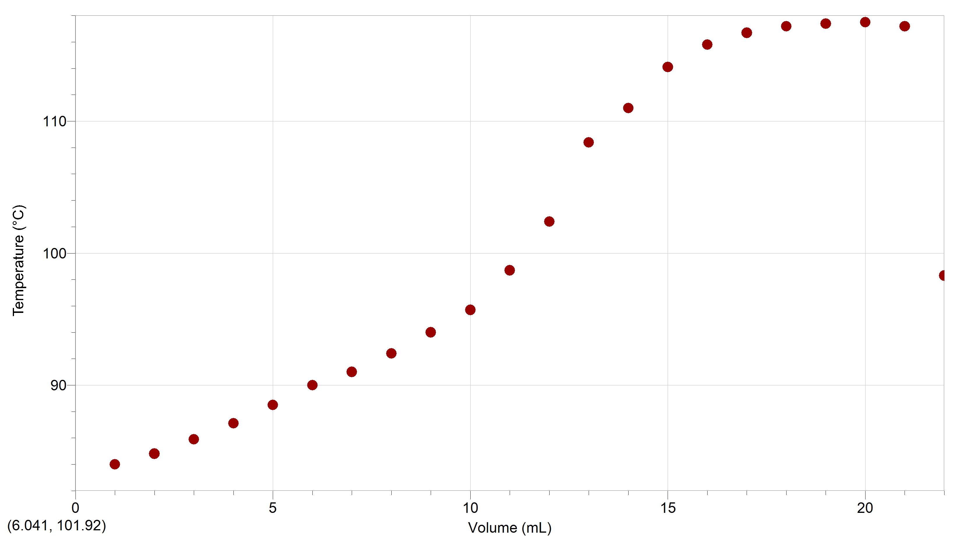
Figure 1 shows the temperature of the vapour at which each mL of 1:1 [2-propanol:1-butanol] solution was distilled using simple distillation.
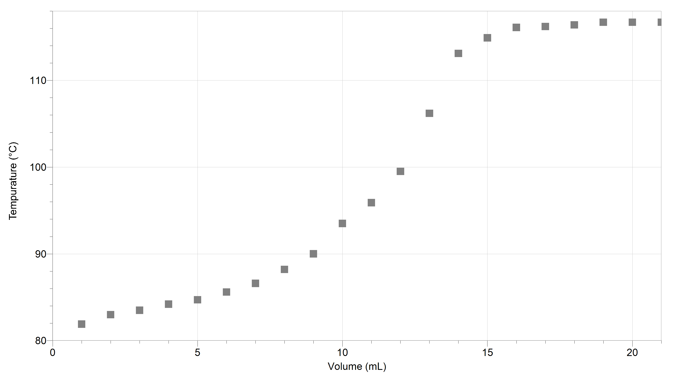
Figure 2 shows the temperature of the vapour at which each mL of 1:1 [2-propanol:1-butanol] solution was distilled using fractional distillation.

Discussion
- Distillation is used to separate liquids by vaporizing them. It works best when they have very dissimilar boiling points, so that it is very clear when they separate.
- Simple distillation is used to distill 1 compound, while fractional distillation separates the two before they move down the condenser. Fractional distillation works by forcing the compound with the higher boiling point to drip back down into the distilling flask so that the lower boiling substance can move to the receiving flask, making it more pure and clear that it is not mixed. Simple distillation is typically fast and works best when there is a difference of boiling points greater than 100°C. Fractional distillation tends to be slower but more efficient and is more accurate than fractional distillation when the boiling point difference is less than 100°C.
- Both curves look relatively similar, but the fractional distillation curve has a steeper slope. It was expected that the fractional curve would have an even steeper slope still, but it did not because of how close the boiling points of the two substances are. The boiling point of 2-propanol is 83°C and the boiling point of 1-butanol is 118°C, leaving a difference of only 35°C which is relatively small. This data suggests that there was not a very good separation of the two compounds, although it is noticeable when the 2-propanol was gone because the temperature jumped.
- The products seem to be mostly pure because the standard boiling point of 2-propanol is 83°C and this sample boiled at 84.0°C. The standard boiling point of 1-butanol is 118°C and this sample boiled around 117°C.
- A source of human error in this experiment was that only the simple distillation was completed because there was not enough time given for the system to heat up. The Variac was set at 60 for the beginning of the lab and should have been up at about 90 for the entire lab. Data for the fractional distillation was obtained from another group.
Questions
- In order for fractional distillation to work, there must be liquid flowing back through the fractionating column in order to get good separation of the components. The concept is that the compound with the higher boiling point drips back down so that the more volatile compound can completely vaporize and separate itself down into the receiving flask before the other one boils.
- It is important to maintain a uniform temperature gradient in a fractionating column so that the entire column is a similar temperature which is just above the boiling point of the more volatile compound. If this is the case, the component with the higher boiling point can drip back down while the other vaporizes down into the condenser and receiving flask. If the temperature gets too low, nothing will vaporise; if it gets too high, everything will vaporize and there will be poor separation of the compounds.
- The boiling point of a liquid is the temperature at which the vapour pressure is equal to atmospheric pressure. Therefore, the vapour pressure of benzene at 81°C is assumed to be the atmospheric pressure at sea level, which is 1 atm.
- Increasing the atmospheric pressure while trying to boil a liquid will increase the boiling point because they are directly related.
- It is important for the cool water to enter the bottom of the condenser so that rather than trickling down it flows all the way through to provide even and effective cooling to the entire condenser.

- This problem can be solved using Raoult’s law:
P_{Total} = (P_{A})(N_{A}) + (P_{B})(N_{B})
P_{A}= 350 mmHg P_{B}= 150 mmHg N= 3:1
P_{Total} = (350 mmHg)(0.75) + (150 mmHg)(0.25)
= 262.5 mmHg + 37.5 mmHg
= 300 mmHg
Therefore, the vapour pressure of the mixture is 300 mmHg
Appendix


