Thin Layer Chromatography

Experiment #1

January 15th, 2018

By: Sean Gariano (300013401)
Partner: William Jiang (8530388)

Protocole
See laboratory manual page 13 to 19.

Observations
2:8 Ethyl Acetate:Hexanes (colourless, odourless, non-viscous, transparent solution)
Unknown Compound 80 (White, grainy, rough, odourless powder)
Dichloromethane (transparent, colourless, non-viscous, odourless solution)
Dichloromethane + Unknown Compound 80 (odourless, clear, colourless, non-viscous solution)
Benzophenone (non-viscous, transparent, odourless, colourless solution)
Biphenyl (clear, non-viscous, colourless, odourless solution)
Ethyl Acetate (clear, colourless, odourless, non-viscous solution)
Hexane (colourless, non-viscous, odourless, transparent solution)
XX (transparent, yellow, odourless, non-viscous solution)
9:1 Hexane:Ethyl Acetate (clear, colourless, non-viscous, odourless solution)
o-bromonitrobenzene (transparent, colourless, non-viscous, odourless solution)
m-bromonitrobenzene (clear, non-viscous, colourless, odourless solution)
p-bromonitrobenzene (colourless, odourless, non-viscous, transparent solution)

TLC

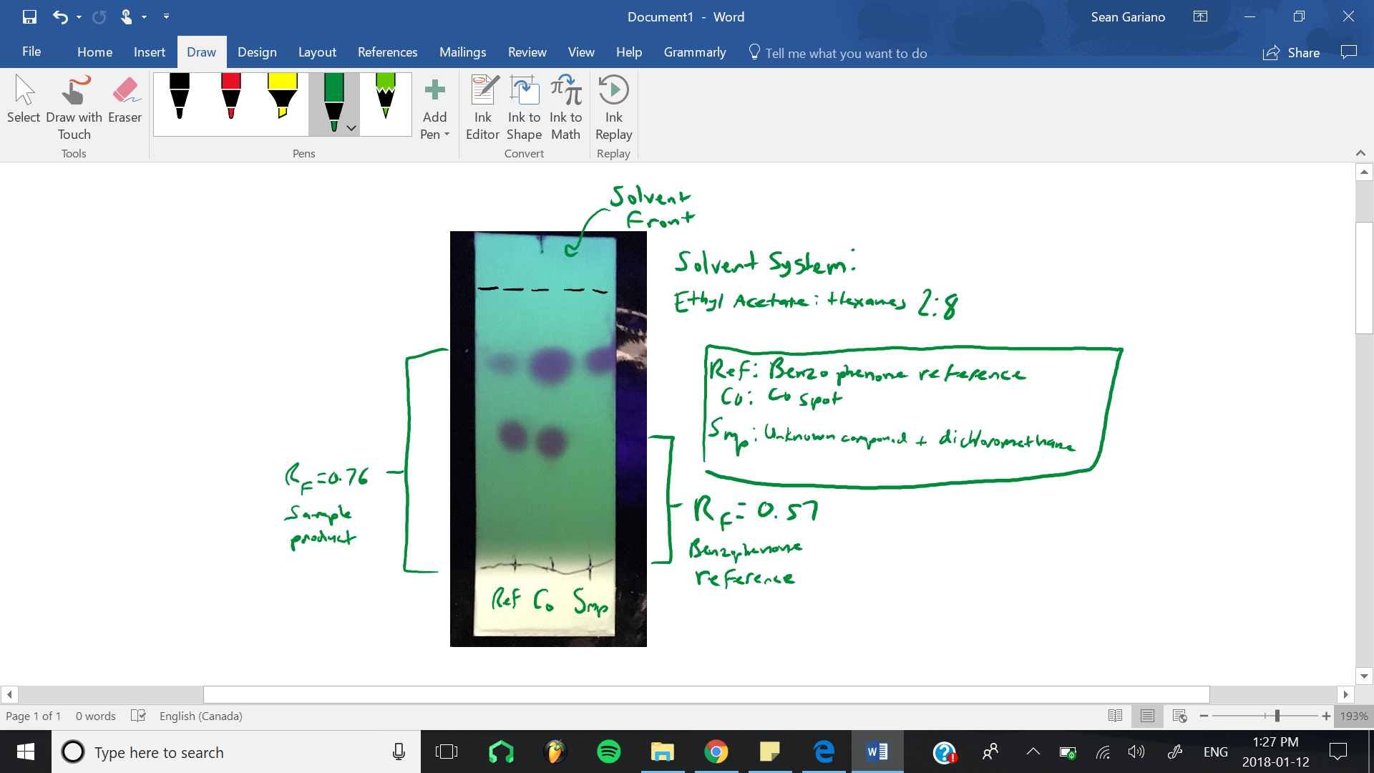
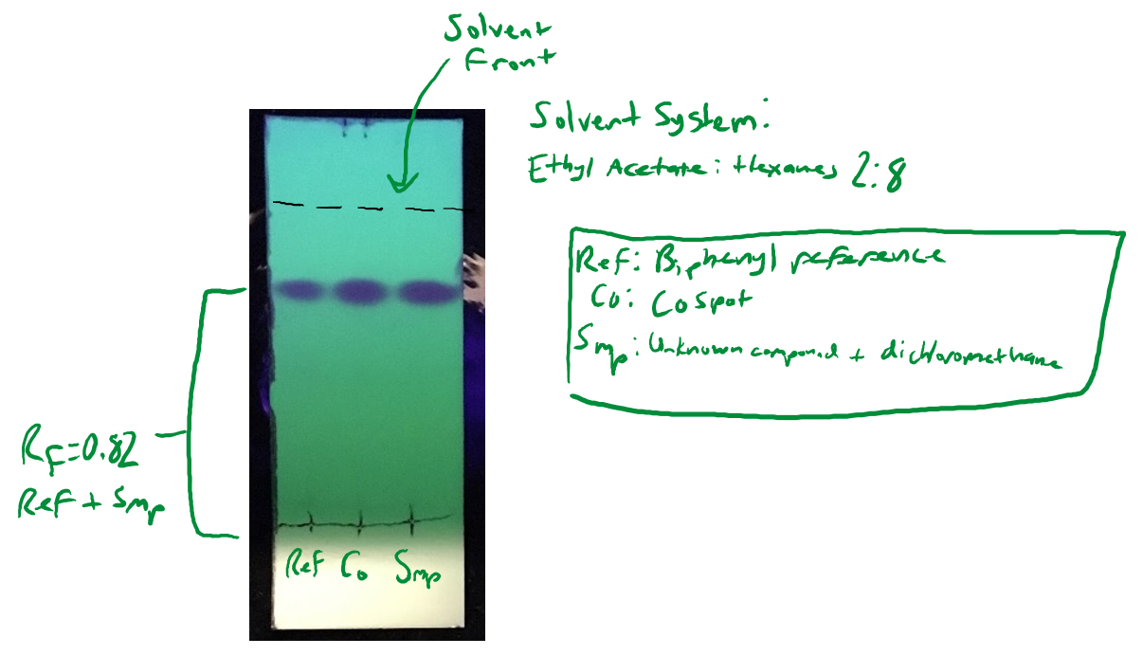

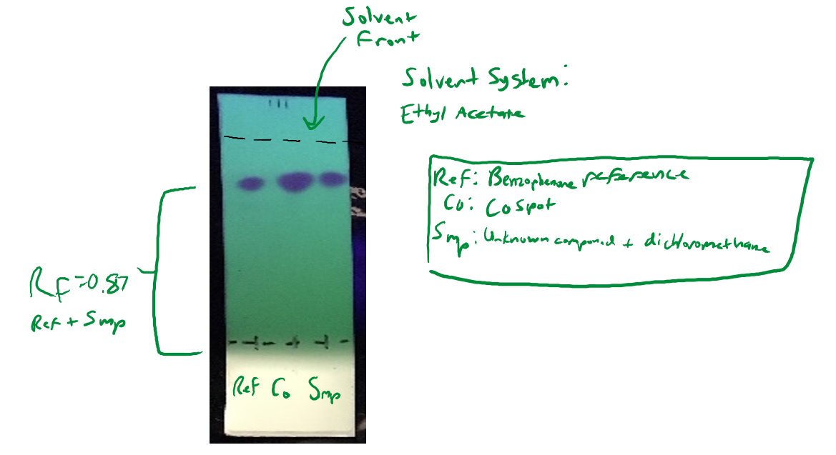

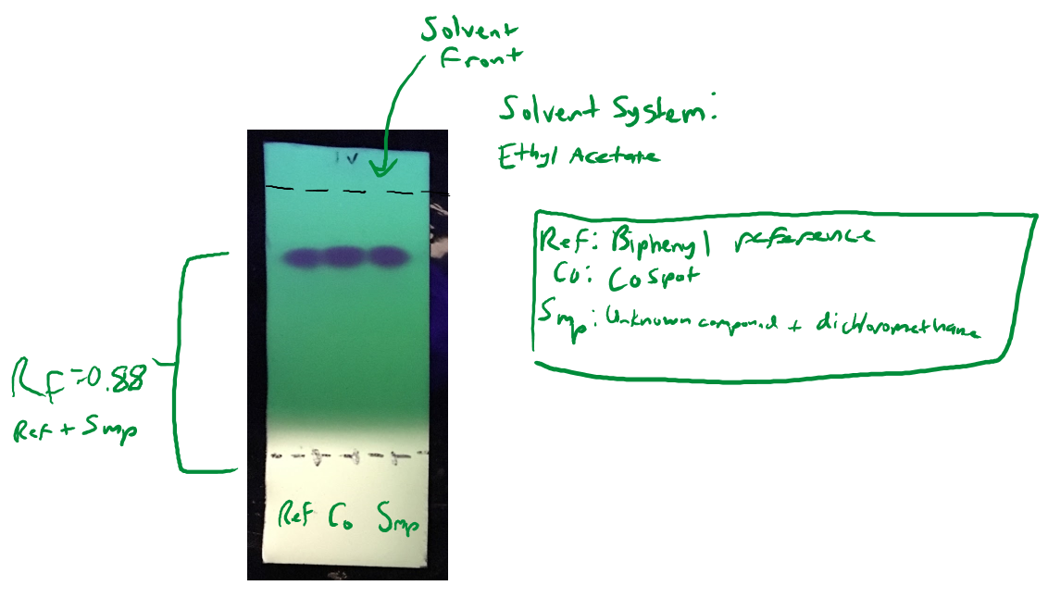

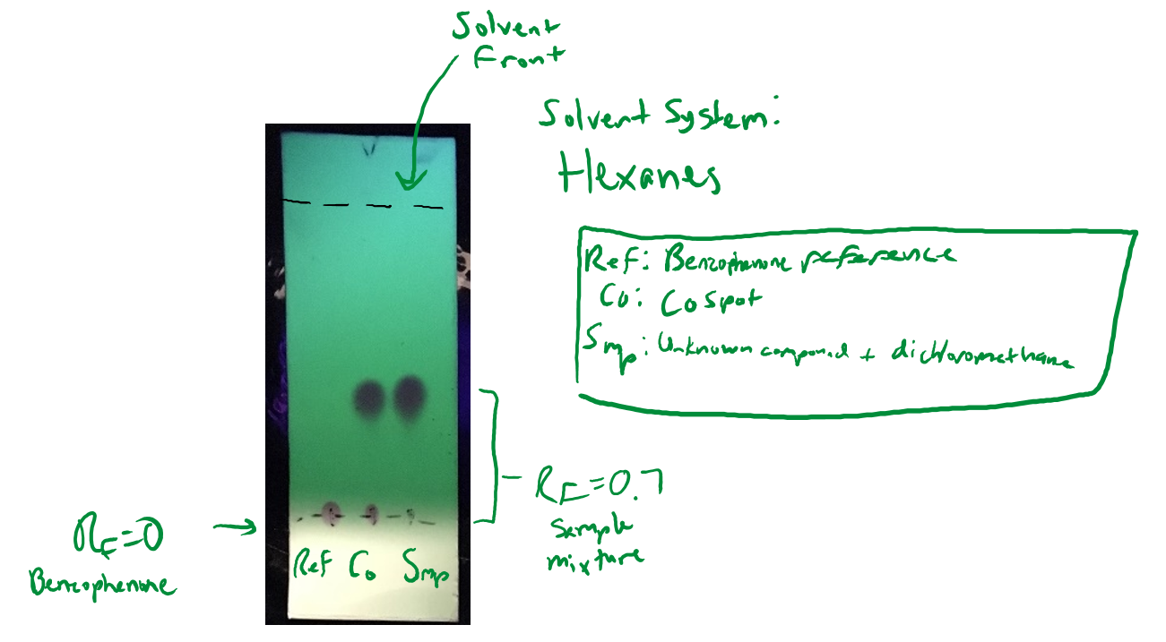

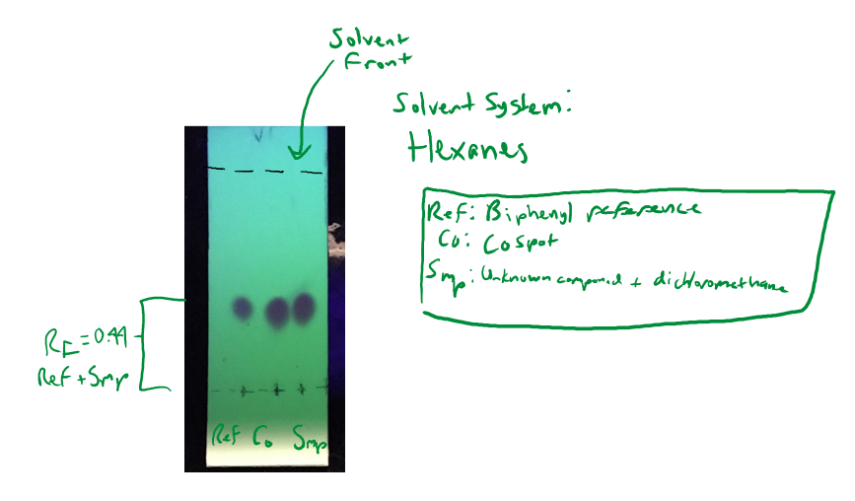

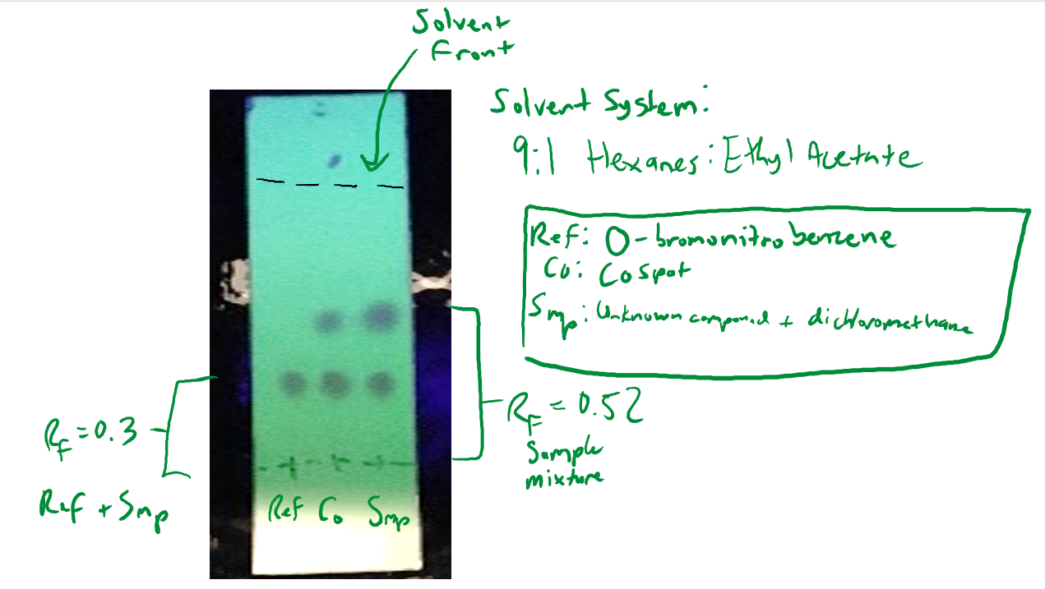

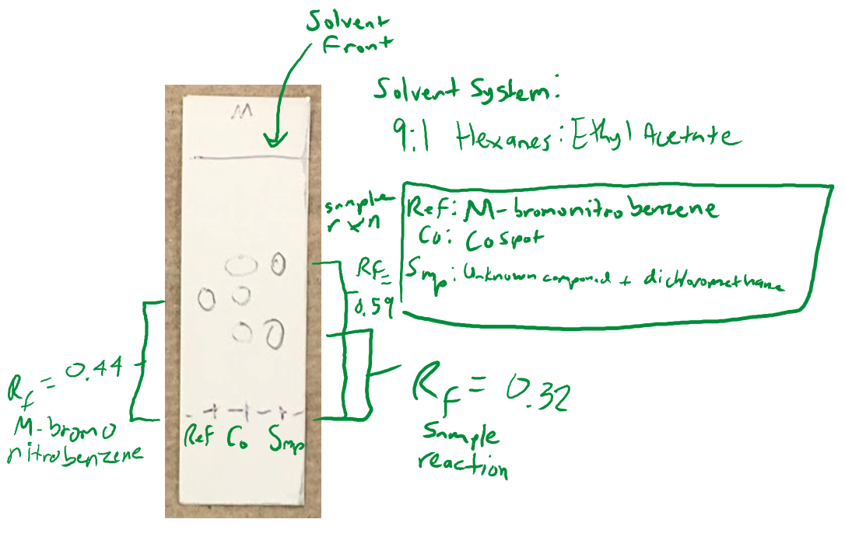

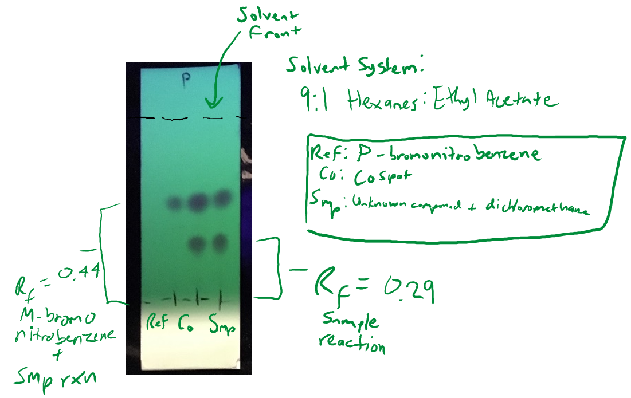

Calculation
For Part A:

Reference: Biphenyl
Solvent: Pure Ethyl Acetate

Rf= (Distance of base line to middle of circle) / (distance of base line to solvent line)
= 3.5 / 4
= 0.875

For Part B:

Our unknown solution XX is a mixture of ortho-bromonitrobenzene and para-bromonitrobenzene. This was concluded by our findings on our TLC’s.

Calculate the absorbance % (found from ImageJ):
Absorbance of p-bromonitrobenzene = 18737
Absorbance of o-bromonitrobenzene = 10994
% Absorbance (para) = (18737 / (18737 + 10994)) x 100 = 63.02%
% Absorbance (ortho) = 100 - 63.02 = 36.98%

These numbers were found by finding the area under the curves of ortho and para on their respective TLC’s.

Calculate the mole %:
y = %Absorbance (ortho) = 36.98%
y =1.0114 (x) - 2.0208
Thus x = 38.56%
% mole (ortho) = 38.56%
% mole (para) = 61.44%

This calculation shows us how much of ortho and para are in solution XX by mole percentage.

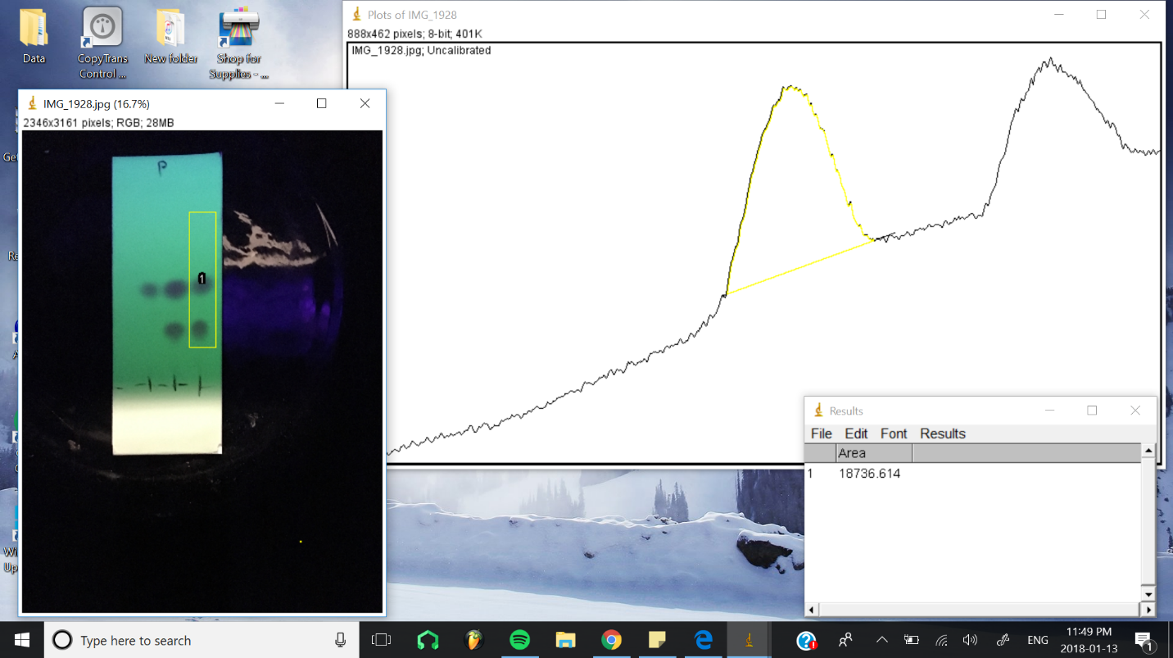

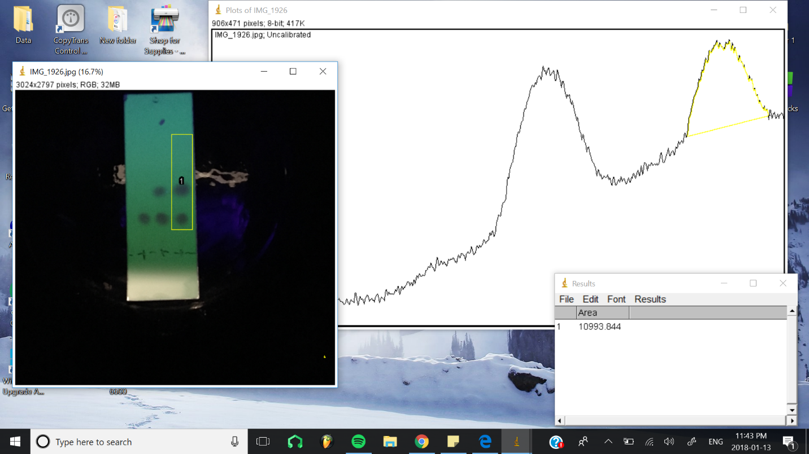

Discussion

We used so many TLC’s for each trial because we wanted to make sure we had proper precision. If we use only a few TLC’s for each part, our source of error is likely to rise with improper results.

We compared our unknown solutions to a reference to get an idea of what compound our unknown solutions were made of. Based on the comparison of the solutions to references in our TLC’s, we were able to make conclusions and do further analysis of our unknown solutions to support our findings.

We used ImageJ to find the mole percentage of each compound in our unknown solution XX. In the 2 screenshots above, I showed how I used a lane of our sample reaction to create a graph. This lane produced 2 curves which represented areas for the 2 dots on our TLC. These dots turned out to be ortho and para, and I was able to determine the mole % of these two compounds in XX.

TLC’s are used for reaction monitoring and sample purification. So, we used TLC’s in our experiment for the sole reason to find the identity of unknown compounds and samples.

We found that there were no 3 dots aligned horizontally on the meta TLC, only the ortho and para. This means that there is no meta at all in solution XX. Since there were those 3 dots aligned horizontally on ortho and para, those 2 compounds are included in the XX solution.

In Part A:

We found Ethyl Acetate to be unknown substance 80. We concluded that by looking at all solvent systems in our experiment and seeing which one produced the most horizontal 3 dots. This indicated which solvent system it was most likely to be. The Rf values on most TLC’s should be the same for Ethyl Acetate to be our unknown substance 80.

Our solvent system Ethyl Acetate is less polar than Benzophenone, because its spot on the TLC is marginally higher. The Ethyl Acetate is only an Rf value of higher than Benzophenone.

In Part B:

In adding Hexane, the Rf value of our spots are increased compared to Part A. Hexane is less polar than Ethyl Acetate; this causes the Rf value to increase on the TLC. There are less intermolecular forces in Hexane to a polar substance.

In adding Ethyl Acetate, the Rf value of our spots are decreased compared to Part A.
Since Ethyl Acetate is more polar, it causes the reaction to move slower up the TLC, which cause the decrease in Rf.

In Part C:

Our unknown substance of XX is a mixture of o-bromonitrobenzene and p-bromonitrobenzene. We concluded that because we looked for the most spots to be on the same horizontal line as the reference of the o, p or m. We found that there were no 3 dots in a row on m, therefore the mixture is o and p.

In increasing order of Rf values, we have p-bromonitrobenzene, m-bromonitrobenzene, and o-bromonitrobenzene.

The smaller the Rf value, the more polar the substance. Therefore, para is the most polar of the 3 compounds.

The ratio of composition of unknown substance XX is around 1:0.64 para:ortho. Since our mole percentage of para is 61% and ortho is 39%, we have 0.64 mole of ortho per mole of para.

Errors:

When putting the solution on the TLC, we put too big of circles of solution so our spots on our TLC after developing were too big. This caused inconclusive results and made us redo the experiments again.

Too much solvent system was on our TLC’s when developing. Extra and unnecessary dots were made on our TLCs when fully developed under the UV lights.

Questions
- How does increasing the polarity of the solvent system affect the results of a TLC?

The faster a solvent moves up the TLC, the bigger the Rf value, and the less polar the solvent is.

The slower a solvent moves up the TLC, the smaller the Rf value, and more polar the solvent is.

The resulting polarity of these solvents is caused by the silica gel at the bottom of the TLC being polar. Polar solvents attract polar solvents due to strong intermolecular forces.

- In the following sets of compounds, which would have the smallest Rf on silica gel? Use a sentence to explain your reasoning. Draw line structures of each compound
- Benzyl Alcohol, Benzaldehyde, Benzyl Acetate
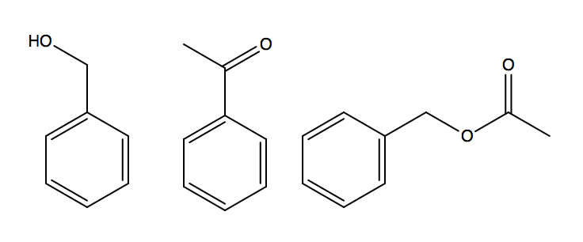

Benzyl Alcohol would have the smallest Rf in this list of compounds. This is because it is the most polar. The OH functional group in the compound allows for the alcohol to have an increased participation in hydrogen bonding. The other compounds lack that H to have hydrogen bonding between the silica gel.

- Aniline, N,N-dimethylaniline, Naphthalene
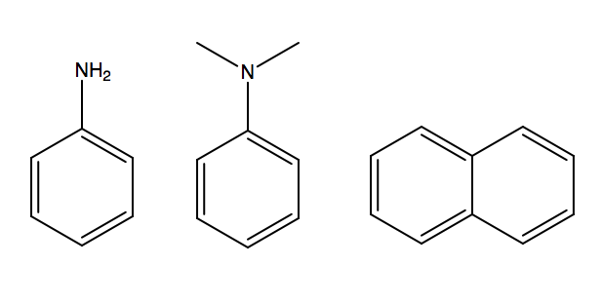
Aniline would have the smallest Rf in this list of compounds. This is because there are 2 hydrogen atoms from the amino group that can be used for a hydrogen bonding. These create dipoles that can have intermolecular forces with the polar silica gel.

- Benzophenone, Biphenyl, Benzoic Acid
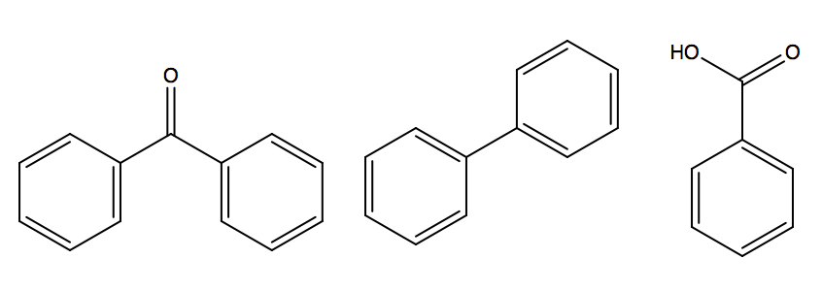

Benzophenone would have the smallest Rf in the list of compounds. It has 1 dipole which creates intermolecular forces with the polar substance on the TLC. One would think the most polar is Benzoic Acid because of the more hydrogen bonding. In fact, the reason is because its 2 pull in the almost the opposite direction. As a result, there is a very small dipole.

Conclusion
The unknown compound is ethyl acetate and XX is a mixture of o-bromonitrobenzene & p-bromonitrobenzene.

Raw Data


