CHAPTER 6: Business Processes and Business Management

Business Process: is an ongoing collection of related activities that create a product or a service of value to the organization, its business partners and/or its customers

The process involves 3 fundamental elements: (I---P(R)----O)
- Input: materials, services, and information that flow through and are transformed as a result of process activities
- Resources(Process): People and equipment that perform process activities
- Output: the product or a service created by the process

- The process involves a customer, then that customer can either internal or external to the organization
- A manager who is the recipient of an internal reporting process is an example of an internal customer
- An individual or a business that purchases the organizations products is the external customer of the fulfillment process

2 fundamental metrics that organizations employ in assessing their processes are efficiency and effectiveness

- Efficiency: focuses on doing things well in the process - for example: progressing from one process activity to another without delay or without wasting money or resources
- Effectiveness: focuses on doing the things that matter; that is, creating outputs of value to the process customer- for example: high quality products

Many process cross- functional areas in an organization – for example: product development involves research, design, engineering, manufacturing, marketing, and distribution

EXAMPLES OF BUSINESS PROCESSES

Cross-Functional Processes
- Fall within a single functional area of the company
- Many other business processes, such as procurement and fulfillment, cut across multiple functional area; they are cross-functional business processes, meaning that no single functional area is responsible for their execution
- Multiple functional areas collaborate to perform the process
- For a cross-functional process to be successfully completed, each functional area must execute its specific process steps in a coordinated, collaborative way

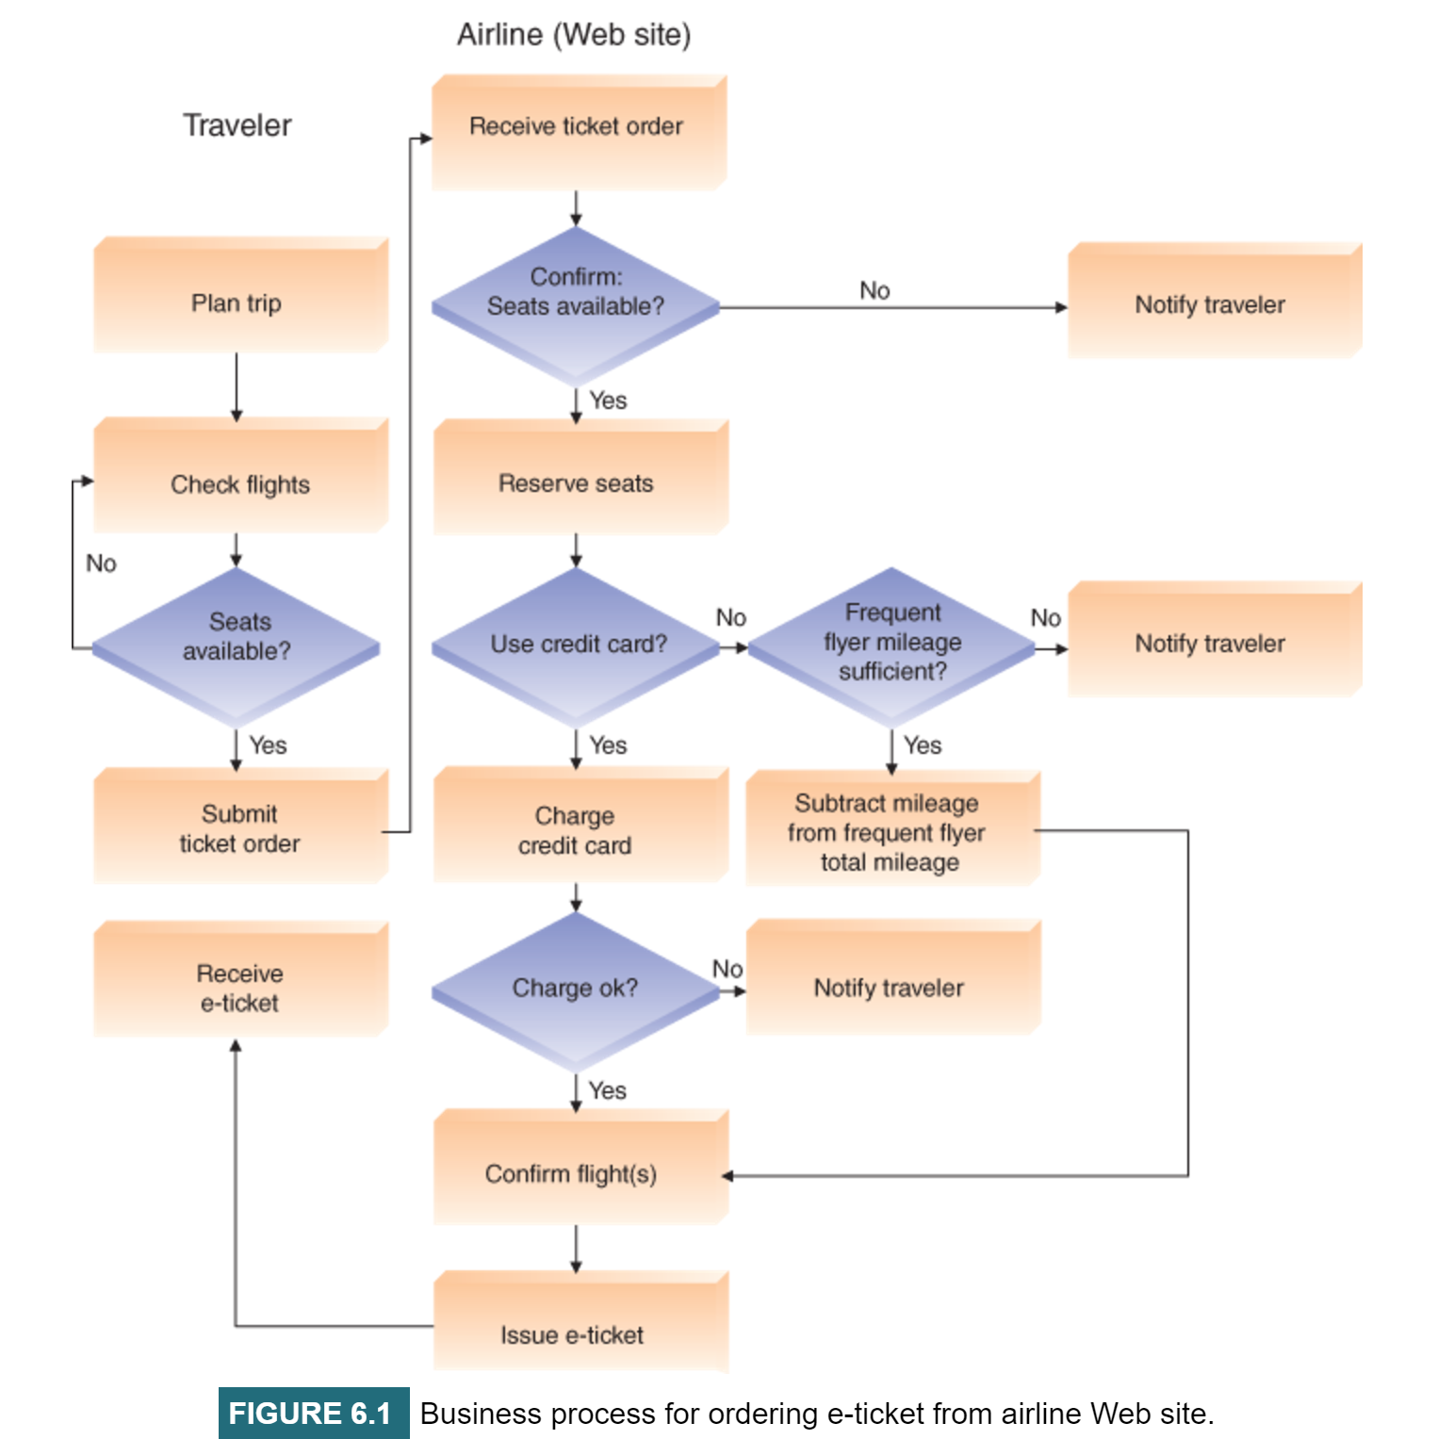

Flowchart Symbols
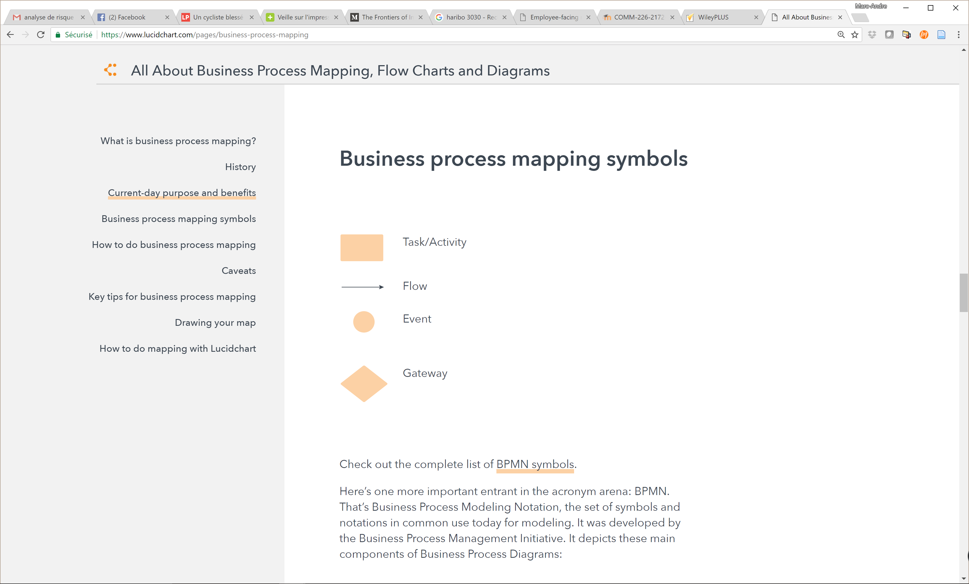

Procurement Process
- Includes all of the tasks involved in acquiring needed materials externally from a vendor
- Consists of 5 steps that are completed in 3 different functional areas of the firm: warehouse, purchasing, and accounting

The process begins when the warehouse recognizes the need to procure materials, perhaps due to low inventory levels. The warehouse documents this need with a purchase requisition, which it send to the purchasing department (STEP 1)

The purchasing department identifies a suitable vendor, creates a purchase order based on the purchase requisition and sends the order to the vendor (STEP 2)

When the vendor receives the purchase order, it ships the materials, which are received in the warehouse (STEP 3)

The vendor then sends an invoice, which is receive by the accounting department (STEP 4)

Accounting sends payments to the vendor, thereby completing the procurement process (STEP 5)

Fulfillment process: is concerned with processing customer orders
- Is triggered by a customers purchase order that is received by the sales department
- Sales then validates the purchase order and creates a sales order
- Sales order communicate data related to the order to other functional areas within the organization, and it tracks the progress of the order

The warehouse prepares and sends the shipment to the customer. Once accounting is notified of the shipment, it creates an invoice and sends it to the customer, the customer then makes a payment which accounting records.

An organizations business processes can create a competitive advantage if they enable the company to innovate or to execute more effectively and efficiently than its competitors

To provide competitive advantage, these sites must be highly responsive and they must provide both current and accurate information on flights and prices (EX)

An up-to-date- user friendly site that provides fast answers to user queries will attract customers and increase revenues

In contrast, a site that provides outdated or inaccurate information, or has a slow response time, will hurt rather than improve business

E-ticketing consists of 4 main process: searching, reserving, processing and issuing e-ticket

NOTE: that different symbols correspond to different types of process steps

These symbols are important in the process flowchart (which is similar to a programing flowchart)
Other symbols may be used to provide additional process details

The process creates customers value by efficiently generating an output that meets the customer search criteria – dates and prices

The performance of the process depends on efficiency metrics such as the time required to purchase and e-ticket from the moment the customer initiates the ticket search until he or she receives the e-ticket

Effectiveness metrics include customer satisfaction

The performance of the process may be affected if the quality or the timeliness of the inputs is low

Information Systems and Business Processes
Information systems (IS): is critical enabler of organizations business processes
- Facilitates communication and coordination among different functional areas, and allow easy exchange of and access to, data across processes

IS play a vital role in 3 areas:
- Executing the process
- Capturing and storing process data
- Monitoring process performance
Executing The Process
- IS helps organizations execute processes efficiently and effectively
- Typically embedded into the processes, and they play a critical role in executing the processes
- If the IS does not work, the process cannot be executed
- IS helps execute processes by informing people when it is time to complete a task, by providing the necessary data to complete the task, and in some cases, providing the means to complete the task
- IS generates the purchase requisitions and then informs the purchasing department that action on these requisitions is needed
- The accountant will be able to view all shipments received to match an invoice that has been received from a supplier and verify that the invoice is accurate
- The fulfillment process, the IS will inform people in the warehouse that orders are ready for shipment
- It also provides them with a listing of what materials must be included in the order and where to find those materials in the warehouse

Capturing and Storing Process Data
- Processes create data such as data, times, product number, quantities, prices, and addresses as well as who did what, when, and where
- IS captures and stores these data, commonly referred to as process data or transaction data
- Other data are generated outside the IS and must be entered into it
- Data entry can occur in various ways, ranging from manual entry to automated methods involving data in forms such as bar codes and RFID tags that can be read by machines
- In fulfillment process, when a customer order is received by mail or over the phone, the person taking the order must be enter data such as the customers name what the customers ordered, and how much is ordered
- Data such as the name of the person entering the data (who), at which location the person is completing the task (where), and the data and time (when) are automatically included by the IS when It creates the order
- The data is updated as the process steps executed
- When the order is shipped the warehouse will provide data about which products were shipped and in what quantities and the IS will automatically include data related to who, when, and where
- An important advantage of using IS compared to manual system or multiple functional area information system is that the data needed to be entered into the system only once
- Once they are entered, other people in the process can easily access them, and there is no need to reenter them in subsequent steps
- The data captured by the IS can provide immediate feedback

Monitoring Process Performance
- A 3rd contribution of IS is to help monitor the state of the various business processes
- IS indicates how well a process is executing
- The IS performs the role by evaluating information about a process
- This information can be created either at the instance level (specific task or activity) or at the process level (the process as a whole)
- not only can the IS help monitor a process, but it can also detect problems with the process
- IS performs this role by comparing the information with a standard, what the company expects or desires to determine if the process is performing within expectation
- Management establishes standards based on organizational goals
- If the information provided by the IS indicates that the process is not meeting the standards, them the company assumes that some type of problem exists
- Some problems can be routinely and automatically detected by the IS, whereas others require a person to review the information and make judgment
- Monitoring process system then helps to detect problems with these processes
- Very often these problems are really symptoms of a more fundamental problem
- IS can help diagnose the cause of the symptoms by providing managers with additional, detailed information
- A manager can drill the info to diagnose the underlying problem to accomplish this task, the manager can request a break down of the information by type of product, customer, location, employees, day of week, time of day etc..

Business Process Improvement, Reengineering, Management
- Excellence in executing business processes is widely recognized as the underlying basis of all significant measures of competitive performance in an organization, consider the following measures;

Consider the following measures, for example:

Customer satisfaction: the result of optimizing and aligning business processes to fulfill customers needs, wants and desires

Cost Reduction: the result of optimizing operations and suppliers processes

Cycle and Fulfillment Time Reduction: the result of optimizing the manufacturing and logistic processes

Quality: the result of optimizing the design, development, and production processes

Differentiation: the result of optimizing the marketing and innovation processes

Productivity: the result of optimizing each individuals work processes

- Reengineering the Corporation first published in 1993, Michael Hammer and James Champy argued that to become more competitive, American businesses needed to radically redesign their business processes to reduce costs and increase quality

Business Process Reengineering (BPR): is a strategy for making an organization business processes more productive and profitable
- The key to BPR is for enterprises to examine their business processes from a “clean sheet” perspective and the determine how they can best reconstruct those processes to improve their business functions
- BPR popularity was propelled by the unique capabilities of information technology, such as automation and standardization of many process steps and error reduction due to improved communication among organizational information
- The impact on employs, on facilities, on existing investments information systems, and even on organizational cutlures was overwhelming
- Despite the many failures of BPR implementation, businesses increasingly began to organize work around business processes rather than individual tasks
- The result was less radical, less disruptive, and more incremental approach, called Business Process Improvement (BPI)

Business Process Improvement (BPI)
- Focuses on reducing variation in the process outputs by searching for root causes of the variation in the process itself or among the process input
- BPI usually performed by teams of employees that include a process expert, usually the process owner (individual manager who oversees the process) as well as other individuals who are involved in the process
- These individuals can be involved directly
- Excellence in executing business processes is widely recognized as the underlying basis for all significant measures of competitive performance in an organization.

Six Sigma BPI initiative – 5 basic phases (define, measure, analyze, improve, and control (DMAIC)

- Define:
- BPI team documents the existing “as is” process activities, process resources, and process inputs and outputs, usually as a graphical process map or diagram
- The team also documents the customer and the customers requirements for the process output, together with a description of the problem that needs to be addressed

- Measure:
- BPI team identifies relevant process metrics, such as time and cost to generate one output (product or service) and collects data to understand how the metrics evolve over time
- Sometimes the data already exist, in which case they can be extracted from the IS that supports the process
- Many times, however, the BPI teams needs to combine operational process data already stored in the company’s IS systems with other data sources such as customer and employee observations, interviews and surveys
- Analysis:
- BPI team examines the “as is” process map and the collected data to identify problems with the process (decreasing efficiency or effectiveness) and their root causes
- If possible, the team should also benchmark the process, that is compare its performance with that of similar processes in other companies or other areas of the organization
- The team can employ IT application such as statistical analysis software or simulation packages in this phase

Valuable to use process simulation software during the analysis phase
Utilizing this software provides 2 benefits

- It enables a process manager to quickly simulate a real situation (with a certain number of people undertaking activities) the manager can then estimate the process performance over time without having to observe the process in practice

- It allows the manager to create multiple scenarios, for instance, using a different number of resources in the process and/or using a different configuration for the process steps. Process simulation software can provide a number of outputs regarding a process including the times used by all resources to execute specific activities, the overall cycle time of a process, the identification of resources that are infrequently used, and the bottlenecks in the process. The process is extremely valuable for process managers because it is risk-free and inexpensive test of an improvement solution that does not need to be conducted with real resources

- Improve:
- BPI team identifies possible solutions for addressing the root causes, maps the resulting “to be” process alternatives and selects and implements the most appropriate solution
- Common ways to improve processes are eliminating process activities that do not add value to the output and rearranging activities in a way that reduces delays or improves resource utilization
- The organization must be careful, however, not to eliminate internal process controls- those activities that safeguard company resources, guarantee the accuracy of its financials reporting and ensure adherence to rules and regulations

- Control:
- Team establishes process metrics and monitors the improved process after the solution has been implemented to ensure the process performance remains stable
- IS system can be very useful for this purpose

- BPI initiatives do not deliver the huge performance gains promised by BPR, many organizations prefer them because they are less risky and less costly
- BPI focuses on delivering quantifiable results and if a business case cannot be made, the project is not continued
- BPI projects tend to be performed more from the bottom up in contrast to BPR projects, which involve top down change mandates
- BPI projects take less time overall, and even if they are unsuccessful they consume fewer organizational resources than BPR projects

To sustains BPI efforts over time, organizations can adopt Business Process Management (BPM)

Business Process Management:
- A management system that includes methods and tools to support the design, analysis, implementation, management, and continuous optimization of core business processes throughout the organization
- BPM integrates disparate BPI initiatives to ensure consistent strategy execution
- BPM are process modeling, web enabled technologies, and business activity monitoring
- BPM begins with process modeling, which is a graphical depiction of all of the steps in a process
- Process Modeling helps employees understand the interactions and dependences among the people involved in the process, the information systems they rely on, and the information they require to optimally perform their tasks

Web-Enabled Technologies: displays and retrieve data via a Web Browser, they enable an organization to integrate the necessary people and applications into each process, across functional areas and geographical locations

Business Activity Monitoring (BAM)
- Is a real time approach for measuring and managing business processes
- Companies use BAM to monitor their business processes identify failure or exceptions, and address these failures in real time
- Because BAM tracks process operations and indicates whether they succeed or fail, it creates valuable records of process behaviors that organizations can use to improve their processes
- BPM activities are often supported by Business Process Management Suits (BPMS)

Business Process Management Suits (BPMS)
- Is an integrated set of applications that includes a repository of process information such as process maps and business rules; tools for process modeling, simulations, executions, coordination across functions, and re-configuration in response to changing business needs; as well as process-monitoring capabilities

- Gartner, leading IT research and advisory firm, stated that companies need to focus on developing and mastering BPM skills throughout the organization

- Gartner predicts that by 2016, high performing companies will use BPM technologies such as real time process monitoring, visualization, analytics, and intelligent automated decision making – all of them integrated in second generations BPMS – to support intelligent business operations

- Promising emerging trend is social BPM- this technology enables employees to collaborate, using social media tools on wired and mobile platforms, both internally across functions and externally wish stakeholders (such as customers or experts) to exchange process knowledge and improve process execution

- BPM initially helps companies improve profitability by decreasing costs and increasing revenues

- BPM can create a competitive advantage by improving organizational flexibility- making it easy to adapt changing business conditions and to take advantage of new opportunities

- BPM can reduce costs, increase customer satisfaction, and ensure compliance with rules and regulations, in all cases, the company’s strategy should drive the BPM effort

