CHAPTER 5- Organizational Strategy, Competitive Advantage, and Information Systems
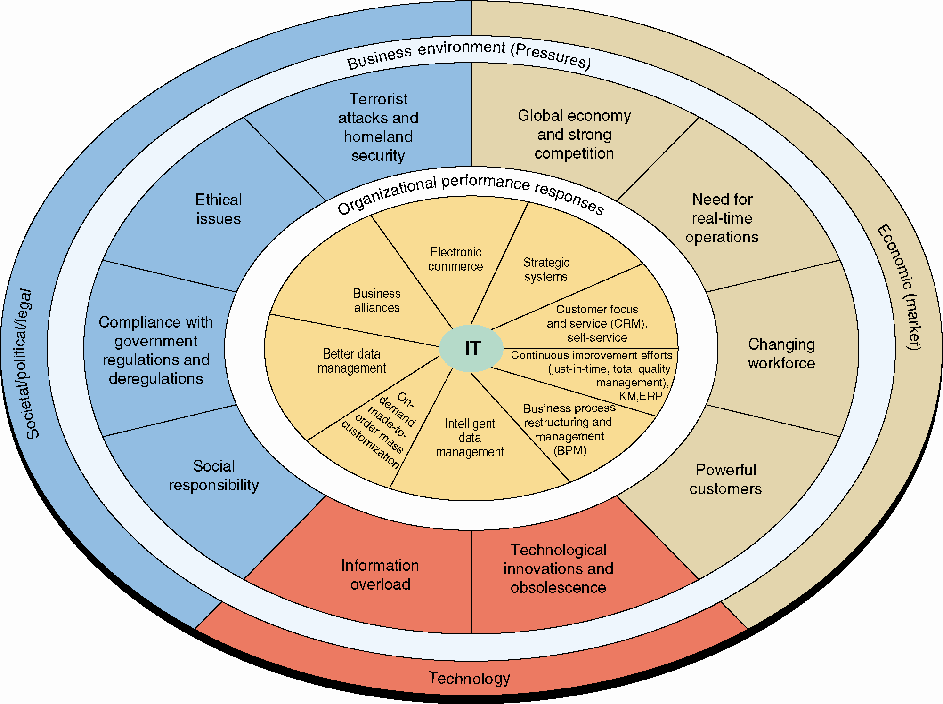

Competitive Advantage:
- Refers to any assets that provide an organization with an edge against its competitors in some measure such as cost, quality, or speed.
- Helps organization to control a market and to accrue larger than average profits
- Both strategy and competitive advantage take many forms

Competitive Advantage: any assets that provide an organization with an edge against its competitors in some measure such as cost, quality, or speed. It also helps an organization to control a market and to accrue larger-than-average profits.

Business Environment: the combination of social, legal, economic, physical, and political factors in which businesses conduct their operations. Significant changes in any of these factors are likely to create Business Pressures on organizations.

Organizations Responses: Organizations respond to the various pressures by implementing Information Technology (IT) such as strategic systems, customer focus, make-to-order and mass customization, and e-business.

Business Pressures, Organizational Responses, and Information Technology Support
- Modern organzaitions compete in challenging environment
- To remain competitive, they react rapidly to problems and opportunities that arise from extremely dynamic conditions

Business Pressure:
- Market Pressures
- Technology Pressures
- Societal/Political/Legal Pressures

Market Pressures: business pressures generated by the global economy, intense competition, the changing nature of the workforce, and powerful customers.

Technology Pressures: business pressures caused by technological innovation and information overload.

Societal/Political/Legal Pressures: business pressures related to social responsibility, government regulation/deregulation, spending for social programs, spending to protect against terrorism, and ethics.

Business Environment:
- Is a combination of social, legal, economic, physical, and political factors in which businesses conduct their operations
- Changes in any of these factors are to create business pressures on organization
- Organizations respond to these pressures with activities by IT

Market Pressure: are generated by the global economy, intense competition, the changing nature of the workforce, and powerful customers

(a)Globalization: Integration and interdependence of economic, social, and ecological facets of life, made possible by rapid advances in information technology

(b)Changing Nature of the Workforce: The workforce, particularly in developed countries, is becoming more diversified. Increasing numbers of women, single parents, minorities, and persons with disabilities are now employed in all types of positions.

(c) Powerful Customers: consumer sophistication and expectations increase as customers become more knowledgeable about the products and services they acquire. Customers can use the Internet to find detailed information about products and services, to compare prices, and to purchase items at electronic auctions.

Ex:
- Multinational corporations operate on a global scale, with offices, and branches located worldwide

- Many automobile manufactures use parts from other countries such as car being assembled in the United States with parts coming from Japan, Germany or Korea

Technology Pressures:
- Technological Innovation and Obsolescence
- Information Overload

Technological Innovation and Obsolescence: Few and improved technologies rapidly create or support substitutes for products, alternative service options, and superb quality. As a result, today’s state-of-the-art products may be obsolete tomorrow.

Information Overload: Internet and other telecommunications networks are bringing a flood of information to managers. To make decisions effectively and efficiently, managers must be able to access, navigate, and utilize these vast stores of data, information, and knowledge.

Societal/Political/Legal Pressures:
- Social Responsibility
- Compliance with Government Regulations
- Protection Against Terrorist Attacks
- Ethical Issues

Social Responsibility: Social issues that affect businesses and individuals range from the state of the physical environment, to company and individual philanthropy, to education. Some corporations and individuals are willing to spend time and/or money to address various social problems. These efforts are known as organizational social responsibility or individual social responsibility.

Compliance with Government Regulations: government regulations regarding health, safety, environmental protection, and equal opportunity. Businesses tend to view government regulations as expensive constraints on their activities. In general, government deregulation intensifies competition. In the wake of 9/11 and numerous corporate scandals, the U.S. government passed many new laws, including the Sarbanes–Oxley Act, the USA PATRIOT Act, the Gramm–Leach–Bliley Act, and the Health Insurance Portability and Accountability Act (HIPAA).

Protection Against Terrorist Attacks: Since September 11, 2001, organizations have been under increased pressure to protect themselves against terrorist attacks. In addition, employees who are in the military reserves have been called up for active duty, creating personnel problems. Information technology can help protect businesses by providing security systems and possibly identifying patterns of behavior associated with terrorist activities, including cyberattacks.

Ethical Issues: Ethics relates to general standards of right and wrong. Information ethics relates specifically to standards of right and wrong in information processing practices. Ethical issues are very important because, if handled poorly, they can damage an organization’s image and destroy its employees’ morale.

Social Responsibility:
IT is instrumental in organizational efforts to “go green” in three areas:
- Facilities design and management
- Carbon management
- International and U.S. environmental laws

Digital Divide: refers to the wide gap between those individuals who have access to information and communications technology and those who do not.

Organizational Responses
- Strategic Systems
- Customer Focus
- Make-to-Order and Mass Customization
- E-Business and E-Commerce

Strategic Systems: provide organizations with advantages that enable them to increase their market share and/or profits, to better negotiate with suppliers, and to prevent competitors from entering their markets.

Customer Focus: Organizational attempts to provide superb customer service can make the difference between attracting and retaining customers versus losing them to competitors. Numerous IT tools and business processes have been designed to keep customers happy.

Make-to-Order: a strategy of producing customized (made to individual specifications) products and services.

Mass Customization: a company produces a large quantity of items, but it customizes them to match the needs and preferences of individual customers. Mass customization is essentially an attempt to perform make-to-order on a large scale (Example: Bodymetrics <www.bodymetrics.com>).

E-Business and E-Commerce: Conducting business electronically is an essential strategy for companies that are competing in today’s business environment.
Electronic commerce (EC or e-commerce): describes the process of buying, selling, transferring, or exchanging products, services, or information via computer networks, including the Internet.

E-business: a somewhat broader concept than EC that includes servicing customers, collaborating with business partners, and performing electronic transactions within an organization.

Competitive Advantage and Strategic IS’s
- Porter’s Competitive Forces Model
- Porter’s Value Chain Model
- Strategies for Competitive Advantage
- Business – Information Technology Alignment

Strategic Information Systems (SISs): provide a competitive advantage by helping an organization implement its strategic goals and improve its performance and productivity.

Porter’s Five Forces Model
- The threat of new competitors
- The bargaining power of suppliers
- The bargaining power of customers (buyers)
- The threat of substitute products or services
- The rivalry among existing firms in the industry

Threat of Entry of New Competitors: The threat that new competitors will enter your market is high when entry is easy and low when there are significant barriers to entry.

Bargaining Power of Suppliers: Supplier power is high when buyers have few choices from whom to buy and low when buyers have many choices.
Bargaining Power of Customers (Buyers): Buyer power is high when buyers have many choices from whom to buy and low when buyers have few choices.

Threat of Substitute Products or Services: If there are many alternatives to an organization’s products or services, then the threat of substitutes is high. If there are few alternatives, then the threat is low.

Rivalry Among Existing Firms: The threat from rivalry is high when there is intense competition among many firms in an industry. The threat is low when the competition is among fewer firms and is not as intense.

Barrier to Entry: a product or service feature that customers have learned to expect from organizations in a certain industry. A competing organization must offer this feature in order to survive in the marketplace (e.g., legal requirements such as admission to the bar to practice law).

Switching Costs: the costs, in money and time, imposed by a decision to buy elsewhere (e.g., contracts with smartphone providers).
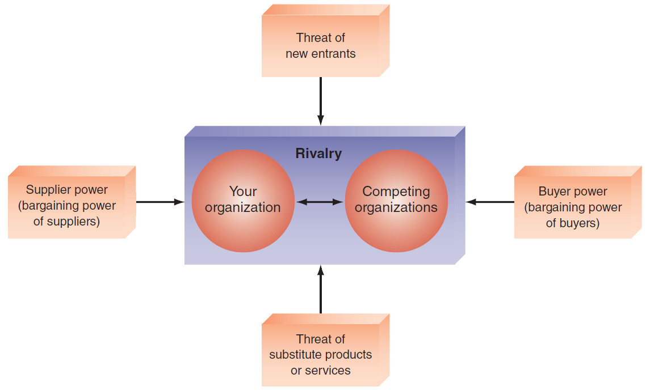

Porter’s Value Chain Model
- Value Chain
- Two Categories of Organization Activities in the Value Chain
  - Primary Activities
  - Support Activities

Value Chain: a sequence of activities through which the organization’s inputs, whatever they are, are transformed into more valuable outputs, whatever they are.

Value System: includes the suppliers that provide the inputs necessary to the firm along with their value chains. After the firm creates products, these products pass through the value chains of distributors (which also have their own value chains), all the way to the customers. All parts of these chains are included in the value systems

Two Categories of Organization Activities in the Value Chain:
- Primary Activities: relate to the production and distribution of the firm’s products and services. These activities create value for which customers are willing to pay.
- Support activities: contribute to the firm’s competitive advantage by supporting the primary activities, but do not add value directly to the firm’s products or services.
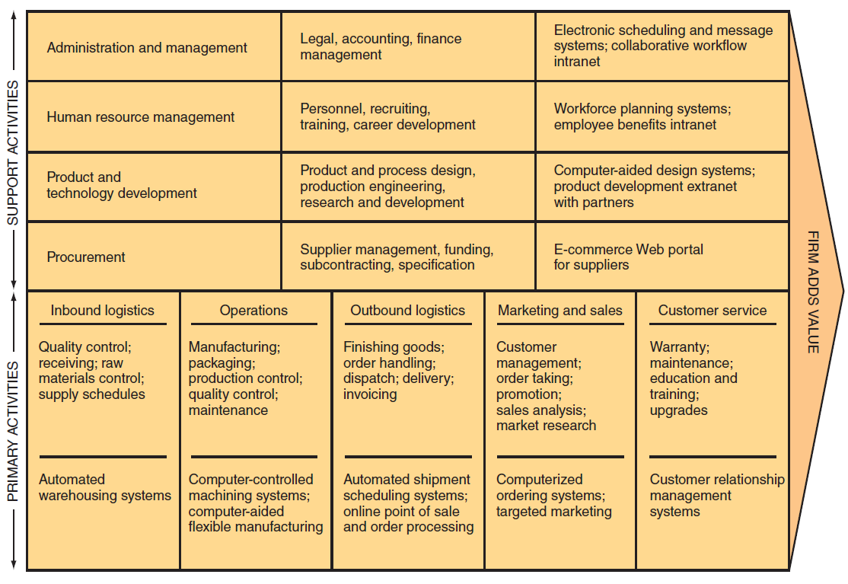

Primary Activities
Five Sequenced Primary Activities of Typical Manufacturing Companies:
- Inbound logistics (inputs)
- Operations (manufacturing and testing)
- Outbound logistics (storage and distribution)
- Marketing and sales
- Services

Support Activities
Value Chain Support Activities Typically Include:
- The firm’s infrastructure (accounting, finance, management)
- Human resources management
- Product and technology development (R&D)
- Procurement

Strategies for Competitive Advantage
Competitive Advantage Strategies:
- Cost leadership strategy: Produce products and/or services at the lowest cost in the industry (e.g., Walmart’s automatic inventory replenishment system).
- Differentiation Strategy: Offering different products, services, or product features than your competitors (e.g., Southwest Airlines has differentiated itself as a low-cost, short-haul, express airline).
- Innovation Strategy: Introduce new products and services, add new features to existing products and services, or develop new ways to produce them (Classic Example: the first introduction of automated teller machines (ATMs) by Citibank).
- Operational Effectiveness Strategy: Improve the manner in which a firm executes its internal business processes so that it performs these activities more effectively than its rivals. Such improvements increase quality, productivity, and employee and customer satisfaction while decreasing time to market.
- Customer Orientation Strategy: Concentrate on making customers happy. Web-based systems are particularly effective in this area because they can create a personalized, one-to-one relationship with each customer.

Business-Information Technology Alignment
- IT function directly supports the business objectives of the organization through the tight integration of the IT function with the organization’s strategy, mission, and goals.

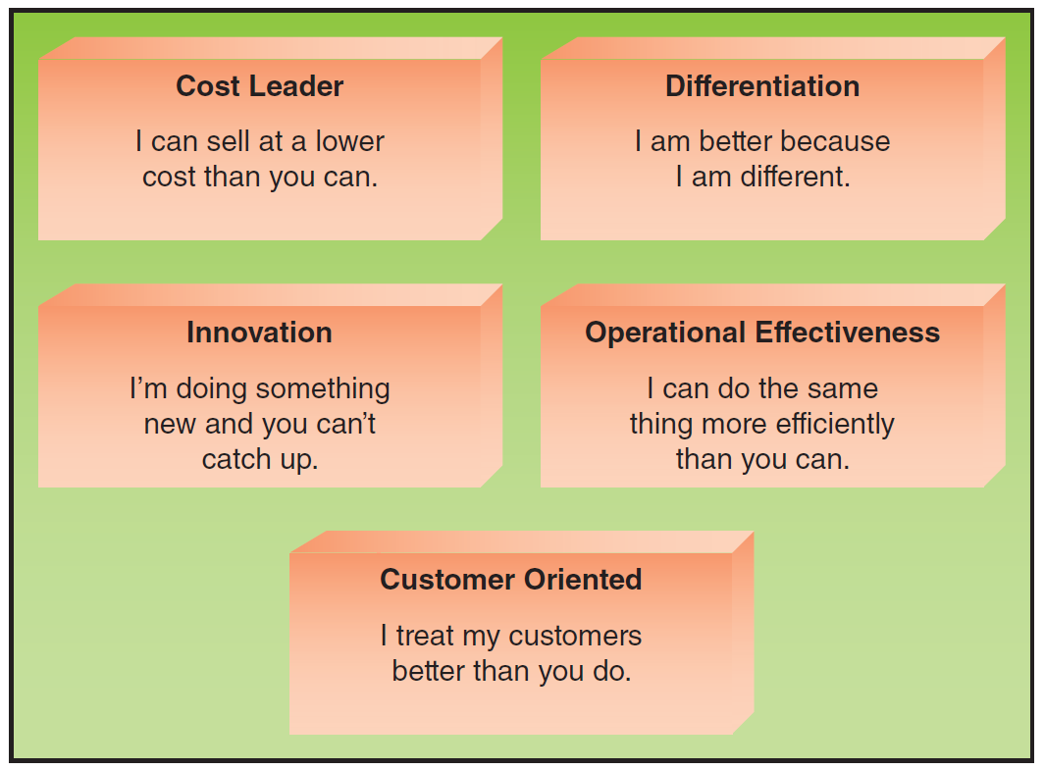

6 Characteristics of Excellent Business-IT Alignment
- Organizations view IT as an engine of innovation that continually transforms the business, often creating new revenue streams.
- Organizations view their internal and external customers and their customer service function as supremely important.
- Organizations rotate business and IT professionals across departments and job functions.
- Organizations provide overarching goals that are completely clear to each IT and business employee.
- Organizations ensure that IT employees understand how the company makes (or loses) money.
- Organizations create a vibrant and inclusive company culture.

