Experiment 1:
Verification of Boyle’s Law

Class: CHM1311(D)
Lab: Section 09
Names/Student#: Jacob Steele(0300043498)
Sept 19, 2017

Introduction Theory:
Boyle’s theory states that for “a fixed amount of an ideal gas kept at a fixed temperature, pressure and volume are inversely proportional.” According to Boyle, if the volume of a set amount of gas changes than the pressure will be effected inversely proportional. That is, if the temperature remains constant. The purpose of the experiment is to validate this event. In our experiment, we will use a specific volume of air in a syringe and change the volume by pulling the plunger. The pressure inside the syringe will change and be measured by the Gas Pressure Sensor.
Hypothesis:
The relationship between pressure and volume will be inversely proportional. Since this has been done before, I believe that will prove this theory by resulting in a constant “C” value after calculations. PV=nRT PV=C
Equipment:
- 20ml Syringe
- LabQuest2
- Vernier Gas Pressure Sensor
- USB drive
Procedure:
- Ensure lab area is clean of debris and you are wearing appropriate safety equipment.
- Connect the sensor to LabQuest2
- Prepare a volume of air in the syringe(1-20ml)
- Attach & lock the syringe to the Gas-Pressure-Sensor by ½ turn
- Pull the plunger to change the volume of your sample
- Collect and record data at different intervals of volume (repeat for 6-8 trials)
- Set the syringe back to the initial volume to check for a difference in pressure (Kpa)
- Decide and delete one of the two points; keep the one that is most accurate.
- Using the data that you collected, create a graph using LabQuest2 and save to an external storage device for later use.
Volume(ml) * Pressure(Kpa) = Constant(C) [PV=C]
2.8 * 101.8 = 285.04
4.8 * 54.73 = 262.704
6.8 * 37.28 = 253.436
8.8 * 28.06 = 246.928
10.8 * 22.8 = 246.24
12.8 * 19.02 = 243.456
14.8 * 17.72 = 262.256
16.8 * 14.68 = 246.624

Data/Calculations:
Volume (ml) | Pressure (Kpa)
2.8 | 101.08
4.8 | 54.73
6.8 | 37.28
8.8 | 28.06
10.8 | 22.8
12.8 | 19.02
14.8 | 17.72
16.8 | 14.68

Average Constant (C) : (285.04+262.704+253.436+246.928+246.24+243.456+262.256+246.624)/8 = 255.84kpa*ml
This graph is of our volume of air tested and the pressure associated with it. We could find an equation that fit the trend of the data very accurately. More on our data is explained in the following sections.
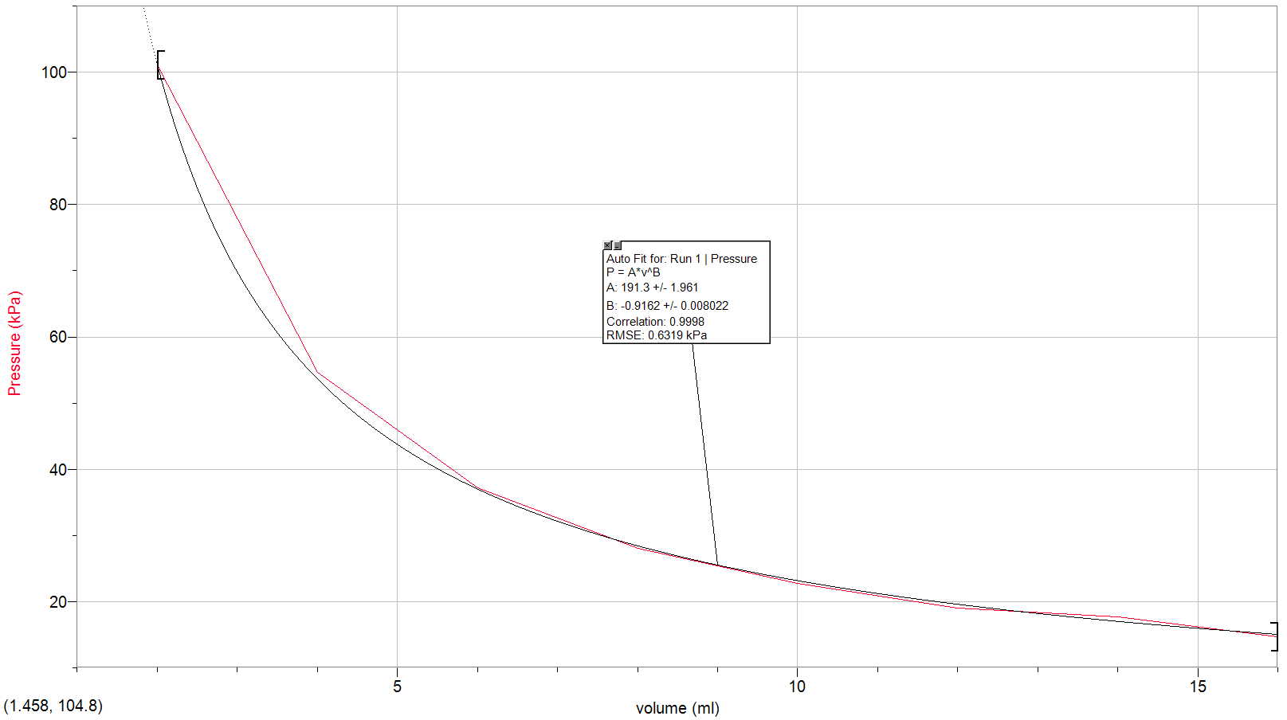

Since the volume pressure relationship will be inversely proportional I decided to show this in a second graph. If Boyle’s law were to be true, we would see a linear correlation for our data that gave us a constant “C” value.
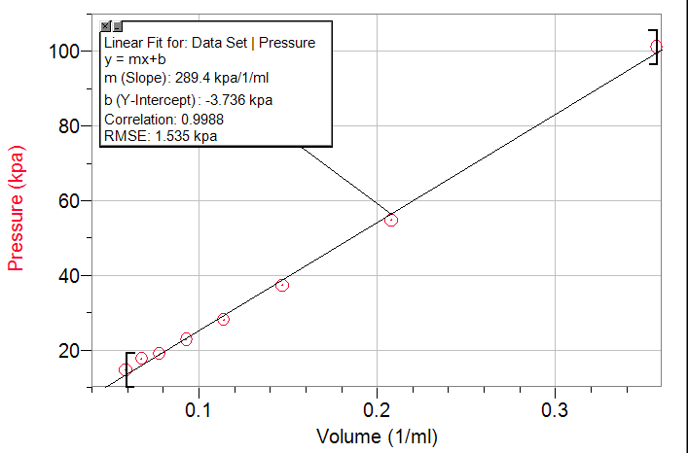
Volume (1/ml) | Pressure (Kpa)
.375 | 101.08
.208 | 54.73
.147 | 37.28
.114 | 28.06
.093 | 22.8
.078 | 19.02
.068 | 17.72
.059 | 14.68

Discussion:
In our attempt to prove Boyles Law, we performed 8 trials. These 8 trials included 7 different volumes and an initial trial at atmospheric pressure. Our goal was to get a constant for each variable that we tested. If we could get a constant value that was consistent throughout all of our calculations; we would know we proved Boyle’s Law sucessfully.

Possible errors:
Or results for our constant varied between 246.24 -> 285.04 kpa*ml. This range is not ideal as we would have hoped to see the same constant for every pressure*volume calculation in order to prove Boyle’s law more accuratly. Some errors for not receiving the dseired results could be:
- Inconsistent room temperature
- Not being carful enough when setting the plunger for a reading
- Not waiting for the pressure to stabalize
- Air could have escaped the syringe
In my opinion, the lack of accuracy when reading the plunger is mainly at fault for not returing consistant values. My partner had said that he was having difficulty keeping the plunger at an exact spot because as the pressure decreased it became more difficult to pull.
For the purposes of this lab we assumed that the temperature remained constant. If the room temperature fluctuated at all by any means, the results would have been altered. Thus, giving a larger range for the constant variable that we came across.
Air could have escaped the syringe aswell. The seal may have not been perfect at the Gas Sensor. We tried to rule this error out by taking a reading at the beginning and end of our 2.8ml of air to see if there were any differenences. The change was very little so we disregarded the trial at the end and kept the first one. This very minescule change in pressure or volume could have been an indicator that some gas had been lost.

Significance of Results:
If you view the graph, it matches up reasonably close to what it theoretically should. Each one of our trials most likely has some amount of human error involved but one in particular stood out to me. That is, trial 14. The results for trial 14 indicate that the pressure is less than the trend should allow for. Since our data can be modeled by a function of p(x)=201.64^{-.94278}+.8 ; it would suggest for the pressure to be slightly lower than it is. This result in question, would have led to a more accurate constant if it were at a lower pressure. Overall, our constant is found out to be 255.8355 kpa*ml by using the formula PV=nRT or PV=C. I found this value by using all our resulting constants and taking the average of them.

We further proved our results by checking if the relationship between volume and pressure was indeed inversely proportional by making a second graph. Basically, volume was recalculated by “1/original_volume.” The original pressure reading were used and caused a linear correlation that indicated a constant value.
These results will change as atmospheric pressure will change with elevation. Depending on the location where this experiment is conducted, results will be slightly different.

Questions (Data Analysis):
- I determined the constant by using the formula PV = C . I multiplied the pressure and volume recorded from each trial to get a final constant. These results were somewhat varied so I took the average of them all by adding them together and dividing by how many trials I performed.
- The mathematical relationship illustrated by Boyle’s Law is a power function. I used LoggerPro to find the equation that would best fit our trend of data. The equation turned out to be p(x)=201.64^{-.94278}+.8
- Taking a reading at the beginning and end of the dependent variable for the same value of the independent value is important to do to see if you have lost any pressure while doing your trials. Depending of the difference of the beginning and ending values, you would have gotten different results.
- Boyle’s Law requires for the temperature to remain constant for any gas variables. In our experiment, we tried our best to keep the temperature constant to room temperature. An inconsistent temperature can negatively affect your findings. An increase in temperature will cause an increase in pressure and a decrease in temperature will cause a decrease in pressure. Both situations will affect your results. This can be seen by looking at Gay-Lussac’s Law.

Single line conclusion to state results/findings.
Overall, my partner and I have successfully proved Boyle’s law. Setting aside the probability of human error and assuming the room temperature remained constant. Such variants aside, we were able to prove that the relationship of pressure and volume were inversely proportional through data analysis.

References
- NASA. Boyle’s Law
https://www.grc.nasa.gov/www/k-12/airplane/boyle.html (accessed September 19, 2017).

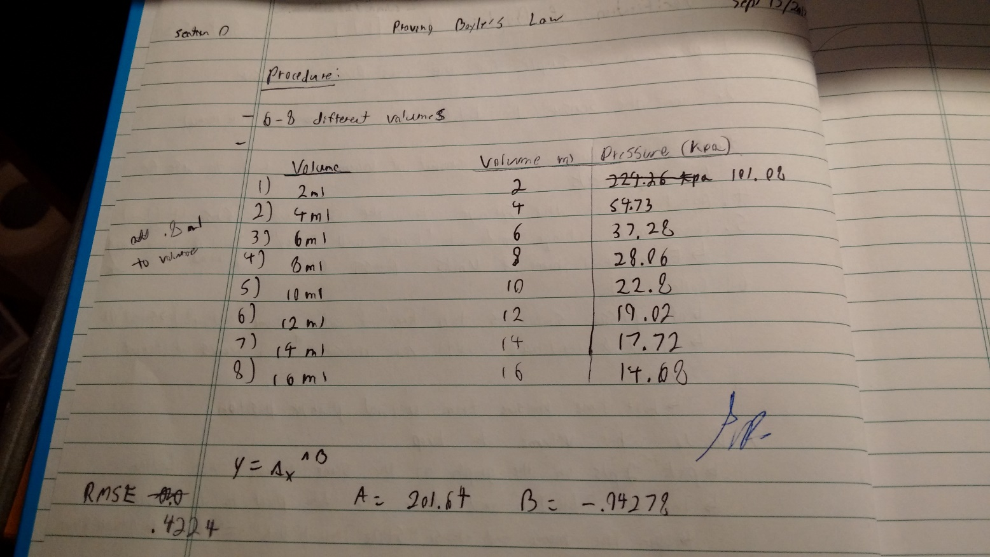
RAW DATA:
RAW DATA:



