BTM 200
ASSIGNMENT 2: ASSESS YOUR HARDWARES
- Windows tools
My machine is a Dell Inspiron 15 7566. These are the laptop’s specs:
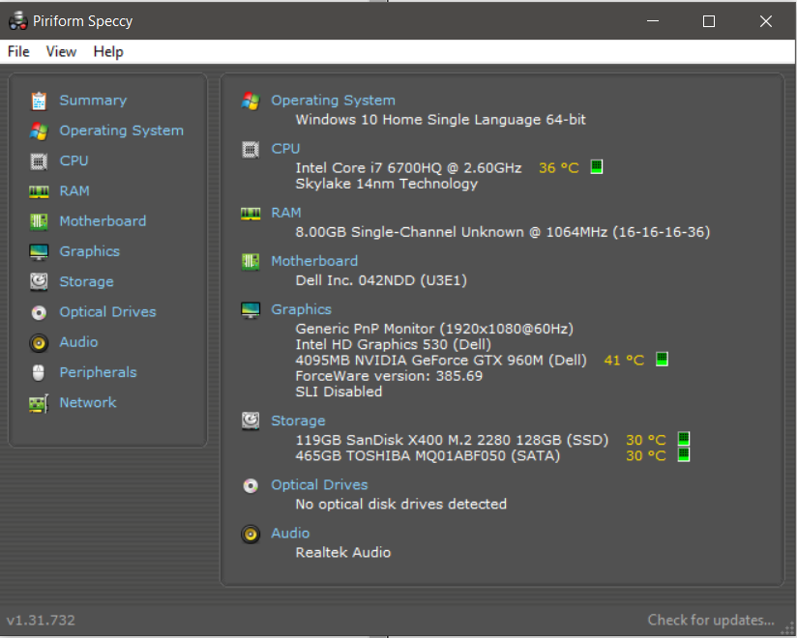
The software I’m using to check my laptop specs is called Speecy. It can tell the full system information and even the temperature of important parts: CPU, GPU, etc.

On a normal school day, my laptop usages are quite standard: Internet browsing, video streaming, music and Microsoft Office. This is a screenshot of the system performance:
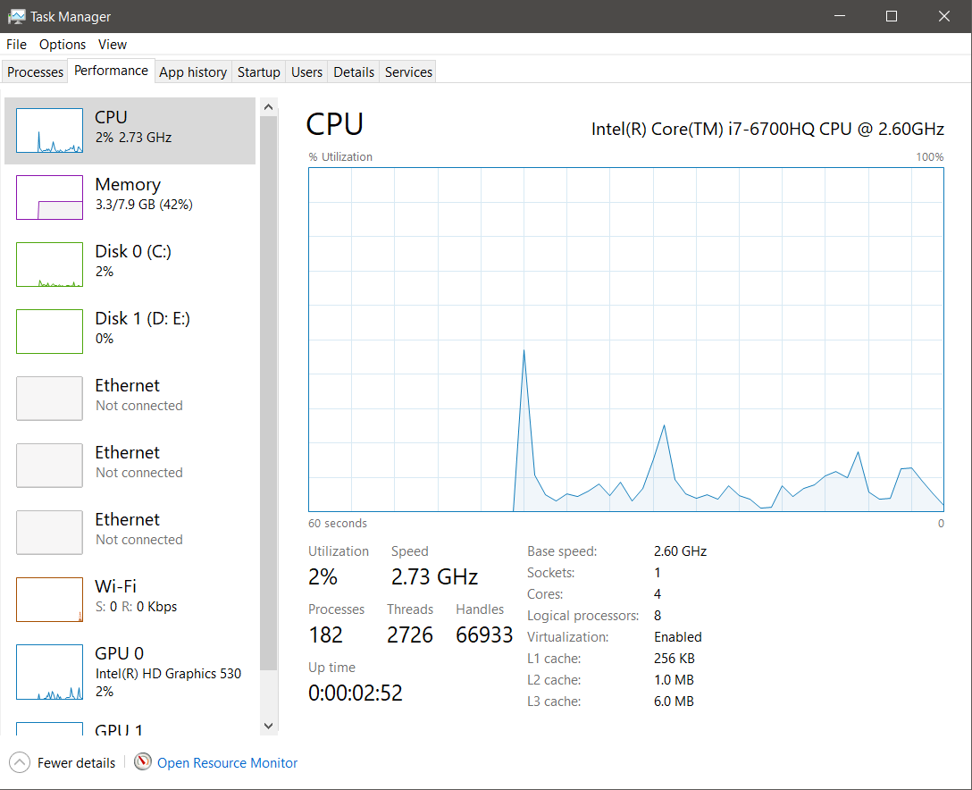

The CPU usage are low at only 2% while the RAM usage is at 44%: 3.2Gb in use and 4.5Gb available usage, and 138Mb for hardware reserved. The RAM really is an issue for me because there is only one stick of 8Gb RAM inside. For basic activities like surfing webs, streaming music/video or office work, 8Gb is more than enough. But when it comes to more demanding tasks like video/picture editing, the machine can not handle the workload and usually stutters, lags and eventually crashes the program. I’m able to use older software such as Adobe Lightroom 5, or Corel Video Studio X6 which require lower specs to run but it is slower than I want it to be.
For normal use, the integrated GPU inside my graphics card can process the graphics data perfectly fine: at around 1-2% utilization. This is very easy to understand cause the softwares I use on a daily basis or not that GPU demanding. The dedicated GPU on the GTX 960M remains at idle.

Beside form softwares I use everyday, I sometimes play online games as well. Most of the game I play are not heavy in CPU/RAM memories. The screenshot below is the hardware usage of my laptop when I play DOTA 2.
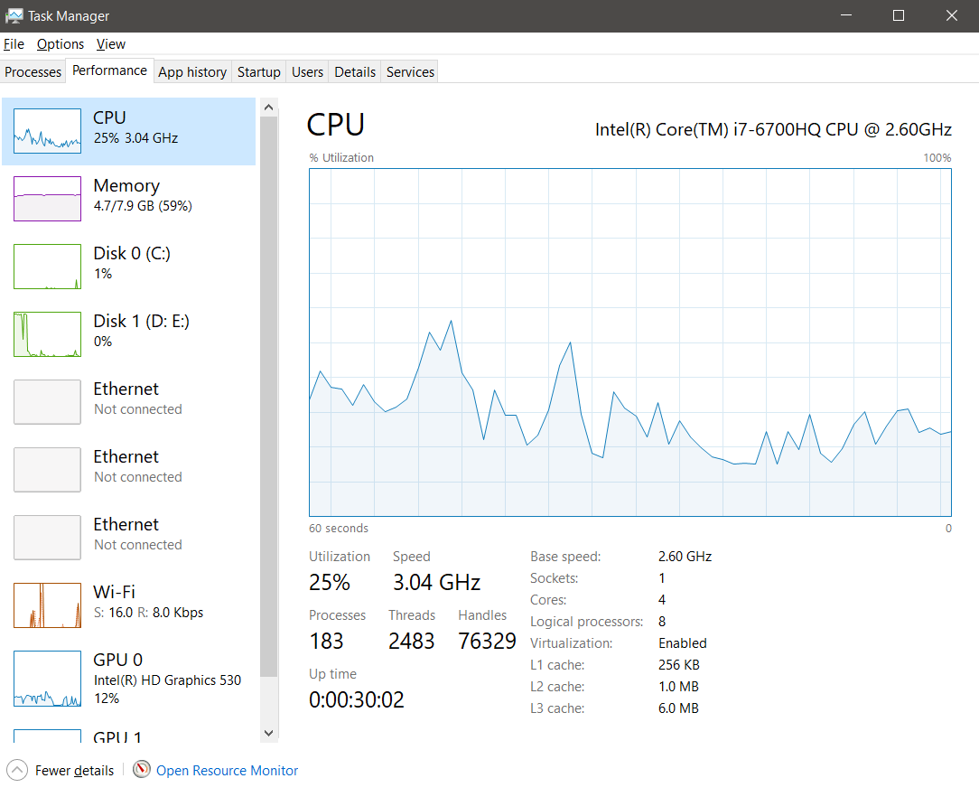
CPU usage varies around 18-40%, RAM usage at 58% (4.6Gb in use, 3.2Gb available)
The GPU on my dedicated graphics card handle most of the game graphics, at around 50% utilization.
These figures are mostly the same for all of the online games I played.
At this moment, I don’t have any video/picture editing softwares left in my laptop to put in comparison with the examples above.

- Benchmark
For benchmarking, I tried all the benchmark softwares mentioned in the assignment.
- Cinnerbench R15
- Geekbench
- Performance Test 9.0
Cinnerbench R15 test my CPU performance by using all of my system’s processing power to render a very realistic-looking 3D picture. And from my research, this picture uses various elements such as reflection, area light, shadows, shades, etc to seriously stress my processor. Cinnerbench also test my dedicated graphics card: Nvidia GTX 960M by demanding the GPU to process and display a small clip of a car chase in 3D. The procedure also uses different elements and effects to give the best overview of the graphics hardware.
This are the result:
- CPU multi-core performance test: 664 ranked 4th on the respective list
- CPU single-core performance test: 139 ranked 3rd on the respective list
- Graphics card performance test (Open GL): 71.86 fps ranked 1st on the respective list.

Geekbench 4 also measure my system’s power (CPU and GPU) but in disclose tests:
This are the result:
- GPU (Open CL) score: 52685
- Single-core score: 3716
- Multi-core score: 10816

Performance Test 9.0 is the benchmark suit I interested in the most. I find more details of this benchmark suit on their website: https://www.passmark.com/products/pt.htm. It contains 5 individual test suits with a total of 32 standard tests:
- CPU test: mathematical operations, compression, encryption, physics.
My configuration score: 7275.1.
The 6700HQ manages to place in the top 20th highest mark, which was not very surprised to me considered this laptop model was quite new at the time.
- 2D graphics tests: Vectors, different types of font and size of text.
My configuration score: 565.3
- 3D graphics test: DirectX9 to 12 in 4K resolution, DirectCompute/OpenCL test
My configuration score: 4113.4.
For the 2D/3D graphics test, my scores were low but that is understandable. The 960M is more on a low-end spectrum compare to new mobile graphics card like the GTX 1050, 1060,….

- Memory test: Memory access speeds and latency
My configuration score: 1638.5
- Disk test: Read, write, seek files on disk and input/output operation per second
My configuration score: 3445.4
I haven’t found any chart with my specific storage to compare with but throughout the process of usage, I’m really please with the read and write speed for both of my HDD and SDD although the storage are relatively small: 128Gb on the SDD, 500Gb on HDD.

I also look up my system hardwares ranking on their website which I link with the result below:
Intel Core i7-6700HQ overall rank: 317
Link: cpubenchmark.net/cpu.php?cpu=Intel+Core+i7-6700HQ+%40+2.60GHz&id=2586
NVIDIA Geforce GTX 960M overall rank: 226
Link: videocardbenchmark.net/gpu.php?gpu=GeForce+GTX+960M&id=3176
My CPU mark is very close to their average mark which was 8141
My GPU 3D mark is higher than their average mark which was 2065
Overall, I think that my laptop has a relatively good specs inside. It managed to score higher than I expected I’d be for all of the test. Both my CPU and GPU perform well and able to handle most of my demand. The Dell 7566 doesn’t have much space for upgrades: and extra slot of RAM (maximum of 16Gb), a slot for another hard drive. If I want to use more advance video/picture editing softwares like Adobe Premiere, Adobe Photoshop, I would have to consider buying a new laptop or build a brand new desktop rig suitable for the task. Nonetheless, I think this system can still handle the workload for another 2 to 3 years before being replaced.

