Notes for midterm B – HSS 1101 fall 2012
Chapter 4 – Personal fitness
most info was collected from Health: the basics 5th Canadian edition by Donatelle
Physical activity: Body movements produced by skeletal muscles resulting in energy expenditure
Three main categories:
- Physical activities for health – light forms of leisurely activities ex: walking, gardening
- Physical activities for fitness – Includes forms of repeated exercise with fitness as the main goal
- Physical activities for performance – Activates to improve athletic performance
Exercise: Planned, structured, and repetitive bodily movements done to improve or maintain one or more components of physical fitness
Physical fitness: A set of attributes that are either health or performance related
Benefits of regular physical activity:
- Improved cardiorespiratory endurance – aerobic training
  - Reduced risk of heart disease
  - Prevention of hypertension
  - Improved blood lipid and lipoprotein profile
    - Reduces LDL, overall cholesterol, and triglyceride levels while increasing HDL
- Improved Bone health – Weight bearing/strength training
- Improved weight management
- Improved health and lifespan
  - Prevention of type 2 diabetes
  - Increased longevity
  - Improved immunity to disease
- Improved mental health and stress management
    - Exercise “burns off” chemicals by-products of stress
    - Greater self-esteem from physical benefits
Cardiorespiratory endurance: The ability of the heart, lungs, and blood vessels to function efficiently
Aerobic power: The current functional status of a person’s cardiorespiratory system; measured as VO₂max and referring specifically to the volume of oxygen consumed by the muscles during exercise
Graded physical test: A test of aerobic capacity administered by a physician, exercise physiologist, or other trained person
Generally, the optimal amount of aerobic physical activity needed is 20-30 minutes of moderate intensity (70-90% of max heart rate or 55-85% of VO₂max) activity, 3-5 times a week
Target heart rate: The desired intensity of aerobic exercise for improving or maintaining cardiorespiratory fitness; calculated as a percentage of a maximum heart rate (220 [males] / 226 [females] minus age)
Frequency: The frequency that a physical activity is repeated ex: 5 times a week
Intensity: Difficulty of the physical activity ex: 80% of maximum heart rate
Time: The amount of time spent doing the activity, ex: 30 minutes of jogging
All of the above three variables can be changed in any fashion, but the overall caloric expenditures should be 300-500 kcal per day or 1500-2100 kcal per week.
Health and performance related components of physical fitness
Health |  | Performance
Cardiorespiratory endurance | Ability to sustain moderate-intensity whole-body activity for extended time periods | Agility | Speed in changing directions or in changing body positions
Muscular strength | Ability to apply maximum force with a single muscle contraction | Power | Combination of strength and speed
Muscular endurance | Ability to perform muscle contractions repeatedly | Balance | Maintenance of stable body position
Flexibility | Range of motion in a joint or series of joints | Coordination | Ability to have things work together
Body composition | Ratio of fat to total body weight | Reaction time | Ability to adjust or “react” to stimuli
Body composition | Ratio of fat to total body weight | Speed | Ability to move quickly

Musculoskeletal health: the combination of strength, endurance and flexibility and their influence on various components of health
Muscular strength: The maximal amount of force that a muscle or groups of muscles is capable of exerting
One repetition maximum (1RM): The maximal amount of weight/resistance that can be lifted/moved only once
Muscular endurance: A muscle’s or group of muscles’ ability to exert force repeatedly or to sustain a contraction without fatiguing
Principles of strength development:
- The tension principle (must create enough of it to create significant stress)
- The overload principle (figure 4.2)
- The specificity of training principles (doing bench presses won’t increase leg strength)
- The recovery principle (must allow 48h for the body to recover from and adapt to the training)
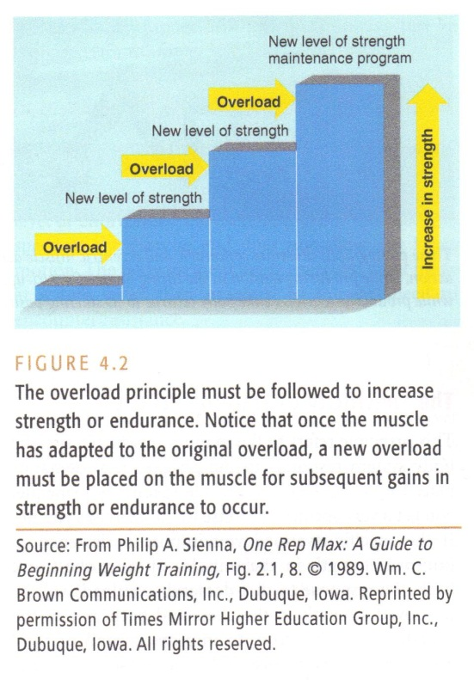
Hypertrophy: Increased size (girth) of a muscle
Types of muscle contractions:
- Isometric muscle contraction: force produced without muscle movement
- Concentric muscle contraction: force produced while shortening the muscle
- Eccentric muscle contraction: force produced while lengthening the muscle
Methods of providing resistance:
- Body weight resistance
- Fixed resistance (barbell)
- Variable resistance (consistent force output through ROM such as a fitness machine)
- Accommodating resistance (consistent speed through ROM such as isokinetic machines)
See table 4.2 p. 90
Flexibility: the range of motion, or the amount of movement possible, at a particular joint or series of joints
Static stretching: Assuming a “stretching” position – at the point of tension – for 10 to 30 seconds in which there is a gradual lengthening of a muscle (usually repeated 2-3 times in succession)
Ballistic stretching: a form of passive stretching or dynamic stretching in a bouncing motion. Should be reserved to athletes who know their limitations (may cause hyperextension injuries in the untrained)
Proprioceptive neuromuscular facilitation (PNF) stretching: stretching technique commonly used in clinical environments to enhance both active and passive range of motion. The literature regarding PNF has made the technique the optimal stretching method when the aim is to increase range of motion, especially in short-term changes
Yoga: physical activity involving static stretching that originated in India about 5000 years ago. Yoga blends the mental and physical aspects of exercise to provide a relaxing and satisfying union of the body and mind. There is more than 200 asanas (positions) and many different variations exist
Table 4.3 p. 43 (probably irrelevant)
Tai Chi: ancient form of exercise performed by the monks (1000 CE) that combines stretching, balance, coordination, and meditation. It involves a fluid series of positions based on Chinese martial arts. Often described as “meditation in motion”
Pilates: a physical fitness system developed in 1926 by Joseph Pilates. It improves flexibility, agility, coordination, strength and tone.
Overuse injuries: injuries that result from the cumulative effects of day-after-day stresses placed on tendons, muscles and joints. The three most common overuse injuries are: plantar fasciitis, “shin splints”, and “runner’s knee”
Traumatic injuries: Injuries that are usually accidental in nature and occur suddenly and violently. Includes bone fractures, ligament/tendon sprain/rupture, laceration and head injuries among others
RICE: acronym for the standard first aid treatment for injuries: rest, ice, compression and elevation
Heat cramps: Muscle cramps that occur during or following exercises in hot/warm conditions
Heat exhaustion: A heat stress illness caused by significant dehydration resulting from exercise in hot and/or humid conditions; frequent precursor to heat stroke
Heat stroke: a deadly heat stress illness resulting from dehydration and overexertion in hot conditions; can cause body core temperature to rise rapidly from normal to 43C in just a few minutes
Hypothermia: a potentially fatal condition resulting from abnormally low body core temperature

In Class Notes
Energy pathways:
ATP - CP (alactic system: anaerobic) - Up to first 15 seconds
Glycolysis (lactic system: anaerobic) - 15 – 90 seconds
Glycolysis (aerobic) - 90 – 180 seconds
Fatty Acid Oxidation (oxidative: aerobic) - 180 seconds+

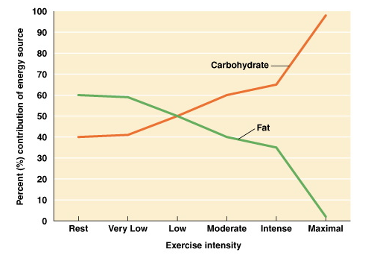
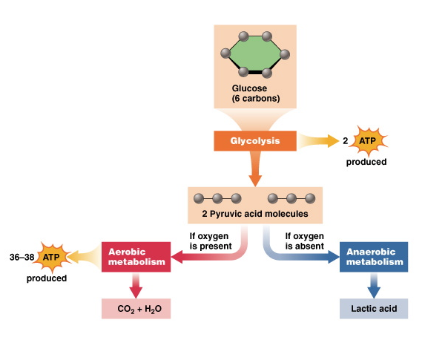

Chapter 5 – Nutrition
most info was collected from Health: the basics 5th Canadian edition by Donatelle
Hunger: the feeling associated with the physiological need to eat
Appetite: The desire to eat; often more psychological than physiological
Nutrition: The science that investigates the relationship between physiological function and the essential elements of food we eat
Nutrients: the constituents of food that sustain us physiologically; water, protein, carbohydrates, fats, vitamins, and minerals
Calorie: a unit of measure that indicates the amount of energy obtained from a particular food
Digestive process: the process by which foods are broken down and absorbed or excreted by the body;
- Food enters mouth and saliva starts breaking it down with its enzymes (amylase ->initiates carbohydrate digestion)
- Goes down esophagus (23-25cm) be a series of slow contractions and relations
- Goes in stomach where hydrochloric acid and enzymes break down food further (pepsin -> enzyme digesting proteins.) The stomach also creates a layer of mucous to protect it from the strong acids
- Goes in small intestine (8m.) Each section secretes enzymes along with pancreas and liver to break down and absorb all macro-nutrients
- Water, fiber and salts proceed to large intestine where the majority of water and salts are absorbed
- Whole process takes approximately 24 hours
See figure 5.2 p.111
RNI: Recommended Nutrient Intake (the old Canadian standard)
RDA: Recommended Daily Allowance (old American standard)
DRI: Dietary Reference Intake
*RDA and DRI are now the standard in Canada and the US
AI: Adequate Intake (when RDA cannot be established)
The Macro Nutrients
Proteins: An essential constituent of nearly all body cells; necessary for the development and repair of bone, muscle, skin, blood, key elements of antibodies, enzymes and hormones (Provides 4 kcal/g)
Recommended intake: 0.8g per kg of bodyweight per day
Amino acids: building blocks of protein (22 types, although Pyrrolysine, is often omitted as it is not used by humans)
Essential amino acids: 8 of the amino acids that cannot be synthesized do novo (“from scratch”) by humans
Complete (high quality) proteins: Contain all 8 essential amino acids (from animal source)
Incomplete proteins: proteins lacking one or more essential amino acid (plant source)
*Combine 2 of the 4 types of plant proteins for complete proteins:

- Grains
- Legumes
- Seeds/nuts
- Vegetables

Carbohydrates: basic nutrient that supply the body with energy. They are easily converted to glucose which is the preferred fuel of the blood and nerves (Provides 4 kcal/gram)
Simple carbohydrates: found mostly in fruit; quickly digested; made of simples sugars (monosaccharide) and Disaccharides (which must be broken down to simple sugars to be used)
Monosaccharides: glucose; fructose; galactose; (one sugar molecule)
Disaccharides: maltose; lactose; sucrose; (two sugar molecules)
Complex carbohydrates: combination of long chains of sachharides
- Starch: most commonly consumed; main energy source of plants (breads, pasta, potatoes….)
- Glycogen: main energy source of animals (usually stored in muscle and liver cells)
- Cellulose (Fibre): Indigestible portion of plant food that makes up the cell wall
Dietary fibre: non-digestible part of plants
Functional fibre: manufactured/extracted from plants
Insoluble fibre: lowers cancer risk, clings to water and helps move material in large intestines
- Wheat cellulose, vegetable lignin, hemicellulose…
Soluble fibre: swells with water and traps nutrients, slowing down absorption; provides felling of “fullness”
- Oats, barely, legumes, fruit pectins….
Fats: basic nutrient that provides taste and texture to food, absorbs vitamins A, D, E and K, and are needed for the proper functioning of cells, insulation of body organs against shock, maintenance of body temperature and healthy skin/hair (provides 9 kcal/g)
Triglyceride: most common form of fat in body and blood. Constitutes 95% of body fat
Cholesterol: a form of fate circulating in blood that can accumulate on the inner walls of the arteries
Saturated fats: fats that are unable to hold any more hydrogen in their chemical structures; derived mostly from animal sources; solid at room temperature
Unsaturated fats: fats that have more room for hydrogen in their chemical structures; derived mostly from plants; liquid at room temperature. Mono/poly- prefix refers to the amount of hydrogen atoms missing
Trans-fatty acids: fatty acids produced when polyunsaturated oils are hydrogenated to make them more solid. They change into irregular shapes at the molecular level, priming them to clog arteries. More harmful than saturated fats as they increase LDL and decrease HDL in blood
The Micronutrients
Water: the most necessary nutrient; the water in our system bath cells, aids in fluid & electrolyte balance, maintains pH balance and transports molecules and cells through the body. 6-8 glasses of water per day is necessary and the DRI is 13 cups for men and 9 for women
- Constitutes 50-60% of body weight
Dehydration: abnormal depletion of body fluids
Vitamins: essential organic compounds that promote growth and maintain life and health
See table 5.1 p.118-119
Minerals: inorganic indestructible elements that aid physiological processes
Macro minerals: minerals that the body needs in large amount: sodium, calcium, phosphorus, magnesium, potassium, sulfur and chloride
Trace minerals: minerals that the body only needs in trace amounts: iron, zinc, manganese, copper iodi9ne and cobalt
See table 5.4 p. 120
Anemia: iron deficiency disease that results from the body’s inability to produce hemoglobin
Some facts about meat:
- Men who eat red meat as a main dish 5 or more times a week are 4 times more at risk of colorectal cancer than men who eat red meat once a month
- Heavy red meat eaters are twice as likely of getting prostate cancer
- For every 3 servings of veggies a day, men care 22% lower risk of stroke
- High fruit and veggie eaters who smoke have a 10 times higher risk to lung cancer instead of 20
- Fruits and vegetable consumption may lower chances of esophagus cancer in men
Vegetarian is a term with a variety of meanings:
- Vegans avoid all food of animal origin
- Lacto-vegetarians avoid flesh foods and consume dairy products
- Ovo-vegetarians avoid flesh foods and consume eggs
- Lacto-ovo-vegetarians avoid flesh foods and consume eggs and dairy products
- Pesco-vegetarians consume eat seafood, egg and dairy products
- Semi-vegetarians (“non-red meat eaters”) consume seafood , chicken, dairy and eggs

Vegans typically get 50-60g of protein per day
Lacto-ovo vegetarians typically get 70-90g of protein per day
Food borne illness:
- 10 000 reported cases per year in Canada
- Occurrence of food borne illness has increased in recent years, probably due to:
  - Produce import (exotic pathogens)
  - “organic” manure fertilizers (lack of pesticide regulation)
    - Esheria coli can survive in manure for 70 days unless heat or additives such as salt and preservatives are used to kill them
  - Insufficient education on food safety
    - 30% of food borne illness can be prevented in the kitchen
Food allergies: Overreaction by the body to normally harmless food proteins perceived as allergens. In response, the body produces antibodies, triggering allergic reaction
Food intolerance: adverse effects resulting when people who lack the digestive chemicals/enzymes needed to break down certain substances, eat those substance
Organically grown: foods grown without pesticides or chemicals
In Class Notes: what do we find on nutritional labels
- DVs
- Ingredients list
- Servings per container
- Serving size
- Macronutrients
- Vitamin A, C; Calcium & Iron

Chapter 6 – Managing your weight
most info was collected from Health: the basics 5th Canadian edition by Donatelle
Overweight: A weight greater than expected for a specific height (usually determined with BMI). Risks include greater chance of heart disease, stroke, high blood pressure, some types of cancer, type 2 diabetes, gall bladder disease and osteoarthritis.
Obesity: An excessive accumulation of body fat at which level the risk for health problems is increased
Based on these definition it is possible for someone to be overweight even though he is clearly not obese (such as a lean muscular athlete), while it is possible to also be obese while not being overweight.
Body mass index (BMI): a technique of weight assessment based on the relationship of weight to height; it is calculated by dividing your weight (in kg) by your squared height (in m). Healthy weight to height ratio is a BMI between 18.5 and 24.9. Values above 25 are referred as overweight. 30 to 34.9 is “considered” obese class I, 35-39.9 is obese class II and over 40 is obese class III, with extremely high health risk
See table 6.1 and 6.2 p.135
- Body composition is broken down in two components: fat mass and fat free mass
- Everyone has essential fat (3-4% in men, 8-13% in women) to maintain normal physiological functioning
- Storage fat comprises the rest and is used as insulation, padding and energy storage
- Excessively low fat is unhealthy and may cause condition like amenorrhea or oligomenorrhea in women; a cessation or disruption of menstrual cycle respectively
Dual-energy X-ray absorptiometry (DXA): A method of body composition assessment in which estimates are made of bone mineral content, lean and fat mass by using photon radiation. It is considered the “gold standard” as it not only determines composition but also the distribution
Hydrostatic weighing: A method of determining body fat by measuring the amount of water displaced when a person is completely submerged and by using under water and out-of-water weight (fat is less dense)
Air displacement plethysmography (ADP): A method used to determine body fat from estimates of total body volume. Like hydrostatic weighing but with air
Skinfold measurements: A method of assessing body fat where double folds of skin and the underlying tissue are measured with skinfold calipers. Very common but not the most precise method; fatter persons will have a less accurate measurement
Waist circumference: A method of assessing abdominal fat where a measuring tape is used to assess the girth at the top of the iliac crest. A waist of more than 102cm in men and 88cm in women indicates a greater risk of heart disease, type 2 diabetes, metabolic syndrome, hypertension and hyperlipidema
Bioelectrical impedance analysis (BIA): A technique of body fat assessment in which the resistance to a weak electrical current is measured (based on the fact that fat free mass has much more water and electrolytes.) It has seen a popularity hike in recent years due to its convenience, low cost and speed alter fluctuation in body water content may alter the basement.
Resting metabolic rate (RMR): The energy expenditure of the body while at rest, which includes basal metabolic rate (the metabolic rate of the body at complete rest) plus the energy required by sedentary activities, such as food digestion, sitting, studying, or standing.
Basal metabolic rate (BMR): The energy expenditure of the body under resting conditions at normal room temperature.
Exercise metabolic rate (EMR): The energy expenditure of physical activity.
Very-low-calorie diets (VLCD): diets with caloric value of 400-700 kcal per day. Very unhealthy and changes the body’s food store so that it may retain the most energy (consumes lean mass to keep glucose and fat reserves high [survival instinct]) after depleting protein reserves, the body will revert to fat
Ketosis: a condition in which the body adapts to prolonged fasting or carbohydrate deprivation by converting body fat to ketones, which can be used as fuel for brain activity
William Sheldon’s somatotypes (1940):
Endomorphy: relative fatness of the body; soft appearance
Mesomorphy: relative muscularity of the body
Ectomorphy: relative linearity of the body; tall and slender
Genes play a large role in obesity:
- 40% of children with one obese parent are likely to be obese
- 80% of children with both obese parents are likely to be obese
- Weather raised in environments with fat or thin family members, separated twins with obese parents tended to be obese later on in life
- There have been two genes linked to obesity; the GAD2 gene (“I need to eat” gene) and the Ob gene (disrupts the “I had enough to eat” signalling system)
Hunger: An inborn physiological response to nutritional needs.
Appetite: A learned response tied to an emotional or psychological craving for food often unrelated to nutritional need.
Satiety: The feeling of fullness or satisfaction after eating.
Adaptive thermogenesis: Theoretical mechanism by which the brain regulates metabolic activity according to caloric intake.
Brown fat cells: Specialized type of fat cell that affects the ability to regulate fat metabolism.
Hyperplasia: An increase in the number of cells. Usually stops for fat cells after growth but may be increased if energy input is constantly much higher than output.
Hypertrophy: An increase in the size of cells. The general occurrence to fat cells for most weight gain
Yo-yo diet: Cycles in which people repeatedly gain and lose weight. This lowers their BMR, which favours the weight gain process.
Setpoint theory: A theory that suggests fat storage is determined by a thermostatic mechanism in the body that acts to maintain a specific amount of body fat.
Weight bias: Negative attitudes that have a harmful effect on a person’s interpersonal interactions and activities with persons who are obese.
Eating disorder: A term used to describe a collection of psychiatric diseases that involve severe disturbances in eating behaviours, unhealthy efforts to control body fat and weight, and abnormal attitudes toward one’s body weight and shape. (90-95% of all case occur in females, with the majority between 14-25yrs old)
Anorexia nervosa: Eating disorder characterized by excessive preoccupation with food, self-starvation, and/or extreme exercising to achieve weight loss. Effects can be life threatening and can cause serious damage to bones, muscle, organs and create a host of medical problems
Bulimia nervosa: Eating disorder characterized by cycles of binge eating and purging (that is, various methods taken to prevent calorie absorption).
Binge eating disorder (BED): Eating disorder characterized by recurrent binge eating without any purging behaviours,
Disordered eating: refers to a wide range of abnormal eating behaviors; not to the same extant as eating disorders

