ADMS 1000 Study Notes
Chapter 1
Functions of a manager:
Planning - Assessing organizations goals. Generating strategies.
Organizing - How work tasks wil be grouped, how tasks will be assigned, how authority will be allocated to make best use of work resources
Controlling - Assessing if the organizaton is progressing towards its goals. Establishing standards.
Leading - Guiding and motivating all members toward the achievement of the organizations goals.
Roles of managers:
Interpersonal Roles: Figurehead, leader
Informaitonal Roles: Monitor, spokesperson
Decision Roles: Entrepreneur, Negotiator
Management Philosophies:
- Classical
- Scientific Management - Standardizing, Supervising, Moticating
- Administrative Management (Henry Fayol) - Report to one boss, team spirit, company goals over individual goals
- Bureaucratic Management (Mac Weber)- Rules and procedures, hierarchy of authority, impersonality

- Behavioural
- Human relations movement
- Mary Parker Follet - Coordination, Self management and collaboration. No force or coercion, involvement and group efforts instead.
- Chester Barnard - Organizations are social systems: continual communication and cooperaion among all memebers. Motivation
- Modern Behavioural Science - Motivating employees - motivated workplace

Contingency Approach
- Organizational Size - Large organization with hundreds of employees cannot be managed in the same manner as small organizations due to employee size
- Routiness of Task and Technology - Some organizations may require assembly-line fashion,
- Individual Differences - Empoyees differ with regart to their ability and motivation. Some function better with clear guidance, other perform beter when ruls gverning their performance are minial.
- Environmental Uncertainy - An organization that exists within a volatile evironment must be prepared for change. Organizations in rapidly charning evironments wont do well in a classical school of management.
Chapter 2
The changing nature of organizations.
- Traditional Bureaucracy
- Tall Hierarchical
- Rigid, rule-oriented
- Buffed from the environment
- Narrow Market
- Modern Organizations
- Flat - Increased decision making speed, react faster to changes. More responsibility to employees. Lower level employees more decison-making power.
- Fluid - Adaptable to change. Suital in dynamic evironments. Organic structure.
- Integrated - Cross functional - self management - information sharing
- Global - Global competition - access to new markets - increased networking

Types of organizations
- Public/ governmental - provide goods and services without necessarily generating a profit
- Private/Nongovernmental organizations - Same as above
- Private organization - Produce goods or services with the intent of making a profit for the benefit of their owners or shareholders.
Organizations as systems
- Closed Systems - have been defined as fully self sufficient entities requiring no interction with the environment
- Open Systems - Asserts that organizations are entities that are embedded in and depend on exchanges with the environement they operate within. Organizations can be viewed as social systems.

Four Elements of organizaional structure
- Work specialization - How work is going to be divided up. Divided into functinal and social. Function refers to the division of jobs into simple repititve tasks and social refers to the specialization of individuals rather than the specialization of the job .
- Centralizaion - Where authority sits in the organization. Decentralization occurs if lower level empoyees make important decisions.
- Span of control - Hierarchy is connected to span of control
- Formalization - Rule oriented - reflects the degree to which jobs within the orgaization are standardized. It is the degree to which rules will be used to guide members.

Mechanistic vs. Organic

Virtual Organization
- Outsourcing - Contracting out - Involves hiring external organizations o conduct work in certan functions.
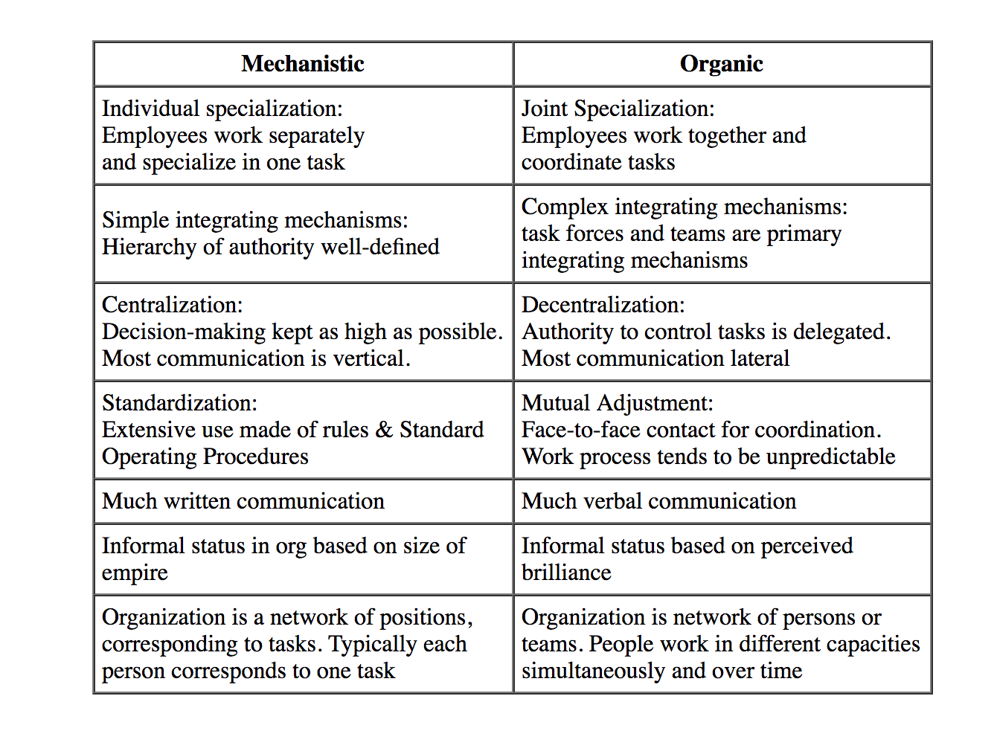
- Networking - Organizations can engage in cooperative relationships with suppliers, distributors and competitors. Aims to improve effciency in flexability meeting new customer needs.
- Shedding noncore functions -
Benifits: Cost savings, great alternaive for entrepreneurs, fast way to evelop and market new producs, fast and flexible
Risks: Losing control. Lack of employee loyalty. Potential sacrifice of competitive learning opportuninties.

Downsizing - Planned reduction in the breadth of an organizations operations. Entails terminating relatively large number of employees or decreasing number of products or services the organization provides. Reduction of workforce. Contractng and dropping product lines.
Risks of downsizing: Efficint departments are hurt. Loss of corporate memeory. Not guided by strategic plan. Loss of ocntrol over outsourced work. Plan is not share.
How can it fail? Lack of strategic planning. Lack of involvment of employees. Removal of corporate memory.
Learning organization: An organizaton that faciliates the learning of all its members and consciiously transforms itself and its context. Adapts to its environment, learning from its poeple.
How can organizations learn?
Single loop learning - Error detection and correction. Deals with symptoms. Does not consider underlying causes
Double- Loop learning - Considerings the underlying system. Goes to the source of the problem. Deals with root cause.
Chapter 3
What is strategic management?
Consists of the analysis, decisions, implementations, and evaluations a firm undertakes to create and sustain its competitive advantages.
Strategy? The plans made or the actions taken in an effort to help an organization obtain its intended purposes.

Five forces. *
Potential Entrants
Suppliers
Buyers
Substitutes
Industry Competitors

VRIO Model*
Value
Rareness
Imitability
Organization

Different levels of strategies
Business level -
Cost leadership, Economies of scale, learning curve economies, Access to low- cost factors of production
product diffrentiation, Production features, links between functions, location, product mix, links with other firms, services.
Focus, particular buyer group, segmant of the product line, geographic market.

Corporate level strategy: What businesses and markets should the firm compete in?
What are types of diversificaion?
Related - refers to situations where a firm expands its core businesses on markets into related businesses or markets.
unrelated - where a firm diversifies into a new market that is not similar to its current market.
vertical integration - refers to an extension or expansion of firm value chain by intergrating preceding or successive productive processes.

What are the ways companies can diversify?
Internal development
Mergers or aquisitions
Strategic alliances

Chapter 4
Forms of business ownership
Sole proprietorsip - Owned by one person, may have many employees. The sole owner oversees and controls the day to day bueiness opertions and holds the burden of all legal and financial responsibilities.

Partnership:
Non incorporated business that is established by two or more people. The partners financial resources are pooled and put into the business. All partners then share in the profits of the business according to the legal agreement created. Most popular form is general partnership

Limited partnership:
One or more owners will serve as general partners who manage the business and have the same unlimited liabilty as sole proprieters.

Corporation:
All corporations share the same basic characteristics, the most significant of which is their existance as legal entities that are independent of the existence of their owners. Limited liability. Permanency. Transferabilty of ownershp. Access to capital

Components of corporate governance.
- Corporate charter - provides right of & terms for existence
- Shareholders - should have ultimate control and right to select board. Degree of cocontrol relates to number of shares held and corresponding voting rights.
- Board of directors - elected by shareholders to oversee organizational management. Issues can arise if board found to be ineffective. They provide legitimacy, accountabiity and responsible ownership. They oversee management activity.
- Management - People hired by the board to run the company. Establishes organizational policy usually with Board of Directors
- Employees - Hired by managers/company to perform operational work. Here understood as non- managerial

