ChaChapter 1
Human Resources Management (HRM)
- managing people in organizations to drive successful organizational performance and achievement of organization’s strategic goals
- managing human capital: knowledge, education, training, skills, expertise
HRM Responsibilities:
Operational
These services include:
- analyzing jobs
- planning future workforce requirements
- selecting employees
- orienting and training employees
- managing compensation and reward plans
- communicating with employees (including counselling and disciplining)
HRM Responsibilities:
Strategic
- strategy – the company’s plan for how it will balance its internal strengths and weaknesses with external opportunities and threats in order to maintain a competitive advantage
- increasingly, the HR department is being viewed as an equal partner in strategic planning process
- HR specialists are expected to be change agents

Measuring the Value of HR: Metrics
The use of various metrics, or statistics to measure the results of HR, is quite common
Balanced scorecard – a measurement system that translates organization’s strategy into a comprehensive set of performance measures
External Environmental Influences
- economic conditions
- labour market issues
- government
- technology
- globalization
External Environmental Influences:
Economic Conditions
- employment levels
- productivity levels
- growth of the service sector
External Environmental Influences: Workforce Issues
- Canada’s workforce is among the most diverse in the world
- increasing workforce diversity: visible and ethnic minorities, women, aboriginal population, persons with disabilities
- generational differences – Traditionalists, Baby Boomers, Sandwich Generation, Generation X, Generation Y
External Environmental Influences: Workforce Issues
- demographic issues
- education
- non standard/contingent workers – workers who do not have regular full-time employment status
External Environmental Influences: Technology
- from Twitter to Facebook to videoconferencing, a wide range of technology is available to organizations today
- questions are raised concerning data control, accuracy, right to privacy, and ethics
- firms are monitoring employee e-mail, voice mail, telephone conversations, computer usage, and behaviour (using video surveillance)
External Environmental Influences: Government
- ensure policies and practices comply with new and changing laws covering:
  - human rights
  - employment standards
  - labour relations
  - occupational health and safety
  - workers’ compensation
External Environmental Influences: Globalization
- firms extend business operations abroad
- emergence of one world economy
- increased international competition
- multinational corporations: conduct business around the world, seek cheap skilled labour
- HR professionals must become familiar with employment legislation in other countries and manage ethical dilemmas when labour standards are lower than those in Canada
External Environmental Influences: Environmental Concerns
- sustainability
- climate change
- global warming
- pollution and carbon footprint
- extinction of wildlife species
- ecosystem fragility
- other related issues are increasingly important to people around the world
Internal Environmental Influences
- Organizational Culture
  - core values, beliefs and assumptions that are widely shared by members of an organization
  - often conveyed through an organization’s mission statement
- Organizational Climate
  - prevailing atmosphere that exists and impacts employees
  - friendly or unfriendly, open or secretive, rigid or flexible, innovative or stagnant
  - influenced by leadership, HR polices, organizational communication
- Empowerment
  - providing workers with the skills and authority to make decisions that would traditionally be made by managers
Brief History of HRM
- Scientific Management
  - process of “scientifically” analyzing manufacturing processes to reduce costs and compensating employees based on their performance levels
- Human Relations Movement
  - belief that the attitudes and feelings of workers are important and deserve more attention (concern for people)
- Human Resources Movement
  - focus on concern for people and productivity
Growing Professionalism in HRM
- common body of knowledge
- certification of members (CHRP)
- self-regulation
- code of ethics, social responsibility

Chapter 2
Legal Framework For Employment Law in Canada
- Constitutional law
Charter of Rights and Freedoms
- Legislated Acts of Parliament
Laws that regulate some areas of HR
E.g., Income Tax Act, Occupational Health and Safety
- Regulations
Rules to aid in the interpretations of laws –Regulatory
Bodies such as the Human Rights Commissions
- Common law
- Contract law
Major Forms of Employment Legislations
Employment/Labour
Standrars legislation
- Establish minimum employee entitlements pertaining to: wages, paid holidays and vacation maternity, parenting and adoption leaves bereavement and compassionate care leave termination notice and overtime pay
- Set limit on maximum number of work hours permitted per day or week
- Principle of equal pay for equal work
Cannot pay male and female workers differently if performing the same work
Legislation Protecting Human Rights
Charter of Rights and Freedoms (1082)
Guarantees fundamental freedoms to all Canadians
Section 15 guarantees the right to:
- Equal protection and equal benefit of the law withouw discrimination, and in particual, without discrimination based on race, national or ethnic origin

Discrimination
- Distinction, exclusion or preference based on a prohibitied ground which nullifies or impairs a persons rights to full and equal recognition and exercise of human rights and freedoms
- Broad application
- All provinces and territories have legislation which prohibits discrimination on a number of grounds
Systematic vs. Intentional
Systematic: Employment criteria that have athe ffect of discrimination on prohibited grounds but are not used with intent to discriminate
- Policies or practices
Intentional: Deliberate use of race, religion or other prohibited criteria in employment decisions
Reasonable Accommodation
Asdjustments in job content and working conditions that an employer may be expected to make in order to accommodate a person protected by human rights provisions
Undue Hardship
- Human rights legislation mandates employers musct accommodate to point of undue hardship
- Undue hardship refers to the point to financial jeopardy of the company or peoples healthy
Bo Fide Occupational Requirement (BFOR)
- A justified business reason for discriminating against a member of a protected class.
Harassment
- Unwelcome behaviour that demeans humiliates, or embarrasses a person and htat a reasobable person should have known would be unwelcome.
- E.q., Bullying
- Employers responsibility to protect employees from harassment
What is Sexual Harassment?
Unwelcome sexual advances, requests for sexual favours, ond other physical and verbal contact of a sexual nature when it affects the terms of employment under one or more of following conditions: such an activity is a condition for employment: such an activity is a condition of emplopyment.
Harassment Policies
To reduce liability and encourage a respectful workplace employers should:
- Esblish sound harassment policies
- Communicate such policies to all employees
- Enforce policies ina fair and consistent manner
- Take an active role in maintaining a working environment
Employment Equity
- Federal Employment Equity Act
- Based on Charter of Rights and Freedoms
- More proactive approach needed
- Protects women, visible minorities, persons with disabilities, Aboriginbal peoples
Removes employement barrier
Improves equity
Diversity Management
- Broader/more inclusive than employment equity
- A s et of activities designed to:
Integrate all employees in multicultural workforce
Use diversity to enhance organizations effectiveness

Chapter 3
Strategic Importance of
Technology in HRM
- HR technology is any technology that is used to attract, hire, retain and maintain talent, support workforce administration, and optimize workforce management
- can be used in different types of human resource information systems, used by various stakeholders and accessed in different ways
Strategic Importance of
Technology in HRM
- A strong strategic relationship between HR and technology will enable HR to achieve three key objectives:
    - strategic alignment with business objectives
    - business intelligence—providing users with relevant data
    - effectiveness and efficiency—changing how HR work is performed by reducing lead times, costs, and service levels
The Impact of Technology on the Role of HR
- The traditional HR role has changed in three major ways as a result of the technologically enabled environment:
- deceased transactional activities
- increased client/customer focus
- increased delivery of strategic services
Human Resources
Information System (HRIS)
- integrated system used to gather, store, and analyze information regarding an organization’s human resources
Major Components of an HRIS
- HR administration
- recruitment and applicant tracking
- time and attendance
- training and development/
- knowledge management
- pension administration
- employment equity
- performance evaluation
- compensation and benefits administration
- organization management
- health and safety
- labour relations
- payroll interface
Key Functions of an HRIS
- create and maintain employee records
- legal compliance
- forecasting and planning HR requirements
- talent management/knowledge management
- strategic alignment
- enhancing decision making
Selecting and Implementing an HRIS
Phase 1: Adoption—Determining the Need
  - needs analysis based on company background, management considerations, technical considerations, HR considerations, and cost considerations
Phase 2: Implementation
  - privacy and security considerations
Phase 3: Integration
  - train the users on the system
  - the organization’s goal is for stakeholders to use the system and reap the benefits from the system identified through the needs analysis
  - as with any change, people need to become comfortable
Electronic HR (e-HR)
- technology that enables HR professionals to integrate an organization’s HR strategies, processes, and human capital to improve overall HR service delivery
- use of intranet network interconnected within one organization, using web technologies for sharing of information internally
e-HR and Web-Based Self-Service Trends
- Employee Self-Service (ESS)
    - enables employees to access and manage their personal information directly
- Interactive Voice Response (IVR)
    - telephone technology in which a touch-tone telephone is used to interact with a database to acquire information from or enter data into the database
Employee Self-Service (ESS)
- ESS enables employees to access and manage personal information directly
- portals (single site accessed within an internet site) used to facilitate ESS
- ESS reduces HR operational costs
- basic administrative/transactional HR activities shifted to employees
Management Self-Service (MSS)
- enables managers to access a range of information about themselves and about employees who report to them and to process HR-related paperwork that pertains to their staff
Brief History of Evolution of HR Technology
Stage 1: Paper-Based Systems
Stage 2: Early Personal Computer Technology
Stage 3: Electronic Database Systems
Stage 4: Web-Based Technology
HR Technology Strategy
- a plan that is aimed at increasing the effectiveness of HR programs, processes, and service delivery by shortening cycle times, increasing customer service levels, reducing costs, and adding new service capabilities
Trends in HR and Technology
Watson Wyatt consultants have identified several major technology trends that will influence HR management in the future:
- increased use of portals and intranets and a greater focus on the use of virtual technology
- greater access to technology
- continued optimization of current systems
- enhanced focus on workforce analytics
- increased focus on reducing costs
- increased use of standards for data exchange and processes
- contingency planning
- heightened awareness of HR data privacy
- enhanced focus on workforce analytics
- continued use of outsourcing of non-core HR related work

Chapter 4 Designing and Analyzing Jobs
Job Design
- Job Design
  - process of systematically organizing work into tasks required to perform a job
- Job
  - group of related activities/duties for one or more employees
- Position
  - collection of tasks/responsibilities performed by one person
Job Design Considerations
- Job Specialization (Industrial Engineering)
  - work simplification
  - industrial engineering
- Behavioural Aspects
  - job enlargement, job rotation, job enrichment, team based job design
- Ergonomic Aspects
  - physical needs of workers
- Increasing Job Flexibility
  - cognitively complex, more team-based, more dependent on social skills and technological competence, time pressured, mobile, and less dependent on geography
The Nature of Job Analysis
Job Analysis
- procedure for determining tasks, duties and responsibilities of each job and the human attributes (knowledge, skills, abilities) required to perform it
Methods of Collecting Job Analysis Information – Quantitative
Position Analysis Questionnaire
- questionnaire used to collect quantifiable data concerning the duties and responsibilities of various jobs
- very structured job analysis questionnaire which contains 194 items
- provides quantitative job score on six dimensions of job requirements:
- information input
- mental processes
- work output (physical activities and tools)
- relationships with others
- job context (physical and social environment)
- other job characteristics (pace and structure)
Methods of Collecting Job Analysis Information – Quantitative
Functional Job Analysis
- quantitative method for classifying jobs based on types and amounts of
  - responsibility for data, people, and things
- performance standards and training requirements are also identified
National Occupational Classification (NOC)
- reference tool for writing job descriptions and job specifications
- compiled by the federal government (HRSDC)
- contains comprehensive, standardized descriptions of about 30,000 occupations and the requirements for each
- NOC and it counselling component, The Career Handbook, both focus on occupations rather than jobs
- an occupation is a collection of jobs that share some or all of a set of main duties
Writing Job Descriptions and Job Specifications
Job Description
- a list of the duties, responsibilities, reporting relationships, and working conditions of a job—one product of a job analysis
Job Specification
- a list of the “human requirements,” that is, the requisite knowledge, skills, and abilities, needed to perform the job—another product of a job analysis
Job Description Information
- job identification
- job summary
- relationships
- duties and relationships
- authority
- performance standards/indicators
- working conditions and physical environment
Job Descriptions and Human Rights Legislation
- job descriptions are not legally required but are highly advisable
- essential job duties should be clearly identified in the job description
- the only criteria examined should be knowledge, skills, and abilities required for the essential duties of the job
- when an employee cannot perform one or more of the essential duties because of reasons related to a prohibited ground, such as a physical disability or religion, reasonable accommodation to the point of undue hardship is required
Job Specifications
- Writing the job specification involves examining the duties and responsibilities and answering the question “What human traits and experience are required to do this job?”
- Complying with human rights legislation means keeping a few pointers in mind:
  - all listed qualifications are bona fide occupational requirements (BFORs), based on the current job duties and responsibilities
  - unjustifiably high educational and/or lengthy experience requirements can lead to systemic discrimination
  - qualifications of the current incumbent should not be confused with the minimum requirements, since he or she might be underqualified or overqualified
    - For entry-level jobs, identifying the actual physical and mental demands is critical
Competency Based Job Analysis
Competencies
  - Demonstrable characteristics of a person that enable performance of the job
Competency-Based Job Analysis
  - Describing a job in terms of the measurable, observable behavioural competencies an employee must exhibit to do a job well
3 reasons to describe jobs in terms of competencies rather than duties:
  - traditional job descriptions (with their lists of specific duties) may actually backfire if a high-performance work system is your goal
  - describing the job in terms of the skills, knowledge, and competencies the worker needs is more strategic
  - measurable skills, knowledge, and competencies support the employer’s
  - performance management process

Chapter 5 Human Resources Planning
Strategic Importance of Human Resources Planning
Human Resources Planning (HRP)
  - the process of forecasting future human resources requirements to ensure that the organization will have the required number of employees with the necessary skills to meet its strategic objectives shortages/surpluses
  - key steps in the HRP process include:
    - forecasting demand for labour
    - analyzing the labour supply
    - planning and implementing HR programs to balance supply and demand
The Importance of Environmental Scanning
- The external environmental factors most frequently monitored include:
    - economic conditions (general, regional, and local)
    - market and competitive trends
    - new or revised laws
    - social concerns related to health care, childcare, and educational priorities
    - technological changes
    - demographic trends
Steps in HRP
3. Planning and implementing HR programs to balance supply and demand
2. Forecasting availability of internal and external candidates (supply)
1. Forecasting future HR needs (demand)
Forecasting Future HR Needs (Demand)
Forecasting based on:
- projected turnover
- quality and nature of employees relative to needs
- decisions regarding product quality and new markets
- plans for technological and administrative changes to increase productivity and reduce headcount
- financial resources available
Quantitative Approaches:
- trend analysis: review past employment levels
- ratio analysis: ratio of business activity (e.g. sales) and number of employees needed
- scatter plot: used to determine whether two factors (business activity and staffing levels) are related
- regression analysis: examines the statistical relationship between business activity and employees
Qualitative Approaches:
- Nominal Group Technique
  - decision making technique that involves a group of experts meeting face to face
  - steps include independent idea generation, clarification and open discussion, and private assessment
- Delphi Technique
    - judgmental forecasting method used to arrive at a group decision, typically involving outside experts as well as organizational employees
  - ideas are exchanged without face-to-face interaction and feedback is provided and used to fine-tune independent judgements until a consensus is reached
- Managerial judgment
Staffing Table
Staffing Table:
- a pictorial representation of all jobs within the organization, along with the number of current incumbents and future employment requirements (monthly or yearly) for each
Forecasting Availability of
Internal and External Candidates (Supply)
Markov Analysis
- a method of forecasting internal labour supply that involves tracking the pattern of employee movements through various jobs and developing a transitional probability matrix
Forecasting Availability of
Internal and External Candidates (Supply)
Skills Inventories
- manual or computerized records summarizing employees’ education, experience, interests, skills, and so on, which are used to identify internal candidates eligible for transfer and/or promotion
Management Inventories
- records summarizing the qualifications, interests, and skills of management employees, along with the number and types of employees supervised, duties of such employees, total budget managed, previous managerial duties and responsibilities, and managerial training received
Replacement Charts
- visual representations of who will replace whom in the event of a job opening
- likely internal candidates are listed, along with their age, present performance rating, and promotability status
Replacement Summaries
- lists of likely replacements for each position and their relative strengths and weaknesses, as well as information about current position, performance, promotability, age, and experience
Succession Planning
- process of ensuring suitable supply of successors for current and future senior or key jobs so that careers of individuals can be effectively planned and managed
- includes:
- analysis of the demand for managers and professionals in the company
- audit of existing executives and projection of likely future supply
- planning of individual career paths based on objective estimates of future needs, performance appraisal data, and assessments of potential
- career counselling and performance-related training and development to prepare individuals for future roles
- accelerated promotions, with development targeted at future business needs
- planned strategic recruitment, aimed at obtaining people with the potential to meet future needs, as well as at filling current openings
External
To project supply of outside candidates, employers assess:
- general economic conditions
- national labour market conditions
- local labour market conditions
- occupational market conditions
Planning and Implementing HR Programs to Balance Supply and Demand
- A labour surplus exists when the internal supply of employees exceeds the organization’s demand
- Employers may respond with:
  - hiring freeze
  - attrition
  - early retirement buyout programs
  - job sharing
  - work sharing
  - reduced work week
  - layoff
  - supplemental unemployment benefits
  - termination with severance package
A labour shortage exists when the internal supply of human resources cannot meet the organization’s needs
  - Employers may respond with:
  - overtime
  - hiring temporary employees
  - transfer
  - promotion
Balancing Supply and Demand
- Canada’s Looming Labour Shortage
- over the next 20 years, the vast majority of baby boomers will transition from working life to retirement, creating a critical undersupply of labour
- Strategies to deal with Canada’s looming labour shortage:
  - increase the workforce participation of older Canadians
  - increase the number of Aboriginal employees
  - increase the number of visible minority employees
  - increase the number of female employees
  - access largely untapped pool of talent from people with disabilities
  - offer flexible work arrangements
Flexible Work Arrangements
- Flextime
  - employees build their workday around a core of midday hours
- Compressed Work Week
  - an arrangement that most commonly allows employees to work four ten hour days instead of the more usual five eight-hour days
- Flexyear
  - a work arrangement under which employees can choose (at six-month intervals) the number of hours that they want to work each month over the next year
- when the labour supply matches the labour demand, organizations replace employees who leave the firm with individuals transferred or promoted from inside or hired from outside
- as in shortage situations, performance management, training, and career development play crucial roles

Chapter 6 Recruitment
Strategic Importance of Recruitment
The quality of an organization’s human resources begins with a strategic perspective in management of recruitment
- Recruitment
  - The process of searching out and attracting qualified job applicants, which begins with the identification of a position that requires staffing and is completed when résumés and/or completed application forms are received from an adequate number of applicants
- Recruiter
  - A specialist in recruitment, whose job it is to find and attract capable candidates
Strategic Importance of Recruitment
- Employer Branding
  - The image or impression of an organization as an employer based on the benefits of being employed by the organization
  - Branding includes experiences a candidate goes through while interacting with a company throughout the recruitment process, including:
    - what candidates experience when they go to the company’s website
    - whether HR sends an acknowledgement letter or email thanking each candidate who sends in a résumé
    - how candidates are greeted by the receptionist when they make initial contact by phone or in person
    - whether the HR person who interviews candidates is a good spokesperson who can articulate organization’s values and culture
Employer Branding involves three steps:
- Step 1 - define the target audience, where to find them, and what they want from an employer
- Step 2 - develop the employee value proposition - the specific reasons why the organization is a unique place to work and a more attractive employer for the target audience compared to other organizations
- Step 3 - communicate the brand by incorporating the value proposition into all recruitment efforts
Recruiting Within the Organization:Advantages
- employees see that competence is rewarded thus enhancing commitment, morale and performance
- insiders may be more committed to company goals and less likely to leave
- mangers are provided with a longer-term perspective when making business decisions
- firm is likely to have a more accurate assessment of person’s skills and performance level
- inside candidates require less orientation
Recruiting Within the Organization:Disadvantages
- discontent of unsuccessful candidates
- time consuming to post and interview all candidates if one is already preferred
- employee dissatisfaction with insider as new boss
- possibility of “inbreeding”
Recruiting Within the Organization:Requirements
- Job Posting
- Human Resources Records
- Skills Inventories
Recruiting Outside the Organization:Advantages
- generation of a larger pool of qualified candidates
- availability of a more diverse applicant pool, which can assist in meeting employment equity goals and timetables
- acquisition of skills or knowledge not currently available within the organization and/or new ideas and creative problem-solving techniques
- elimination of employee rivalry and competition for transfers and promotions
- potential cost savings resulting from hiring individuals who already have the skills, rather than providing extensive training
- larger, more diverse pool of qualified candidates
Recruiting Outside the Organization: Planning External Recruitment
- type of job affects recruitment method chosen
- yield ratios - percentage of applicants that proceed to next stage of selection
- time lapse data - time from start of recruitment to new employee starting work
External Recruitment Methods
- online recruiting
- social networking sites
- print advertising
- private employment agencies
- executive search firms
- walk-ins and write-ins
- employee referrals
- former employees
- educational institutions
- Human Resources and Skills Development Canada (HRSDC)
- professional and trade associations
- labour organizations
- military personnel
- open houses and job fairs
AIDA Principles To achieve optimum results from an advertisement, the following four-point guide, called AIDA, should be kept in mind as the ad is being constructed:
- The ad should attract attention
- The ad should develop interest in the job
- The ad should create a desire for the job
- The ad should instigate action
Recruiting Non-Permanent Staff
Three sources of non-permanent staff are:
- temporary help agencies
- contract workers
- employee leasing
Recruiting A More Diverse Workforce
- attracting older workers
- attracting younger employees
- recruiting designated group members
Developing and Using Application Forms
- Even when detailed résumés have been submitted, most firms also request that a standardized company application form be completed
- There are many reasons for this practice:
  - candidate comparison is facilitated because information is collected in a uniform manner
  - information that the company requires is specifically requested, rather than just what the candidate wants to reveal
  - candidates are asked to complete an application form while on company premises, and thus it is a sample of the candidate’s own work
  - application forms ask the candidate to provide written authorization for reference checking
  - candidates are asked to acknowledge that the information provided is true and accurate, which protects the company from applicants who falsify credentials
  - many application forms today have an optional section regarding designated group member status
Human Rights Legislation and Application Forms
- specific guidelines regarding questions that can and cannot be asked on application forms are available through the human rights commissions in each jurisdiction
Using Application Forms to Predict Job Performance
Weighted Application Blank (WAB)
- responses weighted based on statistical relation to job performance
Biographical Information Blank (BIB)
- data predictive of job success is scored
Chapter 7 Selection
Selection
- the process of choosing among individuals who have been recruited to fill existing or projected job openings
important because:
- quality of human resources determines organizational performance
- high cost of inappropriate selection decisions
- significant legal implications
Guidelines for Avoiding Legal Problems
- selection criteria based on the job
- adequate assessment of applicant ability
- careful scrutiny of applicant-provided information
- written authority for reference checking
- save all records and information
- reject applicants who make false statements
Step 1: Preliminary Applicant Screening
- initial applicant screening is performed by HR department
- application forms and résumés are reviewed
- candidates not meeting essential selection criteria are eliminated first
- candidates who most closely match the remaining job specifications are identified and given further consideration
- use of technology is becoming increasingly popular to help HR professionals improve the initial screening process
Importance of Reliability and Validity
Reliability:
- the degree to which interviews, tests, and other selection procedures yield comparable data over time
- in other words, the degree of dependability, consistency, or stability of the measures used
Validity:
- the accuracy with which a predictor measures what it is intended to measure
Types of Validity
Differential Validity:
- confirmation that the selection tool accurately predicts the performance of all possible employee subgroups, including white males, women, visible minorities, persons with disabilities, and Aboriginal people
- Criterion-Related Validity:
- extent to which a selection tool predicts or significantly correlates with important elements of work behaviour
Types of Validity
Content Validity:
- extent to which a selection instrument, such as a test, adequately samples the knowledge and skills needed to perform the job
Construct Validity:
- extent to which a selection tool measures a theoretical construct or trait deemed necessary to perform the job successfully
Types of Tests Used in Selection
Tests of Cognitive Abilities
- intelligence tests
- emotional intelligence tests
- specific cognitive abilities

- Motor/Physical Abilities
- Personality and Interests
- Achievement Tests
- Work Sampling
- Management Assessment Centres
- Situational Testing
- Micro-assessments
- Physical Examination and Substance Abuse Testing
Physical Examination and Substance Abuse Testing
Three main reasons that firms may include a medical examination as astep in the selection process:
- to determine that applicant qualifies for the physical requirements of the position and, if not, to document any accommodation requirements
- to establish a record and baseline of the applicant’s health for the purpose of future insurance or compensation claims
- to reduce absenteeism and accidents by identifying any health issues or concerns that need to be addressed
Medical exams are only permitted after a written offer of employment has been extended (except in the case of bona fide occupational requirements)

Physical Examination and Substance Abuse Testing
- the purpose of pre-employment substance abuse testing is to avoid
  - hiring employees who would pose unnecessary risks to themselves or others and/or perform below expectations
- in Canada, employers are not permitted to screen candidates for substance abuse
- alcohol and drug addiction is considered to be a disability under human rights codes, and an employee cannot be discriminated against during the selection process based on a disability

Step 2: Selection Testing
- selection testing is a common screening device used by approximately two thirds of Canadian organizations
- used to assess specific job-related skills, general intelligence, personality characteristics, mental abilities, interests, and preferences
- testing techniques provide efficient, standardized procedures for screening large numbers of applicants
- tests and other selection techniques are only useful if they are reliable and valid
Step 3: The Selection Interview
Interviewer Objectives:
- assess applicant’s qualifications
- observe applicant’s behaviour
- gather information to predict future performance
- communicate information about job
- promote organization
- determine how well applicant would fit in
Step 3: Selection Interview
Applicant Objectives:
- present a positive image
- sell their skills and market positive attributes
- gather information about job and organization
Types of Interviews
Selection interviews can be classified according to:
- degree of structure – unstructured, structured, mixed (semi-structured)
- content – situational, behavioural
- way in which interview is administered – one on one or panel of interviewers, sequentially or all a once, face to face or videoconferencing
Interviewing and the Law
- interviewers cannot ask questions that would violate human rights legislation, either directly or indirectly
- all interviewees must be treated in the same manner
- cutting short an interview based on preconceived notions about the gender or race of the “ideal” candidate should be avoided because this is an example of illegal differential treatment
- interviewers should focus on the job description and job specification in order to gather all the information required to assess applicants without infringing on the candidates’ legal rights
Common Interviewing Mistakes
- poor planning
- snap judgments
- negative emphasis
- halo effect
- poor job knowledge
- contrast error
- influence of nonverbal behaviour
- telegraphing
- too much/too little talking
- similar-to-me bias
Designing an Effective Interview
- decide who will be involved and develop selection criteria
- specify “musts” and “wants” and weigh “wants”
- determine assessment strategies and develop evaluation form
- develop interview questions to be asked of all candidates
- develop candidate-specific questions
Conducting an Effective Interview
- Planning the interview
- Establishing rapport
- Asking questions
- Closing the interview
- Evaluating the candidate
Step 4: Background Investigation/Reference Checking
- information to be verified
  - basic background check includes a criminal record check, verification of educational qualifications, verification of at least five years’ employment, checks of performance-related references from past supervisors
  - for financially sensitive positions, a credit check may also be included
- obtaining written permission
- making reference checks more effective
- providing references
Step 5: Supervisory Interview and Realistic Job Preview
- supervisor is best qualified to assess job knowledge and skills
- supervisor can answer job-specific questions
- supervisor must feel comfortable with new hire
- supervisor can assess fit with current team members
Realistic Job Preview (RJP)
- strategy used to provide applicants with realistic information—both positive and negative—about the job demands, the organization’s expectations, and the work environment
Step 6: Hiring Decision and Candidate Notification
- combine information from all selection techniques used
- subjective evaluation of information about each candidate
- immediate supervisor usually makes final hiring decision
- statistical strategy: identify valid predictors and weight them statistically e.g. multiple regression
- often, the initial offer is made by telephone, but it should be followed up with a written employment offer that clearly specifies important terms and conditions of employment, such as starting date, starting salary, probation period, and so on.
- candidates should be given a reasonable length of time in which to think about the offer and not be pressured into making an immediate decision
- all finalists not selected are notified

Chapter 8 Orientation and Training
Employee Orientation (onboarding)
- A procedure for providing new employees with basic background information about:
    - the firm
    - the job
Employee Orientation
Socialization
- ongoing process of instilling in all employees the prevailing attitudes, standards, values, and patterns of behaviour that are expected by the organization
Reality Shock
- discrepancy between what new employee expects from his/her new job and realities of it
Purpose of Orientation Programs
- improved job performance
- reduced first day jitters and reality shock
- foundation for ongoing performance management
- improved productivity
- improved retention levels and reduced recruitment costs
Special Orientation Situations
- diverse workforce
- mergers and acquisitions
- union versus non-union employees
- multi-location organizations
Problems with Orientation Programs
- too much information in a short time leading to an overwhelmed employee
- too many forms to fill out
- little or no orientation provided
- HR information too broad; supervisory information too detailed
Evaluation of Orientation Programs
- Employee Reaction
- Socialization Effects
- Cost/Benefit Analysis
Executive Integration
- integration at senior levels in the organization requires ongoing process that can continue for months as the new executive learns about unspoken dynamics of the organization that are not covered in orientation programs
The Training Process
Step 1. Training Needs Analysis
- determine what training is required, if any
- for new employees, determine what the job entails and break it down into subtasks, each of which is taught to the new employee
- for current employees, determine whether or not training is the solution
Task Analysis (assess training needs of new employees)
- task list
- when and how often performed
- quantity and quality of performance
- conditions under which performed
- competencies and specific knowledge required
- where best learned
Performance Analysis (determine training needs of current employees)
- verify performance deficiency and determine whether deficiency should be rectified through training or some other means

Step 2. Instructional Design
- prepare curriculum
- ensure training materials support learning objectives
- ensure quality and effectiveness of program elements
Traditional Training Techniques
- on-the-job training
- apprenticeship training
- informal learning
- job instruction training
- classroom training
- audiovisual techniques
- programmed learning
- vestibule or simulated training
E-Learning
- delivery and administration of learning opportunities and support via computer, networked, and web-based technology, to enhance employee performance and development
- flexible, personalized and cost effective
Step 3. Validation
- an often-overlooked step in the training process
- validate training using representative audience
- make revisions based on pilot results
Step 4. Implementation
- once the program has been validated, it is ready to be implemented by professional trainers
- train-the-trainer workshops may be required
- focus on presentation as well as content
Step 5. Evaluation of Training
- Reaction
- Learning
- Behaviour
- Results
Training for Special Purposes
- Literacy and essential skills training
- Diversity training
- Customer service training
- Training for teamwork
- Training for first-time supervisors
- Training for global business

Chapter 9
Career Development
Career Planning and Development
- process through which an employee becomes aware of personal career-related attributes and the lifelong series of activities that contribute to his or her career fulfillment
Roles in Career Development
- the individual, the manager and the employer all have roles in the individual's career development
- ultimately, however, it is the individual who must accept responsibility for his or her own career

Individual’s Role In Career Development
- accept responsibility for own career
- requires:
  - self-motivation
  - independent learning
  - effective time and money management
  - self-promotion
- networking is the foundation of effective career management
Manager’s Role In Career Development
- provide timely and objective performance feedback
- offer developmental assignments and support
- participate in career development discussions
- act as coach, appraiser, advisor, and referral agent
Employer’s Role In Career Development
- provide training and development opportunities
- offer career information and career programs
- offer a variety of career options
Factors That Affect Career Choices
Identify Career Stage
- growth stage (birth to age 14)
- exploration stage (age 15 to 24)
- establishment stage (age 24 to 44)
- maintenance stage (age 45 to 65)
- decline stage (retirement age)
Factors That Affect Career Choices
Identify Occupational Orientation
- realistic
- investigative
- social
- conventional
- enterprising
- artistic
Factors That Affect Career Choices
Identify a Career Anchor – a concern or value you
will not give up if a choice must be made:
- technical/functional
- managerial competence
- creativity
- autonomy and independence
- security
- service/dedication
- pure challenge
- lifestyle
Responsibilities of the Organization
- provide realistic job previews
- avoid reality shock
- provide challenging initial jobs
- be demanding
- provide period developmental job rotation
- provide career oriented performance appraisals
- provide career planning workshops
- provide opportunities for mentoring
- become a learning organization
Managing Transfers
- greater possibility of advancement
- personal enrichment
- more interesting job
- greater convenience
- two-thirds of transfers refused due to family/spousal concerns
Making Promotion Decisions
- Is Seniority or Competence the Rule?
- How Is Competence Measured?
- Is the Process Formal or Informal?
- Vertical, Horizontal, or Other Career Path?
Management Development
- attempt to improve current or future management performance by imparting knowledge, changing attitudes, or increasing skills
Management Development Process
- the ultimate aim of management-development programs is to achieve business strategy
- the management-development process consists of:
  - assessing HR needs to achieve strategic objectives
  - creating a talent pool
  - developing managers
Succession Planning
- a process through which senior-level and critical strategic job openings are planned for and eventually filled
- successful succession planning begins with CEO leadership and involvement in the following steps:
  - establishing a strategic direction for the organization
  - identifying core skills and competencies needed in jobs that are critical to achieve the strategy
  - identifying people inside the organization who have, or can acquire, those skills and providing them with developmental opportunities
On-the-Job Management-Development Techniques
- Developmental Job Rotation
- Coaching/Understudy Approach
- Action Learning
Off-the-Job Management-Development Techniques
- case study method
- management games
- outside seminars
- college/university related programs
- role playing
- behaviour modelling
- in-house development centres
Typical Roles in an Employee Discipline Role-Playing Exercise
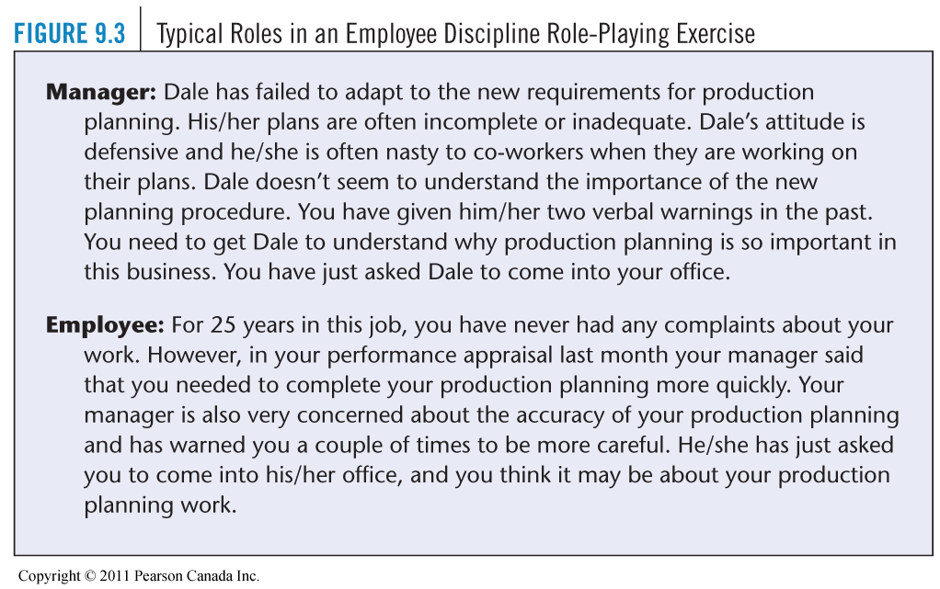
Executive Development
- Canada facing a shortage of leadership talent
- three basic requirements for successful leadership are knowledge, competency, character
- six categories of leadership competencies:
  - self-mastery
  - futuring/vision
  - sense-making/thinking
  - design of intelligent action
  - aligning people to action/leading
  - adaptive learning
Banff Centre Competency Matrix Model
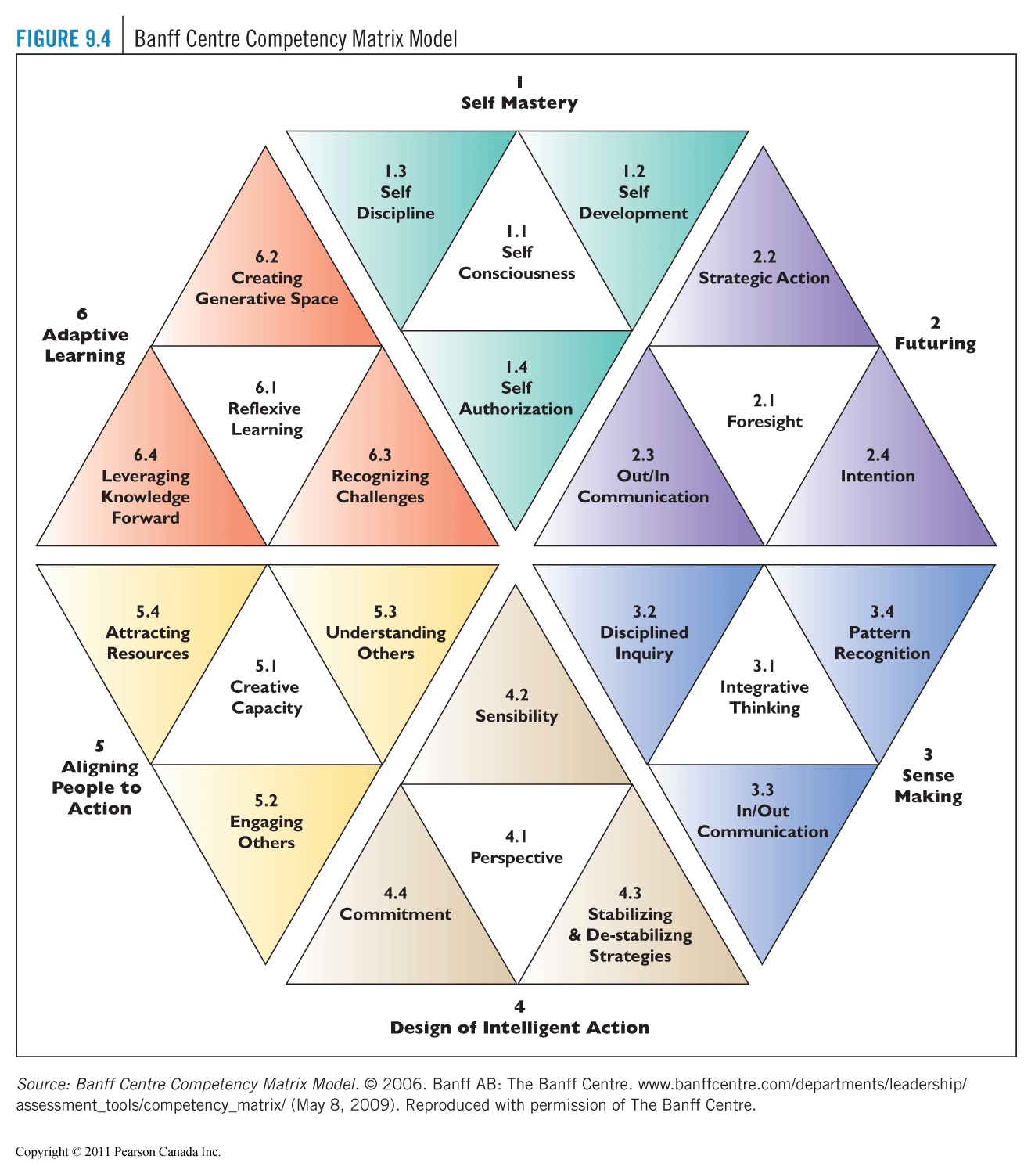

Chapter 10
Performance Management
- process encompassing all activities related to improving employee performance, productivity, and effectiveness
- includes goal setting, pay for performance, training and development, career management, and disciplinary action
Performance Management Process
Performance Management Process contains five steps:
- Defining performance expectations
- job description often insufficient to clarify performance expectations
- measurable standards related to strategic objectives should be developed for each position

- Providing ongoing feedback and coaching
- important to have open two-way communication
- both the employee and the manager need to check in frequently throughout the performance management process to talk about progression toward goals

- Conducting performance appraisal and evaluation discussions
- the appraisal itself is generally conducted with the aid of a predetermined and formal method such as:
  - graphic rating scale
  - alternation ranking method
  - forced distribution method
  - critical incident method
  - narrative forms
  - behaviourally anchored rating scales
  - management by objectives
  - computerized and web based performance appraisal
Graphic Rating Scale
- a scale that lists a number of traits and a range of performance for each
- the employee is then rated by identifying the score that best describes his or her level of performance for each trait
Alternation Ranking Method
- ranking employees from best to worst on a particular trait

Paired Comparison Method
- ranking employees by making a chart of all possible pairs of employees for each trait and indicating the better employee of the pair
Forced Distribution Method
- predetermined percentages of ratees are placed in various performance categories
- for example, it may be decided to distribute employees as follows:
- 15 percent high performers
- 20 percent high-average performers
- 30 percent average performers
- 20 percent low-average performers
- 15 percent low performers
Critical Incident Method
- keeping a record of uncommonly good or undesirable examples of an employee’s work-related behaviour and reviewing the list with the employee at predetermined times
Narrative Forms
- some employers use narrative forms to evaluate employees
- for example, the form in Figure 10.5 presents a suggested format for identifying a performance issue and presenting a performance improvement plan
Behaviourally Anchored Rating Scales
- an appraisal method that aims to combine the benefits of narratives, critical incidents, and quantified ratings by anchoring a quantified scale with specific narrative examples of good and poor performance
Behaviourally Anchored Rating Scales
generate critical incidents
- job experts specify effective and ineffective performance
develop performance dimensions
- cluster the incidents into a smaller set of performance dimensions
reallocate incidents
- different experts group incidents into same clusters and retain incidents similarly assigned twice
Behaviourally Anchored Rating Scales
scale the incidents
- rate the behaviour described in the incident as to how effectively or ineffectively it represents performance
develop the final instrument
- a subset of the incidents is used as behavioural anchors for each dimension
Behaviourally Anchored Rating Scales
Advantages
- more accurate measure
- clearer standards
- assists feedback
- independent dimensions
- consistency
Disadvantage
- time consuming
Management by Objectives (MBO)
- set the organization’s goals
- set departmental goals
- discuss departmental goals
- define expected results (individual goals)
- performance reviews: measure the results
- provide feedback
Computerized and Web-Based Performance Appraisal
- enables managers to keep computerized notes on employees, combine these with ratings on several performance traits, and then generate written text to support each part of the appraisal
- most web-based performance management systems provide advanced reporting capabilities, which allow managers to track the status of performance management initiatives easily
- electronic performance monitoring (EPM) refers to having supervisors electronically monitor the amount of computerized data an employee is processing per day and thereby his or her performance
Performance Appraisal Problems
- validity and reliability
- rating scale problems
  - unclear performance standards
  - halo effect
  - central tendency
  - leniency or strictness
  - appraisal bias
  - recency effect
  - similar-to-me bias

Important Advantages and Disadvantages of Appraisal Tools
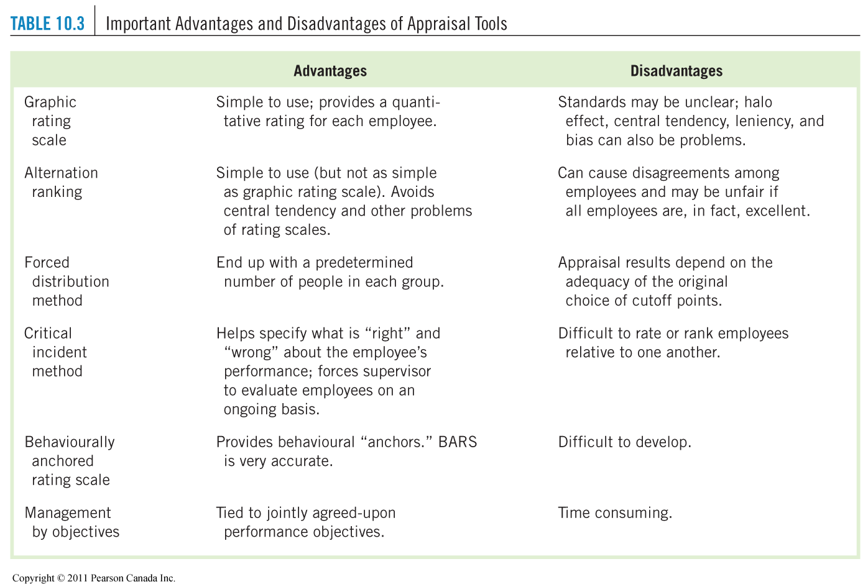

Who Should Do the Appraising?
- supervisors
- peers
- committees
- self
- subordinates
- 360-degree appraisal (all of the above)

How to Conduct the Interview
- be direct and specific
- do not get personal
- encourage the person to talk
- develop an action plan
How to Handle Criticism and Defensive Employees
- recognize that defensive behaviour is normal
- never attack a person’s defenses
- postpone action
- recognize human limitations
Ensuring That the Appraisal Interview Leads to Improved Performance
Legal experts suggest following these seven steps:
- Let the employee know that his or her performance is unacceptable and explain your minimum expectations
- Ensure that your expectations are reasonable
- Let employees know that warnings play a significant role in the process of establishing just cause
- Ensure that you take prompt corrective measures when required
- Avoid sending mixed messages, such as a warning letter together with a “satisfactory” performance review.
- Provide the employee with a reasonable amount of time to improve performance
- Be prepared to provide employees with support to facilitate improvement

- Determining performance rewards/consequences such as promotions, salary, increases and bonuses
Two most important aspects used to determine the appropriate reward/consequence are:
- achievement of goals
- how the employee meets the defined standards

- Conducting development and career opportunities discussions
- manager and employee discuss opportunities for development to strengthen or improve the employee’s knowledge, skills, and abilities
- business needs must be balanced with the employee’s preferences
The Future of Performance Management
Effective performance management involves:
- linking individual goals and business strategy
- showing leadership and accountability at all levels of the organization
- ensuring close ties among appraisal results, rewards, and recognition outcomes
- investing in employee development planning
- having an administratively efficient system with sufficient communication support

Chapter 11 Strategic Pay Plans
Strategic Importance of
Total Rewards
- an integrated package of all rewards (monetary and non-monetary, extrinsic and intrinsic) gained by employees arising from their employment
- aligned with business strategy
Five Components of Total Rewards
- compensation
- benefits
- work-life programs
- performance and recognition
- development and career opportunities
The Total Rewards Model
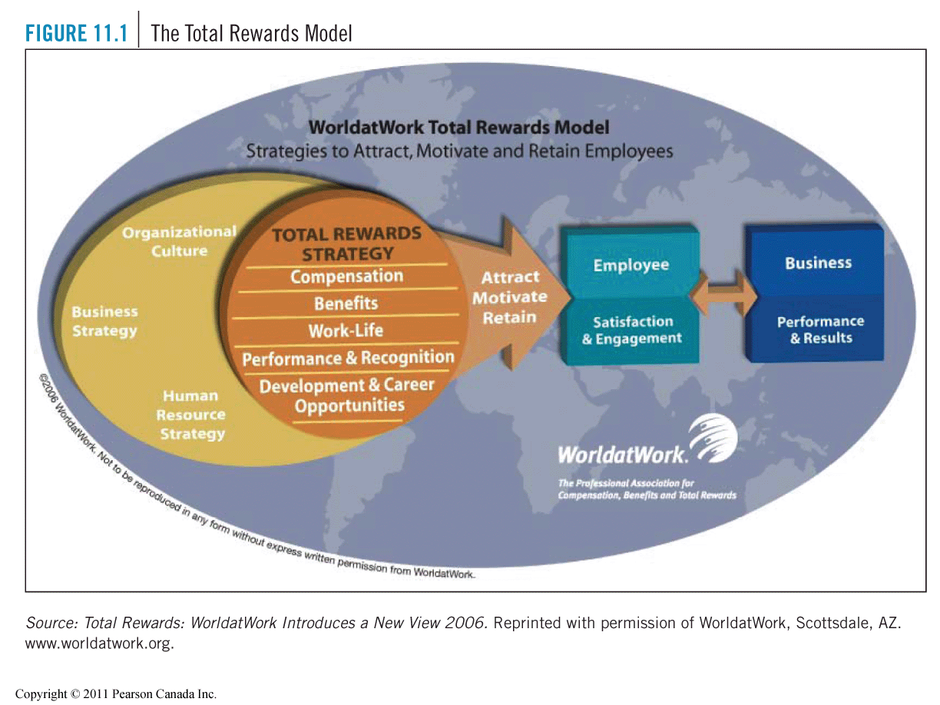

Basic Considerations in Determining Pay Rates
- Legal Considerations in Compensation
  - Employment/Labour Standards Act (Canada Labour Code)
  - Pay Equity Acts
  - Human Rights Acts
  - Canada/Quebec Pension Plan
  - Workers’ Compensation Laws
  - Employment Insurance Act
- Union Influences on Compensation Decisions
- Compensation Policies
- Equity and Its Impact on Pay Rates
Establishing Pay Rates
- Stage 1: Job Evaluation
- Stage 2: Conduct a Wage/Salary Survey
- Stage 3: Combine Job Evaluation and Salary Survey Information to Determine Pay for Jobs
Stage 1: Job Evaluation
Job Evaluation
- systematic comparison to determine relative worth of jobs within a firm
Benchmark Job
- job that is critical to the firm’s operations or commonly found in other organizations
Compensable Factor
- fundamental, compensable element of a job, such as skill, effort, responsibility, and working conditions
Job Evaluation Methods
1)Classification/Grading Method 2)Point Method
Classification/Grading Method
- classification/grading method categorizes jobs into groups (classes or grades)
- classes contain similar jobs
- grades contain dissimilar jobs of equal difficulty
- grade/group description is a written description of the level of compensable factors required by jobs in each grade
Point Method Overview
- identify compensable factors
- determine the degree to which each factor is present in each job
Point Method Steps
- preliminary steps
- determine factor weights and degrees
- assign points for each degree of each sub-factor
- evaluate the jobs
Stage 2: Conduct a Wage/Salary Survey
Wage/Salary Survey
- a survey aimed at determining prevailing wage rates
- a good salary survey provides specific wage rates for comparable jobs
- formal written questionnaire surveys are the most comprehensive
Stage 3: Combine the Job Evaluation and Salary Survey Information to Determine Pay for Jobs
Wage Curve
- a graphic description of the relatiopnship between the value of the job and the average wage paid for this job
Pay Ranges
- a series of steps or levels within a pay grade, usually based on years of service
Stage 3: Combine the Job Evaluation and Salary Survey Information to Determine Pay for Jobs
Broadbanding
- reducing the number of salary grades and ranges into just a few wide levels or “bands”, each of which then contains a relatively wide range of jobs and salary levels
Red Circle Pay Rate
- a rate of pay that is above the pay range maximum
Pay for Knowledge
Pay for knowledge program should include:
- competencies and skills - directly important to job performance - that can be defined in measurable and objective terms
- new and different competencies that replace obsolete competencies or competencies that are no longer important to job performance
- On-the-job training, not “in the classroom.”

Competency-Based Pay
Competencies
- individual knowledge, skills and behaviours that are critical to successful individual or corporate performance
- pay for range, depth and types of knowledge that employees are capable of using, rather than current job duties
Pay for Managerial and Professional Jobs
- Salary (market pricing) *reduced emphasis

- Benefits
- Short-term incentives *increased
- Long-term incentives emphasis
- Perquisites
Pay Equity
- providing equal pay to male dominated job classes and female dominated job classes of equal value to the employer
- Wage gap: average pay for males is 30% higher than average pay for females
- pay equity intended to eliminate systemic pay discrimination by providing equal pay to male-dominated job classes and female-dominated job classes of equal value to the employer
- must ensure no gender bias in job evaluation
Pay Equity Results
- pay equity has narrowed the wage gap, but not eliminated it
- no explanation other than systemic discrimination for much of 30% remaining gap
- long-term solution is women and men equally represented in all jobs, i.e. no male or female- dominated jobs (occupational segregation)

Chapter 12 Pay-for-Performance and Financial Incentives
Money and Motivation
Variable Pay
- any plan that ties pay to productivity or profitability
Types of Incentive Plans
- incentives for operations employees
- incentives for senior managers and executives
- incentives for salespeople
- incentives for other managers and professional employees
- organization wide incentives
Incentives for Operations Employees – Piecework Plans
Piecework
- a system of pay based on the number of items processed by each individual worker in a unit of time, such as items per hour or items per day
Straight Piecework Plan
- a set payment for each piece produced or processed in a factory or shop
Guaranteed Piecework Plan
- the minimum hourly wage plus an incentive for each piece produced above a set number of pieces per hour
Incentives for Operations Employees – Standard Hour Plan
- a plan by which a worker is paid a basic hourly rate plus an extra percentage of his or her base rate for production exceeding the standard per hour or per day
- similar to piecework payment but is based on a percentage premium
Incentives for Operations Employees – Team or Group Incentives
- a plan in which a production standard is set for a specific work group and its members are paid incentives if the group exceeds the production standard
Incentives for Senior Managers and Executives
- short term incentives – annual bonus
- long term incentives – stock options, share units, relating strategy to executive compensation

Long-Term Incentive Plans, 2008
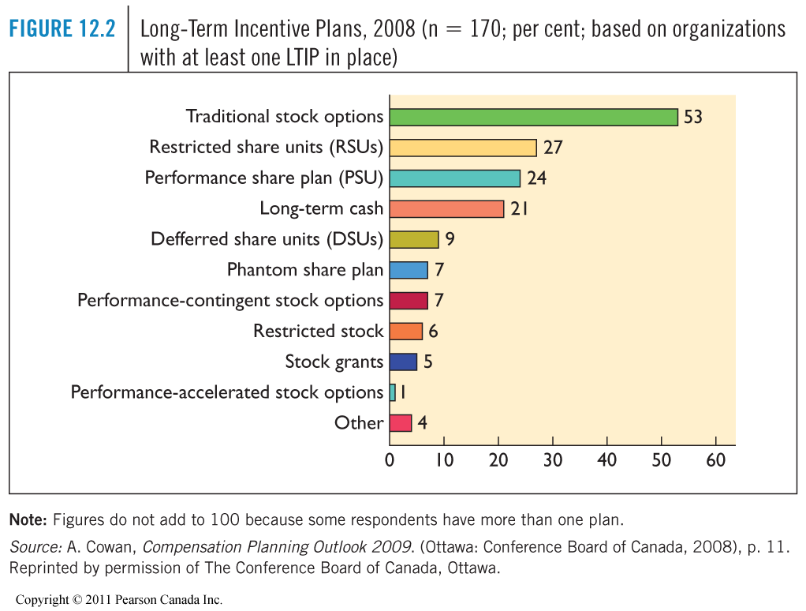
Incentives for Salespeople
- salary plan
- commission plan
- combination plan
- sales compensation in e-commerce era
Incentives for
Other Managers and Professionals
Merit Pay (merit raise)
- any salary increase awarded to an employee based on his or her individual performance
Organization Wide Incentive Plans
Profit Sharing Plans
- a plan whereby most or all employees share in the company’s profits
Employee Share Purchase/Stock Ownership Plan
- a trust is established to hold shares of company stock purchased for or issued to employees
- the trust distributes the stock to employees on retirement, separation from service, or as otherwise prescribed by the plan
Scanlon Plan
- an incentive plan developed in 1937 by Joseph Scanlon and designed to encourage cooperation, involvement, and sharing of benefits

Gainsharing Plan
- an incentive plan that engages employees in a common effort to achieve productivity objectives and share the gains
Developing Effective Incentive Plans
Before deciding to implement an incentive plan, it is
important to remember several points:
When to use incentives:
- performance pay cannot replace good management
- firms get what they pay for
- pay is not a motivator
- rewards rupture relationships
- rewards may undermine responsiveness
How to implement incentive plans:
- pay for performance
- link incentives to other activities that engage employees in the business
- link incentives to measurable competencies that are valued by the organization
- match incentives to the culture of the organization
- keep group incentives clear and simple
- over communicate
- remember that the greatest incentive is the work itself

Employee Recognition Programs:Common Recognition Awards
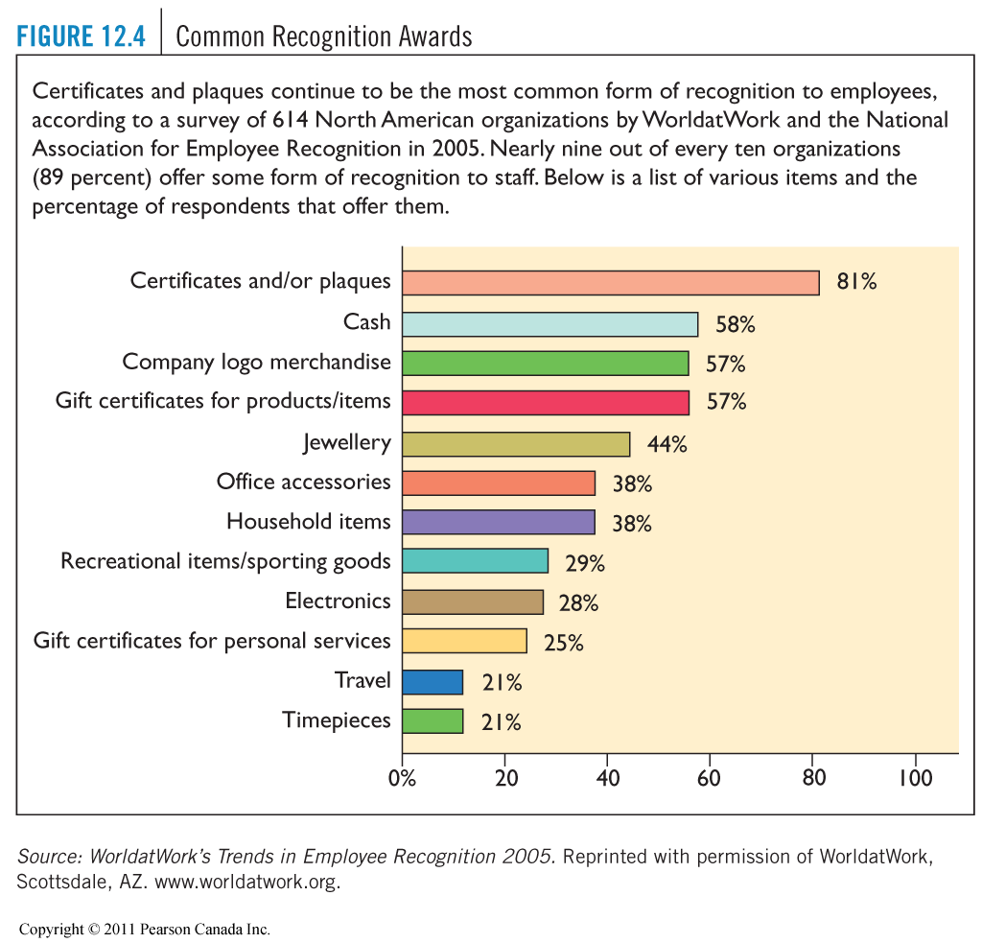
Chapter 13 Employee Benefits and Services
Strategic Role of Employee Benefits
Employee Benefits
- indirect financial payments given to employees
- may include supplementary health and life insurance, vacation, pension, education plans, and discounts on company products
Government-Sponsored Benefits
- Employment Insurance (EI)
- Canada/Quebec Pension Plan (C/QPP)
- Workers’ Compensation
- Vacations and Holidays
- Leaves of Absence
- Pay on Termination of Employment
Employment Insurance (EI)
- a federal program that provides income benefits if a person is unable to work through no fault of his or her own
Canada/Quebec Pension Plan (C/QPP)
- programs that provide three types of benefits:
- retirement income
- survivor or death benefits payable to the employee’s dependants regardless of age at time of death
- disability benefits payable to employees with disabilities and their dependants

- benefits are payable only to those individuals who make contributions to the plans and/or available to their family members
Workers’ Compensation
- provides income and medical benefits to victims of work related accidents or illnesses and/or their dependants, regardless of fault
Vacations and Holidays
- labour/employment standards legislation sets out a minimum amount of paid vacation that must be provided to employees, usually two weeks per year, but the requirements vary by jurisdiction
- paid time for vacation and statutory holidays

Leaves of Absence (unpaid)
- specified in employment standards legislation
- maternity/parental leave
- parental/adoption leave
- bereavement leave
- compassionate care leave
Pay on Termination of Employment
- specified in employment standards legislation
- pay in lieu of notice
- severance pay
- pay for mass layoffs
Voluntary Employer-Sponsored Benefits
- life insurance
- supplementary health care/medical insurance
- short-term disability and sick leave
- long term disability
- additional leaves of absence
- additional paid vacations and holidays
- retirement benefits
Employee Services
- personal services
- job related services
- executive perquisites (perks)
Employee Services: Personal Services
- credit unions
- counselling services
- employee assistance programs (EAPs)
- other (social and recreational)
Employee Services:Job-Related Services
- subsidized childcare
- eldercare
- subsidized employee transportation
- food services
- educational subsidies
- family-friendly benefits

Employee Services:Executive Perquisites (Perks)
- management loans
- salary guarantees (golden parachutes)
- financial counselling
- relocation benefits
- outplacement assistance
- company cars, chauffeured limousines
- concierge service
Flexible Benefit Programs
individualized benefit plans to accommodate employee needs and preferences
Flexible Benefit Programs
Advantages
- employees choose packages that best satisfy their unique needs
- help firms meet the changing needs of a changing workforce
- increased involvement of employees and families improves understanding of benefits
- flexible plans make introduction of new benefits less costly
- cost containment—the organization sets the dollar maximum
Disadvantages
- employees make bad choices and find themselves not covered for predictable emergencies
- administrative burdens and expenses increase
- adverse selection—employees pick only benefits they will use, increasing cost
Benefits Administration
Use of Software
Outsourcing
Benefits of Communication

Chapter 14 Occupational Health and Safety
Strategic Importance of Occupational Health and Safety
- investment in disability management and proactive wellness programs create measurable bottom-line returns
- according to the Association of Workers’ Compensation Boards of Canada, in 2007 there were 1055 deaths and 317 524 injuries resulting from accidents at work
- on April 28 each year, a day of mourning is observed for Canadian workers killed or injured on the job
- workplace accidents can be prevented
Basic Facts About OHS Legislation
- OHS Legislation:
  - laws intended to protect the health and safety of workers by minimizing work-related accidents and illnesses
- Purpose:
  - These laws fall into three categories:
    - general health and safety rules
    - rules for specific industries (e.g. mining)
    - rules related to specific hazards (e.g. asbestos)
Basic Facts About OHS Legislation:
Responsibilities and Rights of Employers and Employees
  - Due Diligence - employers are responsible for taking every reasonable precaution to ensure the health and safety of their workers
  - specific duties of the employer include:
    - filing government accident reports
    - maintaining records
    - ensuring that safety rules are enforced
    - posting safety notices and legislative information
Basic Facts About OHS Legislation:
Responsibilities and Rights of Employers and Employees
  - employees are responsible for taking reasonable care to protect their own health and safety and, in most cases, that of their co-workers
  - specific requirements include wearing protective clothing and equipment and reporting any contravention of the law or regulations
  - employees have three basic rights:
    - the right to know about workplace safety hazards
    - the right to participate in the OHS process
    - the right to refuse unsafe work

Basic Facts About OHS Legislation:
Joint Health and Safety Committees (JHSC)
- the JHSC provides a nonadversarial atmosphere where management and labour can work together to ensure a safe and healthy workplace
- committees are usually required to consist of between 2 and 12 members, at least half of whom must represent workers
- in small workplaces, one health and safety representative may be required
Basic Facts About OHS Legislation:
Joint Health and Safety Committees (JHSC)
JHSC is responsible for:
- inspecting the workplace in order to identify potential health and safety hazards
- evaluating the hazards
- implementing solutions
- investigating employee complaints
- investigating accidents
- promoting measures to protect health and safety
- disseminating information about health and safety laws and regulations
Basic Facts About OHS Legislation:
Enforcement of OHS Laws
- in all Canadian jurisdictions, occupational health and safety law provides for government inspectors to periodically carry out safety inspections of workplace
- penalties consist of fines and/or jail terms
- the Criminal Code includes a criminal offence commonly known as “corporate killing,” which imposes criminal liability on “all persons” who direct the work of other employees and fail to ensure an appropriate level of safety in the workplace
Basic Facts About OHS Legislation:
Control of Toxic Substances
Workplace Hazardous Materials Information System
(WHMIS) legislation has three components:
- labelling of hazardous material containers
- material safety data sheets (MSDS)
- employee training
Basic Facts About OHS Legislation:
OHS and Other Legislation
  - health and safety, human rights, labour relations, and employment standards laws are in force in every jurisdiction in Canada in an interlaced web of legislation
  - situations arise in which it is difficult to know which law is applicable, or which one takes precedence over another
  - for example:
    - are the human rights of one employee to wear a ceremonial knife related to a religion more important than the safety of other employees?
    - is sexual harassment a safety hazard?
Basic Facts About OHS Legislation:
Supervisor’s Role in Safety
- most jurisdictions impose a personal duty on supervisors to ensure that workers comply with occupational health and safety regulations
- specific obligation on supervisors to advise and instruct workers about safety, to ensure that all reasonable precautions have been taken to provide for the safety of all employees, and to minimize risk of injuries or illness
- safety-minded managers must aim to instill in their workers the desire to work safely
What Causes Accidents?
Three Basic Causes of Accidents
Chance Occurrences (beyond control)
- contribute to accidents but are more or less beyond management’s control
- e.g. walking past a plate-glass window just as someone hits a ball through it
Unsafe Conditions
- improperly guarded equipment
- defective equipment
- hazardous procedures
- unsafe storage
- improper illumination
- improper ventilation
Unsafe Acts (by employees)
- throwing materials
- operating or working at unsafe speeds
- rendering safety devices inoperative
- using unsafe equipment or using equipment unsafely
- taking unsafe positions under suspended loads
- lifting improperly
- distracting, teasing, abusing, startling, horseplay, quarrelling

How to Prevent Accidents
- reduce unsafe conditions
- reduce unsafe acts
  - selection testing
  - top-management commitment
  - training and education
  - positive reinforcement
Three Other Work-Related Accident Factors
- Job (some inherently dangerous)
- Work Schedule ( fatique)
- Psychological Climate (Stress)
Controlling Workers’ Compensation Costs
- Before the accident
  - accident prevention measures
- After the accident
  - provide first aid and ensure medical attention
  - commitment to keeping in touch with the worker and ensuring his or her return to work
  - collaboration among the parties involved, including medical, family, and workers’ compensation
  - creativity in focusing on how to use the worker’s remaining abilities on the job
Employee Wellness Programs
- proactive approach to employee health and well being
- management strategy to achieve measurable outcomes related to productivity, cost reduction, recruitment/retention, and profit
- wellness initiatives often include:
  - stress management
  - nutrition and weight management
  - smoking cessation programs
  - tai chi
  - heart health
  - physical fitness programs
  - ergonomics
Occupational Health Issues and Challenges
- substance abuse
- job stress
- repetitive strain injuries
- workplace toxins
- workplace smoking
- influenza pandemic
- violence at work

Benefits for Employers from Action on the Determinants of Health
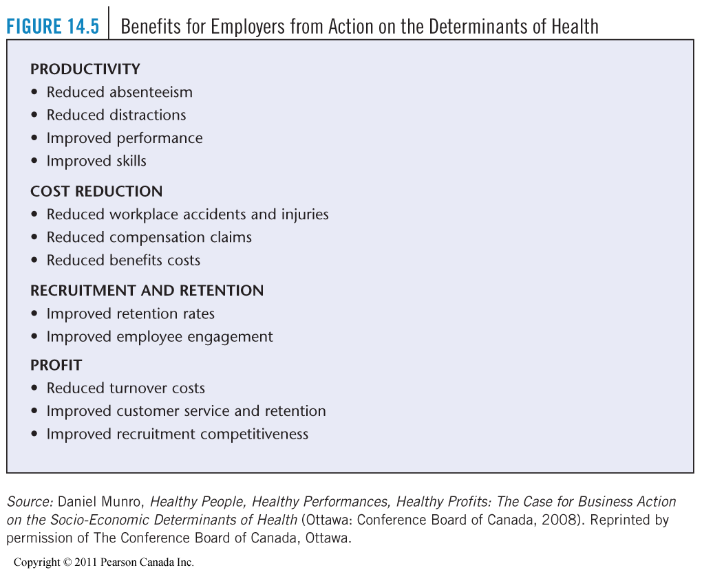
Substance Abuse and the Law
- alcohol/drug abuse considered a disability (human rights law) vs. employers’ due diligence requirement (OHS law)
- substance abuse testing only legal if:
  - test is rationally connected to performance of the job
  - test is adopted in honest and good-faith belief that it is necessary for fulfillment of work-related purpose
  - test is reasonably necessary to the accomplishment of the work-related purpose
Substance Abuse Testing
- random substance abuse testing is illegal
- employers can:
  - forbid drugs/alcohol in workplace
  - require random drug testing only for “safety-sensitive” jobs
  - require mandatory drug testing “for cause” or “post-incident” in certain circumstances
- positive test results must result in accommodation of the employee’s disability
- immediate termination is not generally justifiable
Traditional Techniques for Dealing with Substance Abuse
- Discipline
- Discharge
- In house counselling
- Referral to outside agency
Job Stress
Human Consequences of Job Stress include:
  - anxiety
  - depression
  - anger
  - various physical consequences (e.g. cardiovascular disease, headaches, and accidents)
- mental health issues are the leading cause of both short and long-term disability claims
Job Stress: Sources
Environmental Factors
- high demand job
- high levels of mental and physical effort
Personal Factors
- Type A personalities
- patience
- tolerance for ambiguity
- self-esteem
- health and exercise
- work and sleep patterns
- non-job-related problems like divorce, depression, work/family time conflict
Reducing Job Stress
Employee Can:
  - get more sleep, eat better, take vacation, meditate, find a more suitable job, get counselling, organize each day’s activities
Employer/Supervisor Can:
  - offer a EAP
  - monitor each employee’s performance to identify symptoms of stress and then inform the person of organizational remedies
  - ensure fair treatment
  - permit employee to have more control over his or her job
- HR executives must become advocates for employee mental health
- within the senior management team
Burnout
- the total depletion of physical and mental resources caused by excessive striving to reach an unrealistic work-related goal
Avoiding Burnout:
  - break patterns
  - get away from it all periodically
  - reassess goals
  - think about work
  - reduce stress
Workers’ Compensation and Stress-Related Disability Claims
- all Canadian jurisdictions provide benefits for post-traumatic stress caused by a specific and sudden workplace incident
- however, when it comes to chronic stress, there is very limited or no coverage, depending on the jurisdiction
- the rationale is that stress has multiple causes, including family situations and personal disposition
Repetitive Strain Injuries
- activity-related soft-tissue injuries of the neck, shoulders, arms, wrists, hands, back and legs
- employers must advise and train workers about the risk of RSIs from workplace activity, identify and assess job-related RSI risk factors, encourage workers to report RSI symptoms early, and use ergonomic interventions
- ergonomics refers to the art of fitting the workstation and work tools to the individual
Workplace Toxins
- leading cause of work-related deaths around the world is cancer
- in addition to known carcinogens, such as asbestos and benzene, new chemicals and substances are constantly being introduced into the workplace without adequate testing
- workers’ compensation laws in several provinces have been amended to provide benefits to firefighters who develop specific job related cancers
Workplace Smoking

- most Canadian jurisdictions have banned smoking in workplaces
- Health Canada is urging employers to implement smoking cessation programs for employees to achieve:
  - better health for employees
  - better business results
  - legislative compliance
  - increased employee satisfaction (especially for the 80 percent of Canadians who do not smoke)
  - avoidance of litigation
Influenza Pandemic
- the first organizational impact of a pandemic will be absenteeism, estimated at 35 percent in the influenza plan for the Government of Canada
- HR will be a key player in responding to a pandemic as most employers are planning to continue their business operations using the existing workforce—in other words, with substantially fewer employees
- business leaders are well advised to prepare their organizations
Violence at Work
- most Canadian jurisdictions now have workplace violence legislation in place covering physical violence, and some include psychological/emotional violence
- human rights laws across the country prohibit various forms of harassment and bullying
- employers may be found liable for violent acts of their employees on the basis that the employer negligently hired or negligently retained someone whom the employer should reasonably have known could cause the violent act
- employers may also be found liable when they are aware of violent incidents and fail to respond
Prevention and Control of Workplace Violence
- identify jobs with high risk of violence
- institute workplace violence policy
- create a healthy work environment
- heighten security measures
- provide workplace violence training
- improve employee screening

Chapter 15 Fair Treatment: The Foundation of Effective Employee Relations
Strategic Importance of Effective Employee Relations
- for competitive advantage, employees must be motivated and engaged in pursuing organizational goals
- ensure employees are treated ethically, fairly, and legally
Strategic Importance of Effective Employee Relations
- Distributive Justice
  - fairness of a decision outcome
- Procedural Justice
  - fairness of the process used to make a decision
- Interactional Justice
  - fairness in interpersonal interactions by treating others with dignity and respect
Employee Engagement
- a positive, fulfilling, work-related state of mind characterized by vigour, dedication, and absorption
Top Drivers of Attraction, Retention, and Engagement in Canada
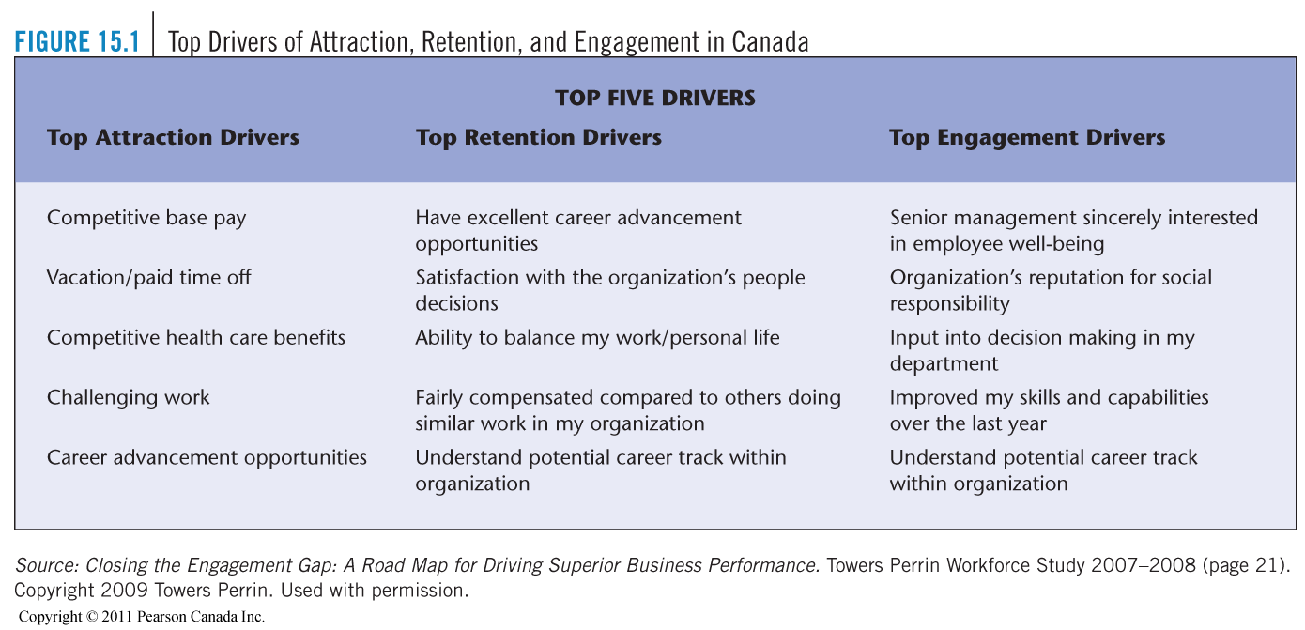

Outcomes of Engagement
- employees’ highest productivity
- best ideas
- genuine commitment to the success of the organization
- improvements in service quality, customer satisfaction, and long-term financial results
- serves the individual, fulfilling a basic human need to be connected to worthwhile endeavours and make a significant contribution
- engagement is good for the company and good for the employee
Effective Employee Communication
- suggestion programs
- employee opinion surveys
- communication from management
Respecting Employee Privacy
- employees are concerned with privacy—their control over information about themselves and their freedom from unjustifiable interference in their personal life
- Personal Information Protection and Electronic Documents Act (PIPEDA) governs the collection, use, and disclosure of personal information across Canada, including employers’ collection and dissemination of personal information about employees
- employers must obtain consent from employees whenever personal information is collected, used, or disclosed
- some employers have resorted to electronic monitoring (video surveillance
Video Surveillance
- some employers install video surveillance of employees to prevent theft and vandalism and to monitor productivity
- employees must be made aware of the surveillance
Preserving Dignity in the Retirement Process
- by 2025, more than 20 percent of the Canadian population will be over age 65, and the labour force will shrink dramatically
- for many years, the trend has been toward earlier retirement—the average retirement age dropped from 65 in 1979 to 61 in 2005
- at any age, retirement for most employees is bittersweet
- pre-retirement counselling refers to counselling provided to employees some months (or even years) before retirement, which covers such matters as benefits advice, second careers, and so on
- there are major changes expected in the management of the retirement process

Managing Retirement As Baby Boomers retire, it is expected that:
- longstanding trend to early retirement will change
- late retirement will be promoted to help ease labour shortage
- joint retirement issues for dual-career couples will increase
- flexibility in retirement arrangements will increase dramatically
Fair Treatment in Layoffs and Downsizing
- layoff refers to the temporary withdrawal of employment to workers for economic or business reasons
- there are several alternatives to layoffs
- downsizing refers to the process of reducing, usually dramatically, the number of people employed by the firm
- group termination laws refer to laws that require an employer to notify employees in the event that an employer decides to terminate a group of employees
Fairness in Discipline and Dismissals
- Discipline
  - a procedure intended to correct an employee’s behaviour because a rule or procedure has been violated
- Dismissal
  - involuntary termination of an employee’s employment
- Insubordination
  - wilful disregard or disobedience of the boss’s authority or legitimate orders
Fairness in Discipline and Dismissals
Wrongful Dismissal
- an employee dismissal that does not comply with the law or does not comply with a written or implied contractual arrangement
Avoiding Wrongful Dismissal Suits
- Use employment contracts with a termination clause and with wording clearly permitting the company to dismiss without cause during probationary period
- Document all disciplinary action
- Do not allege just cause for dismissal unless it can be proven
- Time the termination so that it does not conflict with special occasions, such as birthdays or holidays
- Use termination letters in all cases, clearly stating the settlement offer
    - 6. Schedule the termination interview in a private location at a time of day that will allow the employee to clear out belongings with a minimal amount of contact with other employees
- Include two members of management in the termination meeting
Constructive Dismissal
- the employer makes unilateral changes in the employment contract that are unacceptable to the employee, even though the employee has not been formally terminated
Termination Interview
- the interview in which an employee is informed of the fact that he or she has been dismissed
Guidelines for the termination interview:
  - Step 1: Plan the Interview
  - Step 2: Get to the Point
  - Step 3: Describe the Situation
  - Step 4: Listen
  - Step 5: Review All Elements of the Severance Package
  - Step 6: Identify the Next Step
Outplacement Counselling
- a systematic process by which a terminated person is trained and counselled in the techniques of self-appraisal and securing a new position

Chapter 16 Labour Relations
Introduction to Labour Relations
Labour Union (union)
- an officially recognized association of employees practising a similar trade or employed in the same company or industry who have joined together to present a united front and collective voice in dealing with management
Labour–Management Relations
- the ongoing interactions between labour unions and management in organizations
Introduction to Labour Relations
Collective Agreement (union contract)
- a formal agreement between an employer and the union representing a group of its employees regarding terms and conditions of employment
Collective Bargaining
- negotiations between a union and an employer to arrive at a mutually acceptable collective agreement
Bargaining Unit
- the group of employees in a firm, a plant, or an industry that has been recognized by an employer or certified by a Labour Relations Board (LRB) as appropriate for collective bargaining purposes
Canada’s Labour Laws: Two General Purposes
- To provide a common set of rules for fair negotiations
- To protect public interest by preventing impact of labour disputes from inconveniencing the public
Labour Legislation – Commonalities
- certification procedures
- minimum one year collective agreements
- procedures preceding legal strike/lockout
- no strikes/lockouts during life of contract
- interpretation disputes settled by final and binding arbitration
- prohibition of unfair labour practices
- labour relations boards to enforce legislation

Labour Movement in Canada Today
Types of Unions
Type of Worker Eligible for membership
- craft
- industrial
Geographic Scope
- international
- national
- Local
Labour Congress Affiliation
- CLC
- CSN
- AFL-CIO
Managments Labour Relations Strategy
- Union acceptance strategy
- Union avoidance strategy
  - Union substitution
  - Union suppression
Canada’s Labour Laws: Jurisdiction
Provincial/Territorial
90% of labour-management relations
Federal
10% of labour-management relations
Current Challenges Facing the Canadian Labour Movement
- global competition
- demographics
- unionization of white-collar employees
Labour Relations Process
- Employees decide to seek collective representation
- The union organizing campaign begins
- The union receives official recognition
- Union and management negotiate collective agreement
- Day-to-day contract administration begins

Step 1: Desire for Collective Representation
- job dissatisfaction
- lack of job security
- unfair administration of policies
- perceived inequities in pay
- lack of opportunity for advancement
- lack of influence on work-related decisions
- belief that unions can improve pay and working conditions
Step 2: Union Organizing Campaign
- Step 1. Employee-union contact
- Step 2. Initial organizational meeting
- Step 3. Formation of in-house committee
- Step 4. Organizing campaign
- Step 5. Outcome
Union Organizing: Employer Rights
- express views on unions
- state position on remaining non-union
- prohibit union activity on company property/time
- increase wages in normal course of business
- gather employees to state company’s position if:
  - purpose stated in advance
  - attendance optional
  - no threats/promises
Step 3: Union Recognition
Voluntary Recognition
- by employer
Regular
Certification
- labour union obtains a certificate from the relevant LRB declaring that the union is the exclusive bargaining agent for a defined group of employees
Pre-hearing
Votes
- an alternative mechanism for certification, used in situations in which there is evidence of violations of fair labour practices early in the organizing campaign
Termination of Bargaining Rights
Decertification
- the process whereby a union is legally deprived of its official recognition as the exclusive bargaining agent for a group of employees
Step 4: Collective Bargaining
- process by which a formal collective agreement is established between labour and management
- union and management must bargain in good faith
Three steps:
- preparation for bargaining
- face-to-face negotiations
- obtaining approval for proposed contract
Preparation for Negotiations
Both union and management will:
- gather data on general economic trends
- analyze other collective agreements
- conduct an analysis of grievances
- review existing contract or union’s promises
- conduct wage and salary surveys at competitor organizations
- prepare cost estimates of monetary proposals
- make plans for possible strike or lockout
- management negotiators will obtain input from supervisors
- union negotiators will obtain input from union stewards, obtain the company’s financial information, gather demographic information on membership, and obtain input from members
Face-to-Face Negotiations
Location, Frequency and Duration of Meetings
- negotiations are held at a neutral, off-site location, such as a hotel meeting room, so that there is no psychological advantage for either team and so that interruptions and work distractions can be kept to a minimum
- each side generally has another room in which intra-team meetings, known as caucus sessions, are held
- meetings are held as often as either or both parties consider desirable, and they last as long as progress is being made

Bargaining Zone
- the area defined by the bargaining limits (resistance points) of each side, in which compromise is possible, as is the attainment of a settlement satisfactory to both parties
Distributive Bargaining
- a win–lose negotiating strategy, such that one party gains at the expense of the other
Integrative Bargaining
- a negotiating strategy in which the possibility of win–win, lose–win, win–lose, and lose–lose outcomes is recognized
- acknowledgement that achieving a win–win outcome will depend on mutual trust and problem solving
Mutual Gains (interest-based) Bargaining
- a win–win approach based on training in the fundamentals of effective problem solving and conflict resolution
- interests of all stakeholders are taken into account
Contract Approval Process
Memorandum of Settlement
- a summary of the terms and conditions agreed to by the parties that is submitted to the constituent groups for final approval
Ratification
- formal approval by secret-ballot vote of the bargaining unit members of the agreement negotiated between union and management
Third Party Assistance and Bargaining Impasses
Conciliation
- the use of a neutral third party to help an organization and the union representing a group of its employees to come to a mutually satisfactory collective agreement
Mediation
- the use (usually voluntary) of a neutral third party to help an organization and the union representing its employees to reach a mutually satisfactory collective agreement
Strike
- the temporary refusal by bargaining unit members to continue working for the employer

Strike Vote
- legally required in some jurisdictions, it is a vote seeking authorization from bargaining unit members to strike if necessary
- a favourable vote does not mean that a strike is inevitable
Picket
- stationing groups of striking employees, usually carrying signs, at the entrances and exits of the struck operation to publicize the issues in dispute and discourage people from entering or leaving the premises
Boycott
- an organized refusal of bargaining unit members and supporters to buy the products or use the services of the organization whose employees are on strike in an effort to exert economic pressure on the employer
Lockout
- temporary refusal of a company to continue providing work for bargaining unit employees involved in a labour dispute, which may result in closure of the establishment for a time
Wildcat Strike
- a spontaneous walkout, not officially sanctioned by union leadership, which may be legal or illegal, depending on its timing
Arbitration
- the use of an outside third party to investigate a dispute between an employer and union and impose a settlement
Interest Arbitration
- the imposition of the final terms of a collective agreement
Interest Dispute
- a dispute between organization and union representing employees over terms of a collective agreement
Collective Agreement:Typical Provisions
- union recognition
- union security/checkoff
- no strikes or lockout
- management rights
- arbitration

Step 5: Contract Administration
- seniority and discipline issues tend to be the major sources of disagreement between union and management
Seniority
- length of service in the bargaining unit
Discipline
- most collective agreements restrict an employer’s right to discipline employees by requiring proof of just cause for the disciplinary action imposed
- disciplinary issues must be handled in accordance with the terms of the collective agreement and backed by carefully documented evidence
Grievance Resolution and Rights Arbitration
Grievance
- a written allegation of a contract violation, filed by an individual bargaining unit member, the union, or management
Impact of Unionization on HRM
- building effective labour-management relations
- instituting an open-door policy
- extending the courtesy of prior consultation
- demonstrating genuine concern for employee well-being
- forming joint committees, holding joint training programs
- meeting regularly
- using third party assistance

Chapter 17 Managing Human Resources in a Global Business
Globalization of Business and Strategic HR
- globalization of business is now the norm
Expatriate
- employees who are citizens of the country where the parent company is based, who are sent to work in another country
Global Relocation
Some of the most pressing challenges are techniques used to recruit, select, train, compensate, and provide family support for employees who are based abroad, such as the following:
- candidate identification, assessment, and selection
- cost projections
- assignment letters
- compensation, benefits, and tax programs
- relocation assistance
- family support
Why Expatriate Assignments Fail
Expatriate Assignment Failure
- early return of an expatriate from a global assignment
- given the fact that family issues are the number one cause of expatriate assignment failure, it is important that the employer understand just how unhappy and cut off the expatriate manager’s spouse can feel in a foreign environment
- the employer can provide realistic previews of what to expect, careful screening, improved orientation, and improved benefits packages, as well as other solutions
How Intercountry Differences Affect HRM
- cultural factors
- economic systems
- legal systems
- labour cost factors
- industrial relations factors

Selection for Global Assignments
- global staffing policy
  - an ethnocentric staffing policy is based on the attitude that home-country managers are superior to those in the host country, and all key management positions are filled by parent-country nationals
  - a polycentric staffing policy is based on the belief that only host-country managers can understand the culture and behaviour of the host-country market, and therefore foreign subsidiaries would be staffed with host-country nationals and its home-office headquarters with parent-country nationals
  - a geocentric staffing policy assumes that management candidates must be searched for globally, on the assumption that the best manager for any specific position anywhere on the globe may be found in any of the countries in which the firm operates
- selecting global managers
  - selecting managers for expatriate assignments means screening them for traits that predict success in adapting to what may be dramatically new environments
- adaptability screening
  - realistic job preview, pre-assignment visit, paper-and-pencil tests
- success of Canadian expatriates
  - Canadian companies have reported low failure rates for expatriates relative to other countries, particularly the U.S, which has a failure rate of 40 to 50 percent
  - the country’s diverse ethnic makeup has produced a generation of business leaders who mix easily with different cultures
Maintaining Global Employees
orienting and training employees for global assignments
  - cross-cultural training
  - leadership development opportunities
international compensation
  - balance sheet approach
  - variable pay
  - international EAPs

Maintaining Global Employees
- performance appraisal of global managers
  - stipulate the assignment’s difficulty level
  - weight the evaluation more toward the on-site manager’s appraisal than toward the home-site manager’s distant perceptions of the employee’s performance
  - if the home-site manager does the actual written appraisal, he or she should use a former expatriate from the same overseas location to provide background advice during the appraisal process
  - modify the normal performance criteria used for that particular position to fit the overseas position and characteristics of that particular locale
  - attempt to give the expatriate manager credit for relevant insights into the functioning of the operation and specifically the interdependencies of domestic and foreign operations
- international labour relations
  - firms opening subsidiaries abroad will find substantial differences in labour relations practices among the world’s countries and regions
- personal safety abroad
  - provide expatriates with general training about travelling and living abroad and specific information about the place that they are going to
  - have travellers arrive at airports as close to departure time as possible and wait in areas away from the main flow of traffic where they are not as easily observed
  - equip the expatriates’ car and home with adequate security systems
  - tell employees to vary departure and arrival times and take different routes to and from work
  - keep employees current on crime and other problems by regularly checking travel advisory service and consular information sheets
  - advise employees to remain confident at all times; body language can attract perpetrators, and those who look like victims often become victimized
Repatriation
- process of moving the expatriate and his or her family back home from the foreign assignment
- repatriation can be more difficult than going abroad

How To Implement a Global HR System
Global HR System
- a standardized HR system in all company locations around the world
- making the global HR system more acceptable:
  - global systems are more accepted in truly global organizations
  - investigate pressures to differentiate and determine their legitimacy
  - try to work within the context of a strong corporate culture
Developing a More Effective Global HR System
- form global HR networks
- remember that it’s more important to standardize ends and competencies than specific methods
- for example, with regard to screening applicants, the researchers concluded, “while companies may strive to standardize tools globally, the critical point is to standardize what is assessed but to be flexible in how it is assessed”
Implementing the Global HR System
- you can’t communicate enough
- dedicate adequate resources for the global HR effort

