Protocol:
Procedure/Protocol sourced from CHM1321 Lab Manual, Laboratory Coordinator, Dr. Rashmi Venkateswaran. Experiment Pages 17-19.

Observations:

0.01g of “20” the white powder, mixed with 2mL of dichloromethane was our sample (from now on refer to this mixture as “Sample 20”)

Part A:
Sample Used | Solvent Used (10mL) | Reference Used | Observations
Sample 20 | (2:8) Ethyl acetate:hexane | Benzophenone | - 4 circles total (high on the TLC)  - 2 in the CO column  - 1 higher in the sample column, and one lower in the reference column. There fore the reference and the sample do not have the same polarity and are not the same.
Sample 20 | (2:8) Ethyl acetate:hexane | Biphenyl | - 3 circle in total (high on the TLC)  - all circles as in line, therefor our sample has the same polarity as Biphenyl, implying that they are the same compound.
TLCs:
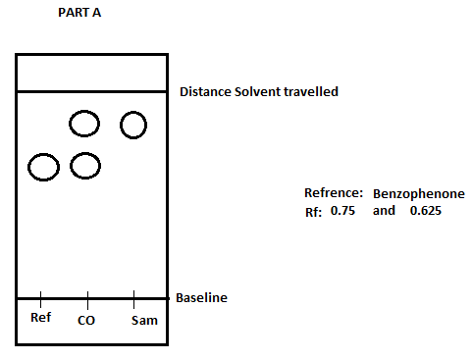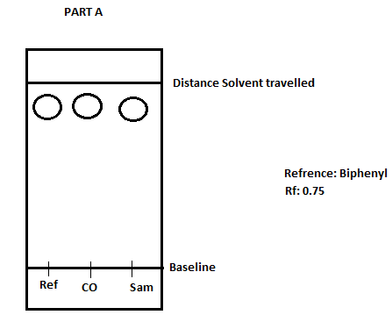

Part B:
Sample Used | Solvent Used (10mL) | Reference Used | Observations
Sample 20 | Ethyl Acetate (part A) | Biphenyl | - 3 circle in total (high on the TLC)  - all circles as in line, therefor our sample has the same polarity as Biphenyl, implying that they are the same compound.
Sample 20 | Ethyl Acetate (part A) | Benzophenone | - 3 circle in total (slightly lower on the TLC than Biphenyl)  - all circles as in line, therefor our sample has the same polarity as Biphenyl, implying that they are the same compound.
Sample 20 | Hexane (Part B) | Biphenyl | - 3 circle in total (low on the TLC)  - all circles as in line, therefor our sample has the same polarity as Biphenyl, implying that they are the same compound.
Sample 20 | Hexane (Part B) | Benzophenone | - 4 circles total (low on the TLC)  - 2 in the CO column  - 1 higher in the sample column, and one lower in the reference column. The one in the reference column did not move from its spot. Therefore the reference and the sample do not have the same polarity and are not the same.
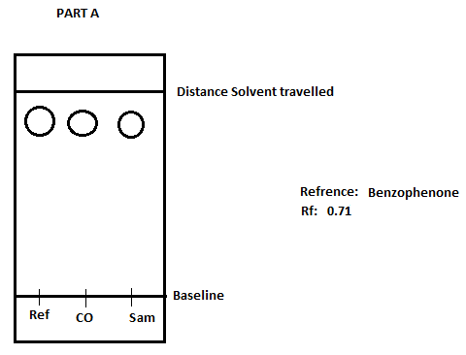TLC:
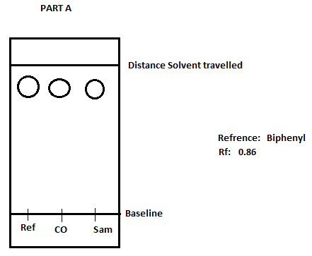
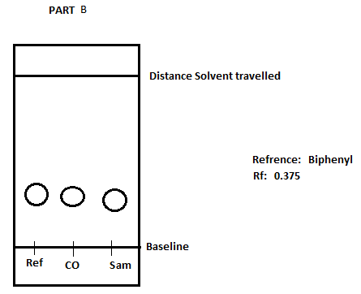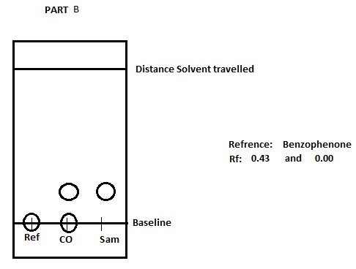

Part C:
Sample used | Solvent used (10mL) | Reference used | Observations
ZZ | (9:1) Hexane:Ethylacetate | Ortho- bromonitrobenzene | - 5 circles total (relatively low)  - 2 in CO, 2 in sample, and 1 lower circle in reference  - the source did not have the same result, therefor they are not the same compound
ZZ | (9:1) Hexane:Ethylacetate | Meta- bromonitrobenzene | - 6 circles total (middle of the TLC)  - 2 rows of 3 circles  - 2 in each column  - this shows that our sample has the same polarity as our reference and is therefore implying that they are same compound
ZZ | (9:1) Hexane:Ethylacetate | Para- bromonitrobenzene | - 6 circles total (Middle-high on the TLC)  - 3 in CO  - 1 highest in reference and the 2 lower ones in sample  - this implies that the two compounds are not the same

From these TLC’s we can see that our mixture “ZZ” was a combination of Ortho- and Meta-

The unknown sample that we used for part A and B was number 20, it was a white powdered substance.
The unknown sample that was used for part C was ZZ, a clear liquid.

For every TLC, the solvent was about 1.0cm from the bottom, as time passed the solvent eluted up the TLC and carried with it the organic compound. Once removed it took about 10 seconds to dry. After this the TLC was placed under a UV light and we could observe the organic compound as a small circle.

Calculations:
R_{f} = D₁/D₂
D₁ is the distance from the baseline travelled by the solute
D₂ is the distance from the baseline travelled by the solvent
Example: R_{f} = 1.5cm/3cm
R_{f} = 0.5

Percentage of absorbance:
Peak 2: Absorbance if Meta = | 26 774
Peak 1: Absorbance of Ortho = | 17 001
%Absorbance (meta) = | (26 774/ (26 774+17 001)) X 100% = 61%
%Absorbance (Ortho) = | (17 001/ (26 774+17 001)) X 100% = 39%

Mole Percentage:
Y = | %absorbance (meta) = 61%
Y = | 1.7373(x) + 0.31
X_{meta} = | %mole (meta) = 34.9%
X_{ortho} = | %mole (ortho) = 65.1%

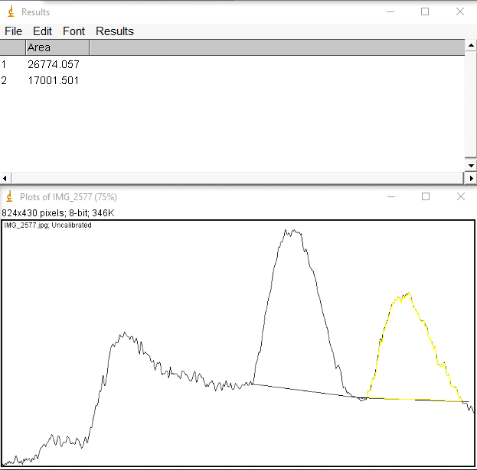

Discussion:
Part A:
- The goal of part A was to determine the unknown sample given to you by the TA.
- After 2 tests: one with Benzophenone as the reference, and one with Biphenyl as the reference. It was determined that our unknown was Biphenyl because our reference, CO, and sample spots had the same circles at the same distance from the baseline. Giving the TLC a even row of 3 circles. The Rf value for this test was 0.75, a relatively high Rf value, which makes sense because Biphenyl is not very polar. Meaning that it would travel far up the TLC.
- For the other test Benzophenone was our reference. This test determined that our unknown was not the same compound. The TLC did not give even rows, meaning that our sample and our reference do not have the same polarity. The two Rf values were 0.625 and 0.75, this tells us that Benzophenone was slightly more polar than out sample (Biphenyl). This test confirms the result we got from the first test.
- Overall it was determined that out sample was Biphenyl based on two different references.

Part B:
- The goal of this experiment was to see the difference that a solvent can make on a TLC experiment.
- The two solvents used were ethyl acetate and hexane. Two tests identical to part A were done for each.
- The first two were done with ethyl acetate as the solvent. When these tests were done we got very similar results for both Biphenyl and Benzophenone: a row of 3 circles. The only difference was the Rf values, for Biphenyl it was 0.86 and for Benzophenone it was 0.71. This shows that the solvent used has a very large effect on the outcome of the experiment meaning that it is important to use the right solvent. Ethyl acetate carried both reference far up the TLC because it is a very polar molecule meaning that it interacted with the silica more.
- The second two experiments were done with hexane as the solvent. These tests had different results, unlike the first two experiments. When Biphenyl was used as the reference the TLC had 3 circles in a row close to the bottom, and a Rf value of 0.375. this is very different from the results in the first test, this is because hexane is not as polar so it did not carry the reference as far as ethyl acetate. When Benzophenone was used as the reference it has a unique appearance: the reference did not move at all and the sample only moved slightly up the TLC. The Rf values for this were 0.43 and 0, showing that hexane was not good as carrying compounds up the TLC.
- Overall the solvent that you pick has a large effect on the outcome of the experiment, and whether it is polar or non-polar can change this.

Part C:
- In part C the goal again to determine what unknown you had, but by a different means of doing so.
- A different solvent, reference, and sample was used for this experiment. The solvent was hexane:ethylacetate, the sample was unknown “ZZ”, and the reference was Meta- Orth- or Para-bromonitrobenzene.
- When using Para-bromonitrobenzene, once put under black light our TLC showed us 6 cirlces, and the reference lane did not correspond to any circles in the sample. This told us that our sample ZZ did not consist of any Para-
- When using Meta- bromonitrobenzene as the reference we got one reference circle to line up with the sample circle. This means that our sample consisted partially of Meta-. After taking pictures of the TLC, it was analyzed in ImageJ and found that the mole percentage was 34.9%. this is relatively low, however the rest of the sample is made up of the other compound.
- When using Ortho-bromonitrobenzene as the reference one circle lined up with the sample circle. This means that our sample consisted partially of Ortho- and partially of Meta-. After taking pictures of the TLC, it was analyzed in ImageJ and found that the mole percentage was 65.1% Ortho-. This shows us that our sample was mostly Ortho- bromonitrobenzene
- Overall it can be concluded that sample ZZ was made up of 65% Ortho-bromonitrobenzene and 35% Meta- bromonitrobenzene.

Conclusion:
In conclusion, this lab gave us the opportunity to work with and learn how to use Tin Layer Chromatography to identify unknown substances. It also shows us the differences in polarity between organic molecules and some of the effects that polarity has.

Questions:
- How does increasing the polarity of the solvent system affect the results of a TLC?
Increasing the polarity of the solvent system would drag the organic compound further up the TLC. This is because silica is polar, so increasing the polarity of the solvent would make the solvent react more with the silica and go further up the TLC.

- In the following sets of compounds, which would have the smallest RF on silica gel? Use a sentence to explain your reasoning. Draw line structures of each compound
a. Benzyl alcohol, benzaldehyde, benzyl acetate
b. Aniline, N,N-dimethylaniline, naphthalene
c. Benzophenone, Biphenyl, Benzoic acid
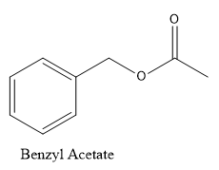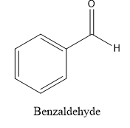
- 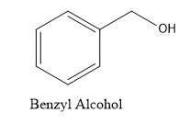

The Compound with the smallest RF value on silica gel would be Benzyl Alcohol because due to the alcohol group it is the most polar, and would interact with the silica gel more than the others.

- 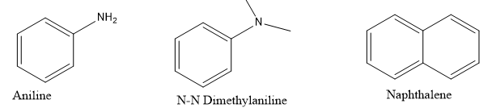

The Compound with the smallest RF value on silica gel would be Aniline because it is the most polar compound and therefore interact with silica gel the most.

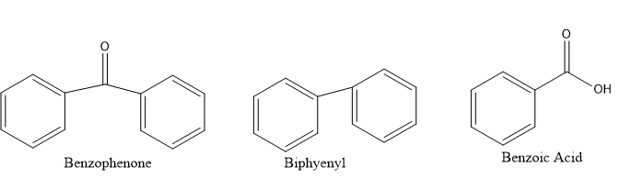
- The Compound with the smallest RF value on silica gel would be benzoic acid because it is the most polar and would interact with the polar silica gel the most.

