Business Analytics Notes
WEEK 2

Special Cases in Linear Programming

1. Redundant constraints:
A constraint that does not form a unique boundary of the feasible solution space; its removal would not alter the feasible solution space.

Example: x <= 10
x <= 12

The second constraint is redundant

2. No feasible solution
Occurs in problems where to satisfy one of the constraints, another constraint must be violated.
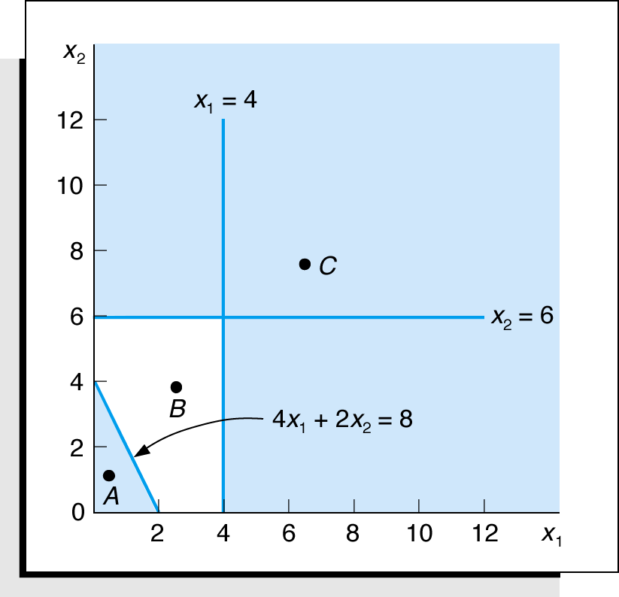
Maximize Z = 5x₁ + 3x₂
subject to: 4x₁ + 2x₂ ≤ 8
x₁ ≥ 4
x₂ ≥ 6
x₁, x₂ ≥ 0

3. Multiple Optimal Solutions
Problems in which different combinations of values of the decision variables yield the same optimal value.
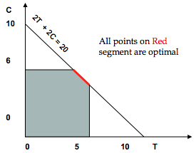
Max 2T + 2C
Subject to:
T + C < 10
T < 5
C < 6
T, C > 0

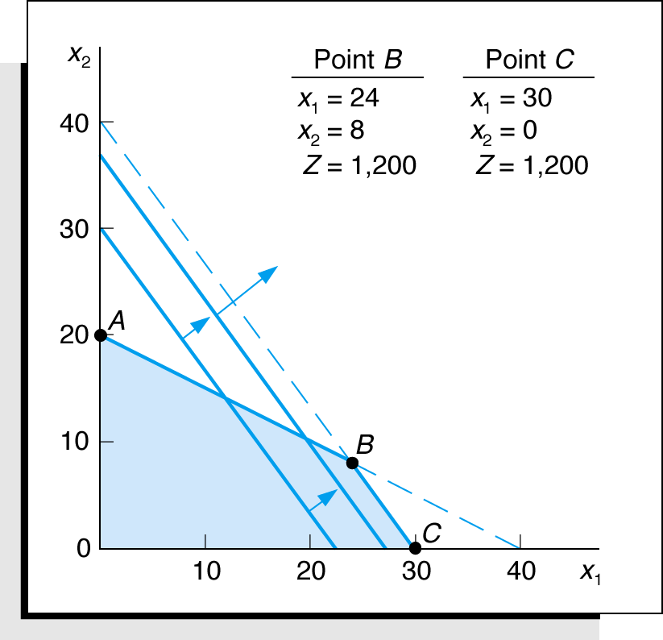

The objective function can be
parallel to a constrain line.

Maximize Z=$40x₁ + 30x₂
subject to: 1x₁ + 2x₂ ≤ 40
4x₁ + 3x₂ ≤ 120
x₁, x₂ ≥ 0
Where:
x₁ = number of bowls
x₂ = number of mugs

4. Unbounded Solution
When nothing prevents the solution from becoming infinitely large
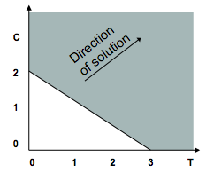
Max 2T + 2C
Subject to:
2T + 3C > 6
T, C > 0

Value of the objective function increases indefinitely.
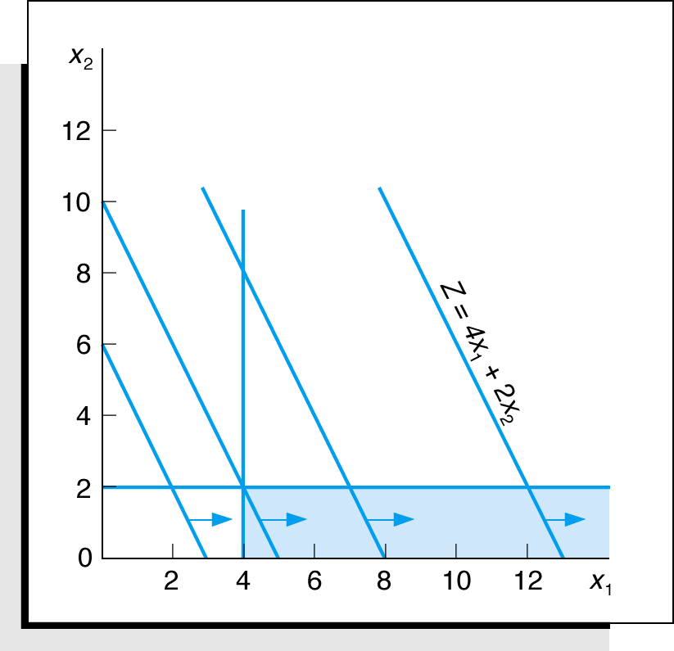
Maximize Z = 4x₁ + 2x₂
subject to: x₁ ≥ 4
x₂ ≤ 2
x₁, x₂ ≥ 0

Characteristics of Linear Programming
- Feasible Region: The set of points that satisfies all constraints
- Corner Point Property: An optimal solution must lie at one or more corner points
- Optimal Solution: The corner point with the best objective function value is optimal

**Sample Midterm Question**

Consider the following linear program:

Max Z = X₁ – 2X₂

Subject to
– 4X₁ + 3X₂ <= 3
X₁ – X₂ <= 3
X₁, X₂ >= 0

a) Graph the feasible region for the problem.

b) Is the feasible region unbounded? Explain.

c) Find the optimal solution.

d) Does an unbounded feasible region imply that
the optimal solution to the linear program
will be unbounded?

WEEK 3 / WEEK 4
Example:

RMC, Inc. is a firm that produces chemical based products. In a particular process three raw materials are used to produce two products. The Material requirements per ton are:

Product Material 1 Material 2 Material 3
Fuel additive 2/5 0 3/5
Solvent base 1/2 1/5 3/10

For the current production period RMC has available the following quantities of each raw material. Because of spoilage, any materials not used for current production must be discarded.
Number of Tons Material Available for Production
Material 1 20
Material 2 5
Material 3 21

If the contribution to the profit is $40 for each ton of fuel additive and $30 for each ton of solvent base, How many tons of each product should be produced in order to maximize the total contribution profit?
RMC Problem Formulation

Max Z = $ 40 x1 + 30 x2

Subject to
2/5 x1 + 1/2 x2 ≤ 20 (Material 1)
1/5 x2 ≤ 5 (Material 2)
3/5 x1 + 3/10 x2 ≤ 21 (Material 3)
x1 ≥ 0, x2 ≥ 0

x1: number of tons of fuel additive that RMC produces
x2: number of tons of solvent base that RMC produces
Decision variables

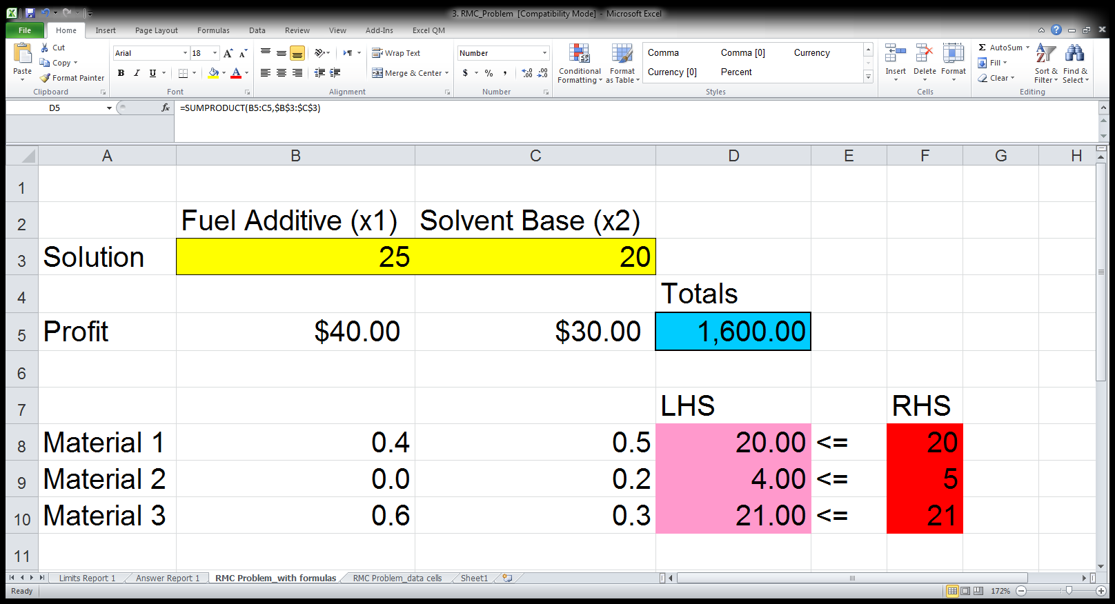

Step #1: Data Cells
- Enter all of the data (i.e. parameters) for the problem on the spreadsheet.
- Make consistent use of rows and columns.
- In the excel file (RMC.xls), data cells are:
- B5:C5, B8:C10, F8:F10

Step #2: Variable Cells
- Solver refers to decision variables as variable cells.
- Add a cell in the spreadsheet for every decision that needs to be made.
- In RMC example, there are two decision variables cells B3 and C3 to represent number of tons of fuel additive to make (x1) and number of tons of solvent base to make (x2), respectively.
- If you don’t have any particular initial values, just enter 0 in each.
- It is a good idea to color code these “variable cells” (e.g., yellow with border).

Step #3: Objective Cell
- Develop an equation that defines the objective of the model.
- Typically this equation involves the data cells and the changing cells in order to determine a quantity of interest (e.g., total profit or total cost).
- SUMPRODUCT(B5:C5,$B$3:$C$3)
- This is equivalent to =B5*B3+C5*C3
- It is a good idea to color code this cell (e.g., blue with heavy border).

Step #4: Constraints
- Each constraint has three parts -
- A left hand side (LHS) part consisting of every term to left of equality or inequality sign. (shaded in pink, called the “output cells”).
- calculate the amount of that resource used in a cell on the spreadsheet (an output cell). Refer to the equation in the cell D8:D10

- A right hand side (RHS) part consisting of all terms to right of equality or inequality sign (shaded in Red)

- Equality or inequality sign.
- Define the constraint in three consecutive cells. For example, if Quantity A <= Quantity B, put these three items (Quantity A, <=, Quantity B) in consecutive cells.

Interpretation of the Solution
- The solution indicates that if RMC, Inc. produces 25 tons of fuel additive and 20 tons of solvent base, it will receive $1600, the maximum profit possible given the Material constraints (resources constraints)

- The solution tells management that the optimal solution will require all available material 1 and material 3, but only 4 of 5 tons of material 2. (the 1 ton of material 2 is referred as slack

Linear Programming Applications

Two Central Steps
- Which are the values that we need to decide? Replacing them by (decision) variables. (independent variables)
- Which are the requirements? Representing them using variables in (1) (dependent variables)

Outline:
- Marketing (e.g. Advertisement, Marketing research)
- Financial (e.g. Portfolio selection, Investment, Financial Planning)
- Ingredient Blending/Diet
- Manufacturing ( e.g. Product Mix, Production Scheduling)
- Scheduling (e.g. Assignment problems (chapter 15), Labor Planning, Multiperiod Work Scheduling)
- Transportation/Shipping ( to be discussed in Chapter 15)

Introduction
- Applications exist in managerial decision making areas, such as:
- production mix, labor scheduling, job assignment,
- production scheduling, marketing research,
- media selection, shipping and transportation,
- ingredient mix, and financial portfolio selection.
- Purpose is to show how one can use LP to modeling for decision-making in these areas.

Marketing Applications
- Decision aid in selecting an effective media mix
- Objective:
- Maximize Audience Exposures
- Minimize Advertising Cost
- Constraints: Contract requirements, limited media/budget availability, company policy…
- Example (refer to “LP_Applications.doc”)

Financial Applications
- The selection of specific investments from among a wide variety of alternatives
- A problem encountered by managers of banks, mutual funds, investment services, insurance company…
- Objective: to maximize expected return on investment
- Constraints: legal, policy, risk…
- Example (refer to “LP_Applications.doc”)

Blending Applications

A. Diet and Feed Mix Problems
- “Involves specifying a food or feed ingredient combination that satisfies stated nutritional requirements at a minimum cost level”

B. Ingredient Mix and Blending Problems
- Decision regarding the blending of 2 or more resources to produce 1 or more products.
- Resources contain 1 or more ingredients that must be blended so that each final product contains specific percentages of each ingredient.
- Example (refer to “LP_Applications.doc”)

Example:
Let X_{ij} = number of gallons of crude i used to make product j
i = 1, 2 and j = r, h ( r = regular octane gasoline, h = high octane gasoline)

Min $ 0.1X_{1r} + 0.1X_{1h} + 0.15x_{2r} + 0.15 x_{2h}

Subject to

-.2 X_{1r} + 0.1 X_{2r} >= 0 (ingredient A in Regular Octane)
0.1X_{1h} - 0.2 X_{2h} <= 0 (ingredient B in High Octane)
X_{1r} + X_{2r} >= 800,000 (Demand for Regular Octane)
X_{1h} + X_{2h} >= 500,000 (Demand for High Octane)

X_{1r}, X_{2r}, X_{1h}, X_{2h} >= 0 (non negativity)

Manufacturing Applications
A. Production Mix
- Planning for the optimal mix of products to manufacture.
- Goal: Generate the largest profit possible
- Constraints: financial, sales demand, material contracts, union labor demands…

B. Production Scheduling
- Setting a low-cost production Schedule over a period of weeks or months
- Factors involved: labor capacity, inventory, storage costs, space limitations, product demand…
- Objective: maximize profit or minimize the total cost (production + inventory)
- Example (refer to “LP_Applications.doc” or next slide)
- A Multiperiod Applications problem

Example
The Silver Star bicycle Company will be manufacturing both men’s and women’s models for its Easy-Pedal 10-speed bicycles during the next 2 months.

The company wants to develop a production schedule indicating how many bicycles of each model should be produced each month. Current demand forecasts call for 150 men’s and 125 women’s models to be shipped during the first month and 200 men’s and 150 women’s models to be shipped during the second month. Additional data are shown:

Labor Requirements (hours)

Model Prod. Costs Manufacturing Assembly Current Inventory

Men’s $ 120.00 2.0 1.5 20
Women’s $ 90.00 1.6 1.0 30

Last month the company used a total of 1000 hours of labor. The company’s labor relation policy will not allow the combined total hours of labor (manufacturing plus assembly) to increase or decrease by more than 100 hours from month to month. In addition, the company charges monthly inventory at a rate of 2% of the production cost based on the inventory levels at the end of the month. The company would like
to have at least 25 units of each model in inventory at the end of month 2.

- Establish a production schedule that minimizes production and inventory costs and satisfies the labor-smoothing, demand, and inventory requirements. What inventories will be maintained and what are the monthly labor requirements?

Scheduling Applications
A. Assignment Problems
- Determine the most efficient assignment of people to jobs, machines to tasks, sales people to territories…
- Objective: to minimize travel time or costs or to maximize assignment
- Will be discussed in Chapter 15

B. Labor Planning
  - Address staffing needs over a specific time period.
  - Useful when assigning workers to jobs that require overlapping or interchangeable talents
  - Large banks frequently uses LP to tackle their labor scheduling
  - Example (refer to “LP_Applications.doc”)

Summary
- A systematic Approach to Model formulation:
- Define the decision variables
- Construct the objective function
- Develop each constraint separately
- Do NOT attempt to “see” the whole problem during the first reading.
- Developing the problem statement, the parameters, and objective function, Identifying all constraints without omitting any require extensive data collection efforts, time, and assistance of individual…
- Problems that one face in actual practice are much larger.

WEEK 5

Introduction
- Assumption: The parameters of the model were known with certainty.
- In Reality: the model parameters are simply estimates that are subject to change.
- Example (RMC Problem).

Example

RMC, Inc. is a firm that produces chemical based products. In a particular process three raw materials are used to produce two products. The Material requirements per ton are:

Product Material 1 Material 2 Material 3
Fuel additive 2/5 0 3/5
Solvent base 1/2 1/5 3/10

For the current production period RMC has available the following quantities of each raw material. Because of spoilage, any materials not used for current production must be discarded.

Number of Tons Material Available for Production
Material 1 20
Material 2 5
Material 3 21

If the contribution to the profit is $40 for each ton of fuel additive and $30 for each ton of solvent base, How many tons of each product should be produced in order to maximize the total contribution profit?

RMC Problem Formulation (refer also “RMC_problem.xls”)

Max Z = $ 40 x1 + 30 x2

Subject to
2/5 x1 + 1/2 x2 ≤ 20
1/5 x2 ≤ 5
3/5 x1 + 3/10 x2 ≤ 21
x1 ≥ 0, x2 ≥ 0

x1: number of tons of fuel additive that RMC produces
x2: number of tons of solvent base that RMC produces

Answer Report
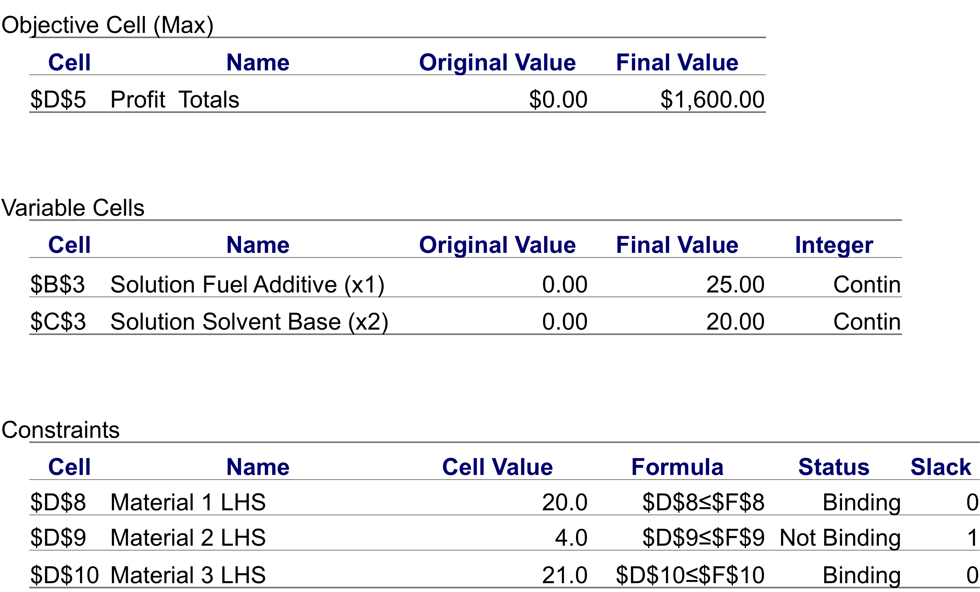

Sensitivity Report
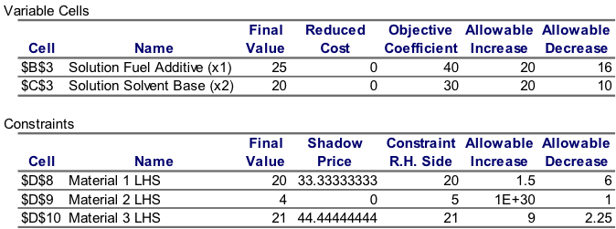

- What_if Analysis = Sensitivity Analysis = Postoptimality Analysis = Parametric Programming = Optimality Analysis.
- The analysis of the effect of parameter changes (coefficient of the LP problem) on the optimal solution.
- Centered around “What-if question?”.

Changes in the Objective Functions Coefficient

- Definition:
- c1: the objective function coefficient of x1 (c1= )
- c2: the objective function coefficient of x2 (c2 = )
- Purpose
- Sensitivity analysis is performed to determine the range for cj over which the current solution remain optimal
- This can be directly obtained from Excel’s sensitivity report.

- Graphically
- Changes in the objective function coefficients values do not affect the size of the feasible region.
- The range of optimality
- The range of values over which a variable’s coefficient can change without causing a change in the optimal solution (x1= 25, x2= 20) is:

24 ≤ c1 ≤ 60 (refer to the Excel Sensitivity analysis report)
20 ≤ c2 ≤ 50 (refer to the Excel Sensitivity analysis report)

- What about the value of Z?
Zero value decision variable (unused activity)
    - For example, the optimal solution shows that it’s better not to produce any basketballs and to only produce soccer balls and footballs. It will be a moot point for the marketing team to debate how much more to sell them.
    - The value of the objective function, Z, will not change.
- Non Zero value decision variables
- The value of Z, will change.

Question : What will happen if the estimate of the unit profit of ONE of the RMC’s chemical based product is inaccurate?

Answer: The range of values is wide for both objective function coefficients. Thus we can still be confident that we have obtained the correct optimal solution

Visual aid: Changing the objective coefficient
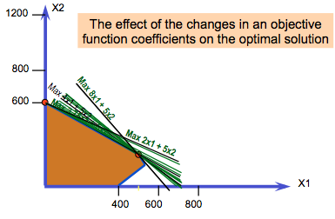
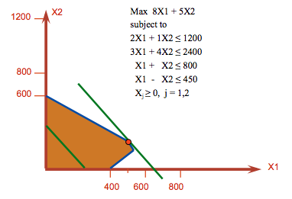

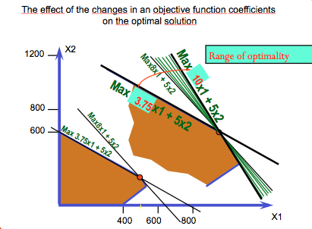

Changes in the Right-Hand Sides (RHS) values
- Changes in constraints quantity values = changes in resources = changes in the managerial policy decisions

- qi = the RHS value for constraint i
- q1 = 20 , q2 = 5 and q3 = 21
- Graphically
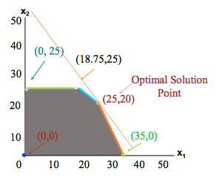
- A change in qi usually affects the size of the feasible region and often the value of the optimal solution.

- Shadow Price
- The value of an additional unit of resources (e.g. an additional 1 ton of Material 1 will increase my profit by how much? Is it worth it?)
- How to find the value of the shadow price?
  - Increase the RHS by one in the spreadsheet, and solve.
  - Look at the sensitivity report.

Shadow Prices (Definitions):
- Is the marginal profit of additional unit of resource.
- The maximum price you are willing to pay for 1 unit of the resources.
- Amount by which profit will decrease if the availability of the resource associated with the constraint is reduced by 1 unit.

Purpose
  - The effect on the optimal value if a small change were to be made in the RHS constraint (done for each constraint, one at a time).
  - We want to find the range value of qi over which the shadow prices remain valid
    - The range over which the solution remain feasible. Where x1 and x2 remain different than zero, however their values may change.
- Range of Feasibility
  - The range of values over which the value of the right hand side (qi) can vary without causing a change in the corresponding shadow price value.
  - In RMC:
14 ≤ q1 ≤ 21.5
4 ≤ q2
18.75 ≤ q3 ≤ 30

Explain why q2 has no upper limit?

- Changes in the right hand side of a binding constraint causes the value of the optimal solution to change.
- What about changes in the right hand side of a none binding constraint?
  - Let’s look at material 2
  - Note: 1E+30 = infinitely large

Simultaneous Changes in the Objective Function Coefficients
- The range of values discussed is based on the assumption that only one coefficient changes, and all the other coefficients remain the same (accurate).
- Purpose
- Determine, without solving the problem, whether optimal solution may change if certain changes occur simultaneously in the coefficients of the objective function (given that those changes are within the corresponding range).
100 Percent Rule for Objective Function Coefficients
- For all objective function coefficients that are changed, sum the percentage of the allowable increases and the allowable decreases represented by the changes. If the sum of the percentage changes does not exceed 100%, the optimal solution will not change.

- (Change / Allowable change)*100 ≤ 100

Example
Management would like to modify our resources such that:
c1: 40 50 and c2: 30 35

Percentage allowable increase for c1
= (50-40)/ (allowable increase for c1) %
= (50-40)/20 *100 = 10/20 = 50 %

Percentage allowable increase for c2
= (35-30)/ (allowable increase for c2) %
= (5)/20 *100 = 25 %

Sum= 50% + 25% = 75% <100%
Thus, the optimal solution does not change

Example: Management would like to modify our resources such that:
c1: 40 25 and c2: 30 40

Percentage allowable decrease for c1
= (40-25)/ (allowable decrease for c1) %
= (15/16) *100 = 93.5 %

Percentage allowable increase for c2
= (40-30)/ (allowable increase for c2) %
= 10/20 *100 = 50 %

Sum= 93.5 % + 50% = 143.5% >100%
Since the 100% is not satisfied, it may change. We must resolve the problem to determine if the optimal solution will change or not.

Simultaneous changes in the RHS
- The 100 percent Rule:
- For all right hand side that are changed (with their corresponding range of feasibility), sum percentages of allowable increases and allowable decreases. If the sum does not exceed 100% then the shadow prices will not change.
- Example:
- q1: 20 21 , 14 ≤ q1 ≤21.5
- q2: 5 5, 4 ≤ q2
- q3: 21 24 , 18.75 ≤ q3 ≤ 30

100 Percent Rule for the RHS
Example solution:

q1: 20 21
= (21-20)/ (allowable increase for q1) %
= (21-20)/1.5 *100 = 66.67%
q2: 5 5
No change (0%)
q3: 21 24
= (24-21)/ (allowable increase for q1) %
= (24-21)/9 *100 = 33.33%

Sum = 66.67% + 0% + 33.33% = 100%
Shadow prices remain valid since the 100% rule is respected. Shadow prices definitely did not change (refer to the excel file).

Reduced Cost
- Reduced cost of an unused activity is:
- The amount by which the profit contribution of an activity (objective function coefficient) needs to be increased before producing this activity.
See RMC Obj Change Sensitivity tab in Excel
If c2 was increased from 15$ to 20$, we would begin producing product 2
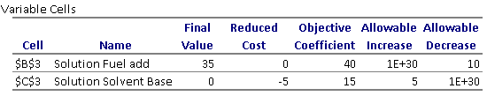

the amount by which the profit will decrease if 1 unit of this activity is forced into the solution.

Multiple Optimal Solution
- Zero in the “final value” and reduced cost” column.
- zero in the “allowable increase” or “allowable decrease” columns of the variable cells table.
- See Labor Planning Problem 2 (last week)
Problem 1

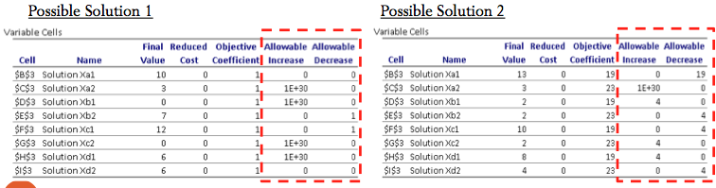

Pricing-out New Variables
- Information given in sensitivity report can be used to study the impact of introducing new decision variables (products).
- For example: Management would like to add a new product to its product line.
- Will it be recommended that the new product be made based on solving the model with the new information?
- Or, will it be recommend that the new product not be made, which implies that we will continue two offer our existing two products (fuel additive and solvent base).

- Suppose RMC, Inc. wants to produce another chemical based product called ultra base (x3).
- RMC’s supply chain and marketing department provided the following information on the new product:
It will require:
0.1 ton of material 1
0.1 ton of material 2
0.8 ton of material 3
- It will sell for:
- $35 each ton

- Checking validity of the shadow price using 100% rule.
- Compute the opportunity cost: marginal worth of the resources that would be diverted from existing product + cost of making the product (it is 0 in this example).
- Opportunity cost > profit contribution
  - Do not produce the product.
Practice

6 Large bricks
8 Small bricks

Build tables and chairs:

Item | Large Bricks | Small Bricks
Table | 2 | 2
Chairs | 1 | 2
**Each table brings $20 while each chair brings $15.

How many tables and/or chairs to build to maximize earnings?

Linear Programming Model

Max $20x₁ + $15x₂

Subject to
2x₁ + x₂ ≤ 6 use and availability of large bricks
2x₁ + 2x₂ ≤ 8 use and availability of small bricks
x₁ ≥ 0; x₂ ≥ 0

Optimal Solutions: 2 tables and 2 chairs

Z: 2 tables * 20$ + 2 chairs * 15$ = 70$
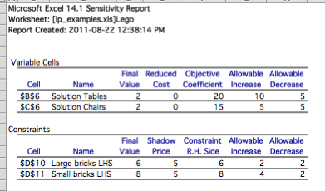

Sensitivity Analysis

- What to do if profit from a table increases to $25?
- What if it increases to $35?
- How much to pay for an extra large brick?
- Is it worth buying extra 3 large bricks?

Example
Worksheet: Product Mix:

Harry Bartlett is the owner of the Bartlett Nurseries Inc. From the beginning he worked closely with the local agricultural extension service in order to recommend fertilizers to his customers. After extensive soil analyses, he discovered that standard fertilizer blends did not quite match the requirements of Alberta soil conditions. Upon the recommendation of area soil chemists, and in the belief that significant profits could be made from selling fertilizer, Bartlett began mixing his own blend for sale to local customers. He was fully aware that he would need to minimize his costs in order to compete with commercial fertilizers. Harry's favorite blend was Nitrogrow-X. This fertilizer combined the following chemical compounds containing nitrogen: NG100, NG250, NG350 and NG500.
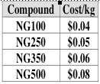
The cost per kilogram for each compound are:
Specifications for the Nitrogrow-X blend follow:
fertilizer is packed and sold in 100 kg bags,
NG100 and NG250 can constitute no more than 40%
of the blend
NG350 and NG500 must constitute at least 50% of the blend
NG500 must constitute at least 10% of the blend.

Question: What blend of the compounds will enable Bartlett to minimize the cost of a 100-kg bag of fertilizer?

LP Model

x₁ - unknown amount (in kg) of NG100 in a bag
x₂ - unknown amount (in kg) of NG250 in a bag
x₃ - unknown amount (in kg) of NG350 in a bag
x₄ - unknown amount (in kg) of NG500 in a bag

Min = 0.04x₁ + 0.05x₂ + 0.06x₃ + 0.08x₄

Subject to
s.t.
x₁ + x₂ + x₃ + x₄ = 100 size of a bag
x₁ + x₂ ≤ 40 requirement for the amounts of NG100 and NG250
x₃ + x₄ ≥ 50 requirement for the amounts of NG350 and NG500
x₄ ≥ 10 requirement for the amounts of NG500 in a bag
x_{1,} x_{2,} x_{3,} x₄ ≥ 0
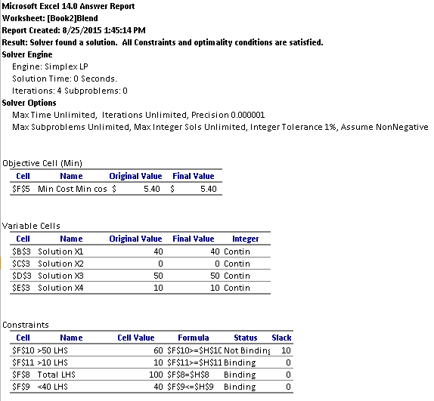

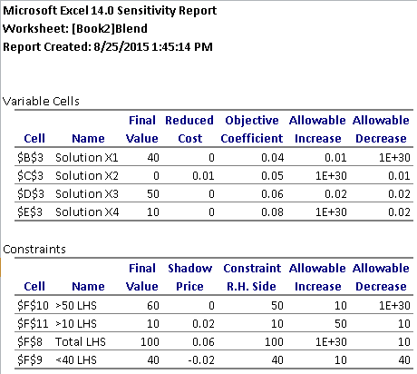

Solution:
40kg of NG100, 50kg of NG350 10kg of NG500
Bag cost: 5.40$

- By how much cost of NG100 can go up?
- What happens if cost of NG350 falls to $0.03/kg?
- What happens if cost of NG500 increases to $1/kg

WEEK 6

Transportation and Assignment Problems
Introduction
- Transportation and assignment problems belong to a special class of LP problems called Network Flow Problems
- They can be solved using the Simplex method (EXCEL Solver)
- There are specialized algorithms that are more efficient (northwest corner rule, minimum cost method, stepping stone method, Hungarian Method)

Approach
- Illustrate each problem with a specific example (application):
  - Develop a graphical representation, called network of the problem
  - Formulate the problem in a LP form
  - Solve the LP using EXCEL Solver (using the simplex method)
It’s time for a fun fact on the creator of the simplex method
George B. Dantzig

Early Anecdote
- One day in 1939, Dantzig arrived late for class taught by Professor Neyman and mistakenly thought that two unsolved problems in statistics that Neyman had written on the board were homework problems. After a few days of struggling, he solved them and returned them to Neyman as homework. Dantzig described the event in his own word:
- During my first year at Berkeley I arrived late one day to one of Neyman's classes. On the blackboard were two problems which I assumed had been assigned for homework. I copied them down. A few days later I apologized to Neyman for taking so long to do the homework - the problems seemed to be a little harder to do than usual.
- About six weeks later, he was awakened by Neyman banging on the front door who said, "I have just written an introduction to one of your papers. Read it so I can send it out right away for publication."^{[8]} The solution to the second homework problem became part of a joint paper with Abraham Wald who proved it in 1950, unaware that Dantzig had solved it. Neyman suggested Dantzig to submit his answers to the "homework" problems as his doctoral dissertation when he was looking for area for research for his doctorate. These experiences ended up as a sermon for a Lutheran minister and the basis for the film, "Good Will Hunting

Transportation Model
Characteristics
- Transportation of goods and services from a number of sources (supply points) to a number of destinations (demand points) at a minimum cost (objective)
- Each source is able to supply a fixed number of units of the goods or services, and each destination has a fixed demand for the goods or services

Objective
- Most common objective of transportation problem is to schedule shipments from sources to destinations so that total production and transportation costs are minimized
- Parameters of the model:
  - Supplies
  - Demands
  - Unit Costs
- All the parameter of the model are included in a parameter table (summarizes the formulations of a transportation problem by giving all the unit costs, suppliers, and demands)

Example
- Wheat is harvested in the Midwest and stored in grain elevators in three different cities – Kansas City, Omaha, and Des Moines. These grain elevators supply three flour mills, located in Chicago, St. Louis, and Cincinnati. Grain is shipped to the mills in railroad cars, each car capable of holding one ton of wheat.
- The cost of shipping one ton of wheat from each grain elevator to each mill, the demand of wheat per month for each mill, and the number of tons that each grain elevator is able to supply to the mills on a monthly basis are shown in the parameters table:

Parameter Table
Mill (destination)
Grain Elevator A. Chicago B. St. Louis C. Cincinnati Supply
(Supplier)
1. Kansas City $6 8 10 150
2. Omaha 7 11 11 175
3. Des Moines 4 5 12 275
Demand 200 100 300

- Determine how many tons of wheat to transport form each grain elevator to each mill on a monthly basis in order to minimize the total cost of transportation
- Goal
  - Select the shipping routes and units to be shipped to minimize total transportation cost

Network Representation
- Each supplier (s_{i},i= 1,2, …,m) and demand (d_{j}, j =1,2,…,n) point is represented by a node (circle)
- Each possible shipping route is represented by an arc (represent the amounts shipped)
- Direction of the flow is indicated by the arrows: Origin to Destination
- The goods shipped from origin to destination represent flow of the network
- Amount of the supply is written next to the origin node (s_{i})
- Amount of the demand is written next to the destination node (d_{j})

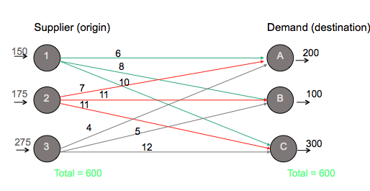

LP Model Formulation
Decision Variables
- The amount of goods or item to be transported from a numbers of origins to a number of destinations
- Apply this definition to our Example
- X_{ij}: The amount of tons of wheat transported from grain elevator i (where i= 1, 2, 3), to mill j (where j = A,B,C)
- General Form:
  - X_{ij:}: number of units shipped from origin i to destination j. (where i = 1, 2,…, m and j = 1, 2, …, n)
  - The number of decision variables = numbers of arcs

Objective Function
- Minimize total transportation cost for all shipments
- The sum of the individual shipping costs from each Grain Elevator to Each Mill:

min Z = $ 6x_{1A} + 8x_{1B} + 10x_{1c} + 7x_{2A}+ 11x_{2B} + 11x_{2C} + 4x_{3A} + 5x_{3B} + 12x_{3C}

Constraints
- Deal with the capacities at each origin (origin has a limited supply)
- Deal with the requirements at each destinations (destination has specific demands)
- Six constraints: One for each Elevator’s supply and one for each Mill’s demand
  - We write a constraint for each node in the network
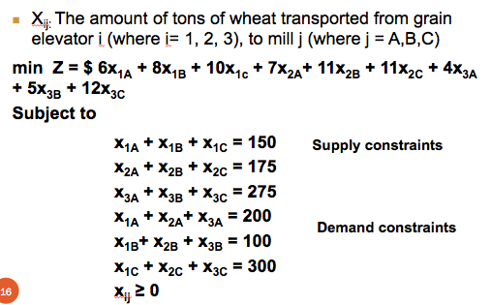

- Deal with the capacities at each origin (origin has a limited supply)
- Deal with the requirements at each destinations (destination has specific demands)
- Six constraints: One for each Elevator’s supply and one for each Mill’s demand
  - We write a constraint for each node in the network
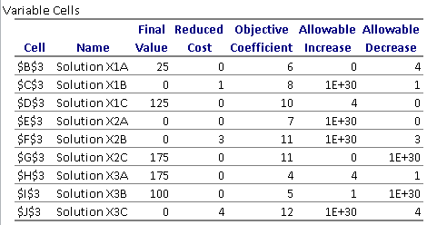

LP Formulation: Comments
- In a balanced transportation model, supply equals demand such that all constraints are equalities (=)
- In an unbalanced model, supply does not equal demand and one set of constraints is <=
- Excel solver uses the simplex method to solve any kind of linear programming problem
  - Refer to the Transportation_Problem.xls file

More than one Optimal Solution
- Alternate solution: Send
  - 150 tons of wheat from Kansas to Cincinnati,
  - 25 tons of wheat from Omaha to Chicago,
  - 150 tons of wheat from Omaha to Cincinnati,
  - 175 tons from Des Moines to Chicago,
  - 100 tons of wheat Des Moines to St. Louis.
  - Total shipping cost is $4,525.
The value 0

Problem Variations
- Total supply does not equal to total demand
- Maximization objective function
- Route capacities or route minimum
- Unacceptable routes

Total Supply not Equal to total demand
- Total Supply > Total Demand:
  - “<=“ used in the supply constraints instead of “=“
  - Excess supply will appear as slack (unused supply or amount not shipped from the origin) in the LP solution
  - Example: refer to “Transportation_Problem.xsl”
- Total Supply < Total Demand:
  - “<=“ used in the demand constraints instead of “=“
  - Some destinations will experience a shortfall or unsatisfied demand
  - Example: Change the demand at Cincinnati to 350 tons

Maximization Objection Function
- Objective: Maximize total transportation profit
- Solve as a maximization LP rather than minimization LP
- The constraints are not affected
Route Capacities or Route Minimum
Constraints need to be added
- Maximum route capacity, Lij:
  - Xij <= Lij
- Minimum Route capacity, Mij:
  - Xij >=Mij

Unacceptable Routes
- Drop the corresponding arc from the network
- Remove the corresponding variable from the linear programming formulation
- If you want to keep the corresponding variable:
  - make the variables that correspond to unacceptable routes equal zero (Xij = 0 if the route from i to j is not possible)

Example 2 (Midterm)
- The U.S. government is auctioning off oil leases at two sites: 1 and 2. At each site, 100,000 acres of land are to be auctioned. Cliff Ewing, Blake Barnes, and Alexis Pickens are bidding for the oil. Government rules state that no bidder can receive more than 40% of the total land being auctioned.
- Cliff has bid $1000/acre for site 1 land and $2000/acre for site 2 land.
- Blake has bid $900/acre for site 1 land and 2200/acre for site 2 land.
- Alexis has bid $1100 /acre for site 1 land and $1900/acre for site 2 land.
- Draw the transportation network model that corresponds to the problem.
- Formulate the linear programming (LP) model to maximize the government’s revenue. (Don’t forget to define the decision variables).

Assignment Problems
- A special form of transportation problem where all supply and demand values equal one
- Involve assigning jobs to machines, agents to tasks, sales personnel to sales territories, contracts to bidders etc…
- Objective: minimize cost, minimize time, or maximize profits etc…

Parameters of the Model
- Assignees (e.g. agents, jobs…)
- Tasks (e.g. shifts, machines…)
- Cost table (gives the cost for each possible assignment of an assignee to a task)
- Example

Example:
- Fowle Marketing Research has just received requests for market research studies from three new clients. The company faces the task of assigning a project leader (agent) to each client (task). Currently, three individuals have no other commitments and are available for the project leader assignments.
- Fowle’s management realizes, however, that the time required to complete each study depend on the experience and ability of the project leader assigned. The three projects have approximately the same priority.

The company wants to assign project leaders to minimize the total number of days required to complete all three projects. If the project leader is to be assigned to one client only, what assignments should be made? The estimated project completion times in days (cost table) is:
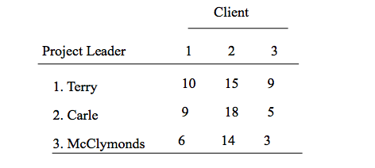

Network Representation
- Nodes
  - Project leaders and clients
- Arcs
  - Possible assignments of project leaders to clients
- The supply at each origin node and the demand at each destination node are 1
- Cost of assigning a project leader to a client
  - Time it takes that project leader to complete the client’s task

LP Model Formulation
- Variable for each arc and a constraint for each node
  - Use of Double-subscripted decision variables
- Objective function
- Constraints

Solution
- Solved with a special purpose optimization method called Hungarian algorithm.
  - Application of this algorithm requires that
number of assignees = number of tasks.
(Balanced Model)
- Refer to Excel
  - (assignment_problems.xsl)
    - Excel Solver uses the simplex method

Problem Variation
- Parallel those for the transportation Problem:
  - Total number of agents (supply) not equal to the total number of tasks (demand)
  - A maximization objective function
  - Unacceptable assignments

Example 4: Employee Scheduling Application

The Department head of a management science department at a major Midwestern university will be scheduling faculty to teach courses during the coming autumn term. Four core courses need to be covered. The four courses are at the UG, MBA, MS, and Ph.D. levels. Four professors will be assigned to the courses, with each professor receiving one of the courses. Student evaluations of professors are available from previous terms. Based on a rating scale of 4 (excellent), 3 (very good), 2 (average), 1(fair), and 0(poor), the average student evaluations for each professor are shown:

Professor D does not have a Ph.D. and cannot be assigned to teach the Ph.D.-level course. If the department head makes teaching assignments based on maximizing the student evaluation ratings over all four courses, what staffing assignments should be made?

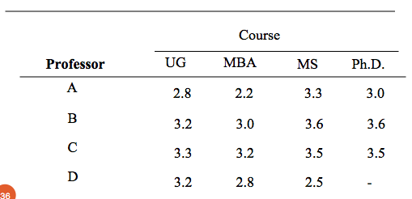

Example 4
- Formulation: is discussed in class if time permits
- Solution: Refer to “assignment_problems.xsl” for the solution
- Recommendation/analysis of the Solution:
  - Assign Prof. A to the MS course, Prof. B to the Ph.D course, Prof. C to the MBA course, and Prof. D to the UG course

Special Consideration
- In a network representation (graphically), what comes out must comes in.
- Hence, if the number of tasks is greater than the number of workers then a dummy worker is added with the zero assignment costs to balance the model.

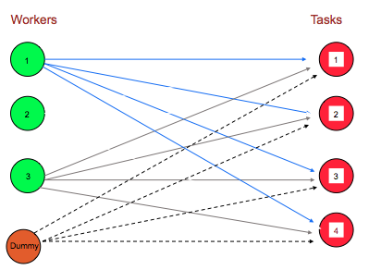

Week 7
Integer and Binary Programming
- Formulate integer programming (IP) models.
- Setup and solve IP models using Solver.
- Understand difference between general integer and binary integer variables.
- Understand use of binary integer variables in formulating problems involving fixed (or setup) costs.
- Formulate goal programming problems and solve them using Solver.

Integer Programming
- Constraints and Objective function similar to the LP model
Difference: one or more of the decision variables has to take on an integer value in the final solution.

Question:
Haven’t we just learned how to use LP to find the optimal number of products?
- Yes, but the LP solution is only used as a “proxy” for an IP problem
- Example of IP: Harison Electric Company

Example 1: Harison Electric Company

The Harison Electric Company, located in Chicago’s old town area, produces two products popular with home renovators: old-fashion chandelier and ceiling fans. Both the chandeliers and fans require a two-step production process involving wiring and assembly.

It takes about 2 hours to wire each chandelier, and 3 hours to wire a ceiling fan. Final assembly of the chandeliers and fans requires 6 and 5 hours, respectively. The production capability is such that 12 hours of wiring time and 30 hours of assembly time are available. Each chandelier produced increases profits by $600 and each fan by $700.

Harison’s production mix decision can be formulated using LP as follows:

Variables:
X1 = number of chandeliers produced
X2 = number of ceiling fans produced

Maximize Profit = 600X1 + 700X2
Subject to
2X1 + 3X2 ≤ 12 (wiring hours)
6X1 + 5X2 ≤ 30 (assembly hours)
X1, X2 ≥ 0

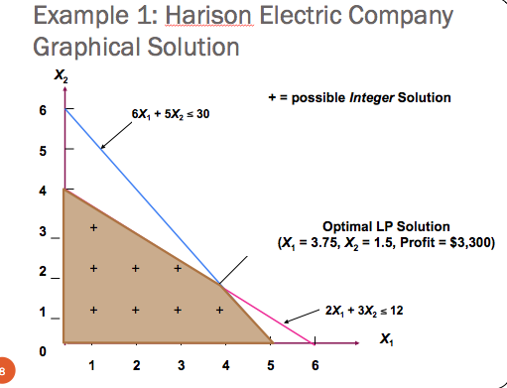

Example: Comments on reaching integer solution
- Rounding off is one way to reach integer solution values, but it often does not yield the best solution.

Problems of Rounding:
- It could push the solution outside of the feasible region (inadmissible solution is selected)
- It may appear logical to round off, but it may not the be optimal integer solution

- An IP solution can never be better than the solution to the same LP problem. The integer problem is usually worse in terms of higher cost or lower profit.
Ex: Think graphically
- Although enumeration is feasible for some small integer programming problems, it can be difficult or impossible for large ones.

Integer Programming Techniques
1. Cutting Plane Method
- A means of adding one or more constraints to LP problems to help produce an optimum integer solution

2. Branch and Bound Method
- An algorithm for solving all-integer and mixed-integer LP and assignment problems. It divides the set of feasible solutions into subsets that are examined systematically.
- The Solver uses this method

Formulating and Solving Spreadsheet Models for Integer Programming Problems
- Similar to LP except we need to include the constraints that the decisions variables need to be integer
  - Variable Cells = integer
  - Solver Options
    - Take off the check mark from “Ignore Integer constraints”
    - Integer Optimality (%)
      - Set at 0.05% default value
    - Maximum Time Allowed
      - Max Time option set to 100 seconds default value
  - See next two slides
    - Refer to : 7_Integer_and_Binary_Programming Problems Solution.xls”

Types of Integer Programming Problems
1. Pure Integer Programming
  - all variables must have integer solutions
2. Mixed Integer Programming
  - some, but not all variables have integer solutions
3. Binary (0-1) Integer Programming
  - all variables have values of 0 or 1
4. Mixed binary integer programming problems.
  - Some decision variables are binary, and other decision variables are either general integer or continuous valued

Binary Integer Programming
  - Binary Integer Programming (BIP): the model for a BIP is identical to that for a LP problem except that the nonnegativity constraints for at least some of the variables are binary variables.
  - Pure BIP problem
  - Mixed BIP problem

- Binary Variables:
  - A variable whose only possible values are 0 or 1.
    - Used when dealing with yes-or-no decisions
      - Example 2
    - OR used to help formulate the model constraints and/or objective function (do not represent a yes-or-no decision)
      - Called “auxiliary binary variable”
      - Example 3
- Binary (zero & one) variables are defined as

1 if an event takes place
Y =

0 if an event doesn’t take place

BIP: Example 2 – Employee Scheduling Application
The Department head of a management science department at a major Midwestern university will be scheduling faculty to teach courses during the coming autumn term. Four core courses need to be covered.

The four courses are at the UG, MBA, MS, and Ph.D. levels. Four professors will be assigned to the courses, with each professor receiving one of the courses. Student evaluations of professors are available from previous terms. Based on a rating scale of 4 (excellent), 3 (very good), 2 (average), 1(fair), and 0(poor), the average student evaluations for each professor are shown:

Professor D does not have a Ph.D. and cannot be assigned to teach the Ph.D.-level course. If the department head makes teaching assignments based on maximizing the student evaluation ratings over all four courses, what staffing assignments should be made?
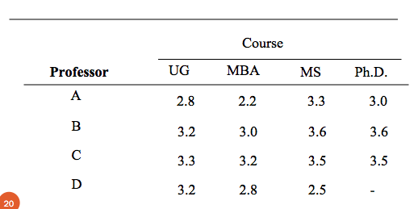
Z = 13.3
(Max rating is 13.3)

- Excel Solution
  - Y11 = 0
  - Y12 = 0
  - Y13 = 1 (assign Prof A to MS)
  - Y14 = 0
  - Y21 = 0
  - Y22 = 0
  - Y23 = 0
  - Y24 = 1 (assign Prof B to PHD)
  - Y31 = 0
  - Y32 = 1 (assign Prof C to MBA)
  - Y33 = 0
  - Y34 = 0
  - Y41 = 1 (assign Prof D to UG)
  - Y42 = 0
  - Y43 = 0

Example 3 – Progressive Company
The Research and Development Division of the Progressive
Company has been developing four possible new product lines.
Management must now make a decision as to which of these
four products actually will be produced and at what levels.

Therefore, a management science study has been requested to
Find the most profitable product mix.

A substantial cost is associated with beginning the production
of any product, as given in the first row of the following table.
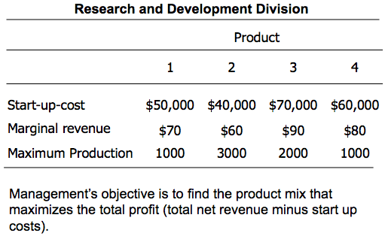

Let the Integer decisions variables x1, x2, x3, and x4 be the total number of units produced of products 1, 2, 3 and 4, respectively. Management has imposed the following policy constraints on these variables:
- No more than two of the products can be produced
- If product 3 or 4 is produced then product 1 or 2 must be produced
- Either:
  - 5x1+3x2+6x3+4x4 <= 6,000 or Either 4x1+6x2+3x3+5x4 <= 6,000
Use binary decision variables to formulate and solve the mixed BIP model.

Let:
- Yi = 1 if product i is produced
0 if product i is not produced
Constraint :
- Y1 + Y2 + Y3 + Y4 <= 2
- Extension of the Mutually Exclusive Alternatives Constraints
  - Mutually exclusive constraint is a constraint requiring that the sum of two or more binary variables be less than or equal to 1. Thus if one of the variables is equal to 1, the others must equal zero.

Either 5x1+3x2+6x3+4x4 <= 6,000
Or Either 4x1+6x2+3x3+5x4 <= 6,000

- Either-or constraints are not allowed in Linear or Integer Programming
  - A pair of constraints such that either one can be chosen to be observed and then the other one would be ignored
- Use auxiliary binary variables to reformulate this model into a standard format, in order to be able to find the optimal solution.
- Y = 0 if 5x1+3x2+6x3+4x4 <= 6,000 must hold
Or 1 if 4x1+6x2+3x3+5x4 <= 6,000 must hold

This definition will be enforced by introducing an extremely large positive number (we will use 1,000,000)
- Either 5x1+3x2+6x3+4x4 <= 6,000 + 1,000,000Y
- Or 4x1+6x2+3x3+5x4 <= 6,000 + 1,000,000(1-Y)
5x1+3x2+6x3+4x4 - 1,000,000Y <= 6,000
4x1+6x2+3x3+5x4+1,000,000Y <= 1,006,000
Y is binary
If Y = 0, then
- 5x1+3x2+6x3+4x4 <= 6,000 (must hold)
- 4x1+6x2+3x3+5x4 <= 1,006,000 (this basically eliminates the constraint)
If Y = 1, then
- 5x1+3x2+6x3+4x4 <= 1,006,000(this basically eliminates the constraint)
- 4x1+6x2+3x3+5x4 <= 6,000 (must hold)

See book page 331 for additional examples on Wyndor problem

Objective function
Max Z = Sale price – Costs to produce
Max Z = 70x1 + 60x2 + 90x3 +80x4 – Costs (Setup Costs)
    - We need to subtract from this expression each setup cost if the corresponding product will be produced, but we should not subtract the setup cost if the product will not be produced.

Setup costs:
Since:
- Yi = 1 if product i is produced
0 if product i is not produced
Then:
- Y1 = 1 if x1 is produced
0 if x1 is not produced
- Y2 = 1 if x2 is produced
0 if x2 is not produced
- Y3 = 1 if x3 is produced
0 if x3 is not produced
- Y4 = 1 if x4 is produced
0 if x4 is not produced

Production constraints:
x1 <= 1000Y1
x2 <= 3000 Y2
x3 <= 2000 Y3
x4 <= 1000 Y4
x1 - 1000Y1 <= 0
X2 -3000Y2 <= 0
x3 - 2000Y3 <= 0
X4 - 1000Y4 <= 0
- We will only have production constraints if we produce the product i

The Mixed BIP Model Summary

Max Z = $70x1 + $60x2 + $90x3 +$80x4 - $50,000Y1 - $40,000Y2 - $70,000Y3 - $60,000Y4

Subject to

Y1 + Y2 + Y3 + Y4 <= 2
Y3 - Y1 - Y2 <= 0
Y 4 - Y1 - Y2 <= 0
5x1+3x2+6x3+4x4 - 1,000,000Y <= 6,000
4x1+6x2+3x3+5x4+1,000,000Y <= 1,006,000
x1 - 1000Y1 <= 0
X2 -3000Y2 <= 0
x3 - 2000Y3 <= 0
X4 - 1000Y4 <= 0
x1, x2, x3, x4 >= 0 and integer; Y,Y1,Y2,Y3,Y4 = 0, 1

Solution
- X2 = 2000
- Y2 = 1 (produce product 2)
- Z = 80000$
  - Here, Excel is telling us that we don’t need to produce anything else than product 2, which satisfies all constraints

Summary
Integer LP models have variety of applications including:
- capital budgeting problems (individual projects are represented as binary variables)
- facilities location problems (selecting a location is represented as a binary variable)
- airline crew scheduling problems (assigning crew to a particular flight is represented as a binary variable)
- knapsack problems (loading an item into a container is represented as a binary variable)

Helpful Rules: Modeling logical requirement for project selection

Let three projects be under consideration. The binary decision variables x₁, x₂, and x₃ represent whether or not each project will be selected.
Having x_{i}= 0 (project i not selected) or 1 (project i selected)
if one and only one of three projects can be selected, then the multiple choice constraint is written as
x₁ + x₂ + x₃ = 1
if at most one project (and possibly none) can be selected, then the multiple choice constraint is written as
x₁ + x₂ + x₃ ≤ 1
if project 1 (x₁) can be selected only if project 3 (x₃) is selected, then the multiple choice constraint is written as
x₁ - x₃ ≤ 0
if both projects 2 (x₂) and 3 (x₃) or neither can be selected, then the multiple choice constraint is written as
x₂ - x₃ = 0

Helpful Rules: Modeling logics using binary programs
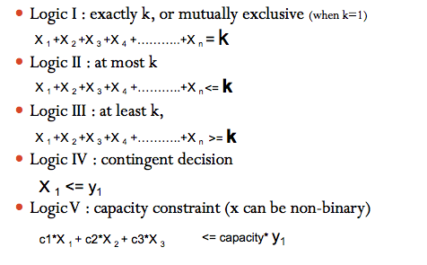

Week 8

- Profit maximization or cost minimization is not always the only objectives
- Maximizing total profit is one of the several objectives including other contradictory objectives as:
  - maximizing market share,
  - maintaining full employment,
  - minimizing insatisfaction,
  - providing quality ecological management,
  - minimizing noise level, and
  - meeting other non-economic targets or goals.

- An important technique developed to supplement LP is Goal Programming
- A technique deisgned to solve problems in which there is more than one objective/multiple goals (Multicriteria Decision Problems)
- For example, being given multiple objective functions to optimize at one revenues, profits and client insatisfaction (which are contradictory)

Goal Programming (vs. LP)
- Multiple Goals (instead of one goal)
- Satisfying instead of optimizing
- Coming as close as possible to reaching the goal
- Objective function is the main difference
- Deviational Variables Minimized (instead of maximizing profit or minimizing cost of LP)
- Once the goal programming is formulated, we can solve it the same way as a LP minimization problem

Max Z = 70x1 + 60x2 + 90x3 +80x4 - 50,000Y1 - 40,000Y2 - 70,000Y3 - 60,000Y4

Goal Programming Terms
- Deviational Variables represent overachieving or underachieving the desired level of each goal
- d+ Represents overachieving level of the goal
- d- Represents underachieving level of the goal
- General form of goal constraint:
Desired Goal
Level
Decision
Variables
- d⁺ + d⁻ =

- Objective function minimizes the sum of the weighted deviations from the target values – this is ALWAYS the objective for Goal Programming

Example of Goal Programming: Harison Electric Company Revisited
- Case presented earlier as IP problem:
Objective: maximize profit = $600X1 + $700X2
subject to

2X1 + 3X2 <= 12 (wiring hours)
6X1 + 5X2 <= 30 (assembly hours)
X1, X2 >= 0 and integer
where
X1 = number of chandeliers produced
X2 = number of ceiling fans produced

- We used the integer LP to find a single optimal solution
- (X1 = 3, X2= 2, profit=$3,200)
- New information: the firm is moving to a new location
- Maximizing profit is not a realistic goal during the move horizon
- Management as set a $3,000 profit level as satisfactory during the adjustment period.
- It is a goal Programming problem in which we want to find the production mix that achieves this goal as closely as possible given the production time constraints.

GP Model Formulation
Define two deviational variables:
- d₁⁻ : underachievement of the profit target
- d₁⁺ : overachievement of the profit target

Min Z = d₁⁻ + d₁⁺
Subject to:
$600X1 + $700X2 + d₁⁻ - d₁⁺ = 3000 (profit goal)
2X1 + 3X2 <= 12 (wiring hours)
6X1 + 5X2 <= 30 (assembly hours)

X1, X2 >= 0 and integer
d₁⁻, d₁⁺ >= 0

The objective function becomes a constraint with a target to meet

Comments on the GP Model
- First constraint:
$600X1 + $700X2 + d₁⁻ - d₁⁺ = $3,000

- The constraint contains over-achievement and under-achievement variables with respect to the $3,000 revised target.
- In the event that the target exceeds $3,000, the over-achievement variable d₁⁺ will state the amount over the target.
- In the event that the target is not met, the under-achievement variable d₁⁻ will state the amount under the target.
- In the event that the target amount is achieved, the under- and over-achievement variables will equal zero.

- If Harrison’s management was only concerned with underachievement of the target goal, how would the objective function change?

d₁⁺ eliminated from the objective function

Min. underachievement of Z = d₁⁻

- Overachievement acceptable the appropriate variable d_{i}⁺ can be eliminated from the objective function.
- Underachievement acceptable the d_{i}⁻ variable should be dropped.
- Seek to attain a goal exactly both d_{i}⁻ and d_{i}⁺ must appear in the objective function

Extension to Equally Important Multiple goals
- Goal 1: to produce as much profit above $3,000 as possible during the production period.
- Goal 2: to fully utilize the available wiring department.
- Goal 3: to avoid overtime in assembly department.
- Goal 4: to meet a contract requirement to produce at least seven ceiling fans.

Definition of the Deviational variables
- d₁⁻: underachievement of the profit target
- d₁⁺ : overachievement of the profit target
- d₂⁻: idle time in the wiring department
- d₂⁺ : overtime in the wiring department
- d₃⁻: idle time in the assembly department
- d₃⁺ : overtime in the assembly department
- d₄⁻: underachievement of the ceiling fan goal
- d₄⁺ : overachievement in the ceiling fan goal

Model Formulation
Min. total deviation = d₁⁻ + d₂⁻ + d₃⁺ + d₄⁻

Subject to
600X1 + 700X2 + d₁⁻ - d₁⁺ =3000 (profit constraint)
2X1 + 3X2+ d₂⁻ - d₂⁺ =12 (wiring hours)
6X1 + 5X2 +d₃⁻ - d₃⁺ =30 (assembly hours)
X2 + d₄⁻ - d₄⁺ = 7 (ceiling fan constraint)

All X_{i} (integer) and d_{i} variables >= 0

Ranking/Weighting Goals
- A key idea in goal programming is that one goal is more important than another.
  - Priorities or weights are assigned to each deviational variable (e.g. P₁ is most important goal, P₂ the next most important, then P₃, and so on.)
- Example: let’s say Harison Electric sets the priorities shown in the following table:

Weighted Goal Programming
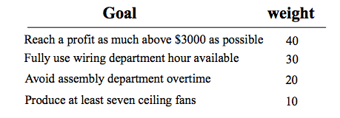
Objective function becomes:
Min. total deviation = 40d₁⁻ + 30d₂⁻ + 20d₃⁺ + 10d₄⁻
The constraints remain identical to the previous ones.

Or Preemptive Goal Programming
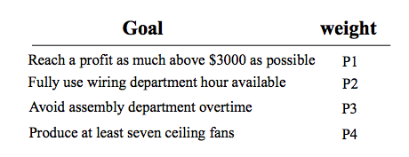
Objective function becomes:
Min. total deviation = P1d₁⁻ + P2d₂⁻ + P3d₃⁺ + P4d₄⁻
The constraints remain identical to the previous ones.

Solving the Goal Programming Problem
- Solve multiple goal program using
  - weighted goals approach
    - Weights can be used to distinguish between different goals (refer to the excel file)
    - The problem reduces to a simple LP model
Or
  - Ranking/preemptive goals approach
    - Requires to solve a series of LP models
      - Four LP models in the case of our example
- Solutions with weighted goals and preemptive goals can be different for the same problem.

Example 1 (Given on a Final Exam)
- Michelow Ski Ldt. (MSL) is planning its winter production schedule for its top-end designer winter sports equipment. MSL manufactures three product lines: snowboards, downhill skis and cross-country skis. To produce a designer snowboard requires two hours of fabrication time and six hours of finishing time. Three hours of fabrication time and five hours of finishing time are needed to produce a pair of designer downhill skis, while a pair of cross-country skis requires 3.5 hours of fabrication time a 4.5 hours of finishing time. Profit per unit for the products is $600 for a snowboard, $700 for a pair of downhill skis and $675 for a pair of cross-country skis. There are 120 hours of fabrication time available, and 300 hours of finishing time.
- MSL has three objectives it would like to meet. First, MSL would like to achieve a profit of at least $30,000. Second, MSL would like to produce exactly 55 snowboards. Finally, MSL would like to use all of the available fabrication time.
- Develop a goal programming model for this problem.

Example 2
A mutual fund manager wants to determine level of future purchases to be made in the following categories:
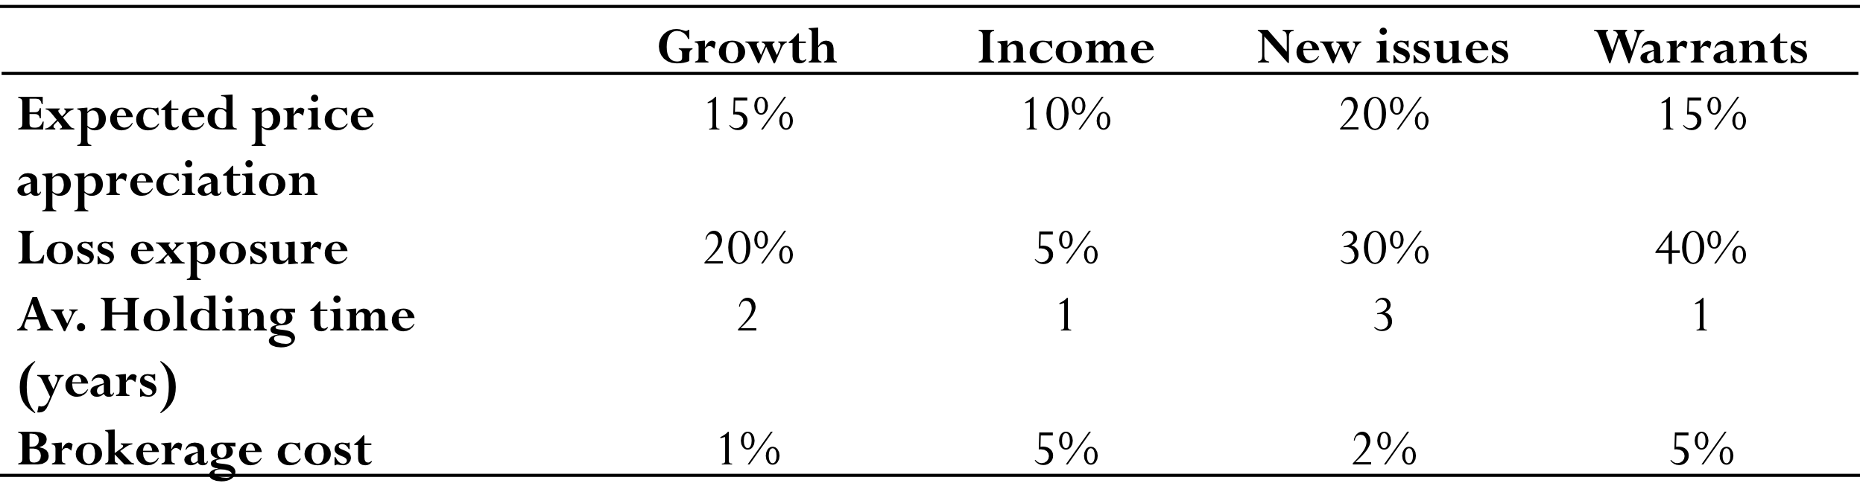
There is $ 1 million to be invested. The following investment should be met:
Goal 1: total potential loss exposure should be no greater than $200,000;
Goal 2: average portfolio holding time should be at least 1.5 years;
Goal 3: total brokerage cost should be $15,000, if possible.

Decision variables:
X1 = unknown amount of $ invested in growth category;
X2 = unknown amount of $ invested in income category;
X3 = unknown amount of $ invested in new issues;
X4 = unknown amount of $ invested in warrants.

Objective function
Minz = d₁⁺+ d₂⁻ + d₃⁺ + d₃⁻

Such that
(Loss exposure)
0.2X1 + 0.05X2 + 0.3X3 + 0.4X4 + d₁⁻ - d₁⁺ = 200,000

(Average portfolio holding)
2X1 + X2 + 3X3 + X4 + d₂⁻ - d₂⁺ = 1.5*1000000

X1, X2, X3, X4 are amounts that multiply average holding years, thus we must have amounts on the right hand side and we multiply by 1 million

(Total brokerage cost)
0.01X1 + 0.05X2 + 0.02X3 + 0.05X4 + d₃⁻ - d₃⁺ = 15000
Xi, di+, di- >= 0 for i = 1 to 3
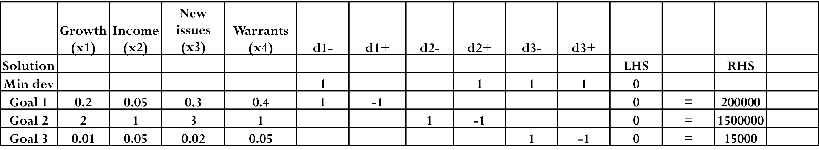
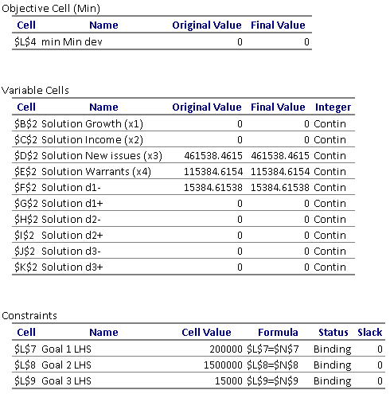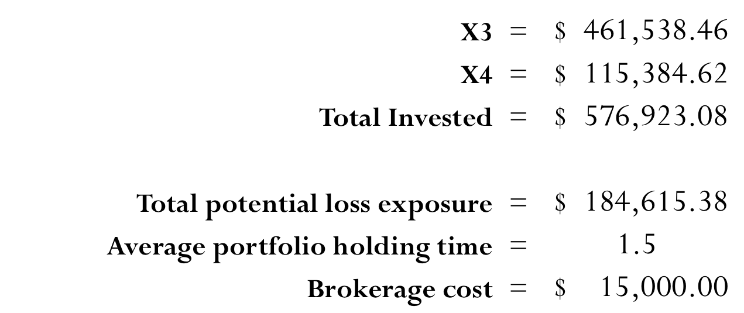

Example 3 – LP Formulation
A company manufactures four models of the lawn mower and in the final part of the manufacturing process there are assembly, polishing and packing operations. For each model, the time required for these operations is shown below (in minutes) as is the profit per unit sold.
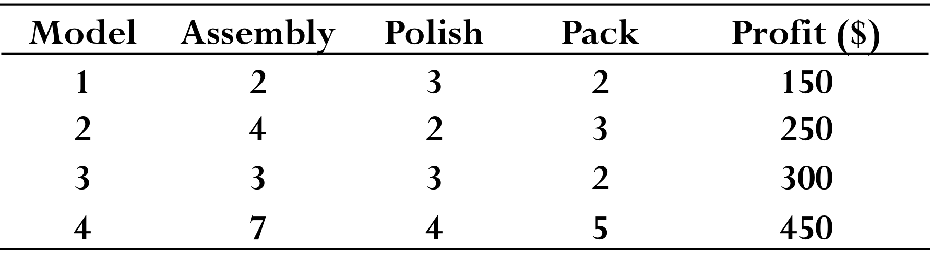

Suppose that the company is free to decide how much time to devote to each of the three operations (assembly, polishing and packing) within the total allowable time of 210000 minutes. In order to take full advantage of new corporate taxation policy, a company plans to achieve a profit of at most $200,000. At the same time, in order to establish its presence in the market niche, it wants that at least $85,000 of its profit is derived from selling models # 3 and 4. How many of each model should the company make per year in order to satisfy these goals?
Formulate a goal programming model.

Variables
Let :
xi be the number of units of model i (i=1,2,3,4) made per year
Tass be the number of minutes used in assembly
Tpol be the number of minutes used in polishing
Tpac be the number of minutes used in packing
where xi >= 0 i=1,2,3,4 and Tass, Tpol, Tpac >= 0
Objective function
min d₁⁺ + d₂⁻
Constraints
(a) operation time definition
Tass = 2x1 + 4x2 + 3x3 + 7x4 (assembly)
Tpol = 3x1 + 2x2 + 3x3 + 4x4 (polish)
Tpac = 2x1 + 3x2 + 2x3 + 5x4 (pack)

(b) operation time limits
Tass + Tpol + Tpac <= 210,000 (total time)

(c) goal constraints
150x1 + 250x2 + 300x3 + 450x4 + d₁⁻ - d₁⁺ = 200,000
300x3 + 450x4 + d₂⁻ - d₂⁺ = 85,000

Example 4
Microcom is a growth oriented firm which establishes monthly performance goals for its sales force

Microcom determines that the sales force has a maximum available hours per month for visits of 640 hours

Further, it is estimated that each visit to a potential new client requires 3 hours and each visit to a current client requires 2 hours

Microcom establishes two goals for the coming month:
- Contact at least 200 current clients
- Contact at least 120 new clients
Overachieving either goal will not be penalized

Step 1: Define the decision variables:

X1 = the number of current clients visited
X2 = the number of new clients visited

Step 2: Define the goals:

Goal 1 – Contact 200 current clients
Goal 2 – Contact 120 new clients

Step 3: Define the deviational variables

d1+ = the number of current clients visited in excess of the goal of 200
d1- = the number of current clients visited less than the goal of 200
d2+ = the number of new clients visited in excess of the goal of 120
d2- = the number of new clients visited less than the goal of 120

Complete formulation:
Minimize Z = d1⁻ + d2⁻

Subject to:

2X1 + 3X2 <= 640
X1 + d1⁻ - d1⁺ = 200
X2 + d2⁻ - d2⁺ = 120
X1, X2 => 0
d1⁺, d1⁻, d2⁺, d2⁻ => 0

X1 = 200 Goal 1 achieved
X2 = 80 Goal 2 not achieved

d1+ = 0 d2+ = 0
d1- = 0 d2- = 40
Z = 40

Week 9 and 10
Introduction
- LP models were all formulated under the assumption that certainty existed
- Several decision making techniques are available to aid the decision maker in dealing with the type of decision situation in which there is uncertainty.

Learning Objectives
- List steps of decision making process.
- Describe different types of decision making environments.
- Make decisions under uncertainty when probabilities are not known.
- Make decisions under risk when probabilities are known.
- Develop accurate and useful decision trees.
- Revise probability estimates using Bayesian analysis.
- Understand the importance and use of utility theory in decision making.

Components of Decision-Making
- Decisions themselves
- State of Nature: the uncontrollable events that may occur in the future
Ex: payoff table

Payoff table
- A mean of organizing and illustrating the payoffs from the different decision (alternative), given the various states of nature in a decision problem.

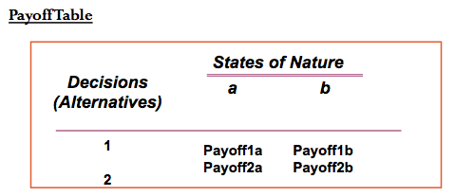

Types of Decision Making Environments

- Decision Making under Certainty
Example
- Decision Making under Risk (Decision making with probability)
Example
- Decision Making Under Uncertainty (Decision making without probability)
Example

The Six Steps in Decision Theory
- Clearly define the problem at hand
- List all the possible alternatives (decisions to be made)
- Identify the possible outcomes (state of nature) of each alternative
- List the payoff or the profit of each combination of alternatives and outcomes
- Select one of the mathematical decision theory models (e.g. Decision Making under Risk)
- Apply the model and make your decision

Example
- An investor is going to purchase one of three types of real estate. The investor must decide among an apartment building, office building and a warehouse (decisions). The future states of nature that will determine how much profit the investor will make are (1) good economic conditions and (2) poor economic conditions.
- The profits that will result from each decision in the event of each state of nature are shown in the following table.
Payoff table for the real estate investment

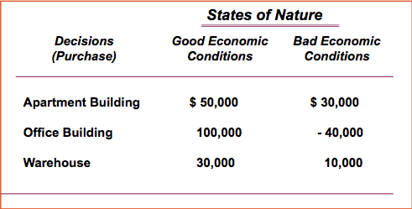

Decision Making Under Uncertainty
Four Criteria
- MAXIMAX - find the alternative that maximizes the maximum payoff for every alternative
- MAXIMIN - find the alternative that maximizes the minimum payoff for every alternative
- EQUALLY LIKELY - find the alternative with the highest average payoff
- MINIMAX REGRET - minimizes the maximum regret (regret is the difference between the payoff from the best decision and all the other decision payoffs)

Maximax Criterion: The Optimistic Approach
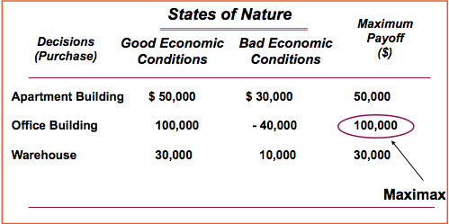

Maximin Criterion: The Conservative Approach

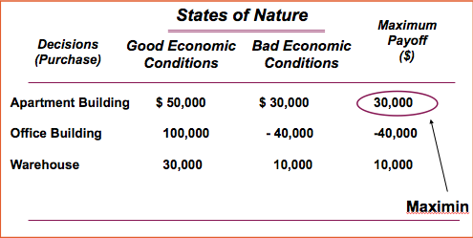

Equally Likely Criterion
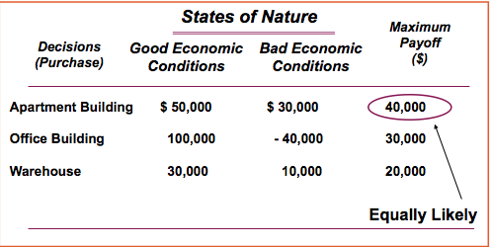

The Minimax Regret Criterion
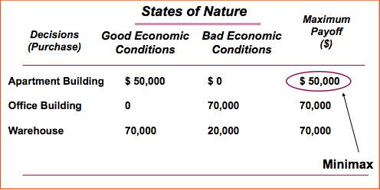

Decision Making Under Risk (probabilities assigned to the states of nature)

Decision Criteria
- The Maximum Likelihood Criterion
- Expected Monetary Value (EMV) = Expected Payoff (EP)
- The Expected Opportunity loss

Expected value of Perfect Information

- Decision Maker must first estimate the probability of occurrence of each state of nature (prior probabilities)
- Once these estimates have been made, then the decision criterion mentioned can be applied

Real Estate Investment Example
- Let us suppose that based on several economic forecasts, the investor is able to estimate 0.6 probability that good economic conditions will prevail and 0.4 probability that poor economic conditions will prevail in the future.

1. The Maximum Likelihood Criterion
- Identify the state of nature with the largest probability
- Choose the decisions alternative that has the largest payoff

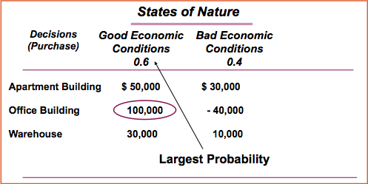

2. Expected Payoff (EP) Criterion
EP (alternative i/decision i) =
(payoff of first state of nature)*(its prob.) + (payoff of second state of nature)*(its prob.)+…+ (payoff of last state of nature) * (its prob.)

- The Best decision is the one with the greatest EP

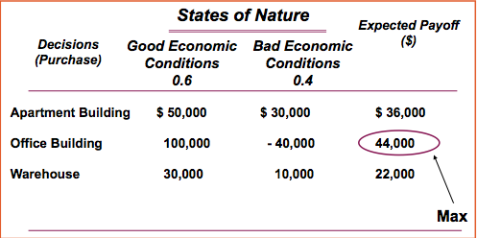

- The EP means that if the decision situation of purchasing an office building occurred a large number of times, an average payoff of $44,000 would result
- If the payoffs were in terms of costs, the best decision would be the one with the lowest EP

3. Expected Opportunity Loss (EOL)
- An alternative approach in decision making under risk is to minimize expected opportunity loss (EOL).
- Opportunity loss, also called regret, refers to difference between optimal profit or payoff and actual payoff received.
- EOL for an alternative is sum of all possible regrets of alternative, each weighted by probability of state of nature for that regret occurring.
- EOL (alternative i) = (regret of first state of nature)
x (probability of first state of nature)
+ (regret of second state of nature)
x (probability of second state of nature)
+ . . . + (regret of last state of nature)
x (probability of last state of nature)

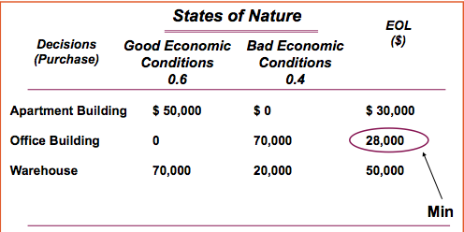

- Using minimum EOL as decision criterion, best decision would be second alternative, “purchase an office building" with an EOL of $28,000.
- Minimum EOL will always result in same decision alternative as maximum EP.

Expected Value of Perfect Information
- Is used to place an upper limit on what you should pay for information that will aid in making a better decision.
- Is the increase in the EP that could be obtained if it were possible to learn the true state of nature before making the decision.
- Is the difference between the expected payoff under certainty and the expected payoff under risk (i.e. without more info)
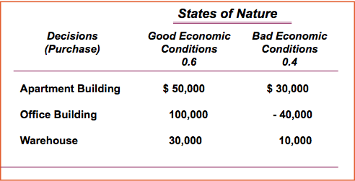

Expected payoff under certainty (EPC) = Expected payoff with perfect information
- If the market is booming : Invest in the office building ($100,000).
- If the market is not booming : Invest in an apartment building ($30,000).
- There is a 60% chance that a payoff will be $100,000 and a 40% chance that it will be $30,000 for an expected value under certainty of
  - EPC = 0.6x100,000 + 0.4 x30,000 = 72,000

- EPC=(best payoff for first state of nature)x(its prob.) + (best payoff for second state of nature)x(its prob.) +…+(best for last state of nature)x(its prob.)
- EPC = 0.6x100,000 + 0.4 x30,000 = 72,000
- $72,000 is the expected on average return, in the long run, if we have perfect information before a decision is to be made (we are certain which state of nature is going to occur before a decision has to be made).

Computing EVPI
- Expected Value of Perfect Information=EVPI = (expected payoff under certainty) – (the expected payoff under risk)
- EVPI = EPC - maximum EP
    - = 72,000 – 44,000 = $28,000
- $28,000 is the maximum amount that would be paid to gain information that would result in a decision better that the one made without perfect information

Example
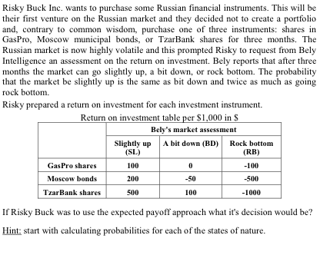Solution
- p(SL) = p(BD) = 2 p(RB)
- p(SL) = 0.4, p(BD) = 0.4, p(RB) = 0.2

EP(GasPro)=0.4*100+0.4*0 + 0.2*(-100)=20
EP(Moscow)=0.4*200+0.4*(-50) + 0.2*(-500) =-40
EP(TzarBank)=0.4*500+0.4*100 + 0.2*(-1000) = 40

- Choose TzarBank

Decision Trees
- A Graphical diagram used for making decisions. It represents the sequence of events in a decision situation.
- What are the benefits and advantages of decision trees?

:A decision node from which one of several alternatives may be selected. The branches emanating from them reflect the alternative decisions possible at that point.
:A state of nature node out of which one state of nature will occur. The branches emanating from them indicate the state of nature that can occur.

The Five Steps with Decision Trees
- Define the problem
- Structure or draw the decision tree
- Assign probabilities to the states of nature
- Estimate the payoffs for each possible combination of alternative and state of nature. Solve the problem by computing expected payoff (EP) for each state of nature node
- Make your decision

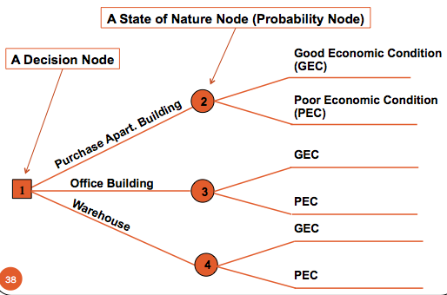

How to compute EP
- Start with the final payoffs and work backward through the decision tree towards node 1
- EP is computed at each probability node

Example
This is just the beginning of the ADM2302 course and Andrew does not know if he should attend all classes. He consulted some other students and came to the following conclusions:
- chances of passing a course while attending all classes are 80%;
- chances of passing a course while attending randomly are 50%.
It is well known that the professor who is teaching that course is giving a second chance to the students who fail. They have to solve a pretty nasty case study. Once again, Andrew estimates that chances of solving this case if he would go to all the classes are 60%, while they drop to just 10% if he would attend classes randomly.
Andrew would be very happy if he passes the course (5 on a happiness scale of 0 - 5). Clearly, he would be very disappointed if he failed (0 on a happiness scale). Going to a classroom requires an effort and diminished happiness associated with passing the course. It goes down by 3 points (happiness scale) for attending all classes and 1 point for random attendance.
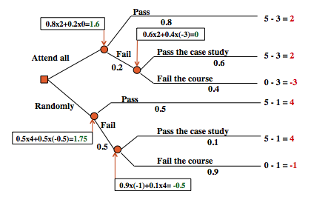
He should attend randomly with 1.75 on the happiness scale which is greater than 1.6

Example 2
- You are currently considering to insure the contents of your house against theft for one year. You estimate that the contents of your house would cost $20,000 to replace. Ottawa crime statistics indicate that there is a probability of 3% that your house will be broken into. In that event your loss would be 10%, 20%, or 40% of the contents with probabilities 0.5, 0.35 and 0.15 respectively.
- An insurance policy from General Accident (GA) costs $200/year but guarantees to replace any losses due to theft. An insurance policy from the Federation Insurance (FI) is cheaper and costs $100/year but you have to pay first $x (if x=200 then it is first $200) of any loss. An insurance policy from Prudential Insurance (PI) is even cheaper at $75/year, but it replaces only a fraction of y% (if y=60 then it is 60%) of any loss suffered. Of course, you could alternatively choose not to insure your house at all.
- Assume that there can be at most one theft a year.

- Decide what to do if x=50 and y=40 and your goal is to minimize your losses.
- Assuming that y=40, what would be the highest value for “x” so the insurance company selected in answer to “1” is still the best choice?
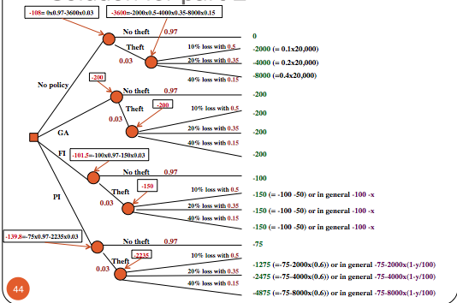

- Values
  - EP (no insurance) = -108
  - EP(GA) = -200
  - EP (FI) = - 101.5
  - EP (PI) = -139.8
- What should be “deductible” x?
Compare FI with the next best option (no insurance)
(-100 - x)x0.03 - 100x0.97 = -108
- Approximately $267

Sequential Decision Trees
Example:
We will alter our real estate investment example to encompass a 10-year period during which several decisions must be made.
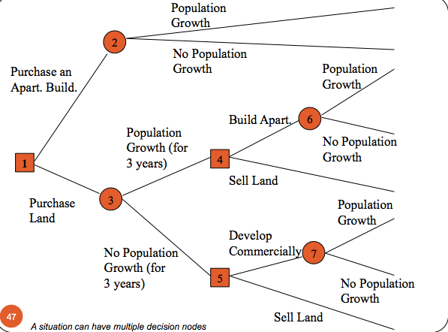

Decision Analysis with Additional Information

Baye’s Theorem( Bayesian Analysis)
- Used to incorporate additional information as it is made available
- To create Revised or Posterior Probabilities
  - We can take into consideration new or more recent data, then revise and improve upon the old probability for an event.

Example: The real estate investment
- Purchasing additional information:
  - Suppose that the investor has decided to hire a professional economic analyst who will provide additional information about future economic conditions. The analyst is constantly researching the economy, and the results of the research are what the investor will be purchasing.
- The economic analyst will provide a report predicting one of two outcomes: positive report or negative report.
- Based on the analyst’s past record in forecasting future economic conditions, the decision maker (the investor) can determine conditional probabilities of the different report outcomes given the occurrence of each state of nature in the future.
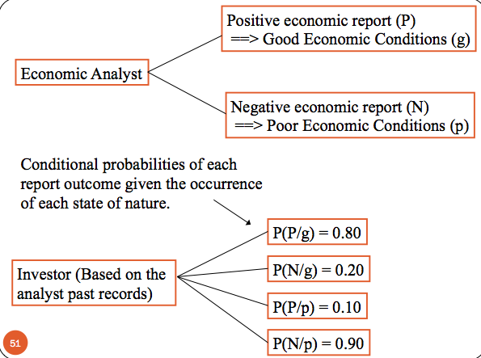

Prior Probabilities
- Is the estimated probabilities of the states of nature prior to obtaining additional information through a test or survey.
- The prior probabilities that good or poor economic condition will occur in the future are:
P(g) = 0.60
P(p) = 0.40

Conditional Probabilities of the report + Prior Probabilities

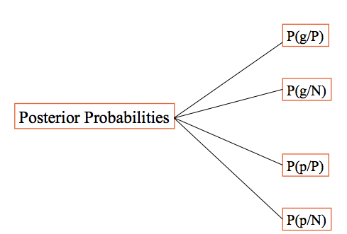

Posterior Probabilities (Revised Probabilities)
- Given the Conditional Probabilities, the Prior Probabilities can be revised to form Posterior Probabilities by mean’s of Baye’s rule.
- E.g. Posterior Probability of good economic conditions given a Positive report is:

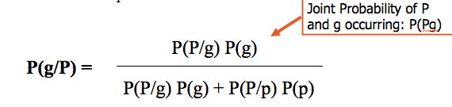

Additional piece of probabilistic information
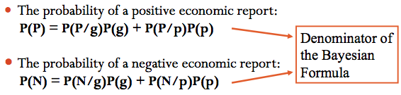

Alternative Method for Computing Posterior Probabilities with Tables
- The more we have additional information the more the size of the problem increases.
- The application of Baye’s rule to compute posterior probability become more complex with larger problems.
- It can be computed using tables. This approach is more systematic than direct Baye’s rule formulas.

1. Probabilities Revisions Given a Positive Economic Report
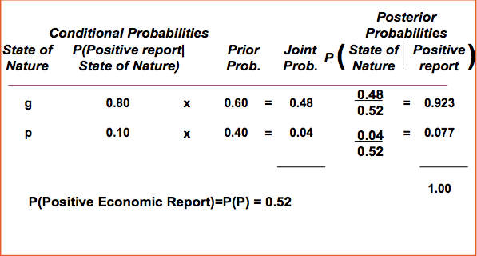

2. Probability Revision Given Negative Report
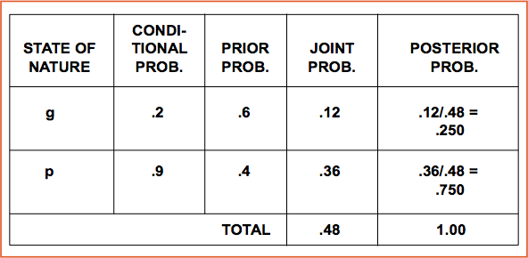

Investor’s Original Decision Tree
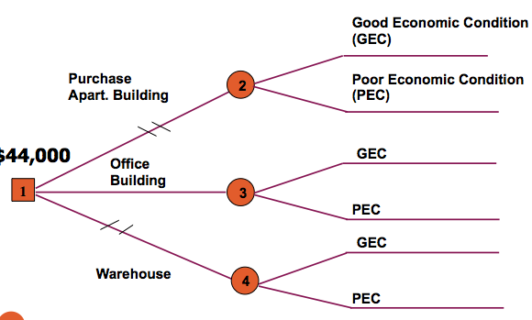

Decision Trees with Posterior Probabilities
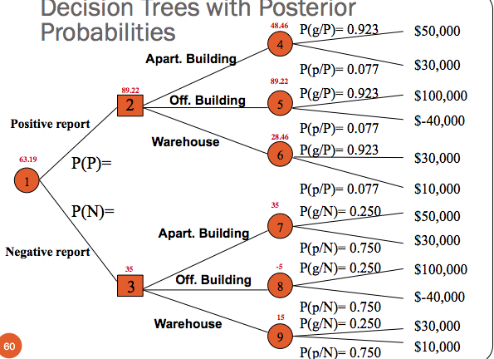

The Difference Between this Tree and the Original One
- A decision tree with two new branches
- Using Posterior Probabilities in the decision tree

Decision Strategies
- A plan of decisions to be made given either a positive or negative report from economic analyst.
  - Example: the two results at node 2 and 3 are referred to as decisions strategies.
- The Expected Payoff of a decision strategy given additional information(a report forecasting future economic condition generated by the economic analyst) is:
- EP (Decision Strategy) = $63,194.4

The Expected Value of Sample Information (EVSI)
- EVSI =
  - Expected Value with information - Expected value without information
- The investor would be willing to pay the Economic Analyst up to $19,194.40 for an economic report that forecasted future economic condition.
- EVPI = $28,000 and EVSI = $19,194.40
- Is this a logical result?

Efficiency of Sample Information
- We can determine how close to perfect our sample information is by computing the efficiency of sample information as follows:
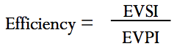

- A high efficiency rating indicates that the information is very good, or close to being perfect information.
- A low rating indicates that the additional information is not very good.
- 0.68 is relatively high; thus it is doubtful that the investor would seek additional information from an alternative source.

