Lab Experiment #1: Verification of Boyle’s Lab
Introduction:
An ideal gas is a hypothetical gas that, through physical behaviour, conforms to the relationship between pressure, temperature and volume. This is known as the general gas law theory, defined by the equation PV=nRT, where “R” is a universal gas constant, “P” is pressure, “n” is the number of molecules, “T” is temperature and “V” is volume.
This theory relies on the following assumptions:
- The gas obeys Newton’s Laws of Motion
- When compared, the volume of the molecules should be smaller than that of the gas.
- No other forces are acting on the molecules (ie. Forces of attraction, gravity, etc.)
The gas law theory is a generalization that includes Boyle’s Law, developed in 1662 stating that the pressure of a gas is inversely proportional to its volume, that being only if it is an ideal gas and the temperature is an absolute constant. This derives the following equation: P₁V₁=P₂V₂ or PV=K.
The purpose of this experiment is to verify Boyle’s Law through the investigation and evaluation of the relationship between the pressure and volume of a confined gas.
In order to prove or falsify Boyle’s Law, in this experiment pressure will be evaluated using LabQuest2 based on the volumes chosen to explore their inverse relations.
Materials:
- Vernier Gas Pressure Sensor
- Syringe
- LabQuest 2
- USB Key
Note: The independent variable is the volume. The dependent variable is the pressure.
Procedure:
Safety Precautions:
- Wear lab coat and eye protection (goggles).
- Have hair tied back.
- Have any loose articles of clothing secured.
- Wear closed-toed shoes.
- No food or drink in the laboratory.
Protocol:
- Prepare the Gas Pressure Sensor by connecting it to the LabQuest 2.
- Prepare the 20 mL plastic syringe with the air sample.
  - Note that the pressure is measured in kPa and volume in mL.
- Attach the 20 mL plastic syringe to the Gas Pressure Sensor.
  - Be sure to secure the syringe by half-turning it to lock into place.
- Set up the LabQuest 2 to data-collection mode.
- To collect and plot measurements, first set the plunger to an initial volume (20 mL) mark. Once this is stabilized, record the data in an observations table.
  - Note to add 0.8mL to the volume to take into account the measurement errors.
- Move the plunger to change the volume and repeat step 5 to retrieve data for another 7 measurements (20mL, 18mL, 16ml, 14mL, 12mL, 10mL, 8mL). Record these values; this will count as trial one.
- Repeat steps 5 and 6 for another 2 trials and record these values as well.
- Since the initial volume (20mL) was measured twice, choose the data set that is more precise with the rest of the other data.
- Proceed to plotting the points onto LabQuest 2, and observe the graphs.
- Save the graphs onto a USB when completed.
Observations Table:
Table 1: Relationship between Pressure and Volume of a Confined Air Sample
Independent Variable  Volume (mL) | Trial #1  Dependent Variable – Pressure (kPa) | Trial #2  Dependent Variable – Pressure (kPa) | Trial #3  Dependent Variable – Pressure (kPa) | Average of Trials – Pressure (kPa)
20.8 | 101.26 | 101.30 | 101.30 | 101.29
18.8 | 111.86 | 111.52 | 111.23 | 111.54
16.8 | 125.55 | 124.62 | 124.57 | 124.91
14.8 | 142.34 | 142.06 | 142.24 | 142.21
12.8 | 164.88 | 165.79 | 164.20 | 164.96
10.8 | 193.82 | 197.15 | 195.78 | 195.58
8.8 | 225.25 | 225.26 | 225.26 | 225.26

Graphical Observations:
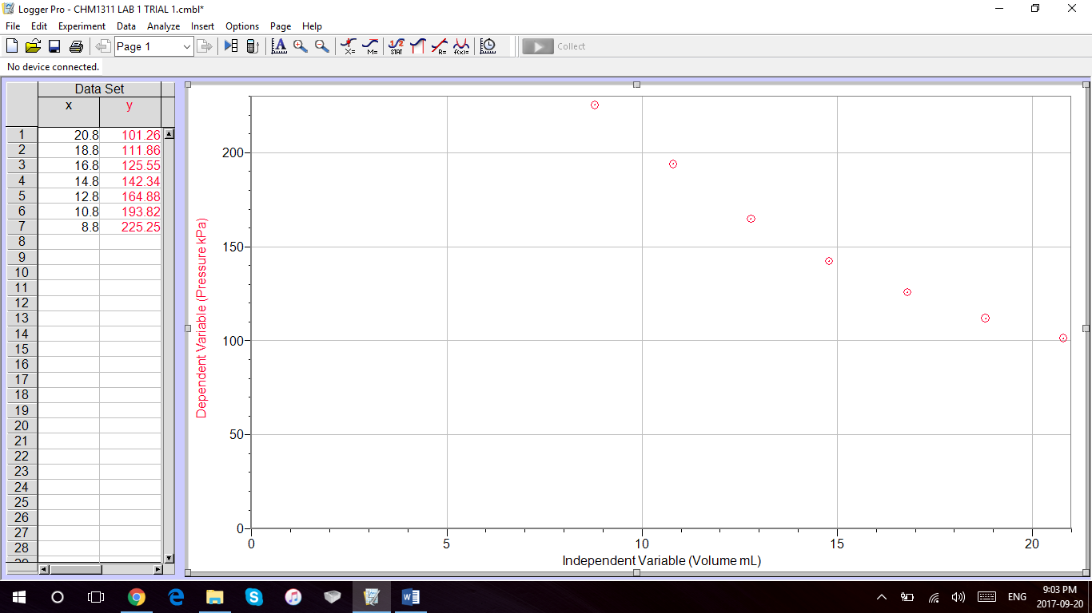
Graph #1: Lab Results: Relationship Between Volume and Pressure, Trial #1
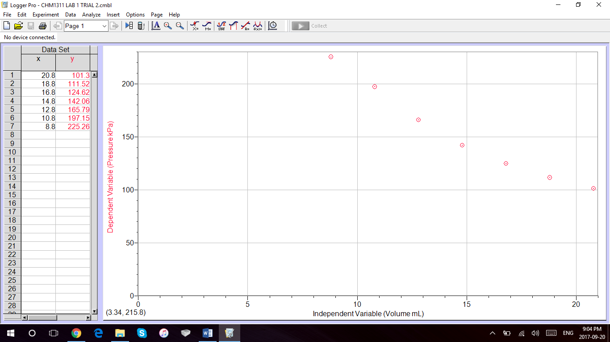
Graph #2: Lab Results: Relationship Between Volume and Pressure, Trial #2
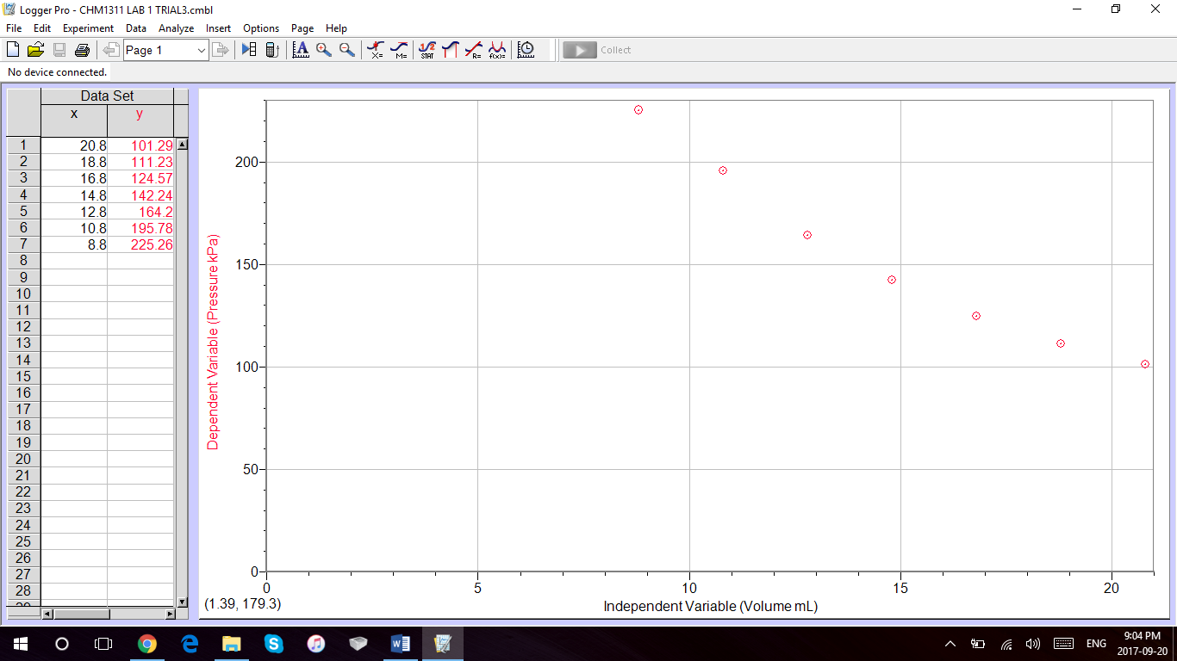
Graph #3: Lab Results: Relationship Between Volume and Pressure, Trial #3
Calculations:
PV=K
(20.8 ML)(101.29 kPa)=2110
(18.8 ML)(111.54 kPa)=2110
(16.8 ML)(124.91 kPa)=2110
(14.8 ML)(142.21 kPa)=2110
(12.8 ML)(164.96 kPa)=2110
(10.8 ML)(195.59 kPa)=2110
(8.8 ML)(225.26 kPa)=1980
Discussion:
Based on the lab results, the value of Boyle’s Law constant is approximately 2110, if one does not take into the account the possible experimental error. This constant was determined by evaluating the pressure-volume product if the temperature remained the same in the closed system of the ideal gas, defined by the equation PV=K.
The mathematical relationship illustrated by Boyle’s Law is that the pressure of a gas is inversely proportional to its volume, as initially presumed. Since P₁V₁ and P₂V₂ are both equal to “K”, which is a constant, then Boyle’s Law can be defined by the equation: P₁V₁=P₂V₂.
In this lab, it was stated that the initial and ending measurements had to be taken at the same mark of the syringe. The importance of taking these measurements is to evaluate the changes in pressure as it reaches the standard of 101.3 kPa, in reference to the effect that volume has on this standard.
Meanwhile, Boyle’s law requires that the temperature remains constant. However, when preforming the experiment, while these variables are taken into account, there is experimental error because temperature could have been affected by external conditions. This would be seen the most when looking at the calculations of the “k” constant for the 8.8 mL, since there was a slight change in temperature due to thermal energy transferred from the body to the syringe, and hence experimental values was not precise with the other data.
Alongside this, there is experimental error since the LabQuest2 is dependent on the value on the syringe being kept stable, and the pressure in the syringe made it difficult to have a precise set of values for pressure.
In order to visually evaluate these results, please refer to “Graphical Observations” for the graphs from Logger Pro.
Conclusion:
The purpose of this lab was to verify Boyle’s Law. This was done by observing the relationship between pressure and volume at standard temperature with a “k” constant that is inversely proportional relationship, as defined by PV=K or P₁V₁=P₂V_{2.} Boyle’s Law constant was calculated and the results was 2110.
Reference:
The Editors of Encyclopædia Britannica. “Boyle's Law.” Encyclopædia Britannica, Encyclopædia Britannica, Inc., 16 Apr. 2014, www.britannica.com/science/Boyles-law.

Raw Data


