Chapter 3 Homeostasis: Control Mechanisms
Homeostasis: Ability of body to maintain relatively stable internal conditions even though continuous change in outside world
- Not unchanging: it is dynamic state of equilibrium involving many systems:
  - (i) adequate blood levels of vital nutrients
  - (ii) heart activity/blood pressure monitored & adjusted as needed
  - (iii) wastes must not accumulate
  - (iv) body temperature (high temperature=permanent protein denaturisation)

3 Essential Characteristics of Homeostatic Control Mechanism:
- receptor: senses change (stimulus) & sends info (afferent pathway) to:  - control centre: determines set point (level/range) for variable maintenance; analyzes information and determines correct response  - effector: provides means for response (output along efferent pathway)  - feedback (negative/positive): allows for regulation within a range/enhanced response  - Variable: factor or event being regulated (e.g. body temperature, blood sugar) | 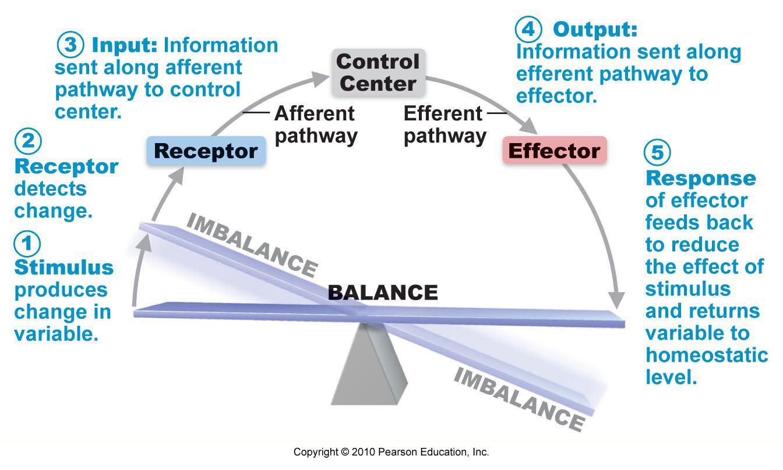
Negative Feedback Mechanisms
- Mechanisms cause variable to change in opposite direction; Shuts/reduces original effect of stimulus
- Goal: prevent sudden severe change in body, maintain around set point by:
  - (1) 1 hormone/neural pathway regulating a process via secretion
    - E.g. heart rate, blood pressure, rate of breathing
  - (2) Process regulated in opposite directions by 2 different hormones/neural pathways
    - E.g. Control of blood sugar
Positive Feedback Mechanisms
- Mechanism response enhances stimulus=output further stimulated  - Positive=Change in same direction as original response; Goal attained  - Controls infrequent events not requiring continuous adjustments  - Set off series of events; self-perpetuating (called cascades)  - E.g. Blood clotting: Maintains homeostasis as disturbance is sealed preventing further disruption  - Diseases =homeostatic disturbances=homeostatic imbalance  - Aging: progressive decrease in ability to maintain homeostasis (greater risk for illness); e.g Type 2 Diabetes  - NFM overwhelmed, PFM take over | 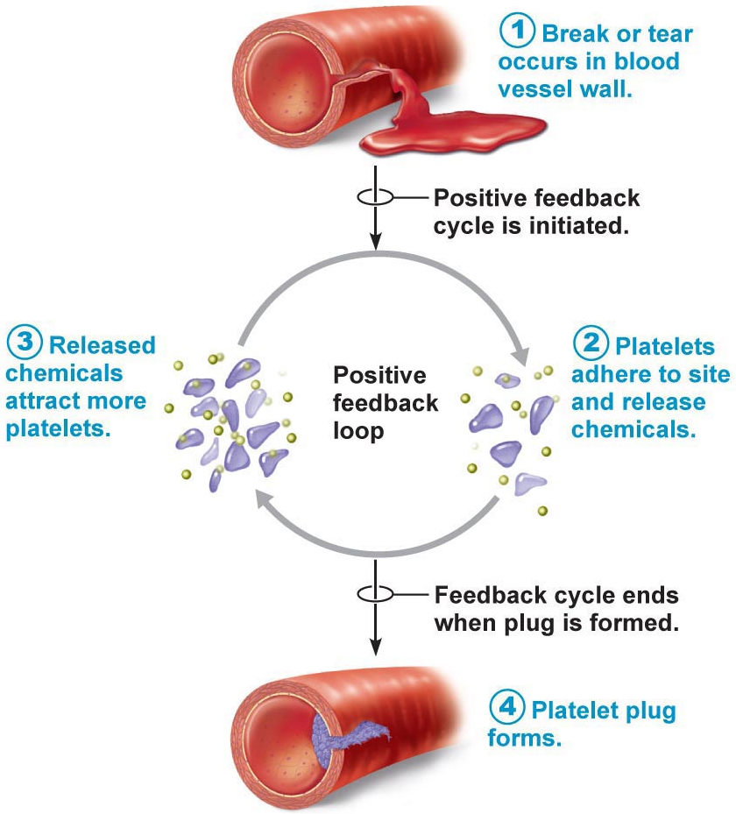
Chapter 14: The Autonomic Nervous System
- Auto=self, nom=govern (Parts of Peripheral NS)  - ANS (Involuntary)=system of motor neurons to smooth & cardiac muscle & glands to allow responses usually without our awareness (monitors stability of internal environment)  - Somatic NS (Voluntary): associated with skeletal muscle | 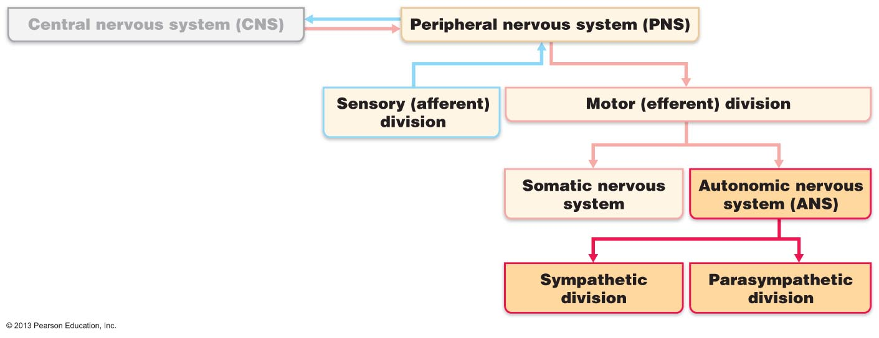
Examples of Functions:
- (i) shunt blood to more needy areas
- (ii) Speed/slow heart & respiratory rates
- (iii) Adjust blood pressure, body temperature
- (iv) Increase/decrease gastric secretions

14.1 The ANS differs from the Somatic Nervous System in that it can stimulate or inhibit its effectors
Key differences: (i) their effectors, (ii) their efferent pathways, (iii) target organ responses to their NT
Effectors: Somatic NS stimulates skeletal muscles, ANS innervates cardiac/smooth muscle, and glands
Efferent Pathways and Ganglia:  - Somatic: Thick, myelinated axon from spinal cord to skeletal muscle; rapid conduction of impulses (no ganglia)  - Motor neuros cell bodies in CNS, and axon extend from spinal cord to skeletal muscle  - Automatic: Two-neuron chain:  - Preganglionic neuron (cell body): originates in brain or spinal cord  - Preganglionic axon synapses with 2nd motor neuron (post ganglionic) in ganglion outside CNS  - Post ganglionic axon extends to effector organ  - Conduction slow: preganglionic axons thin, lightly myelinated; post ganglionic axons thinner & unmyelinated | 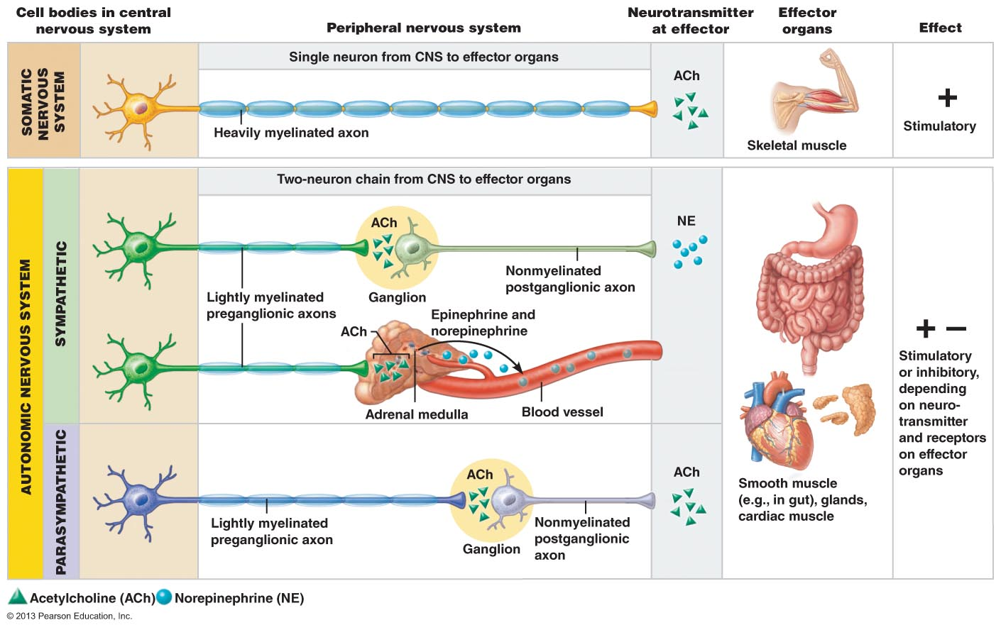

Neurotransmitter Effects:
- All somatic motor neurons release acetylcholine (ACh) at synapses (at neuromuscular junction)
  - Effect always excitatory, if stimulation reaches threshold then muscles contract
- Automatic post ganglionic fibers release two NT:
  - Norepinephrine secreted by most sympathetic fibers
  - ACh secreted by parasympathetic fibers
  - Depending on receptor on target organ, can be excitatory or inhibitory

14.2 The Autonomic System Consists of the Parasympathetic and Sympathetic Nervous System
- Dual-innervation: One system stimulates the contraction or secretion of gland while other inhibits
Role of the Parasympathetic System (most dominant):
- Active in non-stressful situations <<resting and digesting system>>
- Keeps body’s energy use low while regulating <<housekeeping>> activities (digestion, elimination of feces/urine)
  - Explains why good idea to rest after eating, so sympathetic system does not interfere
  - E.g. Person reads magazine after eating=blood pressure & heart rate regulated at low normal levels, GI tract actively digests food; Pupil are constricted and lenses are accommodated for close vision
- “D” system: digestion, defecation, diuresis
Role of Sympathetic Division:
- “Fight or flight” system: important during exercise—increased heart rate, rapid deep breathing, cold sweaty skin, dilated pupils (controls blood pressure at rest)
  - Physical activity: constricts visceral blood vessels (shunting blood to skeletal muscles/heart), dilated bronchioles increase air flow, simulate liver releasing more glucose, temporarily reduces GI activity
- ‘E” system: exercise, excitement, emergency, embarrassment

Key Anatomical Differences:
 | Parasympathetic | Sympathetic
Origin | - Craniosacral part (originate in brain): brain stem nuclei of cranial nerves, spinal cord segments (S2-S4) | - Thoracolumbar part (originate in thoracic and lumber regions): lateral horns of gray matter of spinal cord
Location of ganglia | - Terminal ganglia within visceral organ or close to target organ | - Ganglia within few centimetres of CNS; alongside vertebral column and anterior to vertebral column (collateral ganglia)
Relative length of pre and post ganglionic fibers | - Long preganglionic; short post ganglionic | - Short preganglionic; long postganglionic
Rami communicators | - NONE | - Grey and white rami communicants  - White rami myelinated preganglionic fibers  - Gray non-myelinated postganglionic fibers
Degree of branching of preganglionic fibers | - Minimal | - Extensive
(Functional role, neurotransmitters)

14.6 Acetylcholine and norepinephrine are major ANS neurotransmitters
- ACh is released by: (1) All ANS preganglionic neurons; (2) All parasympathetic postganglionic axons
- Fibers releasing ACh called cholinergic fibers
- Most sympathetic postganglionic axons release NE (called adrenergic fibers)
  - Exception is fibers secreting ACh onto sweat glands
- Action of any NT depends on the receptor it binds to (therefore ACh and NE not always excitatory)
Cholinergic Receptors: two types called nicotinic receptors (respond to nicotine) and muscarinic receptors (mushroom poison)
- Nicotinic Receptors: Found on all postganglionic neurons (in sympathetic and parasympathetic), hormone producing cells of adrenal medulla, sarcolemma of skeletal muscle at neuromuscular junction
  - Effect is ALWAYS stimulatory, ACh broken down by achtylcholindase enzyme
- Muscarinic Receptors: All postganglionic cholinergic fibers (All parasympathetic target organs, some sympathetic)
  - E.g. Sweat glands of sympathetic system; Excitation in most cases, inhibition in cardiac muscle
Adrenergic fibers: Two major classes of receptors: alpha and beta (with subclasses of 1,2,3)
- Can be excitatory or inhibitory depending on which sub-class of receptor is prominent (Table 14.3, pg 539)
  - E.g. B1 receptors pf cardiac muscle prompts heart for more vigorous activity
  - B2 in smooth muscle of bronchioles causes it to relax

14.7 Parasympathetic and Sympathetic Divisions usually produce opposite effects
Interactions of Autonomic Divisions
- Most visceral organs receive dual innervation (both parasympathetic and sympathetic)
Antagonistic Interactions: e.g. Activity of heat, GI system, respiratory system
Case of Fight or Flight | PNS | SNS
Heart | Slows down heart rate | Increases heart rate
GI system | Stimulatory | Inhibitory
Respiratory System | Not as many deep breaths | Increases rate of breathing
Define: Sympathetic Tone and Parasympathetic Tone
- SNS and vascular tone: Blood vessels kept in state of partial vasoconstriction
  - Blood vessels innervated by sympathetic fibers keeping them at partial constrictions
  - When blood pressure too low, vasomotor fibers fire more rapidly (vessel constricts and raises bp)
  - When blood pressure too high, vasomotor fibers fire less rapidly (vessels dilate)
  - More blood needed for high demand of skeletal muscle, blood vessels for skin/abdominal viscera constricts
    - Blood shunting possible via variations in sympathetic output to specific vessels
- PNS and tone: Tonic slowing effect on heart, regulation of contractile activity of smooth muscle of GI & urinary tracts
  - Can be overridden by SNS (during times of stress, drugs blocking response causing fecal/urinary retention)
  - Activate most glands except sweat glands and adrenal glands
Cooperative Effects:
- E.g. regulation of external genitalia during intercourse
  - a) PNS: dilation of blood vessels in penis=erection of male penis or female clitoris
    - Anxiety can impair sexual performance (sympathetic system takes over)
  - b) SNS: ejaculation, reflex, peristalsis

Unique Roles of Sympathetic NS:
SNS regulation only: adrenal medulla, sweat glands, arrector pili muscle of skin, kidneys, most blood vessels
- Also: thermoregulatory responses to heat
  - Mediates reflexes that regulates body temperature
  - Body temp rises= (1) Reflexive dilation of blood vessels (constricts after) and (2) Activation of sweat glands
- Renin (enzyme) release from kidney= increased blood pressure (stimulates formation of hormones)
- Metabolic effects:
  - (i) Increases metabolic rate of body cells
  - (II) Raises blood glucose levels
  - (iii) Stimulates mobilization of fats
  - (iv) Increases mental alertness
  - (v) Increases speed/strength of muscle contraction

Localized versus Diffuse Effects
- Parasympathetic=short-lived, highly localized control over effects (one preganglionic neuron synapses to one postganglionic neuron); All release ACh
- Sympathetic= preganglionic neurons branch profusely entering sympathetic trunk and synapse with postganglionic neurons at several levels=acts in a diffuse and interconnected way
  - Longer lasting effects (releases epinephrine producing hormones that reinforce & prolong effects)
  - Effects continue until liver destroys hormones
  - Why we need to “calm down” after stressful situation

14.8 The hypothalamus oversees ANS activity (the “boss”)
- Brain Stem & Spinal Cord Controls  - Lowest level of brain: brain stem  - Significant (most) direct effects on ANS-regulated activities  - Motor centres in ventro-lateral medulla reflexively regulate (cardiovascular centre heart rate, blood vessels, GI, respiratory centres)  - Sensory impulse with ANS reach brain via vagus nerve afferents  - Mid-brain centres (oculomotor nuclei) control muscles concerned with pupil diameter and lens focus  - Defecation and urination reflexes empty rectum/bladder at spinal cord level  - Hypothalamic Controls  - Hypothalamus=integration centre of ANS  - Anterior regions=parasympathetic  - Posterior regions=sympathetic  - Exert effects directly and via reticular formation (influences preganglionic neurons in brainstem/spinal cord)  - Hypothalamus contains centres to coordinate heart activity, blood pressure, body temperature, water balance, endocrine activity; also centres that help mediate emotions and biological drives | 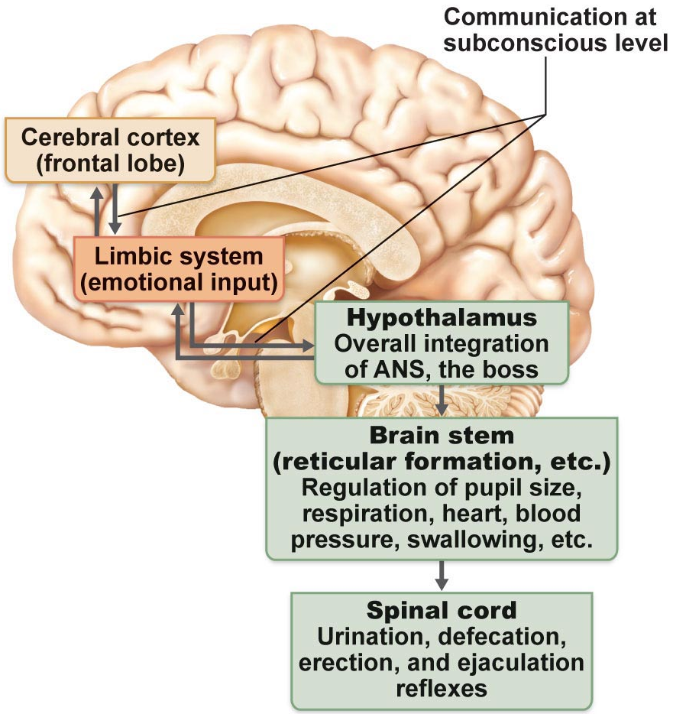
- Cortical Controls
- E.g. Mediation and Biofeedback allow some conscious control over visceral activities
- E.g. During mediation can lower heart and breathing rates, oxygen use, metabolic rate
- Biofeedback to improve management of migraine headaches, stress & cardiac function
- Homeostatic Imbalances of ANS
  - E.g. Hypertension: chronically elevated blood pressure (can use your own ability to body’s response to decrease stress OR medication)

- After surgery patients unable to urinate/bowel sounds absent. What division of ANS is affected by anesthetic?
- Anesthetic affects parasympathetic
- Ulcers risk factors can be stress & associated excess activity of sympathetic nervous system. E.g. One contributing factor to ulcers is severe reduction in blood flow to stomach wall. How related to sympathetic function?
- It sends blood to muscles or heart
- High stress jobs: Not enough blood flow so enough mucus is not made to protect=ulcer (stress contributing factor)

The Endocrine System
What is a hormone?
- Chemical substance released into ECF regulating metabolic function of other cells in body
- transportation: blood stream (mostly), some travel via extracellular fluid to neighbouring cell; effects longer than NS
- Remember: Hormones must bind to specific receptors to influence target cell function (are long-distance signals)  - Hormones are specific (because of receptor); level of target cell activation depends on:  - (i) Hormone concentration (amount of hormone)  - (ii) Target cell receptor content (small number then stimulated weakly, no receptor=no effect)  - (iii) Affinity of hormone for receptor  - Exocrine glands: Produce non-hormonal substances (e.g. sweat & saliva) and have ducts carrying the substances  - Endocrine glands: Are ductless and produce hormones  - Hypothalamus is neuroendocrine organ (produces hormones and regulates activity) | 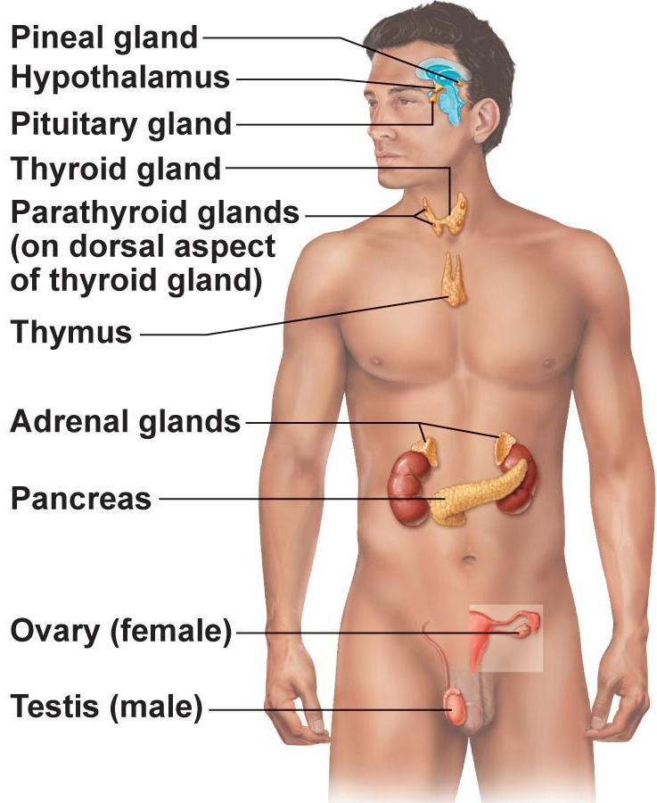
Mechanism of Hormone Action
- Hormones alter levels of cell activity:
  - Membrane permeability/potential (through opening/closing ion channels)
  - Simulates synthesis of enzymes within cells
  - Enzyme activation/deactivation (level of activity affected)
  - Induction of secretory activity (e.g. opening channels usually brining Ca2+)
  - Stimulation of mitosis (stimulate for more cells within particular tissue for healing/child)
- 3 structural group of hormones:
  - (i) Amino acids, peptides, proteins (water soluble, most hormones)
    - Molecular size varies, cannot cross plasma membrane
  - (ii) Steroid hormones (derivatives of cholesterol, cell regulated by enzymes that catalyse the cholesterol to hormones—lipid soluble) influencing rate of production of proteins
    - only gondal and adrenocortical hormones are steroid
  - (III) Eicosanoids (derivatives of arachidonic acid, lipid soluble, typically localized=considered hormone-like)
    - E.g.. leukotrienes (mediate inflammation) & prostaglandins (multiple target organs, raise bp)
2 Main mechanisms of action:
Peptide/protein hormones (exception of thyroid hormone): Hormone (first messenger) binds to cell surface receptor
- Causes change in shape which activates membrane-bound G protein (GDP bound is displaced by high-energy GTP)
- G protein activates adenylate cyclase by binding to it: G proteins stimulate/inhibit AC
  - G protein later hydrolyzed (GTP/GDP)=inactive
- Production of 2nd messenger (cyclic AMP (cAMP), calcium) from AC (cAMP brief as phosphodiesterase degrades fast)
- Activation of protein kinases to regulate activity of key enzymes

16.2: Cyclic AMP Second Messenger Mechanism of Water Soluble Hormones
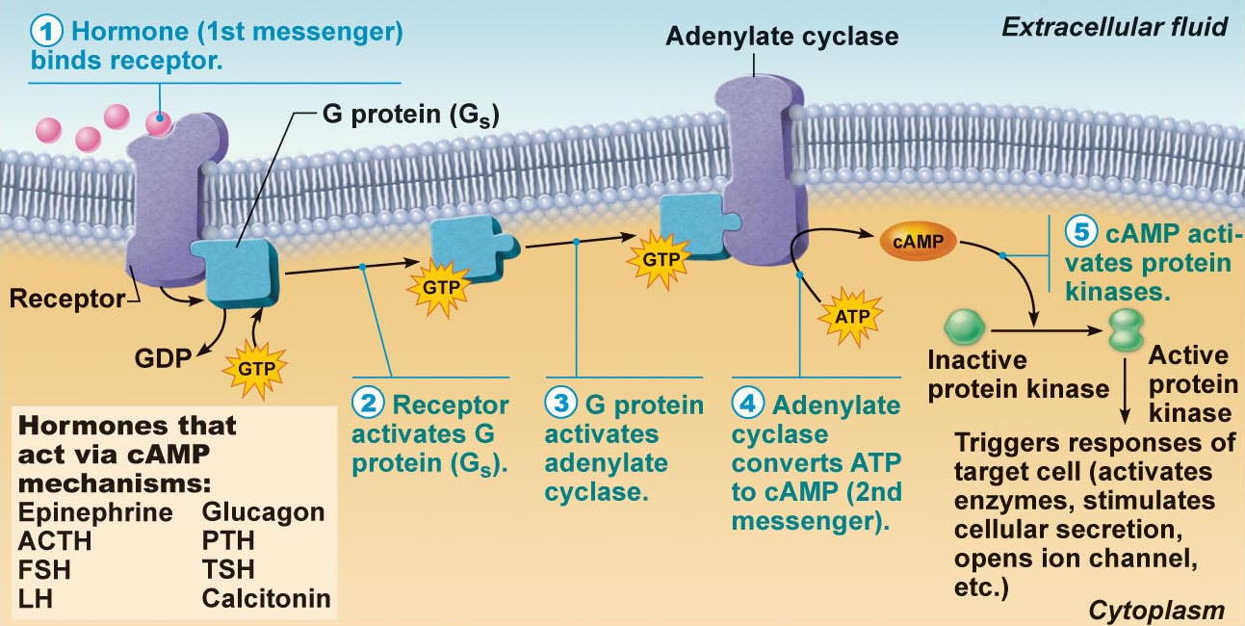
(PART IN PAGE 599)
16.3 Steroid hormones/Thyroid hormones usually act in nucleus to influence gene transcription  - Steroid hormones: Entry into nucleus and activation of gene transcription | 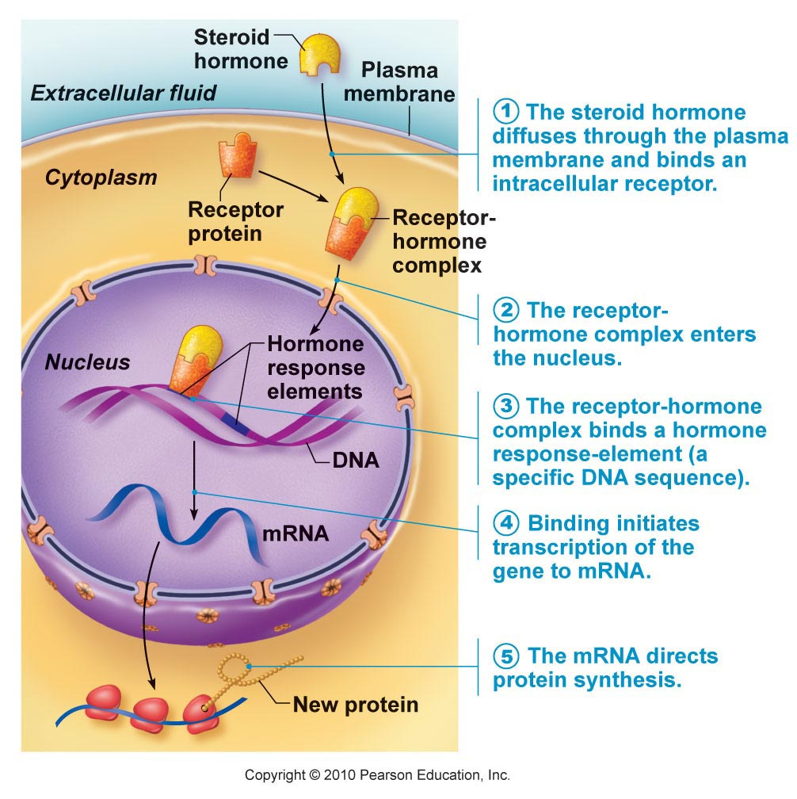

Half Life, Onset & Duration of Hormone Activity (Table 16.1, page 603)
- Hormones are potent: ; lipid soluble hormones travel in blood stream bound to plasma proteins
- Blood level of hormone depends on: (1) Rate of synthesis, (2) Rate of degradation/clearance from blood
- Half life: Persistence of hormone in blood (usually < 1 minute to a week; water-soluble have shortest half-life)
- Tine of onset of hormone action variable: Enzyme activation—rapid (minutes); enzyme synthesis (hours to days)
- Some hormones secreted as prohormones; activated once reach target cell
- Duration of hormone action also variable (hours to days)
Control of Hormone Release
- Usually negative feed back (setpoint); sometimes positive feedback (goal)  - 3 types of stimuli: humoral, neural & hormonal  - (i) Humoral stimuli: Hormone secretion in direct response to change in blood level of nutrient, ion [e.g. parathyroid hormone (PTH) & blood calcium; insulin & blood glucose] (blood levels of something releases a hormone to regulate blood levels)  - (ii) Neural stimuli: Not as common e.g. Sympathetic nervous system & epinephrine release by adrenal medulla, hypothalamic neurons & oxytocin release  - (iiiI) Hormonal stimuli: 3-tiered system involving hypothalamus, pituitary & target endocrine gland (concept of hypothalamic pituitary axis)  - Response to other hormones secreted | 

