Anatomy
- Scientific study of the structure of body parts and their relationship to one another

Physiology
- Scientific study of how the body functions

Structural organization of the human body

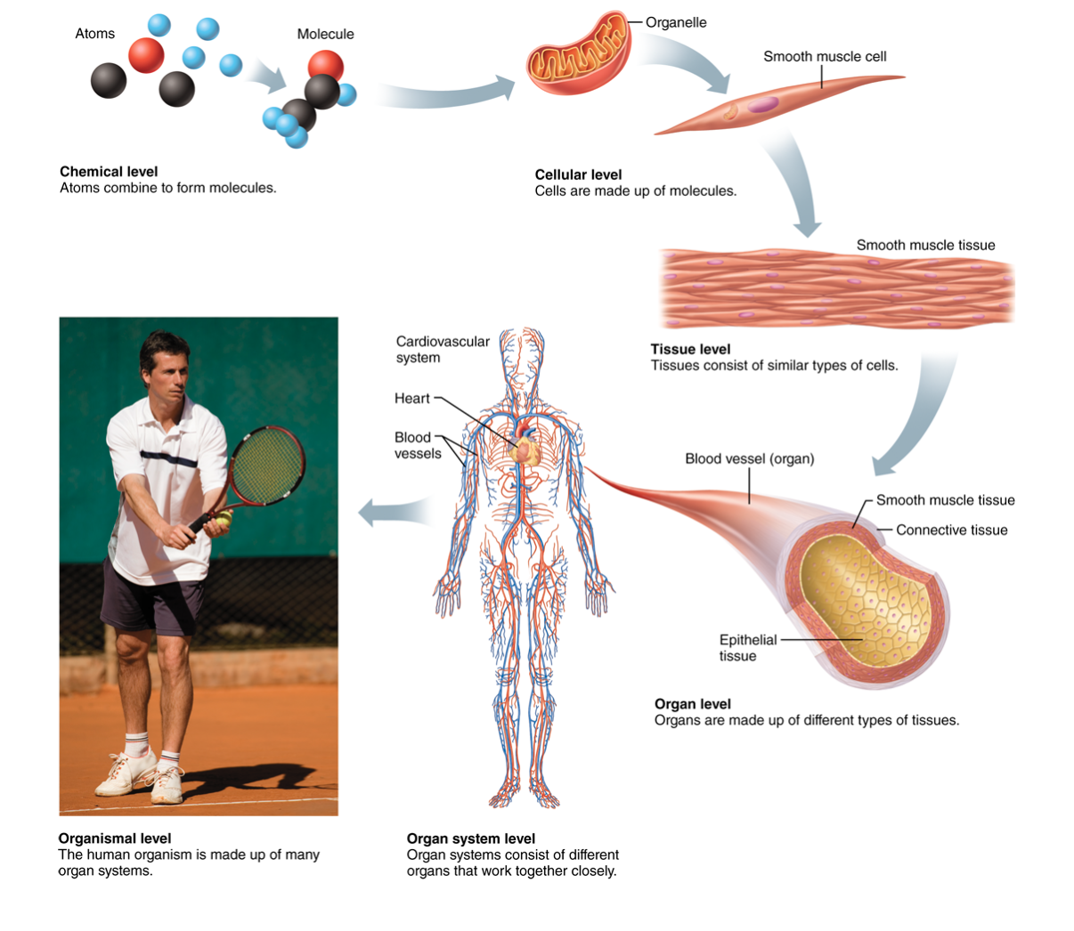
Atom
- Building blocks of matter
- Three different parts
  - Electron (-)
  - Proton (+)
  - neutron

Molecule
- A combination of atoms
- Example; water

Organelle
- Molecules associate in specific ways to form organelles
- Basic components of cells
- Examples;
  - Nucleus
  - Mitochondrion
  - Golgi apparatus
  - Lysosome
  - Endoplasmic reticulum

Cells
- Fundamental structural and functional unit of a living thing
- Smallest unit of life that can maintain and perpetuate
- Cells vary widely in shape and size reflecting unique functions in the body

Tissue
- Groups of similar cells that have a common function
- Four types of body tissue;
  - Epithelium tissue- covers body and lines cavities
  - Muscle tissue- movement
  - Connective tissue- support and protection
  - Nervous tissue- communication

Organ
- Discrete structure composed of at least two tissue types (four is more common) that performs a specific function for the body

Organ System
- Organs that work closely with one another to accomplish a common purpose
- 11 organ systems;
  - Integumentary
  - Skeletal
  - Muscular
  - Nervous
  - Endocrine
  - Cardiovascular
  - Lymphatic
  - Respiratory
  - Digestive
  - Urinary
  - Reproductive (male & female)

