Lecture 2

Chapter 2—Company and Marketing Strategy: Partnering to Build Customer Relationships

Defining a market oriented
Ex. Concordia To help every student to have a successful career
To do!: Research; to contribute to society
Setting Goals!

Learning Objectives
- Explain company-wide strategic planning and its four steps
- Discuss how to design business portfolios and develop growth strategies
- Explain marketing’s role in strategic planning and how marketing works with its partners to create and deliver customer value
- Describe the elements of a customer-driven marketing strategy and mix, and the forces that influence it
- List the marketing managements functions, including the elements of a marketing plan and discuss the importance of measuring and managing return on marketing investment
Steps in Strategic Planning
- Objective-based process of developing and maintaining a strategic fit between the organization’s goals and capabilities and its changing marketing opportunities
Corporate Level:
- Defining the company mission
- Setting company objectives and goals
- Designing the business portfolio
Business Unit, Product and Market Level:
- Planning marketing strategy as well as other functional strategies

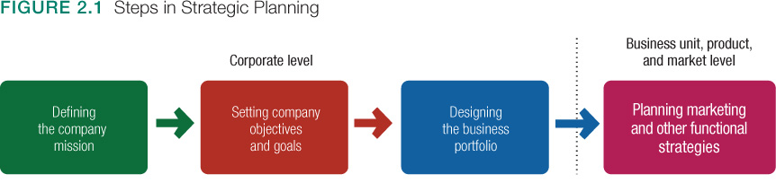
Mission Statement: Statement of the organizations purpose—the value it offer and for whom

Mission Supporting objectives
Ex. Business objective: increase profits; Marketing objective: increase market share of domestic and international markets

Business portfolios & Growth Strategies
Business portfolio:
- Evaluate the firm’s current business and products and decide which should receive more, less or no investments
- Ex. Apple: IPhone, iTunes, iPod, IPad, mac/MacBook, apple TV, I Watch.

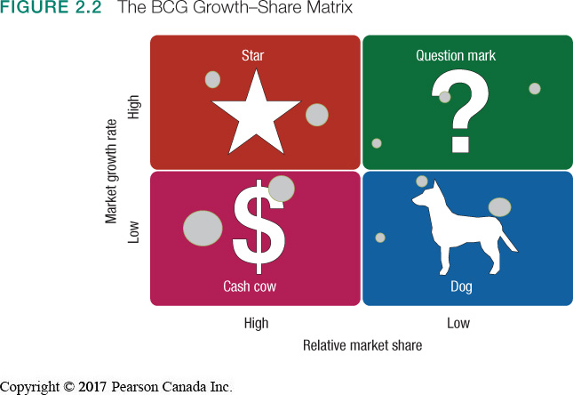
Growth Share Matrix

Star: iPhone
Cash Cow (still selling but not great): iPad
Question Mark: Apple TV??, iWatch
Dog: iPod (not common anymore)

Challenges in Portfolio Analysis:
- Time consuming, costly to implement
- Measuring market share and growth rate
- Future planning de-emphasized
- Companies must develop strategies for growing and downsizing portfolios
- Downsizing eliminates products or business units that are not profitable or no longer fit the company’s overall strategy
  - Main reason exists for downsizing
    - Ex. Blackberry, Nokia, ect.

Product Market Expansion grid
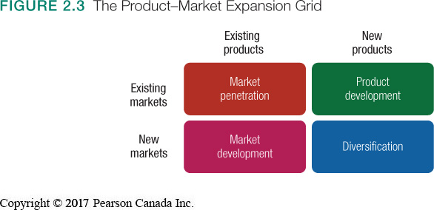

Tim Hortons® concludes it must grow in order to keep up with social preferences and competitive forces. Using the PM grid method, it could do any of the following:
- Market penetration: make the same products for the same market in an attempt to increase market share
- Product development: create a reduced calorie donut targeted at its current market
- Market development: attempt to reach dinner market with current products
- Diversification: create a gluten-free product for the gluten-intolerant market

Planning Marketing: Partnering to Build Customer Relationships
- Provide a guiding philosophy
  - The Marketing concept
- Provides input to strategic planners
  - Identifies opportunities
- Suggests strategies to reach objectives
Role of Marketing in Planning
Partner Relationship Management:
- Working with internal partners’ cam create an effective value chain (within the company)
- Working with external partners helps to form a superior value delivery network
Value deliver network include:
- Company’s value chain
- Suppliers
- Distributors
- Customers
The goal is to improve performance in delivering value to customers
Marketing Strategy and the Marketing Mix
Objective: build profitable customer relationships through value creation
Strategies include:
- Market Segmentation and targeting
- Differentiation and positioning
Marketing strategy guides marketing mix decisions
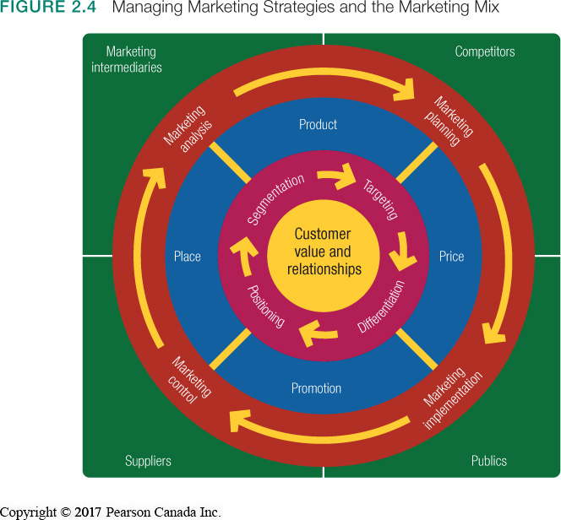

Segmentation:
- Divinding a market into segments of buyers according to needs
Targeting:
- Evaluating each segment and selecting which to pursue
Positioning:
- Attempting to occupy a desirable place in the minds of target consumers
Differentiation:
- Creating unique and superior customer value
Marketing Mix: (4Ps)
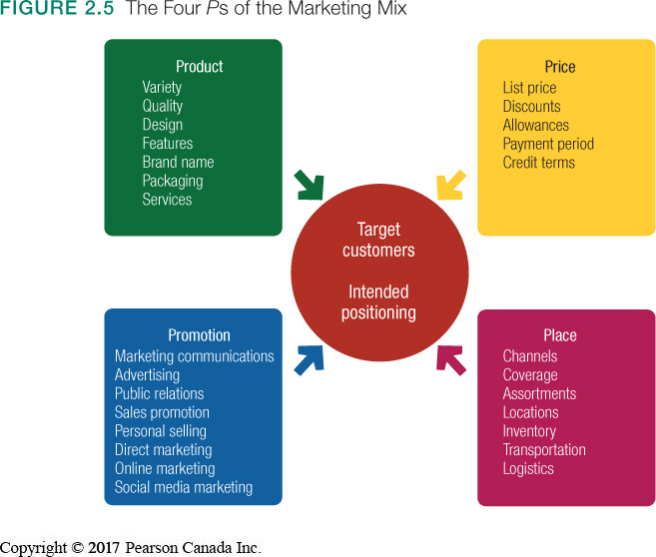
-Product
-Price
-Place
-Promotion

4Cs
-Customer Solution
-Customer Cost
-Convenience
-Communication

Seller View—Four Ps | Buyer View—Four Cs
Product | Customer Solution
Price | Customer Cost
Place | Convenience
Promotion | Communication

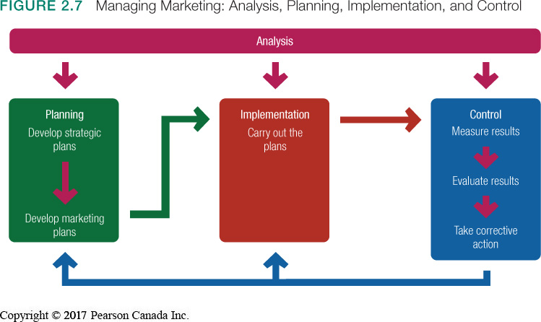

Marketing Management: Function 1
SWOT Analysis:
Strengths, weaknesses, opportunities, threats
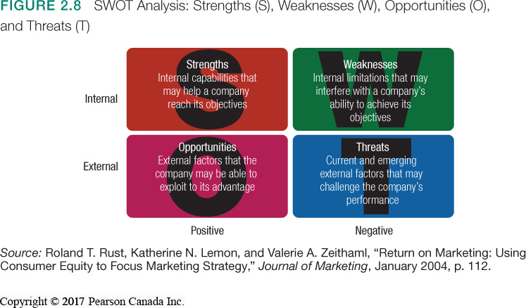

Marketing Management: Function 2
Marketing Plan
- Executive Summary
- Current Marketing Situation
- SWOT
-Objectives and Issues
-Marketing Strategy
-Budgets
-Controls

Marketing Management: Function 3
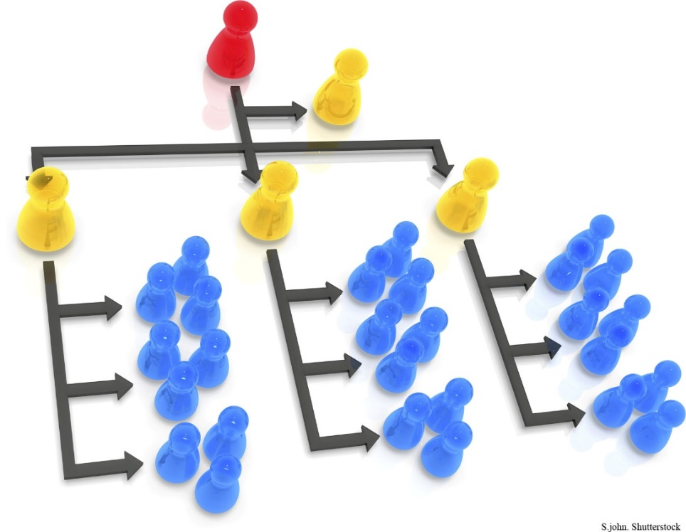
Implementation:
Plans converted to actions by assigning: (Turns mrk. plans into mrk. actions)
- Who
- Where
- When
- How
Marketing Department Organization
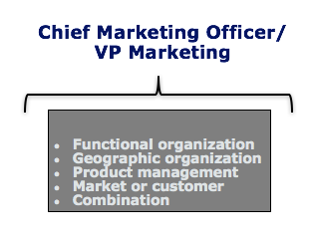

Marketing Management: Function 4
-Marketing Control involves four steps:
1. Set Specific Marketing goals
2. Measure performance in the marketplace
3. Evaluate performance
4. Take corrective action to close the gaps between goals and performance
Operation Control:
- Evaluate performance against the annual plan and takes corrective action
Strategic Control:
- Evaluates whether strategies match opportunities

Chapter 4-- Analyzing the Marketing Environment
Learning Objectives
- Describe the environmental forces that affect the company’s ability to serve its customers
- Explain how changes in the demographic and economic environments affect marketing decisions
- Identify the major trends in the firm’s natural and technological environments
- Explain the key changes in the political and cultural environments
- Discuss how companies can react to the marketing environment
The Marketing Environment
- Factors and outside marketing management’s ability to build and maintain successful relationships with target customers
Microenvironment:
- Forces with direct impact to the company
- Internal &external
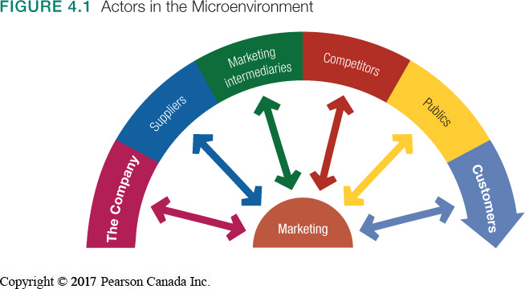

The company
Suppliers
Marketing intermediates
Competitors
Publics
Customers

Marketing Intermediaries:
- Resellers
- Physical distribution firms
- Marketing service agencies
Publics
- Financial publics
- Media publics
- Government publics
- Citizen-action publics
- Legal publics
- General public

Macro environment:
- External forces with direct impact across industries
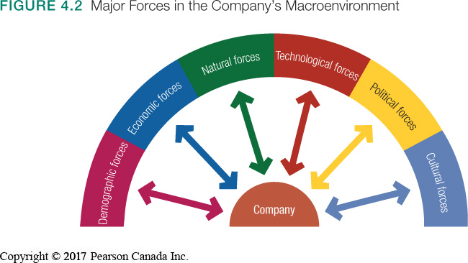

Demographic Forces
Economic Forces
Natural Forces
Technological Forces
Public Forces
Cultural Forces

Demographic Environment
Demography:
- Study of human populations
- Strategic decisions often based upon shifts in demographics
- Changing age demographics of the Canadian population is both an opportunity and a threat
Three Largest Generational Groups:
Baby Boomers: 1947-1966
9.8 million
Wealthy but hard hit by recession
Generation X: 1967-1976
7 million
Highly educated
Experientially driven
Millennials (Gen Y): 1977-2000
10.4 million
Tech savvy
Personally centered
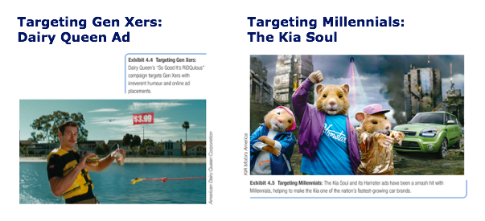
Targeting Gen Xers and Millennials

The Demographic Environment
Generation z
- Born after 2000
- Make up important kid, tween and teen markets
- 5.6 million
- Fluent with digital technology
Canadian family/households are changing:
- Growing market of “non-traditional” households
- Growing “crowded nest” syndrome
- Fewer families have children
- More dual-income families
Geographic Shifts in Population
- Growth rates across Canada are not uniform
- Rural to urban migration continues
- Buying habits differ by region
- Growth in telecommuting market
Better Educated, White-Collar Population:
- Increased demand for higher quality
- Increased understanding of value
- Creates demand in different products
Increasing Diversity:
- Large and growth visible minority market
- Growth in recognized disabilities
- Acceptance of LGBT and gay marriages
The Economic Environment
Nations vary greatly in their level and distribution of income
- Industrial economies
- Subsistence economies
- Developing economies
Factors that affect spending

- Changes in income
- Consumption frenzy, record personal debt
- Economic crisis leading to consumer frugality
- Value marketing is key to success
- Changes in spending patterns
  - Engel’s laws note that consumers at dif income levels have dif spending patterns
Natural Environment
Natural Resources used to produce goods
- Shortage of raw materials
- Increased pollution
- Increased government intervention
  - Strategic decisions around creating environmentally-sustainable products

Technological Environment
Technology Advances
- Creating new markets and opportunities
- Increasing obsolescence
- Accelerating customer needs
- Resulting in constantly evolving regulations
Political Environmental
  - Regulatory Trends—Evolving laws influence organizations
  - Business legislation:
    - Protects companies from each other
    - Protect consumers from unfair business practices
    - Protects the interests of society
  - Increased emphasis on ethics and socially responsible behavior
Cause-Related marketing
  - Companies linking themselves with worthwhile causes
The Cultural Environment
  - Standard acceptable belief system that affects a society’s basic values
    - Core belief’s slow to change
    - Secondary beliefs are more open to change
  - Society’s major cultural views are expressed in people’s views of:
    - Themselves
    - Others
    - Organizations
    - Society
    - Nature
    - The Universe
Responding to the Marketing Environment
Reactive | Proactive
Wait for change; then react | Anticipate change; act now
Missed opportunities | Seized opportunities
Damage from threats | Mitigate impact of threats

  - Examples of Proactive Responses:
    - Hiring lobbyists
    - Running “advertorials”
    - Initialing lawsuits
    - Filling complaints with regulators
    - Forming agreements to control channels

