ADM2336: Organizational Behaviour

Chapter 1: Introduction to Organizational Behaviour

Organizational behaviour –the field of study devoted to understanding, explaining and ultimately improving the attitudes and behaviours of individuals and groups in organizations.
- How organizations can be designed and structured more effectively.
- How managers can manage more effectively.
- OB can be contrasted with human resources management and strategic management.

Human resource management –field of study that focuses on the applications of OB theories and principles in organizations.

Strategic management –field of study devoted to exploring the product choices and industry characteristics that affect an organization’s profitability.

-An OB study might explore the relationship between learning and job performance.
-An HR management study might examine the best ways to structure training programs to promote employee learning.
-A strategic management study might examine the relationship between firm diversification (i.e. firm expand new product segment) and firm profitability.
Early Studies of Management

The study of organizations started with the industrial revolution (late 1800s/early 1900s).

It attempts to prescribe the correct way to manage an organization and achieve its goals:
- Classical law –scientific management (i.e. Frederic Taylor, bureaucracy)
- Human relations view
Bureaucracy –an organizational form that emphasizes the control and coordination of its members through:
- The division of labour with a high level of technical specialization
- A strict chain of command (authority hierarchy) in which every member reports to someone at a higher level in the organization.
- A system of formal rules/procedures that ensures consistency and impersonality throughout the organization.
- Decision making at the top of the organization (centralized)
Contemporary management theory –today, it recognizes the dependencies between the classical approach and the human relations approach.
- This approach is reflected in many theories/models of OB.
- The consequences of situational characteristics depend on characteristics of the individual (vice versa).
- There is no one best, universal approach.
Human relations movement –field of study that recognizes that the psychological attributes of individual workers and social forces within work groups have an effect on work behaviour.

Contingency Approach

The contingency approach to management recognizes that there is no one best way to manage.
- Benefits to both approaches
General answer to many of the problems in organizations is, “it depends…”
- An appropriate management style depends on the demands of the situation.

Integrative Model of Organizational Behaviour
There are 2 primary outcomes of interest to OB researchers:
- Job performance
- Organizational commitment

Most employees’ 2 primary goals for their working lives:
- Perform their jobs well.
- Remain members of an organization that they respect.

Most managers’ 2 primary goals for their employees:
- Maximize job performance.
- Retain these employees for a significant length of time.
When all taken together, it constitutes good job performance.
Use performance and commitment to highlight the practical importance of OB.

What do you know about organizational behaviour?
- Effective leaders tend to possess identical personality traits. FALSE
- All workers prefer stimulating, challenging jobs. FALSE
- Pay is the best way to motivate most employees and improve job performance. FALSE

Organizational behaviour helps us to:
- Predict organizational behaviour and events.
- Explain organizational behaviour and events in organizations.
- Manage/improve organizations.

Social Recognition and Job Performance

Hypothesis: “Social recognition will be positively related to job performance and organizational commitment of their work units.”
- Performance? Organizational commitment? How to measure relationship?
- How often does social recognition lead to higher job performance and organizational commitment?
Individual Mechanisms

They directly affect job performance and organizational commitment.

Job satisfaction –captures what employees feel when thinking about their jobs and doing their daily work.
Stress –reflects employees’ psychological responses to job demands that tax/exceed their capabilities.
Motivation –captures the energetic forces that drive employees’ work effort.
Trust, justices and ethics –reflect the degree to which employees feel that their company conducts business with fairness, honesty and integrity.
Learning and decision-making –deals with how employees gain job knowledge and how they use that knowledge to make accurate judgments on the job.

Individual Characteristics and Group Mechanisms

- Personality, cultural values and ability
- Teams, diversity and communication
- Norms, member roles and the way members depend on and relate to one another.

Organizational Mechanisms

- Individuals and groups function within an organizational context.
- Every company has an organizational structure that dictates how the units within the firm link/coordinate with other units.
- Every company has a culture that captures “the way things are” in the organization (share knowledge about rules, norms, and values that shape attitudes/behaviour.

Does OB Matter: Building a Conceptual Argument

Resource-based view –a model that argues that rare resources help firms maintain competitive advantages. These resources make them capable of creating long-term profits.
- Resource is more valuable when it is ‘rare’.
- Resource is also more valuable when it is ‘inimitable’ (incapable of being imitated/copied).

3 Reasons Why People Inimitable

- History –a collective pool of experience, wisdom, and knowledge that benefits the organization.
-Cannot be bought.
- Numerous small decisions –captures the idea that people make many small decisions.
-Big decisions can be copied (visible by competitors and observable by analysts)
- Socially complex resources –people are the source of socially complex resources, such as culture, teamwork, trust and reputation.
-Socially complex because unclear how they came about, but it is clear which organization do and do not possess them
Research Evidence

Good people are both rare and inimitable and therefore create a resource that is valuable for creating competitive advantage.
- Conceptual arguments would be more helpful if there were hard data to back them up.
- The study gathered information for each firm: average annual rate of turnover, productivity level, market value of the firm and corporate profitability.

So, what is so hard?
Pfeffer: There is no ‘magic bullet’ OB practice –one specific thing that will increase profitability.

Rule of one eighth –belief that at best one-eighth (12%), organization will do what is required to build profits by putting people first.
- One-half of organizations won’t believe the connection between how they manage their people and the profits they earn.

High job performance depends on employee motivation, fostering high levels of satisfaction, effectively managing stress, creating a trusting climate and committing to employee learning.

How do we ‘know’ what we know about OB?

Scientific Studies

Theory –a collection of verbal/symbolic assertions that specify how and why variables are related, as well as the conditions in which they should/should not be related.
- A scientist could build a theory explaining why social recognition might influence the performance and commitment of work units.
Hypotheses –written predictions that specify relationships between variables.
- Might analyze data by examining the correlation between social recognition behaviours and employee turnover to see if hypotheses supporters.
Correlation –describes the statistical relationship between two variables.
- Can be positive or negative and range from 0 (no statistical relationship) to +/- 1 (a perfect statistical relationship).
- Look at a scatterplot for the best way to visualize the correlation.
Meta-analysis –a method that combines the results of multiple scientific studies by calculating a weighted-average correlation across studies.
- Larger studies receive more weight in the average.

Chapter 2: Job Performance

Job performance –the value of the set of employee behaviours that contribute, either positively or negatively, to organizational goal accomplishments.
- Behaviours are under the control of the employee.
- Puts a boundary on which behaviors are/are not relevant to job performance.
Ex: getting coffee during break is not relevant to organizational goal accomplishment.

Job performance consists of…
- Task performance (positive)
-Employee behaviours that are directly involved in the production of goods/services.
- Citizenship behaviour (positive)
- Counterproductive behaviour (negative)

Task Performance

Task performance –employee behaviours directly involved in the transformation of organizational resources into goods/services the organization produces.

Types of Task Performance:

1. Routine task performance –well known responses by employees to demands that occur in a normal, routine or predictable way. (i.e. Starbucks).
2. Adaptive task performance (adaptability) –responses to demands that are unpredictable, novel or unusual (i.e. Pilot).
3. Creative task performance –developing ideas for outcomes that are novel and useful (i.e. advertising, architecture)

How do you identify task performance?
Many organizations identify task performance behaviours by conducting a job analysis.

Job analysis –a process by which an organization determines requirements of specific job.
It consists of 3 steps:
- Generate a list of activities
- Rating of activities by “subject matter experts” (SMEs)
- Retain most important activity

When organizations find job analysis impractical to identify behaviours needed to define task performance, they can turn to a database the government created to help describe a wide variety of jobs.

National Occupational Classification (NOC) –a nationally accepted reference to occupations in Canada.
- Over 30,000 job titles into 520 job descriptions.
- Used by people to compile, analyze and communicate information about occupations, and to understand the jobs found throughout Canada’s labour market.

How important is it to organizations that employees go ‘above and beyond’ their actual job duties?
Important! This is called citizenship behaviour.

Citizenship behaviour –voluntary employee activities that may/may not be rewarded but that contribute to the organization by improving the overall quality of the setting in which work takes place.
There are 2 types: interpersonal and organizational.

1. Interpersonal citizenship behaviour –benefit coworkers and colleagues and involve assisting, supporting and developing other organizational members in a way that goes beyond normal job expectations.
- Helping (assisting coworkers)
- Courtesy (keeping coworkers informed)
- Sportsmanship (maintaining good attitude with coworkers)
2. Organizational citizenship behaviour –benefit the larger organization by supporting and defending the company, working to improve its operations and being loyal.
- Voice (speaking up and offering constructive suggestions for change)
- Civic virtue (participating in the company’s operations at a deeper level)
- Boosterism (represent the organization in a positive way in public)

Virtually any job, regardless of the particular nature of its tasks, have clear benefits of these behaviours in terms of the effectiveness of work units and organizations.
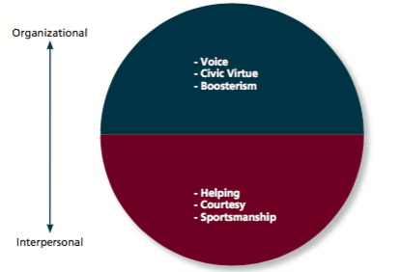

Counterproductive behaviour –intentionally hinder organizational goal accomplishment.
- Consists of 4 different categories:
- Property deviance –harms the organization’s assets and possessions.
i.e. theft, vandalism
- Production deviance –reduces the efficiency of work output.
i.e. wasting resources, substance abuse
- Political deviance –intentionally disadvantages other individuals.
i.e. gossiping, incivility
- Personal aggression –hostile verbal/physical actions directed toward other employees.
i.e. harassment, abuse
- Apply to all jobs (waste, steal, people to gossip about)
- Apply to all performers
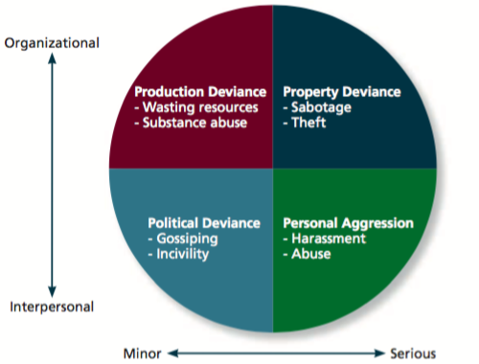
Counterproductive behaviour questions:
Are there ‘bad apples’?
Yes, there is a pattern of behaviour.

Does counterproductive behaviour only apply to certain jobs?
No, not necessarily. There will always be things to waste, steal and people to gossip about. It is relevant to all jobs.

Does it only apply to poor performance?
Not only, research shows a “weak negative correlation between task performance and counterproductive behaviour.” Often, the better performance can better get away with this.

Summary: Being a Good Performer

- Someone is good at the particular job tasks
- The employee engages in citizenship behaviours directed at both co-workers and the larger organization.
- He/she refrains from engaging in the counterproductive behaviours that can damage the climate of an organization.

Application: Performance Management

The type of information collected on employee performance can have a significant impact on employee behaviours and, in the end, an organization’s ability to achieve its mission.

Management by objectives (MBO) –philosophy that bases employee evaluations on whether specific performance goals have been met.
- An employee meets with his/her manager to develop a set of mutual objectives that are specific and measurable.
- Agree on time period to achieve these objectives

Behaviourally anchored rating scales –use examples of critical incidents to evaluate an employee’s job performance behaviours directly.
- Supervisors rate performance dimensions using BARS and scores an employee’s overall job performance.
- Helps an employee develop and improve over time.
360-degree feedback –performance evaluation system that uses ratings provided by supervisors, co-workers, subordinates, customers and employees.
- Used to evaluate employees for admin purposes (raises, promotions)
- Problems: ratings vary across sources, could be given biased evaluations

Forced ranking –a performance management system in which managers rank subordinates relative to one another.
Social networking systems –recently applied in organizational contexts to develop and evaluate employee job performance.
Chapter 3: Organizational Commitment

Organizational commitment –the employee’s desire to remain a member of the organization.
- It influences whether an employee stays at the organization (is retained) or leaves to pursue another job (turns over).
- It equates to dollars $$ -it is more costly recruit new employees.
- If commitment is low, employees engage in withdrawal behaviour –actions that employees perform to avoid the work situation (can lead to the employees quitting).
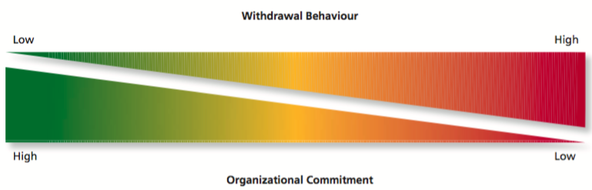
Scenario:
Imagine you take a job as a teller at RBC after graduating. You have been there for 2 years and a competitor has approached you. What are the factors that would get you to stay at RBC?

Answer: Factors that Foster Commitment

- Wages/salary
- Energy and time spent
- Amicable with coworkers
- Higher level job role or opportunities to advance in the firm.
- Emotionally committed to employer due to training, experience and relationship.
- Organization culture
- Stability of the job
- Enjoy the work
- Work/life balance
- Benefits (compare them to the other offer)
- Difficulty changing and adapting to a new role.

Forms of Commitment
The desire to stay with the organization because of…

Affective commitment –an emotional attachment to and involvement with that organization (emotion-based reasons).
- Stay because you want to
Employees with high sense of affective commitment:
-Identify with the organization.
-Accept the organization’s goals and values (committed, loyal).
- We want to encourage this commitment
-more emotionally attached
-willing to exert extra effort
-more citizenship behaviors

We encourage affective commitment through 2 models:
- The erosion model –employees with fewer bonds will be most likely to quit the organization.
- The social influence model –employees who have direct linkages with “leavers” will be more likely to leave.
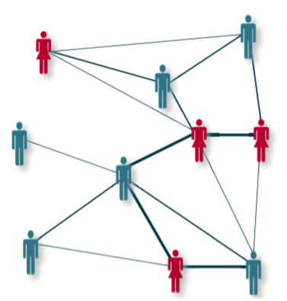
Continuance commitment –an awareness of the costs associated with leaving it (cost-based reasons).
- You stay because you need to.

Cost to leave versus the benefit to stay.
This cost/benefit analysis increases by:
- Investment made by employee –more investment in the firm, harder it is to leave.
- Lack of employment alternatives –less options, harder it is to leave.
Do we want to increase continuance commitment?
Yes, but we need to be aware that:
-It tends to create a more passive form of loyalty.
-Negligible or negative relationship with work outcomes, except turnover.
-Sometimes they’re staying because they have to.

Continuance commitment can be increased by:
- Trying to increase embeddedness
-A person’s links to the organization and the community.
-His/her sense of fit.
-What he would have to sacrifice for a job change.
- Embeddedness strengthens continuance commitment.
-Provides more reasons to stay
-More sources of anxiety upon leaving
i.e. Fort McMurray.
Normative commitment –a feeling of obligation (obligation-based reasons)
- You stay because you ought to.
The focus of commitment refers to the people, places and things that can inspire a desire to remain a member of an organization.

Staying is the ‘right’ or ‘moral’ thing to do.
This feeling could be developed from:
- Personal work philosophies
- Organizational socialization
Do we want to increase normative commitment?
Yes, 2nd most important.
An increase in normative commitment causes a reduction in turnover.

Normative commitment is increased by:
- Organizational support –wanting to give back.
- i.e. training and development –pay tuition, support language skill development.

We care about commitment because…
- Up to 2.3 of Canadians are willing to voluntarily switch jobs.
- More of a risk to companies in a competitive market.
- Particularly certain skills.
We want to discourage employee withdrawal.

Activity: 2 Scenarios

1. Boring job:
Working at current company for 1 year. You realize your job it boring. It’s the first real job you’ve had (nice to have money, something to do every day). The new job excitement has worn off and things are monotonous. What do you do? List 2 behaviours.

2. Pay and seniority.
Working at current company for 1 year. You’re doing a great job: excellent performance evaluations and have emerged as a leader on many projects,

Destructive Constructive | Voice | Loyalty
Destructive Constructive | Exit  Physical withdrawal | Neglect  Psychological withdrawal
Active Passive

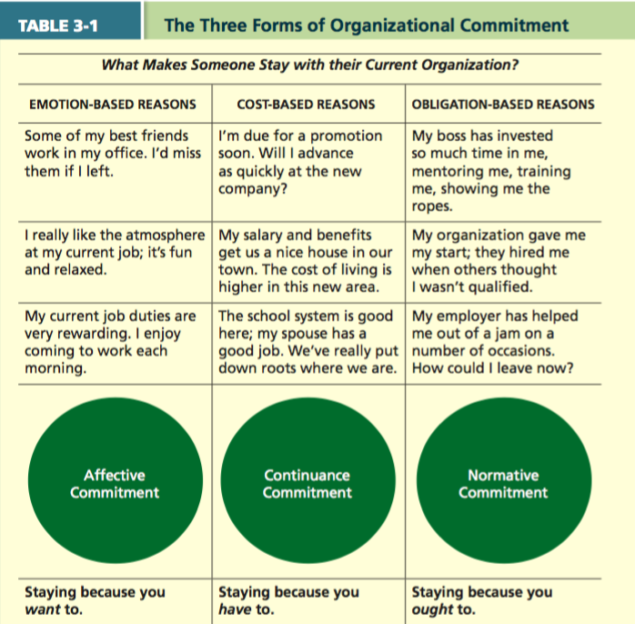

Thursday, January 19, 2017

Chapter 5: Job Satisfaction

Reflection –think about the worst job you ever held.
How do you feel during your shift? How did the feelings influence your behavior?
Compare this with the best job you’ve had.

Job satisfaction –pleasurable emotional state resulting from the appraisal of one’s job or job experiences.
- It represents how you feel about your job (affective part) and what you think about your job.
- These feelings, in turn, influence employee behaviour.

Video Clip from Jerry Maguire: Why are some Employees more satisfied than others?

He was leaving his job, interested in working with fewer clients and focusing on relationships with clients versus minimal effort with large client base.

Employees are satisfied with their job when it follows the employees overall values.

Types of Employee Values

- Pay (high and secure salary)
- Promotions (responsibility)
- Supervision (respect, praise for good work)
- Co-workers (communication, relationship)
- The work itself
- Altruism
- Status
- Environment

Value-Percept Theory

Job satisfaction depends on whether you perceive that your job supplies the things that you value.

Dissatisfaction = (V_{want} – V_{have}) (V_{importance})

People evaluate job satisfaction according to specific “facets” of the job.
Ex: Pay ($50,000 - $40,000) x importance
- This example equals the satisfier.
- Value of importance is difficult to be numeric in comparison to pay.
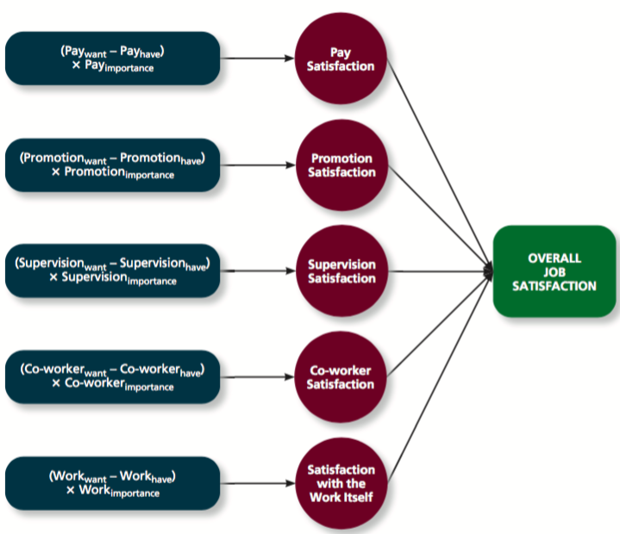

The point: high and low facets that vary that can balance the overall job satisfaction.

Pay satisfaction
- Is it as much as they deserve?
- Is it adequate/enough?
What is special about pay, more than any other value facet?
A: We compare ourselves to others with pay.
We expect equity!

Promotion satisfaction
- Are promotion policies fair?
- Are they implemented fairly?
- Based on ability?

Supervision satisfaction
- Is the boss competent, polite?
- Can they help me attain the things that I value?
- Are they generally likable?
Coworker satisfaction
- Can they help me do my job?
- Do I enjoy being around them?

Satisfaction with the work itself
- Are the tasks challenging, interesting?
- Do they make use of key skills?
- Am I learning the skills necessary to obtain my career goals?
Question: which of the 5 facets contribute most to overall job satisfaction? Order of significance, highest to lowest.

- Pay, promotions, supervisor
- Supervisor, co-worker, pay
- Work, supervisor, co-worker
- Work, pay supervisor
Answer: c), but all facts are positively correlated to overall job satisfaction.

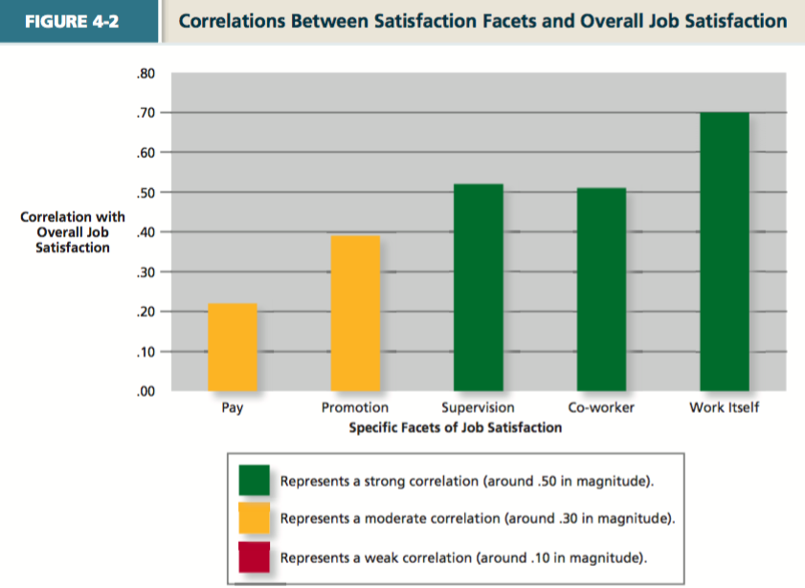
Based on this graph, employers should figure out what their employees’ top values/facets are and focus on them. Intrinsic factors to the job itself.

Critical Psychological States

- Meaningfulness of works
Degree to which work tasks are viewed as meaningful –something that ‘counts’.
- Responsibility for outcomes
Degree to which employees feel that they are key drivers of work quality.
- Knowledge of results
The extent to which employees know how well they are doing.
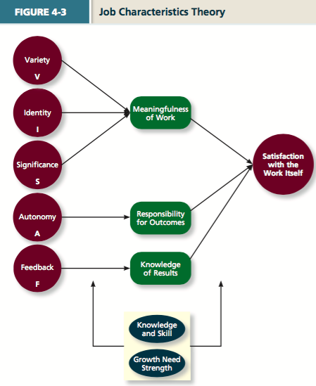

Job Characteristics Theory

Variety –involves a number of different activities; uses different skills and talents.
Ex: architecture, musicians, professors, designers, engineers.

Identity –completing a whole piece of work from beginning to end with a visible outcome.
Ex: Painters, surgeons, project managers who complete the whole project.

Significance –impact on the lives of other people; it really matters and impacts society as a whole.
Ex: fundraisers, health/medical field, emergency response.

Autonomy –provides independence and discretion to the individual doing the work.
Ex: entrepreneurs, free-lance photographers.

Feedback –feedback from the job itself about how well the worker is performing.
Ex: hands on jobs (i.e. Apple Genius bar fixing a laptop, the job itself has reward), serving/waitressing.

Overall: the job characteristics are moderately to strongly related to all job satisfaction.
As these characteristics increase, job satisfaction goes up (positive correlation).

Question: Do all employees want more variety, autonomy, etc…?
Answer: Not necessarily, this depends on:
Job Characteristic Moderators:
- Knowledge and skill
-The degree to which employees have the skills and knowledge needed for their jobs.
- Growth need strength
-The degree to which employees wish to develop themselves.
When higher growth need strength plus an increase in job characteristics will increase job satisfaction even higher.

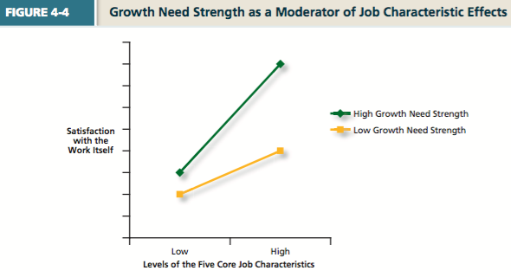
Job Enrichment

Job enrichment –duties and responsibilities are expanded (don’t give them more to do, give them skill developing tasks). This provides more variety, identity and autonomy (more free-rein).
Enrichment can:
- Boost job satisfaction levels.
- Heighten work accuracy and customer satisfaction
- Negative: training and labour costs tend to rise as a result of such changes.
Job enlargement –giving people more work.

Moods and Emotions

Job satisfaction reflects what you think/feel about your job.
- Rational
- Emotional

A satisfied employee feels good about his/her job on average.

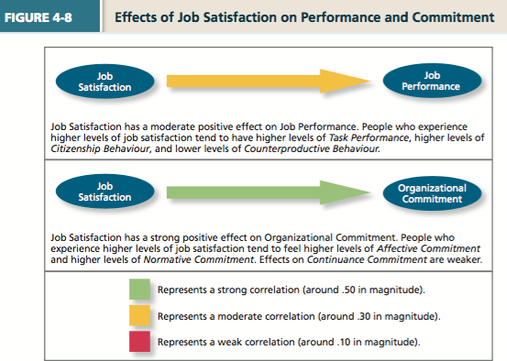
There is higher affective commitment and normative commitment when employees experience higher levels of job satisfaction.
They have higher levels of task performance.

Chapter 6: Stress

Stress Management Video

Benign job demands- job demands that are not appraised as being stressful.

Stress influences attitudes and actions.
Good stress, called eustress gives you energy and motivation.
- It may inspire creativity.
- It can drive you to deliver your best work.

Bad stress, called distress makes you feel:
- Anxious, tired and lack productivity
- Heart rate increase and heart disease.
- Physically wear you down (i.e. short of breath, headaches, nausea, back aches, heart disease, stomach disorders)
- Depression

Types of Stressors

Hindrance stressors –stressful demands that are perceived as hindering progress toward personal accomplishments or goal attainment.
- Trigger negative emotions (i.e. anger, anxiety)

Challenge stressors –stressful demands that are perceived as opportunities for learning, growth and achievement.
- Although exhausting, they often trigger positive emotions (i.e. pride, enthusiasm).

Work Hindrance Stressors

Role conflict –others’ is having differing expectations of what an individual needs to do in a role.
-I.e. call centers: you must call as many people as possible, yet answer customers’ questions.
Role ambiguity –a lack of direction and information about what needs to be done in a role.
-Unsure of project budget, time frame or how the final product is supposed to look.
Role overload –an excess of demands on an employee preventing him/her from working effectively.
-I.e. 80 hours/week becoming the norm.
Daily hassles –minor day-to-day demands that interfere with work accomplishment.
-I.e. unnecessary paperwork, equipment malfunctions, conflict with coworkers.

Work Challenge Stressors

Time pressure –the sense that the amount of time you have to do a task is not quite enough.
-I.e. stressed from deadlines.
Work complexity –the degree to which job requirements tax or exceed employee capabilities.
Non-Work Hindrance Stressors

Work-family conflict –form of role conflict in which the demands of a work role hinder the fulfillments of the demands in a family role (or vice versa).
Negative life events –events such as divorce or death of family that tend to be appraised as a hindrance.
Financial uncertainty –uncertainties with regard to the potential for loss of livelihood, savings or the ability to pay expenses.

Non-Work Challenge Stressors

Family time demands –amount of time committed to fulfilling family responsibilities.
Personal development –participation in activities outside of work that foster growth and learning.
Positive life events –events such as marriage or the birth of a child that tend to be appraised as a challenge.
How People Cope with Stressors.
Secondary appraisal –when people determine how to cope with the various stressors they face.
-Transactional theory of stress; questions like, “What should I do?” and “What can I do?”
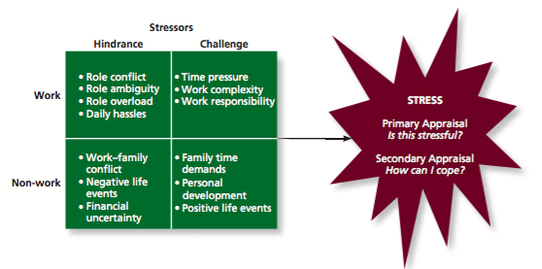

Coping –behaviours/thoughts used to manage stressful demands and emotions associated with them.

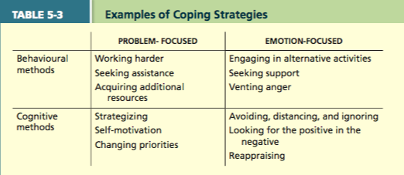

Types of Coping

Behavioural coping –physical activities used to deal with a stressful situation.
-I.e. yoga, meditation.
Cognitive coping –thoughts used to deal with a stressful situation.
-Being positive.
Problem-focused coping –behaviours/cognitions of an individual intended to manage the stressful situation itself.
Emotion-focused coping –behaviours/cognitions of an individual intended to help manage emotional reactions to the stressful demands.

Experience of Strains

Physiological strains –reactions from stressors that harm the human body.
i.e. illness, high blood pressure, heart disease, headaches, stomach pain.

Psychological strains –negative psychological reactions from stressors.
i.e. depression, anxiety, anger, irritability.

Behavioural strains –patterns of negative behaviours that are associated with other strains.
i.e. alcohol and drug use, teeth grinding, compulsive behaviours, overeating.

Burnout –emotional, mental and physical exhaustion from coping with stressful demands on a continuing basis.

Managing Stress

Take good care of yourself.
Stay calm, regulate your breathing, look at all perspectives.
Identify things that add to stress and what you can do to reduce stress.
Prioritize tasks in order not overwhelm yourself.
Rely on support systems:
Social support –help people receive from others when they are confronted with stress.
Instrumental support –help people receive from others that can be used to address a stressful demand directly.
Emotional support –empathy and understanding people receive from others that can be used to alleviate emotional distress.
Reduce stressors through job sharing -2+ people share the responsibilities of a single job.

Work-Life Balance

It is important to have hobbies and enjoy yourself outside of work.
Reframing –look at the worst-case scenario, analyze the situation in other perspectives (third person) and ‘reframe’ your thinking in a different way.

Type A Behavior Pattern –people who tend to experience more stressors, to appraise more demands as stressful, and to be prone to experiencing more strains.

Assessment
Stress audit –an assessment of the sources of stress in the workplace

Providing Resources

Training interventions –practices that increase employees’ competencies and skills.
Supportive practices –ways in which organizations help employees manage and balance their demands.

Reducing Strains

Relaxation techniques –calming activities to reduce stress.
Cognitive-behavioural techniques –various practices that help workers cope with life’s stressors in a rational manner.
Health and wellness programs –employee assistance programs that help workers with personal problems such as alcoholism and other addictions.

Chapter 7: Motivation

Motivation is a set of energetic forces that determine the direction, intensity and persistence of an employee’s work effort.
- The extent to which persistent effort is directed toward a goal.

Motivation determines the…
- Intensity of effort
-How hard are you going to work on it?
- Persistence of effort
How long are you going to work on it?
- Direction of effort
-Towards organizational goals
i.e. studying the wrong things or focusing on the wrong projects

Engagement –a widely used term; most often refers to motivation, but it can refer to affective commitment.

Intrinsic Motivation

Intrinsic motivation is a type of motivation that stems from the direct relationship between the worker and the task.
-Comes from “within”
Doing something because it is inherently interesting or enjoyable –task performance serves as its own reward.

Extrinsic Motivation

Extrinsic motivation is a type of motivation that stems from the work environment external to the task itself.
-Doing something to get a reward.
-i.e. bonuses, benefits, pay, excellent training programs to develop skills.
-Usually extrinsic when it costs the firm money.

Theories of Work Motivation

- Expectancy Theory
A theory that describes the cognitive process employees go through to make choice among different voluntary responses.

Employees need to see clear links between effort, performance and outcomes (EPO).
Based on perceptions of the individual worker.
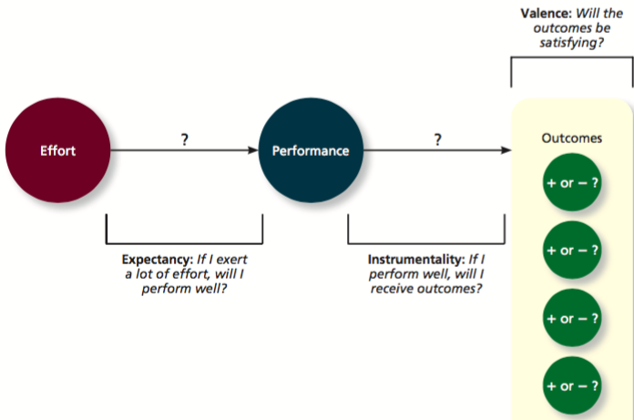
Expectancy Theory Diagram

1. Expectancy is the belief that high level effort results in successful performance (EP)
-Subjective probability ranging from 0 to 1 (1=100% chance of success)
-Affected by self-efficacy –the belief that a person ahs the capabilities needed to succeed.
Past accomplishments, vicarious experiences, verbal persuasion, emotional cues.

2.Instrumentality is the belief that performance outcome (PO)
-Subjective probability, ranging from 0 to 1.

3. Valence is the degree to which an individual values an outcome.
-Denoted (V)
-Can be positive, negative or zero (0 to 10)
What makes some outcomes more “positively valenced” than others?
Outcomes are deemed more attractive when they help satisfy needs.
Needs –outcomes that have critical psychological or physiological consequences (if not satisfied).
-Maslow’s Hierarchy of Needs

Force –the total direction of effort:
Motivation force = (EP) x (sum [(PO)xV])
Motivational force equals zero if any one of the three beliefs is zero.

- Goal Setting Theory
Views goals are the primary drivers of the intensity and persistence of effort.
Assigning employees specific and difficult goals will result in higher levels of performance.
Why specific goals? Why difficult?
If a task is too easy, you are not stimulating yourself enough and will not try hard enough.
Specific goals are more rewarding. Difficult goals illustrate the relationship between goal difficulty and task performance.
Specific and difficult goals –are goals that stretch n employee to perform at his/her maximum level while still staying within the boundaries of his/her ability.
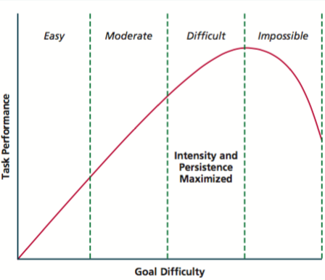

Self-set goals are the internalized goals that people use to monitor their own task progress.
-Challenging goals increase the intensity of effort.
-Increase the persistence of effort.

Moderators
Feedback –in goal setting theory, it refers to progress updates on work goals.
Task complexity –the degree to which the information and actions needed to complete a task are complicated.
Goal commitment –the degree to which a person is determined to reach the goal.

S.M.A.R.T. goals –specific, measurable, achievable, results-based, time-sensitive goals.
-These goals were created to combat the lack of feedback provided in firms.

- Equity Theory
Equity theory is motivation also depends on what happens to other people.
This theory compares the inputs one invests in a job and the outcomes one receive in comparison to the inputs and outcomes of a comparison other (someone who provides a frame of reference).

Equity exists when:
My outcomes = Other’s outcomes
My inputs Other’s inputs

Cognitive calculus is any imbalance in ratios triggers equity distress –an internal tension that can only be alleviated by restoring balance to the ratios.

Cognitive distortion –reevaluation of the inputs an employee bring to a job.
-Often occurring in response to equity distress.

Internal comparisons –comparing oneself to someone in your same company.
External comparisons –comparing oneself to someone in a different company.
3 General Possibilities

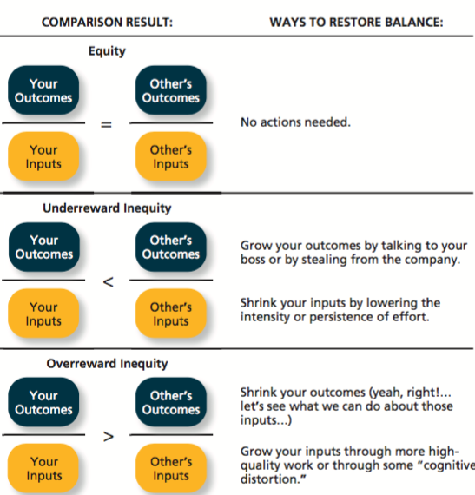

Case Incident

Joan had been working as a reporter for a large television network for 7 years. She was a graduate of Stanford University, was an experienced and hardworking reporter who had won many awards over the years for her outstanding work. The work was exciting and challenging, and at $75,000 a year plus benefits she felt well paid and satisfied.

What does the ratio look like for Joan?
Inputs? Outcomes?

A: O = $75,000 + benefits; exciting and challenging
I 7 years; Stanford University graduate, awards

Then… she found out that 2 recent graduates from one of the best schools of journalism in the United States had just been hired by her network at a starting salary of $80,000. Further, two other reporters who worked with Joan and had similar track records had just received job offers from American networks and were being offered $150,000 plus $10,000 for every award won for their reporting.

According to equity theory, how does Joan feel? What might she do?

O = $80,000 starting and $150,000 + $10,000 per award
I Best schools Same as Joan

Joan feels under reward inequity or equity distress.
She might talk to her manager and ask for a reward or lower her inputs (might not work as hard, withdrawal behaviour such as job searching).

- Psychological Empowerment

The belief that work tasks contribute to some larger purpose –can be intrinsically motivating:
Meaningfulness is the degree to which one feels that work tasks contribute to society.
Self-determination is a sense of choice.
Competence is a belief in ones ability to perform work tasks successful (=self-efficacy).
Impact reflects the sense that a person’s actions “make a difference”; towards an important purpose; making progress.

Tuesday, February 14, 2017

Daniel Pink Motivation Ted Talk
3 Cognitive Motivators:
- Autonomy
- Mastery
- Purpose

Pay people off the table; pay people equitably.
Watch the Ted Talk and Write Notes

Chapter 8: Trust, Justice and Ethics

Justice
Justice –the perceived fairness of an authority’s decision making.

4 Types of Justice

1. Distributive Justice –the perceived fairness of decision-making outcomes.
-Equity is the norm in most businesses.

What does this type of justice relate to?
This relates to equity theory:
My outcomes = Other’s outcomes
My inputs Other’s inputs

2. Procedural justice –the perceived fairness of decision-making processes.
-Fostered when authorities adhere to rules of fair process:
Voice –employees have a chance to express their views.
Correctability –appeal process. Have recourse.

Procedural Justice Rules

Consistency, bias suppression, representativeness and accuracy rules:
Help ensure that procedures are neutral and objective, not biased and discriminatory.
Ex: applying for government positions, interview questions.

Does procedural justice matter?
Yes, distributive justice and procedural justice combine to influence employee reactions.

When does procedural justice matter most?
When outcomes are bad/poor, procedural justice becomes very important.
I.e. midterm results

3. Interpersonal justice –perceived fairness of the treatment received by employees from authorities.
-Fostered when authorities follow 2 rules:
i) Respect rule –treat employees in a dignified and sincere manner.
ii) Propriety rule –refrain from making improper or offensive remarks.

4. Informational justice
The perceived fairness of communications provided to employees.
Increases when:
Justification rule –comprehensive and reasonable.
Truthfulness rule –communications are honest and candid.

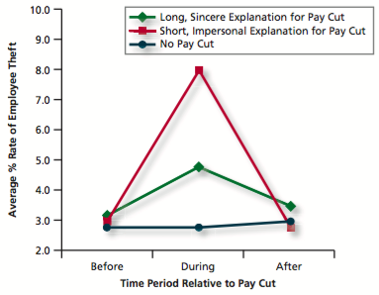

Trust

Trust –the willingness to be vulnerable to an authority based on positive expectation about the authority’s actions and intentions.
i.e. Presidents/Prime Ministers, Car Brands

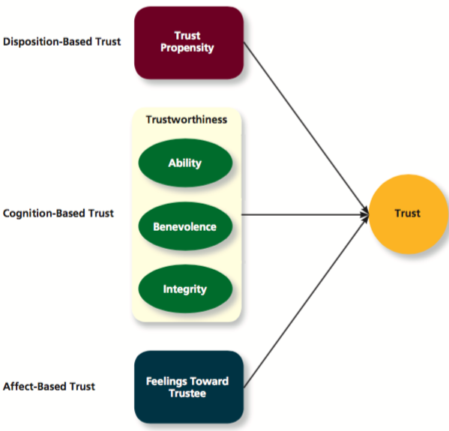

Trust is rooted in Different Factors

Disposition-based trust –trust rooted in one’s own personality.
Cognition-based trust –based on a rational assessment of the authority’s trustworthiness.
As we gain more knowledge about the person (authority), we determine trustworthiness based on cognitions.
- Trustworthiness –the characteristics of a trustee that inspire trust.
-Driven by the authority’s track record –ability, benevolence and integrity.
- Ability –skills, competencies and areas of expertise that enable an authority to be successful.
- Benevolence –belief that an authority wants to do good for a trustor.
-Apart from any selfish/profit-centered motives.
- Integrity –the authority adheres to a set of values and principles that the trustor finds acceptable.
Trust Propensity –general expectation that words, promises and statements of individuals and groups can be relied upon.
-Trustor is high in trust.
-Shaped by genetics and environment.
-Affect by national culture.

Affect-based trust –trust that depends on feelings toward the authority.
-Often more emotional than rational.
-We trust because we have feelings for the person in question.
-May supplement the types of trust discussed previously.
-Our feelings may increase our trust (willingness to accept vulnerability).

Ex: you want to purchase a new bicycle, potentially online. How do you determine the trustworthiness of the company/vendor?
-Ability, Benevolence, Integrity
Online reviews, internal search of information, quality of materials (China versus Canada), perceived quality with pricing, show rooming, do they contribute to charities?.

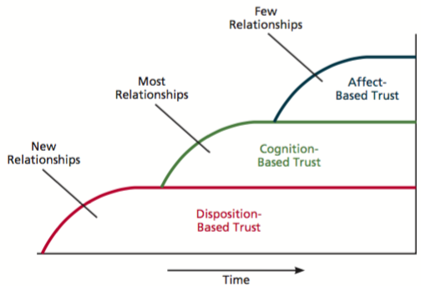

Ethics

Ethics –the degree to which the behaviours of an authority are in accordance with generally accepted moral norms.

Whistle blowing –employees’ exposing illegal or immoral actions by their employer.

Four-component model –model that argues that ethical behaviours result from multistage sequence of: moral awareness, moral judgment, moral intent and ethical behaviour.

- Moral awareness –recognition by an authority that a moral issue exists in a situation.
- Moral judgment –when an authority can accurately identify the “right” course of action.
-Cognitive moral development –as people age, they move through several states of moral development, each more mature than the previous one.
-Moral principles –prescriptive guides for making moral judgments.
-Moral intensity –the degree to which an issue has ethical urgency.
- Moral intent –an authority’s degree of commitment to the moral course of action.
- Moral identity –the degree to which a person views himself/herself as a moral person.

Thursday, January 26, 2017

Chapter 4: Personality, Cultural Values and Ability

Personality –structures inside a person that explain their patterns of thought, emotion and behaviour.
- Reflects what people are like and creates social reputation; cultural values and ability.
- Often called traits –recurring trends in people’s responses to their environment.
Culture –the shared values and beliefs that result from common experiences of members of a society.
- Transmitted across generations.
Cultural values –shared beliefs about modes of conduct in a given culture.
Ability –relatively stable capabilities that people for performing related activities.

Values across Cultures
Geect Hofstede’s study, where he discovered 5 basic dimensions:

- Individualism/collectivism –the degree to which culture has a loosely or tightly knit social structure.
- Power distance –to which a culture accepts unequal power distribution.
- Uncertainty avoidance –degree to which a culture tolerates ambiguity (vagueness).
- Masculinity/femininity –the degree to which a culture values stereotypically male traits.
- Long-term/short-term orientation –degree to which a culture stress values that are short term versus long term.

The Big Five Theory (Figure 9-1)

CANOE theory:

Conscientiousness –dependable, organized, reliable, ambitious, hardworking and persevering.
- Prioritize accomplishment striving: a strong desire to accomplish task-related goals.
- Work harder and longer on task assignments
Agreeableness –warm, kind, cooperative, sympathetic, helpful and courteous.
- Prioritize communication striving; a desire to obtain acceptance in personal relationships as a means of expressing personality
- Focus on “getting along”
- Beneficial in some position; not so much in others.
Extraversion –talkative, sociable, passionate, assertive, bold and dominant.
- Easiest to judge in zero acquaintance situations.
- Prioritize status striving: reflects a desire to obtain power and influence within a social structure as a means of expressing personality.
- Tend to be high in positive affectivity; dispositional tendency to experience pleasant moods (i.e. enthusiasm, excitement, happiness)
- Ex: politicians, entrepreneurs.
Neuroticism –nervous, moody, emotional, insecure and jealous (opposite is emotional stability, what you want in a job).
- Synonymous with negative affectivity: tendency to experience unpleasant moods.
- More likely to appraise situations as ‘stressful’.
- Less likely to believe they can cope with the stressors that they experience.
- Strongly related to locus of control –whether people attribute the cause of events to themselves.
Openness –curious, imaginative, creative, complex, refined and sophisticated.
- Also called ‘inquisitiveness’ or ‘intellectualness’
- Ex: entrepreneurs (innovators), artistic and scientific fields; high levels of creative performance.

Trait Adjectives Associated with the Big Five

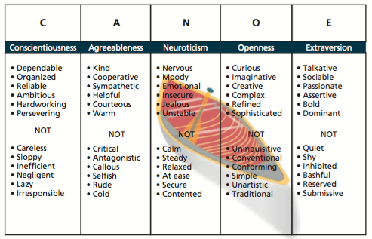

Using the Big Five

- Agreeableness and conscientiousness predict ‘getting along.’
- Conscientiousness predicts ‘getting things done’ (on time, according to plan); higher performance.
- Extraversion and agreeableness predict higher performance on work/jobs requiring teamwork or high interpersonal interactions.
- The Big Five is applicable cross-culturally.

The Myers-Briggs Type Indicator (MBTI)

It assesses personality through 4 categories:

- Introversion versus extraversion (energy)
- Sensing versus intuition
- Thinking versus feeling
- Judging versus perceiving.
It measures individual personalities along these four continuums to create 16 (4x4) personality types.

Cognitive Ability –capabilities related to use of knowledge to make decisions and solve problems.
- Verbal ability –various capabilities with understanding and expressing oral/written communication.
- Quantitative ability –capabilities with basic mathematical operations and formulas.
- Reasoning ability –diverse set of abilities associated with sensing and solving problems using rules and logic.
- Spatial ability –capabilities associated with visual and mental representation.
- Perceptual ability –capacity to perceive, understand and recall patterns of information.
Emotional ability:
- Emotional intelligence –set of abilities related to the understanding and use of emotions that affect social functioning.
- Self-awareness –ability to recognize and understand the emotions in oneself.
- Other awareness –ability to recognize and understand the emotions that other people feel.
- Emotion regulation –ability to recover quickly from emotional experiences.
Physical ability:
- Strength –degree to which the body is capable of exerting force.
- Stamina –ability of a person’s lungs and circulatory system to work efficiently while he/she is engaging in prolonged physical activity.
- Flexibility and coordination –ability to bend, stretch, twist or reach.
- Sensory ability –capabilities associated with vision and hearing.
- Psychomotor –capabilities with manipulating and controlling objects.
- Sensory –capabilities with vision and hearing.

Effects of Personality on Performance and Commitment

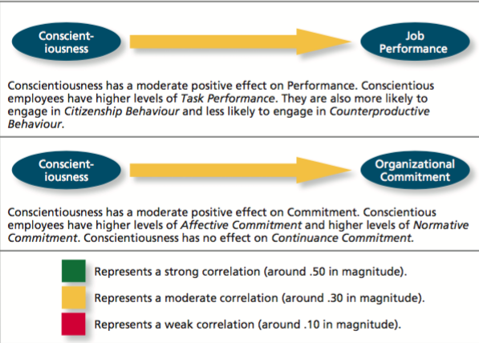

Typical performance –performance in the routine conditions that surround daily job tasks.
Maximum performance –performance in brief, special circumstances that demand a person’s best effort.

Situational strength –degree to which situations have clear behavioural expectation, incentives,
or instructions that make differences between individuals less important.

Trait activation –the degree to which situations provide cues that trigger the expression of a given personality trait.

Tuesday, February 28th, 2017

Chapter 9: Learning and Decision Making

Learning –a relatively permanent change in an employee’s knowledge or skill that results from experience.
Decision-making –the process of generating and choosing from a set of alternatives to solve a problem.

Expertise –the knowledge and skills that distinguish experts from novices.

Types of Knowledge

Explicit knowledge –kind of information you are likely to think about when you picture someone sitting down at a desk to learn.
-Information that is relatively easily communicated.
-A large part of what companies teach during training sessions.

Tactic knowledge –what employees can typically learn only through experience.
-It is not easily communicated.
-Most important aspect of what we learn in organizations.
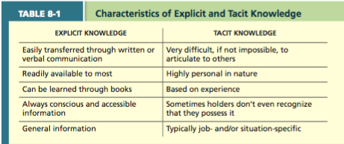

Methods of Learning

Operant conditioning –learning by observing the link between our voluntary behaviour and the consequences that follow it.
-Antecedents in organizations are typically goals, rule, instructions or other types of information that help show employees what is expected of them.

Contingencies of reinforcement –four specific consequences used by organizations to modify employee behaviour.

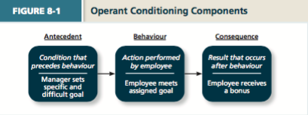

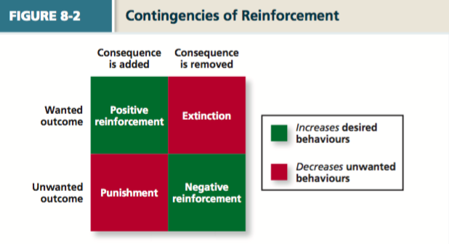

Contingencies of Reinforcement

1. Negative reinforcement occurs when an unwanted outcome is removed following a desired behaviour.
I.e. performing a task to not get yelled at.

2. Punishment occurs when an unwanted outcome follows an unwanted behaviour.
I.e. employee given something they do not like as a result of performing behaviour the organization does not like.

3. Extinction is the removal of a consequence following an unwanted behaviour.
-Can be purposeful or accidental.
i.e. employee getting attention from co-workers when they act somewhat childish.

4. Positive reinforcement –a reinforcement contingency in which a positive outcome follows a desired behaviour.
-I.e. public recognition, feedback.
-Encourages employees and helps ensure that desirable behaviours will be imitated/repeated.

Positive reinforcement and extinction should be the most common forms of reinforcement used be managers to create learning.

Schedules of reinforcement –the timing of when contingencies are applied or removed.
Continuous reinforcement –a schedule of reinforcement in which a specific consequence follows each and every occurrence of a certain behaviour.
-Impractical for most jobs; you cannot provide positive reinforcement every time.
Types of Reinforcement Schedules

Variable-interval schedule is a schedule whereby reinforcement occurs at random periods of time.
-I.e. supervisor walking around at different point of time every day.

Fixed-interval schedule is a schedule whereby reinforcement occurs at fixed time periods.
-Workers are rewarded after a certain amount of time.

Variable-ratio schedule is a schedule whereby behaviours are reinforced after a varying number of them have been exhibited.
-I.e. salespeople being compensated with commission, but sales vary.

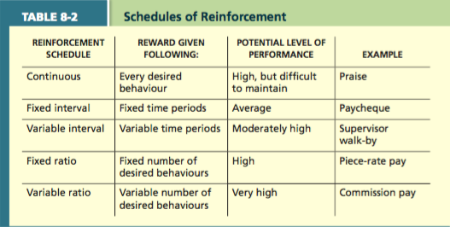

Social learning theory argues that people in organization learn by observing others.
Behavioural modeling is when employees observe the actions of others, learn from what they observe, and then repeat the observed behaviour.

The Behavioural Modelling Process

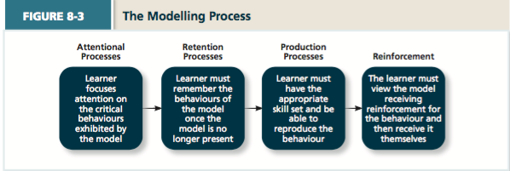

Goal Orientation

Learning orientation –a predisposition or attitude according to which building competence is deemed more important by an employee than demonstrating competence.
-Learning-oriented people enjoy working on new tasks.
-They view failure in positive terms, increasing knowledge and skills in the long run.

Performance-prove orientation –a predisposition or attitude by which employees focus on demonstrating their competence so that others think favourably of them.
Performance-avoid orientation –a predisposition or attitude by which employees focus on demonstrating their competence so that others will not think poorly of them.
-Performance-oriented people tend to work on tasks they are already good at, preventing them from failing in front of others.

Learning goal orientation improves:
- Self-confidence
- Feedback-seeking behaviour
- Learning strategy development
- Learning performance
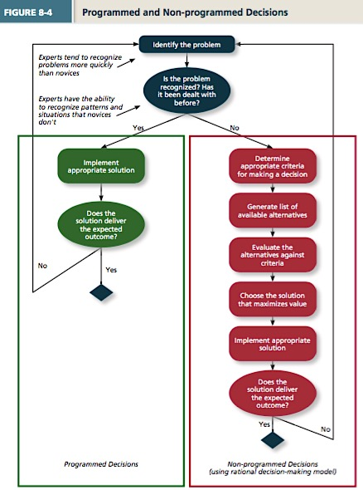
Methods of Decision Making

Programmed decisions are decisions that become somewhat automatic because the decision maker’s knowledge allows him or her to recognize the situation and the course of action to be taken.

Intuition is an emotional judgment based on quick, conscious gut feelings.

Crisis situation is a change (sudden or evolving) that results in an urgent problem that must be addressed immediately.

Non-programmed decisions are decisions made by employees when a problem is new, complex or not recognized.

Rational decision-making model is a step-by-step approach to making decisions that is designed to maximize outcomes by examining all available alternatives.

Decision Making Problems

Bounded rationality is the notion that people do not have the ability or resources to process all available information and alternatives when making a decision.
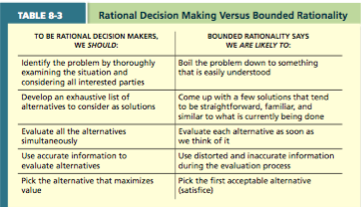

Satisficing –what a decision maker is doing who chooses the first acceptable alternative considered.

Faulty Perceptions.
Selective perception is the tendency for people to see their environment only as it affects them an as it is consistent with their expectations.
-“You only see what you want to see”.

Projection bias –the faulty perception by decision makers that others think, feel and act as they do.
Social identity theory –people identify themselves according to the various groups to which they belong and judge others according to the groups they associate with.
-Groups may be based on demographics, occupation, workplace, nationality, etc…
Stereotype is assumptions made about others based on their social group membership.
-Decision making process becomes fault when we make inaccurate generalizations.
Heuristics are simple and efficient rules of thumb that allow one to make decisions more easily.
-Usually lead to correct decisions; can also bias toward inaccurate decisions at times.

Availability bias is the tendency for people to base their judgments on information that is easier to recall.

Fundamental attribution error is the tendency for people to judge others’ behaviours as being due to internal factors such as ability, motivation or attitudes.
-We are less harsh judging ourselves than others.

Self-serving bias is when one attributes one’s own failures to external factors and success to internal factors.

Escalation of commitment is a common decision-making error in which the decision maker continues to follow a failing course of action.
-“Throwing good money after bad”
-People have a tendency to escalate their commitment to previous decisions, even if they were failures.
-People have a tendency to escalate their commitment to previous decisions, even if they were failures.

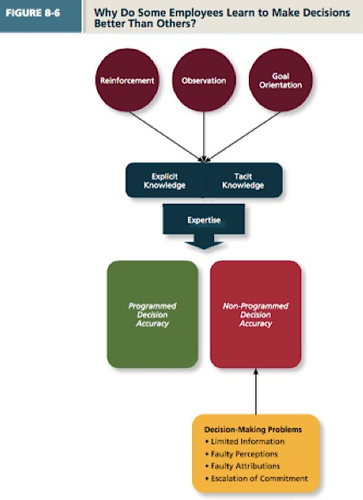

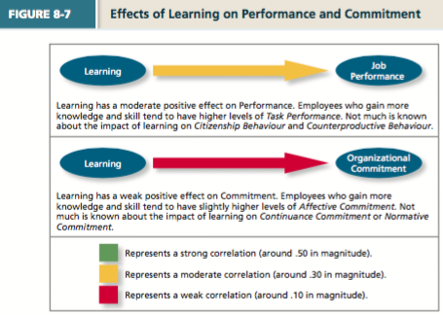

Tuesday, March 7nd, 2017

Chapter 12: Power, Influence and Negotiation

Power –the ability to influence the behaviour of others and resist unwanted influence in return.

Five major types of power that can be grouped along 2 dimensions:
- Organizational power
- Personal power

Organizational Power

Legitimate power –derived from a position of authority in the organization
-Sometimes called “formal authority”
Reward power –when someone has control over the resources or rewards.
Coercive power –when someone has control over punishments in the organization.
-Runs off of a “fear principle”, we do not like to use this in organizations.

Personal Power

Expert power –derived from a person’s expertise, skill or knowledge on which others depend.
i.e. an IT expert is depended upon to fix a website crash.
Referent power –when others have a desire to be associated with a person.

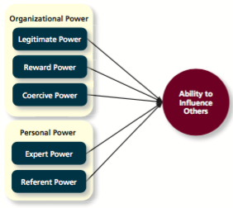

Contingency Factors

Contingency factors –factors/situations that make it more or less likely that people can use their power to influence others.

- Substitutability –the degree to which people have alternatives in accessing resources.
- Discretion –the degree to which managers have the right to make decisions on their own.
- Centrality –how important (central) a person’s job is.
- Visibility –how aware others are of a leader’s power and position.

Using Influence Tactics
We can use “tactics” to influence others in organizations towards organizational goal.
They will respond in different ways: resist, comply or internalize.

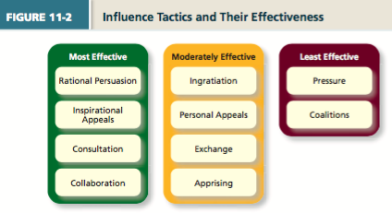

If power in organizations is used to further one’s own self-interests, what is it called?
A: Organizational politics –individual’s actions that are taken to further their own self-interests.
Good or bad?
Not necessarily bad, this is political skill –the ability to understand others at work and use the knowledge to enhance personal and/or organizational objectives.

Using Influence to Manage Organizational Conflict

Approaches to Managing Organizational Conflict.
In Class Activity: Filling out Questionnaire and determining your primary and secondary approaches.
Options: competing, accommodating, compromising, avoiding, collaborating.

Avoiding

Avoiding –low assertiveness of one’s own interests and low cooperation with the other party.
“Hiding your head in the sand”

This is a sensible response when:
- The issue is trivial (you are neutral about the decision)
- Want to remain neutral
- Information is lacking
- Postpone conflict (i.e. people need to cool down)
- The opponent is very powerful and hostile.

Issue: this does not really resolve the conflict (depends on circumstances).

Accommodating

Accommodating –cooperate with the other part (high cooperation) while not asserting one’s own interests (unselfish).

This is a sensible/effect strategy when:
- You realize that you are wrong –can learn, show reasonableness
- The issue is more important to the other party
- You want to build good will; harmony/stability.
- You have less power anyway –going to lose.

Competing

Competing –maximizes assertiveness and minimizes cooperation.
It can be effective when:
- Emergencies –no time.
- You have a lot of power.
- You are sure of your facts –welfare of the company.
- Unpopular issues –truly win-lose
- You will not have to interact with the other party in the future.
Creates a win-lose situation.

Compromising

Compromising –combines intermediate levels of assertiveness and cooperation.
It is a sensible reaction when:
- There is conflict stemming from scarce resources.
- Have equal power but mutually exclusive goals.
- You need a good fallback position if other strategies fail.

Collaborating

Collaborating –maximizes both assertiveness and cooperation.
Any attempt to secure an integrative agreement that fully satisfies the interests of both parties (a win-win resolution).
Works best when:
- Conflict is not intense.
- Each party has information that is useful to the other.
- Take time to share information, work through differences/feelings that have interfered in the past.

Using Influence during Negotiation

A process among interdependent parties attempt reach agreement about their differences.
There are distributive and integrative negotiation tactics.

Tuesday, March 14, 2017

Chapter 13: Leadership Styles and Behaviour

Leadership is the use of power and influence to direct the activities of followers toward goal achievement.
-Can affect followers’ interpretation of events, organization of their work activities, commitment to key goals, and relationships with others.

Leader-member exchange theory describes how leader-member relationships develop over time on a dyadic (interactive) basis.
Role taking is a phase in leader-follower relationships when a leader provides an employee with job expectations and the follower tries to meet those expectations.
Role making is the phase in a leader-follower relationship when a follower voices his/her own expectations for the relationship, resulting in a free-flowing exchange of opportunities and resources for activities and effort.
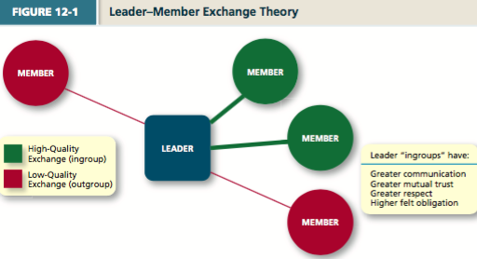

Why are some leaders more effective than others?
Leader effectiveness –the degree to which the leader’s actions result in the achievement of the unit’s goals, the continued commitment of the unit’s employees and the development of mutual trust, respect and obligation in leader-member dyads.

- High openness to experience
- High extraversion
- High general cognitive ability
- High energy level
- High stress tolerance
- High self-confidence

Leader emergence is the process of becoming a leader in the first place.

- High conscientiousness
- Low agreeableness
- High openness to experience
- High extraversion
- High general cognitive ability
- High energy level
- High stress tolerance
- High self-confidence

Leader Decision Making Styles

Autocratic style –leader makes the decision alone without asking for opinions/suggestions of the employees.
Consultative style –leader presents the problem to employees asking for their opinions/suggestions before making the decision.
Facilitative style –leader presents the problem to a group of employees and seeks consensus on a solution, making sure his/her opinion is equal to others.
Delegative style –leader gives the employee the responsibility for making decisions within some set of specified boundary conditions.

Time-driven model of leadership –a model that suggests that 7 factors, including:
The importance of the decision, the expertise of the leader, and the competence of the followers, combine to make some decision-making styles more effective than others in a given situation.
- Decision significance –is the decision significant to the success of project/organization?
- Importance of commitment –is it important that employees “buy in” to the decision?
- Leader expertise –does the leader have significant knowledge/expertise about the problem?
- Likelihood of commitment –how likely will employees trust the leader’s decision and commit?
- Shared objectives –do employees share and support the same objectives, or do they have own agenda?
- Employee expertise –do the employees have significant knowledge/expertise about the problem?
- Teamwork skills –do the employees have the ability to work together to solve the problem or will they struggle with conflicts/inefficiencies?

Day-to-Day Leadership Behaviours

Initiating structure –pattern of behaviour where the leader defines and structures the roles of employees in pursuit of goal attainment.
-Leaders play a more active role in directing group activities.
-Prioritize planning, scheduling and trying new ideas.
-Emphasize the importance of meeting deadlines, follow formalized procedures, criticize poor work.

Consideration is a pattern of behaviour where the leader creates job relationships characterized by mutual trust, respect for employee ideas, and consideration of employee feelings.
-Create a climate of good rapport and strong, to way communication.
-Exhibit deep concern for welfare of employees.

Life cycle theory of leadership –a theory stating that the optimal combination of initiating structure and consideration depends on the readiness of the employees in the work unit.

Readiness is the degree to which employees have the ability and the willingness to accomplish their specific tasks.

- Telling –when the leader provides specific instructions and closely supervises performance.
- Selling –when the leader explains key issues and provides opportunities for clarification.
- Participating –leader behaviour in which the leader shares ideas and tries to help the group conduct its affairs.
- Delegating –leader behaviour in which the leader turns responsibility for key behaviours over to employees.

Transformational leadership –a pattern of behaviour in which the leader inspires followers to commit to a shared vision that provides meaning to their work while also serving as a role model who helps followers develop their own potential and view problems from new perspectives.

Types of Leadership

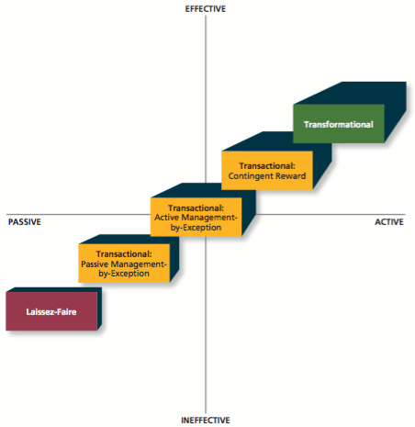
Laissez-faire leadership –when the leader avoids leadership duties altogether.
Transactional leadership –a pattern of behaviour in which the leader rewards or disciplines the follower on the bases of performance.
Passive management by exception –a type of transactional leadership in which the leader waits around for mistakes and errors, then takes corrective action as necessary.

Active management-by-exception –a type of transactional leadership in which the leader arranges to monitor mistakes and errors actively, and takes corrective action when required.

Contingent reward –a more active and effective type of transactional leadership, in which the leader attains follower agreement on what needs to be done using rewards in exchange for adequate performance.

How important is leadership?
All styles and behaviours of leadership have their own unique importance.

Substitutes for leadership model –a model that suggests that characteristics of the situations can constrain the influence of the leader, which makes it more difficult for the leader to influence employee performance.
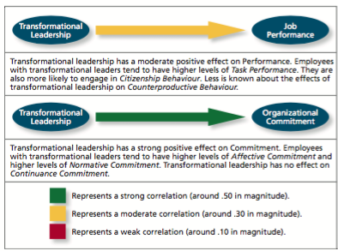

Tuesday, March 28th, 2017

Chapter 11: Focus on Teams

A team consists of two or more people interacting interdependently to achieve a common goal.

How is a team different than a group?
- Produce joint products
- Deeper dependence upon one another
- Shared accountability
- Members have a specific task-related purpose

A team is always a group, but a group is not always a team.

State of Team Development

Forming –try to understand the boundaries and expectations.
Storming –remain committed to ideas (can trigger conflict)
Norming –resolve issues, realize that they need to work together to accomplish team goals.
Performing –team focuses on accomplishing tasks; makes progress towards goals.
Adjourning –disengage, members may experience anxiety.

Punctuated Equilibrium Model

-Initial team meeting –members establish a pattern of behaviour that lasts for the first half.
-Midpoint transition is critical for the group to progress.
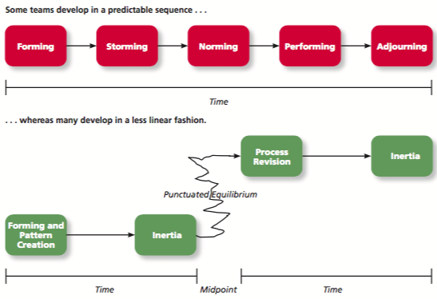

Team Interdependence

Task interdependence –the degree to which team members interact.
-How they are linked.
-Rely on others for materials and resources.
-4 types:

1. Comprehensive task interdependence –requires the highest level of interaction and coordination.
-Each member has a great deal of discretion –collaborative effort.
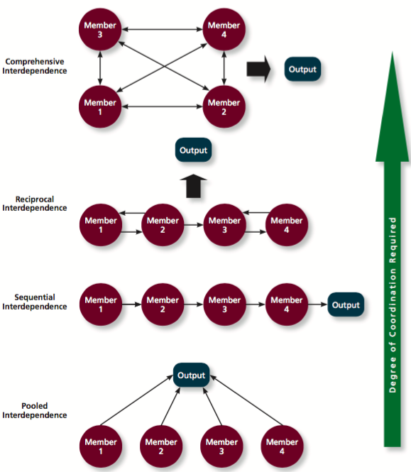
2. Reciprocal task interdependence –members are specialized to perform specific tasks.
-Not a strict sequence

3. Sequential task interdependence –different tasks are done in a prescribed order.
-Group is structured so members specialize in these tasks.
-Interaction only occurs between members who perform tasks that are next to each other in the sequence.
-I.e. classic assembly line.

4. Pooled task interdependence –lowest degree of coordination.
-Members complete their work independently.
Goal interdependence –degree to which team members have a shared goal and align their individual goals with that vision.

Outcome interdependence –degree to which team members share equally in the feedback and rewards that result from the team achieving its goals.
Team Composition

Team composition –the mix of the various characteristics that describe the individuals who work in the team.

5 Aspects of Team Composition
1. Member roles –behaviour a member is expected to display.
2. Member ability –team members provide a wide array of abilities, both physical and cognitive.
- Disjunctive tasks –tasks with an objectively verifiable best solution.
- Conjunctive tasks –depends on the abilities of the ‘weakest link’.
- Additive tasks –tasks for which the contributions resulting in ‘add up’.
3. Member personality
- Agreeable –cooperative and trusting.
- Conscientious –dependable, work hard to achieve goals
- Extraverted –perform effectively in interpersonal interactions.
4. Team diversity –surface-level diversity.
- Diversity regarding observable attributes.
- Ex: ethnicity, sex, age.
Deep level diversity –attributes are less easy to observe initially.
-But discover after more direct experience (value, attribute).

5. Team size –having a greater number of members is beneficial for management and project teams.
-Large teams are not beneficial in production tasks.
Process gain –when team outcomes are greater than expected.
-Based on capabilities of individual members.

Process loss –loss occurred when team outcomes are less than expected.
-Social loafing and social riding.
- Coordination loss –consumers time and energy that could otherwise be devoted to actual activity.
- Production blocking –a member has to wait on the previous member.
- Motivational loss –team members do not work as hard as they could.
- Social loafing –members exert less effort on team tasks than they would on their own.
Thursday, March 30, 2017

Chapter 10: Communication

The Communication Process
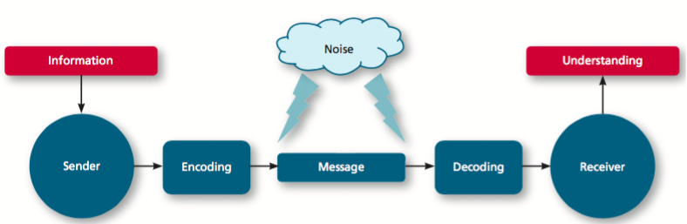

Face-to-face communication –exchange of information when individuals are physically present (no mediating technology)
- Verbal communication
- Nonverbal communication
-Information exchange that doesn’t involve spoken or written words.

How much is conveyed with nonverbal?
70-90% of a message’s meaning is conveyed, not by words, but rather by body language.

Computer-mediated communication:
- Web 2.0 applications
- Electronic Mail (e-mail)
- Videoconferencing
- Wikis
- Social Network Applications
-LinkedIn –used by 300M for professional networking.
-Achievers –workplace social network technology –Razor Suleyman; recognition program.

Potential Issues with Communication

1. Communicator Competence –the ability of communicators to encode and interpret messages.
3 components:
Sensing –receiving signals from the sender and paying attention to them.
Evaluating –understanding the message meaning, evaluating the message, and remembering the message.
Responding –providing feedback to the sender, which motivates and directs the speaker’s communication.

2. Active listening –you spend much of your communications time listening –over 45%
-The average person speaks at about a rate of 150 words per minute (wpm).
-But…we can hear at about a rate of 1,000 wpm.

5 Tips of Active Listening

- Paraphrase the message –to the speaker to confirm your understanding.
Explain by putting the message in your own words, you concentrate on what was said, making you listen better.
- Repeat the message –help you remember what was said.
Do this to other person’s satisfaction that you heard his/her message correctly. You are listening and really understanding what was said.
- Probe for missing information –explain by requesting/asking questions. You find out any information that might be missing or that you need/want.
- Clarify any points that you might not completely understand. Ensure that you heard exactly what the speaker is saying.
- Remember the important points of the message for future application.

3. Information richness –the amount and depth of the information transmitted in a message.

What has a higher level of information richness?
- A handwritten note versus an email message?
- A text versus an email?
- Video-conferencing versus conference call?
- One-on-one meeting versus a team meeting?
- A computer-generated report versus a written message?

4. Gender Differences –the different ways men and women tend to process and interpret information and communicate with others.

Deborah Tannen:
Men tend to use a style of communication that helps them achieve and maintain status, power and independence (‘one up’).
Women tend to send messages and use a style that builds and strengthens their relationships –rapport (‘one down’).

Tuesday, April 4, 2017

Chapter 13: Organizational Structure

Organizational structure –how jobs and tasks are divided and coordinated between individuals and groups within the company.

An organizational chart is a drawing that represents every job in the organization and the formal reporting relationships between those jobs.

5 Elements of Organizational Structure
- Work specialization – the degree to which tasks in an organization are divided into separate jobs.
-The division of labour.
- Chain of command – “Who reports to whom?” and signifies formal authority relationships.
-Hierarchy of authority.
- Span of control –how many employees each manager in the organization has responsibility for.
-Narrow spans of control, managers are more hands on with employees and vice versa.
- Centralization –where decisions are formally made in organizations.
- Formalization –degree to which rules and procedures are used to standardize behaviours and decisions in an organization.

Organizational Design
Organizational design is the process of creating, selecting or changing the structure of an organization.
-Proactively designed to match specific circumstances and needs.
1.Business environment –the outside environment, including customers, competitors, suppliers, and distributors, which all have an impact on organizational design.
-Big factor: is outside environment stable or dynamic?
-Stable environments do not change frequently or quickly.
-Dynamic environments change on a frequent basis and organizations must have adaptive structures.
2. Company strategy –an organization’s objectives and goals and how it tries to capitalize on its assets to make money.
-Low cost producer (sell at lowest cost) or differentiator (unique products).
3. Technology –the method by which an organization transforms inputs to outputs.
4. Company size –the number of employees in a company.
Common Organizational Forms

Simple structure –an organizational form that features one person as the central decision-making figure.
Ex: Figure 13-3 Organizational Structure for a Small Restaurant.
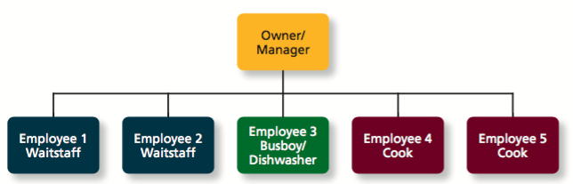

Bureaucratic Structures

1. Functional structure –employees are grouped by the functions they perform.
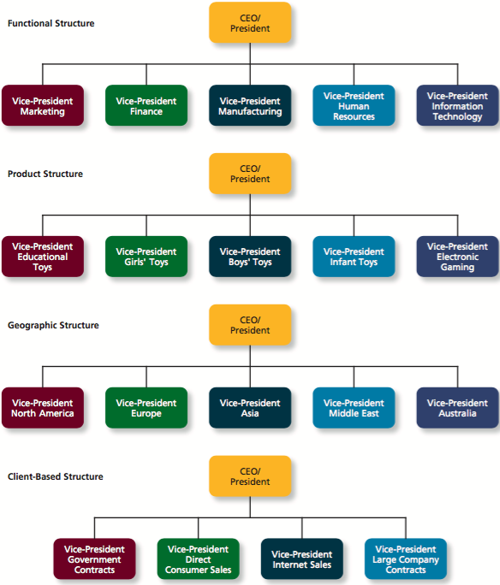

2. Multi-Divisional Structures –employees are grouped into divisions around products, geographic regions, or clients.
-Product structures group business units round different products that the company produces.

3. Geographic Structures –are generally based around the different locations where the company does business.

4. Client structure –employees are organized around serving customers.

Matrix structure –a more complex form of organizational design that tries to take advantage of:
- Functional Structure
- Product Structure
*At the same time.
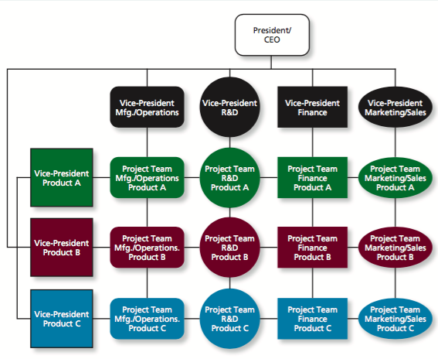

Why Do Some Organizations Have Different Structures than Others?

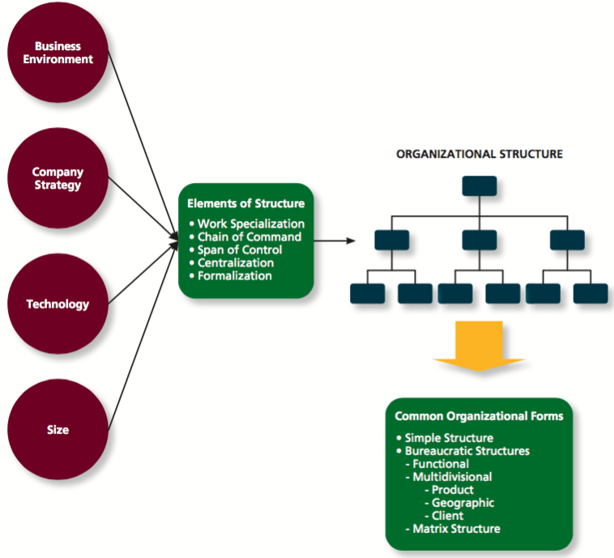

Chapter 15: Organizational Culture and Change

Organizational culture –shared social knowledge within an organization regarding the rules, norms and values that shape the attitudes and behaviours of employees.

3 Components of Organizational Culture
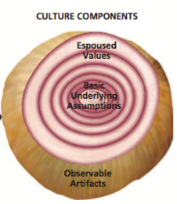
1. Basic underlying assumptions –taken for granted beliefs and philosophies.
So ingrained that employees simply act on them rather than questioning them.
2. Espoused values –the beliefs, philosophies and norms that a company explicitly states.
I.e. published documents, verbal statements made to employees by managers, information on the website.
Espoused values vs enacted values.
-“Walk the talk”
3. Observable artifacts –the manifestations of an organization’s culture that employees can easily see or talk about.
- Symbols i.e. corporate logo, website, uniforms.
- Physical structures i.e. office layout and design.
- Language i.e. slogans, acronyms.
- Stories i.e. founders, anecdotes, myths.
- Rituals i.e. routines.
- Ceremonies i.e. formal events.

Organizational Culture Types

FIGURE

Specific Culture Types
- Customer service culture
- Safety culture
- Diversity culture
- Creativity culture

Are Cultures Consistent?

The hardware and software division have rather different beliefs, values and assumptions.
This illustrates the operation of:
A –Symbolic cultures
B –Ritual cultures
C –Strong cultures
D -Subcultures
E –Pathological cultures

Culture Strength

A strong culture –employees agree about the way things re supposed to be (high consensus) and their behaviours are consistent with those expectations (high intensity).

Culture Strength Subcultures

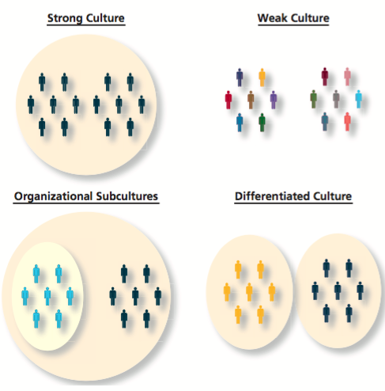

Building and Maintaining an Organizational Culture

Socialization –process by which employees learn the social knowledge that enable s them to understand and adapt to the organization’s culture.
- Anticipatory stage –prior to an employee starting work.
- Encounter stage –begins the day an employee starts
-Reality shock
- Understanding and adaptation –start to internalize the organizational norms.

Managing Socialization

How can organizations minimize reality shock and promote socialization?
1. Realistic job preview (RJP) –need to determine the person-organization fit.
2. Newcomer orientation sessions.
3. Mentoring programs

Culture Change
When culture change is needed what can be done?
The change process involves 3 sequential steps:
- Unfreezing
- The Change Initiative
- Refreezing
Issues: culture clash, improper diagnosis, resistance.
Create a need for change or else people do not want to do it.
Thursday, April 6, 2017

Exam Review

4 questions on chapters 2-7
7 questions on new chapter 8-15
This will include approx. 5-8 questions from class.

Chapter 8 –Trust, Justice, Ethics
Justice –perceived fairness of authority’s decision making.
4 Different types of justice:
1. Distributive –perceived fairness of decision making outcomes.
-This justice relates to equity theory.
2. Procedural –perceived fairness of decision-making processes.
-Voice, correctability.
-Rules: consistency, bias suppression, representativeness, accuracy.
-Matters the most when outcomes are bad.
3. Informational –perceived fairness of communications provided to employees.
-Increases when: justification rule, truthfulness rule.
4. Interpersonal.-perceived fairness of treatment received by employees from authorities.
-2 Rules –respect rule, proprietary rule.

Trust –willingness to be vulnerable to a trustee.
3 types:
Cognitive –rational assessment of authority’s trustworthiness.
-Ability, benevolence, integrity.
Disposition –your personality traits.
Affect –depends on feelings toward authority.
Factors that affect trust diagram.
Trust propensities by nation (influence of culture on trust).
*4 component model of ethical decision making.
1. Moral awareness
2. Moral judgment
3. Moral intention
4. ?

What influences whether someone intends to ‘do the right thing’?
1.organizational culture/norms
2. moral identity (individual factor)
*What is whistleblowing?

Ch. 9. Learning and Decision Making

Types of Knowledge
-Explicit knowledge –easily communicated and available to everyone.
-Tacit knowledge –learned through experience

-Operant conditioning
Daniel Pink called this: if then rewards–rewards based on behaviour, either to repeat or stop.
2 contingencies used to increase desired behaviours:
Positive reinforcement –a positive outcome follows a desired behaviour.
-Most common; i.e. pay, promotion, praise.
Negative reinforcement –an unwanted outcome is removed following a desired behaviour.
-i.e. perform a task to do so that you will not be reminded (wear hard had to stop reminders of penalties).

2 contingencies used to decrease undesired behaviours:
1.Punishment –an unwanted negative outcome follows an unwanted behaviour.
i.e. suspension
2. Extinction –when there is the removal of a positive consequence following an unwanted behaviour
-I.e. stop picking up a baby who is crying.
2 types of decision-making:
1. Programmed decisions –quick decision based on intuition.
-automatic, gut feeling, based on experience, expertise.
2. Non programmed decisions –situations that are new, complex, no recognized.
*Rational decision making model
-problem with this model: based on assumptions which leads to faulty decision making.
Limited information:
Bounded rationality
Satisficing

*Faulty perceptions (and types)
*Decision making biases
Faulty attributions:
-Fundamental attribution error
-Self-serving bias.

Attribution process:
Consensus –did other act the same under similar situations?
Distinctiveness –does this person act differently?
Consistency -
Internal attribution –low consensus, low distinctiveness, high consistency.
External attribution –high consensus, high distinctiveness, low consistency.

*Escalation of commitment –decision to continue to follow a failing course of action.
-Escalate their commitment to previous decision even in the face of obvious failures.

Chapter 11: Teams and Diversity
Stages of Team Development:
Forming –understand boundaries/expectations
Storming –remain committed to ideas, can trigger conflict
Norming –realize they need to work together to accomplish goal.
Performing –members are comfortable working on their goals
Adjouring –

*Punctuated equilibrium model.
-Groups have a specific deadline to complete a problem-solving ask, they tend to follow this pattern.

Types of interdependence
-Sequential
-Pooled
-Reciprocal
-Comprehensive
Types of interdependence
-Goal
-Outcome
Desert survival activity –disjunctive.
Group consensus decision at the end
A large group be better than a small group for disjunctive tasks.

-Disjunctive
-Conjunctive
-Additive
Group activity: Team is better than the best performer.

She never does none of the above.

Process loss
-coordination loss
-production blocking
-motivational loss
-social loafing

Types of Power: organizational power and personal power

*approaches to managing organizational conflict.

Ugli orange –one used juice, other rind.

Four styles of leadership decisions: autocratic( highest leader control) , consultative, facilitative, delegative (lowest leader control).

Time driven –situational aspects are more important.

