1. Three types of proteins and their roles
Integral Proteins:
- To be an integral protein it must span the membrane at least once
- Different shapes or sizes
- Can be outside and inside
- Can have N or C terminal portions outside or inside
- Some span the membrane on
- ly once in which case there is no ability to transport
- Some span multiple times:
  - Tend to have a tertiary structure that is ribbon like
  - Have a combination of polar and nonpolar amino acids with nonpolar amino acids facing where interaction with phospholipids are
  - Beta barrels: made up of a series of beta pleated sheets and facing the side of the fatty acid tails and you’ll have polar acids forming the inner core.

Peripheral Proteins:
- Proteins that interact with one of the membrane layers and are not bound or anchored to the membrane
- Non covalently bound to something that is part of the membrane or interacts with the membrane
- Usually, peripheral proteins act as a link between the cytoskeleton and the membrane or the extracellular matrix and the membrane
- It is not embedded in the membrane
- Because they are non covalently bound and tend to interact with integral or cytoskeletal proteins, they tend to contribute a lot to elasticity and support
- They work collaboratively with proteins that support the membrane
Example: Red blood cells:
- Has to continuously change shape and regain its shape without harm or damage
- Their membrane is built with lots of protein that interact with a network of peripheral protein that interact with the cytoskeleton
- Allows it to compress and regain its structure without being damaged

Lipid-anchored Proteins:
- Bound to something that makes up the membrane
- Does not span the whole membrane
- Covalently bound to their anchors while peripheral are not covalently bound
- Two types are told apart by which layer of the membrane they are anchored to and what they use to anchor themselves
- GPI anchors: Anchored to the extracellular matrix
  - Used for recognition
- Fatty acid or prenyl group: Used to anchor the protein to the inner layer, facing the inside of the cell
  - Useful for proteins involved in cell signaling and triggering cell growth or division
  - Much easier to move the protein around because only the anchor is bound
  - Moves along the membrane and reaches another target to send signals
  - Anchor can move around membrane as well
- All of these are covalently bound to the protein you are anchoring
- Requires enzymes and energy to get rid of this bond

2. How do large cells maintain a good surface area; volume ratio?
-microvilli?
- increases SA, cell size remains the same

3. Why is phosphoethyldiamine amphipathic?
-amphipathic: molecule with polar and non-polar properties
- 2 fatty acid or hydrocarbon nonpolar tails and a polar head group
- All of the 4 phospholipids are amphipathic (Phosphatidylethanolamine, Phosphatidylserine, Phosphatidylcholine, Sphingomyelin)
-PE increases fluidity
- PC decreases fluidity

4. She shows you a diagram of a type of transport? (the answer was exocytosis)
- Types of transports:
- Passive Transport: Relies solely on concentration gradient, solute’s permeability and the membrane’s fluidity. If the membrane is very rigid, even if you have a favourable concentration gradient and a normally permeable molecule, the rate will be lower
Facilitated diffusion: can use channels are carriers
  - Carrier saturates more than transporters
  - Still travelling along the concentration gradient so it is still passive

**PASSIVE AND FACILITATED TRANSPORTS PICTURES ARE ON THE NEXT PAGE**
2. Active Transport: Two types, rely on energy sources but diff types of energy sources 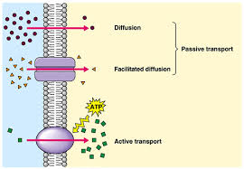

3. Secondary Active Transport:
- If solutes travel in the same direction: symport
- If solutes travel in opposite directions: antiport

Example:
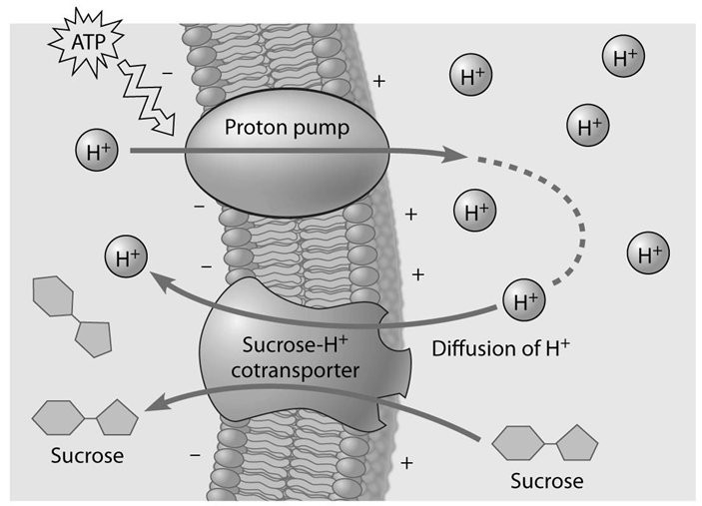
4. Primary active transport:
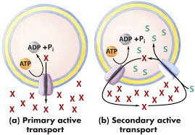
5. Endocytosis & exocytosis:
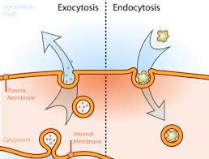

6. Pinocytosis
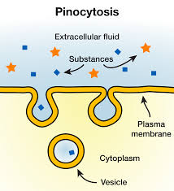
7. Phagocytosis
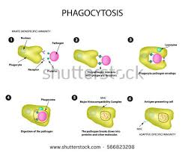

5. 5 T/F questions in a table. (They were really short and weird concerning tubules and, no explanation needed)

Microtubules:
- Needs to be flexible
- Made from proteins called tubulin
- Formed from dimers
- Constantly lengthening and shortening
- Hydrogen bonding and van der Waal interactions
- No covalent bonds because they are hard to break and require too much energy to break → huge energy investment
- Cells are highly efficient and most efficient way is without covalent bonds so weak chemical bonds hold these tubulin together to form microtubules
- 2 tubulin assemble together to form dimers

To determine orientation of a microtubule:
- Each dimer has a bound GTP (same as atp instead of adenine its guanine)
- When dimer is formed they stack on top of the other
- On one end the GTP is exposed and on the other end it isn’t
- This is what determines the polarity on the microtubule
- It refers to the presence of GTP and the absence of GTP
- Beta (+) exposes the GTP, alpha (-) covers the GTP (buried within the dimer)
- In a stack of dimers, the beta end faces where the microtubule is growing
- Anchorage is on the alpha side
- A string of dimers is called a protofilament and these assemble one on top of the other as a sheet
- Because of the 3D configuration of the protein dimers, 13 protofilaments form a complete hollow tube which becomes a microtubule
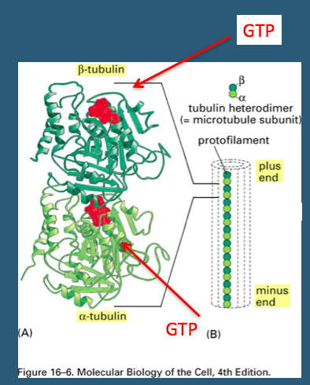

What kind of proteins are these?
- Shape is very compact and spherical
- Tubulin is very soluble within the cytoplasm
- Once the microtubule is formed it is a very rigid support protein but its made of globular soluble protein
- As it forms a polymer it changes the chemical properties and becomes a very rigid component of the cell

Microfilaments:
- Another oriented cytoskeletal fiber made up of a different globular protein called actin
- Actin molecules assemble in a staggered manner
- Actin are smaller fibres, not hollow
- Once these actin molecules form a microfilament they give the appearance of a right hand helix
- They also have polarity because as they stack some will have ATP exposed whereas others won’t
- Without ATP exposed is pointed end, (-)
- With ATP exposed is barbed end (+)

Where do we find microtubules and microfilaments?
- Microtubules cover most of the area of the cell except not entirely to the end of the plasma membrane
  - Ex. Responsible for carrying chromosomes and bringing them to each pole during mitosis
- Microfilaments cover up to the edge of the plasma membrane because microfilaments branch out

Microfilaments’ interaction with binding proteins:
- Actin microfilaments need to determine if they can continue to grow or not
- Capping proteins bind to the positive ends to prevent filament from growing
- Arp proteins bind to filament and serve as a branching point to begin another branch of microfilaments
- In diagram on slide 7: Membrane sticking out: different extensions of the membrane and the microfilament structures are what is pushing against the membrane

Intermediate filaments:
- Instead of being made of compact, globular, soluble proteins, it is made of multiple monomers of long fibrous proteins assembled in a braided or rope like structure
- Proteins like keratin and lamin (fibrous protein)
- First form dimers and assemble them head to toe and then combine these tetramers together to form very complex structures
  - 8 tetramers twisted into ropelike structure
- Intermediate filaments are found near the membrane
- Involved in joining two cells together
- They are also very flexible and have a certain degree of elasticity and are also very strong so they protect the nucleus
- Cytoskeletal fibers help protect the cell against compression and torsion
- Found in very high concentrations around the nucleus to prevent the nucleus from rupturing
- Fibers are not oriented, identical on both ends of the intermediate filaments
- Good at protecting nucleus, compression, making connections with other cells but are not involved at all in cellular transport because they are not oriented, there is no polarity so motor proteins don’t know which direction to go

How do cells carry things in multiple directions?
- Motor proteins travel towards different directions
- Kinesin travels towards beta (+) tubulin and dynein travels towards alpha (-) end of the tubulin

How is it possible for cargo to switch directions?
- Cargo was exchanged between motor proteins

How do they travel:
- Motors need energy
- Have specific domains/areas within their structure
- One is specialized at binding cargo
  - The cargo can be a vesicle, organelle, pigment
- Another area is specialized at interacting with its preferred cytoskeletal fibre (microtubule/microfilament)
  - Kinesin and dynein travel on microtubules
  - Myosin travels along microfilaments
- All of these proteins require energy because the area specialized at interacting with these fibers are like feet and they step over your cytoskeletal fibre
- Each step requires energy
- Within the molecular motor there is an enzymatic area that hydrolyses ATP and uses that energy to propel the feet forward
- As you consume ATP you can move the feet forward which allows you to travel along the cytoskeletal fibre

6. 2 pieces of evidence that supports the theory of endosymbiosis

Endosymbiotic theory explains how the ancestral eukaryote came about at a time in Earth’s development where an atmosphere began to form and new sources of energy were require
- Some prokaryotes had abilities that others didn't → aerobic abilities as oxygen became present in Earth’s atmosphere
- One prokaryote engulfed another prokaryote that possessed aerobic abilities
- They lived together in a mutually beneficial relationship

Scientific Evidence for endosymbiotic theory:
- If both of these prokaryotes were originally independent they should have their own DNA
- Mitochondria and chloroplast (organelles in eukaryotes) have DNA

Morphology:
- Shape and size of mitochondria and chloroplast are comparable to shapes and sizes of prokaryotes
Genome:
- Both mitochondria and chloroplast contain their own circular DNA. Both have the ability to transcribe and translate proteins → have their own genes and ribosomes
Reproduction:
- Prokaryotes use binary fission: divides into two identical cells
- In a eukaryotic cell mitochondria and chloroplast divide by binary fission and increase their numbers due to the requirement of energy
Transcription and Translation:
- The specially adapted prokaryote had an electron transport chain and the means to produce energy
- Both mitochondria and chloroplast have an electron transport chain
Sequence of DNA:
- Highly comparable DNA and RNA
  - Mitochondria → proteobacteria
  - Chloroplast → cyanobacteria
Example of endosymbiosis: bioluminescence
  - Bacteria reside within the fish and emit luminescence that allows the fish to attract prey and allows bacteria to feed
Example: bacteria in our bodies

7. She shows you a diagram and asks what it is. (we got secondary antisymport)
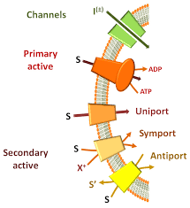

8. Another table of T/F regarding microfilaments and microtubules (explain if something is false)
- T
- Microfilaments and chromosomes movement (F)
- Microfilaments and diynein (F)
- Microtubules and Arp2/3 complex (F)

9. Associate the following structures with the given sizes. She gave 4 structures and they had to write the corresponding letter to its appropriate sized-structure.
10. 6 molecules. List which ones are polar and circle the evidence that indicates why.

11. Describe motion of cilia/flagella and the reason behind it
- Cilia are shorter than flagella and because of the difference in length they make a different motion
- Cilia make a rapid whip-like movement
- Flagella make a wave like motion
- One or two flagella on a cell while there are many cilia
- Flagella is used to propel the cell (mobility)
- While cilia sweep what is in the immediate vicinity of the cell (motility)

12. Labelling a cell and their function. (plant cell: nucleus, central vacuole, plasmodesmata, cell wall, chloroplast)
- Plasma membrane:
  - Semi-permeable phospholipid bilayer that allows for the passage of some molecules but does not allow the passage of others.
  - Consists of proteins, sterols, glycolipids, and carbohydrates.
- Golgi Complex:
  - Looks like layers of membrane
  - Molecules travel via cytoskeleton from ER to Golgi
  - Golgi receives vesicles from the ER
  - Post-transcriptional modification and maturation of proteins starts from the cis-face to the trans-face (exit site) of the Golgi
  - Proteins are packed in vesicles and are sent off to other organelles within the cell
  - Receives vesicles via the trans- side
- Nucleus:
  - Site of genetic information (stored in chromosomes)
  - Selectively permeable nuclear membrane which contains nuclear pores (allows for the passage of some substances, such as transcription factors)
  - Double membrane
  - Nucleolus is the site of ribosome synthesis
- Ribosomes:
  - Made of two subunits that do not assemble until translation needs to be done
  - Subunits are formed in nucleolus and are put together as a ribosome after they are translated out of the nucleolus via nuclear pores and put to work
  - (Double membrane of nucleus is semi permeable)
  - Nuclear pores: openings across the membrane built of proteins
  - Proteins have ability to inspect what is trying to get into the nucleus and out of the nucleus
  - Change shape to open and close the pore
- Endoplasmic Reticulum:
  - Series of folds in the membrane called cisternae
- Rough ER:
  - Studded with ribosomes
  - Protein translation
- Smooth ER:
  - Nuclear membrane projects to form smooth endoplasmic reticulum
  - Vesicles bud off the ER and are transported across cytoskeletal fibers
  - Functional role: synthesize lipid, sometimes detoxify the cell
- Mitochondria:
  - Site of ATP synthesis
  - Key to a whole slew of metabolic reactions, involved in the biochemical regulation of the cell
  - Regulates calcium storage in the cell: triggers cell death if necessary
  - Smaller genome: Streamlined to keep genes relevant to the mitochondria
  - Maintains genome for the proteins it needs to build proteins to carry out local tasks
  - DNA is like that of ancient proteobacteria
  - Transcription and translation machinery in place
  - Same size as proteobacteria
  - Double membrane indicates that it creates its own energy
  - Electron transport chain present, can produce its own energy
  - This is why it was engulfed by an ancient bacterium
  - Reproduces by binary fission (if more mitochondria are needed by the cell from an energy standpoint)
- Chloroplasts:
  - Present in plants only
  - Produce energy using photosynthesis (chlorophyll is present)
  - Organized into little compact structures/disks called granums
  - Were engulfed by bacteria long ago (initially cyanobacteria)
  - Same evidence as mitochondria
- Central vacuole:
  - Lysosome of plant cells
  - Very large compared to regular vacuoles (which act as storage pods)
  - Its membrane is called a tonoplast
  - Able to swell up and absorb water, unlike other membranes
  - Applies turgor pressure to cell wall; stabilizing the cell wall and maintaining cell’s shape and structure
- Plasmodesmata:
  - Holes in cell wall that allow for passage between cells
  - Small molecules like water, ions
  - Nothing larger than a monosaccharide
  - No receptors, just holes (not selective)
- In prokaryotic cells:
  - Nucleoid houses the circular DNA
  - Have an exterior structure surrounding the plasma membrane
  - When rigid, it is known as a cell wall
  - When flexible, capsule (jelly-like)
  - When slimy (lots of glycoproteins), referred to as a glycocalyx
  - Flagella: Locomotion organelles of some bacteria
  - Fimbriae: Attachment structures on the surface of some prokaryotes (cilia are the whips on the fimbriae

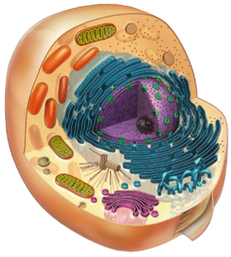

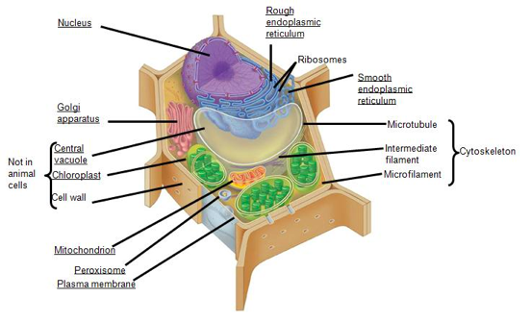
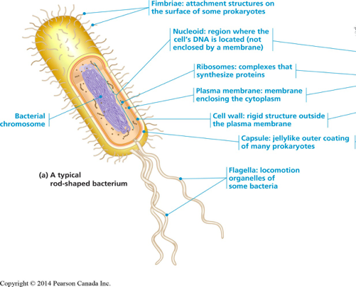

13. What influences the fluidity of the plasma membrane?
Role of sterols:
- Regulates membrane fluidity and prevent phospholipids from packing together too tightly
- Promote wiggle room between phospholipids to increase fluidity
- If the membrane is too fluid it can also bring the phospholipids closer together
- Sterols act as buffers
  - Regulates fluidity and are able to increase or decrease it depending on its environment
Important membrane properties:
- Fluidity (conditions that influence it)

Fluidity:
What contributes to fluidity?
- When temperature rises, fatty acids become in a higher vibrational state
  - By vibrating more they are less tightly packed
- If the temperature is low, the vibrational state is also lower and the movement between the fatty acid tails is also slower so the ability to compact these phospholipids is greater
- Fluidity is controlled by temperature and is regulated by sterols (ex. cholesterol)
  - Adding cholesterol increases or decreases fluidity
  - Acts as a buffer
- You can also change the length of the fatty acid tails
  - If all fatty acid tails have the same length and degree of saturation, it’s easy to pack them tightly together
  - Different fatty acid lengths or saturations makes it harder to pack them and end up being more loosely packed
  - Makes it easier for a molecule to squeeze its way through the phospholipid bilayer
- They don’t all have the same degree of polarity
  - Different polar head groups allow a membrane to influence its fluidity in that given area
  - Phosphatidylcholine contributes to low fluidity
  - Phosphatidylethanolamine contributes to high fluidity
- Degree of saturation of fatty acid tails
  - You can introduce a double bond or remove a double bond
  - There is an enzyme that is sensitive to temperature
  - If temperature changes this enzyme’s activity changes too
  - This enzyme desaturates the fatty acids and increases fluidity

14. List 3 techniques & how you’d use them to look at a protein:

- Transmission electron microscopy:
- A beam of electrons is focused on a thin section of a specimen in a vacuum
- Electrons pass through the image and the structures that scatter electrons are shown to be dark
- Used primarily to examine structures within cells

B. Scanning electron microscopy:
- A beam of electrons is scanned across a whole cell or organism
- Electrons that are excited on the specimen are converted to a 3D image

Example:
- If you’re trying to look at lipids or carbohydrates → not able to see with a light microscope as they are low resolution
- Ex. Q: You need to be able to see a membrane receptor responsible for binding insulin and letting the cell know that you need to get more glucose. What microscope do you use?
  - Electron microscope
C. Fluorescence microscopy:
- Different components are stained with fluorescent dyes
- The stains are seen under UV light

