Assignment 1
Important Note: Our group did not successfully complete the genomic DNA isolation (exercise 2.2) and so we borrowed that of several other groups in order to complete the lab
Part I
 | Solution A | Solution B | Solution C | H2O | Final Solution
V1 (mL) | 125 | 50 | 25 | 600 | 800
C1 (M) | 1.6 | 1.33 | 0.29 | - | -
C2 (M) | 0.25 | 0.084 | 0.0089 | - | -

- 0.084M
- 25.00mL/part
- 0.025 % (m/m) C
- 5.00% (m/v) A
- 32.00 parts
- 6.29 % (m/v) solute
- 1:2:5:24 C:B:A:H₂O
- 1:2.14:5.10:23.3 C:B:A:H₂O
- 0.61% (m/v) KNO₃
- 50.00 mL NaCl
- 3.00 M NO₃⁻
- 2.07M HCl
- 907.41mL H₂O
- 2.33M Cl
- 1.95 uL of dye
- 769.81 ug/mL
- Factor of 5.36
- 646.00 ug/L
- 3.90g of K and 4.75g PO₄
- 476.19 mL
Part II
Question 1
Solution Letter | Wavelength | Abs.
a | 450 | 0.605
b | 450 | 0.63
c | 595 | 0.312
d | 450 | 1.399
e | 450 | 1.308

Question 2

Figure 1. This graph depicts the absorbance of known volumes of distilled water loaded into a 96 well plate by person 1 and read at a wavelength of 977nm. A polynomial line of best fit was added. The most linear portion of the dataset had an R² value of 0.9885.

Figure 2. This graph depicts the absorbance of known volumes of distilled water loaded into a 96 well plate by person 2 and read at a wavelength of 977nm. A polynomial line of best fit was added. The most linear portion of the dataset had an R² value of 0.9721.
Question 3
Example calculation: Average volume
Well G1-3. Abs=0.128.
$$y =2 x{10}^{-6}x^{2} + 4x{10}^{-5}x +0.0638$$
$$0.128 =2 x{10}^{-6}x^{2} + 4x{10}^{-5}x +0.0638$$
$$0 =2 x{10}^{-6}x^{2} + 4x{10}^{-5}x-0.0642$$
$$x=\frac{-4x{10}^{-5}±\sqrt{{4x{10}^{-5}}^{2}-4(2 x{10}^{-6})(-0.0642)}}{2(4x{10}^{-5})}$$
$x=$8.47 uL

Well | Average ABS. | Equation Used | Average Volume (uL)
G1-3 | 0.128 | Person 1 | 153.56
H1-3 | 0.131 | Person 2 | 160.50
G4-6 | 0.192 | Person 1 | 259.67
H4-6 | 0.142 | Person 2 | 177.83

Question 4

Question 5 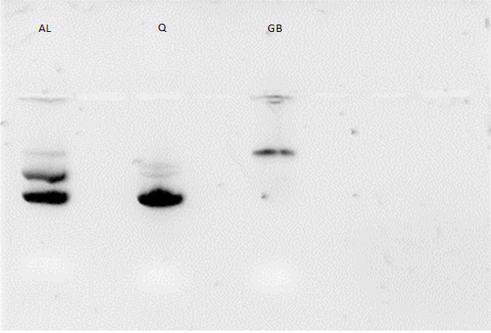
Figure 3. Gel electrophoresis of E.coli plasmid and of yeast genomic DNA using a 1% agarose gel at 100V for thirty minutes. The pUC9 and pUC19 vectors of E.coli plasmid DNA were obtained using two methods: alkaline lysis plasmid isolation (pUC9) and Qiagen plasmid isolation (pUC19). Yeast genomic DNA was obtained using glass beads. The methods of isolation are indicated at the top (AL-alkaline lysis isolation, Q-Qiagen isolation, GB-glass bead isolation).
Question 6

Figure 4. This graph depicts a series of solutions containing known concentrations of salmon sperm. The solutions were loaded into a 96 well plate and read at a wavelength of 260nm.
Question 7
Sample Calculation: Average Concentration of Undiluted Solution
At a dilution factor of 4, the unknown sample of salmon sperm has an absorbance of 0.358.
1 A 260 unit of ds DNA = 50 ug/ml
$$\frac{1}{50}=\frac{0.258}{x}$$
$$x=12.9 ug/ml$$
Undiluted sample:
$$12.9\frac{ug}{ml}x 4=51.6 ug/ml$$
At a dilution factor of 10, the unknown sample of salmon sperm has an absorbance of 0.142.
Undiluted sample =71 ug/ml
$$Ave(undiluted)=\frac{51.6\frac{ug}{ml}+71\frac{ug}{ml}}{2}=61.3\frac{ug}{ml}$$
Question 8
Abs. 260 | 0.339
Abs. 280 | 0.218
Abs. 260 : Abs. 280 ratio | 1:0.643
Concentration of undiluted preparation (ug/uL) | $$0.01695$$
Total yield (ug) | 16.95

Example calculation: concentration
1 A 260 unit of ds DNA = 50 ug/ml
$$\frac{1}{50}=\frac{.339}{x}$$
$$x=16.95\frac{ug}{ml}x\frac{1 ml}{1000 uL}$$
$$x=0.01695 ug/uL$$
Example calculation: Total yield
$$Yield=0.01695 \frac{ug}{uL}x 10 x 100uL$$
$$Yield=16.95 ug$$

