September 7, 2017: L1 – Intros and Course Outline
- Office is Room 236
- Pay attention to which lab section you’re in so that you catch the right bus/first half starts at 2:30 and 2nd half starts at 4pm
  - See courselink for updates
  - Meet bus b/w the ANNU and Food Science buildings

September 12, 2017: L2 – Importance of Livestock Production

What is Livestock?
- Animals raised for production of meat, milk, eggs, fibre, leather, and draft/work
- Includes beef and dairy cattle, sheep, swine, goats, and poultry
- Largely from domestic animals
  - Except bison
- Others outside of N. America?
  - Emus, camels,

What is Domestication?
- Adaptation of the behaviour of animals to suit the needs f humans
- Livestock species: 6000 – 12000 years ago

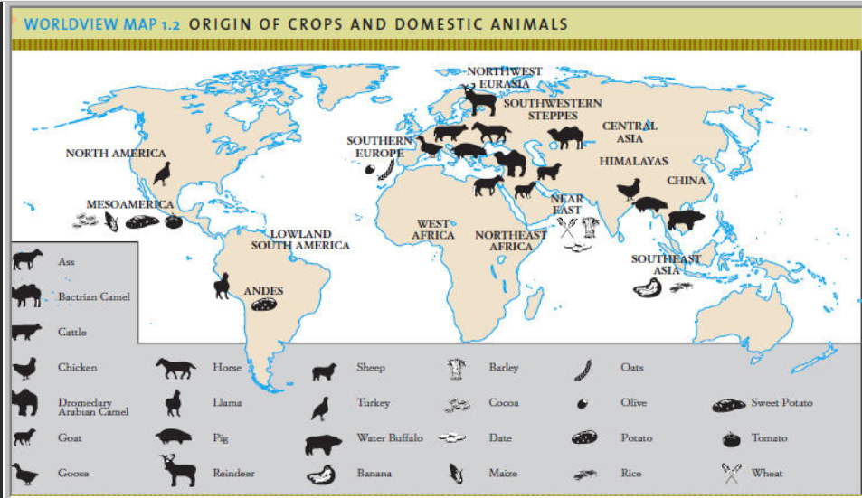

Timeline of Domestication of Livestock
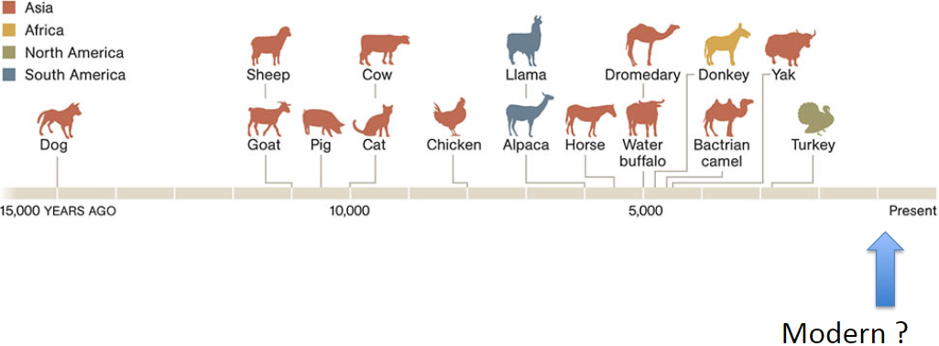
- Modern domestication: bison (meat), foxes (fur), crickets and other insects (food), fish (food)
- Dogs were once a food source, then a tool to help w/hunting and protection
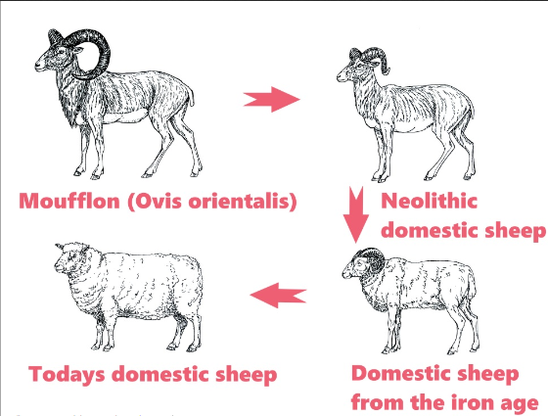
- Domesticated other animals like sheep, goat, etc. as we domesticated crops too

Are we finished domesticating animals?

Domestication of Sheep
- Evidence of people wearing wool 10 000 BCE
- From mouflon in Central Asia (Turkey, Syria, Iran)
- One of the first domesticated species
  - Small in size
  - Provided meat, milk, and clothing

- Horns have gotten smaller, wool is more likely to be white
  - In hotter areas, there are more hair sheep
  - Wool sheep live in colder areas

Domestication of Cattle
- Two groups
  - Taurine (Bos taurus) – 10 500 years ago
  - Indicine (Bos indicus) zebu humped cattle– 8 500 years ago
  - Aurochs – 2 m tall at shoulder, big horns, dark coloured
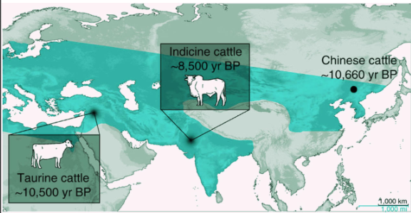
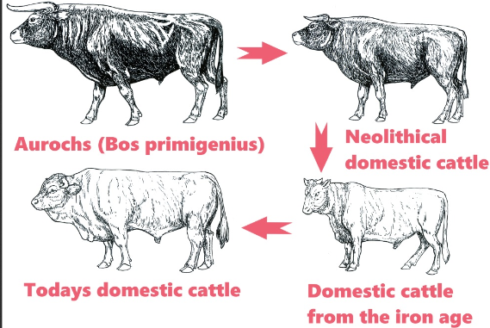
- Began to unearth some new bones in China, think Taurine cattle may have been domesticated in China and other parts of Southeast Asia as well

Domestication of Pigs
- Domesticated from wild boars
- Approx. 10 000 years ago
- Believed to be from Turkey and Middle East
- Forest dwelling, tuber eaters
  - Deforestation probably encouraged/led to domestication bc the forest was gone so the pigs had to find other food sources and it made it easier for people to find/eat the pigs
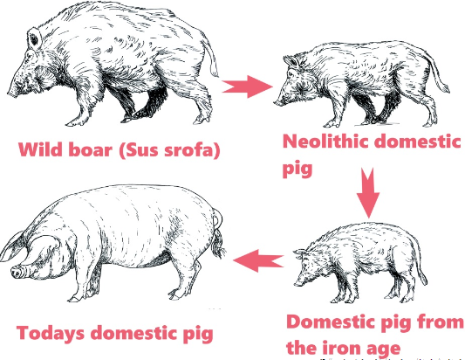

Domestication of Chickens
- Much less is known
- ~6000 years ago
- Southeast Asia
  - Bamboo forests
- Gallus gallus – red junglefowl
- Reproduction highly responsive to nutrition
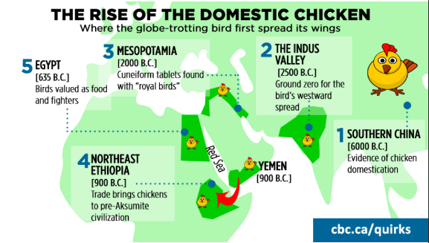

Domestication of Horses
- Eurasia ~3000 BC
- First hunted for meat, then herded
- Used as draft animals, then riding to keep track of flocks/herds (transport)

Domesticated animals…
- Must have a trait of interest/value
- Depend on humans for survival
- Behaviours are changed w/domestication ex. Not as fearful of dogs/predators, not afraid f humans
- Humans have control over breeding/reproduction
  - Selective breeding

What is selective breeding?
- Identify traits of interest
- Often domesticated animals have traits rarely seen in the wild ex. White colouring, big ears, lack of horns

Reasons for Domestication of Animals

Food production – meat, fish, milk, eggs, honey
- Why?
  - Tasty
  - Protein - Amino acids more closely match human requirement
    - Vitamin B12
      - Most easily absorbed from animal sources, harder to absorb from plants
*insert table* - pulses are lentils, beans, etc.
- Animal product consumption
  - Closely tied to economic status

Clothing – wool, leather, fibre (bristles/brushes), feathers

Non-food products
- Insulin, heparin, thrombin, etc.
- Rennet – used to make cheese, starts curdling process
- Industrial products
- Meat and blood meals
- Research

Power
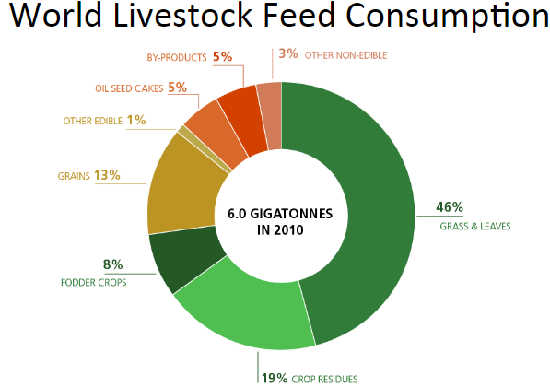
- Draft
  - Important to developing countries
  - A variety of species
- Transportation
  - Historically important

Land management
- Use of low productive lands
  - Pasture/range
  - Hilly terrain
- Globally 2/3 of arable land is in pasture/range
  - However, 60% is not suitable for cultivated crops
- Manure
  - Low cost nutrient source
  - Provides nutrients and organic matter
    - N, P, and K valued at over $1 billion UDS
  - Can also be used as a fuel ex. Biodigesters or burning
- Conservation
  - Environmental goods and services
  - Lots of growth in this area
  - Tourism ex. Farmers in Switzerland are paid to have cattle roam and wear traditional dress bc tourists like it
  - Urban grazing: Calgary pilot project
    - Used herds of goats instead of equipment or chemicals to manage weed control
  - Ducks Unlimited Pasture Projects
    - Buy up wetlands to preserve them for waterfowl, partner with farmers
      - Cattle grazing on land helps preserve wetland bc that way the farmers don’t destroy it
        - Cows get food, wildlife keeps wetland/home

Recreation/Sport
- Religious/non-secular
- Racing
- Rodeos
- Breeding shows
- Companionship

Economic benefits
- Livestock production adds value to a commodity crop
  - Historically true
    - Grains were cheap, so you can feed the cow, and get more money by selling the cow than you would selling the grain
  - Modern agriculture
    - Not always, higher demands ex. Ethanol production, price increases
- Outlet for crops not fit for human consumption
  - Forages
  - Off-grade grains
  - Feed by-products

Towards 2050
- Increasing population
- Improving economies and income
  - Fastest growing economies are in developing countries
- Increasing urbanization

Challenge as Animal Scientists
How to meet increasing global demand for animal products, in a sustainable fashion

