Lab 1: Thin Layer Chromatography
Anu Makinde, 300015112
Lab section C04, Tuesday Evening
Dylan Errulet
January 21, 2018
Protocol
SEE LAB MANUAL, pages 13 to 18
-while placing the TLC plate containing inside the solvent system of hexane the plates were kept inside for approximately 6 minutes instead of the indicated 6

Observations and Results
-all liquid were transparent in colour and had a strong odour
-then the unknown substance #43 was placed in dichloromethane there was an initial precipitate that dissolved as the test tube was shaken slightly
-each liquid was very low viscosity
-the unknown compound in part C (YY) was pale and yellowish in colour
-the TLC plate changed colour when under the UV light

Results
Figures 1-3 . TLC Plate Drawings
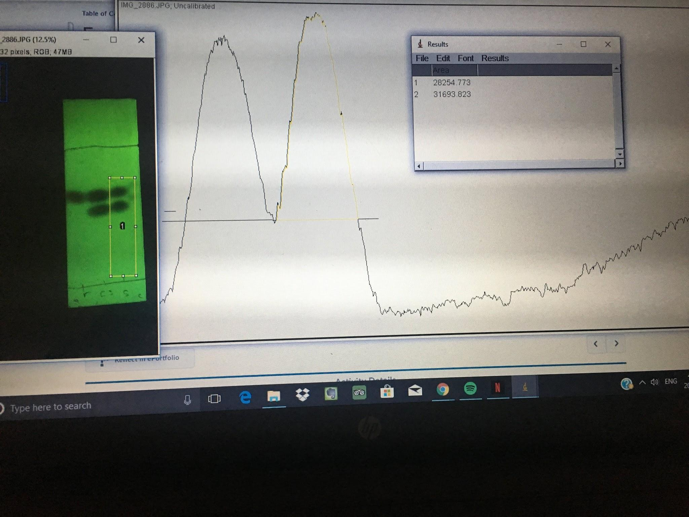
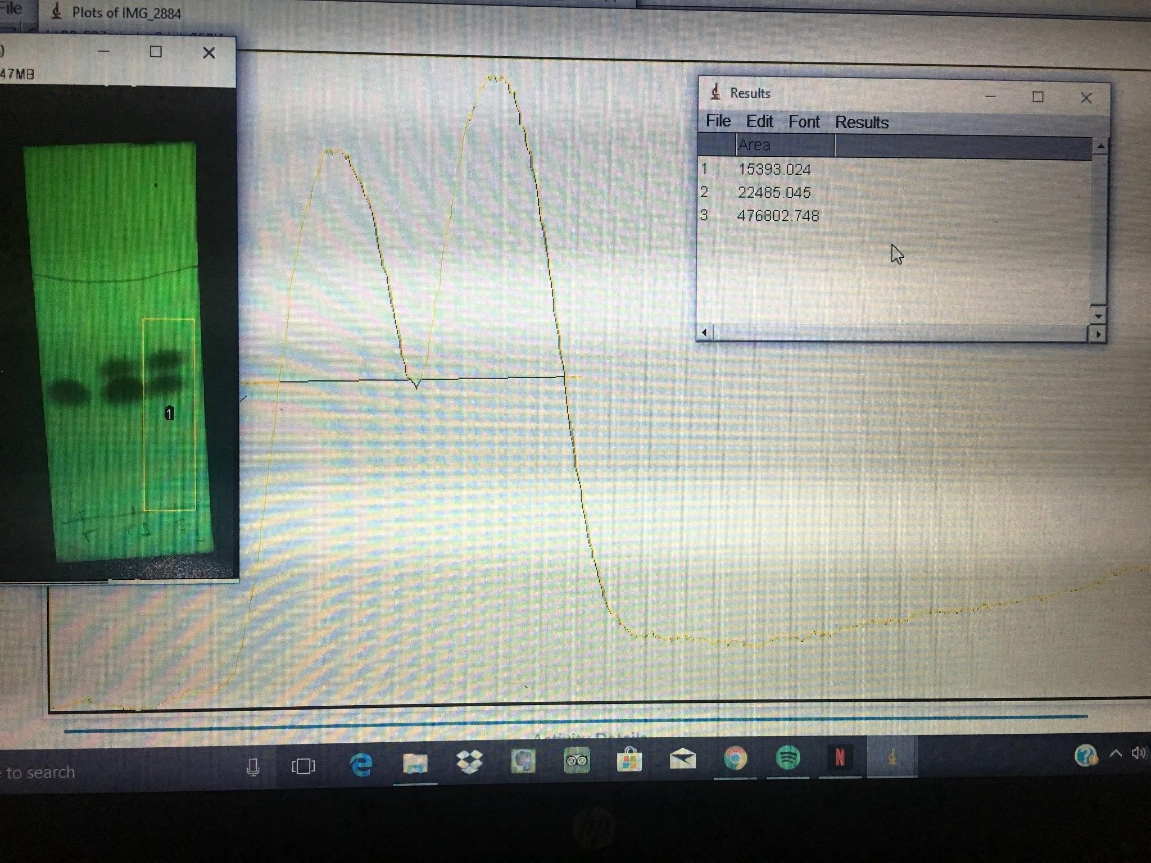
.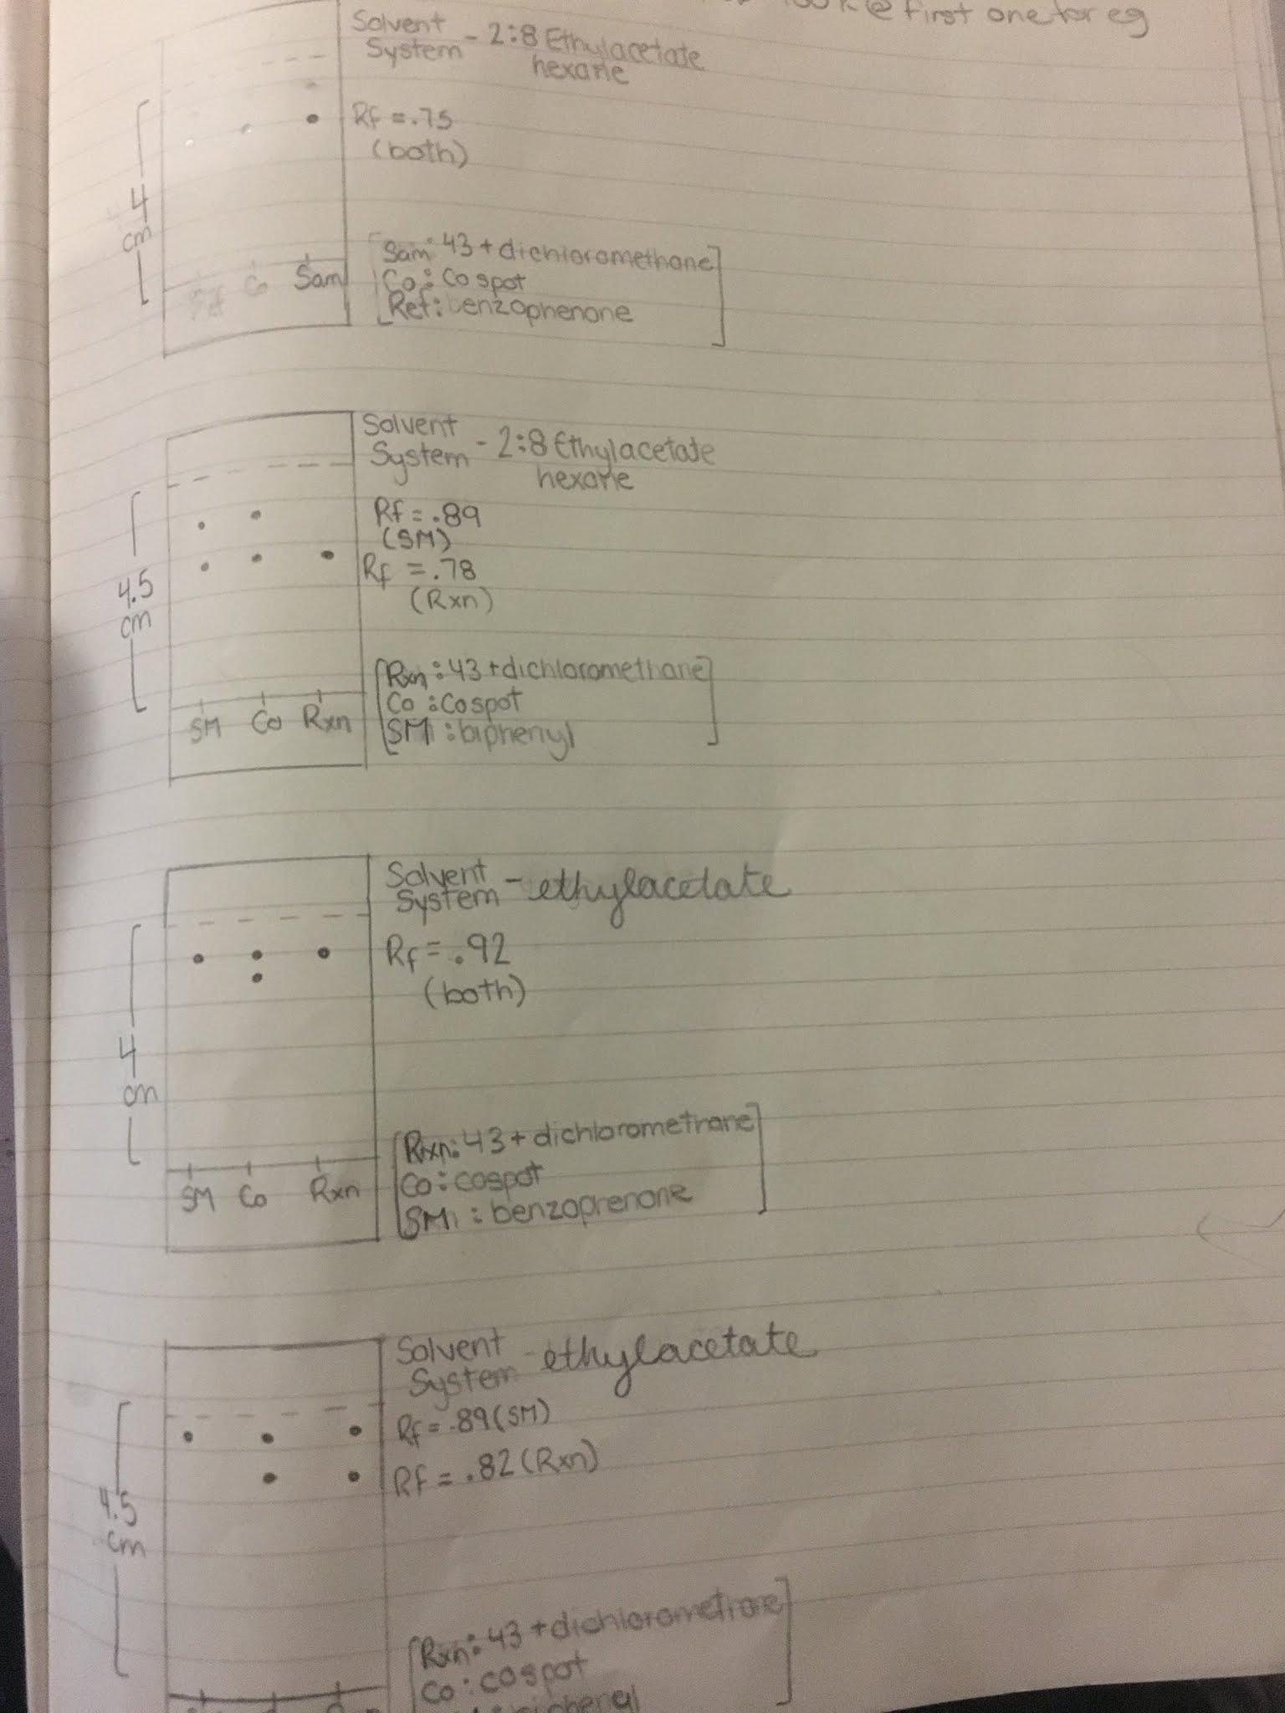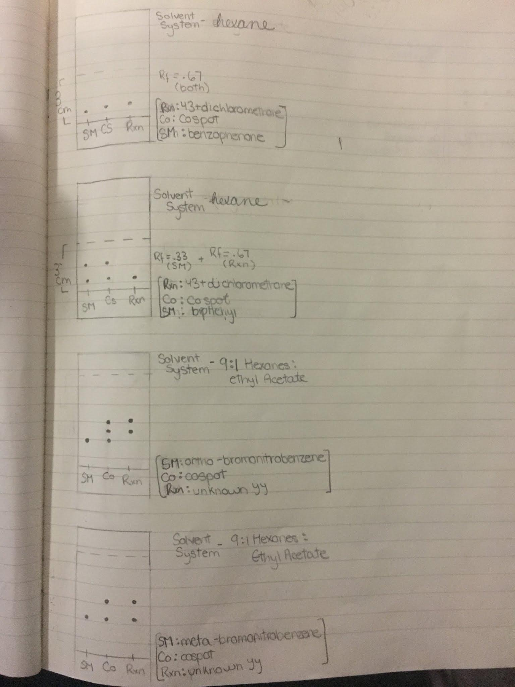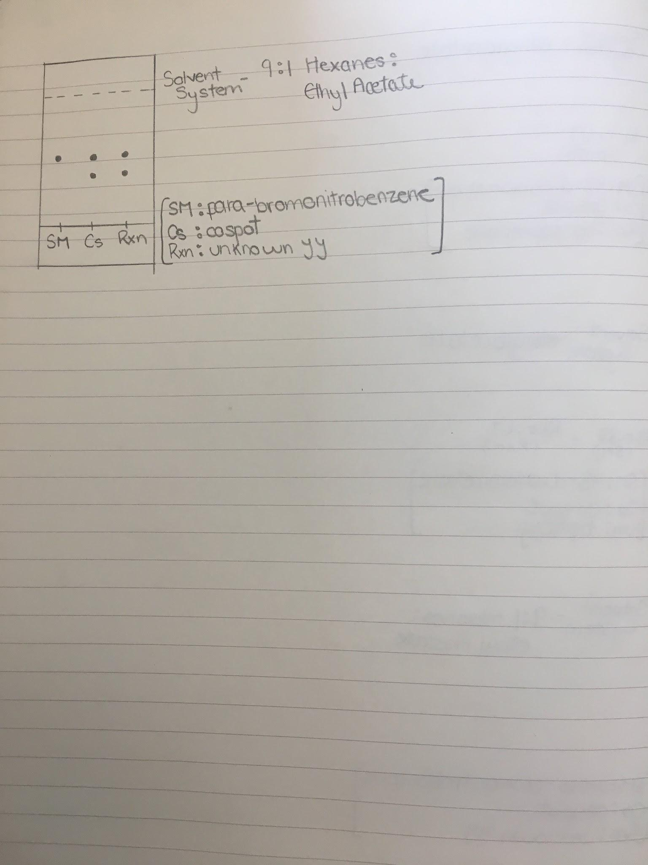

Discussion
-TLC plates were used for different instances
-parts A to C the TLC plates were able to distinguish the unknown compound, display the effects of a solvent polarity and compare the composition of a certain molecule.
-main reason these results were found was due to the polarity of the silica gel compared to the polarity of the other compounds.
-use for a co-spot is to have an area where both compounds exist.
-enables a comparison of distance travelled by the reference and sample compounds
-to see these different compounds distance there must be a mobile phase or polar solvent that allows the compounds to move through capillary action.
-the stationary is not only polar but just as important to the the success of a TLC plate.
-When the stationary phase comes in contact with the mobile phase the two compounds- sample or reference, will choose which phase they chose.
-done through the hydrogen bonding, a more polar compound will closer to the bottom because it favours the stationary/ more polar phase. Meanwhile, a less polar compound will “chose” to h-bond with the mobile phase and move up the TLC plate just as the mobile phase has.
-Part A of the lab was done to determine the nature of the unknown compound, would it be benzophenone or biphenyl?
-Two different TLC plates were made, one having biphenyl as the sample and one having benzophenone.
-The TLC plate with the biphenyl had two different Rf values, indicates that there was no biphenyl in the unknown compound.
-different polarities explains that the reference compound was a more polar because it was closer to the bottom of the TLC plate for a number of reasons.
-one, the idea that “like attracts like” proves that the more polar silica will attract the more polar compound and not move with the mobile phase.
-Also, the polar compound travels slower, which results in lower Rf value, because of the increased IMF needed to be broken within the solid phase , essentially making “stick” to the silica.
-TLC plate with benzophenone had the same Rf as the unknown indicating that the unknown is somewhat composed of benzophenone.
-structure of this compound is the main reason why is was at an equal level as the reference on the TLC plate, although a non-polar molecule, it is able to move with the less polar mobile phase and end up at the same level as the reference.
- equal Rf values of .75 indicate that there are less intermolecular forces to break allowing them to move essentially, at the same speed.
-Benzophenone also makes hydrogen bonds because of its structure allowing it to bind easier to the mobile phase.
-purpose of part B was to see the effects different polarities of solvents used as an eluent had on the TLC system.
-part A 2:8 Ethyl Acetate Hexane was used and it allowed for a good separation of compound A and B on the TLC plate.
-However, when using a very polar solvent like ethyl acetate the difference becomes harder to distinguish because the two compounds in the co spot are so close together near the top with both plates.
-The increased Rf value happens because the eluent solvents increased polarity simultaneously increases its ability to attract polar molecules while undergoing a competition reaction with the silica.
-The mobile phase has a greater amount which is now able to carry the compounds very close to the ‘finish line’ rather than being near the bottom because the solid phase has relatively no effect on the compounds.
-the benzophenone is the more polar molecule and when placed in a more polar eluent solvent the Rf value increased greatly.
-clear to see that a high Rf value indicates a higher polarity of a compound.
-biphenyl TLC with the ethyl acetate solvent system had an increase in Rf values also, although the dichloromethane mixture had a lower Rf indicating that it was less polar than the reference.
-In part B, the solvent system of hexanes was also used, a lot less polar than ethyl acetate and this is why, in the finished TLC, the co spot compounds were very close together nearer to the bottom.
-competition reaction took place between the hexanes and silica where they do not interact leaving the compounds able to ‘stick’ to the silica.
-This result occurred because the compounds form h-bonds with the silica since there are less IMFs to overcome.
-closer to the bottom because the mobile phase is a less polar solvent not allowing the compounds to quickly flow to the top of the plate.
-polar compounds are more likely to move slower in the TLC compared to non polar ones, the use of a less polar mobile phase will only strengthen this phenomena.
-The less polar solvent has relatively no effect on the compounds and leaves them at the bottom of the TLC plate.
-Rf values are considerably lower, at .67 and .33 meaning that the system is much less polar.
-part C of the experiment is to determine the amount of the compounds ortho, meta, and para bromonitrobenzene in the unknown compound.
-The unknown compound chosen was YY in this case. The analysis of the TLC plate using the ortho-bromonitrobenzene resulted in the compound not being found in the unknown YY.
-This is known because the sample is not found in the same spot as the reference and that the ortho-bromonitrobenzene is more polar than the unknown compound because it is found lower on the plate.
-When looking at the structure of the molecule, the Bromine is found on the first carbon and the N02 is found on the second carbon.
-both groups have polar dipoles and being so close together on the ring strengthens the charges making it more polar than the meta and para molecules.
-can deduce that the unknown compound will be one that is less polar.
-TLC plate using the meta-bromonitrobenzene as the reference resulted in a confirmation that it was apart of the unknown compound, these results were found relatively low on the TLC plate. -this could be due to the fact that it is more polar than the para molecule because of the relative locations on the benzene.
-a para molecule the two polar groups are on opposite ends and this cancels out the polarity
-in the meta isomer, the charges are not so close together that they strengthen the charges but rather leave the molecule a regular polar amount.
-why the TLC plate of the para isomer they are found closer to the top of the plate because it is less polar and moves with the less polar mobile phase.
-source of error that could have led to skewed results may have been cross contamination of compounds, in part B the need for two separate solvent systems with different polarities is essential to see the effect of polarity.
-To reduce risk the graduated cylinder was double washed with detergent.
-also the effect of having too much of a solvent system would limit the sample and reference would not undergo capillary action because the sample compounds are not able to move up with the mobile phase
-one last source of error was the possible contamination of biphenyl, this could be possible because the spots on the TLC instead of having only one spot had two.
-this possible contamination could have lead to skewed results on the TLC plate

Calculations
Sample Calculation for R${}_{f}$
Rf=$\frac{d1}{d2}$
=$\frac{3.5}{4.5}$
=.78

Sample Calculation for Mole Percentage
% of meta absorbance in compound= 37878.069/(37878.069+54547.773)*100
=40.9
% of para=100-40.9
=51.1%

y=.976x+.809
40.9-0.809+.976x
x=41.1
Mole% abundance of meta=41.1%
Mole % abundance of para =100-41.1
=58.9%

Questions
1) How does the increased polarity of a solvent affect the results of a TLC plate.
-it makes the sample compounds move with mobile phase rather than stay with silica gel
-this is because there are less IMF to overcome with the stationary phase
-the Rf values would increase because they have travelled a longer distance with the mobile
-closer to the finish line rather than the the bottom of the plate and silica
-if the sample is polar then it will compete will chose the phase with the least IMF to overcome and the stationary phase and mobile phase will compete and try to get it to move or stay
-if the sample is less polar it will be less attracted to the silica and move even quicker up the TLC plate
2) Which would have the smallest Rf value out of the three.
a) -the benzyl alcohol because it is a more polar compound due to the OH functional group that enables more h-bonds to be made and essentially stick to the silica gel rather than move with the mobile phase.
b) -the aniline because the Nitrogen makes the molecule more polar and the Hydrogens attached are able to form more h-bonds than that of N,N dimethylaniline therefore the molecule is more attracted to the more polar silica gel leaving it closer to the bottom of the TLC plate.
c) -benzoic acid will have a lower Rf value because it has a carboxylic functional group that makes it more polar due to the h-bonds it can form. Compared to the benzophenone which only has a double bonded oxygen.
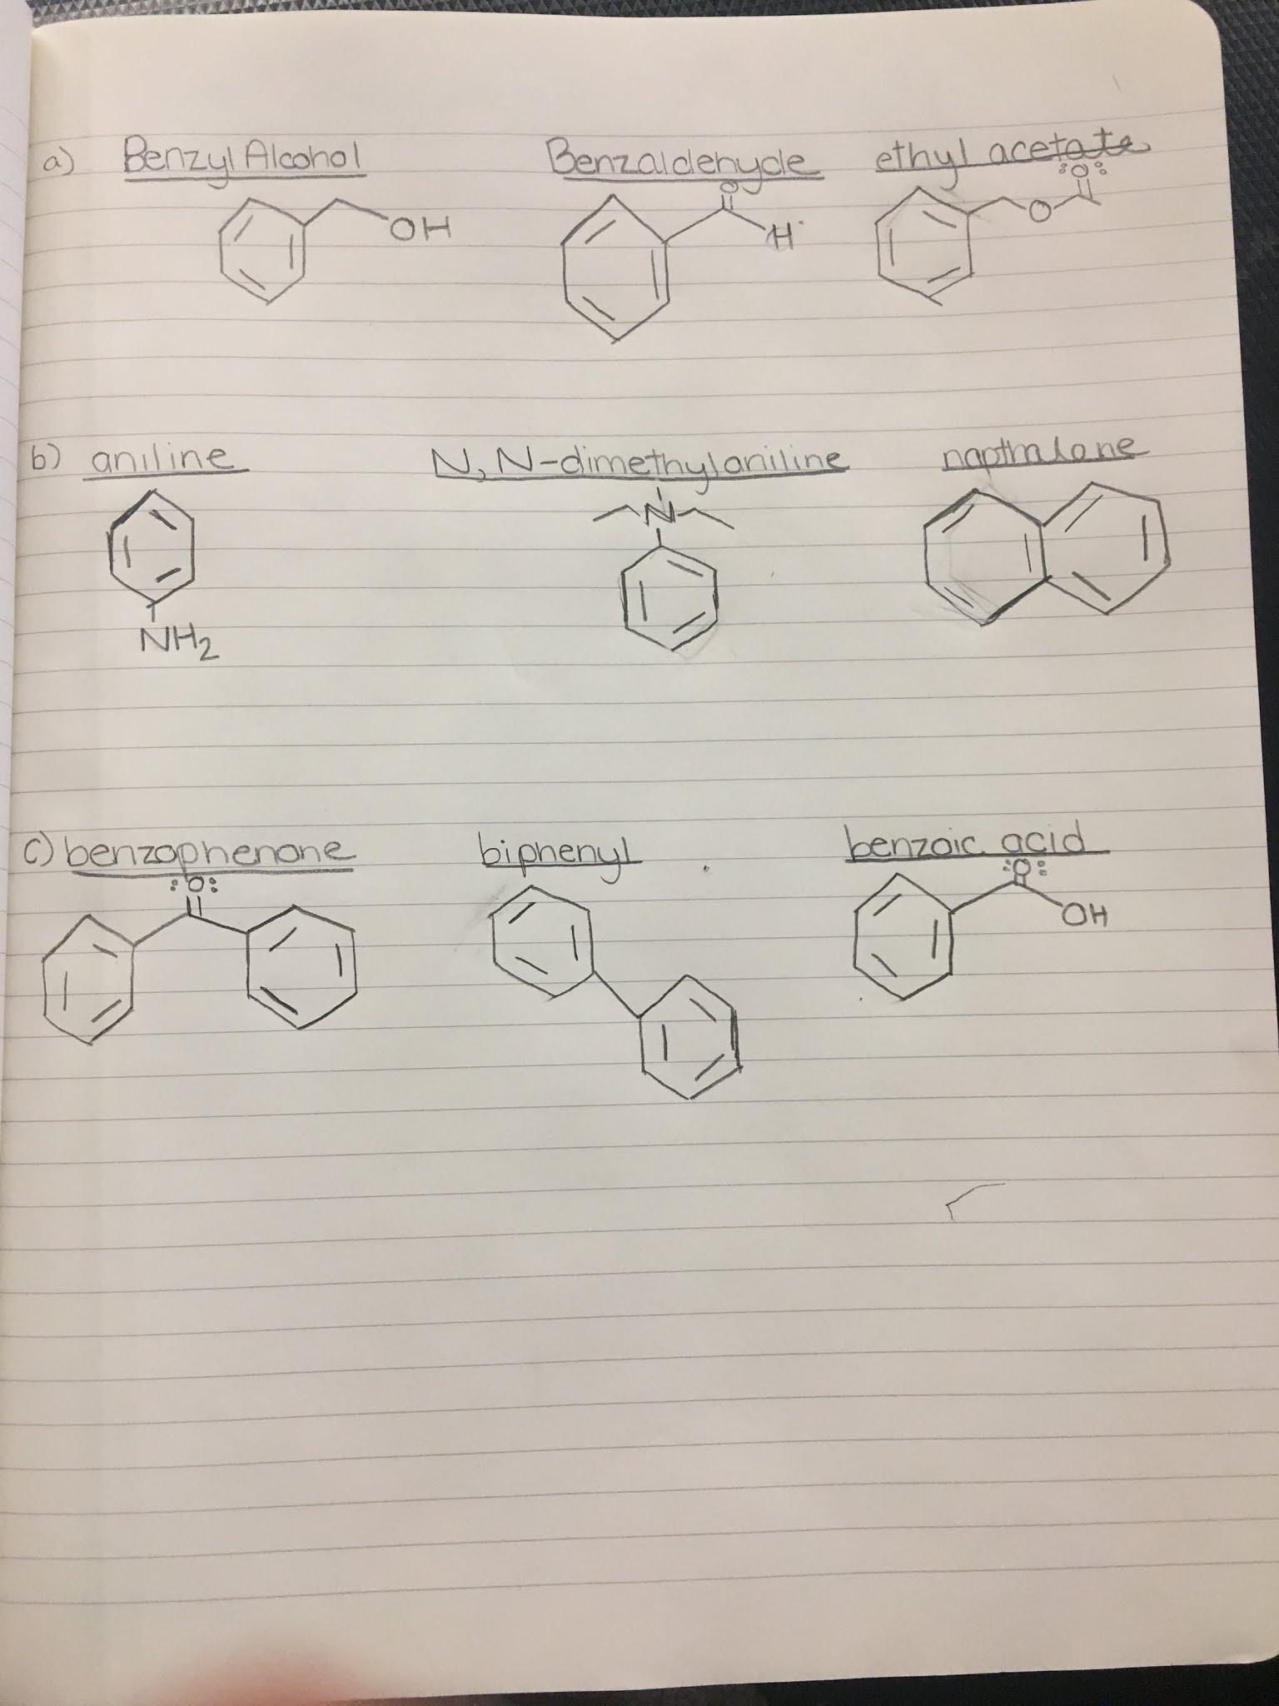
NOTE: chem-draw was not downloading on computer so hand drawn structures had to be done.

Raw Data
Figures 4-5. Raw Data from lab book


