Verification of Boyle’s Law

By: Skyler Cole
300006435
Nicole Weisemberg
300015875

CHM1311-Section 3

TA: Marina Sanita
msani009@uottawa.ca

September 19th, 2017

Department of Chemistry
University of Ottawa

Theory
The goal of this experiment was to see how the pressure of a gas in a closed system, changed in relation to volume, so long that temperature remained constant. The relationship between pressure, and volume is modelled by Boyle’s Law, which ultimately proves that pressure and volume are inversely proportional. This relationship is modelled by the following equation P∝1/V. Some limitations that occurred in the lab is that, the volume was limited to a maximum of 20mL, the readings of pressure on the LabQuest 2 screen was constantly changing, therefore forcing us to round to an average number. At the end, 0.8mL was added to our volume in the data, to account for any margins of error. These factors restricted the accuracy of our results and precision of our data.
https://www.grc.nasa.gov/www/k-12/airplane/boyle.html, Nancy Hall, NASA Boyle’s Law
Procedure
- Ensure that proper eye protection is worn.
- Draw back syringe so that it contains 20mL of air.
- Attach syringe to gas pressure sensor by placing tip of syringe to sensor, and twisting clockwise 180 degrees, until locked in place.
- Take note of initial pressure listed on LabQuest 2 screen.
- Press on top of syringe with precision, exerting air into gas pressure sensor, until desired test volume is reached.
- Take note of change, and new pressure showed on screen.
- Add 0.8 mL to each volume reading to account for any marginal errors.
- Repeat this process 6-8 times, testing various volume variables.
- Observe the change in pressure, in accordance to volume.

Tables
Volume (mL) | Pressure (kPa)
6.8 | 101.27
8.8 | 77.20
10.8 | 63.68
12.8 | 52.80
14.8 | 45.70
16.8 | 40.50
18.8 | 36.32
20.8 | 32.22

Observations
In our experiment, we tested the change in pressure, as volume went up, and as volume went down. In both experiments, as volume went up, pressure went down, and vice versa. These results are shown when volume is halved, pressure is doubled, and when the volume is doubled, pressure is halved. Therefore, the change in pressure is inversely proportional to that of volume, proving Boyle’s Law.
Note: As the volume was reaching 8.0 mL it was becoming increasingly difficult to push the syringe down.
Graphs
Boyle’s Law
Change in Pressure, in Accordance to Volume
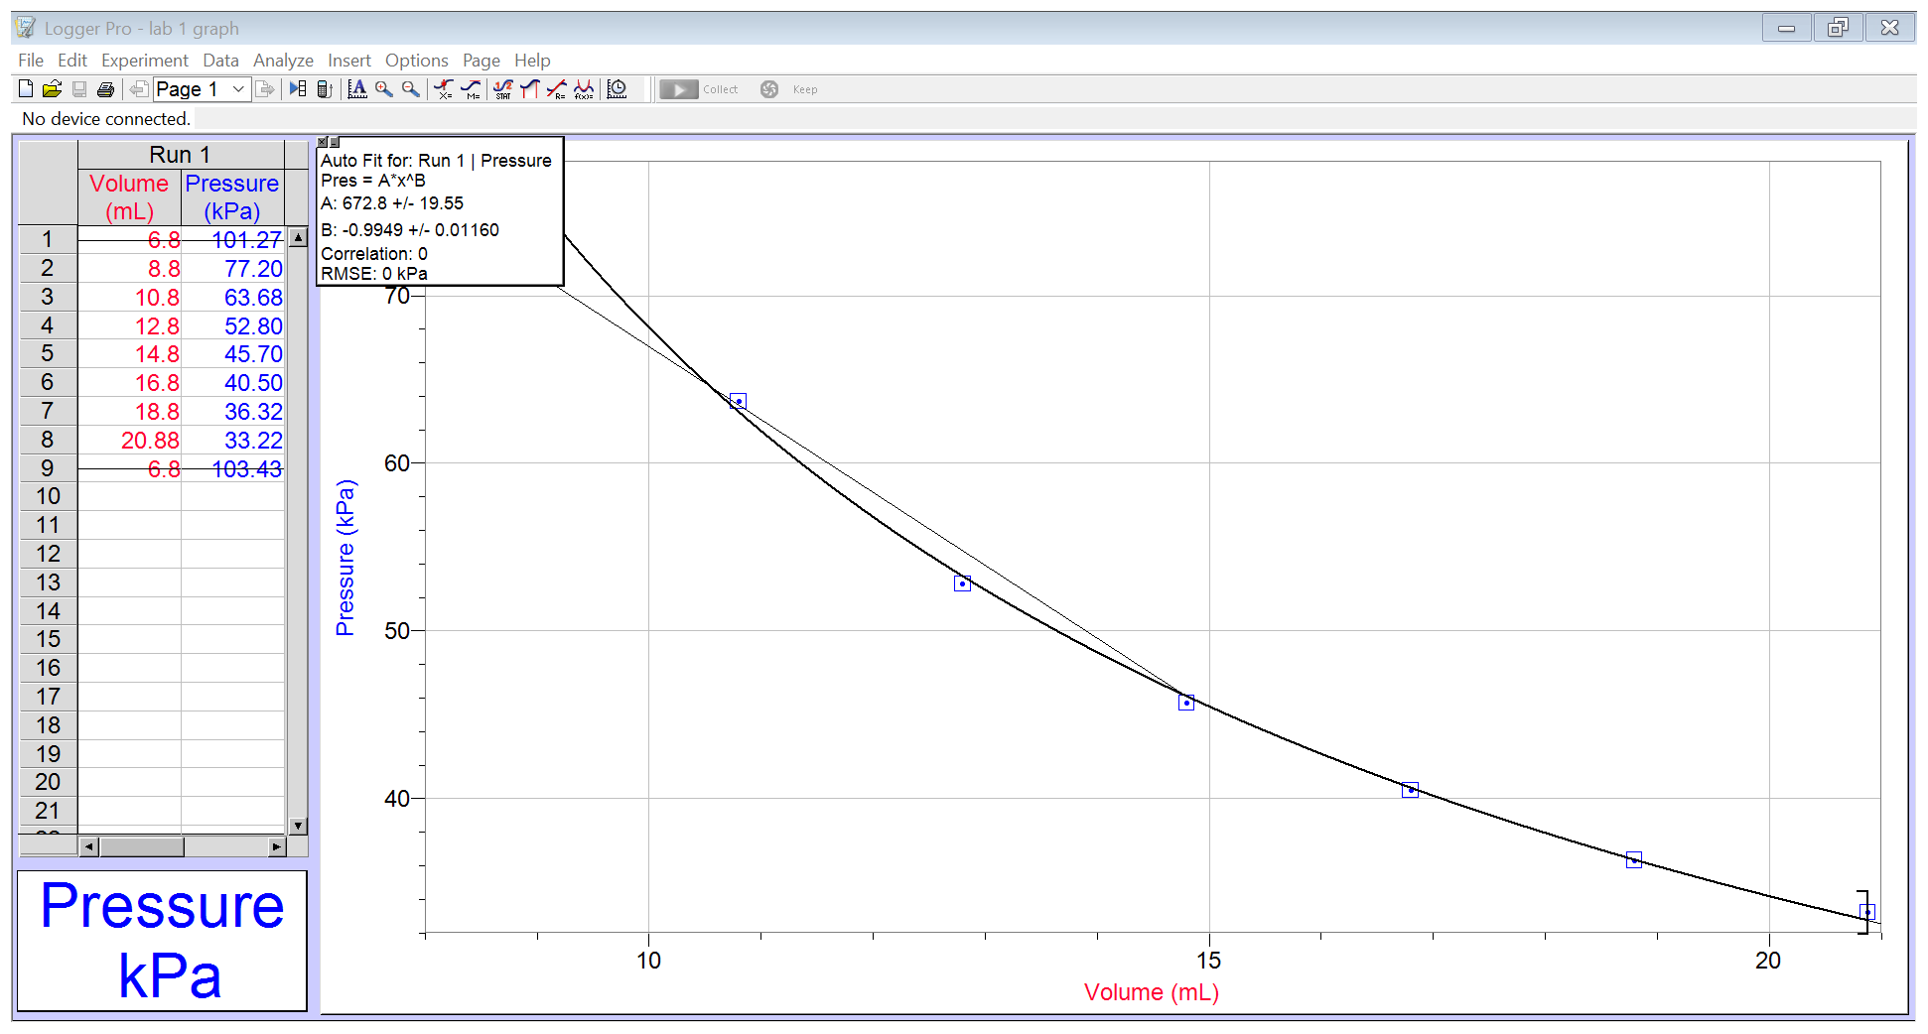

Calculations
Volume (mL) | Pressure (kPa) | K (constant)
6.8 | 101.27 | (6.8mL)(101.27kPa)= 688.636
8.8 | 77.20 | 679.36
10.8 | 63.68 | 687.744
12.8 | 52.80 | 675.84
14.8 | 45.70 | 676.36
16.8 | 40.50 | 680.4
18.8 | 36.32 | 682.816
20.8 | 32.22 | 670.176
Average K |  | 680.1665

The consistency of volume, and temperature is shown through a constant k. So long as temperature remains constant as well as the amount of energy given to the closed system remains throughout the experiment, theoretically, the value of k should remain constant.
Discussion
We determined the constant k by multiplying the volume of the gas, with its corresponding pressure. We performed this calculation (PV=k), on every value, and then calculated the average of the k values.
- The mathematical relationship between volume and pressure in Boyle’s Law, is that volume is inversely proportional to pressure. With our new calculated constant, the equation for Boyle’s law would be, PV=680.1665.
- It is important to take multiple readings of the dependent variable (pressure) for the same independent variable (volume), because you want to ensure, that the results that are presented are accurate and consistent. Also, as you go through your experiment, you want to make sure that your first reading will remain constant, even after moving the syringe up and down.
- For Boyle’s Law to be true, temperature must remain constant, and volume of gas must remain unchanged. When performing this experiment, it was assumed that the temperature remained at room temperature, and volume of gas remained in a closed system. Therefore, these variables remained constant. Having the gas in a closed system, refrained gas from getting in, and leaking out. In any experiment, there is always opportunity for risk factors, especially something sensitive like temperature, however throughout the duration of our experiment, the laboratory seemed to remain approximately close to the same temperature the whole time.

Conclusion
Considering our value for k remained within a 10-digit range for each of the trials, our data seems valid. The goal of our lab was too determine the relationship between pressure and volume, ultimately proving that they are inversely proportional. After gathering, and analyzing our results and putting it in a graph, it was visible to see that the relationship was in fact inversely proportional, and revolved around keeping k a constant value.

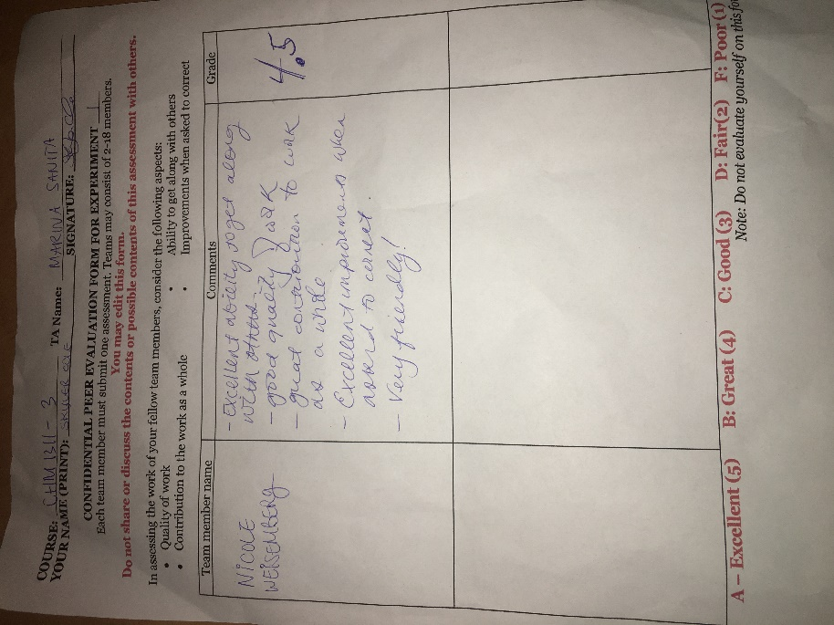
Peer Evaluation Sheets

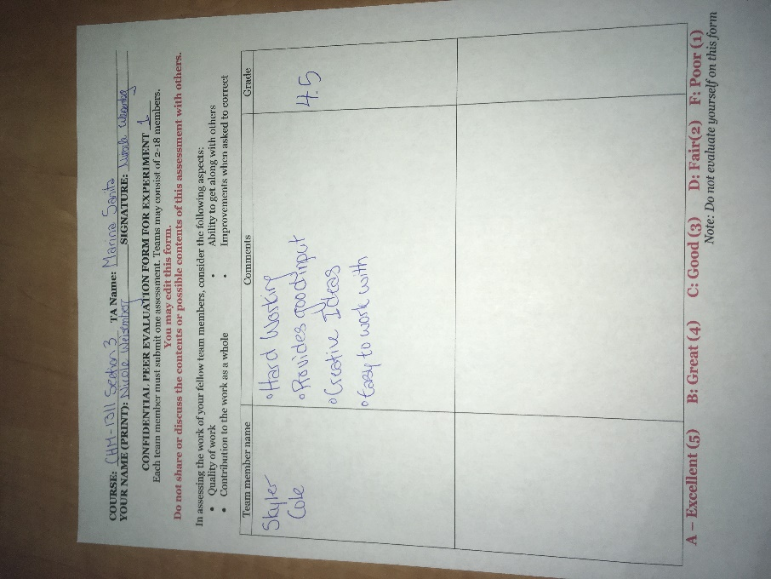

Data


