Kirsten Holy
300007228
Section: C4
Lab Day: Tuesday
Lab Time: 2:30-5:30
CHM 1321
Alexander Daniels

Experiment 2
Distillation

Protocol
Please refer to Lab Manual from pages 25 to 27.

Observations
The mixture we used in the distillation process was a 50:50 mixture of 2-propanol and 1-butanol. It was liquid at room temperature, colourless and clear. It had a sharp smell, similar to acetone. The liquid has a very low viscosity, similar to that of water, because it poured easily and the spinner bar rotated easily in the mixture.
During distillation, both simple and fractional, the mixture took multiple minutes (between 3 and 8) to heat up but once it did the temperature jumped from room temperature up to around 80 degrees.

Data
Part A: Simple Distillation Data
Volume  (mL) | Temperature (ºC)
0 | 24.0
1 | 88.1
2 | 89.1
3 | 89.9
4 | 90.8
5 | 91.2
6 | 91.8
7 | 92.6
8 | 93.8
9 | 94.3
10 | 95.1
11 | 97.0
12 | 98.4
13 | 100.2
14 | 101.9
15 | 102.9
16 | 105.7
17 | 108.2
18 | 111.1
19 | 114.7
20 | 116.5
21 | 117.3
22 | 117.7
23 | 117.9
24 | 117.4
25 | 116.0

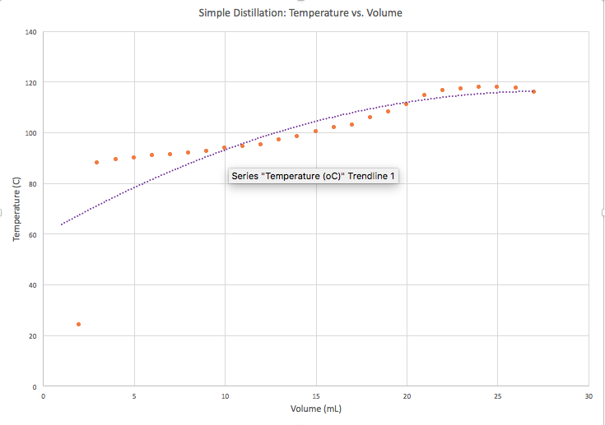
Figure 1. The graph of the temperature versus volume relationship for Simple Distillation.

Part B: Fractional Distillation Data
Volume  (mL) | Temperature (ºC)
0 | 63.0
1 | 79.5
2 | 79.8
3 | 80.1
4 | 80.7
5 | 81.0
6 | 81.6
7 | 81.8
8 | 81.8
9 | 82.0
10 | 82.6
11 | 82.0
12 | 81.8
13 | 81.7
14 | 82.0
15 | 83.4
16 | 81.8
17 | 80.2
18 | 86.0
19 | 89.3
20 | 96.6
21 | 101.9
22 | 104.5
23 | 105.0
24 | 104.4
25 | 102.4

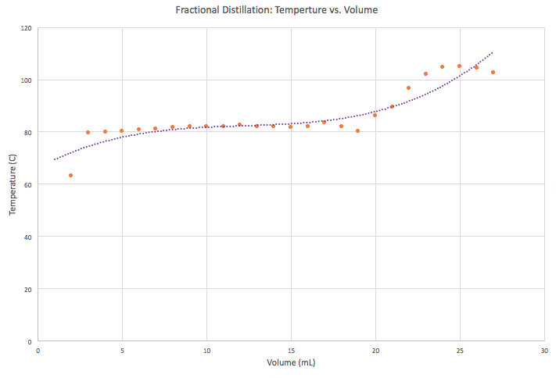
Figure 2. The graph of the temperature versus volume relationship for Fractional Distillation.

Discussions
This lab involved distillation. In general distillation is used as a way to purify compounds. It works to separate to compounds that have been mixed based on the difference in the boiling points. The mixture of compounds is heated and whichever compound is more volatile will condense and exit into the graduated cylinder or flask at the end of the condenser. Once the temperature is raised and the more volatile species has been condensed out of the Distilling flask the second compound will begin condensing and exiting into the graduated cylinder₁. After this all of the mixture will be in the graduated cylinder. In this experiment 2-propanol and 1-butanol where used. These two compounds have different boiling points, 2-propanol has a boiling point of 83 degrees Celsius and 1-butanol has a boiling point of 118 degrees Celsius. This means that 2-propanol is more volatile because it takes less energy in order to boil and evaporate it, turning it to gas₁.
A simple distillation is a quick process used for two compounds mixed together that have differences in boiling points by over 100 degrees Celsius. With the difference of 35 degrees Celsius between 1-butanol and 2-propanol the simple distillation will not be very effective₂. This means that the 2-propanol will enter the receiving flask first, as it heats up some 1-butanol will enter as well and the 2-propanol will not exist in the distilling flask anymore. The last thing to enter the receiving flask will be pure 1-butanol because it becomes a volatile at the higher temperature₂. When you look at the curve of a simple distillation there is no clear jump in temperature, this is because it is designed for compounds that have a big difference in boiling points. The simple distillations are effective at isolating a compound early on in the process, the condensation that drips into the graduated cylinder at the start will be pure.
However, fractional distillation separates the compounds to a higher degree of effectiveness.
It takes about twice the amount of time, depending on the compounds used. Unlike the simple distillation there will be no condensation overlap of the two compounds. This means that 1-butanol will only start condensing after 2-propanol is finished. The curve of a fractional distillation has two plateaus, one occurring at the more volatile compounds boiling point and the second occurring at the other compounds boiling point. Between the plateaus there is a relatively steep jump compared to the simple distillation curve. Again, this is because of the more effective separation of compounds in fractional distillation₃.
Fractional distillation uses the same equipment as a simple distillation but it has one additional piece, the fractionating column. This piece contains inert material that increases the surface area and allows the compounds to condense onto it₂. This increases surface area means that either very little or no 1-butanol made it into the condenser with 2-propanol at the beginning of the process. Multiple cycles of condensing and vapourizing occur with the distillate that has risen into the fractioning column. As heat enters the column, the more volatile compound will re-vapourize. It then rises and can enter the condenser where it will condense into liquid and drip out₂. While this happens the less volatile compound will condense and drip back down into the distilling flask again. The separation is maintained, this is why the fractional distillation is more effective₃.
In general, the graphs generated during this experiment have the right shape and reflect the type of distillation that was occurring. For the fractional distillation, there could have been a clearer separation because the jump was not as steep as the ones shown in the lab manual. Also, our separation did not occur until about 3 mL past the halfway mark and the mixture was 50:50. This being said we were working with compounds that have relatively close boiling points so our compounds separated well.
This is why we performed both distillations in the lab. The point was not to purify the liquid further because we let the distillation continue until both compounds were back into the graduated cylinder. The point was to show the differences between the two distillation methods. These differences are evident in the graphs produced from the data sets. The graph of the simple distillation is more of a gradual, increasing slope in temperature while the fractioning distillation graph shows a jump in temperature that starts after the 15 mL mark, this is the point where the compounds were completely separate. All of the 2-propanol was in the graduated cylinder and the 1-butanol was getting ready to be condensed.
Sources of error for this experiment mainly involve the apparatus and the set up. Glassware needs to be checked for cleanliness before an experiment because dirt and dust can impact the effectiveness of the airtight seals. If the glassware did not have airtight seals some of the volatiles could escape and the data for the experiment would be flawed. Another source of error would be the thermometer. Before beginning the thermometer should be checked to see if it is registering room temperature properly. if it is off then it will not register the boiling points of the two compounds properly. The placement of the thermometer also needs to be correct within the glass piece it sits in or it will give temperature readings that are too high or too low. This is dependent on its distance from the volatiles.

Questions
1. Explain why you must have liquid flowing back through the fractionating column in order to get separation of the components during a fractional distillation.
The liquid flowing back down the fractioning column is the less volatile compound. It rose, condensed and the temperature was not hot enough to vapourize it so it dripped back down into the distillation flask. If there was no liquid flowing back this would mean that both compounds were simultaneously vapourizing, this means no separation would be occurring. When the liquid is flowing back then it is clear that the less volatile is rising into the condenser while the other is not, making separation possible.

2. Fractionating columns normally work better if they are insulated in order to maintain a smooth temperature gradient in the column. Why is it important to maintain a uniform temperature gradient in a fractionating column?
In the fractioning column the inert material allows the compounds to condense onto more surface area. As the cycles of vapourization of the more volatile compound and dripping down of the less volatile compound occur the gradient occurs. The column will be enriched with more of the lower boiling point compound as you go up the column. The column needs to have a temperature gradient to allow these cycles and the separation of compounds to occur properly. The cycles are based on the temperature of the surrounding so if the gradient was interrupted and suddenly became very hot more of the less volatile compound would be able to vapourize as well.

3. The boiling point of benzene is 81º C. What is the vapour pressure of benzene at this temperature?
The boiling point of a liquid is equal to the point when the vapour pressure is the same as atmospheric pressure. This means vapour pressure will be 1 atm or 760 torr at 81 degrees Celsius for benzene.

4. What effect does an increase in atmospheric pressure have on the boiling point of a liquid?
The vapour pressure and atmospheric pressure are equal at the boiling point of a liquid. If the atmospheric pressure was increased, boiling point could not be reached until the vapour pressure increases as well. They must be brought up to equal values again for any boiling to happen.

5. Why is it important to have cooling water enter the bottom of the condenser and not the top?
If the water entered the condenser at the top it would not have the ability to fully fill up the condenser. The area of the condenser before the top hole, where the water would be coming in, would not be filled. If the condenser is not kept cold everywhere it cannot perform its job. It needs to be cold in order to force the hot volatiles to condense back into liquid and drip into the graduated cylinder.

6. Compound A has a vapour pressure of 350 mm Hg at 95 degrees Celsius whereas compound B has a vapor pressure of 150 mm Hg at the same temperature. If A and B are miscible, what is the vapour pressure of a 3:1 mixture of A and B at 95 degrees Celsius?
In order to find the combined vapour pressure Raoult’s Law must be used:
P_{A}= x_{A} x Pº_{A}
P_{A} is equal to partial vapour pressure
x_{A} is equal to the mole fraction
Pº_{A} is equal to the vapour pressure of A on its own as a liquid

P_{B}= x_{B} x Pº_{B}
P_{B} is equal to partial vapour pressure
x_{B} is equal to the mole fraction
Pº_{B} is equal to the vapour pressure of A on its own as a liquid

Then the mole fraction is calculated:
x_{A}= moles of A/total moles
=3/4
=0.75
x_{B}= moles of B/total moles
=1/4
=0.25

Solve for the partial pressures and add them to find the total:
P_{A}= x_{A} x Pº_{A}
= 0.75 x 350 mm Hg
=262.5 mm Hg

P_{B}= x_{B} x Pº_{B}
= 0.25 x 150 mm Hg
=37.5 mm Hg

P_{total} = P_{A} + P_{B}
=262.5mm Hg + 37.5mm Hg
=300mm Hg

This means that the vapour pressure of a 3:1 mixture of compound A and B is 300mm Hg.

Citations
1. Durst, Tony et al. CHM 1321 Introductory Chemistry Laboratory Manual 2018. 1st ed. Ottawa:
University of Ottawa, 2018. Web. 30 Jan, 2018.

2. Experiment 2 – Report. Ottawa: University of Ottawa, 2018. Video

3. Duroudier, Jean-Paul, & Duroudier, Jean-Paul, author. (2016). Distillation(Industrial
equipment for chemical engineering set). San Diego: Elsevier Science.

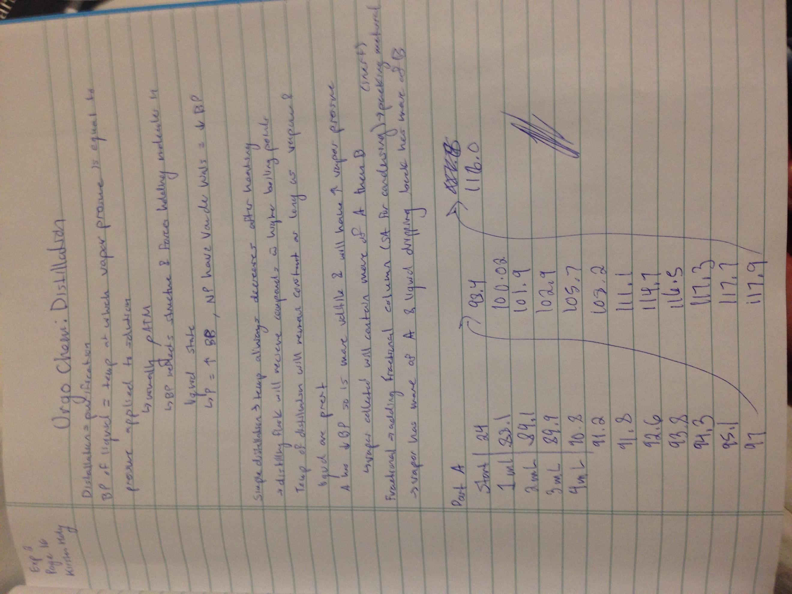
Rough Data


