THIN LAYER CHROMATOGRAPHY

INSERT NAME AND STUDENT #

TA:

CHM1321 Section A02

January 16, 2018 | Week 2

Department of Chemistry

University of Ottawa

Protocole
See CHM1321 organic chemistry laboratory manual 2018 pages 13-19.

Extra trials have been done since results for part a and b were inclusive.

Observations
2:8 Ethyl Acetate:Hexanes
Dichloromethane
Benzophenone
Biphenyl
Ethyl Acetate
Hexane
9:1 Hexane:Ethyl Acetate
o-bromonitrobenzene
m-bromonitrobenzene
p-bromonitrobenzene
The above solutions were colourless, odourless and clear.
ZZ solution transparent, dark yellow, odourless.
Unknown Compound 47 was white, rough, odorless.

TLC PLATES
Figures with * are theoretical
TLC plates are acting as if sample is Biphenyl

R= Reference spot
Co= Coop spot
S=Sample spot
Top dashed line is solvent line
Bottom dashed line is origin line

No Rf values for parts a and b since these are theoretical and are not actually measured.
PART A
Eluent: 2:8 ethyl acetate : hexanes
Reference: Biphenyl
Sample: Unknown #47

TLC 1*
Eluent: 2:8 ethyl acetate : hexanes
Reference: Benzophenone
Sample: Unknown #47

TLC 2*

Part B
Eluent: ethyl acetate
Reference: Benzophenone
Sample: Unknown #47

TLC 3*
Eluent: ethyl acetate
Reference: Biphenyl
Sample: Unknown #47

TLC 4*
Eluent: hexanes
Reference: Benzophenone
Sample: Unknown #47

TLC 5*
Eluent: hexanes
Reference: Biphenyl
Sample: Unknown #47

TLC 6*

Part C
Eluent: 9:1 hexanes : ethyl acetate
Reference: o-bromonitrobenzene
Sample: Unknown #47

TLC 7*
Eluent: 9:1 hexanes : ethyl acetate
Reference: m-bromonitrobenzene
Sample: Unknown #47

TLC 8*
Eluent: 9:1 hexanes : ethyl acetate
Reference: p-bromonitrobenzene
Sample: Unknown #47

TLC 9*

Calculations

Sample calculations

$$\frac{(distance from origin to spot)}{(distance from origin to solvent front)}=Rf$$
1.6/4.0 * 100%= 0.4 Rf

$$\frac{Area of curve}{Area of both curves}*100\%=Absorbance \%$$
8978.551/(8978.551+14645.007) * 100% = 38%
Absorbance percentages:
Absorbance of ortho: 8978.551
Absorbance of meta:14645.007
% absorbance (ortho): 38%
% absorbance (meta): 62%

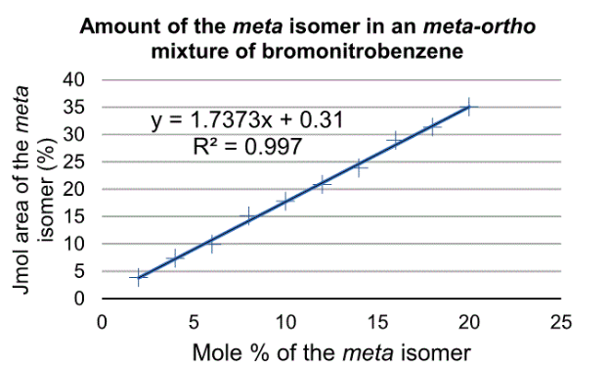
Figure 1

Mole percentage calculations:
y=1.7373x + 0.31 from figure 1
y=meta absorbance %= 62%
x= 35.5%
Mole % (ortho): 64.5%
Mole % (meta): 35.5%

Discussion

Protocol justification

It is important to spot the samples in a specific order.
REFERENCE THEN CO
SAMPLE THEN CO
If CO is not last a contamination can occur affecting results.
We used varying eluants to see the effects of polarity on the TLC plates.
UV lights were used so we can visualize results.
CO spots are used to determine if the reference and sample are the same product.

Errors and amelioration

TLC plates from part A & B were inclusive due to most likely continuous repetition of cross contamination and incorrect use of capillary tubes.
My partner and I realized/were told what we did wrong but did not have enough time to correct our errors.
The results shown in some of our TLC’s looked as if the solution was not transferred from the capillary to the TLC plate properly as certain lanes did not have any spots.
Certain plates showed very big spots as if two samples were mixed from cross contamination.
Unfortunately, my partner and I did not take photos of the TLC plates since we assumed we had enough time to do it again properly.
I did sketch the TLC plates from the trials found below.
Since we know how to perform Thin Layer Chromatography properly we would do it again next time.
We will also be more careful since it is very likely we cross contaminated our results.
We will be more careful by making sure to hold TLC plates from the bottom and side only.
We will make sure we use different capillary tubes when touching different solutions or if we believe it to be contaminated.

Part A

Since our results were inconclusive we do not know if our unknown substance is biphenyl or benzophenone.
In theory, the results would tell us if our unknown substance was either because the TLC plates would show spots that were aligned (meaning the same substance) or not aligned (different substance). All theoretical TLCs are shown.
If all dots are aligned the reference and unknown are the same substance.
If the dots are not the reference and unknown are different.

Part B

Biphenyl is non-polar.
Benzophenone is polar.
Hexanes is non-polar.
Ethyl acetate is polar.

If our unknown is biphenyl it will have a higher Rf value if it’s in ethyl acetate then if in hexanes.

This occurs because polar molecules of attract polar molecules and repel nonpolar molecules.
Hence the higher Rf value in ethyl acetate for biphenyl and lower Rf value in hexanes.

Part C
Used ZZ
Out of three TLC plates two contained two rows and one contained three row.
The one with three rows sample C, p-bromonitrobenzene is not contained in unknown sample.
The two other samples o-bromonitrobenzene and m-bromonitrobenzene are present in the unknown since the rows aligned.

Additional
Rf value is a measure of polarity.
Spots with a higher Rf value are closer to the solvent line and are more non-polar.
Spots with a lower Rf value are closer to the origin spot and are more polar.

Questions

- Increasing the polarity of a solvent system changes the results of a TLC by increasing the Rf values of each spot, as the ability of polar molecules to attract to other polar molecules is increased. Therefore, the spots travel father along the plate.

A
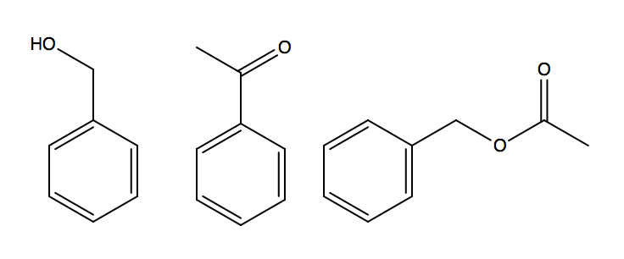
Figure 2 Benzyl alcohol, benzaldehyde and, benzyl acetate. (From left to right)
Benzyl alcohol will have the smallest Rf on silica because of its high polarity. It has an OH group allowing for hydrogen bonding which is very polar in the molecule. In chromatography, functional groups of alcohols slow when compared with ketones and aldehydes which means they move less which leads to a small Rf value.
B
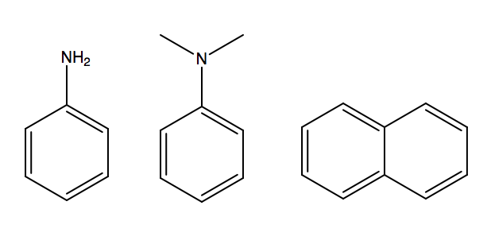
Figure 3 Aniline, N,N-dimethylaniline, Naphthalene. (Left to right)
The same reasoning as A. Aniline would have the smallest Rf. This is because it can hydrogen bond. This results in it being very polar in comparison with the other two molecules. Polar molecules do not move far since they are attracted to the solvent.

RAW DATA



