Procedure: See 2018 Laboratory organic chemistry lab manual page 19-21

Observations:
- Part A- solvent: 2:8 mixture of ethyl acetate
  - The solvent, biphenyl, benzophenone, and the unknown 33 all appeared to be a clear liquid
  - When placed in the solvent, you can see the clear liquid moving up the TLC
  - The first TLC had all three spots had the same height. This sample contained the benzophenone as the reference and unknown number 33.
  - The second TLC had all three spots had slightly different heights. The reference point was higher than the unknown sample. This sample biphenyl as the reference and the unknown number 33.
  - Under the UV light pink dots appeared
- Part B- Solvent A: Hexane
  - The solvent, biphenyl, benzophenone, and the unknown 33 all appeared to be a clear liquid
    - When placed in the solvent, you can see the clear liquid moving up the TLC
    - The first TLC that contained the benzophenone as the reference point contained spots that did not move.
    - The second TLC that contained the biphenyl as the reference point had two spots that moved slightly above, while the unknown and the co-spot (with the unknown and the biphenyl) remained stationery.
    - Under the UV light, both set of dots have appeared light pink
  - Solvent B: 2:8 ethyl acetate
  - The solvent, biphenyl, benzophenone, and the unknown 33 all appeared to be a clear liquid
    - When placed in the solvent, you can see the clear liquid moving up the TLC
    - The first TLC that contained the benzophenone as the reference point, all three spots (unknown, co-spot, and reference point) has moved with the same height
    - The second TLC spot that contained the biphenyl has also moved the same height up the paper
    - Under the UV light, both sets of dots have appeared light pink
- Part C: solvent- 9:1 Hexane, Unknown ZZ
  - The solvent, tube b (meta-bromonitrobenzene) and c (para- bromonitrobenzene) all appeared to be a clear liquid. Tube A (Ortho-bromonitrobenzene) had a slight yellowish pigments.
    - With the TLC that contained Ortho-bromonitrobenzene as the reference, there were 3 pairs of spots that appeared. The highest spot on the paper is the reference and the co-spot, followed by 2 of the co-spot and the unknown. This is most likely because of the solvent being a compound that three spots appeared.
    - The TLC that contained the meta-bromonitrobenzene as the reference, there was three spots above two spots.
    - The TLC that contained the para-bromonitrobenzene as the reference, there were two spots (co-spot and unknown) and three spots below.
  - All the spots on the TLC appeared pink underneath the UV light as well as how far up the solvent went on the TLC paper

TLC images:
*images are not entirely up to scale*
Legend:
Co= co-spot
Be= benzophenol
US= unknown substance
Bi= biphenyl

Part A:
Solvent: 2:8 Ethyl Acetate

Be
USnz
Co

4.5cm
1.0 cm
End of solvent
Starting line
3.7 cm

US
Bi
Co

4.2 cm
1.0 cm

4.8 cm
3.7cm
1
2

Figure 1: TLC- Benzophenol Figure 2: TLC- Biphenyl

Part B:

Solvent #1: Hexane

Be
US
Co

5 cm
1.0 cm

US
Bi
Co

1.2 cm
5.2 cm
1.0 cm

1
Figure 3: TLC- Benzophenol Figure 4: TLC- Biphenyl

Solvent #2: 2:8: Ethyl Acetate

Be
US
Co

3.9 cm
4.7 cm
1.1 cm

Bi
US
Co

4.1 cm
4.7 cm
1.1 cm
Figure 5: TLC- Benzophenol Figure 6: TLC- Biphenyl

Part C:
Solvent #1: 9:1- Hexane

A
ZZ
Co

2.4cm
1.1 cm

4.3 cm
1.3 cm
1
2
1
2

B
ZZ
Co

2.3 cm
1.0 cm

4.7 cm
1.8 cm

2.8 cm
1
1
2
3
Figure 7: Figure 8:
TLC “A”- ortho-bromonitrobenzene TLC “B”- meta-bromonitrobenzene

C
ZZ
Co

2.7 cm
1.0 cm

4.7 cm
1.3 cm
1
2
1
2
Figure 9:
TLC “C”- para-bromonitrobenzene

Calculations:

Sample calculation:
(This is method to the calculations of the below chart)
R_{f}= distance travelled/ distance between the deposition line and solvent front
R_{f}= 3.7cm/ 4.5cm
R_{f}= 0.82

 | Unknown R_{f} | Combined point 1 R_{f} | Combined Point 2 R_{f} | Combined point 3 R_{f} | Reference point 1 R_{f} | Reference point 2 R_{f}
Part A (Ethyl Acetate and Hexane) TLC  - With benzophenol | 0.82 | 0.82 | - | - | 0.82 | -
Part A (Ethyl Acetate and Hexane)  TLC biphenyl | 0.88 | 0.88 | 0.88 | - | 0.88 | -
Part B (Ehtyl Acetate)  TLC  Benzophenol | 0.83 | 0.83 | - | - | 0.83 | -
Part B (Ethyl Acetate)  TLC Biphenyl | 0.87 | 0.87 | - | - | 0.87 | -
Part B (Hexane)  TLC  Benzophenol | 0 | 0 | - | - | 0 | --
Part B  (Hexane)  TLC Biphenal | 0 | 0 | 0.23 | - | 0.23 | -
 | R_{f} A, B, or C | R_{f} co-spots | R_{f} co-spots 2 | R_{f} co-spots 3 | R_{f} reference point ZZ 1 | R_{f}  reference ZZ 2
Part C  TLC A | 0.30 | 0.30 | 0.56 | - | 0.30 | 0.56
Part C  TLC B | 0.78 | 0.49 | 0.78 | 0.60 | 0.49 | 0.60
Part C  TLC C | 0.48 | 0.57 | 0.48 | - | 0.57 | 0.48

Percentage of absorbance:
Absorbance for ortho = 10770.91
Absorbance for para= 34872.09
% d’absorbance (ortho) = (10770.91/(10770.91+34872.09)) x 100 = 23.60 %
% d’absorbance (para) = 100 – 23.60 = 76.40 %

Calculation for molar percentage
y = % absorbance (ortho) = 23.60 %
y = 1.0114(x) – 2.0208
x = (23.60 + 2.0208)/1.0114
x = 25.33 %
% mole (ortho) = 25.33 %
% mole (para) = 100 – 25.33 = 74.67 %

Graphs in Image J:

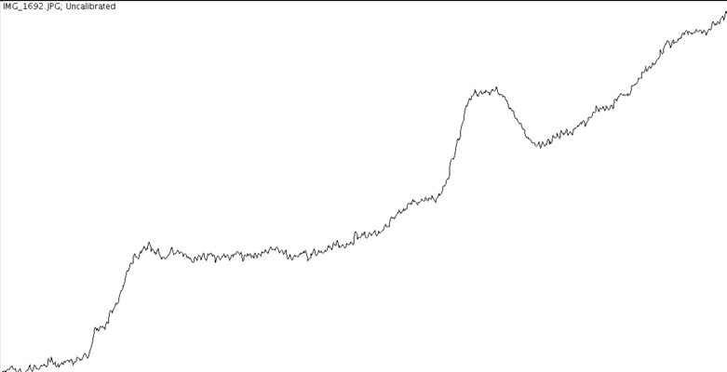
Figure 10 : Ortho-bromonitrobenzene

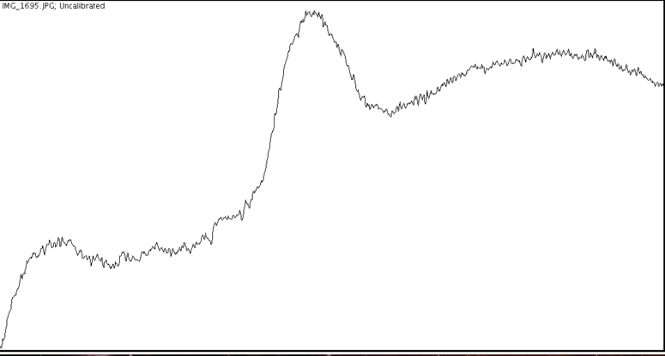
Figure 11: Para-bromonitrobenzene

Discussion:
- Silica is used as stationary phrase
- Silica is polar
- Polar substances would be attracted to the gel because of hydrogen bonds
- Binding with the silica would travel less up the TLC paper
- The more binding of the silica would increase the travel up the TLC paper

Part A:
- During the first part of the experiment, the unknown number 33 has been placed on the far left of the TLC strip
- Afterwards, the benzophenal has has been added on the far right and the co-spot, which contained unknown 33 and the benzophenal
- The TLC plate has been placed in 2:8 Ethyl Acetate and hexane
- When observed under the UV light, it is prominent that all three spots are at the same height
- This indicates that the unknown contains benzophenal, hence the same R_{f} value
- *Insert Rf value*
- For the second part of this section, the scheme of placing the spots were similar, the only difference is biphenyl is used as the reference instead of the benzophenal
- Underneath the UV light, the spots do not correlate at the same height, hence indicating that the unknown does not contain benzophenal

Part B:
- During the second part of the experiment, the polarity of the solvent has been tampered to display the effects of polarity have on the TLC plates
- The solvents used was hexane which is less polar than ethyl acetate
- The procedure does not differ and the only difference was the solvent, which was the ethyl acetate.
  - The three dots being at a similar height still shows that the unknown #33 still contained the biphenyl.
- When biphenyl was used, the two sets of spots are shown
  - Because both of the spots were lower than the TLC with the benzophenal shows that biphenyl is less polar, hence why the spots did not migrate high on the silica gel.
- In conclusion, the unknown solutions contained biphenyl because of the spots on the TLC plates migrating at the same height. In addition, biphenyl was the most polar as it travelled up the TLC plate more efficiently and the hexane was less polar when used with the silica gel.

Part C:
- The last part of the lab consisted of identifying the nature of A (ortho-bromonitrobenzene), B (meta-bromonitrobenzene), and C (para-bromonitrobenzene)
- All 3 TLCs were visible in the UV light.
- 9:1 hexane had good polarity because it has migrated up the TLC
- There are multiple sets of spots because the solvent is a compound
- The unknown solution contains the para-bromnitrobenzene because the reference point for C, co-spot, and the unknown solution’s spot all appeared in the same height on the TLC paper

Discussion questions:
- How does increasing the polarity of the solvent system affect the results of a TLC? (3 points)
  - Silica is very polar
  - In chromatography, there is a stationary phase and the mobile phase
    - The stationary phase is materials being selectively absorbed. This is usually the solid or liquid stage of the chromatography system
    - The mobile phase is usually when the materials start to move because of the solvent and separates over a period of time
    - If the solvent system is more polar than another, then the interaction between the solvent and the compound will be stronger. This causes the overlapping between the solvent and compound
    - Least polar compound has a higher Rf value
    - If the solvent system is less polar, then the solvent would rather bind to the silica. This results into the spots on the TLC plates not travel a higher distance

- In the following sets of compounds, which would have the smallest RF on silica gel? Use a sentence to explain your reasoning.

- Benzyl alcohol would have the smallest RF value because it has an alcohol group
- Alcohol groups have hydrogen bonding with the presence of a single oxygen
- It will be more polar, hence, not moving up the TLC plate very far, hence, it would lead to a smaller RF value

- Draw line structures of each compound:
- Benzyl alcohol, benzaldehyde, benzyl acetate

Benzyl alcohol:

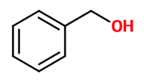
benzaldehyde:

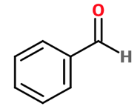
benzyl acetate:

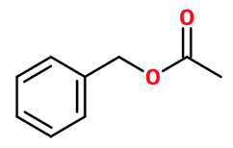

- Aniline, N,N-dimethylaniline, naphthalene

Aniline:
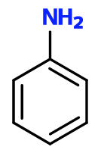

N,N-dimethylaniline:
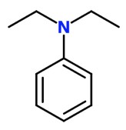

Naphalene:
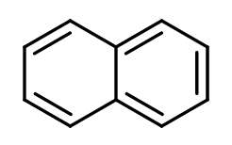

Errors within the lab:
- When using the capillary, even when snapping off the used end, there could be a remaining solution in the tube. This can cause a slight contamination when placing the spots on the TLC plates.
- When cleaning out the beakers and the jar, there could still be remaining chemicals or solutions in the jar which would contaminate the next experiment. This would affect the overall experiment by a slight distance difference that the spots travelled.
- When placing the TLC plate in the jar with the solvent, tipping the TLC plate while the chromatography is in progress would affect the overall result of where the spots would appear on the paper.
- The standard ruler used is not entirely precise, which could affect slightly the measurement, hence affecting the Rf value slightly.

References:

Lab notebook:

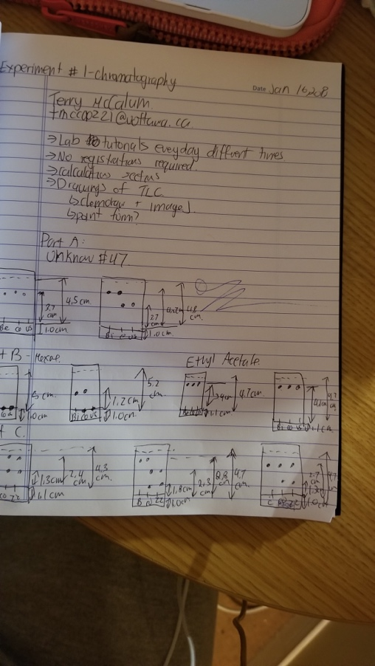

Raw pictures of TLC plates:


