BIO3158 – Vertebrate Zoology Middy 1

Intro:

- Theory of evolution:
  - Pattern – all species share a common ancestor
  - Process – transformation of species through descent with modifications of hereditary traits
    - ie mechanism = natural selection

- Aristotle: Theory of forms
  - World of forms is innate
  - Everything in this world is trying to match an “ideal” model, but it can’t
    - Variability seen in nature is WRONG and imperfect

- Plato: Theory of essentialism
  - Could derive the ideal form from studying the world around us

Aristotle’s Great Chain of Beings:
- Used until Darwin
- 3 level hierarchy:
  - vegetal soul (plants, minerals)
  - animal soul (able to move)
  - rational soul (only humans are capable of rational thought)

LUCA
- last universal common ancestor
- 3.5 billion years since LUCA

How does a cheetah work??
- Mammals: generally
  - Pelvic girdle fused to vertebral column
  - Pectoral girdle sliding on rib cage through muscle
    - Scapula sliding allows for longer stride
  - Head not attached to vertebral column, so head stays steady
  - Change in orientation of neural spine
    - nodal
- Limbs (440 MA)
  - Originitaed as pelvic and pectoral paired fins in fish
  - Pelvic fins were not fused to vertebral column
  - Pectoral was attached to the cranium
  - tetrapod adaptation = pectoral girdle free from cranium
  - vertebrate adaptation = limbs
- Pelvis fused w/ vertebral column (365 MA)
- Erect posture (220 MA)
  - Knee and elbow rotated under the body
  - Mammal adaptation
- Carnivores walk on toes (65+ MA)
  - Lengthens the leg, so they can move faster
  - Digitigrade
    - ** humans are plantigrade (flat feet)
    - **deer are uniguligrade (walk on toes but no claws)
- retractable claws in felines (25 MA)
- cheetah has SEMI-retractile claws (5.5 MA)
  - need the grip for sharp turns

** Any living species is the result of the history of its ancestors (rather than its own history) **

CH. 1: Origin of Chordates and Vertebrates

- Tetrapod Origin
  - First fossil = 375 MA
    - Tiktaalik
  - First tracks = 395 MA
    - Undulating body walking
    - Twist body moves arm up, arm doesn’t move up by itself

- Three major mass extinctions (5 total) OPC
  - Ordovician – 444 MA
    - Sudden glacial period #iceage
  - Permian – 251 MA
    - Siberian volcanic activity
  - Cretaceous – 65.5 MA
    - Asteroid impact

Cambrian explosion (543-520 Ma)
- Life explosion in the ocean
- Innovations:
  - Calcium SKELETAL BODY SUPPORT (first time they’ve been seen)
    - Armored fish
  - Bilaterally
  - Increased O2 levels meant things grew larger
  - Plethora of predators
    - Anomalocaris

First vertebrate: Haikouella 530 MA
- Eyes, brain, no cranium, filter feeder
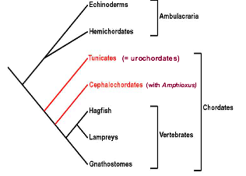
First vertebrate WITH craniums 530 MA
- Myliokunminiga
- Haikoucihthys

Deuterostomia: (sub taxon)
- Phylum Ambulacaria
  - Echinoderms
    - sea stars
  - Hemichordates
    - Acorn worms
- Phylum Chordata (back in the day it was thought urochordates were less derived, but turns out cephlachordates)
  - Cephlachordates
  - Urochordates
  - Vertebrates

Monophyletic = group includes all and only the descendants from a common ancestor

Paraphyletic = common ancestor, but does not include all the descendants
- Ie protochordates, or fish

Deuterostomia formation:
- Unicellular zygote becomes multicellular embryo
- Morula (16 cells) blastula (32 cells) gastrula
- Opening of gastrula becomes anus
- Gastrula has germ layers and coelom
  - Differentiated tissues
- Inside gastrula forms interior primitive lining of gut
  - Archenteron
- Radial indeterminate cleavage

Ectoderm | Mesoderm | Endoderm
- epidermis of skin and its derivatives  - nervous and sensory system  - jaws and teeth  - some glands  - germ cells | - skeletal and muscular systems  - circulatory and lymphatic  - excretory and reproductive  - dermis of skin  - some glands | - epithelial lining of digestive tract and associated organs  - epithelial lining of respiratory, excretory, and reproductive tract and ducts  - some glands

- Echinoderms
  - Adults are radial, larvae are bilateral
  - Ancestral echinoderm fossils showed bilateral symmetry (proving the radial symmetry was derived second)
- Hemichordates
  - Pterobranchs
    - Small colonial animals
    - Can have pharyngeal slits
  - Enteropneusts
    - Acorn worms
    - Have pharyngeal or branchial pores
    - Stomochord present
      - Analogous to notochord
    - Larvae similar to echinoderm
      - Bilateral, planktonic, rows of cilium on surface

Chordate phylogeny:
- Reversed body plan (compared to echinoderms)
- Notochord
- Dorsal nerve tube (hollow)
  - Nerve cord was ventral in annelids and arthorpods
- Post anal tail
- Mesmerisation of body (body segments)
- Endostyle
  - Homologous to thyroid gland
  - Ciliated structure (used to funnel food for filter feeders)

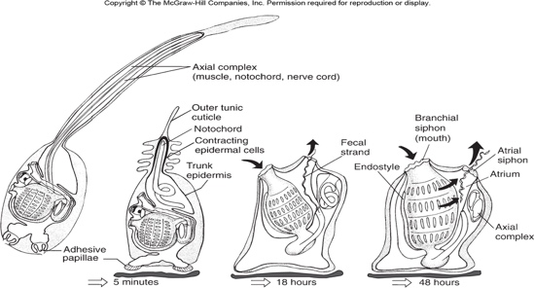
Urochordates:
- Adult ascidian (tunicates)
  - Sessile, marine, found in shallow waters
- Ascidian larvae
  - Tadpole shape and mobile
  - Shows chordate derived characteristics
- Tunicate metamorphosis:
  - Loses all of chordate characteristics, becomes ‘filtering bag’
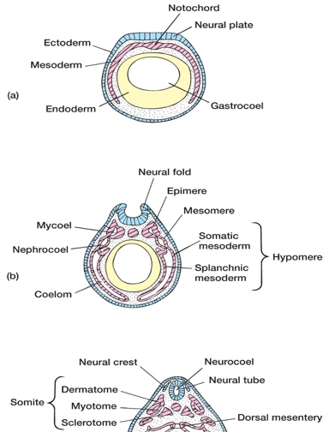
  - Presence of adhesive papillae
  - Axial complex pulled in body
  - Shed outer cuticle

Which is closer to vertebrates, urochordates or cephlachordates?
- Cephlachordates share with vertebrates:
  - Well defined myomeres (metameres)
  - Glandular intestinal caecum
    - Pancreas precursor
- Urochordates (tunicates)
  - Molecular data
  - Migrating cells from neural crest
    - Neural crest originates from dorsal region of the neural tube of urochordates and vertebrate embryos
    - Migrate through the embryo to predetermined destination
** neural cells will migrate all over the body, and are main components of cells, cartilage, etc. Neurocrest cells are ONLY found in vertebrates and urochordates
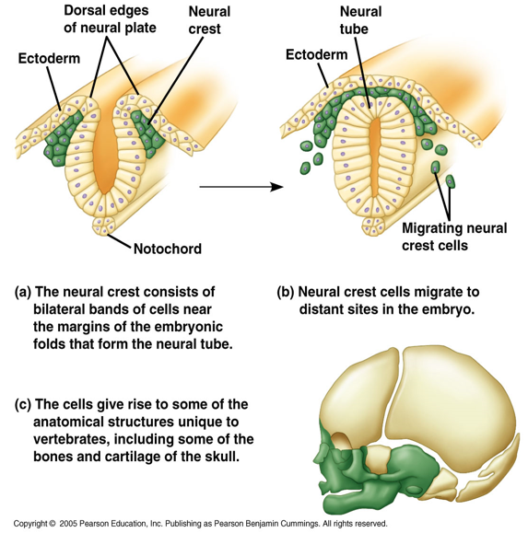
- In urochordates, NCC are for melanocytes production
- Other migrating cells are derived vertebrate characterisitcs

Ectodermic placodes:
- Derived vertebrate character
- Thickening of surface ectoderm
- Often linked to NCC (will form sensory organs)

Chordate Phylogeny:
- Vertebrate fossil (530 MA: Haikouella)
- Filter feeding, no jaws (agnathan), often body shield on anterior part of body, small lateral eyes, lateral stabilizaers
- Ostracoderms = fossil jawless vertebrates
- Agnathans = only living jawless vertebrates
  - Lampreys and hagfish

Classic Garstang hypothesis:
  - Refuted by phylogenetic data, but once thought to be true
  - Peadomorphosis
    - When adults resemble juveniles of their ancestors
    - Larval form becomes reproductively mature

Evolutionary scenarios of vertebrate origin:
- Theory 1:
  - Prechordate was an active suspension feeder
    - Accounts for the chordate characteristics (notochord, dorsal nerve chord, post-anal tail)
- Theory 2:
  - Prechordates were incipient predators
    - Predatory characters were enhanced in vertebrates
    - Characteristics were reversed in cephalochordates and urochordates, returning them to suspension feeders

Origin of vertebrates:
- Muscular pharynx pump requires evolution of two structures:
  - Muscle bands in pharynx
  - Pharynx made of flexible tissues
    - Expand and contract to create pumping motion
- Gill evolution for an active lifestyle
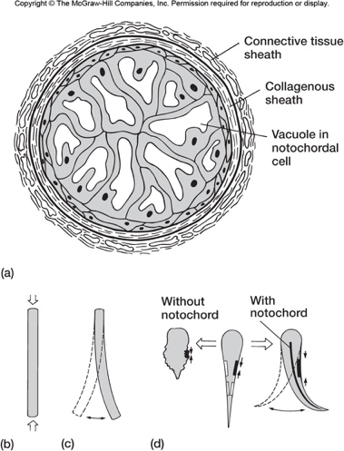
- Pump has feeding and respiratory functions
  - Still no jaws (just feeding on tiny particles)

CH. 2: Support Tissues

Notochord
  - Large vacuolated cells within sheath of fibrous connective tissues
  - In all vertebrates and chordates
    - Usually only seen in the larval stage, but some adults have it
    - Adult lobe finned fishes and primitive amphibians have it
  - Ancestral structure of chordates seen in tunicates and amphioxus
- Notochord replaced by the centrum of the vertebra and other vertebral elements
  - In some vertebrates, notochord is just replaced by a hole
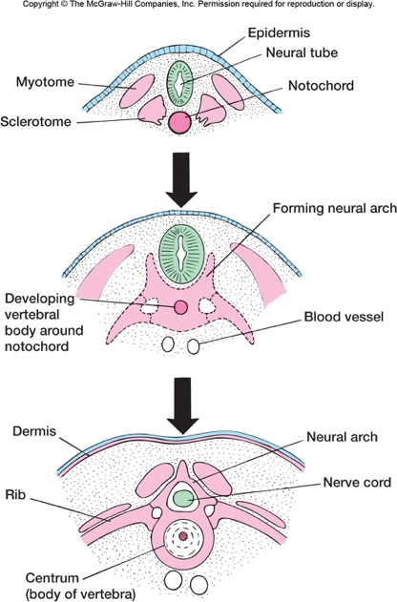
- Vertebrae replace notochord in mammalian embryos
- Sclerotomes are segmented cell clusters gathered around the notochord
  - Differentiate into segmented vertebrae (vertebral column)
- Vertebrae protect nerve cord, and are attachment sites for muscles
- Vertebrae functionally replaces notochord
- Notochord present as small core of intervertebral discs between successive vertebrae

Connective tissues

- Loose connective tissues
  - Mesenchymatous tissue = fibroblasts
    - Gelatinous protein matrix
    - Collagenic fibers
      - weak elasticity and high flexibility
      - sometimes used for bones to form (non compressible fibre)
    - Elastic fibers
      - high elasticity and flexibility
  - concentration of the different fibres depends on the tissue

- dense (fibrous) connective tissues
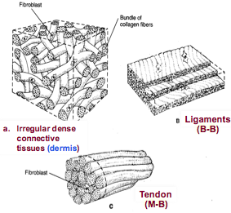

Skeletal tissues: cartilage
- mesenchymatous cells chondrocytes
  - not fibroblast
  - chondrocytes will form the actual cartilage
    - divide within the matrix and secrete cartilage
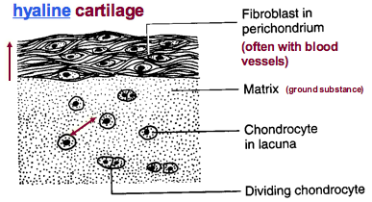
    - low numbers of fibres within the matrix
No blood vessels found within the cartilage... its fed with diffusion through the matrix

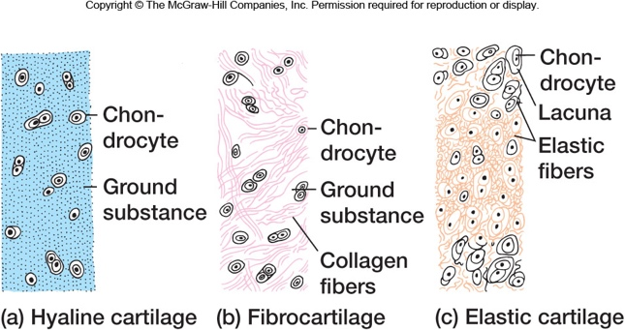

- cartilage types:
  - hyaline cartilage
  - fibrocartilage
  - elastic cartilage
  - calcified cartilage
    - cartilaginous fishes
    - different from bones, since the blood vessels are on the outside

Skeletal tissues: Bones
- formed from mesenchymatous cells
- very hard, opaque and calcified
- ground substance: hydroxyapatite crystals on collagenic fibers
  - bone calcifies by fixation of hydroxyapatite crystals on collagenic fibers
  - osteoblasts (osteogenesis) secretes collagenic fibers ground substance (creates bone)
  - osteoclasts dissolve bones
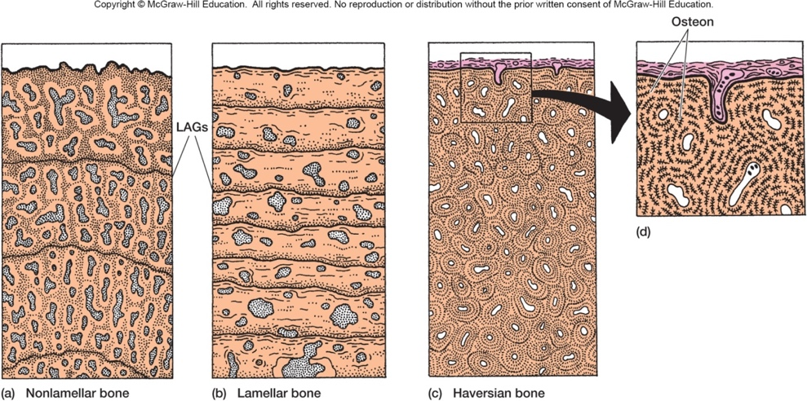

LAG = lines of arrested growth

Nonlamellar:
- fast growth
- collagen fibres unorganized in the bone layers
- young alligators will have a lot of nonlamellar, which will slowly be replaced by lamellar
Lamellar:
- slow growth
- well organized & horizontal compared to nonlamellar’s vertical
Haversian bone:
- special type of lamellar bone
Acellular and lamellar bones
- teleosteans fish scales
- acellular (no bone cells)
- can be cycloid or ctenoid scales (layer growth)
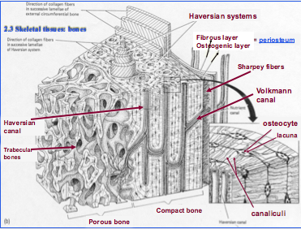
Haversian system:
opening will have haversian canal. Center will have blood vessels

Porous bone:
Osteoblasts and osteoclases have organized themselves in order to reduce stress on the system, creates porous bone

Types of ossification:
- Echondral bone:
  - with cartilaginous precursor
  - cartilage grows faster than bone, so it froms first and then ossification occurs
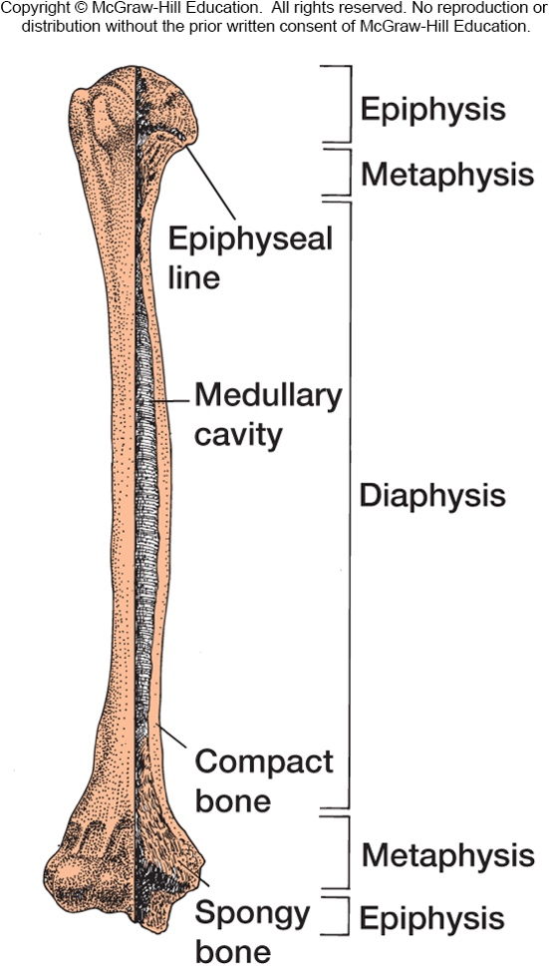
Typical echondral bone:
- Blood forming tissue in medullary cavity of long bones
- End of each bone usually covered in cartilage for limb articulation (epiphysis)
- Medullary cavity may have porous bone
- Epiphyseal plate remains cartilage
  - Allows bone to grow (cartilage faster than bone)

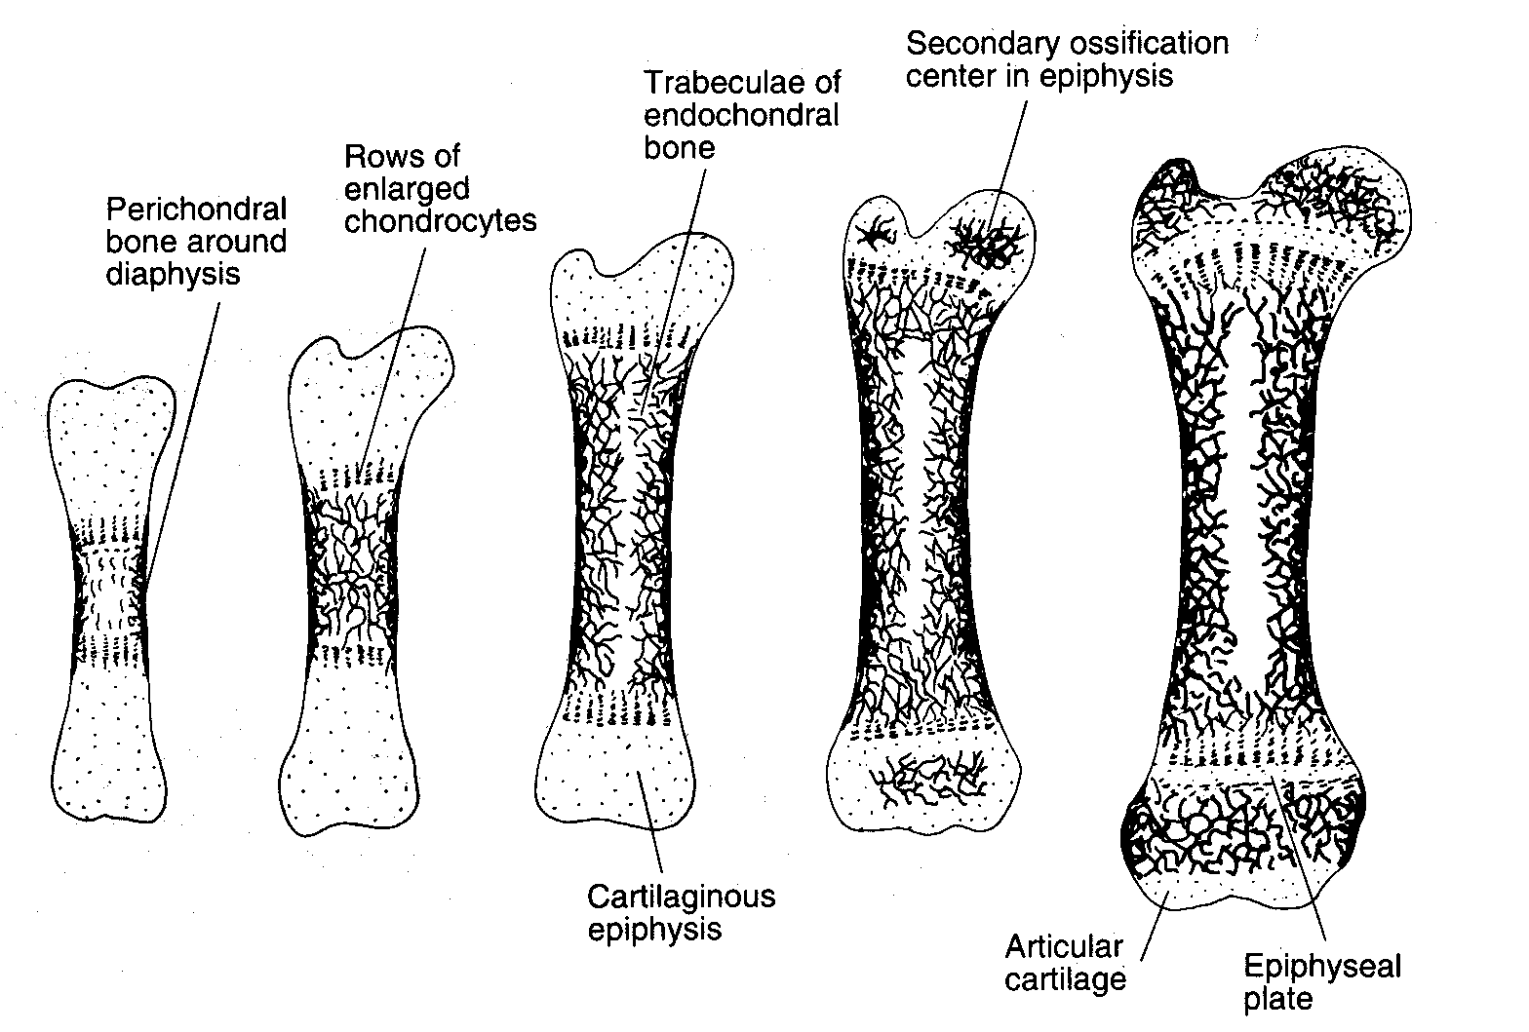

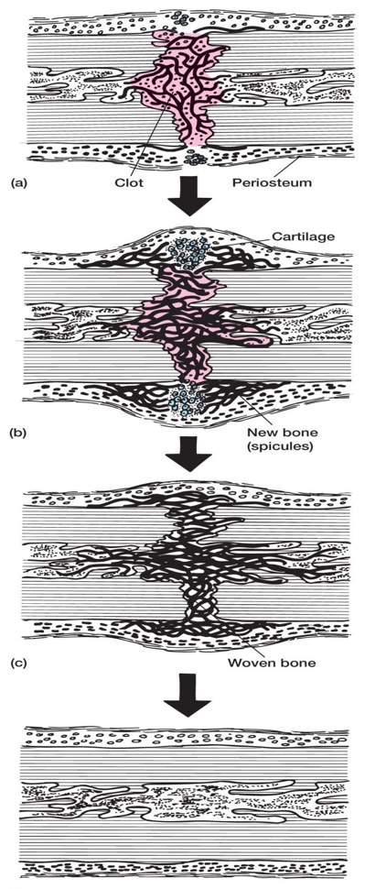
Bone fracture:
- Clot and debris form between ends of fractured bone
- Clot replaced by cartilage. Cartilage becomes calcified , blood vessels invade, osteoblasts and osteoclasts appear new bone matrix laid
- Spicules of woven bone hold broken ends in place through remodeling
- Replace the broken bone

- Intramembranous bone
  - Bone forms without cartilage precursor
  - Direct from mesenchymatous cells (3 types)
    - Dermal/membranous
      - In the skins dermis
      - Ie fish plates are this
    - Perichondral or periosteal bone
      - Formed deep in connective tissues
    - Sesaoid
      - Formed in tendons
      - Ie patella (kneecaps)

Ch. 3: Evolution of fish like vertebrates and primitive amphibians

Vertebrates = gnathostomes & agnatha

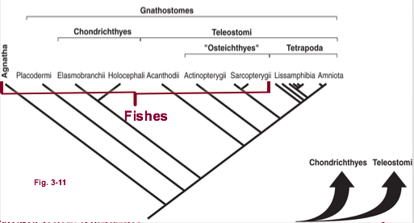
Fishes are paraphyletic (no one characteristic that is unique to fishes)

- Agnatha
  - Haikouella & haikouichthys (first known vertebrates) – 530 MA
  - Conodonts – 500-146 MA
    - Teeth but no jaws #weird
    - Thought to have disappeared during a mass extinction
  - Lampreys
    - Predatory
      - Tail in the sediments and filter water with mouth
    - Non-predatory
      - Latch onto side of fish and borrow into it, feeding off blood particles
  - Hagfish
    - Associated with Cambrian explosion
    - Mucus secreting glands that turn surrounding water into gelatin
    - Scavengers, scrape tissue and fat off dead things
    - Tie knots into their body to make up for not having a jaw
  - Ostracoderm – 359 MA
    - Armored active filter feeders

Gnathostomes:
- Placoderms
  - First jawed animal
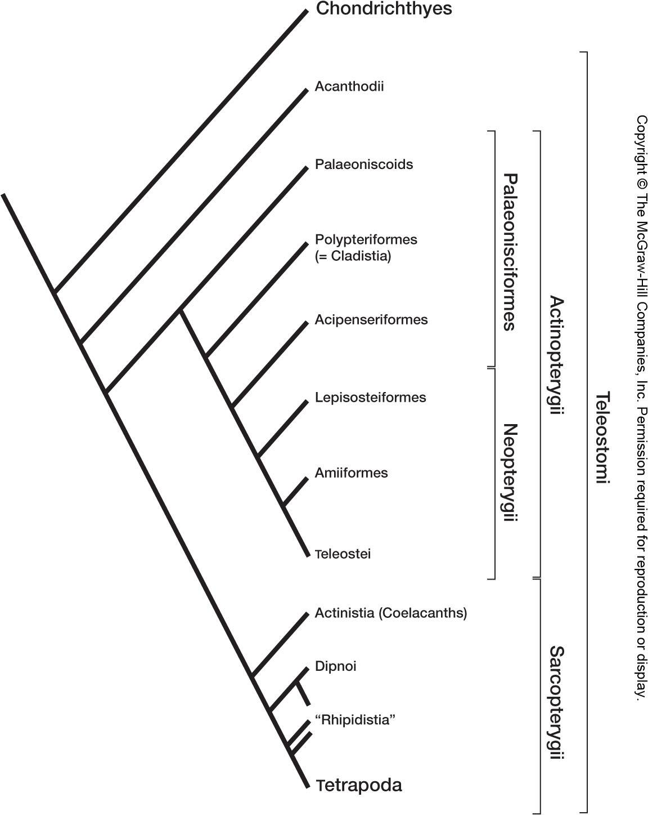
    - No teeth on jaw, just sharp ridges used to cut prey
    - Jaw means predators, so they needed armor
  - Armored fish
  - Paired fins start to appear
- Chondrichthyans
  - elasmobranchs
    - Sharks and skates (elasmobranchs)
  - Holocephali
    - Diverged from shark approx 4 MA
    - Ie chim era
      - Ghost shark, with cartilage skeleton
      - Totally scaleless adults
      - ‘angel’ wings
      - only one opening for gills, rather than gill slits
- teleostomi (spiny fish)
  - acanthodian
    - calcified cartilage skeletons (stronger than straight up cartilage)
    - spines on ventral or dorsal surface of the fish
    - spines parallel lines along ventral surface (origin of limbs evidence)
  - actinopterygians
    - ray finned fishes
    - bony pectoral pelvic fins
    - fin attached directly to the body
      - paleonisciformes (Ganoid scale, very old school)
        - paleoniscoids (fossils)
        - polypteriforms (one African family)
        - acipenseriformes
          - sturgeon acipenser
          - paddle fish polyodon
      - neopterygiens
        - lepisosteiformes
          - functional lungs, can actually breathe
        - amiiformes
          - can also breathe air
        - teleostei
          - over 30,000 species
  - sarcopterygii
    - lobed fin fish
    - fin attached to a bone that pushes the fin away from the body
    - bones inside the projection are homologous to tetrapod limb bone
    - actinistia
      - coelacanth (latimeria)
        - internal nares choana (internal fertilization)
        - cosmoid scales
        - diphycercal caudal fin
        - have lungs for floatation device
    - dipnoi
      - lungfishes
    - rhipidistians
      - eusthenopteron
      - panderichthys
      - tiktaalik
      - structure of limbs may have evolved but fingers/digits are the mark of amphibians
- amphibians
  - tetrapoda
  - amniotes appeared through amphibians

gerobatrachus: the frogmander 290 MA
- common ancestor to frogs and salamanders

CH. 4: Evolution of the axial skeleton
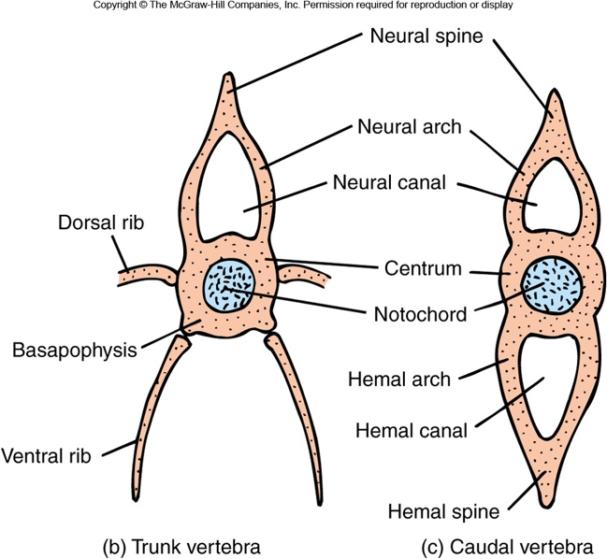
- neural tube is dorsal
- notochord may or may not be present in adults depending on the species
- hemal canal holds blood vessels, and hemal arch protects them

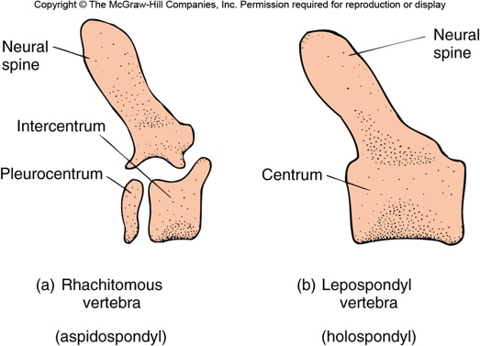
Aspidospondyl:
- Elements of centrum are present
- Evolutionary perspective

Holospondyl:
- What humans have

Acoelous
- Reptiles, birds, mammals
- Nucleus pulposus is notochord remnant
Amphicoelous
- Fishes + first tetrapods
- Both extremities of centrum are convex (curve outward towards each other)
Procoelous & opisthocoelous
- Amphibians and primitive reptiles
- One surface flat, one convex
Heterocoelous
- Neck of birds
- Rotation of head around the neck (owls spinning heads)
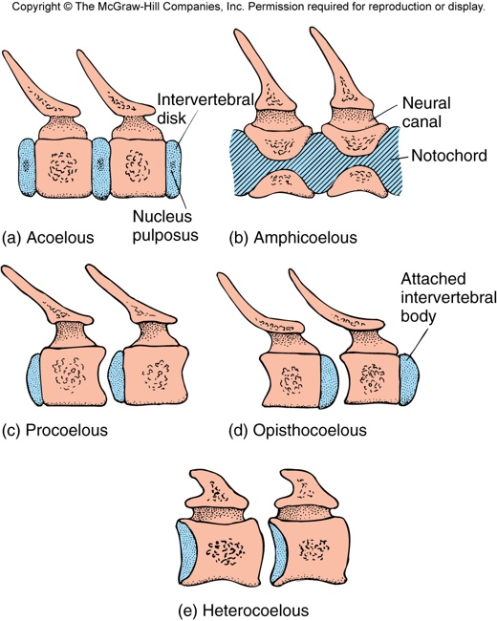

- notochord in adults with few elements of neural arches and spines
  - notochord present with nerve chord on top of it
  - cartilage elements attached onto it, but not a complete neural arch yet

- primitive shark (hybodus 260-100 ma)
  - has notochord that travels down length of body
  - today’s shark has more cartilaginous elemetns and structure surrounding the notochord for origin of muscles
    - almost exactly like our vertebrae centrum

- Bony fishes (teleost)
  - Not complete centrum, but neural + hemal arch is present
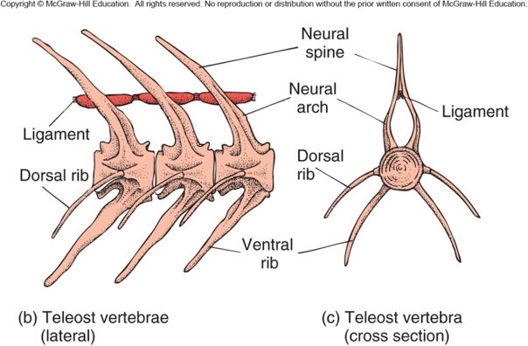
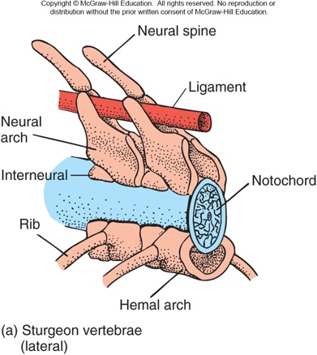

- Sarcopterigyans
  - Latimeria (coelacanth)
    - Notochord + neural spines leading off it (that’s it.. no centrum or anything)
  - Rhipidstian (eusthernopteron)
    - Pleurocentrum present between vertebrae
    - notochordal canal and bony elements surrounding it

- Fish tails
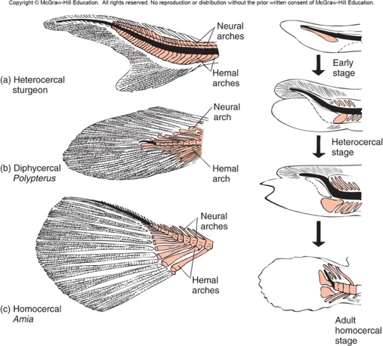
- sharks
- if ventral lobe removed, shark will constantly float upwards (more than intact)
- sarcopterygians
> roundish at end, vertebral column isn’t raised to end of fin

fossil jawless fishes can be hypocercal (bottom part of fin is longer than top half)

- vertebral column not used for support in fish, just as bar for muscles to push against
  - on land, dinosaurs used it for support and locomotion
  - first amphibians would need slight ribs structures, to protect the organs (tiktaalik)
  - amphibian characteristics:
    - eyes on top of head
    - ribs
    - actual digits (tiktalik only has fins, so still precursor to true amphibian)
    - real necks (terrestrial tetrapods)

- amphibians on land:
  - complex vertebral column
  - vertebrae with bony processes create solid longitudinal axis
  - large ribs (esp in fossil forms)
    - smaller ribs indicates still partially aquatic
    - large ribs fight compression of the body/organs on land

- human centrum (amniotes)
  - mostly kept pleurocentrum, with very little intercentrum

amphibians vertebral column
- 1st trunk vertebrae modified into ATLAS (cervical vertebra)
- trunk and caudal vertebrae
- trunk can have ribs associated

reptiles vertebral column:
- 6-10 cervical
- 8-22 trunk vertebrae
- 2-3 sacrals
  - attached to pelvic girdle
- caudal

reptiles:
- atlas-cranium joint for up + down movement of head
- atlas-axis joint for lateral movement of head

turtles:
- neck retracts vertically or horizontally
- horizontal = pleurodires
- vertical = cryptodires
  - all Canadian turtles are this
- shoulder girdle is INSIDE the shell rather than the usual outside
  - turtle ribs grow faster than the girdle, doesn’t work like this in other animals

birds:
- 11-25 cervical vertebrae
- trunk vertebrae
  - 3-19 thoracic
  - 10-23 sacral + some lumbars
- caudel vertebrae
  - 6-7 caudal
  - 4-7 fused pygostyle
    - end of tail
- synasacrum and pelvic girdle have been fused to lighten the bird
  - synasacrum is all the vertebrae except the free caugal vertebrae, pygostyle, and free thoracic vertebrae
  - innominate bone is pelvic girdle, holds the synsacrum

mammals:
- 7 cervical vertebrae (higher or lower tends to mean death)
  - manatees and slots can survive with only 6
- trunk vertebrae 14-30
  - thoracic vertebrae
  - lumbar vertebrae (no ribs, used for faster movement)
- sacral vertebrae
- caudal vertebrae

Convergence b/w great white sharks, ichthyosaurus (fossil reptile) and dolphins:
- fusiform body
  - no need for neck, but still 7 cervical vertebrae
  - necks slow you down in the water, so want the vertebrae fused
- head contour continuous with body
- propulsion through lateral undulations
- dorsal and pectoral fins stabilize
- dorsal fins of ichthyosaurs and dolphins
  - fully convergent, no homology
  - very important for speed

porpoise
- fused cervicals
- propulsion in water = compression forces
  - large disk shaped centra
  - reduced zygapophyses
  - large number of lumbar vertebrae (21)
- metapophyses prevent excessive lateral undulations (on neural spine)
  - prevent over bending
- locomotory muscle for undulations
- reductions of rib cage and sternum
  - in water don’t need all that support

Atlas and axis evolution
- centrum = pleurocentrum
- in mammals, centrum no longer inside the atlas
  - two separate things that fit together

- in upright dinosaurs, tail had to be so long in order to balance weight of the top half of the animals
  - 4 legged animals don’t need their tail for this
- 4 legged animals need back arch maintained by abdominal muscle
  - head region also maintained by ligaments (ensure its straight out)
  - ligaments and ab muscle important in decreasing length of body and resisting compression forces

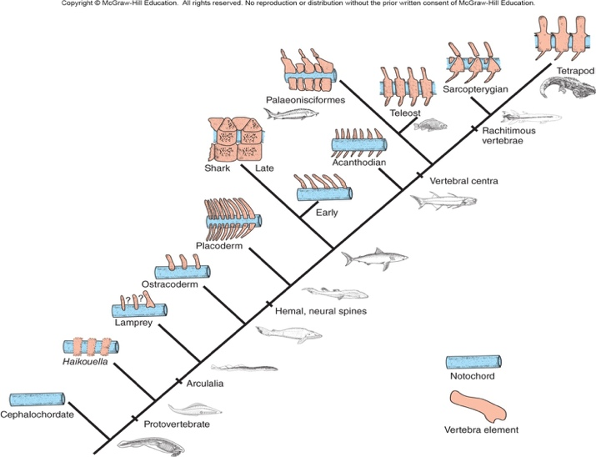
- if first neural arches with thoracic region are very long, the head is so heavy that it needs that to be held up
  - ie bison, giraffe

CH. 5: Evolution of locomotory organs

Fins:
- living agnathans and most fossil ones do NOT have pelvic or pectoral fins
- several have long lateroventral fins
- others have lateral protuberances on their head that could be homolgous with lateral fins
- functions:
  - propulsion and control of roll, pitch, and yaw
    - pitch = up and down
    - yaw = side to side
- fin fold hypothesis:
  - originally had folds on side of body, that would evolve into paired fins
  - no strong evidence but:
    - acanthodian spiny fish show imtermediate spines which could be remnants of the fold
    - maturing sharks start to show very long thin structures on the belly, though to originate from the fin folds

pelvic and pectoral fins: 385 MA
- seen in Bothriolepis (placoderms)

- in sharks, appenicaulr skeleton shows fusion of separate basal girdle elements across the midline
  - puboischiac and scapulocoracoid bars
  - fins attached to each other through these bars
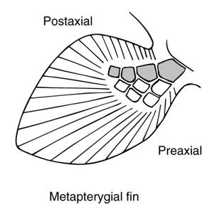
Bonyfishes:
- pectoral girdle is all dermal bone
  - except scaputocoracoid
- all dermal bones will disappear later on, except the clavicle

Lungishes (archipterygial):
- closest living relative to tetrapods
- fin moving further from the body
  - pelvic girdle + femur separates fin from the body
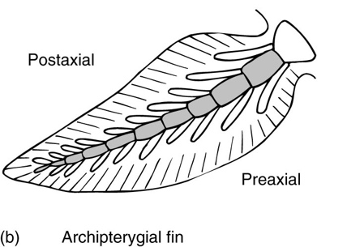
  - lifts its body to walk using its fins, so fins no longer directly connected to pelvic girdle
- modified archipterygial fin
  - main axis in centre of the fin

Pectoral fin of Eusthenopteron:
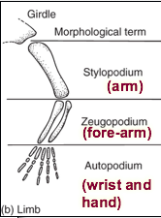
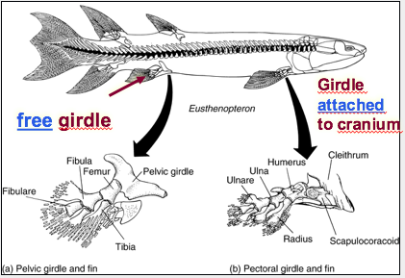

Pre-axial = radius, tibia
Post axial = ulna, fibula

Primitive amphibian:
- pectoral girdle free from cranium
- pelvic girdle attached to vertebral column
- seven digits on hind leg
- aquatic lifestyle
  - smaller girdles, and uniform vertebral column
  - long tail, maybe fins, small ribs
- terrestrial lifestyle
  - larger girdle, large centrum, long neurospine, distinct vertebrae, large flattened head, larger ribs

- scapulacoracoid is only echondral element in fish
  - becomes scapula and porcoracoid in tetrapods
- girdle detached from cranium through loss of dermal bones
  - clavicle is only dermal bone to remain

mammals pelvic girdle:
- no dermal bone (except clavicle)
- three echondral bones:
  - ilium
  - ischium
  - pubis

Evolution of locomotion:
- pectoral girdle
  - bone of dermal origin
    - surface bones ended deeper in the flesh
    - became strcuutual support for the echondral portion of the fin
    - bony bridge to the cranium and attachment of lateral walls of the body
  - pectoral girdle became free from cranium through loss of dermal bones
    - allowed for neck evolution
  - bone of echondral origin
    - scapulocoracoid (direct support trucutre of fin) evolves in a scapula, procoracoid and coracoid of tetrapods
- pelvic girdle
  - except for fish, girdle made of ischium, ilium, pubis
  - stabilization of girdle for all tetrapods by attaching it to vertebral column
- water to land transition:
  - swimming undulating motion used on land
- sprawled vs erect position
  - humerus/femur used to be parallel to ground, causing sprawled position
  - moved directly under the body, creating erect posture
    - knee rotated under body, fingers now face forward rather that outwards
- rather than overhand swing of limbs to move them, dinosaurs used pendulum swing
  - allowed limbs to remain directly under body for better support

Dinosaur success:
- forward rotation of the knee
  - allowed them to get so huge
- bipedalism

Mammals:
- knee and elbow rotations
  - dinos only rotated knees
  - independently occurring of dino rotations
- anterior portion of scapula provides support for shoulder and muscles
  - facilitates pendulum movement of the girdle and limb
- pelvis in longitudinal axis of body
  - lumbar region before pelvis allows movement and flexion
- pectoral girdle slides on rib cage, allowing them to move faster
- pelvic girdle attached directly to vertebral column
  - via sacrum
- evolution towards faster limb oscillation
  - distal muscular mass reduced
  - less digits

** 6-7 MA the hominins shared common ancestor with chimpanzee **

locomotion in brachiators (pre-hominin types):
- large clavicle attached to sternum
  - stabilize shoulder
- clavicle sliding on back of thoracic cage
  - other mammals slid on the side
- long arms (tree life)
- opposable thumbs and big toes for grip

Hominin locomotion:
- position of foramen magnum evidence of upright posture
  - vertebral column is presumed to be underneath, associated with bipedal posture
- 5 lumbar vertebrae
  - chimps have 3-5, but 5 is very rare
  - vertebrae get larger as you move down the body, in order to support the top-heavy weight
- arched feed
  - chimps didn’t have arch, not good for walking
- ilium of pelvic girdle sticks out a lot more in us, better walking stability

Ardipithecus:
- pelvis adapted for upright bipedal stance
- subtle evidence of arched foot and upward flexibility in toes (walks)
- big toe remains opposite to other digits (still tree life)

** last 5 MA, cooler climate – change in landscape vegetation **
^^ affected bipedal evolution

Why become bipedal?
- LCA of chimps and humans; mainly frugivorous
- Selective forces (probs climate change)
  - Diet change: dentitiion change, fallback foods
  - Postural adaptation
    - Reaching more fruits and being able to carry them
  - Energy saving
    - Knuckle walking uses 4X more energy
- Bipedalism was key for other huan species adapations

Cons of bipedalism:
- Weight of pregnancy
  - Needed to modift lumbar region to hold the weight
  - Chimps never had to do this, sicne gravity pulls at it evenly
- Less speed
  - Knuckle walking is fast
- Less stability and agility
  - No longer efficient in trees
- Consequence:
  - Evolution of endurance walking, tool making, and hunting

Australopithecus sp.:
- More efficient endurance walkers
  - Big toe in line with other toes
  - Flat heel bone (shock absorbance)
  - Arches of foot more curved
- Typical morphology of climber
  - Long arms, short legs, curved toes and fingers
- Wider hips needed angled femur inward
  - Placed knee near body midline to keep swing pendulum under the body
    - No swaggy swaying

Homo.
- All changes are now hips up (no longer climbers)
- Hunting and gathering
  - Intensive cooperation
  - Food processing
- Evolutionary novelties
  - Longer legs (longer stride)
  - Thicker bines in legs
    - Increased resistance of leg bones
  - Larger joints
    - Hip, knee, ankle
  - Dome shape of foot
  - Slender built
    - Thorax narrower
- Long distance walkers:
  - Big gluteus maximus
  - Longer Achilles tendon
  - Head stbailized when running
    - Enlarge semicircular canals
    - Nuchal ligament (absent in Australopithecus and chimps)
  - Short toes

Evolution of flying (aerial locomotion):
- Leaping
  - Jump and grab
- Parachuting
  - Maximize drag
- Gliding
  - Minimize drag

True flyers:
- Bats
- Pterosaurs
- Birds
Participating flight digits are lengthened and bones are lengthened
- Very porous bones, and combined with others to lighten overall load

- Primary feathers = thrust
- Secondaries = lift

Differnece in flights are reflected by wing design:
- Hummingbird = hovering
- Frigate bird, rough logged hawk, etc = soaring
- Pheasants = quick burdt
- Swallow, falcons = fast-flying, swept back wing

Owls have discs in the cranium that act as satellite disc
- Centre of disc is their ears, to find prey at night

Origin of flight theories:
    - Feathers did NOT evolve for flight, but are modified for flight
- Arboreal theory
  - Tree down
  - Increased surface for parachuting, then became gliding, then flight
- Insect net theory
  - Jump in air to increase chance of catching insects
  - Ground up theory
  - Very unlikely, wings create too much drag
- Cursorial theory
  - Wing assisted inclined running
  - Used wings to stay close to ground running up steep hills
  - Tried in the lab, works very well so far

CH. 6: Evolution of the visceral and cranial skeletons

Regions of cranial skeleton:

- Chrondrocranium
- Endoskeletal elements (cartilaginous or enchondral) encapsulate the cranium
- Nasal region & inner ear

- Splanchnocranium
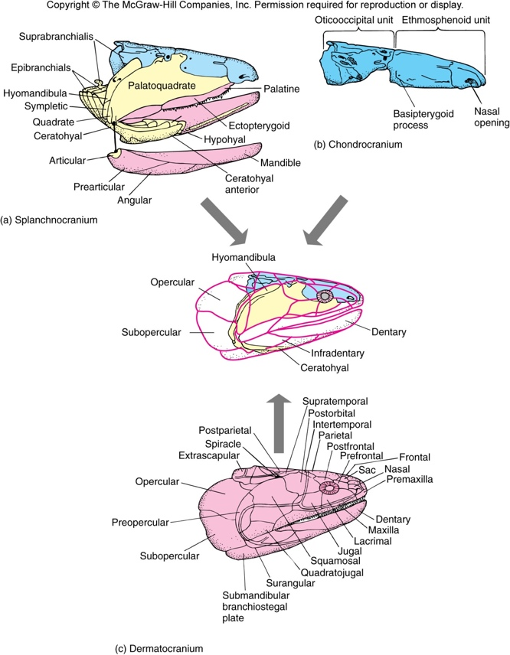
- Visceral arches
- Mandibular, hyoid, and branchial arches

- Dermatocranium
- Dermal elements that enscapulate the chrondocranium and splanchnocranium

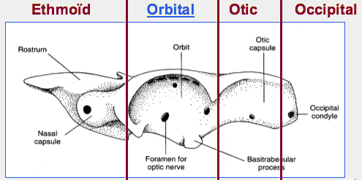
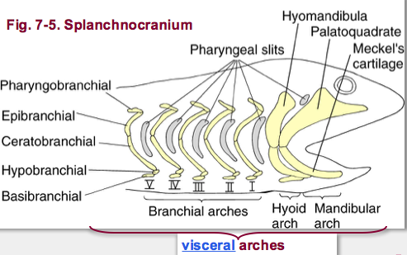
Chrondocranium regions: Splanchnocranium:

Splanchnocranium
- Visceral arches in acanthodes (primitive and fossil spiny fish)
- Note jaw ossification and articulation b/w quadrate and meckel’s cartilage
- Similarities b/w hyoid arch (with gills) and branchial arches
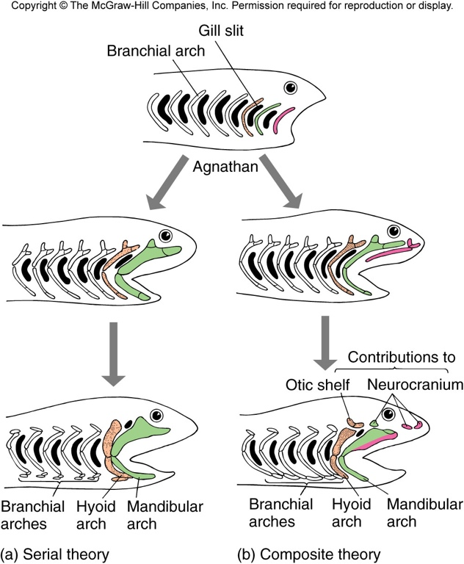
- Presence of hyomandibula IN the hyoid arch

Theories of Origin of Jaws:
- Serial theory
  - Jaws arise completely from one of the anterior branchial arches
  - Elements may be lost within it, but other elements from other branches do NOT contribute
- Composite theory
  - Mandibular arch is formed from elements of several adjacent arches that also contribute to the neurocranium

Suspensorium jaw types

- Euautostylic = mandibular arch suspended from the skull by itself, no help from the hyoid arch
  - Found in placoderms and acanthodians
- Amphistylic = jaws attached to the braincase through two primary articulations, anteriorly by a ligament connecting the palatoquadrate to the skull, and posteriorly by the hyomandibula
  - Early sharks, osteichthyans, rhipistians, modern sharks
- Hyostylic = mandibular arch attached to braincase through the hyomandibula. the sympletic bone aids in jaw suspension
  - Bony fish
- Metautostylic = jaws attached to braincase through the quadrate (bone formed in in posterior of palatoquadrate. Hyomandibula plays no role in jaw
  - Birds, reptiles, amphibians
- Craniostylic = entire upper jaw incorporated into braincase, , but lower jaw suspended from dermal squamosal bone of the braincase. Lower jaw entirely consists of dentrary bone (dermal origin)
  - Mammals
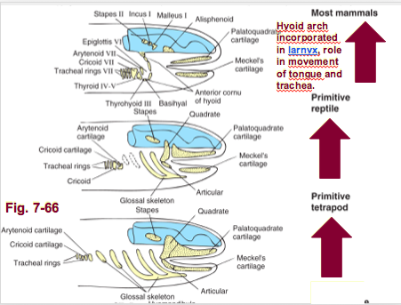
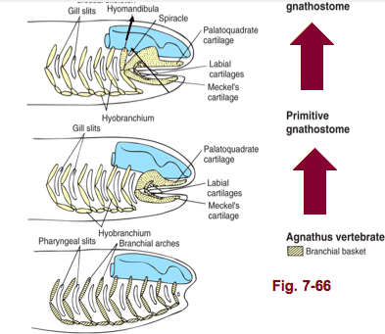

Contribution of echondral bones to braincase:
- Shark
  - Chrondocranium forms a platform for the brain
- Bony fishes + tetrapods
  - Ossification of chondrocranium resulting in a complex osteocranium
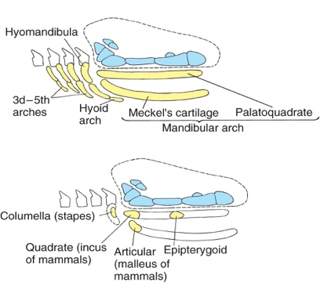
    - Series of otic, occipital and sphenoid bones or cartilages

Contribution of splanchocranium to cranium:

Contribution of dermatocranium:
- facial series
- orbital series
- vault series
- palatal series
- mandibular series

Enchondral neurocranium evolution:
- reduction of enchondral neurocranium
- dermal roof becomes more and more important
- bone fusion
  - ie occipital of tetrapods result from fusion of several bones from fish

Temporal fenestrae
- diapsid
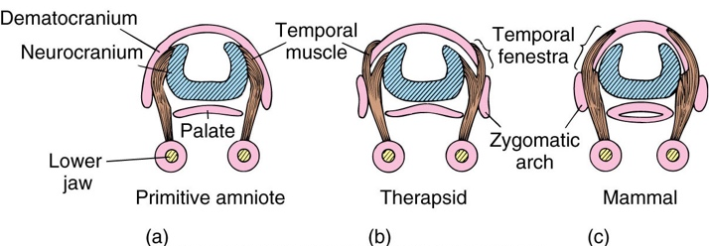
  - 2 temporal fenestrae
  - birds, lizards, snakes
- synapsid
  - 1 temporal fenestrae
  - mammals
- anapsid
  - 0 temporal fenestrae
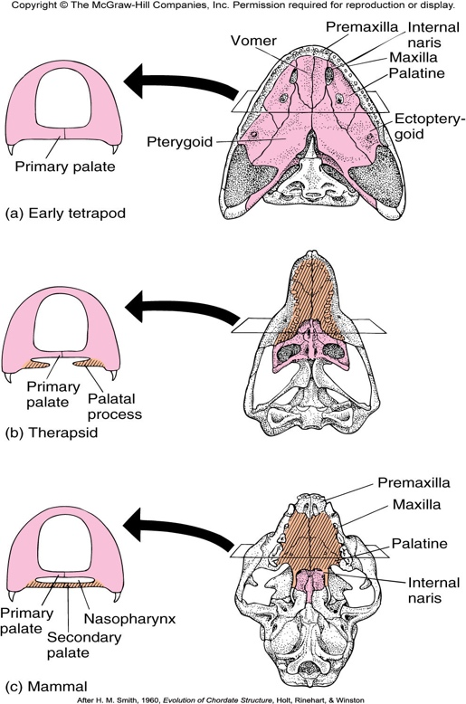
  - turtles

evolution of secondary palate of mammals
- involves maxillary, premaxillary, and palatine

