Rauman Tuan Kichil Intervention

Rauman Tuan Kichil (8247391)

APA 2111: Intervention Theories

Dr. Tanya Halsall
University of Ottawa
November 8th, 2017
Physical activity (PA) is generally seen as a way to increase a person’s fitness and overall health, but the PA of an individual can be influenced by a variety of factors. These factors can range from physical limitations of the individual to poor accessibility or convenience in terms of the environment. An important framework is an ecological model as they can be used to understand the limitations, barriers or opportunities within an individual’s environment that may or may not lead them to physical activity. These models are built on concepts of psychological development, and can used to understand PA-related behaviors and organize PA interventions (Halsall, 2017a). A general ecological model is a multi-stage level system that is tailored to the individual using the intervention. Examples of ecological models include Brofenbrenner’s ecological systems and the Sallis ecological models. These models share a common feature in that they both can be used to increase a person’s PA level; however, the ideologies behind completing these goals differ. The Bronfenbrenner’s theory focuses on the development of the individual and how the different levels of the model can influence the growth and development of the person (HQ, 2017). The Sallis ecological model focuses on the attractiveness, educational and motivational aspects of a person’s life. These concepts were originally used in the psychological fields, but have been modified to be used in the fields of PA interventions. This essay will discuss the importance of the environment as means to physical activity through using ecological models through my perspective – a twenty-year-old male, university student. I will begin by identifying barriers and limitations to PA within my own environment. Next, I will identify opportunities for PA. I will then explain PA through my interpersonal, organizational and community levels. It will conclude with intervention strategies for me to increase my PA levels.
An intervention typically starts by extracting information regarding the individual, at the intrapersonal level. This category involves the characteristics directly related to the individual – this can include the barriers or opportunities that may affect a person. For me, as a university student, there are many barriers. Limitations of PA for me include time constraints, living a sedentary lifestyle, and living in a high traffic area. Most of my barriers come from being a student, as a lot of the obstacles are interrelated. For instance, I want to get into graduate school, which requires a high grade point average (GPA). This means I have to dedicate a large amount of my time studying, which means I am immobile for a large chunk of my day. On top of my responsibilities at school, I also have to balance working a part-time job. Therefore, time is an issue, as I have to balance attending classes, working a part-time job, and the amount of time I spend studying. Referring to Figure 1 in Appendix A, I live near a local highway and in a developing area. This creates a lot of traffic from the nearby residents and from people going to work and from work. This creates a large influx of constant traffic making the area not suitable or sustainable to do PA, as there is a large chance of injury. The barriers can be further categorized into behavioural, environmental, and policy limitations. I do not have the behavioural management skills to allow for the adoption of PA, as I believe I have no time. The environment around me does not provide the safe, attractive or convenient PA, as I have to travel to access these facilities. The policy around me also does not support PA participation, and there is not a lot of campaigning to promote sports leagues and teams.
The opportunities I have to become more physically active are the variety of sports experiences, supportive network, and nearby parks around me. I grew up participating in a multitude of sports ranging from basketball to track and field. The past experiences of these sports can give me a sense of self-efficacy as past performance is seen as the biggest determinant in doing PA (Halsall, 2017b). If I were to continue to do PA, self-efficacy could increase the desire to do PA. I live in a family that recognizes the importance of physical activity, this gives me a supportive network of family members who provide guidance with PA. I am also in a university program where PA is of importance to many of the students and that creates social pressures to participate. Referring the Figure 1 in Appendix A, I live in an area close to multiple parks, which can give me an area to become physically active. This also decreases the chance of getting injured by the high traffic area I live in. The opportunities above can be classified into behavioural, social, and environmental. I have the behavioural capacity to acknowledge the importance of PA and the benefits associated. The social aspect comes from the supportive network around me as it can provide a social environment that facilitates PA. There are safe, attractive environments in the surrounding area, which could encourage me to do PA.
With an understanding of the barriers and limitations that hinder my ability to carry out PA, an intervention can be developed. The intervention would be based off PA as the outcome variable, as the intervention would be to improve my exercise behaviour to show the importance of a consistent exercise regimen (Halsall, 2017c). This can be done by using an interpersonal level from the ecological model. The interpersonal level revolves around people directly related to me. By using a supportive family member, like my sister, or a friend I could possibly change my exercise behaviour. My exercise behavior can be changed, as there are two factors associated with a supportive exercise partner: behavioral and social typologies. The behavioural aspect can be the management skills that are required for the adoption of exercise. The application of the behavioural typology can be from implementation intention or exercise contract (Halsall, 2017d). They are both examples of creating behavioural techniques to maintain the adoption of PA. The social typology helps create an environment where the individual has a social environment that is supportive and enhances PA behaviour change (Halsall, 2017e). Using a supportive family member or a friend can create an enjoyable environment where I can thrive without judgement from others.
The next approach to increase my PA can be at the organizational ecological level. This level discusses the institutions and businesses that can influence the amount of PA being done. They can either prevent PA from occurring or help increase the amount of PA being done. For me, at the organizational level, this would involve using a variety of techniques to increase the amount of PA. One of the main barriers I identified was being a student in university and spending a lot of time remaining immobile to study. A way that I could change my exercise behavior, for example, could be through doing class readings on an exercise bike or another cardio machine. Another variation of this can be using a standing desk or a treadmill desk (Halsall, 2017f). These would allow me to remain active and be able to study at the same time. Both examples are proven to be able to decrease the amount of stress and increase productivity. At Carleton University, their libraries contain treadmill desks for student – this could also be potentially implicated at the University of Ottawa. I could also incorporate active breaks into the studying regimen (Halsall, 2017g), so that I do not remain immobile for long periods of time. An institutional opportunity in my environment is access to the gym. Luckily at the University of Ottawa, gym memberships are covered under tuition; therefore, I could take advantage of this institutional implication to increase my PA. The organizational level can be examples of informational and environmental typologies. Therefore, I would gain informational knowledge and learn the benefits and opportunities of PA, and the different possibilities used to become physically active. There would also be an environmental typology as I would be able to increase PA by changing the environmental setting.
The execution of a community ecological level has the potential to increase my PA, but also the surrounding areas. The community ecological level would explore school, workplace and neighbourhood settings that could increase PA. This would involve looking at the surrounding area to create more opportunities for sports leagues and intra-murals teams. A way to achieve this would be through social media, as it would reach a larger audience and it would be done through another medium. The creation of sports leagues would be appealing to me, as a I have experience playing different spots. It would also recruit other people with similar mindsets; therefore, it can also have implications socially. The community ecological level could also produce a change in the community where PA is the subjective norm and create social pressures for me to participate in PA (Halsall, 2017h). The influence of the community ecological level can be categorized into behavioural, social, environmental, and policy typologies. The behavioural change would occur me participating in the sports league and enjoying the benefits and opportunities for PA. The social and environmental typologies correlate, as the environment would provide a safe and convenient area to do PA, and create an environment that would facilitate PA behaviour change. The policy would be from the community creating more opportunities for PA and in turn support the participation of PA.
This experience allowed me to identify barriers, limitations and opportunities within my environment that may enable or hinder my ability to carry out PA. Through this paper, I was able gain a fuller picture of where there are gaps in my ability to go to the gym or workout. As a student, it is crucial for me to be aware of my health and not just studies. I need to make more time to increase my PA levels and ask a friend or family to go with me, as a means of motivation. Furthermore, I can reach out to the organizational factors around me such as the gym at the University of Ottawa to take advantage of it. Lastly, since I do live in a developing region, I could see what resources are available to not only me, but also my local community. If none exists, I could talk to local stakeholders to increase opportunities for PA. Overall, PA is a crucial component in one’s health and making it a priority is important to a healthy lifestyle.

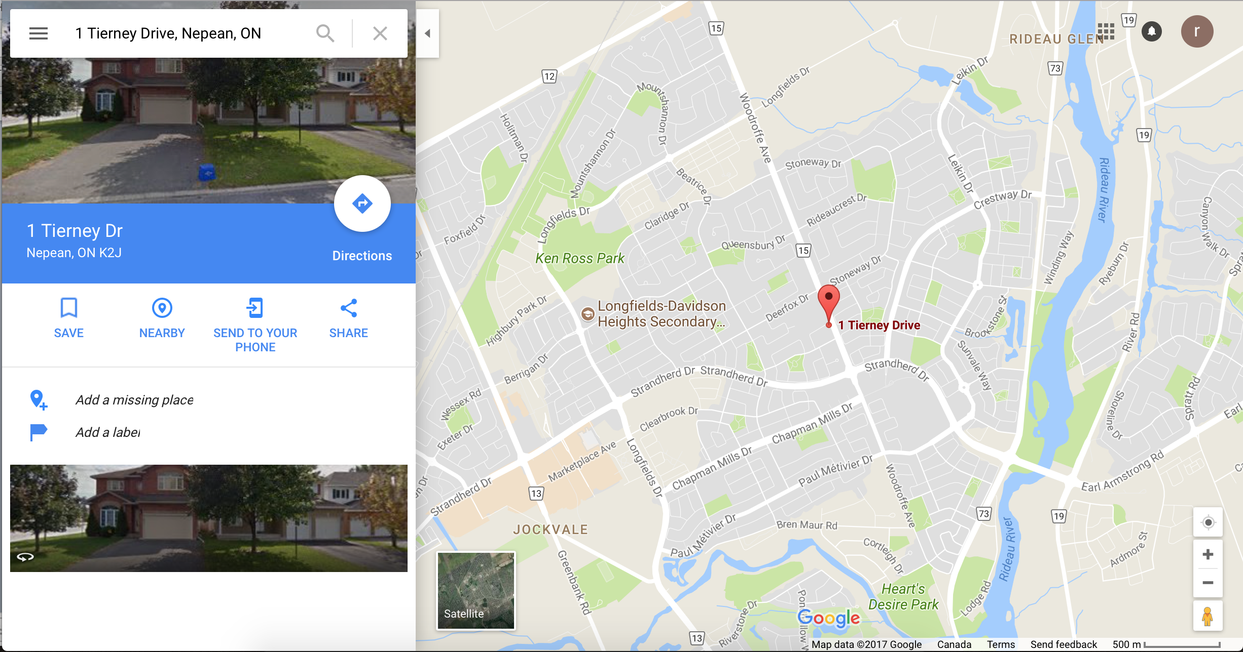
Appendix A
Figure 1. Demonstrates the individual’s central position and an area of 500 metres around the individual.

References

Halsall, T . (2017a). Intervention Theories [Slide 7] Retrieved from
https://uottawa.brightspace.com/d2l/le/content/46167/viewContent/1407615/View
Halsall, T . (2017b). Intervention Theories [Slide 23] Retrieved from
https://uottawa.brightspace.com/d2l/le/content/46167/viewContent/1383950/View
Halsall, T . (2017c). Intervention Theories [Slide 37] Retrieved from
https://uottawa.brightspace.com/d2l/le/content/46167/viewContent/1407615/View
Halsall, T . (2017d). Intervention Theories [Slide 23] Retrieved from
https://uottawa.brightspace.com/d2l/le/content/46167/viewContent/1390090/View
Halsall, T . (2017e). Intervention Theories [Slide 46] Retrieved from
https://uottawa.brightspace.com/d2l/le/content/46167/viewContent/1407615/View
Halsall, T . (2017f). Intervention Theories [Slide 39] Retrieved from
https://uottawa.brightspace.com/d2l/le/content/46167/viewContent/1426647/ViewHalsall, T . (2017g). Intervention Theories [Slide 18] Retrieved from
https://uottawa.brightspace.com/d2l/le/content/46167/viewContent/1426647/ViewHalsall, T . (2017h). Intervention Theories [Slide 28] Retrieved from
https://uottawa.brightspace.com/d2l/le/content/46167/viewContent/1383950/View
HQ, P. (2017). What is Bronfenbrenner's Ecological Systems
Theory?. Psychologynoteshq.com. Retrieved 1 November 2017, from
https://www.psychologynoteshq.com/bronfenbrenner-ecological-theory/

