QUESTION 1:

int i=0;

while(1)
{
i=i+1; printf("%d\n", i);
if (i>3)
break;
}

This code will print as following:

1
2
3
4

It gives this outcome because of the way the code is written. Integer i is made to equal zero in the beginning. Then we have a “while (1)”,which is an infinite loop, and i is made to increase by 1 everytime. Since i is equal to zero at the beginning of the program but when it enters the “while” loop, i becomes 1 because of the equality “i=i+1”, which prints 1. This loop repeats until i becomes 4, which activates the “if (i>3)” statement and the loop “breaks”(highlighted above), or ends. The reason 4 is the last value printed is because “break” statement becomes effective when i>3 not when it is >= 3.

QUESTION 2:

int i=5;

while(i)
{
i=i-1;
printf("%d\n", i);
}

This program will print as following:

4
3
2
1
0

The program gives this output because “int i” is equal to 5 in the beginning. This value is put in the “while” loop in which i is made to decrease by 1 by the equation ”i=i-1” (highlighted green above). This program will print i-1 as the first number, and go all the way down to zero. The “while” loop is not an infinite loop because there is “i” in the brackets instead of “1”, which is also why it ends at 0.

QUESTION 3 (Programming):

Step 1: Problem Identification and Definition

To develop a software that reads the color code on a resistor and calculate its resistance value.

Step 2: Gathering of Information, I/O Description

Color | 1st band | 2nd band | 3rd band(M,multiplier | 4th band (T,tolerance)
Black | 0 | 0 | x 1
Brown | 1 | 1 | x 10
Red | 2 | 2 | x 10^2
Orange | 3 | 3 | x 10^3
Yellow | 4 | 4 | x 10^4
Green | 5 | 5 | x 10^5
Blue | 6 | 6 | x 10^6
Violet | 7 | 7 | x 10^7
Gray | 8 | 8 | x 10^8
White | 9 | 9 | x 10^9
Gold |  |  | x 10^-1 | +-5%
Silver |  |  | x 10^-2 | +-10%

I/O Description:

PROGRAM

Band colors in Resistance Value
order

Step 3: Algorithm Development and Verification
BEGIN
CALCULATE RESISTANCE
READ BAND 4 COLOR
READ BAND 3 COLOR
READ BAND 2 COLOR
READ BAND 1 COLOR

DISPLAY RESISTANCE ALONG WITH TOLERANCE VALUE

END

Test Cases:

 | Test Case 1 | Test Case 2 | Test Case 3
Band 1 | Violet | Orange | White
Band 2 | Violet | Blue | Gray
Band 3 | Yellow | Orange | Red
Band 4 | Silver | Gold | Silver
Resistance along with Tolerance value | 770 +-77 Kilo Ohms | 36+-1.80 Kilo Ohms | 9.80+-0.98 Kilo Ohms

Implementation in C:

See attached file.

Step 6: Verification

Test Case 1:

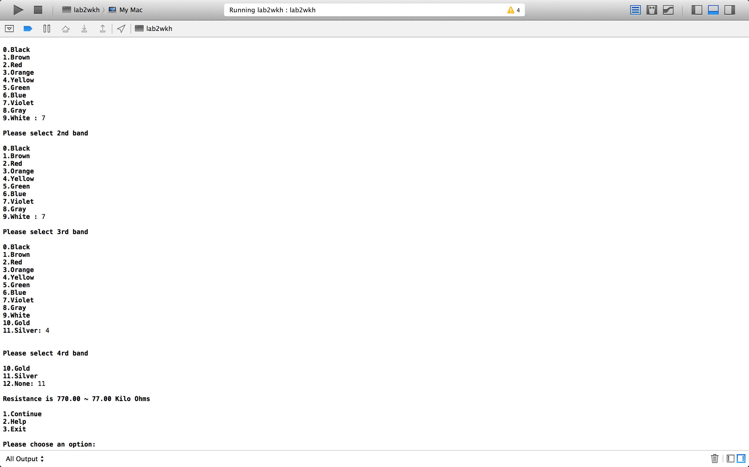

Test Case 2:

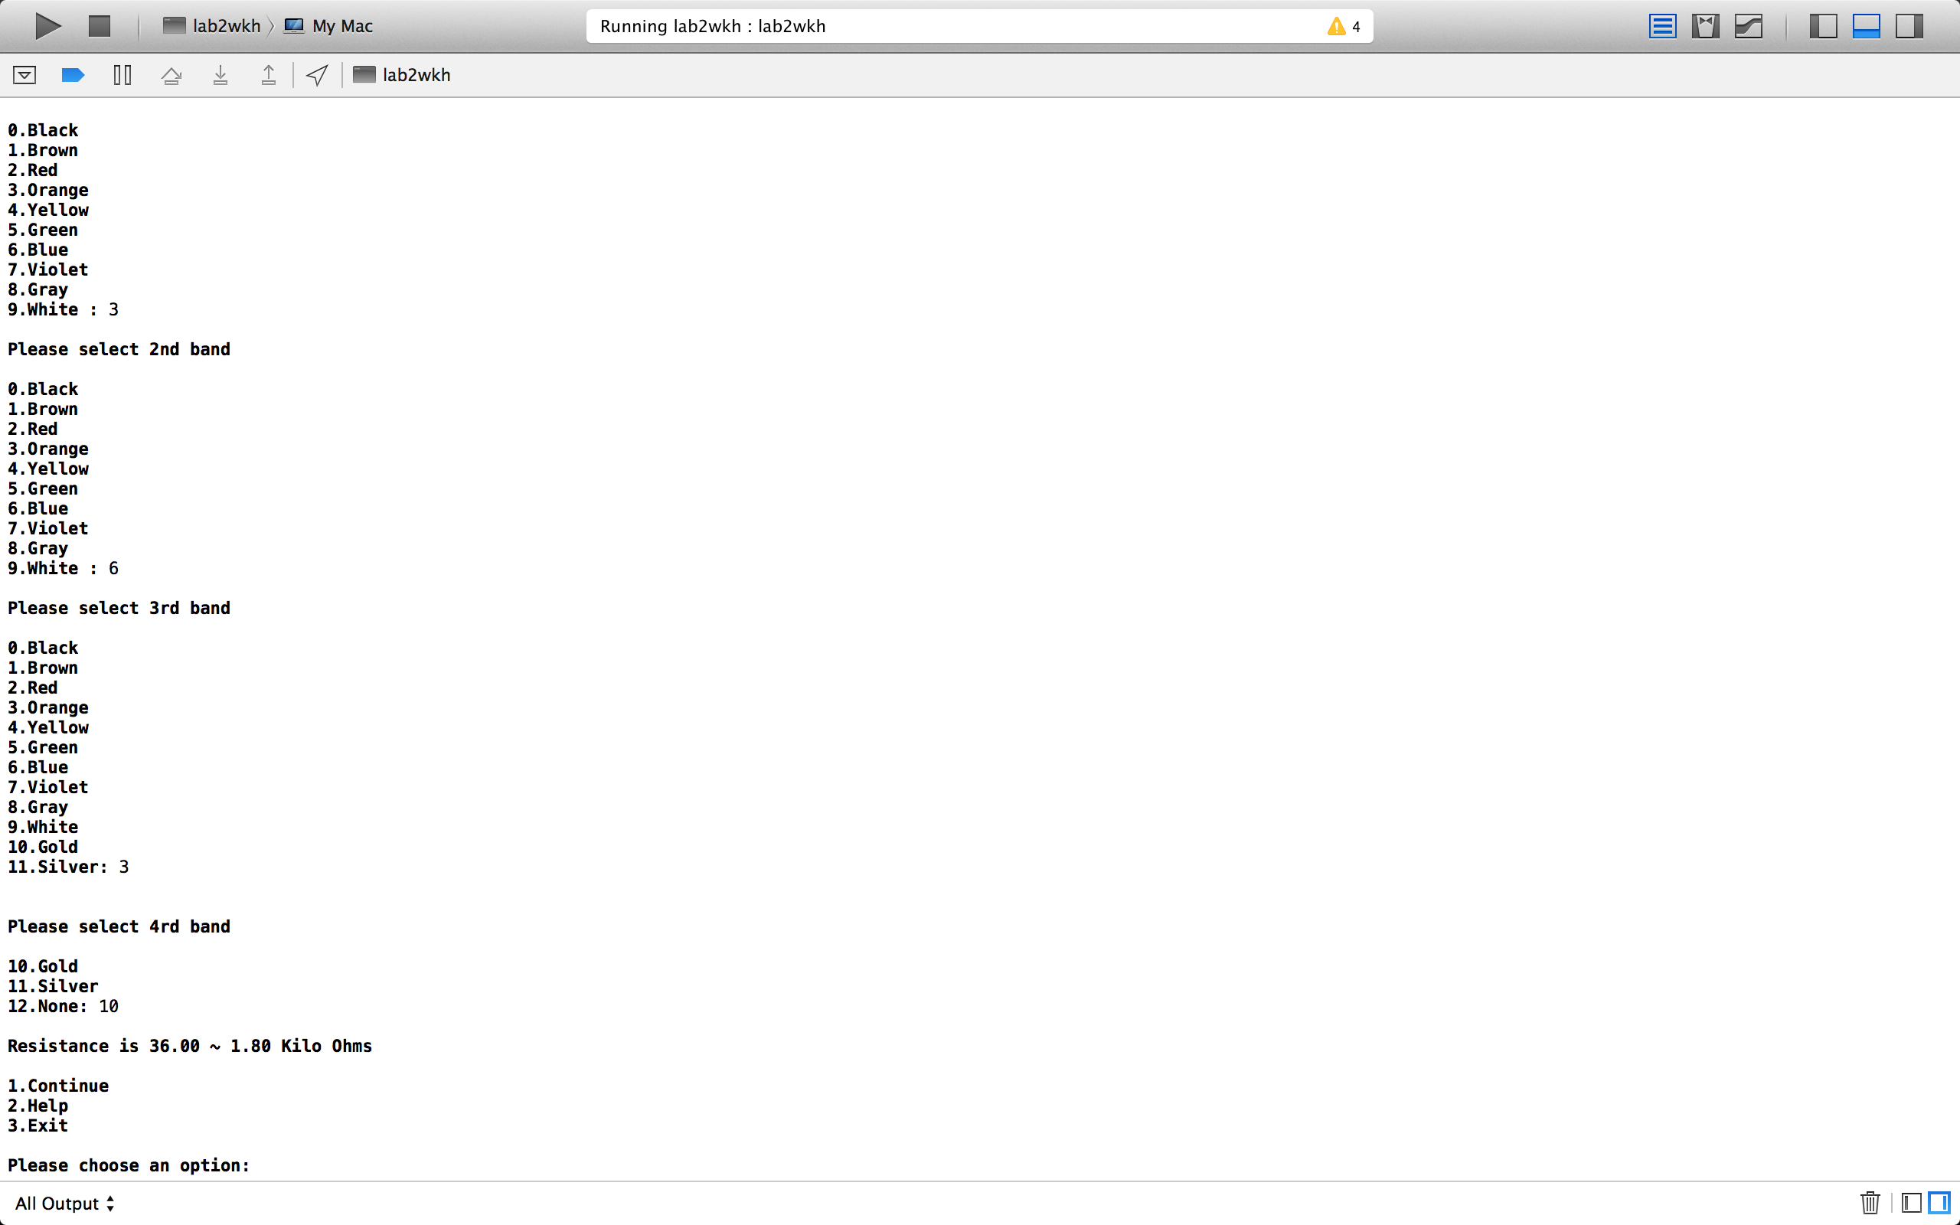

Test Case 3:



