Experiment 1: Validation of Boyle’s Law

Theory:

In this experiment we attempted to validate Boyle’s Law. Boyle’s Law can be defined as an inverse relationship between volume and pressure. When the volume of a gas in a confined space is changed, the pressure inside the jar will either increase or decrease; however Boyle came to the conclusion that the temperature of the gas must be constant. This relation can be expressed as PV=k, k being the constant. Based on Robert Boyle’s discovery and other scientists, the volume of any gas will always have a relationship with temperature but will also be inversely related to the pressure of the gas. Thus, they were able to create the ideal gas law: PV=nRT, where a gas has molecules that have no forces between them and they do not interact. However, in real life gases do not behave ideally. Non-ideal gases have intermolecular forces between them and they also carry volume. In consequent to this scientist Johannes van der Waals created a formula that was non-ideal gases: $p=\frac{nRT}{V-nb}-a\left(\frac{n^{2}}{v^{2} }\right)$ , in this equation b is to correct the molecular size and a is to correct the intermolecular forces. In this experiment we measured the relationship between volume and pressure. Boyle indicates that if you increase or decrease the volume of a confined gas, the pressure should do the opposite of the volume. Therefore in order to validate this experiment we had to identify volume as the independent variable, in which we manipulated and recorded its volume each time it was manipulated. We also had to identify pressure as the dependant variable, in which we recorded how it increased or decreased based on the manipulation of the volume of the confined gas.
ents/85abf193-2bd2-4908-8563-90b8a7ac8df6@
Procedure:

As described in the lab manual (Dr. Rashmi Venkateswaran, “What in the World ISN’T Chemistry”,Experiment 1, (2017)).

Safety
- In this lab, although no chemical operation is performed, eye protection is required at all times.
- Don’t distract others during the procedure time. Stay attentive to your partner and your observations.

In this experiment Boyle’s Law: $PV=k$ will be used and rearranged in order to isolate k. K needs to be the slope, this $V=k\frac{1}{P}$
In terms of increments we’ll commence the experiment at 5 mL and increase in increments of 2 mL.

Tables:

Table #1
Observed Results of how Pressure Varies When Manipulating the Volume of Air within a Syringe

Independent Variable: Volume (mL) | Dependent Variable: Pressure (kPa)  Trial 1 Trial 2 Trial 3
5.8 | 100.82 | 101.81 | 93.66
7.8 | 86.88 | 71.21 | 69.78
9.8 | 58.98 | 56.79 | 56.45
11.8 | 47.86 | 47.29 | 47.04
13.8 | 42.00 | 40.30 | 40.55
15.8 | 36.78 | 35.30 | 35.32
5.8 | 101.65 | 96.20 | 96.95
Derived Quantity: k (slope) | 0.0018228 | 0.001834 | 0.0017789

In trial 1, we decided that the second observed value for pressure, corresponding to the initial volume would be a more accurate volume. This is because by this time in the experiment the machine was more warmed up than when the initial pressure was observed. Therefore, it gave a more accurate result.
For trials 2 and 3, we strategically removed the pressure values of the initial volume of 5.8 mL that had a larger numeric gap from out first accepted pressure of 101.65 kPa.

Observations:
- Our starting volume for this trial was at 5 mL and we increased the volume by increments of 2 mL
- Each time we increased the volume by two increments the pressure began to decrease. However what we observed is that going from 5 mL of air to 7 mL of air, the pressure decreased significantly, ranging from 30-14 kPa.
- Each time we increased the volume of the air by two increments we noticed that the pressure would never have an exact value, it would always fluctuate between values
- Based on the results of our data , we observed that although we increased the volume with a constant value, the pressure never decreased at a constant value
- We also observed that in order to keep the plunger at a certain increment we would have to hold the syringe very firmly or else it would return to the original increment

Discussion:
In our lab, we attempted to validate Boyle’s Law by trapping air in a syringe and manipulated its volume and measured the pressure of the air each time we manipulated the volume. As stated in the observations we realized that as we increased the volume of the air, the pressure began to decrease. Ergo, based upon that observation we validated Boyle’s Law because it states that volume and pressure have an inverse relationship and that was proven in our experiment. However, we realized in each trial that our constants were all very similar numbers. Since the procedure during each trial was identical. The reason for this similarity may be due to the fact that together pressure and volume create a constant . The reason why all 3 trials had similar k values and not the exact same values is because air is not an ideal gas. Meaning that although the law says that pressure multiplied by volume should always give the same constant that is incorrect because based on the data, it's clear that the pressure did not decrease at a constant rate. Factors that could have affected this may have been temperature. We did not record the temperature of the air, meaning the change in temperature was unknown throughout the experiment. In terms of all other possible errors during the experiment, they would be quantitative. When changing the volume of the syringe, the pressure made it difficult to properly stabilize the syringe at the exact volume wanted. Also, the constant fluctuation of the pressure made it difficult to manually input the pressure since stabilization was rare. These two examples would classify as human error.

- Human error - fluctuation of pressure having to input manually

Graphs:

Trial #1: Data did not save for trial one, therefore we have no table

Trial #2
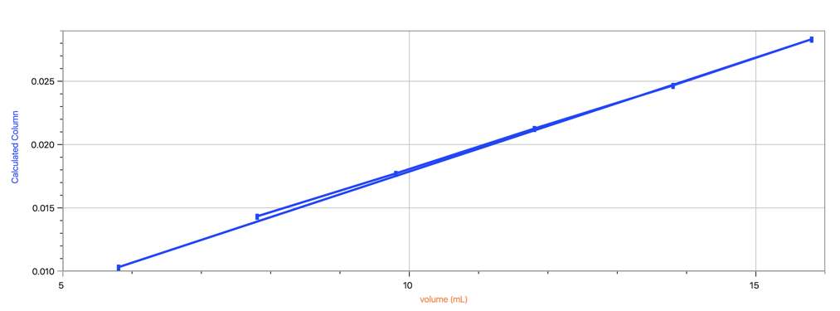

Trial #3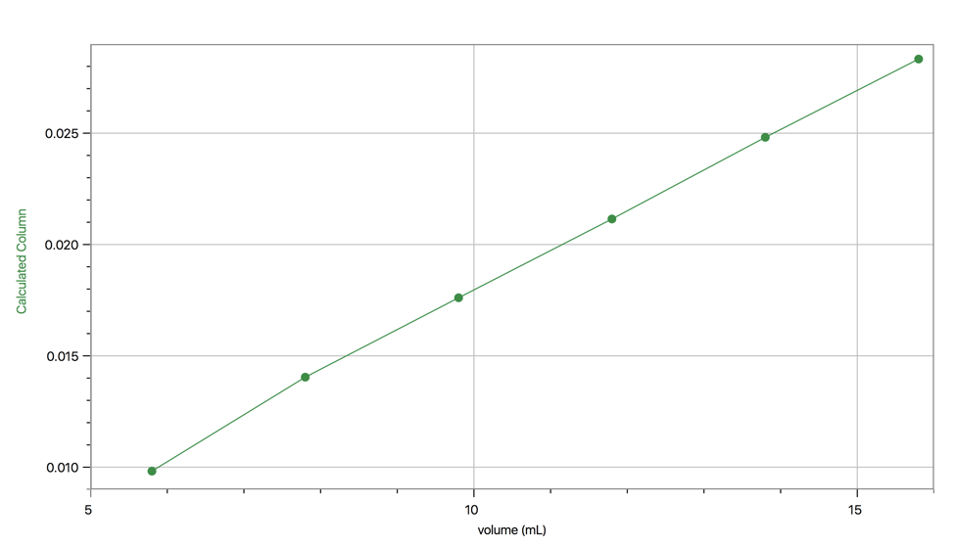

Calculations:
$$PV=k$$
$V=k\frac{1}{P}$

The value of k was given to us by LabQuest 2 in the form of slope in the equation $y=mx+b$. In trial one the slope given was 0.0018228, as shown in Table 1.

Conclusion:
Based on the data we collected, our observations, and also what was discussed one can conclude than Boyle’s Law was validated in this experiment. However one can also conclude that gases in real life do not behave ideally based on the errors that were present during this experiment. Based upon the data we collected one can conclude that volume and pressure have inverse relationship.

Sources Used:

John A. Olmsted, Gregory M. Williams, and Robert C. Burk, “Chemistry, 3rd Canadian Edition”, Chapter 2, Wiley, p 64-65, 93-94, 2016.

Dr. Rashmi Vankateswaran , “ ‘Do I Dare Disturb The Universe?’ (T. S. Eliot) Verification Of Boyle’s Law”, Experiment 1, p 2-5, 2017.

Rice University OpenStax, Chemistry. OpenStax CNX. 2016 http://cnx.org/contents/85abf193-2bd2-4908-8563-90b8a7ac8df6@9.311.

