Problem 1

- The 0.25 in the objective function refers to the selling price for each unit of product 1 (x₁). Therefore, M&C Chemicals receives 0.25 (in thousands), or $250, in each time they sell a ton of product 1.
- The product of 0.30 and the x₂ in the objective function refers to the total amount that M&C Chemicals will receive for each ton sold for product 2 (x₂). The 0.3 is the selling price of product 2, in thousands. Therefore, if M&C Chemicals sells 75 tons of product 2, they will receive $22,500 (0.30 * 75) * 1000.
- The 160 minutes in the first constraint refers to the maximum amount of time that process one can take.
- The 4.8 in the process 3 constraint refers to the cost of product 1, per ton, for process 3. This means that for each ton M&C Chemicals produces, they will have to pay $4.80 per ton for the third process. Therefore, once again, if M&C produces 75 tons of product one, it will cost the company $360 for process 3, for product 1.

Problem 2

Objective Function
Maximize Z = 0.25x₁ + 0.30x₂

Finding the x and y values of each constraint:
Process 1 Constraint:
3.8(0) + 0.8x₂ = 160 | 3.8x₁ + 0.8(0) = 160
0.8x₂ = 160 | 3.8x₁ = 160
x₂ = 200 | x₁ = 42.11

Process 2 Constraint:
3.25(0) + 1.75x₂ = 180 | 3.25x₁ + 1.75(0) = 180
1.75x₂ = 180 | 3.25x₁ = 180
x₂ = 102.86 | x₁ = 55.38

Process 3 Constraint:
4.8(0) + 8.0x₂ = 600 | 4.8x₁ + 8.0(0) = 600
8.0x₂ = 600 | 4.8x₁ = 600
x₂ = 75 | x₁ = 125

Product 2 Constraint 1:
x₂ = 100

Product 2 Constraint 2:
x₂ = 25

Graph the constraints and identify the feasible region:
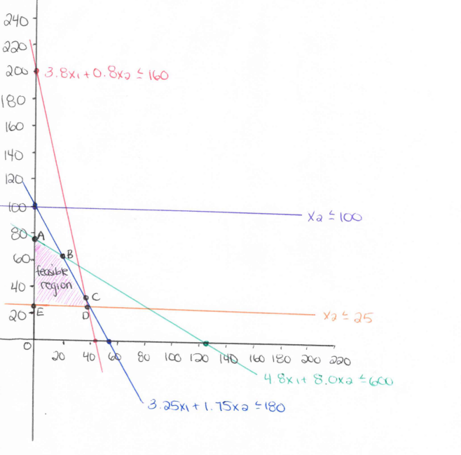

Find the corner points of the feasible region:

A: (0, 80)
B: (22.11, 61.79)
C: (33.61, 40.35)
D: (36.84, 25)
E: (0, 25)

Corner point A
Because this corner point lies on the y-axis, we know that
x = 0
And because it lies on the green line, which refers to the 4.8x₁ +8.0x₂ = 600 constraint, we know that
y = 80

Corner point B (intersection of the blue line and the green line)
1. Put into y =mx + b format  3.25x₁ + 1.75x₂ = 180  1.75x₂ = -3.25x₁ + 180  x₂ = -1.86x₁ + 102.86 | 4.8x₁ + 8.0x₂ = 600  8.0x₂ = -4.8x₁ +600  x₂ = -0.6x₁ + 75
2. Set two equations equal to each other to find the x coordinate  -1.86x₁ + 102.86 = -0.6x₁ +75  27.86 = 1.26x₁  22.11 = x₁ | 3. Plug in x coordinate to one of the equations to find y coordinate  3.25(22.11) + 1.75x₂ = 180  1.86 + 1.75x₂ =180  1.75x₂ = 108.14  x₂ = 61.79

Corner point C (intersection of the red line and the blue line)
1. Put into y =mx + b format  3.25x₁ + 1.75x₂ = 180  1.75x₂ = -3.25x₁ + 180  x₂ = -1.86x₁ + 102.86 | 3.8x₁ + 0.8x₂ = 160  0.8x₂ = -3.8x₁ +160  x₂ = -4.75x₁ + 200
2. Set two equations equal to each other to find the x coordinate  -1.86x₁ + 102.86 = -4.75x₁ + 160  97.14 = 2.89x₁  33.61 = x₁ | 3. Plug in x coordinate to one of the equations to find y coordinate  3.8(33.61) + 0.8x₂ = 160  127.72 + 0.8x₂ =160  0.8x₂ = 32.28  x₂ = 40.35

Corner point D (intersection of the orange line and the red line)
1. Put into y =mx + b format  x₂ = 25 | 3.8x₁ + 0.8x₂ = 160  0.8x₂ = -3.8x₁ +160  x₂ = -4.75x₁ + 200
2. Set two equations equal to each other to find the x coordinate  -4.75x₁ + 200 = 25  175 = -4.75x₁  36.84 = x₁ | 3. Plug in x coordinate to one of the equations to find y coordinate  x₂ = 25

Corner point E
Because this corner point lies on the y-axis, we know that:
x = 0
And because this corner point lies on the orange line, which refers to the x₂ ≤ 25, we know that:
y = 25

Find maximum by plugging in the corner points to the objective function

Corner point A  Z = 0.25x₁ + 0.30x₂  Z = 0.25(0) + 0.30(80)  Z = 24 | Corner point B  Z = 0.25x₁ + 0.30x₂  Z = 0.25(22.11) + 0.30(61.79)  Z = 24.06
Corner point C  Z = 0.25x₁ + 0.30x₂  Z = 0.25(33.61) + 0.30(40.35)  Z = 20.51 | Corner point D  Z = 0.25x₁ + 0.30x₂  Z = 0.25(36.84) + 0.30(25)  Z = 16.71
Corner point E
Z = 0.25x₁ + 0.30x₂
Z = 0.25(0) + 0.30(25)
Z = 7.5

The optimal solution is at the corner point B. M&C Chemicals will need to produce 22.11 (22 rounded down) of product 1, and 61.79 (61 rounded down) of product 2, to obtain the maximum amount of profit of 24.06 (in thousands).

c.

Constraint 1  3.8x₁ + 0.8x₂ ≤ 160  3.8(22.11) + 0.8(61.79) ≤160  133.45 ≤ 160  26.55 slack | Constraint 2  3.25x₁ + 1.75x₂ ≤ 180  3.25(22.11) + 1.75(61.79) ≤180  180 = 180  No slack | Constraint 3  4.8x₁ + 8x₂ ≤ 600  4.8(22.11) + 8(61.79) ≤ 600  600 = 600  No slack

d.

A redundant constraint is a constraint that can be omitted from a system of linear constraints without changing the feasible region. In this case, the 4th constraint, (x₂ ≤ 100) is a redundant constraint. As you can see on the graph above, this constraint is the purple line, which does not affect the feasible region in any way. In other words, you could remove this constraint from the system and the feasible region would remain the same.

Problem 3

Formulation 1

Objective Function
Maximize: 4x + 3y

Find the x and y values of each constraint

Constraint 1  x ≥ 3  x = 3  no y-value  (parallel to the y axis at x=3) | Constraint 2  2x + 2y ≥ 12  2(0) + 2y = 12  2y = 12  y = 6  2x +2(0) = 12  2x = 12  x = 6 | Constraint 3  y ≥ 5  y = 5  no x-value  (parallel to the x axis at y=5)
Graph the constraints

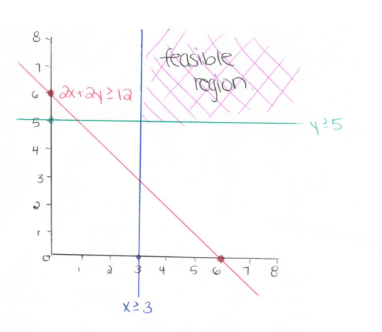

As you can see from the graph above, this linear system has an unbounded solution. This means that the values of the variables may increase indefinitely without violating any of the constraints. The feasible region in this linear system will continue indefinitely.

Formulation 2

Objective Function
Maximize 4x + 4y

Find the x and y values of the constraints

Constraint 1  3x ≤ 10  3x = 10  x = 3.33  no y-value  (parallel to the y-axis at x=3.33) | Constraint 2  x + y ≤ 5  (0) + y = 5  y = 5  x + (0) = 5  x = 5 | Constraint 3  5y ≤ 7  5y = 7  y = 1.4  no x-value  (parallel to the x-axis at y=1.4) | Constraint 4  x ≥ 6  x = 6  no y-value  (parallel to the y-axis at x=6)

Graph the constraints

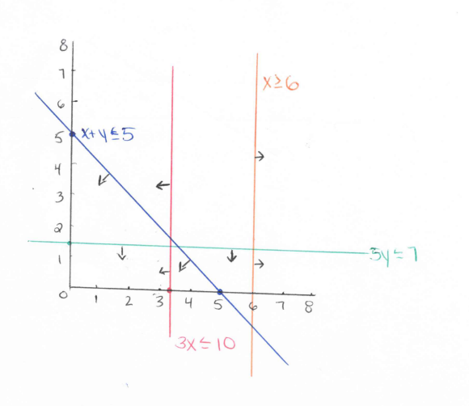
This formulation has an infeasible solution. This means that there is no solution that satisfies all of the constraints. The arrows pointing from each line constraint represents the direction that the solution would have to be to satisfy each constraint. In this case, the constraint x ≥ 6 causes the infeasibility for this system.

Formulation 3

Objective Function
Maximize 4x +3y

Find the x and y values of each constraint

Constraint 1  2x + 3y ≤ 20  2(0) +3y = 20  3y = 20  y = 6.67  2x + 3(0) = 20  2x = 20  x = 10 | Constraint 2  2x + y ≤ 8  2(0) + y = 8  y =8  2x + (0) = 8  2x = 8  x = 4 | Constraint 3  x ≥ 1.5  x = 1.5  no y-value  (parallel to the y-axis at x = 1.5) | Constraint 4  y ≥ 1  y = 1  no x-value  (parallel to the x-axis at y = 1)

Graph the constraints

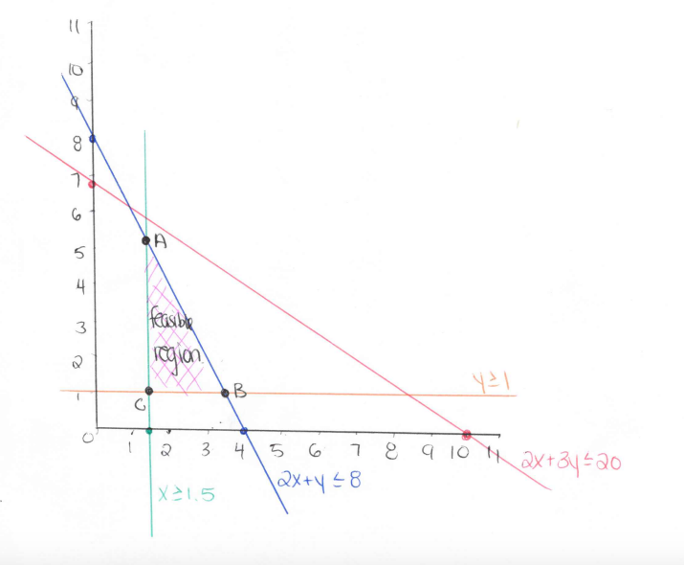

Find the corner points of the feasible region

A: (1.5, 5)
B: (3.5, 1)
C: (1.5, 1)

Corner point A (intersection of the blue line and the green line)
We already know the x value: (because of the x ≥ 1.5 constraint)
x = 1.5

Plug in the x-value into the other equation to find the y-value
2x + y = 8
2(1.5) + y = 8
3 + y = 8
y = 5

Corner point B (intersection of the green line and the orange line)
We already know the y-value: (because of the y ≥ 1 constraint)
y = 1

Plug in the y-value into the other equation to find the x-value
2x + y = 8
2x + 1 =8
2x = 7
x = 3.5

Corner point C (intersection of the green line and the orange line)
We already both the x and y-values of this line because of the third and fourth constraints
x = 1.5
y = 1

Find the Maximum by plugging the corner points into the objective function

Corner point A (1.5, 5)  Z = 4x + 3y  Z = 4(1.5) + 3(5)  Z = 21 | Corner point B (3.5, 1)  Z = 4x + 3y  Z = 4(3.5) + 3(1)  Z = 17 | Corner point C (1.5, 1)  Z = 4x + 3y  Z = 4(1.5) + 3(1)  Z = 9
As you can see, this formulation has one unique optimal solution at the corner point A (1.5, 5) which produces a maximum of 21.

Formulation 4

Objective Function
Maximize 6x + 8y

Find the x and y values of each constraint

Constraint 1  2x ≤ 8  2x = 8  x = 4  no y-value  (parallel to the y-axis at x=4) | Constraint 2  3x + 4y ≤ 16  3(0) +4y = 16  4y = 16  y = 4  3x + 4(0) = 16  3x = 16  x = 5.33 | Constraint 3  4y ≤ 12  4y = 12  y = 3  no x-value  (parallel to the x-axis at y=3)

Graph the constraints

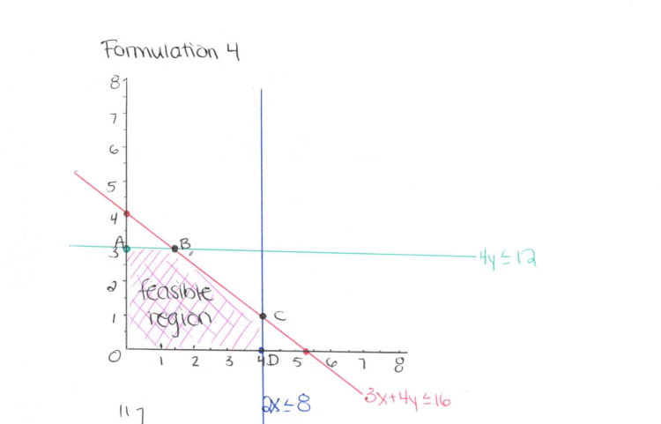

Find the corner points of the feasible region

A: (0, 3)
B: (1.33, 3)
C: (4, 1)
D: (4, 0)

Corner point A:
This corner point lays on the y axis, therefore we know that:
x = 0
And because it involves the green line, which refers to the 4y ≤ 12 constraint, we know that:
y = 3

Corner point B: (intersection of the green line and the red line)
1. Put into y =mx + b format  4y =12  y = 3 | 3x + 4y = 16  4y = -3x +16  y = -0.75x + 4
2. Set two equations equal to each other to find the x coordinate  3= -0.75x + 4  0.75x = 1  1.33 = x | 3. Plug in x coordinate to one of the equations to find y coordinate  4y = 12  y = 3
Corner point C (intersection of the blue line and the red line)
1. Put into y =mx + b format  2x = 8  x = 4 | 3x + 4y = 16  4y = -3x +16  y = -0.75x + 4
2. Set two equations equal to each other to find the x coordinate  We already know the x-coordinate is  x = 4 | 3. Plug in x coordinate to one of the equations to find y coordinate  3(4) + 4y = 16  12 + 4y = 16  4y = 4  y =1
Corner point D
Because this corner point lies on the x-axis, we know that:
y = 0
And because it lies on the blue line, which refers to the 2x ≤ 8 constraint, we know that:
x = 4

Find the maximum (optimal solution) by plugging in the corner points to the objective function

Corner point A (0, 3)  Z = 6x + 8y  Z = 6(0) + 8(3)  Z = 24 | Corner point B (1.33, 3)  Z= 6x + 8y  Z= 6(1.33) + 8(3)  Z = 32
Corner point C (4, 1)  Z = 6x + 8y  Z = 6(4) + 8(1)  Z = 32 | Corner point D (4, 0)  Z = 6x + 8y  Z = 6(4) + 8(0)  Z = 24

As you can see, this formulation has more than one optimal solution. The corner points B and C both produce a maximum value of 32.

Problem 4

a.
Decision Variables
Let:
X₁ = the number of laptops to produce
X₂ = the number of desktops to produce
X₃ = the number of commercial servers to produce

Objective Function
Maximize: 500x₁ + 400x₂ + 650x₃

Constraints

- Cannot produce more than $70,000 worth of products | 400x₁ + 350x₂ + 500 x₃ ≤ 70,000
2. Must produce at least 20 laptops | X₁ ≥ 20
3. Must produce at least 20 desktops | X₂ ≥ 20
4. Must produce at least 20 commercial servers | X₃ ≥ 20
5. No more than 25 commercial severs can be produced | X₃ ≤ 25
6. No more than 40 desktops can be produced | X₂ ≤ 40
7. Must produce at least twice as many laptops than desktops and commercial servers combined | -X₁ + 2x₂ + 2x₃ ≥ 0

b.

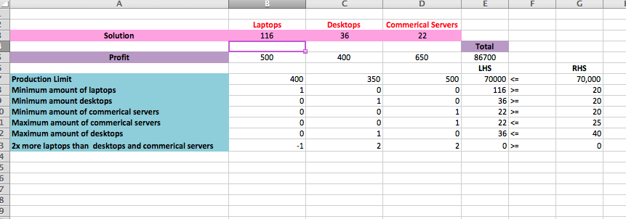

In order to maximize the profit, and meet all constraints, the manufacturing firm should produce 116 laptops, 36 desktops and 22 commercial servers, to obtain a profit of $86,700.

c.

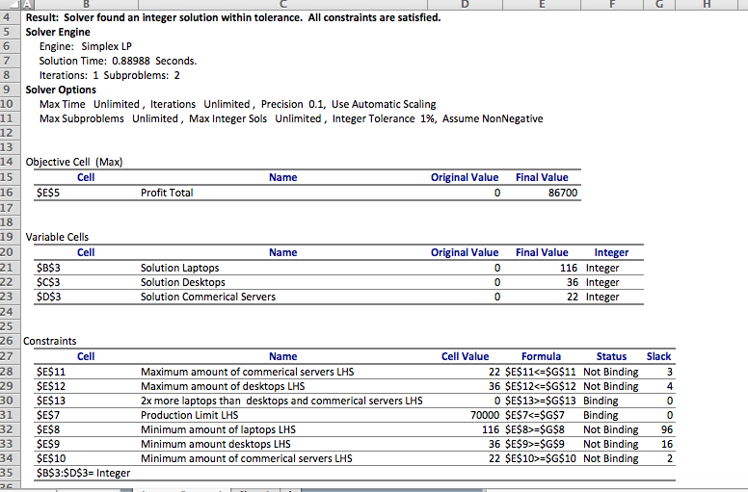

There is no slack for the production limit constraint. The manufacturing firm has a production budget of $70,000 and in order to maximize their profits; they must use all of the money to produce 116 laptops, 36 desktops and 22 commercial servers.

