ECO1104 final exam preparation

Chapter 13

Key terms:
Total revenue: the amount paid by buyers and received by sellers of a good, computed as the price of the good times the quantity sold
Total cost: the market value of the inputs a firm uses in production
Profit: total revenue minus total cost
Implicit costs: input costs that do not require an outlay of money by the firm
Explicit costs: input costs that require an outlay of money by the firm
Economic profit: total revenue minus total cost, including both explicit and implicit costs
Accounting profit: total revenue minus total explicit cost
Variable costs: costs that vary with quantity of output produced
Fixed costs: costs that do not vary with the quantity of output produced
Average variable cost: variable costs divided by the quantity of output
Average fixed cost: total cost divided by the quantity of output
Average total cost: fixed costs divided by the quantity of output
Marginal cost: the increase in total cost that arises from an extra unit of production
Economies of scale: the property whereby long-run average total cost falls as the quantity of output increases
Diseconomies of scale: the property whereby long-run average total cost rises as the quantity of output increases
Constant returns to scale: the property whereby long-run average total cost stays the same as the quantity of output changes
Efficient scale: the quantity of output that minimizes average total cost
Marginal product: the increase in output that arises from an additional unit of input
Diminishing marginal product: the property whereby the marginal product of an input declines as the quantity of the input increases
Production function: the relationship between the quantity of inputs used to make a good and the quantity of outputs of that good

Total revenue, total cost, and profit
- The goal of the firm is to maximize profit
- Total revenue is the amount that the firm receives for the sale of its output
- Total cost is the amount the firm pays for inputs (inputs might be ingredients, workers, etc.)
- Any revenue not needed to cover costs is profit (a.k.a. producer surplus), which is computed as total revenue minus total cost

Implicit and explicit costs
- Implicit costs can be thought of as opportunity costs (all the things that must be given up to do something)
- For instance, if the owner of a firm can make money doing another job, that lost income would be an implicit cost
- Another important implicit cost is the opportunity cost of the financial capital invested in the business; that money could have made interest in a bank account, so that is considered lost income
- Explicit costs are “real” costs, those that require payment (such as ingredients, rent, etc.)

Economic and accounting profit
- Economists include implicit costs in total cost calculations, while accountants don’t (this is the difference between economic and accounting profit)
- Because of this, accounting profit is often larger than economic profit
- For a business to be profitable from an economist’s standpoint, total revenue must cover all the opportunity costs, both explicit and implicit
- A firm making positive economic profit will stay in business
- When a firm is making economic losses (that is, when economic profits are negative), the business owners are failing to make enough to cover all the costs of production
- A business with negative economic profits will eventually shut down and exit the market

Short term costs
- Firms incur costs when they buy inputs to produce the goods and services that they plan to sell
- When considering a firm’s short term costs, we make the assumption that the size of a business owner’s factory is fixed and that they can vary the quantity of cookies produced only by changing the number of workers she employs
- This assumption is realistic in the short run, but not in the long run because a business owner cannot build a larger factory overnight, but she can do so over the next year or two

Production function and marginal product
- The relationship between the quantity of inputs and quantity of output is called the production function
- As the number of workers increases, the marginal product declines, and the production function becomes flatter
- Diminishing marginal product reflects the problems that arise with additional employees
- Since the size of the factory can’t be increased in the short run, the factory becomes crowded, making it harder and less efficient for employees to produce a good or service
- In tables, the marginal product is shown halfway between two rows because it represents the change in output as the number of workers increases from one level to another

Total cost curve
- Total cost is fixed costs plus variable costs (all, or total, cost)
- A total-cost curve shows the relationship between the quantity of output produced and total cost of production
- The total-cost curve gets steeper as the quantity of output increases because of diminishing marginal product
- When the factory is crowded, producing an additional unit requires a lot of additional labour and is thus very costly
- Therefore, when the quantity produced is large, the total-cost curve is relatively steep

The table below shows multiple values related to production. Using these variables, the graphs below graph both the production function and the total cost curve.

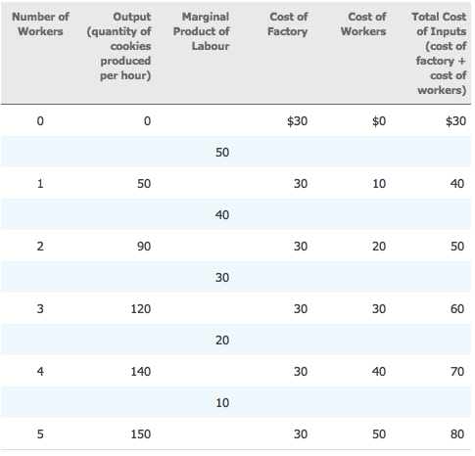

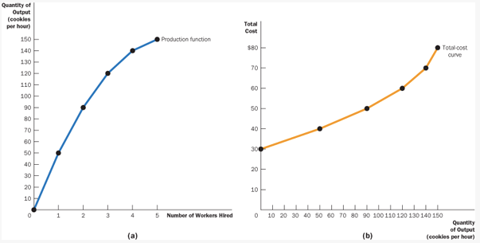

The total cost curve is particularly important, as, from data on a firm’s total cost, we can derive several related measures of cost.

Related measures of cost
- Fixed cost
- Variable cost
- Average fixed cost
- Average variable cost
- Average total cost
- Marginal cost

Using the table below, we will explain all of these measures.

- Fixed cost (red circle shows variables important for finding it): the total cost when quantity produced is zero (because fixed costs do not vary with quantity produced); remains constant
- Variable cost (blue circle): only applies when quantity produced is greater than zero (becuase variable costs do vary with quantity produced); computed as total cost minus fixed cost
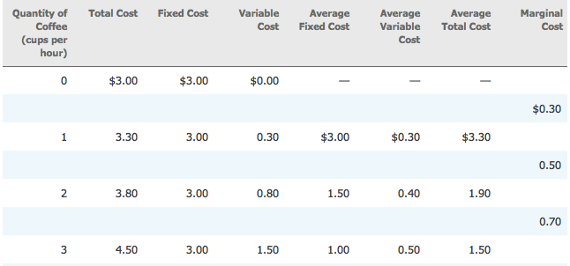
- Average fixed cost (green circle): the fixed cost per unit, which also only applies when quantity produced is greater than zero; computed as fixed cost divided by quantity produced
- Average variable cost (purple circle): the variable cost per unit, which also only applies when quantity produced is greater than zero; computed as variable cost divided by quantity produced
- Average total cost (yellow circle): the average total cost per unit, which also only applies when quantity produced is greater than zero; can be computed as total cost divided by quantity produced, or average fixed cost plus average variable cost
- Marginal cost (pink circle): the additional cost that arises from an additional unit of production; computed as the difference between the total cost for two quantity produced numbers (also computed as change in total cost divided by change in quantity, but when looking at a change in quantity of 1, as above, it’s just change in total cost)

Shapes of cost curves (IMPORTANT)
- Marginal cost rises with the quantity of output; it is often a straight upward line, looking like the supply curve (more on this later)
- Average fixed cost declines with the quantity of output
- Average variable cost usually rises with the quantity of output; it is also straight line up, but is always below the marginal cost curve
- The average-total-cost curve is U-shaped
  - This is because average total cost is the sum of average fixed cost and average variable costs; the tug of war between average fixed cost and average variable costs (one’s high, the other one is low) leads to the U-shape
  - The bottom of the U is the quantity that minimized average total cost and is the efficient scale of the firm
- The marginal-cost curve crosses the average-total-cost curve at its minimum
  - Whenever marginal cost is less than average total cost, average total cost is falling
  - Whenever marginal cost is greater than average total cost, average total cost is rising

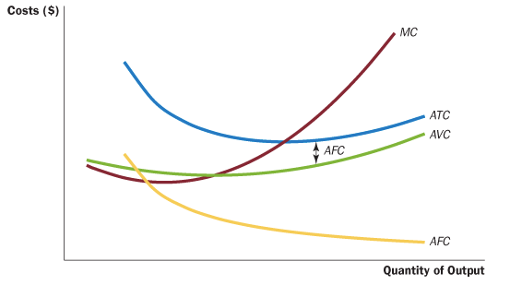
All the curves together for the typical firm:
As you can see here, marginal cost (MC) and average variable cost (AVC) briefly dip before rising. In the case of marginal cost, this is because additional workers (costs) initially work better as a team; as more workers are added to increase quantity of output, the workplace becomes too busy, and these brief gains are negated. In the case of average variable cost, recall that AVC is variable cost divided by quantity of output; that initial division is enough to “reduce” average variable costs, but they soon go back up.

Long run average total cost
- Because many decisions are fixed in the short run but variable in the long run, a firm’s long-run cost curves differ from its short-run cost curves
- For instance, a firm cannot adjust the size or number of its factories in the short run (leases are for a specific period of time and you can’t get out of them early; additionally, additional factories take time to build), but it can in the long run (leases run out, factories are built eventually)
- Therefore, the cost of factories is fixed in the short run, but variable in the long run
- As the firm moves along the long-run curve, it is adjusting the size of the factory to the quantity of production
- The long-run average-total-cost curve is a much flatter U-shape than the short-run average-total-cost curve
- In addition, all the short-run curves lie on or above the long-run curve
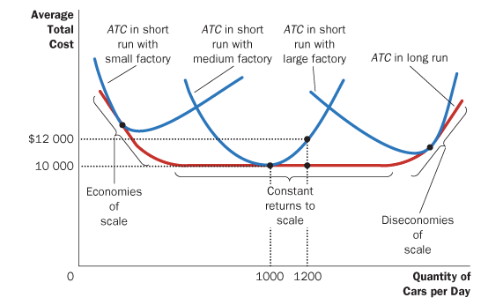
- These properties arise because firms have greater flexibility in the long run; in the long run, a firm can choose the short-run curve it wants to use

Economies and diseconomies of scale
- As shown in the graph above
- When long-run average total cost declines as output increases, there are said to be economies of scale
- When long-run average total cost rises as output increases, there are said to be diseconomies of scale
- When long-run average total cost does not vary with the level of output, there are said to be constant returns to scale
- Economies of scale often arise because higher production levels allow specialization among workers, which permits each worker to become better at a specific task
- Diseconomies of scale can arise because of coordination problems that are inherent in any large organization; the more units produced, the more stretched the management team becomes, and the less effective the managers become at keeping costs down

Chapter 13 Practice Questions
1. Raj opens up a lemonade stand for two hours. He spends $10 for ingredients and sells $60 worth of lemonade. In the same two hours, he could have mowed his neighbour’s lawn for $40. Raj has an accounting profit of ______ and an economic profit of ______.
a. $50, $10
b. $90, $50
c. $10, $50
d. $50, $90

2. Diminishing marginal product explains why, as a firm’s output increases, which of the following is likely to occur?
a. the production function and total-cost curve both get steeper
b. the production function and total-cost curve both get flatter
c. the production function gets steeper, while the total-cost curve gets flatter
d. the production function gets flatter, while the total-cost curve gets steeper

3. A firm is producing 1000 units at a total cost of $5000. If it were to increase production to 1001 units, its total cost would rise to $5008. What does this information tell you about the firm?
a. Marginal cost is $5, and average variable cost is $8.
b. Marginal cost is $8, and average variable cost is $5.
c. Marginal cost is $5, and average total cost is $8.
d. Marginal cost is $8, and average total cost is $5.

4. A firm is producing 20 units with an average total cost of $25 and marginal cost of $15. If it were to increase production to 21 units, which of the following must occur?
a. Marginal cost would decrease.
b. Marginal cost would increase.
c. Average total cost would decrease.
d. Average total cost would increase.

5. The government imposes a $1000-per-year licence fee on all pizza restaurants. Which cost curves shift as a result?
a. average total cost and marginal cost
b. average total cost and average fixed cost
c. average variable cost and marginal cost
d. average variable cost and average fixed cost

6. If a higher level of production allows workers to specialize in particular tasks, a firm will likely exhibit ______ of scale and _______ average total cost.
a. economies, falling
b. economies, rising
c. diseconomies, falling
d. diseconomies, rising

Answers:
1. a
2. d
3. d
4. c
5. b
6. a

Chapter 14

Sunk cost: a cost that has already been committed and cannot be recovered
Marginal revenue: the change in total revenue from an additional unit sold
Average revenue: total revenue divided by quantity sold
Competitive market: a market in which there are many buyers and many sellers so that each has a negligible impact on the market price

Competitive market
- A competitive market, sometimes called a perfectly competitive market, has three characteristics:
  - 1. There are many buyers and many sellers in the market.
  - 2. The goods offered by the various sellers are largely the same.
  - 3. Firms can freely enter or exit the market.
- Because each seller can sell all he wants to at the going price, he has little reason to charge less, and if he charges more, buyers will go elsewhere
- Buyers and sellers in competitive markets must accept the price the market determines and, therefore, are said to be price takers
- A firm in a competitive market, like most other firms in the economy, tries to maximize profit, which equals total revenue minus total cost
- Total revenue is proportional to the amount of output because the price doesn’t change (competitive firms don’t have the market power to change the price and are price takers)
- For all firms, average revenue equals the price of the good
- For competitive firms, marginal revenue equals the price of the good

Profit maximization
- For a competitive firm, profit is maximized when marginal revenue (average revenue, price) = marginal cost
- If marginal revenue is less than marginal cost, the competitive firm should decrease production
- If marginal revenue is more than marginal cost, the competitive firm should increase production
- For a competitive firm, the firm’s price equals both its average revenue (AR) and its marginal revenue (MR)
- Because the firm’s marginal-cost curve determines the quantity of the good the firm is willing to supply at any price, it is the competitive firm’s supply curve
- In the short run, the competitive firm’s supply curve is its marginal-cost curve (MC) above average variable cost (AVC)

Shutting down and exiting
- A shutdown refers to a short-run decision not to produce anything during a specific period of time because of current market conditions
- Exit refers to a long-run decision to leave the market
- The short-run and long-run decisions differ because most firms cannot avoid their fixed costs in the short run but can do so in the long run
- That is, a firm that shuts down temporarily still has to pay its fixed costs, whereas a firm that exits the market does not have to pay any costs at all, fixed or variable
- The firm shuts down if the revenue that it would earn from producing is less than its variable costs of production
- The firm shuts down if TR < VC, or if P < AVC
- The price that coincides with the minimum point on the average-variable-cost curve is sometimes referred to as the shutdown price

Sunk costs
- A cost is a sunk cost when it has already been committed and cannot be recovered
- Regardless of the quantity of output supplied (even if it is zero), the firm still has to pay its fixed costs
- Therefore, the firm’s fixed costs are sunk in the short run, and the firm can safely ignore these costs when deciding how much to produce

Long run decisions to enter or exit a market
- The firm exits the market if the revenue it would get from producing is less than its total costs
- The firm exits if TC > TR, or if ATC > P
- A firm will enter a market if it is profitable, or if TR > TC (ATC < P)
- The competitive firm’s long-run supply curve is the portion of its marginal-cost curve that lies above average total cost

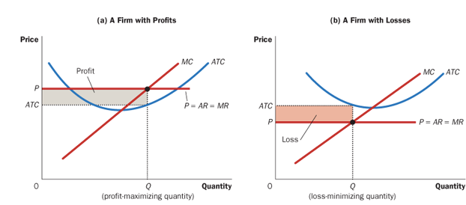
Measuring profit on a graph
- As shown above, a firm’s profit is measured by (P-ATC) multiplied by Q
- A firm’s losses are measured by (ATC - P) multiplied by Q
- A firm making a loss chooses to exit the market in the long run

Market supply in the short run
- In the short run, there are a fixed number of firms in the market; no firms can enter or exit
- In the short run, all a firm can do is shut down
- Remember, the supply curve in the short run is marginal cost over average variable cost
- Therefore, the supply curve for the market is simply Quantity Produced per Firm multiplied by Number of Firms

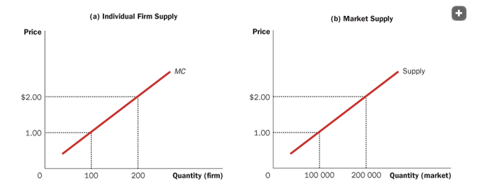
This graph shows individual firm supply and market supply if there are 1,000 firms in the market. As you can see, the quantity of the market is simply Firm Quantity multiplied by Number of Firms.

Market supply in the long run
- Market supply in the long run is more complicated, as firms can enter and exit the market in the long run
- If firms in the market are profitable, then firms may want to enter the market
- If firms in the market are making losses, those firms may want to exit the market
- The only way this process of entry and exit ends is if firms in the market make zero profit
- Recall the equation for profit: (P - ATC)(Q)
- Based on this equation, profit is only zero if price equals average total cost
- Recall also that price must equal marginal cost for a firm to produce efficiently (maximize profit)
- Therefore, marginal cost and average total cost must be equal, but this only happens when average total cost is at its minimum
- Since price must equal both marginal cost and average total cost, this means that firms can only have zero profit at their efficient scale
- The long term supply curve is a horizontal line at the price that is the minimum of average total cost
- Any price above this would cause firms to enter, and any price below this would cause firms to exit; eventually, the price settles to the minimum of average total cost, assuming all firms have the same average total cost
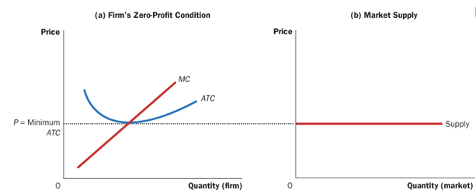
Why do firms stay in business if they’re making zero profit?
Profit is total revenue - total cost. Total cost includes wages paid to the owner of the firm, which is enough incentive for the firm to stay in business. A firm that makes zero economic profit does not actually make zero accounting profit.

Chapter 14 Practice Questions

- Which of the following occurs in the case of a perfectly competitive firm?
a. chooses its price to maximize profits
b. sets its price to undercut other firms selling similar products
c. takes its price as given by market conditions
d. picks the price that yields the largest market share
2. A competitive firm maximizes profit by choosing the quantity where which condition occurs?
a. average total cost is at its minimum
b. marginal cost equals the price
c. average total cost equals the price
d. marginal cost equals average total cost
3. A competitive firm’s short-run supply curve is its ___ cost curve above its ___ cost curve.
a. average total, marginal
b. average variable, marginal
c. marginal, average total
d. marginal, average variable
4. If a profit-maximizing, competitive firm is producing a quantity at which marginal cost is between average variable cost and average total cost, it will do which of the following?
a. keep producing in the short run but exit the market in the long run
b. shut down in the short run but return to production in the long run
c. shut down in the short run and exit the market in the long run
d. keep producing both in the short run and in the long run
5. In the long-run equilibrium of a competitive market with identical firms, what is the relationship between price P, marginal cost MC, and average total cost ATC?
  - P > MC and P > ATC.
  - P > MC and P = ATC.
  - P = MC and P > ATC.
  - P = MC and P = ATC.

Answers:
1. c
2. b
3. d
4. a
5. d

Chapter 15

Price discrimination: the business practice of selling the same good at different prices to different customers
Natural monopoly: a monopoly that arises because a single firm can supply a good or service to an entire market at a smaller cost than could two or more firms
Monopoly: a firm that is the sole seller of a product without close substitutes

Monopolies and barriers to entry
- Monopolies usually arise due to barriers to entry (there are barriers preventing other firms from entering the market)
- Barriers to entry include:
  - Monopoly resources: A key resource is owned by a single firm. In practice, this is rare.
  - Government regulation: The government gives a single firm the exclusive right to produce some good or service. For instance, the government allows inventors to patent their inventions, giving them monopoly power in the market for their invention.
  - The production process: A single firm can produce output at a lower cost than can a large number of producers. A natural monopoly arises when there are economies of scale over the relevant range of output. When a firm’s average total cost continually declines, it is an economy of scale; it also causes a natural monopoly. A natural monopoly can evolve into a competitive market as the market expands.

Monopolies are price makers, and other differences between monopolies and competitive firms
- Monopolies are price makers; as the only firm in a market, they set the price as they would like
- A competitive firm is a price taker, as a very small part of a very large market
- The demand curve for these two types of firms is also different
- The competitive firm has a horizontal demand curve, as it can sell as much as it wants at the going price
- The monopoly faces a downward sloping demand curve, the regular demand curve
- This means that, despite its status as a price maker, its profits are not unlimited
- As the price goes up, demand goes down
- To increase the amount sold, a monopolist must decrease the price of its good

Marginal revenue for a monopolist
- A monopolist’s marginal revenue is always less than the price of its good
- This is different than a competitive firm, for whom marginal revenue equals price
- This is because the competitive firm can sell all it wants at the going price and does not face changes in price with changes in quantity
- A monopoly, on the other hand, must decrease its price to sell a higher quantity, causing a marginal revenue that is lower than price
- Average revenue always, like for a competitive firm, equals the price of the good
- Since a firm’s price equals average revenue, the demand curve is also the average revenue curve
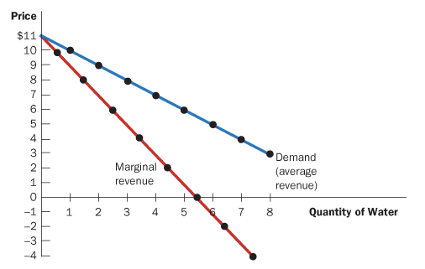
- A monopoly’s marginal revenue curve lies below the demand curve

Profit maximization for a monopoly
- To maximize profit, the monopoly produces the quantity at which the marginal cost and marginal revenue curves intersect, then sets a price based on the demand curve
- In competitive markets, price equals marginal cost
- In monopolized markets, price exceeds marginal cost
- While both maximize profit by selecting the quantity where marginal cost equals marginal revenue, this difference is key

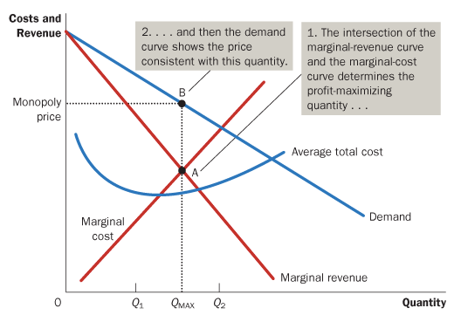

Calculating a monopoly’s profit
- The equation for a monopoly’s profit is the same for that of a competitive firm: (P - ATC) multiplied by Q
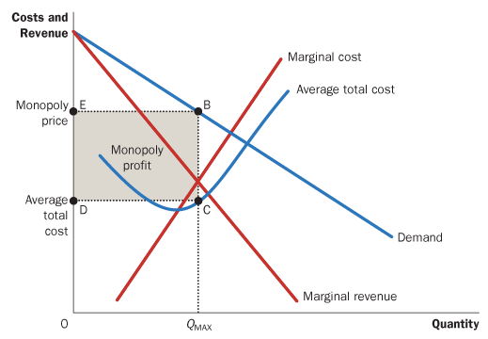
- The monopoly is allowed to make an economic profit because it doesn’t effect entrance and exit into the market

Deadweight loss of a monopoly
- Since a monopoly charges a price higher than its marginal cost, which is this leads to an inefficient outcome and causes a deadweight loss
- Because the monopolist charges such a high price, not all people who want the good are able to purchase it
- Therefore, the socially optimal quantity is more, leading to a lower price
- The deadweight loss is represented by the area of the triangle between the demand curve (which reflects the value of the good to consumers) and the marginal-cost curve (which reflects the costs of the monopoly producer)
- The monopoly’s profit is not actually what causes deadweight loss
- The problem is that the firm produces and sells a quantity of output below the level that maximizes total surplus
- In other words, if the high monopoly price did not discourage some consumers from buying the good, it would raise producer surplus by exactly the amount it reduced consumer surplus, creating a socially optimal total surplus

Price discrimination
- Unlike competitive firms, monopolies can set different prices for different buyers
- By charging different prices to different customers, the monopoly can increase its profit
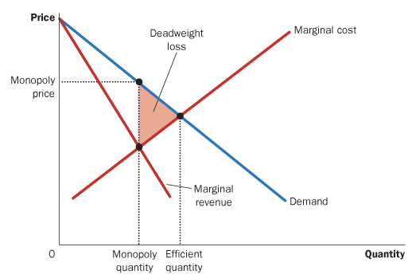
- If the different price is equal to that specific customer’s willingness to pay, the monopoly has a customer it would not otherwise have
- However, a monopoly must be able to separate customers by their willingness to pay for price discrimination to work
- If the monopoly knows this, it is called perfect price discrimination
- There is a surprising result of perfect price discrimination: it reduces the deadweight loss of a monopoly
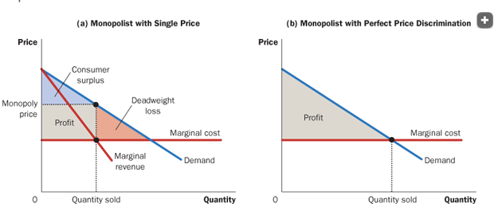
- This is because, while consumer surplus is negligible (price is exactly their willingness to pay), producer surplus is perfect: every customer gets the good
- Price discrimination is not perfect in reality; it is impossible for a monopoly to know every customer’s willingness to pay
- As such, firms price discriminate by splitting customers into groups
- 2nd degree price discrimination is when firms reward customers for buying a large quantity of the good
- This is a successful way of price discrimination, as a customer’s willingness to pay decreases with each additional good they buy
- 3rd degree price discrimination is when the firm can separate customers into groups based on their assumed willingness to pay
- For instance, a movie theatre has different prices for children, adults, students, and seniors

Public policy towards monopolies
- The government can respond to monopolies in four ways
  - By trying to make monopolized industries more competitive—the government can prevent mergers between companies that create monopolies, but sometimes this can make the system more efficient, so the government must distinguish between efficient and inefficient mergers
  - By regulating the behaviour of the monopolies—
  - By turning some private monopolies into public enterprises
  - By doing nothing at all

