ECO1104 2nd midterm preparation

Italics show the corresponding definition/flashcard.

Chapter 7

Key terms:
Producer surplus: the amount a seller is paid for a good minus the seller’s cost
Cost: the value of everything a seller must give up to produce a good
Consumer surplus: a buyer’s willingness to pay minus the amount the buyer actually pays
Willingness to pay: the maximum amount a buyer will pay for a good
Welfare economics: the study of how allocation of resources affects economic wellbeing

Welfare economics
- When price/quantity are at equilibrium, the benefits received by buyers and sellers are maximized; this is one of the many reasons equilibrium is good

Consumer surplus
- Consumer surplus depends on the demand curve
- The area under the demand curve and above the price is the consumer surplus
- Consumer surplus measures the benefit that buyers receive from a good as the buyers themselves perceive it
- Free markets allocate the supply of goods to the buyers who value them most highly, as measured by their willingness to pay

Producer surplus
- Producer surplus depends on the supply curve
- The area above the supply curve and below the price is the producer surplus
- Free markets allocate the demand for goods to the sellers who can produce them at the lowest cost

Total surplus is consumer surplus plus producer surplus.
- When total surplus is maximized, the market is efficient
- Free markets produce the quantity of goods that maximizes the sum of consumer and producer surplus
- At any quantity below equilibrium, value to the buyer exceeds cost to the seller
- At any quantity above equilibrium, cost to the seller exceeds value to the buyer

Consumer surplus and producer surplus on a graph with both supply and demand curves look like this:

Supply curve shifts to the left:
Consumer surplus decreases
Producer surplus increases

Supply curve shifts to the right:
Consumer surplus increases
Producer surplus increases or decreases, depending on the exact numbers

Demand curve shifts to the left:
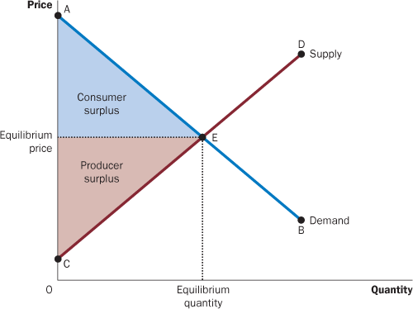
Consumer surplus increases or decreases, depending on the exact numbers
Producer surplus decreases

Demand curve shifts to the right:
Producer surplus increases
Consumer surplus increases or decreases, depending on the exact numbers

Because these are imprecise, memorizing what happens when a curve shifts isn’t the best way to go. It is better to act on a case-by-case basis; you won’t be asked to estimate what happens to, for instance, producer surplus when the supply curve shifts to the right.

Mathematical appendix
- To calculate consumer or producer surplus, use the formula for area of a triangle: 1/2 × base × height; the triangle referenced is shown in the above graph

Chapter 8

Key term (only one!):
Deadweight loss: the fall in total surplus that results from a market distortion, such as a tax

- When a tax is levied on buyers, the demand curve shifts downward by the size of the tax; when it is levied on sellers, the supply curve shifts upward by that amount

Deadweight loss
- Total government tax revenue is tax x quantity sold
- TR (tax revenue) is represented by a rectangle on the graph between the price paid by buyers and the price received by consumers

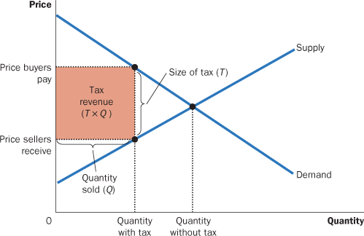

- The triangle to the right of tax revenue is the deadweight loss
- Before a tax was imposed, that amount of deadweight loss was included in producer surplus and consumer surplus
- Even taking into account tax revenue, there is still an overall loss of benefit, which is what deadweight loss illustrates
- When the reduction in consumer/producer surpluses exceeds the tax revenue, there is a deadweight loss
- Taxes cause deadweight losses because they prevent buyers and sellers from realizing some of the gains from trade

Impact of elasticities on deadweight loss
- The price elasticities of supply and demand determine if deadweight loss is big or small
- When the price elasticities are large, the deadweight loss is bigger; buyers/sellers are willing to leave the market, so the quantity sold can decrease by a lot when a tax is imposed, which means that tax revenue doesn’t offset the losses in surplus (when quantity decreases to 0, tax revenue is $0)
- When the price elasticities are small, the deadweight loss is smaller; this is because buyers/sellers are less likely to leave the market, so the quantity sold does not decrease so dramatically as to negate tax revenue
- The greater the elasticities of supply and demand, the greater the deadweight loss of a tax

Laffer curve
- When a tax is increased, government revenue doesn’t always rise (because of the Laffer curve, see below); however, deadweight loss always increases
- According to the Laffer curve, when a tax is increased, tax revenue will rise then fall

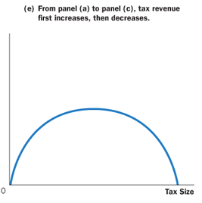

Mathematical appendix
- The formula to calculate deadweight loss is (1/2)T(Q1 - Q2), where T = tax, Q1 = quantity sold before a tax was imposed, and Q2 = quantity sold after a tax was imposed

Chapter 10

Key terms:
Externality: the uncompensated impact of one person’s actions on the well-being of a bystander
Corrective taxes: taxes enacted to correct the effects of negative externalities
Internalizing the externality: alternative incentives so that people take account of the external effects of their actions
Coase theorem: the proposition that if private parties can bargain without cost over the allocation of resources, they can solve the problem of externalities on their own
Transaction costs: the costs that parties incur in the process of agreeing to and following through on a bargain

Impact of externalities on the market
- In the absence of externalities, the natural equilibrium is efficient
- The market equilibrium is not socially efficient when there are externalities
- This is because buyers/sellers don’t adjust how much they buy/sell based on the impact of their actions (they only care about themselves)
- To fix this, the government has to step in

Negative externalities
- When the impact of an externality is adverse (causes harm to the bystander), it is a negative externality
- Negative externalities are related to the supply curve (society wants less supply)
- When there is a negative externality (for instance, producing a good causes pollution, which negatively impacts bystanders), the cost to society of producing a good is greater than the cost to the producers
- Negative externalities lead markets to produce a larger quantity than is socially desirable
- The social cost includes the private costs of the aluminum producers plus the costs to those bystanders affected adversely by the pollution
- The social cost curve is above the supply curve
- The optimum quantity (that is, the socially ideal quantity) is the new equilibrium formed by the social cost curve and the demand curve

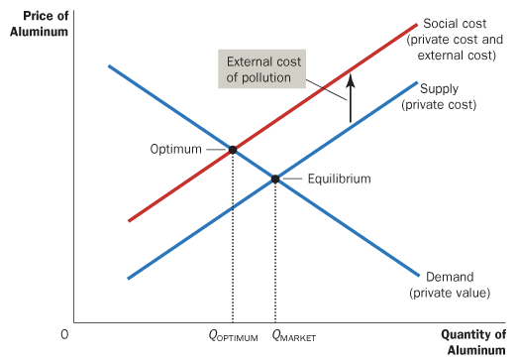

- Consumer surplus is still the area under the demand curve and above price
- Producer surplus is the amount received by sellers (PMARKET x QMARKET) - the social cost to society (the area between the social-cost curve and the market quantity)

Deadweight loss of a negative externality
- When there is a negative externality and production continues at the market (equilibrium) quantity, there is a deadweight loss of the area between the equilibrium, the optimum, and the social cost at the market quantity (area H)

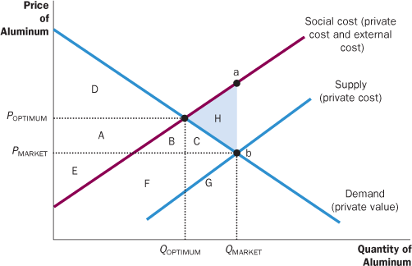
- At QMARKET, consumer surplus is area A + B + C + D
- At QMARKET, producer surplus is area E + F + G (amount received by sellers) - (F + G + B + C + H) (social cost, the area between the social cost curve and the market quantity), which reduces to E - (B + C + H)
- At QMARKET, total surplus is (A + B + C + D) + [E - (B + C + H)], which reduces to A + D + E - H
- As such, H is the deadweight loss at QMARKET
- At QOPTIMUM, consumer surplus is area D, a loss of A + B + C
- At QOPTIMUM, producer surplus is area A + E (there isn’t any social cost to subtract), an increase of A + B + C + H
- At QOPTIMUM, total surplus is D + A + E
- When the equilibrium shifts to optimum, the deadweight loss is removed
- This is because, despite consumer surplus going down by A + B + C, producer surplus is no longer weighed down by the social cost (there isn’t any), which results in a gain in the amount of H

Positive externalities
- When the impact of an externality is beneficial (helps the bystander), it is a positive externality
- Education is an instance of a positive externality
- While the consumer (the student) reaps the direct benefits of education, society as a whole is better off; a more educated society leads to more informed voters (leading to a better government), lower crime rates, and more
- Positive externalities are related to the demand curve (society wants/demands more educated people)
- The socially optimal quantity is higher than the market quantity
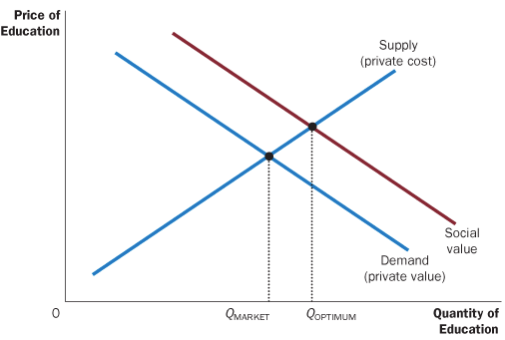

Methods of changing QMARKET to QOPTIMUM
- In the case of a negative externality, a tax on producers for every good produced is an instance of the government internalizing the externality; if the tax is the right amount, it incentivizes producers to produce the optimum quantity, because it is no longer profitable for them to produce the market quantity
- In the case of a positive externality, the government wants to incentivize people to use more of a good; it can internalize the externality using subsidies, where the government incentivizes people to do something (i.e. OSAP for school) and makes it profitable for them

Command-and-control policies
- Command-and-control policies regulate behaviour directly by making certain behaviours either required or forbidden
- For example, it is a crime to dump poisonous chemicals into the water supply; the external costs to society far exceed the benefits to the polluter, so the government institutes a command-and-control policy that prohibits this
- However, policies that prohibit actions are rarely the right choice
- For example, all forms of transportation pollute, but the government can’t outright ban every type of transportation
- As such, certain kinds of pollution are allowed in certain quantities; pollution is regulated
- Policies can set maximums for pollution or require the adoption of more environmentally friendly technology

Market-based policies
- Market-based policies provide incentives so that private decision makers will choose to solve the problem on their own
- Market-based policies are, for economists, preferable because they can reduce externalities at a lower cost to society
- Market-based policies give producers an incentive to keep reducing the amount of pollution they produce (since every pollution “unit” costs them money); command-and-control policies don’t give producers any reason to keep reducing the amount of pollution below the set limit (no benefit to them)
- Market forces, properly redirected, are often the best remedy for market failure
- There are two types of market-based policies: corrective taxes/subsidies and tradable pollution permits

- Corrective (Pigovian) taxes and subsidies
  - Taxes enacted to deal with negative externalities are corrective taxes
  - It does not matter who the tax is imposed on; as with other taxes, regardless of whether it’s imposed on buyers or sellers, the result is the same
  - Ideal corrective taxes equal the external cost from the activity with negative externalities
  - The perfect corrective tax is the difference between the social-cost curve and the private-supply curve (area H, the deadweight loss)
  - Ideal corrective subsidies equal the external value from the activity with positive externalities
  - The corrective tax places a price on the right to pollute
  - Unlike other taxes, which distort incentives, move the allocation of resources away from the optimum, and cause deadweight losses, corrective taxes move the allocation of resources towards the optimum and reduce deadweight loss
  - Thus, while corrective taxes raise revenue for the government, they also enhance economic efficiency
- Tradable pollution permits
  - The government can “produce” a certain number of pollution permits, which allow companies to pollute a certain amount
  - The companies that have the highest willingness to pay will get the permits
  - This creates a market, which is then guided by the forces of supply and demand
  - The companies with the lowest cost of reducing pollution can sell the permits they get and the companies with the highest cost of reducing pollution can buy the permits they need
  - As long as it is a free market, efficient allocation of resources will occur, regardless of the initial allocation
  - Both corrective taxes and pollution permits make it costly for producers to pollute
  - Pollution permits can sometimes be better than pollution permits
  - When the demand curve is unknown (and therefore, the ideal corrective tax cannot be determined), a set number of pollution permits can be auctioned off, achieving the same result as a corrective tax

Private solutions to externalities
- Charities like Greenpeace, funded by private donations, work to correct environmental externalities
- Colleges and universities are also sustained by private donations by alumni/companies
- These types of private solutions are encouraged by the government by tax write-offs for donations
- Internalizing externalities is one reason that some firms are involved in multiple types of business; they can adjust the amount produced of one good based on the positive externality conferred by another good, since they control both
- Another way for the private market to deal with external effects is for the interested parties to enter into a contract; companies can create contracts which set the quantity produced of certain goods (perhaps involving payment for keeping the quantity in line with the contract), achieving the same result as a company involved in multiple types of business

Coase theorem
- If the cost of a negative externality is higher to X than the value of that good to Y, X can simply pay Y to get rid of the thing causing the negative externality
- The initial distribution of rights does not matter for the market’s ability to reach the efficient outcome
- This means that, even if there is a law against the negative externality, which is to X’s advantage, X will probably not be able to convince Y to get rid of the thing causing the negative externality based on the law alone
- The presence of a right/law, however, does change who pays who; the person who has a right will be paid to do what the other party wants
- The Coase theorem says that private economic actors can potentially solve the problem of externalities among themselves
- Whatever the initial distribution of rights, the interested parties can reach a bargain in which everyone is better off and the outcome is efficient
- However, the Coase theorem doesn’t always work in the real world
- Bargaining can be expensive (transaction costs: lawyers are almost always involved), bargaining can simply break down, or there can be too many parties involved to effectively coordinate everyone
- The government often plays a role in cases where the Coase theorem doesn’t work

Chapter 11

Key terms:
Rival in consumption: the property of a good whereby one person’s use diminishes other people’s use
Excludable: the property of a good whereby a person can be prevented from using it
Excludability: the property of a good whereby a person can be prevented from using it
Private goods: goods that are both excludable and rival in consumption
Public goods: goods that are neither excludable nor rival
Common resources: goods that are rival in consumption but not excludable
Club goods: goods that are excludable but not rival
Tragedy of the Commons: a parable that illustrates why common resources get used more than is desirable from the standpoint of society as a whole
Cost-benefit analysis: a study that compares the costs and benefits to society of providing a public good
Free rider: a person who receives the benefit of a good but avoids paying for it

Private goods
- These are the goods that we have studied thus far
- Consumption of these goods is determined by the forces of supply and demand
- Those who can pay for the good get the good (except in cases of shortage, but we aren’t considering those)
- Therefore, private goods are excludable
- If one person buys a private good, the amount of that good available for others to purchase is reduced
- Therefore, private goods are rival in consumption
- You don’t get a private good unless you pay for it, and once you have it, you are the only person who benefits

Public goods
- A tornado siren in a small town is an example of a public good
- Once the siren sounds, no one can be prevented from hearing it
- Therefore, public goods are not excludable
- When one person gets the benefit of the warning, they do not reduce the benefit to anyone else
- Therefore, public goods are not rival in consumption
- Public goods include:
  - National defence, provided by the government: once the country is defended, it is impossible to prevent any single person from enjoying the benefit of this defence; additionally, when one person enjoys the benefit of national defence, he does not reduce the benefit of anyone else
  - General knowledge, which is often developed through government agencies like the CSA: a mathematician cannot prevent others from using a theorem; additionally, one person’s use of the theorem does not prevent any other person from using the theorem

Common resources
- Fish in the ocean are an example of a common resource
- It is difficult to prevent people from fishing, considering the vast size of the ocean
- Therefore, common resources are not excludable
- One person catching a fish reduces the number of fish for others to catch
- Therefore, common resources are rival in consumption
- Once the good is provided, policymakers need to be concerned about how much it is used
- Common resources include:
  - Congested roads: if a road is not congested, then one person’s use does not affect anyone else; in this case, use is not rival in consumption, and the road is a public good. However, if a road is congested, then use of that road yields a negative externality; when one additional person drives on the road, it becomes more crowded, and other people must drive more slowly. In this case, the road is a common resource. One way for the government to address the problem of road congestion is to charge drivers a toll; a toll is, in essence, a corrective tax on the externality of congestion.
  - Fish, whales, and other wildlife: fish and whales have commercial value, and anyone can go to the ocean and catch whatever is available; each person has little incentive to maintain the species for the next year. Excessive fishing and whaling can destroy commercially valuable marine populations, so the government charges for fishing and hunting licences and restricts the lengths of the fishing and hunting seasons.

Club goods
- Fire protection in a small town is an example of a club good
- The firefighters can simply let a house burn down
- Therefore, club goods are excludable
- Once a town has paid for a fire department, the cost of protecting one more house is small
- Therefore, club goods are not rival in consumption

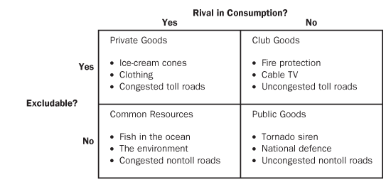

- Contrary to the above table, the boundaries between the categories are sometimes fuzzy
- For instance, the ocean can be fully monitored if there is a large enough system in place, so fish in the ocean can be excludable
- Similarly, although fish are generally rival in consumption, this would be less true if the population of fishermen was small relative to the population of fish

Externalities related to common resources and public goods
- For both of these types of goods, externalities arise because something of value has no price attached to it
- If one person was to provide a public good, such as a tornado siren, other people would be better off; they would receive a benefit without paying for it—a positive externality
- When one person uses a common resource such as the fish in the ocean, other people are worse off because there are fewer fish to catch; they suffer a loss but are not compensated for it—a negative externality
- Private decisions about consumption and production can lead to an inefficient allocation of resources
- As such, government intervention can potentially raise economic well-being

Free riders
- Suppose there was a fireworks display (a public good) for which tickets were sold at a price
- Since fireworks are public goods (and not excludable), free riders are people who do not buy tickets and view the fireworks for free
- Free riders receive the benefit of seeing the fireworks but do not pay for that benefit
- Because people would have an incentive to be free riders rather than ticket buyers, the market would fail to produce an efficient outcome
- The private market cannot make a profit, so the good doesn’t get produced
- The government is the only “producer” that can sustain free riders, which is why the government uses tax revenue to hire traditional producers, who produce most public goods
- If the government decides that the total benefits exceed the costs, it can provide the public good and pay for it with tax revenue, making everyone better off

Cost-benefit analysis
- The government must determine what kinds of public goods to provide and in what quantities
- The production costs for public goods are the same as for private goods
- When buyers of private goods enter a market, they reveal the value they place on it by the prices they are willing to pay
- However, unlike private goods, there is no price with which to judge the value of a public good
- Simply asking people doesn’t work, as those who want the public good will exaggerate how much they value it (vice-versa with those who don’t want the public good)
- Findings on the costs and benefits of public projects are, therefore, rough approximations at best

Tragedy of the Commons
- Let’s say that a town has a booming wool industry and, as such, has a lot of sheep
- All of the sheep graze on the same plot of land, which is a common resource owned by all town residents, available to be used by everyone
- As the number of sheep increases, the land loses the ability to replenish itself
- Eventually, all the grass runs out and sheep cannot be raised; because of this, the town loses a source of income and families lose their source of livelihood
- To sum up: because people are not charged for their use of common resources, they tend to use them excessively, which has negative implications
- The Tragedy of the Commons arises because of an externality
- When one family’s flock grazes on the common land, it reduces the quality of the land available for other families
- Because people neglect this negative externality when deciding how many sheep to own, the result is an excessive number of sheep
- The government can solve the problem by reducing use of the common resource through regulation or taxes, or by turning the common resource into a private good

