Macro – Economics

Chapter 7 – Measuring the Wealth of Nations
Major Elements of chapter:
- Circular flow model gives basic structure of macroeconomy
- Major components of national income
- National accounting
- Nominal versus real quantities
- Interpretation of real GDP
Circular flow model:
- Gives the structure, or the skeleton, of the macroeconomy
- The textbook gives a simple version, which is fine with me
Definitions:
- A flow quantity is an amount per unit of time, like a current of water passing through
- A stock is an amount observed at a point in time, like the volume of water in a tank
  - Think of a snapshot
  - No time frames
- Value of stock at time t = value of stock at time t – 1 + value of inflow – value of outflow
  - Leakages and injections are both flow quantities
Basic Concept:
- Flows of expenditures and incomes circulating through the markets that comprise the macroeconomy
  - Analogous to the cardio-vascular system of blood circulating through the human body
The concept of twos
- Two by two by two is simplest version, which is what the textbook does
- Two types of markets
  - Factor markets (inputs)
  - Goods and services markets (outputs)
- Two types of actors
  - Households
  - Producers (firms, businesses)
- Two types of flows denominated in $
  - Income flows from services rendered
  - Expenditure flows from G & S produced
- In the diagram coming up:
  - the green arrows denote financial flows
  - The red arrows denote the REAL flows of either factors being rendered or goods and services being exchanged
The Structure of the Model
- In the factor market (on the left)
  - Households are the sellers and earn income
  - Firms are the buyers and spend
- In the goods and services market (on the right)
  - Households are the buyers and spend
  - Firms are the sellers and earn income

The Circular-Flow Diagram
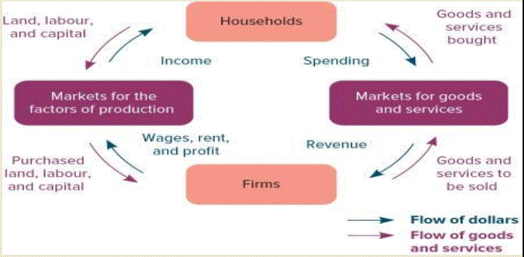

Key Point
- Expenditure for one actor is income for another within each of the 2 markets
  - Every dollar which circulates is both income and expenditure
  - Every dollar has a double identity
  - as a result, total (aggregate) expenditure = total (aggregate) income
  - “This equality is a crucial idea in the study of macroeconomics” (p. 206)
Complication
- Add a money market to the model
- Savings leak out of the G & S market to enter the money market, which transforms them into investment spending, and they are injected back into the G & S market
- The foreign sector and the government sector are two other actors within the G & S market
National Accounting
- The objective is to measure GDP
- The circular flow model gave the Structure or the anatomy, which is the relationship of the flows. Now we want to discover the size of them.
- Similar to accounting at a firm level
  - The idea is to track and measure economic activity
- Two major approaches
  - Expenditure approach
  - Income approach
  - Textbook mentions the value-added approach
- Recall income and expenditure are distinct flows within the macroeconomy, and are equal in the aggregate
Expenditure Approach (Figure 7.2 – 2014 figures)
- Expenditure approach is the easiest. All spending activity is broken down as:
  - Consumption spending
  - Investment spending
  - Net export spending
    - Exports minus imports
  - Government spending
- GDP = C + I + G + X – Imports
  - These % figures are for the year 2014
  - Consumption is relatively stable but has declined in relative terms in recent decades (about 56 % of GDP)
  - Investment is unstable and is the hardest to model (about 24% of GDP)
  - Government spending refers only to government purchases, and does not reflect transfer payments.
    - It has grown in relative terms in recent decades to about 21 % of GDP
  - Imports reflect Canadians’ spending on foreign goods
  - the spending LEAKS from the circular flow
    - about 33 % of GDP
  - Exports reflect foreigners’ spending on Canadian goods
  - the spending is INJECTED into the circular flow
    - about 32 % of GDP
  - NX = X – Import is NET EXPORTS
    - minus 1 % of GDP

- Injections enter with + signs
  - Government spending
  - Investment spending
  - Export spending
- Imports enter with a negative sign
  - They are already counted in consumption, and so we do not want to double count them
  - Also, they are not produced in Canada
- Three types of investment activity, or capital spending.
  - residential investment
  - plant and equipment
  - inventory accumulation (is a flow)
    - inventory levels are a stock
- It is possible for one economic agent to contribute to C, I, Import, G spending simultaneously.
  - i.e. I am a consumer, an investor, and an importer
- Therefore, in order to classify spending as C, I, G, X, or Import, it is not the IDENTITY of the spender that matters, but rather the NATURE of the good or service being purchased

Factors Incomes approach
- This time, the focus is on income EARNING activity, not on SPENDING activity. The question now is ‘How was this dollar earned?’
  - My approach a bit different than the one in the textbook
- Y (aggregate income) broken down into:
  - factor payments
  - indirect taxes
  - depreciation
- NDP (net domestic production) = Factor incomes + indirect taxes
- GDP (same as Y) = NDP + depreciation (capital consumption allowance)
- In 2014 it amounted to about $ 55,822 per capita
- factor payments include:
  - salaries and wages to labour
    - About 51 % of GDP in 2014
  - rent to landlords and landladies
  - interest and dividends to investors
  - profits to entrepreneurs
  - According to table 5.2 (page 98), payments to land and capital are classified as:
    - Gross operating surplus
    - Gross mixed income
- These quantities give income at factor cost. This is not total income at market prices.
- Indirect taxes fill this gap.
  - PST, GST, HST excise taxes
  - Incurred only upon act of purchase
- Depreciation refers to what is required in order to maintain the capital stock in its existing condition
- It is possible for one economic agent to earn income from land, labour, and/or capital simultaneously
- Therefore, it is not the IDENTITY of the earner that matters, but rather the MANNER in which the income is earned
APOGEE
- GDP, as calculated by the expenditure approach, should equal Y, as calculated by the factor income approach
  - Statscan does it both ways
  - The ‘bottom line’ figure is the same, but…..
  - the classification schemes are TOTALLY different
- GDP = Y, or gross domestic product = national income
  - This equality is consistent with the circular flow model

Real versus nominal GDP
- Real GDP is nominal GDP adjusted for inflation
- The objective is often to measure changes in the VOLUME of economic activity, as economic well-being depends on the quantity of G & S produced BUT…..
- GDP has to be measured by VALUE, not physical VOLUME, and VALUE depends on both VOLUME and prices.
  - Nominal GDP increases because prices rise
  - Nominal GDP also increases because production—real GDP– increases
- Have to find a way to disentangle changes in volume from changes in prices
- A price deflator (index) is a time series of numbers that measures inflation
  - Think of it like a two-column matrix that gives a one-to-one correspondence between time and the level of prices
- They are used to DEFLATE nominal quantities into real ones
- To this end, deflators account for the inflation that is embodied in nominal quantities
- % change nominal = % change real + inflation rate
  - no inflation means real value = nominal value
- real GDP = (Nominal GDP / deflator) * 100
  - take logs of both sides and differentiate this in order to obtain the expression above
  - Memorise equation 7-3
- Inflation rate = [ (deflator t – deflator t-1) / deflator t-1] * 100
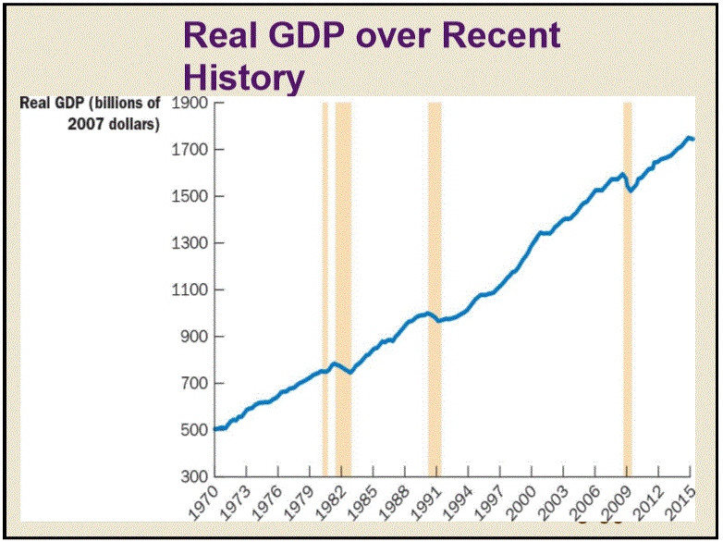
  - It’s the growth rate of the deflator series

How good a measure of economic welfare is GDP?
- In some ways, it underestimates it, so actual economic welfare is higher than the official numbers indicate.
  - the underground economy: activity is not reported (all untaxed, but not all illegal)
  - non-market activities: activity might be reported, but is not traded and not valued
  - It does not reflect time allocated to leisure
- In some ways it overestimates it, so economic welfare is actually lower than the official numbers indicate
  - economic bads: by-products of economic activity, especially pollution and congestion
    - The economic activity which generates the pollution is included in GDP, but the pollution is not accounted for.
  - The value of some activities which do not promote economic welfare are included in GDP, such as criminal justice, national defense, and environmental cleanup
    - i.e. the value of spending to address “necessary evils” IS included in the official GDP figures
- No single statistic will resolve this issue
- Economic well-being and the value of GDP growth are somewhat subjective
  - ‘Left-wing’ types stress distributional issues: what good is GDP growth if the lion’s share goes to capital (read ‘the rich’) rather than labour?
  - ‘right-wing’ types say ‘plenty’, because ‘the rich’ are the goose that lays the golden egg for all of us, and ‘the poor’ would be even ‘poorer’ if ‘the rich’ were not so rich
- Interesting figures in Table 5.4 on international comparisons (2011 data)
  - On average it is estimated that GDP per capita adjusted for local prices is about 82 % in Canada of what it is in the USA.
    - We are slightly better off than the Japanese, the French, the Germans, and the British
  - Canada has a more equal distribution of income than most post-industrial economies
  - Life expectancy in Canada is 3 years longer than it is in the USA

