Student’s name: Anh Phan
Student number: 300001267
Date: January 10th, 2018
TA: Joel Kolle
Partner(s): Kitty Chen

LAB #1: THIN LAYER CHROMOTOGRAPHY
PROCEDURES AND OBSERVATION:
Part A: Identifying the components of an unknown mixture using TLC.
Procedures:
- See laboratory manual from page 17 to 18.
- Spot the reference solution of benzophenone onto the first plate.
- Mark the first plate as A for identification.
- Spot reference solution of biphenyl onto the second plate.
- Mark the second plate as B for identification.
- Spot the unknown solution labeled 95 onto both plates.
- Repeat the procedure for part A 3 times.
- In the 4th trial, the marking of the TLC plates is reversed: A for biphenyl and B for benzophenone.
Observation:
- The given sample was in solid state.
- As the unknown sample was being dissolved in dichloromethane, a translucent solution was produced.
- The TLC plates when brought under the UV light had a green fluorescence while the spots did not show any fluorescence.
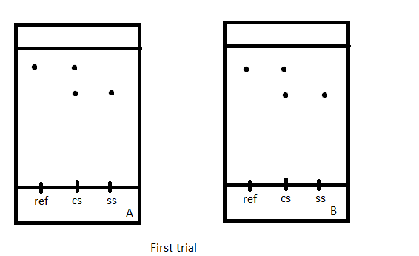
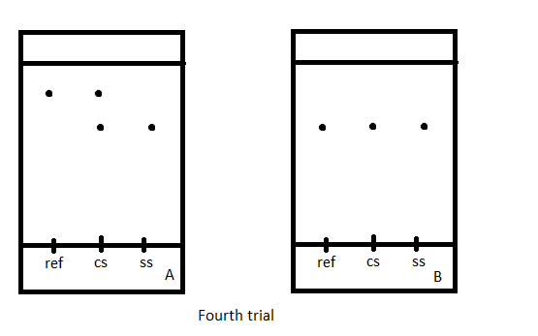

Part B: Effect of solvent on TLC.
Procedure:
- See laboratory manual on page 18.
Observation:
- Plates developed in the jar containing EtOAc as the eluent
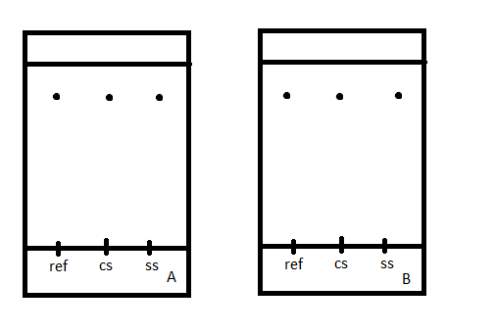

- Plates developed in the jar containing Hexanes as the eluent

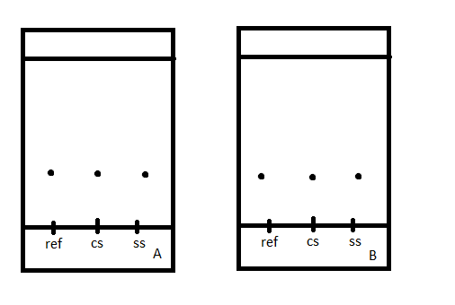

Part C: Ratio of compounds
Procedure:
- The unknown sample was unknown sample XX.
- See laboratory manual from page 18 to 19.

Observation:
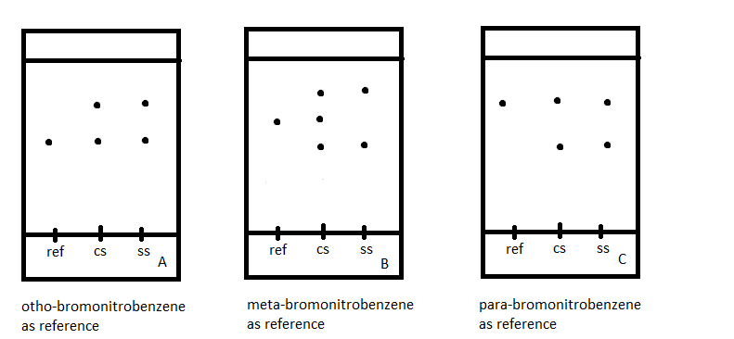

CALCULATIONS:
Part A

Reference Solution | Displacement of Compound (cm) | Displacement of Solvent (cm) | Experimental R_{F} Value
Benzophenone | 3.5 | 4.8 | 0.73
Biphenyl | 3.4 | 4.8 | 0.71
Biphenyl | 4.0 | 4.8 | 0.83

Part B

Solvent | Reference Solution | Displacement of Compound (cm) | Displacement of Solvent (cm) | Experimental R_{F} Value
Ethyl Acetate | Benzophenone | 4.0 | 4.8 | 0.83
Ethyl Acetate | Biphenyl | 4.0 | 4.8 | 0.83
Hexane | Benzophenone | 0.5 | 4.8 | 0.10
Hexane | Biphenyl | 0.5 | 4.8 | 0.10

Part C:
Reference Solution | Displacement of Compound (cm) | Displacement of Solvent (cm) | Experimental R_{F} Value
o-bromonitrobenzene | 3.2 | 5.4 | 0.59
o-bromonitrobenzene | 4.2 | 5.4 | 0.78
m-bromonitrobenzene | 3 | 5.4 | 0.56
m-bromonitrobenzene | 3.8 | 5.4 | 0.70
m-bromonitrobenzene | 4.6 | 5.4 | 0.85
p-bromonitrobenzene | 3.4 | 5.4 | 0.63
p-bromonitrobenzene | 4.3 | 5.4 | 0.80

Percentage of absorbance:
- Absorbance of ortho: 13975
Absorbance of para: 34834
% absorbance (ortho): ($\frac{13975}{13975+34834}$) × 100% = 28.63%
% absorbance (para): 100% - 28.63 = 71.37%

Ortho-bromonitrobenzene as reference solution



Para-bromonitrobenzene as reference solution



Percentage of mole:
- y = % absorbance (ortho) = 28.63%
y = 1.0114x - 2.0208
Thus x = 30.30%
% mole (ortho) = 30.30%
% mole (para) = 100% - 33.2% = 69.7%

DISCUSSION:
Part A
- To prevent mistaking the two reference solutions, we spotted the reference solutions onto the TLC plates first instead of spotting the unknown sample first.
- The TLC plates were also marked for identification.
- During part A, we did 4 trials because during the first 3 trials, we might have used the same reference solution for both TLC plates. This led to the same results in all TLC plates and we could not identify the unknown sample.
- After cleaning out all test tubes and acquiring a new batch of reference solutions as well as preparing a new batch of unknown sample, we were able to identify that the unknown sample contained biphenyl.
- The unknown sample contained biphenyl because the spot created by the unknown sample matched with the spot created by benzophenone as a reference solution.
Part B
- The patterns appeared on TLC plate A and on TLC plate B will remain the same regardless of what reference solution or sample was used.
- The eluent polarity determines where the compound will run on the TLC plates. The more polar the eluent is, the slower the migration will occur.
- Regarding the plates developed in the jar containing ethyl acetate as the eluent, the pattern of the spots appeared higher because ethyl acetate is a more polar solvent. The compound will instead of doing hydrogen bonding with silica will do so with the solvent, making the spot migration faster.
- Regarding the plates developed in the jar containing hexanes as the eluent, the pattern is caused by the fact that hexanes is a less polar solvent. The migration is slower as the compound will only do hydrogen bonding with the silica.
Part C
- Because the spots of the unknown sample matched with the reference solution of ortho- and para-bromonitrobenzene, we concluded that the sample contained ortho- and para-bromonitrobenzene.
- The mole percentage of ortho-bromonitrobenzene is 30.30% which is lower than the 69.7% mole percentage of para-bromonitrobenzene.
- Therefore, we can conclude that the unknown sample XX contained 30.30% of ortho-bromonitrobenzene and 69.7% of para-bromonitrobenzene.
QUESTIONS:
- Increasing the polarity of the solvent system will accelerate the migration of the compound. The speed of migration will result in longer distance between the position of the spots on the TLC plate and the base line.

- Benzyl alcohol, benzaldehyde, benzyl acetate
- Line structures are in order as mentioned above:
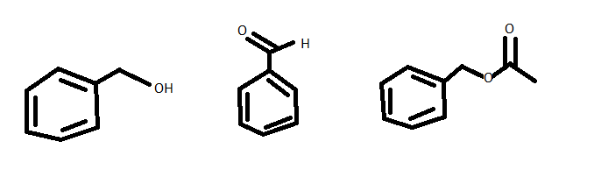
- Benzyl alcohol is the most polar thus it has the smallest R_{f} because its structure allows Hydrogen bonding.

- Aniline, N,N-dimethylaniline, naphthalene
- Line structures are in order as mentioned above:
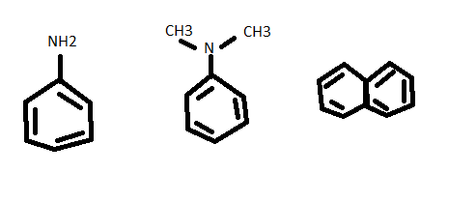
- Aniline is the most thus it has the smallest R_{f} because in NH₂, the Nitrogen allows one more Hydrogen bonding.
- Benzophenone, Biphenyl, Benzoic acid
- Line structures are in order as mentioned above:

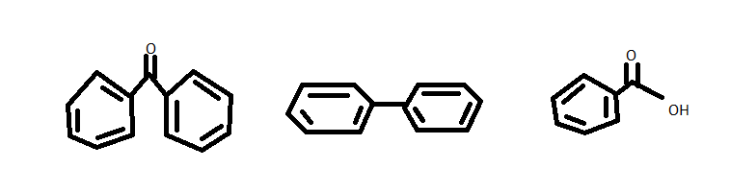
- Benzophenone is the most polar thus it has the smallest R_{f}.

RAW DATA:


