Lab 4: Primeness Check and Prime Factorization

Step 1: Problem Identification and Definition

Develop a program that prompts the user to enter an integer between 2 and 1000,000 and prints out whether it’s a prime. In case it’s not a prime number, the program will print the factorization of the number as a product of primes in ascending order.

Step 2: Gathering of Information and I/O Description

For this particular program, the input values will be the integer entered by user(s), and the output value(s) will be the ones displayed by the program. In this case, the output values will be whether the number entered by user is a prime, and incase it’s not, the factorization of that number as a product of primes in ascending order.

I/O description:

PROGRAM

User(s) enters Integer prints prime, or
Factorization as
Product of primes

Step 3: Algorithm Development and Verification

BEGIN
END
PRINT NUMBER AS PRODUCT OF PRIMES
PRINT NUMBER IS PRIME
CHECK FOR PRIMENESS
PROMPT USER TO ENTER AN INTEGER

TRUE

FALSE

Test Cases:

Test Case 1: 24

24 is not a prime number
prime factors of 24: 2*2*2*3

Test Case 2: 3
3 is a prime number

Test Case 3: 55
55 is not a prime number
prime factors of 55: 5*11

Step 4: Implementation in C

//
// main.c
// lab 4
//
// Created by Saifullah on 5/11/14.
// Copyright (c) 2014 Saifullah . All rights reserved.
//

#include<stdio.h>

int usernumber;
int j=0;
int i;
int y=0;
int g;
int r;

int main()
{

printf("This program is designed to print to verify an integer for its primeness\n\nPlease enter an integer between 2 and 100,000 here==>:");
scanf("%d",&usernumber);

for(i=2;i<=9;i++)
{
if(i!=usernumber && usernumber%i==0)
y=y+1;
}
if(y==0)
printf("\n%d is a prime number\n",usernumber);
else
{
printf("\n%d is not a prime number\n",usernumber);

printf("\nFactors of %d are:\n", usernumber);
for(i=1;i<=usernumber;i++)
{
int div=2;
int i=0,j=0;
int num=usernumber;
int *prime=(int *) malloc(usernumber*sizeof(int));
if (usernumber==1 || usernumber==0)
{
*prime=0;
}
else
{
while(usernumber>1)
{
if ((usernumber%div)==0)
{
*(prime+i)=div;usernumber=usernumber/div;i++;

}
else
{
div++;
}
}
}
for(j=0;j<i;j++)
{
printf (" %d ",*(prime+j));
}

return(0);

}
}
}

Test Cases:

Test Case 1

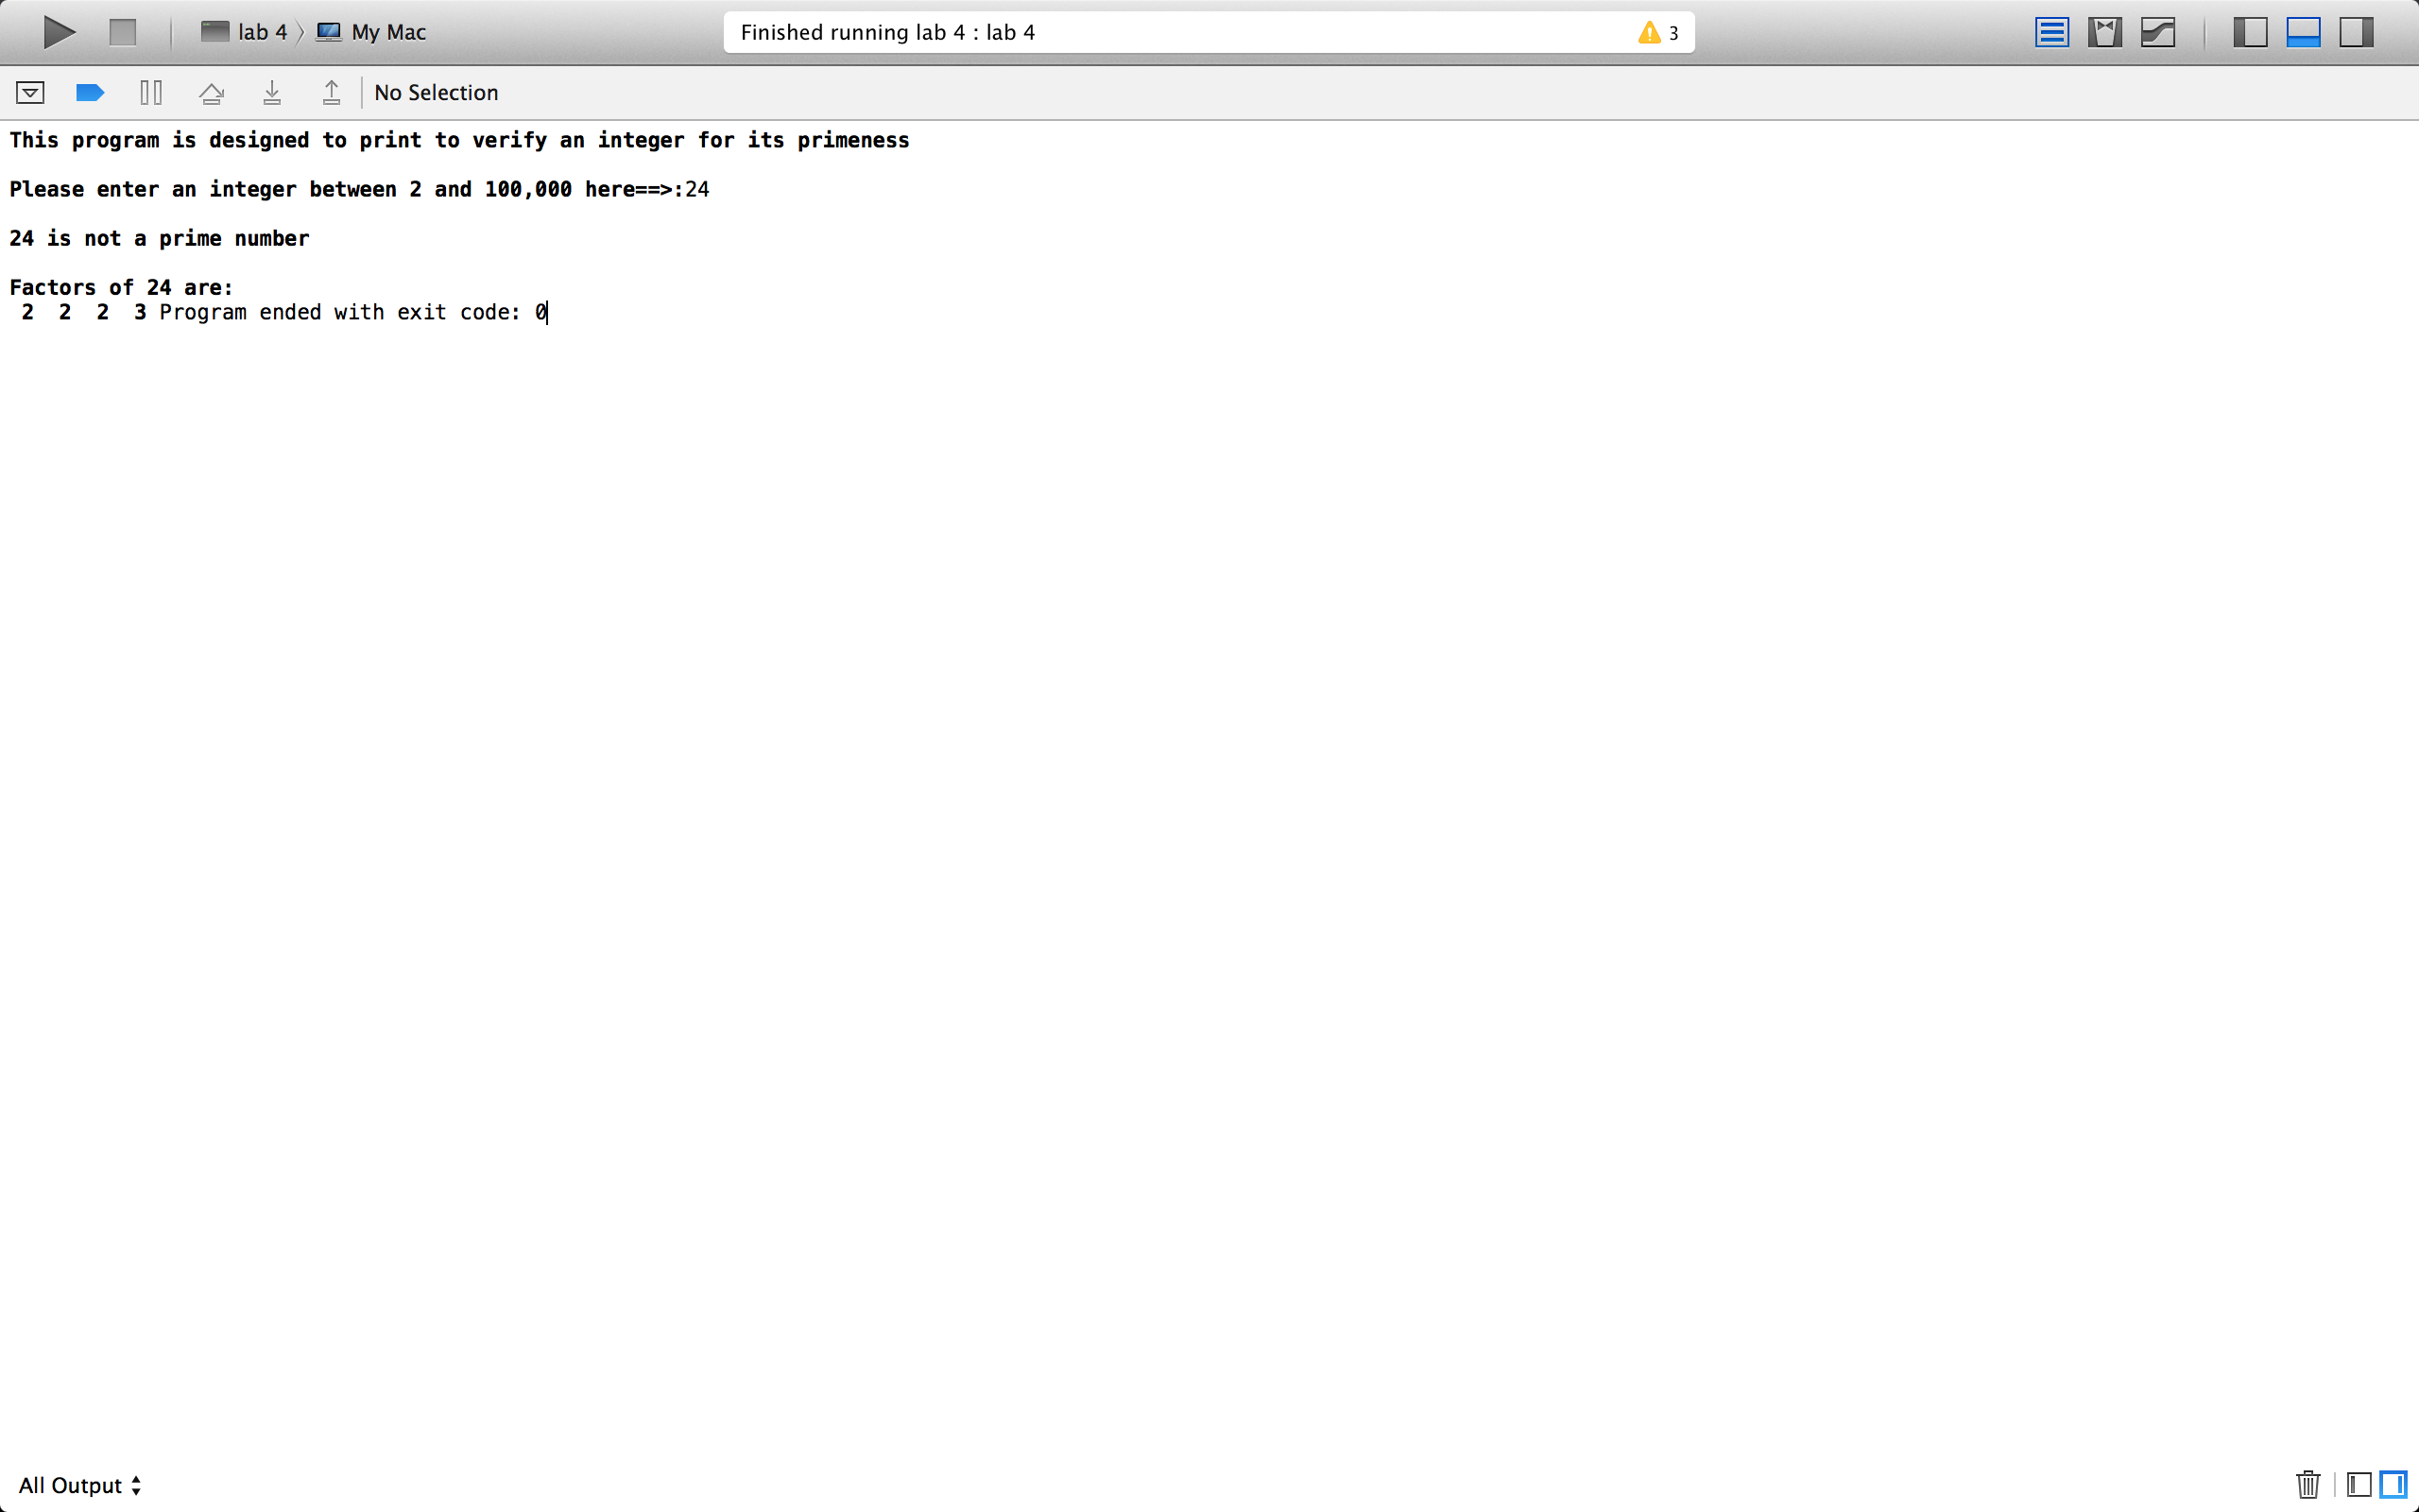

Test Case 2

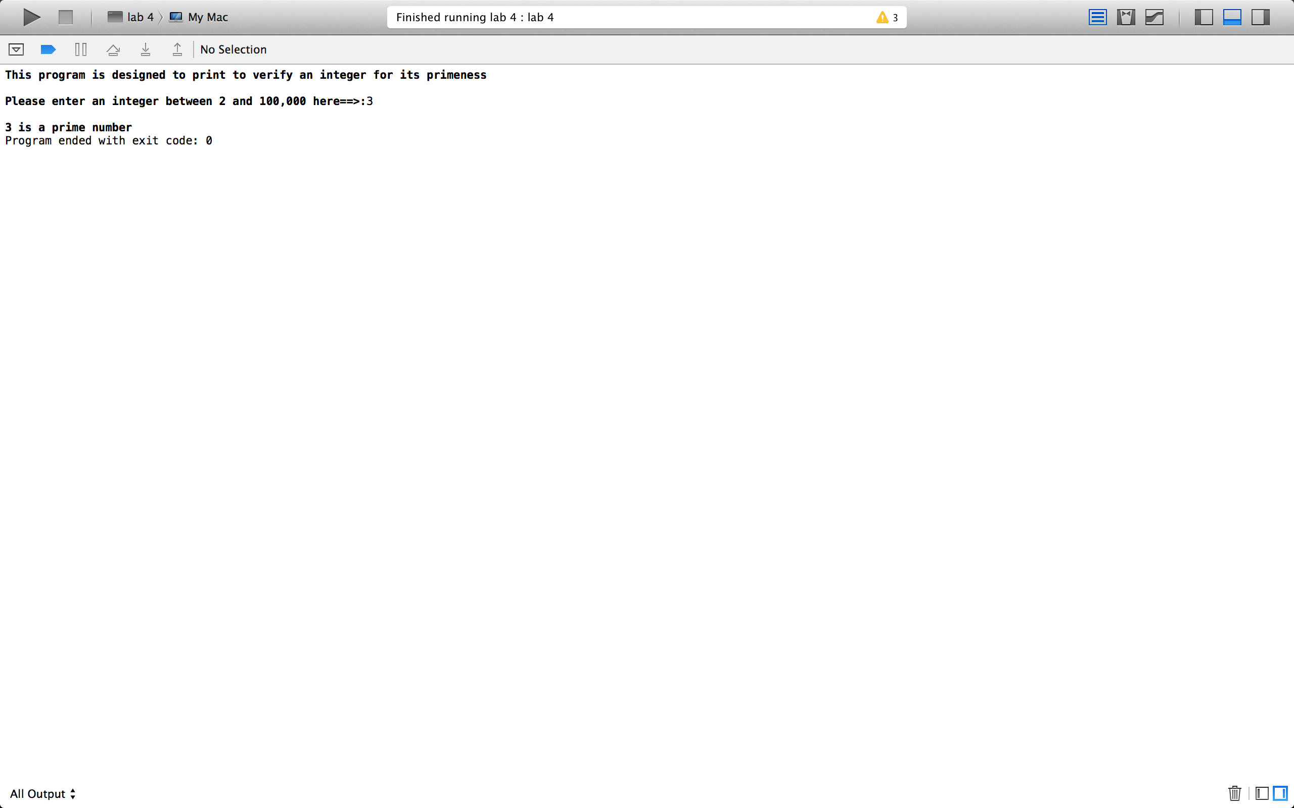

Test Case 3:



