Lab 3: Monty Hall Problem

Step 1: Problem Identification and Definition

Develop a program the acts as Month Hall and plays the door game with the user. Also create a subprogram that allows the user to study the winning statistics by staying with his/her original choice in comparison to switching it.

Step 2: Gathering of Information and I/O Description

At the beginning of the program, User(s) will be displayed three options. To play Monty Hall, Research, or Exit. After receiving the input from user, the program will go to the chosen subprogram.

For the Monty Hall subprogram, the Input values will be the door choice(s) entered by the user(s), and output values will be:

- Win or Loss (depending on user(s)’s choice)
- Win/Loss Count

For the Research Simulation subprogram, the Input value will be the number of gameplays entered by the user(s), and output values will be the number of wins by staying with the original choice and the number of wins by switching.

I/O description:
PROGRAM

User(s) choose door prints win
or loss

Step 3: Algorithm Development and Verification
BEGIN

GIVE OPTION FOR PLAYING MONTY HALL, RESEARCH OR EXIT

MONTY
HALL
RESEARCH

GO TO RESEARCH PROGRAM

GO TO MONTY HALL PROGRAM

EXIT

END
BEGIN
Monty Hall
Game:

PROMPT THE USER TO SELECT A DOOR

SWAP OPTION INITIATED
CHECK IF CHOSEN DOOR IS WINNING DOOR
REVEAL EMPTY DOOR AND GIVE OPTION TO SWAP CHOICE

ORIGINAL DOOR FALSE
KEPT
PRINT “YOU LOST”
CHECK IF CHOSEN DOOR IS WINNING DOOR

TRUE
PRINT “YOU WON”

END

Monty Hall Research:
BEGIN
MAKE DOOR 1 SELECTED DOOR
PROMPT THE USER TO ENTER NUMBER OF GAMEPLAYS

PRINT NUMBER OF WINS BY SWAPPING AND NOT SWAPPING

END

Implementation in C:

#include <stdio.h>
#include <stdlib.h>
#include <time.h>

#define TRUE 1
#define FALSE 0

void MontyHall(void);
void Research(void);
int MontyHallSimulation(int );

int CountWin=0,CountLost=0;

int main(void) {
int userinput;

// INITIALIZE the random number generator
srand(time(NULL));

// include a brief description of the game to the user
printf("Welcome to the Monty Hall Game\n");
//Complete the description

while (TRUE) {
printf("\n\nPlease select one of the following choices:\n");
printf("1. Play Monty Hall\n");
printf("2. Compare Swapping vs. Not Swapping\n");
printf("3. Exit the program\n\n");
printf("Enter selection: ");
scanf(" %d", &userinput);

if (userinput == 1)
MontyHall();
else if (userinput == 2)
Research();
else if (userinput == 3)
break;
else
printf("Error: Only numbers between 1 and 3 can be selected\n");
}
return 0;
}

// Lets user play Monty Hall Game for a single run
void MontyHall(void) {
int box[3];
int i = 0;
int prize_box_number;
int userinput;
int userguess;
int show_box_number;

// initialize all the boxes to FALSE (which is interpreted as a box having no prize)
while (i < 3) {
box[i] = FALSE;
i++; // i = i + 1

}

// randomly generate 0, 1, 2 (with equal likelihood)
prize_box_number = rand() % 3;

//select one of the three boxes randomly to contain the prize (initializing the box to 1 is interpreted as having the prize)
box[prize_box_number] = TRUE;

printf("\n\n\nThank you for playing the Monty Hall game.\n");
printf("Please guess the box (between 1 and 3) that contains the prize. If your guess is correct you win the prize!\n");
printf("Enter guess: ");
scanf(" %d", &userguess);

// converts box number user entered (in terms of 1, 2 and 3) to the way it is stored in the computer (as 0, 1 and 2)
userguess = userguess - 1;

// Check if the userguess is 0, 1 or 2 (if not prompt the user to enter another guess

// Find a box that does not contain the prize and that the user has not selected
i = 0; // so the loop starts at box[0] which means the physical box 1
while (i < 3)
{
if (box[i] == FALSE) // does the current box not have the prize
{ if (userguess != i) // is the box without the prize not the same box the userguess
show_box_number = i;
}
i++; // i = i + 1
}

printf("\n\n\nHey I opened box number %d and it did not contain the prize\n", show_box_number + 1);
printf("Do you want to swap your initial box %d ?\n", userguess + 1);
printf("Enter decision (1 for no swap and 2 for swap): ");
scanf(" %d", &userinput);

// Check if user decided no swap (userinput == 1)
if (userinput == 1) {
if (box[userguess] == TRUE) {
printf("Congratulations! You have won the prize\n");

CountWin++;

}
else {
printf("Sorry you didn't win the prize\n");

CountLost++;
}
}

//Check if user decided to swap (userinput == 2)
if (userinput == 2) {
if (box[userguess] == TRUE) {
printf("Sorry you didn't win the prize\n");
CountLost++;

}
else {
printf("Congratulations! You have won the prize\n");
CountWin++;
}
}

printf("Total Win : %d ",CountWin);
printf("Total Loss : %d ",CountLost);
}

// Compares the winning percentages of the swapping method vs the non swapping method
void Research(void) {

int number_of_runs = 0;
int win_counter_swap = 0;
int win_counter_no_swap = 0;
int i = 1;

printf("Enter number of runs: ");
scanf(" %d", &number_of_runs);

// Simulate how many wins you would get when using the no swap strategy
while (i <= number_of_runs) {
i++;
if (MontyHallSimulation(FALSE) == TRUE)
win_counter_no_swap++;
}

i = 1;
// Simulate how many wins you would get when using the no swap strategy
while (i <= number_of_runs) {

i++;
if (MontyHallSimulation(TRUE) == TRUE)
win_counter_swap++;
}

printf("\nDuring %d runs of the Monty Hall Problem, The amount of wins using ", number_of_runs);
printf("swap vs. no swap strategy are shown below\n");

printf("Number of Wins for No Swap: %d \n", win_counter_no_swap);
printf("Number of loss for No Swap: %d \n",number_of_runs- win_counter_no_swap);
printf("-------------------------------\n");

printf("Number of Wins for Swap: %d \n", win_counter_swap);
printf("Number of loss for Swap: %d \n", number_of_runs-win_counter_swap);

//retrun 0;

}

// Simulates the montyhall game using either the swap or no swap strategy
// The swap function argument contains either a TRUE or a FALSE (FALSE is interpreted
// as a no swap and TRUE is interpreted as a swap)

int MontyHallSimulation(int swap_choice) {
int box[3];
int i = 0;
int prize_box_number;
int swap = swap_choice;
int guessed;
int win;

// initialize all the boxes to FALSE (which is interpreted as a box having no prize)
while (i < 3) {
box[i] = FALSE;
i++; // i = i + 1
}

// randomly generate 0, 1, 2 (with equal likelihood)
prize_box_number = rand() % 3;

// Randomly selects one of the three boxes to contain the prize
box[prize_box_number] = TRUE;

// randomly generates 0, 1, 2 (with equal likelihood)
// These numbers are interpreted as the three boxes
guessed = rand() % 3;

// Contains the simulation strategy choosen (TRUE means swap and FALSe means no
// swap)
swap = swap_choice;

//Enters this conditional statement if the non-swapping strategy is used
//In this strategy if the original box selected contains the prize the person
//wins the prize.
if (swap == FALSE) {
if (box[guessed] == TRUE)
win = TRUE;

else
win = FALSE;
}

if (swap == TRUE) {
if (box[guessed] == TRUE)
win = FALSE;
else
win = TRUE;
}

return win;
}

Test Cases:

Test Case 1
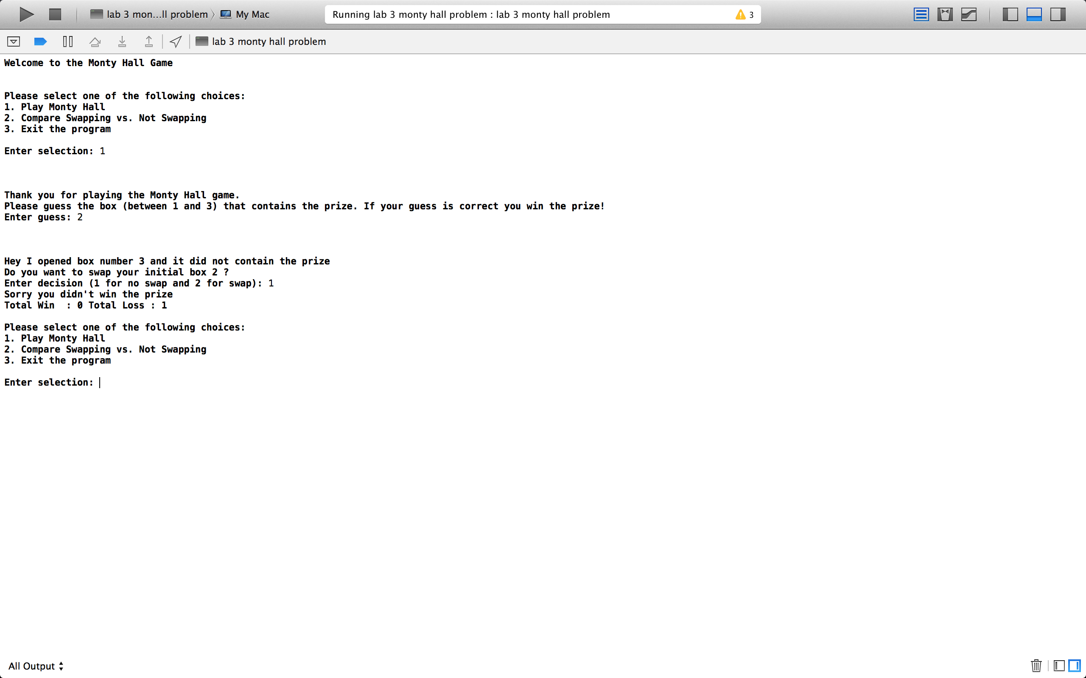

Test Case 2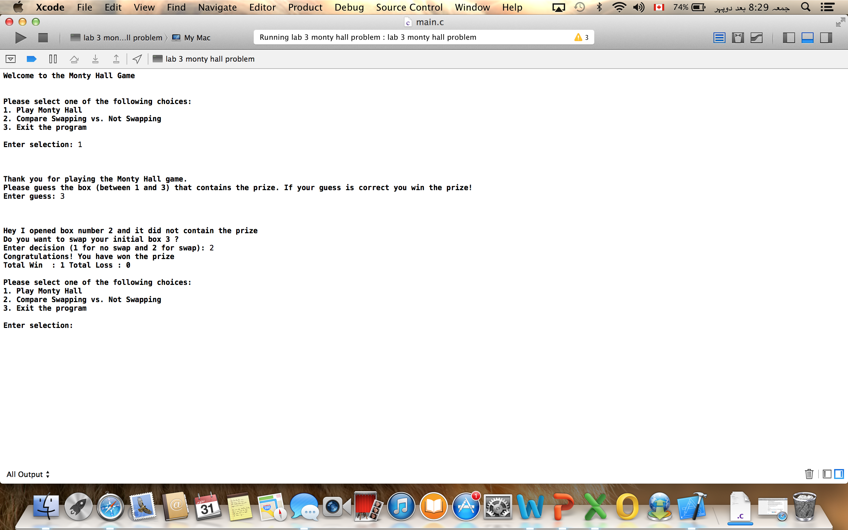

Test Case 3



