Lab 1: Pythagorean Triples

Step 1: Problem Identification and Definition

Develop a program that reads an integer N and prints the total number of Pythagorean triples in the form (a, b, c,) with c < N, every such triple and the triple that has the largest value of c.

Step 2: Gathering of Information and I/O Description

At the beginning of program, User(s) will be asked to enter a positive integer. When an integer has been entered, the compiler will print all the Pythagorean triples found in that range, display number of triples found along with the triple that has the largest value of c.

For this particular program, Input value will be the integer N entered by the user(s), and output values will be:

- Pythagorean triples in the format (a, b, c) with c < N
- Total number of Pythagorean Triples
- The triple with the largest value of c

The equations, and variables used in this program are shown below:

n- integer (entered by user)
z<n
y<z
x<y
x*x + y*y = z*z (x=a), (y=b), (z=c)

I/O description:

PROGRAM

User enters Displays
Positive integer Pythagorean
Triple(s)

Step 3: Algorithm Development and Verification

BEGIN
PRINT TOTAL NUMBER OF TRIPLES AND THE TRIPLE WITH THE LARGEST VALUE OF C
PRINT NO TRIPLES FOUND
TRIPLES FOUND
PROMPT THE USER TO ENTER A POSITIVE INTEGER

TRUE

FALSE

END

Test Cases:

Test Case 1:

n=5
No triples in this range

Test Case 2:

n=24

(3, 4, 5)
(6, 8, 10)
(5, 12, 13)
(9, 12, 15)
(8, 15, 17)
(12, 16, 20)

There are 6 triples in this range
The triple with the largest value of c is (12,16,20)

Test Case 3:

n=55

(3, 4, 5)
(6, 8, 10)
(5, 12, 13)
(9, 12, 15)
(8, 15, 17)
(12, 16, 20)
(15, 20, 25)
(7, 24, 25)
(10, 24, 26)
(20, 21, 29)
(18, 24, 30)
(16, 30, 34)
(21, 28, 35)
(12, 35, 37)
(15, 36, 39)
(24, 32, 40)
(9, 40, 41)
(27, 36, 45)
(30, 40, 50)
(14, 48, 50)
(24, 45, 51)
(20, 48, 52)
(28, 45, 53)

There are 23 triples in this range
The triple with the largest value of c is (28,45,53)

Implementation in C:

//
// main.m
// GNG 1106 LAB 2
//
// Created by Saifullah on 2014-09-29.
// Copyright (c) 2014 Saifullah . All rights reserved.
//

#include <stdio.h>
int a;
int b;
int c;

int main()
{

int x = 0, y = 0, z = 0, n, counter=0;

printf("Please Enter A Positive Integer: \n");

scanf("%d", &n);

for (z=0; z<n; z++)
{
for (y=0; y<z; y++)
{
for (x=0; x<y; x++)
{
if (x*x + y*y== z*z)
{
counter++;
printf("%d", counter);
printf(" \t%d, %d, %d\n", x, y, z);
a=x;
b=y;
c=z;

}
}
}

}
if (counter==0)
printf("No triples in this range");
else if (counter ==1)
printf("There is one triple in this range");
else
{ printf("There are %d triples in this range", counter);

printf("\nThe triple with the largest value of c is (%d,%d,%d).\n", a, b, c);
}

return 0;
}

Testing And Validation:

Test Case 1:
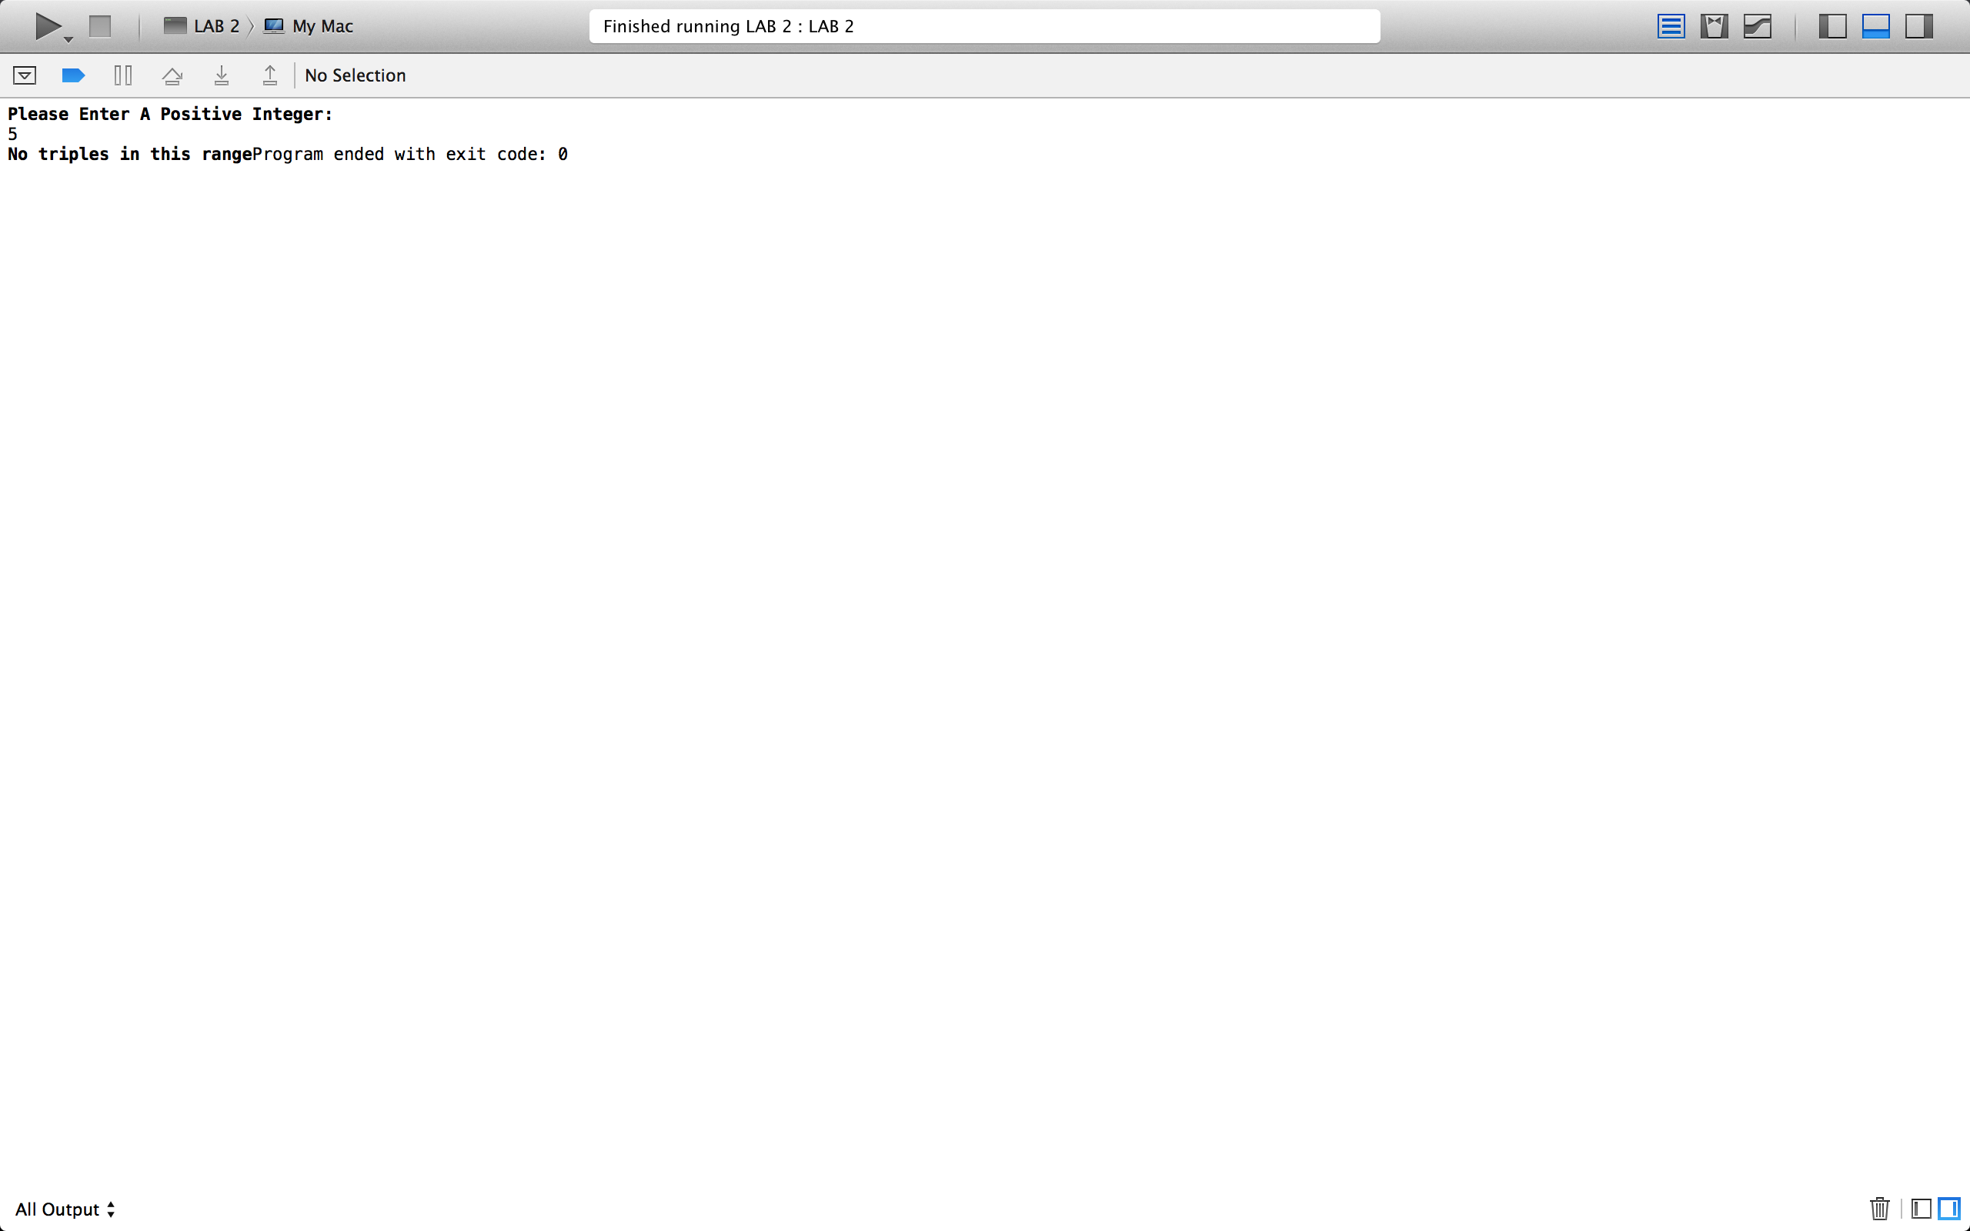Test Case 2:

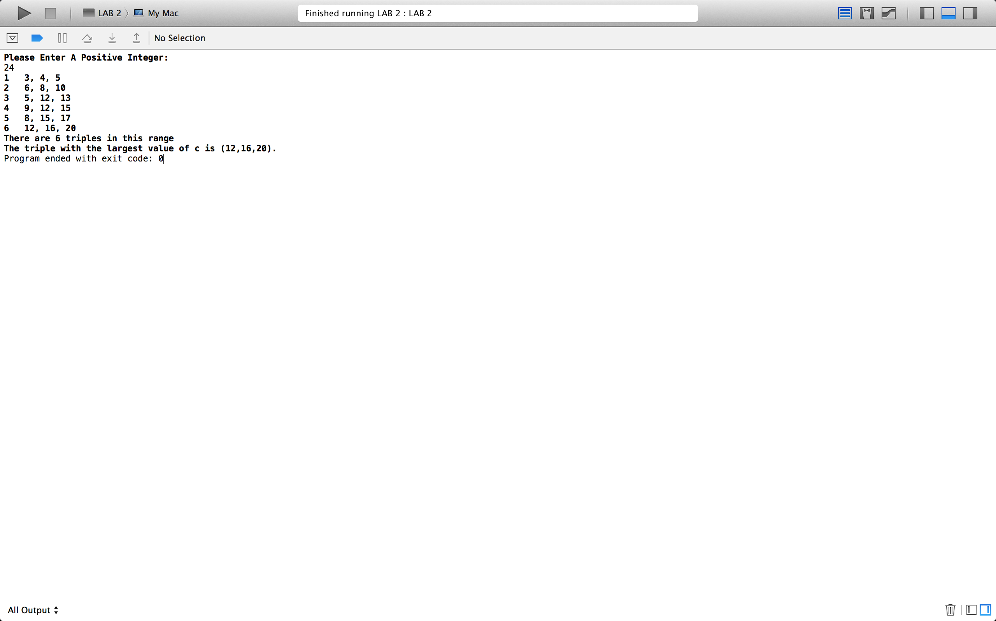

Test Case 3:



