Lab 1: Computing the Area of a Triangle

Step 1: Problem Identification and Definition

Develop a software that will compute the area of a triangle when given three (x, y) coordinate points that are entered by the user.

Step 2: Gathering of Information and I/O Description

At the start of the program, the program will welcome the user and provide them with instructions to enter three (x, y) coordinate points separately. The program will wait for the user to enter the points and after every point will display the values entered in (x, y) format. When the user has entered all three points, the software will display the points that were entered and compute the area for the triangle that will be formed with those points.

For this particular program, the input values will be the ones that are entered by the user, and output value is the area of the triangle formed by the entered points. The calculations and equations used for computing the area of the triangle are shown below:

(x1, y1), (x2, y2), (x3, y3)

Variables Used:
a= sqrt (((x2-x1)*(x2-x1)) + ((y2-y1)*(y2-y1)))
b= sqrt (((x3-x1)*(x3-x1)) + ((y3-y1)*(y3-y1)))
c= sqrt (((x3-x2)*(x3-x2)) + ((y3-y2)*(y3-y2)))
s= (a+b+c)/2
A= sqrt (s*(s-a)*(s-b)*(s-c))

I/O Description

PROGRAM

(x, y) coordinates Area of Triangle

Step 3: Algorithm Development and Verification
BEGIN

END
DISPLAY THE AREA ALONG WITH POINTS ENTERED
FIND AREA OF TRIANGLE FORMED BY USING THE EQUATIONS GIVEN
PROMPT THE USER TO ENTER THREE (x, y) POINTS

Test Cases:

 | Point 1 | Point 2 | Point 3 | Area
Test Case 1 | (0, 3)  x1, y1 | (4, 3)  x2, y2 | (2, 6)  x3, y3 | 6.0000…
Test Case 2 | (4, 8)  x1, y1 | (7, 10)  x2, y2 | (6, 12)  x3, y3 | 3.9999…
Test Case 3 | (-7, 2)  x1, y1 | (-7, -2)  x2, y2 | (4, -3)  x3, y3 | 22.0000…

Implementation in C:

//Saifullah Qasim
//Sept 17, 2014
// GNG 1106 Lab 1
//This program will compute the area of triangle when given 3 points
// Created by Saifullah on 2014-09-16.
// Copyright (c) 2014 Saifullah . All rights reserved.
//

#include <stdio.h>
#include <math.h>
int main()

{
float x1,x2,x3,y1,y2,y3;
float a,b,c,s,A;
printf("Welcome!");
printf("\n\nYou have initiated software XT to calculate the area of a triangle given three (x,y) coordinate points");
printf("\n\nPlease follow the instructions given below to calculate the area");
printf("\n\nEnter x1 coordinate to begin here==>\n");
scanf("%f", &x1);
printf("Enter y1 coordinate here==>\n");
scanf("%f", &y1);
printf("\nYou entered (%f,%f)", x1,y1);

printf("\n\nEnter x2 coordinate==>\n");
scanf("%f", &x2);
printf("Enter y2 coordinate==>\n");
scanf("%f", &y2);
printf("\nYou entered (%f,%f)", x2,y2);

printf("\n\nEnter x3 coordinate==>");
scanf("%f", &x3);
printf("\nEnter y3 coordinate==>");
scanf("%f", &y3);
printf("\nYou entered (%f,%f)",x3,y3);

a= sqrt (((x2-x1)*(x2-x1))+((y2-y1)*(y2-y1)));
b= sqrt (((x3-x1)*(x3-x1))+((y3-y1)*(y3-y1)));
c= sqrt (((x3-x2)*(x3-x2))+((y3-y2)*(y3-y2)));
s= (a+b+c)/2;
A= sqrt ((s)*(s-a)*(s-b)*(s-c));

printf("\n\nThe three (x,y) coordinate points that form the triangle are==> (%f,%f),(%f,%f),(%f,%f)", x1,y1,x2,y2,x3,y3);

printf("\n\nThe area of the triangle formed by the three (x,y) coordinate points shown above is:%f",A);

return 0 ;
}

Testing And Validation:

Test Case 1

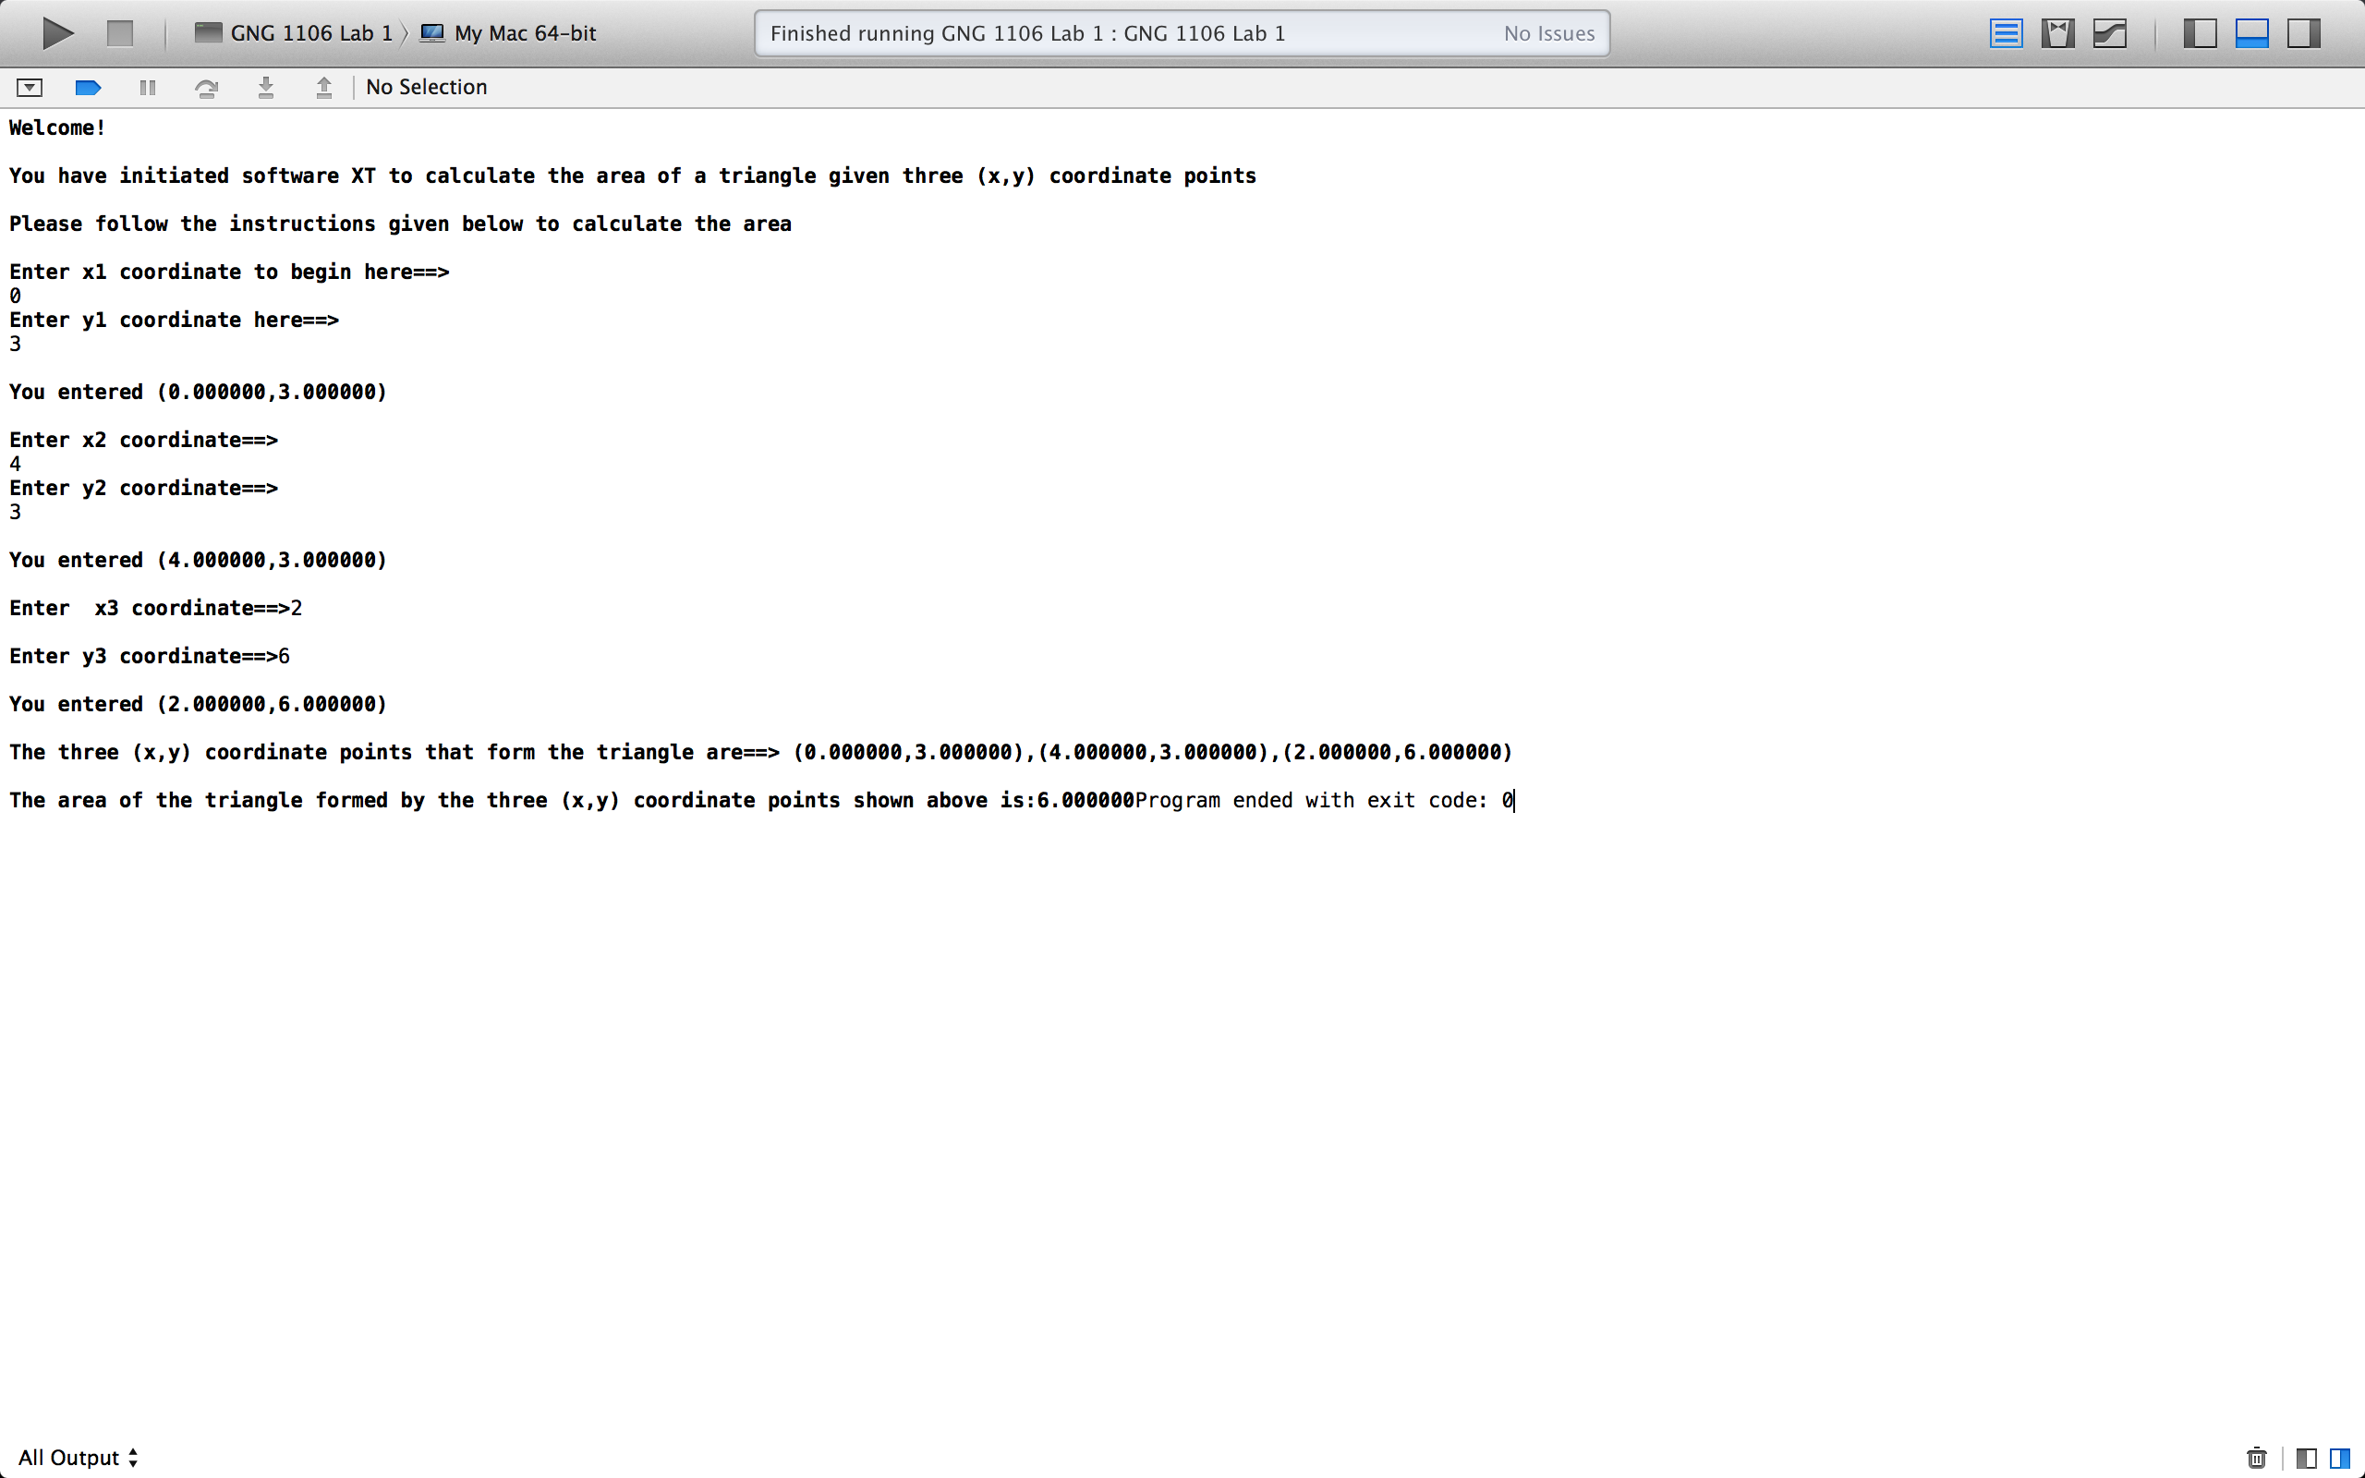
Test Case 2

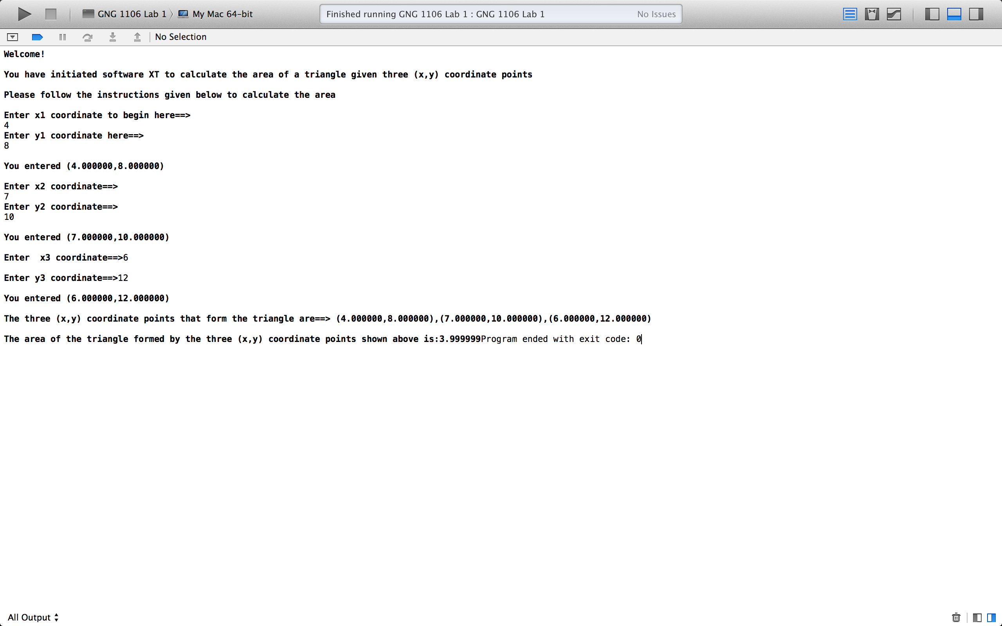

Test Case 3



