QUESTION 1:

#include <stdio.h>

int abc(int a)
{
int x=10;
printf("\t in abc before increasing: x=%d\n", x);
x=x+a;
printf("\t in abc after increasing : x=%d\n", x);
return x;

}

int main()
{
int x=100;
int a=20;
a=abc(x);
x=abc(a);
printf("in main: a=%d, x=%d\n", a, x);
return 0;

}

This code will display as follows:

in abc before increasing: x=10
in abc after increasing : x=110
in abc before increasing: x=10
in abc after increasing : x=120
in main: a=110, x=120

Analysis:

The program reads the “main()” function first and there int x and int a which are both assigned a number value. In 3rd line (highlighted green) the program is told to go the subprogram abc in order to find the value of a. In subprogram abc, int x=10 (highlighted purple) which is why you get the first printf statement as “in abc before increasing: x=10”. Right after this the program moves to the statement “x=x+a”(highlighted yellow). Since x is defined as 10 and a is 100 because of “abc(x)” in which the value of x in the “main()” function is 100. You get the second printf statement as “in abc after increasing : x=110” and then x is returned and its value is stored in “a” as 110. Then in the main function, you have another command to go to the abc function by the statement “x=abc(a)”(highlighted black above). This takes you back to the abc function and you get the third printf statement: “in abc before increasing: x=10”. The reason this is like this is because just before the printf statement int x is made to equal to 10 (refer to line highlighted purple above) and printf statements belong to the command that is just before them. After this the program executes the next command which is “x=x+a”, the value of a is stored in memory as 110 and x is made to equal to 10, which makes x equal to 120. This value is stored as x and x is returned. After this the program comes back to the “main()” function and goes to the “printf” statement and prints “in main: a=110, x=120” and returns “0”.

QUESTION 2:

#include <stdio.h>

int abc(int a)
{
static int x=10;
printf("\t in abc before increasing: x=%d\n", x);
x=x+a;
printf("\t in abc after increasing: x=%d\n",x);
return x;

}

int main()
{
int x=100;
printf("in main: x=%d\n",x);
x=abc(x);
printf("in main: x=%d\n",x);
x=abc(x);
printf("in main: x=%d\n",x);
return 0;
}

This program will print as following:

in main: x=100
in abc before increasing: x=10
in abc after increasing: x=110
in main: x=110
in abc before increasing: x=110
in abc after increasing: x=220
in main: x=220

Analysis:

The program reads the “main()” function first. Int x is made to equal to 100 and after going to the “printf” statement, the following message is printed: “in main: x=100”. The reason it prints that is because this “printf” statement belongs to “int x=100”(highlighted black above). After this the program is instructed to go to the subprogram abc by the statement “x=abc(x)”(highlighted yellow). In subprogram “abc”, there is a “static” variable (highlighted grey), which is why its executed only once in this program. The program reads the printf statement and prints “in abc before increasing: x=10”. The next statement is “x=x+a”(highlighted green above) and the printf statement that belongs to this function prints “in abc after increasing: x=110”. The reason it prints this is because it adds 10 + 100. The value 10 comes from the static variable “x” and 100 comes from “int x” in the “main()” function. The value of x is returned and x in “main” becomes 110. The “printf” statement (highlighted red) is then read by the program and it prints “in main: x=110”. After that the program reads “x=abc(x)” (highlighted pink) which instructs it to go back to the subprogram abc. This time the “static” variable is not used, and the program uses the stored value of x and prints “in abc before increasing: x=110” but when it goes to the second “printf” statement (highlighted maroon), it prints “in abc after increasing: x=220”. The reason it does this is because of the statement “x=x+a” in which x is the previous value of 110 and “a” is also 110 because “x=abc(x)” which goes into the subprogram “int abc(int a)”, in which the value of “a” is 110. The program returns the value of x and goes to the last “printf” statement in the “main()” function. It prints “in main: x=220” and the program ends by returning “0”.

QUESTION 3: Programming

Step 1: Problem Identification and Definition

To develop a software that prompts the user(s) to enter a positive integer number and prints its corresponding Fibonacci number. i.e. the i^{th} number in the Fibonacci sequence.

Step 2: Gathering of Information, I/O Description

Positive Integer | Corresponding Fibonacci Number
1 | 1
2 | 1
3 | 2
4 | 3
5 | 5
6 | 8
7 | 13
8 | 21
9 | 34
10 | 55
11 | 89
12 | 144
13 | 233
14 | 377
15 | 610
16 | 987
17 | 1597
18 | 2584
19 | 4181
20 | 6765

For this program, the input values will be the ones entered by the user(s) and the output value(s) will be the Fibonacci number displayed by the program.

I/O Description:
PROGRAM

Corresponding
The i^{th} number Fibonacci number

Step 3: Algorithm development

BEGIN
END
DISPLAY THE CORESSPONDING FIBONACCI NUMBER
PROMPT THE USER TO ENTER A POSITIVE INTEGER

Test Cases:

 | Positive Integer | Fibonacci Number
Test Case 1 | 1 | 1
Test Case 2 | 4 | 3
Test Case 3 | 9 | 34

Implementation in C:

See attached file.

Step 6: Verification

Test Case 1:

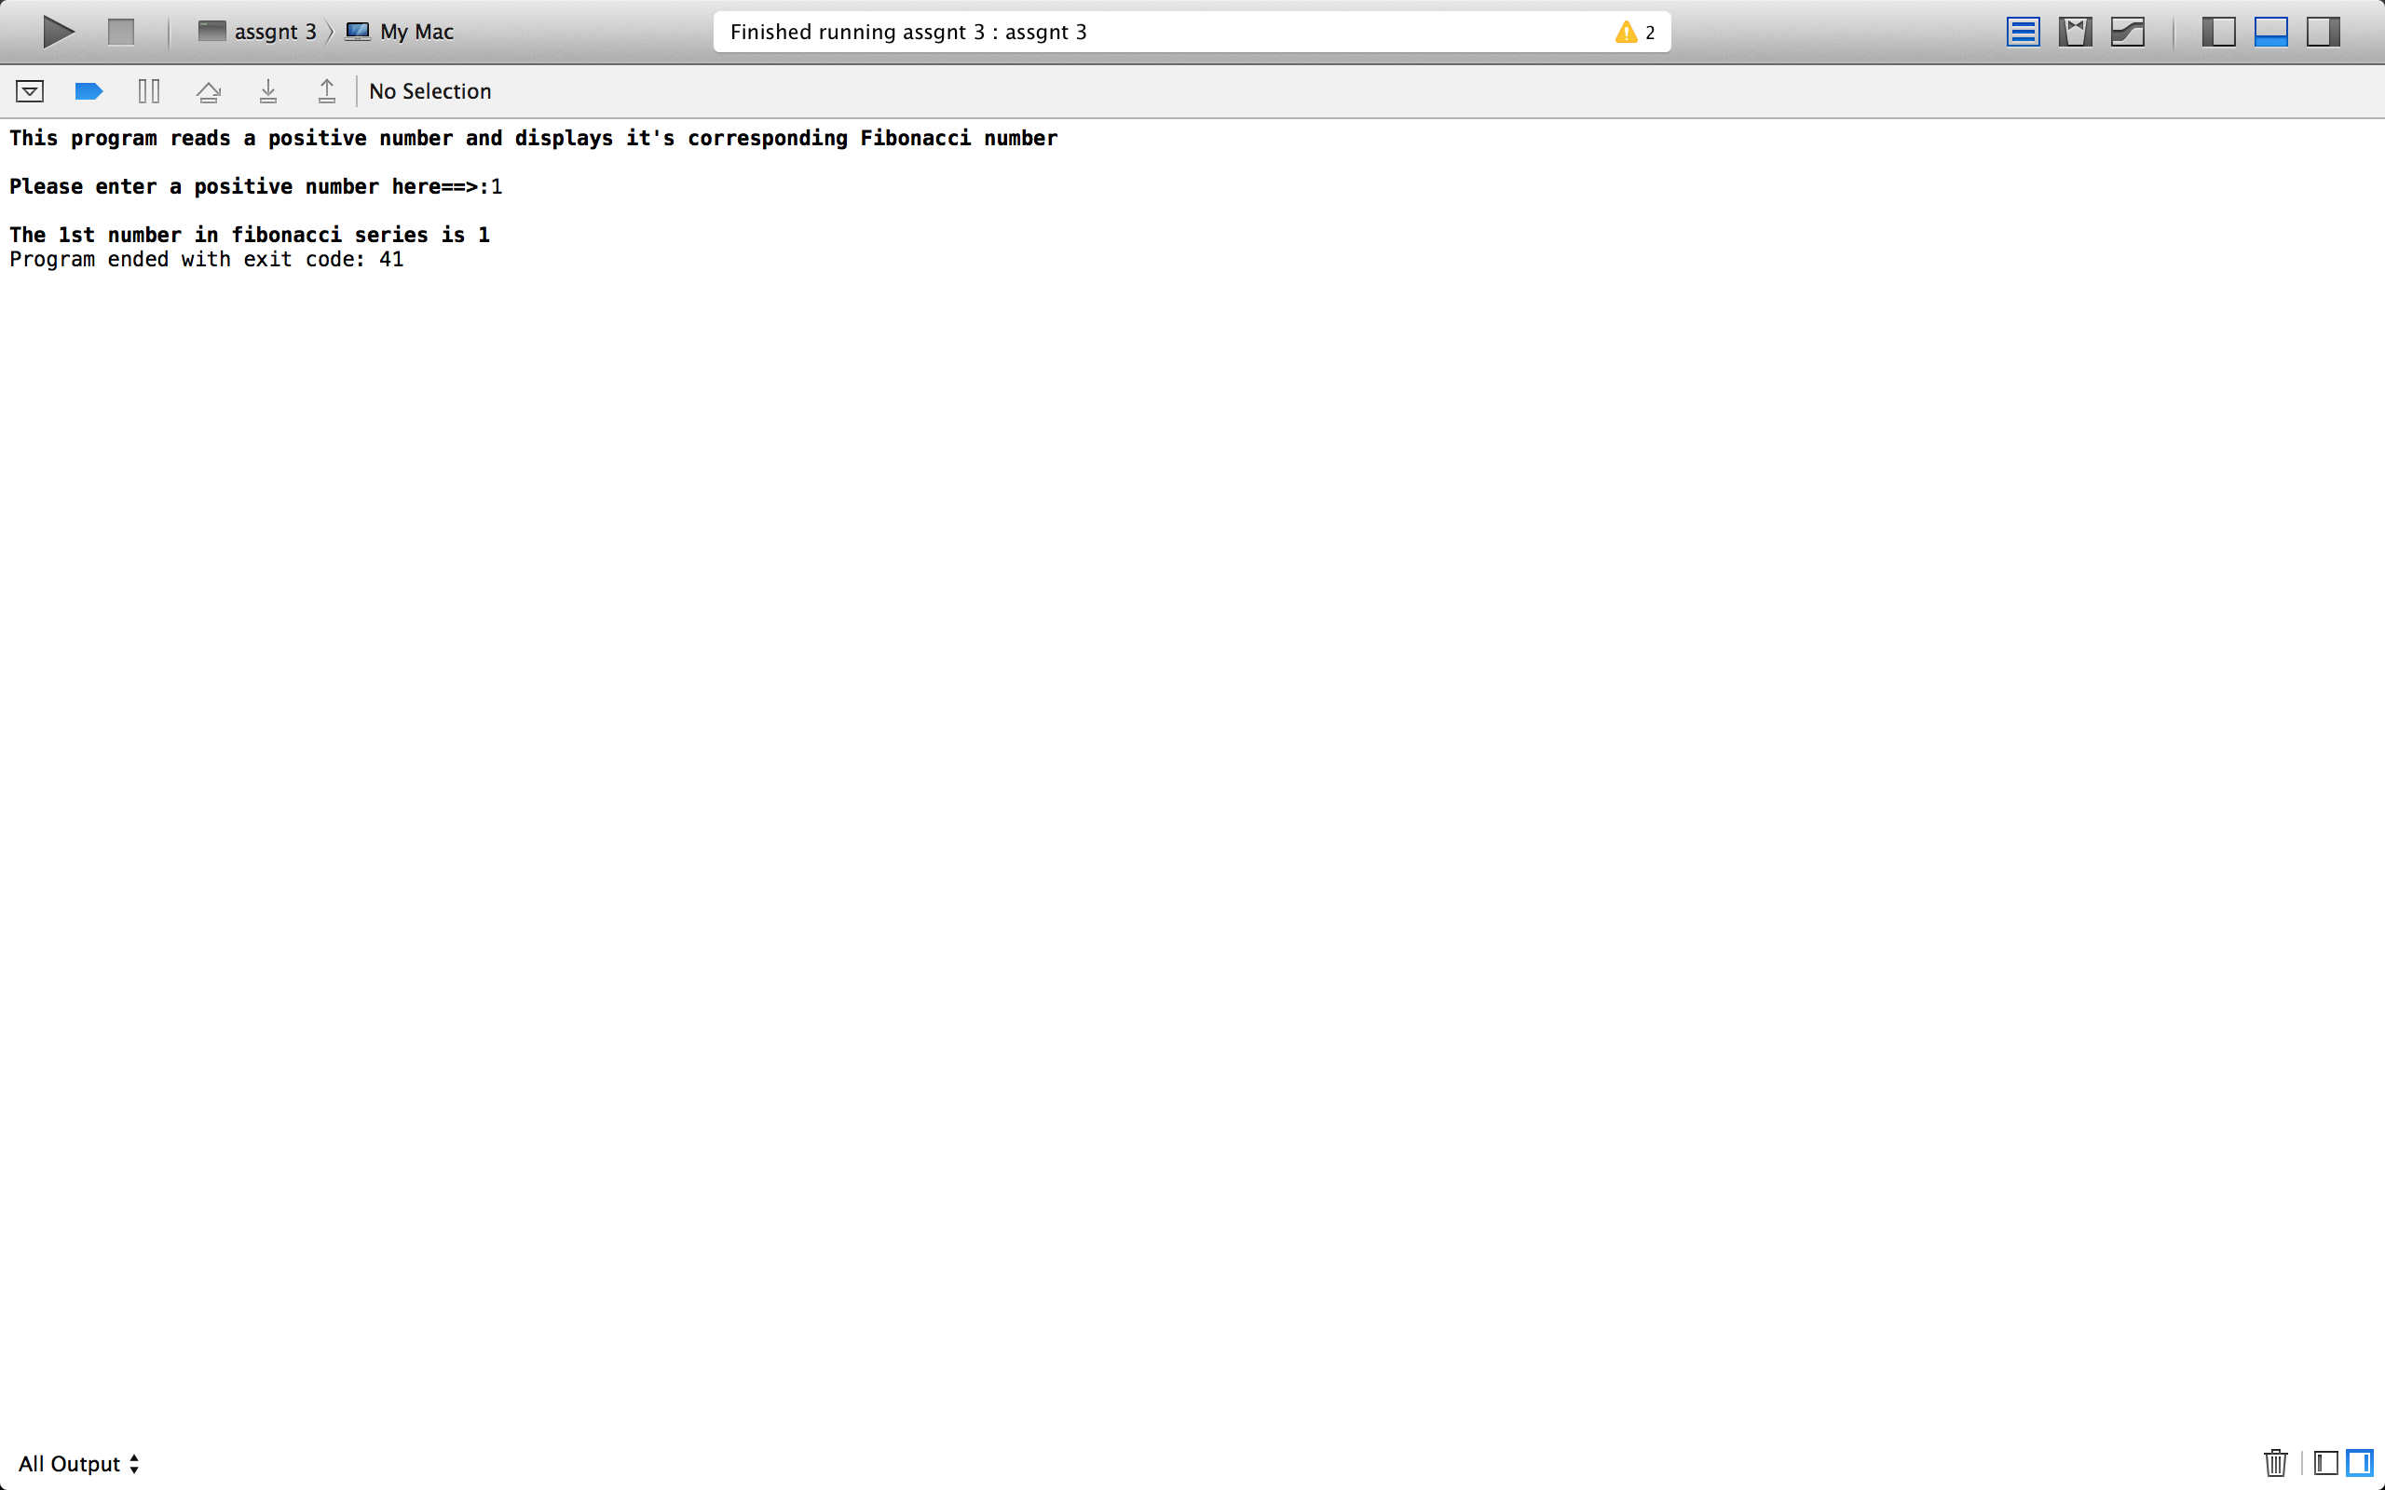

Test Case 2:

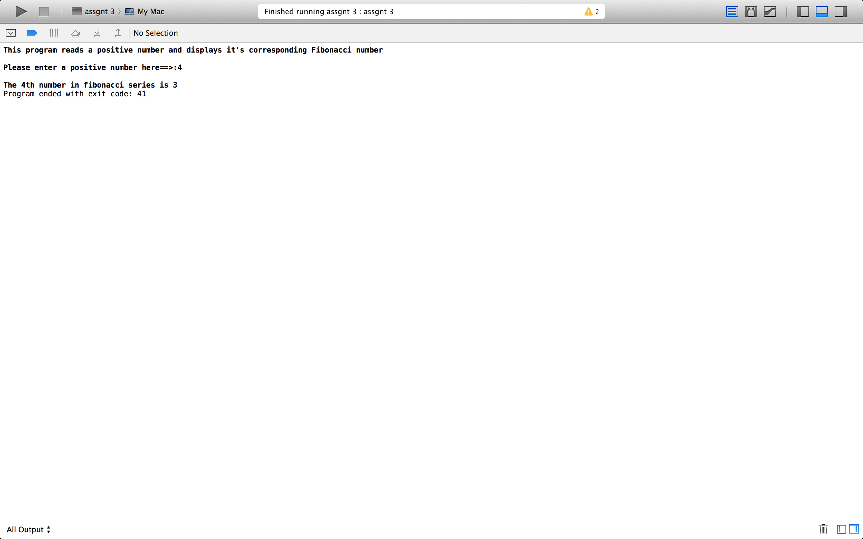

Test Case 3:



